Sightability of Crescent Moon for Shawwal, 1428 Hijra

The Astronomical New Moon is on Thursday, October 11, 2007 at 5:00 GMT (i.e., 1:00 am EDT, or October 10, 10:00 pm PDT). It will not be visible on October 11 anywhere in the world, except Southern tip of South America and Polynesian Islands in the South Pacific. On October 12, it will be visible in New Zealand Australia, Indonesia, South Asia, Africa and Africas. In North America on October 12, it can be seen with some difficulty. Look at the visibilty curve below. Sighting/nonsighting reports will be posted here as soon as they are available.
Visibility Curve for October 11 and 12, 2007 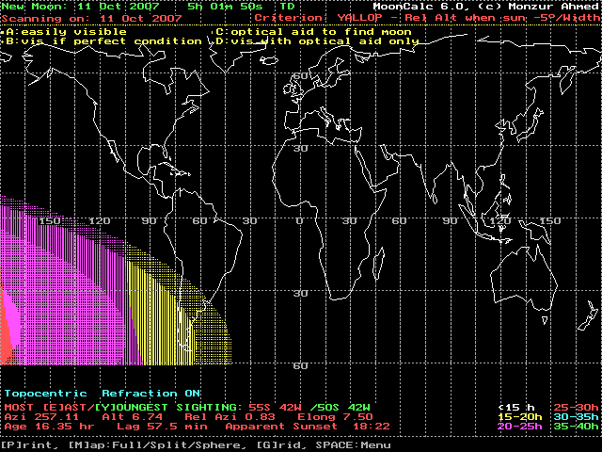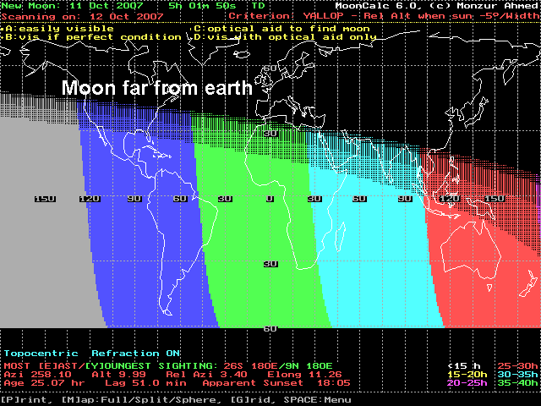

Source: www.moonsighting.com

Phases of the Moon 2007

Universal Time
The following table gives the date and time (Universal Time) of all phases of the Moon for the twenty-five year period 2001-2025. For the year 2000, the length of the mean synodic month (New Moon to New Moon) is 29.530588 days (=29d12h44m03s). However, the length of any one synodic month can vary from 29.26 to 29.80 days due to perturbing effects of the Sun on the Moon's eccentric orbit.
The Phases of the Moon table indicates when an eclipse of the Sun or Moon takes place and gives the eclipse type. An eclipse of the Sun can occur only at New Moon, while an eclipse of the Moon can occur only at Full Moon. (see: Solar Eclipses for Beginners and Lunar Eclipses for Beginners). In any calendar year there are a minimum of two solar and two lunar eclipses. The maximum number of eclipses in any one year is 7 (4 solar and 3 lunar, or 5 solar and 2 lunar). The following table lists abbreviations for the different types of solar and lunar eclipses.
Year New Moon First Quarter Full Moon Last Quarter

2007 Jan 3 13:57 Jan 11 12:45
Jan 19 04:01 Jan 25 23:02 Feb 2 05:45 Feb 10 09:51
Feb 17 16:14 Feb 24 07:56 Mar 3 23:17 t Mar 12 03:54
Mar 19 02:43 P Mar 25 18:16 Apr 2 17:15 Apr 10 18:04
Apr 17 11:36 Apr 24 06:36 May 2 10:09 May 10 04:27
May 16 19:27 May 23 21:03 Jun 1 01:04 Jun 8 11:43
Jun 15 03:13 Jun 22 13:15 Jun 30 13:49 Jul 7 16:54
Jul 14 12:04 Jul 22 06:29 Jul 30 00:48 Aug 5 21:20
Aug 12 23:03 Aug 20 23:54 Aug 28 10:35 t Sep 4 02:33
Sep 11 12:44 P Sep 19 16:48 Sep 26 19:45 Oct 3 10:06
Oct 11 05:01 Oct 19 08:33 Oct 26 04:52 Nov 1 21:18
Nov 9 23:03 Nov 17 22:32 Nov 24 14:30 Dec 1 12:44
Dec 9 17:40 Dec 17 10:17 Dec 24 01:16 Dec 31 07:51

Source: http://sunearth.gsfc.nasa.gov/eclipse/phase/phase2001gmt.html

