Initiating A Knowledge Based ICT Movement in Indonesia:
A 12+ Years Experience

Onno W. Purbo
An Ordinary Indonesian
onno@indo.net.id
http://sandbox.bellanet.org/~onno/

Overview
This report is based on my personal 12+ years experience in attempting to build a financially sustainable community based information infrastructure in Indonesia. Such infrastructure is deployed without relying on Donor Funding, such as, World Bank, IMF even in many cases have to fight with the police as many of our action considered as outlaw.

To start with, no available funding is assumed. I may very much bias to my Indonesian experience. All activities are driven by a simple vision, to see a knowledge-based society in Indonesia. ICT is believed to be the tool of choice to accomplish the task.

Maintain a self-finance & sustainable process under intervention of international bodies or donor agencies is the most difficult task. Most people will likely to assume that international bodies would likely to bring free funding for them. It may work for pilot projects; the process may unfortunately stop as soon as the funding source dried up.

Similarly in most government approaches, bridging a digital divide with imbedded divide policy framework (operator vs. common user) and no room for community-based infrastructure seems to be arguable. Not to mention the highly corrupt environment. Significant part of the existing regulatory framework became an obstacle against our effort intended for people’s movement, and, thus, leads to unnecessary casualties in some cases.

My experience shows that it would be much easier to initiate a self-finance sustainable process if there is no funding from any donor agency to begin with. We can easily see the committed individuals & successful approaches in a free donor agency zone. Care has to be carefully planned to inject funding in a self-finance & sustainable process. Key successes rely heavily on ability to create a tacit knowledge exchange platform enabling knowledge producing young authors follow up by education processes focused on scaling & replicating the process for high impact to the society. Open source, open document, copy left movement would be significant. All processes are self-finance. It has nothing to do with the technological superiority of the equipments. Adjustment should be made for different countries & regulatory environment.

The catch would be in the ability to identify & to work with informal (most likely underground) visionary leaders / pioneers in the country / area. It would unfortunately be very difficult to find one through formal (government) channels.

Conceptual Framework
Creating a self-financed knowledge cycle, there are basically two (2) critical strategies, namely: transforming local youths into knowledge producers; and supply-created-by-demand strategy.

Without skilled and dedicated people to drive this movement, the deployment of such innovative infrastructure would not be possible. This infrastructure model thrives only because it is invested, built, and run by the people for the people. Having easy access to low cost technology is not enough. In Indonesia, ICT knowledge in local language is limited.

A key component for the successful deployment of ICT infrastructure in the Indonesian context is the development of young students to become local knowledge producers. These knowledge producers (young authors) acquire ICT knowledge from various sources, experiment with them, and then author their experiences into publications in the local language (Bahasa Indonesia). To sustain young authors to continue producing knowledge materials they are compensated with US$15-25/article and US$500-700/book. The typical monthly living cost for a student is US$80-95 (including tuition, books, housing and meals).

The impact of knowledge producers is felt on many levels. Not only do their publications educate people, but they also open people’s minds to new ideas and help reaffirm the feasibility of investing their own money in such infrastructure models. Once people are convinced to deploy community neighborhood networks, they can utilize knowledge produced by the young authors to assist in building their capacities. These capacities include initial set up, operation, and maintenance of the infrastructure.

With a sound knowledge base and strong network of knowledge producers, communities can become self-sustaining, by developing and maintaining their own equipment and services. Similar initiatives from large top-down institutions often result in failure because the methodology they use treats people as customers, rather than empowering them to participate in achieving a sustainable solution.

An example in Education Network, since 2001, the Director for Vocational Schools at the Ministry of Education has been leading the integration of close to 3000 vocational schools to the Internet through WiFi. It costs 50 cents US/student/month to self-finance the school Internet program and return of investment in less then two (2) years period. Much ground is left to be covered with a total of 1300 colleges / universities, 10,000 high schools, 10,000 Islamic schools, 4,000 vocational schools yet to be connected.

This journey towards achieving low-cost connectivity was complemented with many talented and dedicated Indonesians who enjoyed sharing their knowledge, expertise and resources for the betterment of Indonesian society.

Today, the learning and development process is continued through various Indonesian mailing lists, such as, orari-news@yahoogroups.com, indowli@yahoogroups.com, and genetika@groups.or.id.

Fully supported by the International Development Research Centre (IDRC) and the Bellanet Secretariat in Canada, the Author is able to share his practical knowledge of wide area WiFi infrastructure deployment in English. This practical knowledge for supporting the development of community-based infrastructure is freely available at the following site: http://sandbox.bellanet.org/~onno.

A conceptual framework of Knowledge Based ICT Infrastructure Deploying Movement

To sustain a digital divide bridge deployment, a supply created-by-demand strategy would be crucial. Most failed approaches will likely to use demand created-by-supply path. Demand in information infrastructure as well as ability to exploit the abundant information & knowledge in the infrastructure will only happen in an educated society. Failure to increase the society's level of education will likely to impede the development of information infrastructure within the society.

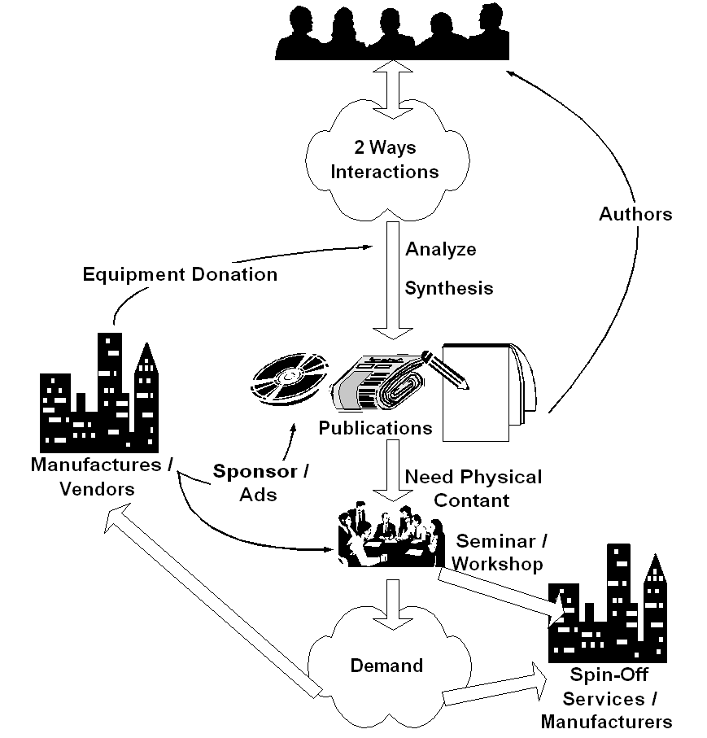
Key success in deploying the information infrastructure would rely heavily on the quality & skill of the human resources. Ability to distribute the needed knowledge & skill at low cost would be crucial in creating demand & needed skilled technician to deploy the infrastructure. Ability to access ICT knowledge in English would be a plus. Interestingly, please note that funding is not the primary concern in deploying ICT infrastructure.

If I may put it in point form, the simplified steps would be something like,

- Create platform for people to do 2 ways interaction. It is basically to facilitate tacit (implicit) knowledge exchange. It may be radio or TV talk shows, or Internet mailing list at no cost. Unlike most assumed condition by 1st world countries, no abundant local content is necessary to start with. Community will create their own content through platform the exploit community implicit knowledge. Today, there are more than 50.000 Indonesian mailing list on the Internet to facilitate such tacit knowledge exchange.

- It may take 1-2 years, before some of the individual start analyze and synthesis the collective community knowledge. These young individual should make their knowledge implicit in written form. It should be distributed through conventional channels, such as, newspaper, magazine, radio & television, and thus transform the mindset of others who are not yet using ICT. It cost US$ 1-2 to access the knowledge by buying the book or magazine. They will produce publications in magazine and books and receive US$ 25 / article or US$ 500 / book.

- Some may need physical contact through seminar and workshop to be convinced. We are normally looking at 500-1000 participants / seminar. It costs US$ 3 / person to enter such seminars as many vendors may likely give sponsorship.

- Creating demand within the people for the "digital divide bridge". Once the demand increases business will respond to the opportunity else persuade people to invest their money into deploying the "bridge". A 50 cents/student/month in a school network or US$15-30/house/month in a US$2000 neighborhood network investment with RoI within 1-2 years is a good enough incentive for people to invest their own money into the "digital divide bridge". Success stories & word of mouth is the typical process to spread the words.

- Deploy & maintain the "digital divide bridge" may be done at 50 cents/student/month at school or about US$ 15-30/month/house. Ah, we finally have financially sustainable digital divide bridges with minimal support from the Bank, the government & hopefully license free.

- In the end, as more and more people connected to the Internet, pressure will be high for the regulators to work on their policies. Hoping no distortion made during the processes.

As shown clearly, all the sequences are self-finance. The normal (not the ideal) sequence would be awareness, demand, business response, and regulation. These steps would not be completed over night. It takes years to complete these steps. Committed leaders & personals are needed for such long-term deployment ICT movement.

Having an alternative bottom-up self-finance community based movement has proven to be a good ICT development model, at least for Indonesia; as a result, we are currently seeing:

- 15+ million Indonesian on the Internet
- 15000+ WiFi outdoor node for bypassing local telco infrastructure
- 2000+ Internet Cafes
- 4000+ schools on the Internet

Note that most of these results are community based funded with not much government support; as well as no funding from World Bank or IMF.

None of these infrastructure and abundant Internet users exists 10 years ago ...
Education is key. Knowledge is power. Share It. It will muliply.

