DIGITAL REVIEW OF INDONESIA
Onno W. Purbo
onno@indo.net.id
November 2002

3.0 SOME HISTORICAL PERSPECTIVE

RMS Ibrahim, Suryono Adisoemarta, Muhammad Ichsan, Robby Soebiakto, Putu, Firman Siregar, Adi Indrayanto, Basuki Suhardiman, Arman Hazairin are some of the legendary names in early Internet development in Indonesia around 1992-1995. Most of the current Indonesian Internet users may not know them. Each of them has dedicated their knowledge in building part of early historical Indonesian Internet. In early 1990, Indonesian Internet was known as PaguyubanNet.

Solidarity, helping each other strongly binds us together. It is quite different than current spirit of Indonesian Internet, more commercial, more individualistic especially those involve in commerce over the Internet.

Articles on the existence on Indonesian Internet can be traced down in several Indonesian national newspaper, such as, KOMPAS, in the end of 1990, we can find an article entitled "jaringan komputer biaya murah menggunakan radio" (low cost radio based computer network) as well as some short articles in Elektron Magazine published by Electrical Engineering Students Society of Institute of Technology Bandung (ITB) around 1989.

The early Internet development in Indonesian was inspired by the activities in Indonesian amateur radio especially the Amateur Radio Club (ARC) ITB in 1986. Equipped with HF SSB transceiver Kenwood TS430 belong to Harya Sudirapratama YC1HCE and Apple ][ computer with 64Kbyte RAM belong to YC1DAV, 10-20 young ITB students, such as, Harya Sudirapratama YC1HCE, J. Tjandra Pramudito YB3NR (now a lecturer at UNPAR), Suryono Adisoemarta N5SNN (now a Proffessor in Texas,US) and me YC1DAV, we learn to our senior amateur radio such as Robby Soebiakto YB1BG, Achmad Zaini YB1HR, Yos YB2SV, YB0TD in 40m band. Mas Robby Soebiakto YB1BG is one of the amateur radio guru among us in Indonesia, he teaches us how to conduct data communication over radio known as packet radio, and interact using TCP/IP protocols on top of it. YB1BG teaches us on using the amateur satellites for data communication. The learning process is later helped by many Indonesian mailing lists, such as, ybnet-l@itb.ac.id, ybqrp@yahoogroups.com, orari-news@yahoogroups.com etc.

The packet radio technology developed by the amateur radio, is the early Indonesian Internet technology implemented to link friends at Ministry of Research and Technology (Jakarta), University of Indonesia (Jakarta), Indonesian Aerospace Institute (Bogor) and Institute of Technology Bandung (Bandung), later known as Paguyuban Network in 1992-1994.

RMS Ibrahim (A.K.A. Ibam) was the driving force behind the operation of Internet at University of Indonesia (UI) in Jakarta. Using UUCP Protocol UI helps us transfer the mail from our slow radio network in Indonesia to the Internet vice versa. Ibam is the first man in Indonesia who handles Indonesia (ID) Country Code Top Level Domain (ccTLD) later known as Indonesia Network Information Center IDNIC (http://www.idnic.net.id).

Muhammad Ihsan was a research staff member at LAPAN Ranca Bungur not too far from Bogor, south of Jakarta, in early 1990's. M. Ichsan was supported by his supervisor Dr. Adrianti and working together with DLR (equivalent of NASA in Germany) trying to setup packet radio computer network in 2 m and 70 cm band, later known as JASIPAKTA. M. Ichsan station, located in Bogor, is the one who relays the traffic from ITB in Bandung to Jakarta.

Mr. Firman Siregar was the driving force at Ministry of Research and Technology who managed packet radio gateway in 70 cm band. A simple 386 machine running Network Operating System (NOS) on top DOS operating system servers as the main radio gateway for the traffic from LAPAN and ITB. Indonesian Internet is in its infancy, traffic to the Internet uses X.25 packet network connected to the gateway at DLR in Germany. The network at Ministry of Research and Technology was later known as Research and Technology Network (a.k.a IPTEKNET) http://www.iptek.net.id.

Putu is the name attached to the development of PUSDATA (Data Center) at Ministry of Industry and Trade during Mr. Tungki Ariwibowo's time. Started with a small Bulletin Board System (BBS) in early 1990 and provides free e-mail service to public, we may now enjoy the transparency many public policy and public documents of Ministry of Industry and Trade at http://www.dprin.go.id. Both Putu and Tungki Ariwibowo should receive most of the credit in transforming a government institution into cyberspace. Mr. Tungki Ariwibowo is the first Indonesian Minister who actively responds to e-mails.

By the end of 1992, Suryono Adisoemarta N5SNN went back to Indonesia. His arrival was exploited by the students at ITB's Amateur Radio Club, such as, Basuki Suhardiman (now at AI3 ITB), Aulia K. Arief (now at jalawave.net), Arman Hazairin (now at Telkomsel cellular) supported by Adi Indrayanto (now completing his PH.D in England) worked on the packet radio gateway at ITB. Having mainly guts to try new things and a used 286 machine, Institute of Technology Bandung (ITB) may be the poorest institution in Paguyuban Network. The radio modem, also known as Terminal Node Controller (TNC), used at ITB was borrowed from Muhammad Ihsan at LAPAN Ranca Bungur.

Start with a slow 1200bps packet radio in early 1993, ITB gradually built the Internet communities in Bandung and its surroundings. In 1995, ITB received a free 14.4Kbps leased line to RISTI Telkom as part of IPTEKNET. It really open the mind set of many the students and young Internet enthusiasts in Bandung. In September 1996, it was the main turning point for ITB, they invested on Ku-Band satellite ground station and integrating ITB into Asia Internet Interconnection Initiatives (AI3) research network to Japan at 1.5Mbps bandwidth (now 2Mbps). ITB added 2Mbps interconnection to TelkomNet for local traffic, which in the end set ITB as one of the leading institution to integrate 25+ Indonesian educational institutions to the Internet around 1997-1999 known as AI3 Indonesia network.

I have to admit that ITB is not the only one who led integrating education institutions to the Internet. Dr. Gatot H.P. at Ministry of Education is currently leading integrating 1000+ vocational schools to the Internet. We are still long way to go with the total of 1300 colleges / universities, 10,000 high schools, 10,000 madrasah / pesantren / Islamic schools, 4,000 vocational schools. It would be a challenging task to integrate all of these educational institutions.

In 1989-1990-an, the first Indonesian mailing list is set at the legendary Indonesians@janus.berkeley.edu. The experience was clearly shown the powerfulness of community building through cyber interaction. It inspires many cyber-Indonesians, and set many Indonesian mailing lists. In 1997, ITB serves the cyber communities on its two mailing list servers on Pentium machines running FreeBSD. Currently, more Indonesians are using the free service at http://groups.yahoo.com for their mailing list servers. The characteristics of Indonesian communities will be described later in the paper.

It is glimpse of some historical aspects on Indonesian Internet. It was an enjoyable process and involving many good and dedicated Indonesians who like to share their knowledge, expertise and resources for the good of Indonesian society.

  - OVERVIEW:

Indonesia, a country with an estimated 228 million people in 2001 is struggling to reach US$2900 GDP per capita with GDP real growth rate at 4% to reach GDP of US$ 654 billion estimated in the turn of the century. Distribution of wealth would be one of the most challenging tasks as it ties to other sectors, such as, education, distribution of power, distribution of authority within the country.

The current ICT infrastructure is equivalent to only 1-5% of the country’s population. The country should be currently satisfied by estimated 7.1 million 100% digital fixed phone line infrastructure, and approximately the same number of cellular subscribers as estimated in 2002.

As reported by IDC, in 2001, Indonesia is spending US$752 million in IT hardware, US$124 million in software, US$ 85 million in IT services. It is estimated a total of US$ 1,228 million of IT spending in 2001. Adding telecommunication spending into the picture, a total of US$ 3.539 million of ICT spending is estimated in 2001. ICT/GDP is about 2.2% or about US$16.6 ICT/Capita. Software over hardware spending is only 16.5%. Internet commerce is very low at 0.10% to total commerce, and it is about US$2.11 per capita. Only 9.8% of IT spending is on eBusiness technology.

In 2001, there is estimated 2.3 million PCs in the country. Most of these PC, about 1.9 million are used in business and government. Only about 251.000 PCs are used in Indonesian household. More than 60.000 educational institutions are currently using only about 58.000 PCs.

It serves in excess of 2 million Internet users, out of approximately 600.000 Internet subscribers. It is not surprising to see 60-70% Internet access is performed through 1500+ Internet cafés in the country. Thus, Internet café seems to be the most common access point for Indonesian communities. It is quite affordable ranging from US$ 0.3-1 / hour. However, in tourist areas, such as, Bali, fare can be as high as US$5-6/hour.

Dial-up service over the noisy lines is commonly used to access the Internet. Not surprising many of the Internet café as well as private sector will likely to bypass the last mile Telco infrastructure using WiFi 11Mbps equipment running at 2.4GHz. Some are currently using 5.8GHz equipment for higher speed. Most of this wireless access points are in cities.

Wireless infrastructure may be away to go for deploying Internet for rural, under-served, poor Indonesian neighborhood. However, issues in rural areas would not only telecommunication / Internet access technology, it is more on the demand, people, social, cultural side as well as the highest stumbling block in the regulatory framework. Need on information and knowledge is virtually non-existence in such areas. Education processes would be the most strategic step to create the need and demand.

Lead by Indonesia Linux User Group, A.K.A Kelompok Pengguna Linux Indonesia (KPLI) www.linux.or.id, the Indonesian Linux community is struggling to grow. Various Indonesian Linux mailing lists hosted at linux.or.id, such as, linux-admin@linux.or.id, lead most of the awareness and education activities among Indonesian Linux users. Physical interaction is still a potent strategic tool to convey Linux knowledge to the society. It is not surprising to see a very high rate 3-4 seminar, talkshow, roadshow per week. Not counting a significant number of magazines and Linux book published. Many young Information Technology (IT) authors emerge.

No indigenous fonts and scripts are used, as Indonesian is currently using the western alphabet in Indonesian language. Our major problem is mainly due to lack of content written in Indonesian. Speak-and-listen is much more common way to communicate in Indonesian culture as compared to read-and-write. By simple evaluation through google.com, it can be clearly seen that only 15.3% of Indonesian content is in in Indonesian language. The rest are written in English by various sources.

3.2 CONTENT:

The evaluation of content consumed in the country can be honestly performed through log report of Web proxy server, such as, Calamaris log report. Two (2) tables of Calamaris log report from Institute of Technology Bandung (ITB) and Internet Café in Makassar will be reported.

Below is the content accessed through proxy server at Institute of Technology Bandung (ITB), analyzed by Calamaris as provided by Computer Network Research Group (CNRG) ITB collected in a period of November-December 2001.

destination request % Byte % hit-%
---------------------------------- --------- ------ -------- ------ ------
<error> 2860212 11.50 3744279K 1.54 4.78
*.yahoo.com 1547041 6.22 8265276K 3.39 2.44
*.detik.com 849392 3.41 2167652K 0.89 67.26
*.yimg.com 833505 3.35 3366633K 1.38 71.81
*.kompas.com 711061 2.86 2747551K 1.13 47.34
*.google.com 469002 1.89 1527486K 0.63 32.63
*.netscape.com 433179 1.74 1431066K 0.59 6.12
*.astaga.com 384038 1.54 910697K 0.37 15.85
*.mtnsms.com 359569 1.45 948082K 0.39 47.73
*.plasa.com 293157 1.18 589902K 0.24 44.16
*.lycos.com 272013 1.09 1671596K 0.69 29.37
*.akamai.net 239955 0.96 2177434K 0.89 39.23
*.doubleclick.net 230459 0.93 287260K 0.12 42.94
*.itb.ac.id 230110 0.93 73340M 30.79 21.79
*.microsoft.com 215087 0.86 2845621K 1.17 24.21
*.msn.com 162074 0.65 1044565K 0.43 26.54
*.geocities.com 142352 0.57 1129032K 0.46 25.62
202.53.225.* 140494 0.56 232280K 0.10 51.18
*.livestat.com 109032 0.44 46347262 0.02 0.00
*.pikiran-rakyat.com 108499 0.44 702780K 0.29 78.92
other: 91103 2nd-level-domains 14285798 57.43 129873M 54.52 30.98
---------------------------------- --------- ------ -------- ------ ------
Sum 24876029 100.00 238208M 100.00 29.19

Below is an example of web access behavior is provided by Adi Nugroho adi@internux.co.id who managed the proxy server of 50% of Internet Café in Makassar, Sulawesi. Shown in the table is the data collected in September 2002.

destination request % Byte % hit-%
---------------------------------- --------- ------ -------- ------ ------
*.yahoo.com 39279 5.82 299745K 6.41 5.56
*.yimg.com 18983 2.81 90733974 1.89 77.15
*.plasa.com 16047 2.38 40083661 0.84 37.96
*.astaga.com 15626 2.32 40179107 0.84 6.96
*.google.com 8712 1.29 24296217 0.51 43.32
*.msn.com 8486 1.26 57609160 1.20 28.81
*.detik.com 7977 1.18 42044900 0.88 82.35
*.akamai.net 6746 1.00 41248239 0.86 73.78
*.microsoft.com 6228 0.92 204634K 4.38 10.07
*.doubleclick.net 5867 0.87 24995726 0.52 24.08
*.boleh.com 5278 0.78 13810868 0.29 84.37
*.17tahun.com 4735 0.70 14426531 0.30 76.71
*.windowsupdate.com 4542 0.67 25429052 0.53 1.34
*.kompas.com 4246 0.63 21250342 0.44 70.49
202.53.225.* 4236 0.63 10318374 0.22 70.40
*.icq.com 3956 0.59 14552491 0.30 85.92
*.geocities.com 3727 0.55 32799130 0.69 23.34
*.gator.com 2632 0.39 9766199 0.20 37.54
*.kinghost.com 2570 0.38 17344692 0.36 38.25
other: 8575 2nd-level-domain 393871 58.37 3517317K 75.22 50.20
---------------------------------- --------- ------ -------- ------ ------
Sum 674758 100.00 4675933K 100.00 39.09

Typical web access (consumption) behavior can be summarized as follows,

- Search engine & web mail are the most accessed sites. It basically tells that most beginners would roam through the Internet through the help from search engines, while e-mail seems to be their main activities.
- News & online media are next in the row.
- Right after it is the Indonesian pornographic site, although, it is only small only percentage. In contrast to heavily cover by the media, pornographic sites are not the main focus for most beginners.
- Quite high percentage of the users are normally mistyped the URL. Thus, users may be vulnerable to crackers who create sites that catch mistyped URLs.
- Yahoo.com & its family are the most (10-13%) accessed sites. I guess, it is a common phenomenon worldwide.

To analyze the Indonesian content produced, google.com might be the best place to get the required data. By putting appropriate keywords in certain topics, we hopefully able to probe the Indonesian content produced in Indonesian and English.

More than ten (10) keywords are used to analyze the number of certain topics and language. To give some example, to probe content on education, the following Indonesian keywords, namely, sekolah. Pendidikan, belajar, pelajaran, kuliah, kurikulum, siswa, cerdas, mengajar, pandai, mata pelajaran, kejuruan and diknas, are used. While in probing English content on Indonesian education, the following keyword, namely, indonesia research, indonesia education, indonesia training, indonesia school, indonesia library, indonesia students, indonesia workshop, indonesia seminar, indonesia teacher, indonesia curriculum, indonesia thesis, indonesia vocational and indonesia extracurricular, are used. The keywords used are picked as the word commonly found for certain context.

A large number of URLs are found after Google search. The following tables will show the number of URLs found as well as rank each topics. It is interesting to know a significantly different emphasis of content in Indonesian as compared to English.

Table. Indonesian Content in Indonesian Language

Rank | Topics in Indonesian Language | Number of URLs
1 | Technology | 1,788,210
2 | News and current affairs | 1,521,300
3 | Education | 1,176,300
4 | Culture and literature | 1,143,760
5 | Industry/Business | 1,123,800
6 | Government | 1,113,770
7 | Civil society | 1,059,290
8 | Health/Nutrition | 810,250
9 | Commerce and tourism | 725,047
10 | Rural development | 517,960
11 | Political groupings | 422,987
12 | Agriculture | 242,321
13 | Non-government organizations | 231,450

Table. Indonesian Content in English.

Rank | Topics in English | Number of URLs
1 | Commerce and tourism | 9,525,870
2 | Industry/Business | 8,571,900
3 | Civil society | 7,698,000
4 | Government | 5,979,990
5 | Culture and literature | 5,611,100
6 | News and current affairs | 5,395,100
7 | Education | 5,039,470
8 | Technology | 4,800,400
9 | Political groupings | 3,339,239
10 | Health/Nutrition | 2,608,250
11 | Rural development | 2,501,030
12 | Non-government organizations | 2,489,215
13 | Agriculture | 2,253,900

As clearly shown in these two (2) tables, more emphasis on technology, news and current affairs, education, culture and literature are apparent in Indonesian language content. While Indonesian content in English, which aim to reach a broader English audience on the Internet, put more emphasis on commerce and tourism, industry/business, civil society, and government. Thus, the interest, needs of Indonesian readers seems to be significantly different than that of English readers. In both Indonesian and English content, not many content produced in rural development, non-government organizations and agriculture.

Ratio of Content in Indonesian Language as compared to English is listed in the following table.

Commerce and tourism 7.1%
Industry/Business 11.6%
Civil society 12.1%
Government 15.7%
Culture and literature 16.9%
News and current affairs 22.0%
Education 18.9%
Technology 27.1%
Political groupings 11.2%
Health/Nutrition 23.7%
Rural development 17.2%
Non-government organizations 8.5%
Agriculture 9.7%

In the average Indonesian content in Indonesian language contributes only about 15.3% of all content on Indonesia. The percentage of Indonesian content in Indonesian language reaches its 27.1% peak in technology related areas; followed by health/nutrition at 23.7% and news current affairs at 22%. The Indonesian techies seem to get the most benefit from the network.
3.3 IMPORTANT INDIGENOUS SOURCES OF CONTENT:

The source of content listed is mainly based on Calamaris log report of large proxy server in Indonesia, namely, Institute of Technology Bandung (ITB) and InterNux (Makassar city).

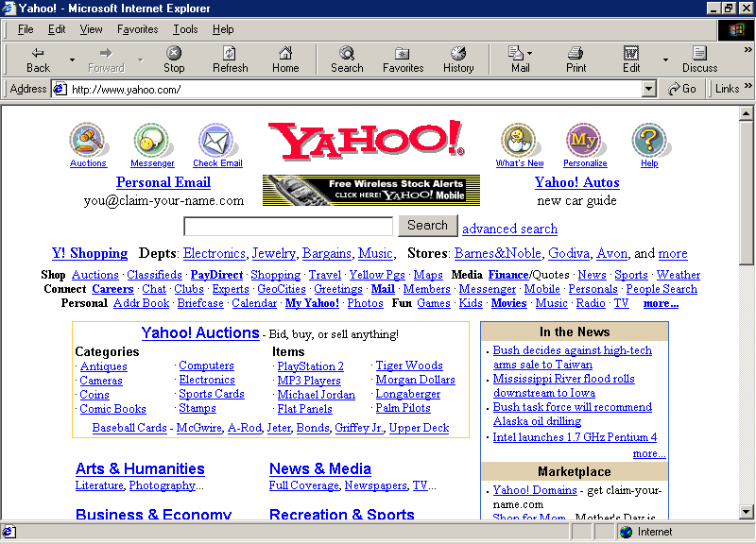
As shown in calamaris log report, the most and consistently popular Internet site in Indonesia is surprisingly yahoo.com, including www.yahoo.com, mail.yahoo.com, groups.yahoo.com. For various reasons, Indonesian Internet users use yahoo.com and its various services for most of their activities. To best of my knowledge, there is no specific service on Indonesian language is on yahoo.com. Although, there are more than 45,000 Indonesian mailing lists are hosted at groups.yahoo.com.

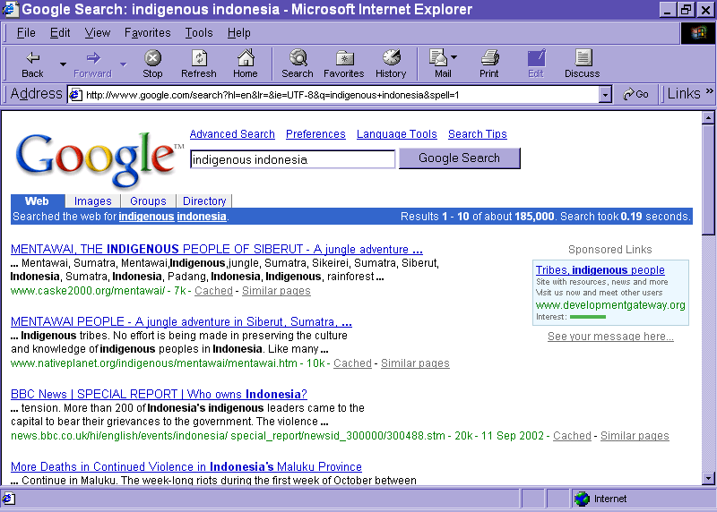
The second popular search engine used by Indonesian people is surprisingly www.google.com. It is clearly shown that the International service on the Internet serves the need of Indonesian Internet users.

Most actively accessed Indonesian sites, as reported by Calamaris log report, are the Indonesian news and current affairs sites. These includes,
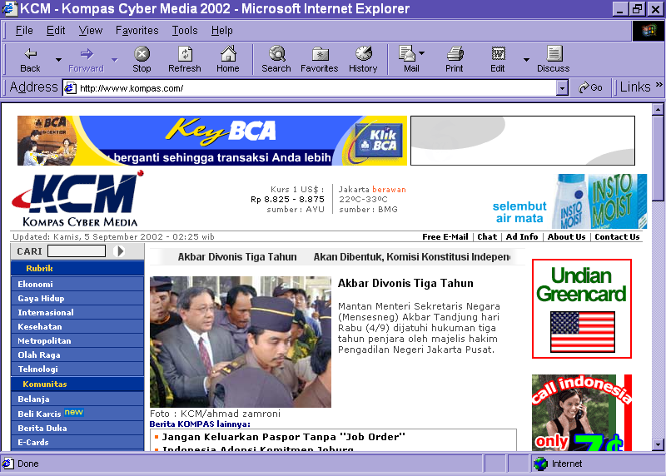
KOMPAS www.kompas.com is one of the two top news site in Indonesia. KOMPAS has the advantage of having the high circulation of its conventional printed newspaper. It is in Indonesian language. It may have version in English.

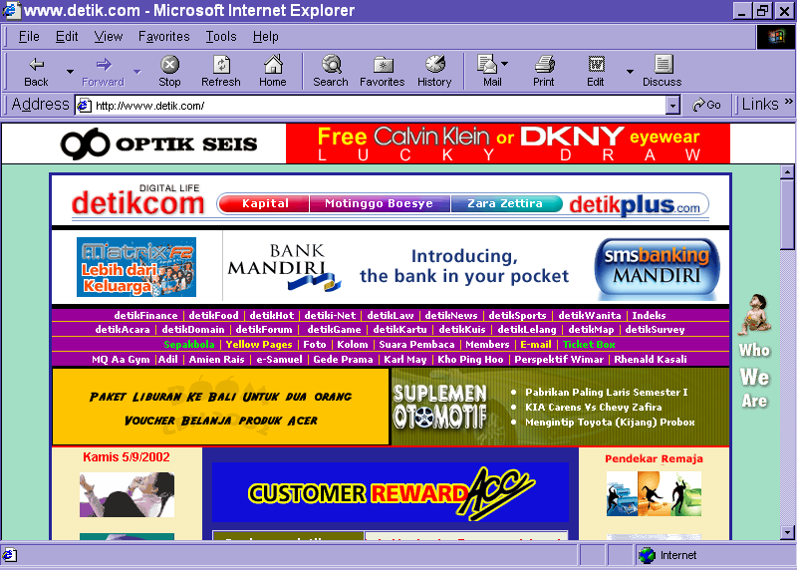
www.detik.com is the leading online media in Indonesia. It does not rely on any printed media. It gains much of their reputation of being the most accurate breaking news site especially during the 1998-1999 riots when all the students fight for the fall of Suharto’s regime. The news are written in Indonesian. Although, there is English version.

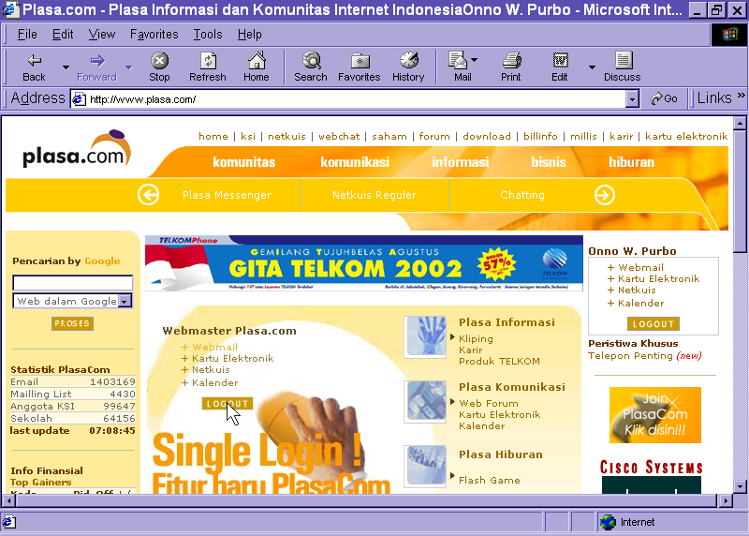
www.plasa.com, which is run by the multimedia division of the Indonesian incumbent telecommunication company. is trying to be one of Indonesian portal. Since plasa.com also provides free webmail service, it attracts people to use its services. Plasa.com provides its service in Indonesian.

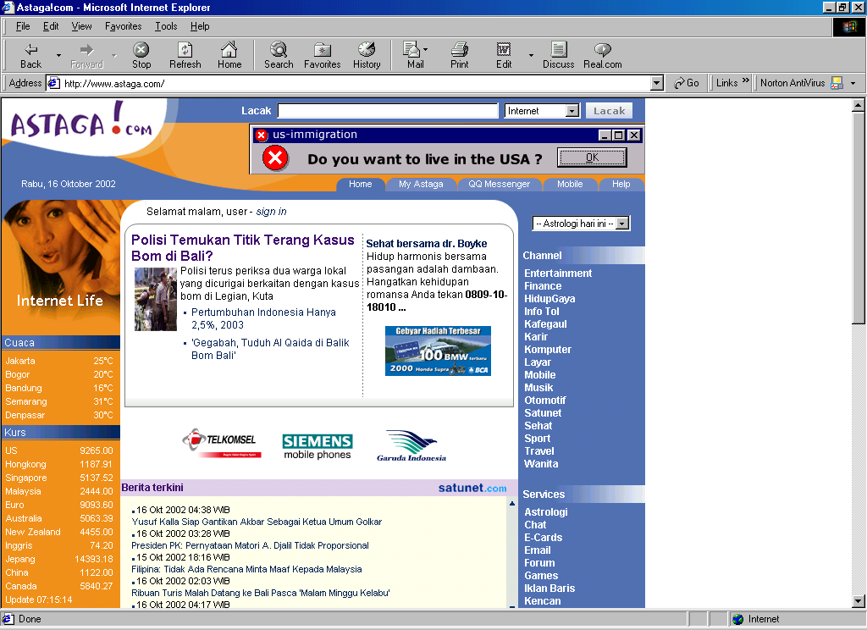
www.astaga.com has been for several years trying hard to become one of the main Indonesian portal. Demand creation might one of their biggest problem. It is currently under Mweb management.

It was started around 1997 by Republika news paper at www.republika.co.id. News and current affairs might be one of the most active web site category in Indonesia as a significant number of Indonesian printed media has their own web site. Some of active sites are www.bisnis.com, www.pikiran-rakyat.com, www.tempo.com; as well as some English online media, such as, www.jakartapost.com

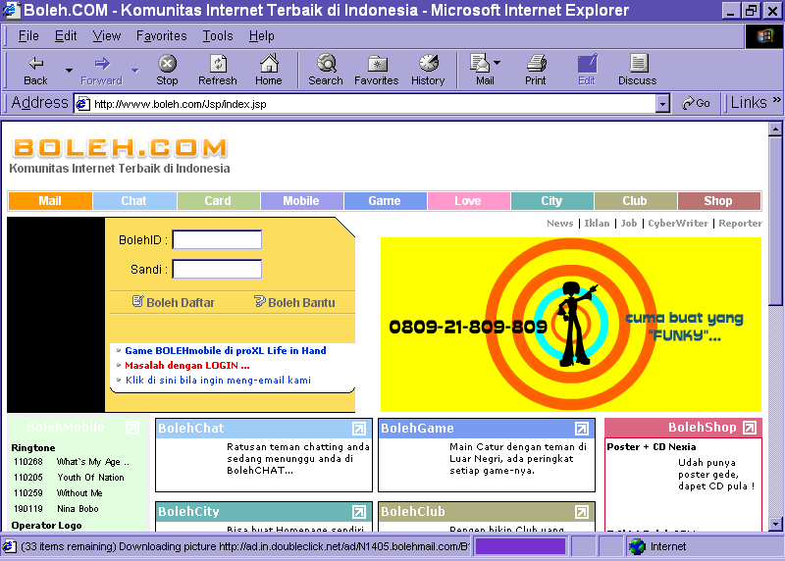
www.boleh.com may be one of the most commonly used Indonesian webmail service after plasa.com. It is privately run and designed for young Indonesian Internet users.

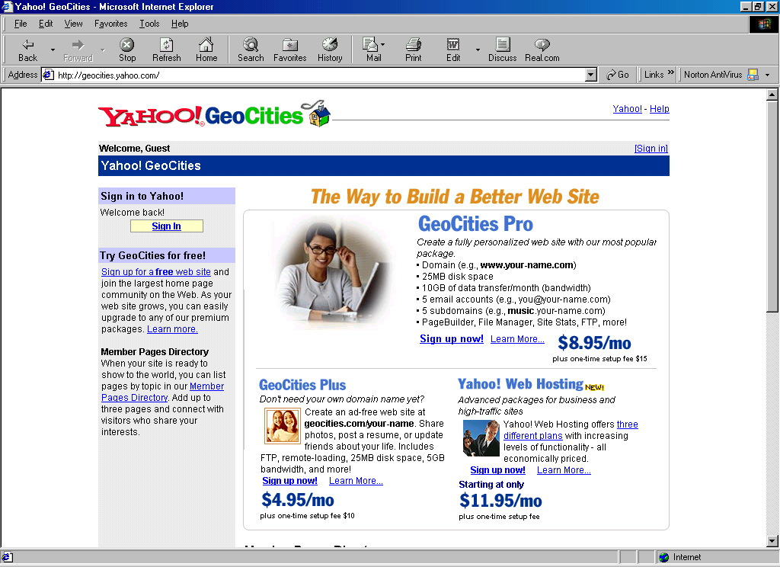
Many Indonesians try to put up their web site on the Internet. www.geocities.com also known as geocities.yahoo.com might be one of the main free web hosting for Indonesians. Free web hosting on the Internet is a great place for beginners as well as advance users to publish their work and interest for others to read.

There are several major Indonesian Web directory services. The Indonesian ICT business communities can be explored through these directory services.

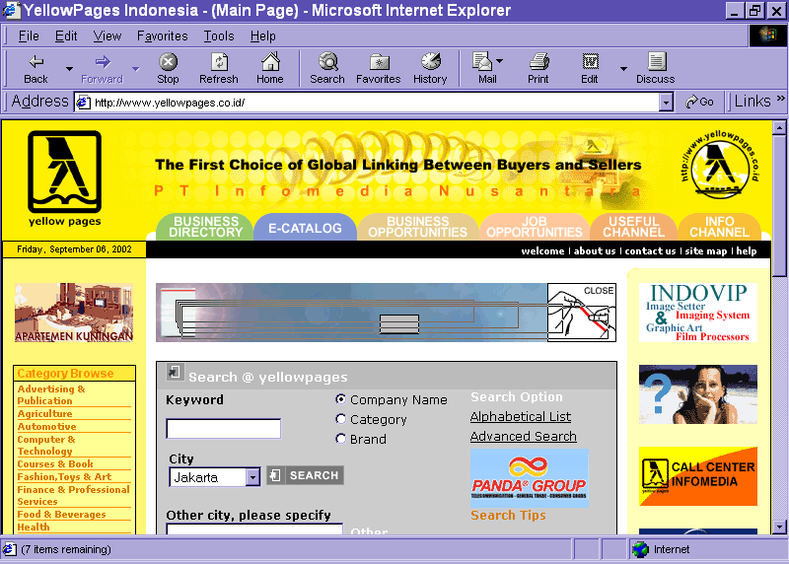
www.yellowpages.co.id might be one of the best Indonesian Internet directory service. This service is part of the Indonesian phone book company. It is not surprising to see an accurate and significant number of companies listed on www.yellowpages.co.id. It is in English.

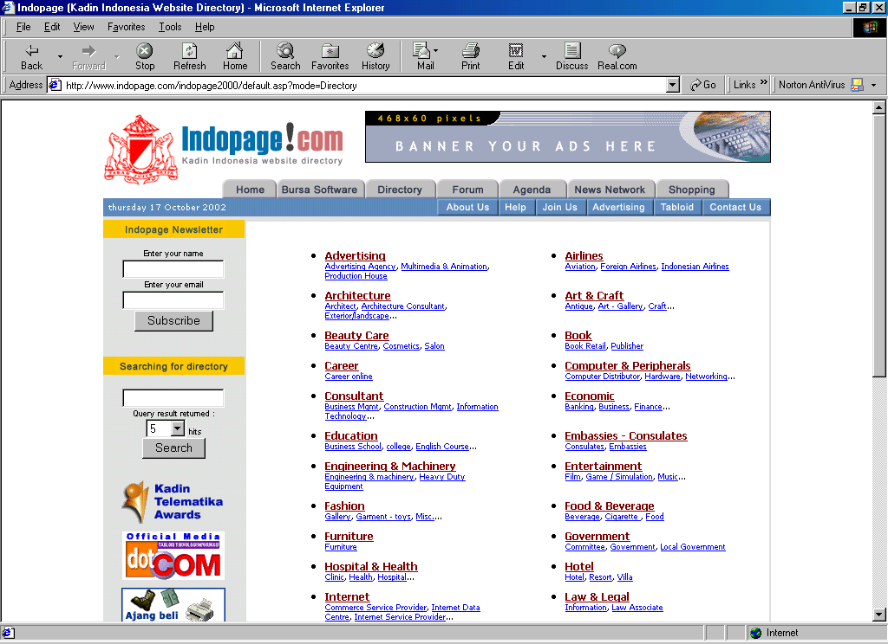
www.indopage.com may be one of unofficial Indonesian chamber of commerce directory service. It contains the web site of Indonesian businesses on the Internet. It uses mixed Indonesian and English.

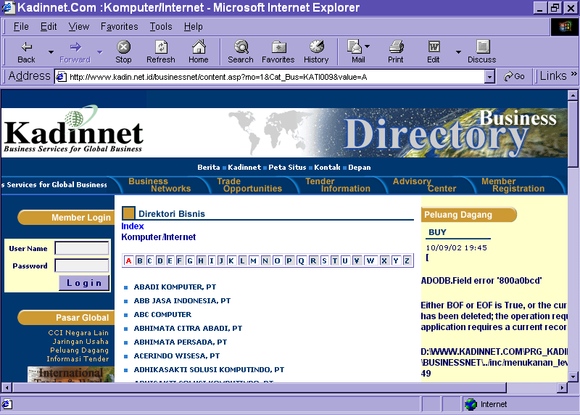
www.kadin.net.id is the formal chamber of commerce web site. They have listed their member in various areas of interest. www.kadin.net.id has an exclusive area for ICT business members.

3.4 ONLINE SERVICES:

    - E-GOVERNMENT
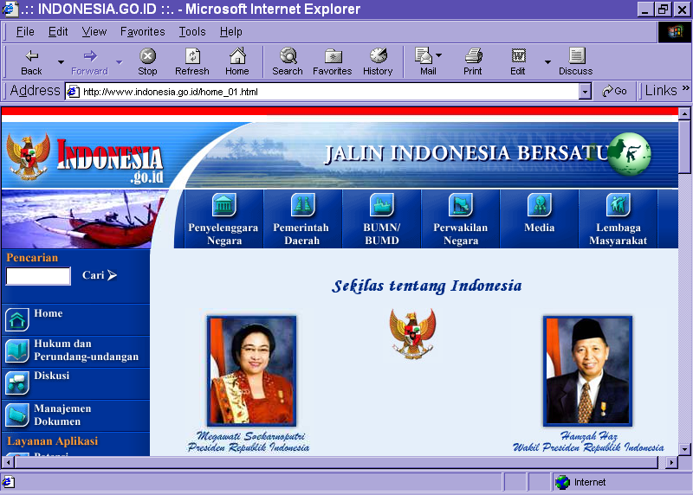
There are several competing activities within the Indonesian government body to claim for the principal e-government center. One of the major page representing the e-government of Indonesia might be www.indonesia.go.id, through which should hopefully reach other government agencies.

A significant increase in activities to build Web sites of various counties, cities and region begins in the early year 2002. The majority, if not all, of Indonesian government sites on the Internet are basically providing information on the potential of each region, and also rule and regulation, and things that should be abide by the Indonesian people. At the moment in time, to best of my knowledge, no known public service is electronically provided via the Web.

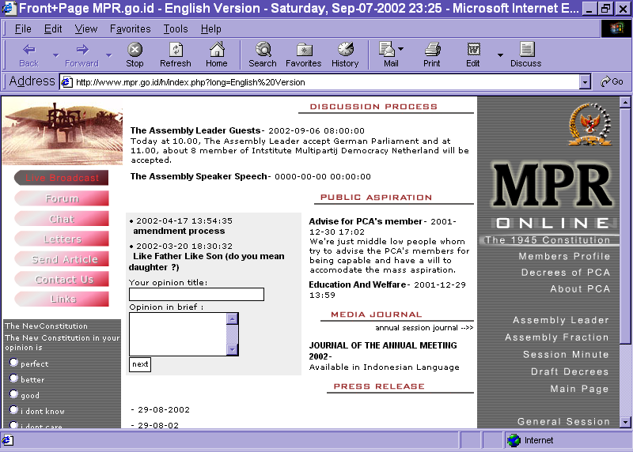
www.mpr.go.id carries the information and activities performed at the Indonesian parliament. We will likely to see a major activities on the web, especially during major planery meetings as well as when election time is closing when the representative need people to vote for continuing their term.
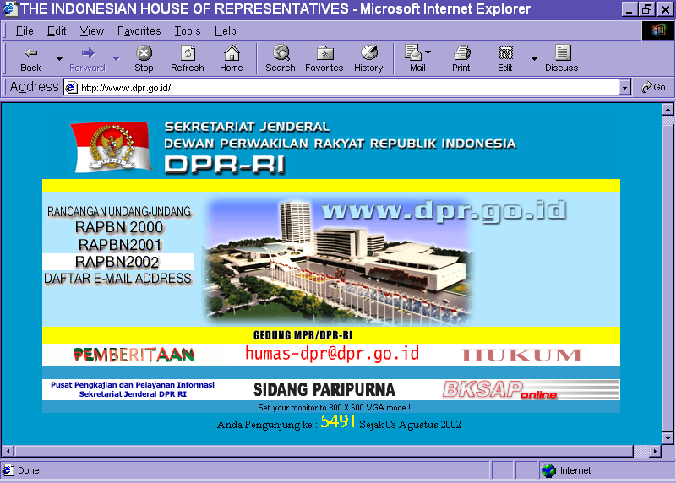
The house of representative can be viewed at www.dpr.go.id. All member of the house have their own e-mail addresses. Thus, we should hopefully be able to interact with Indonesian party leaders and the member of the house via e-mail under the domain dpr.go.id. The Web activities of www.dpr.go.id is fairly similar to www.mpr.go.id.

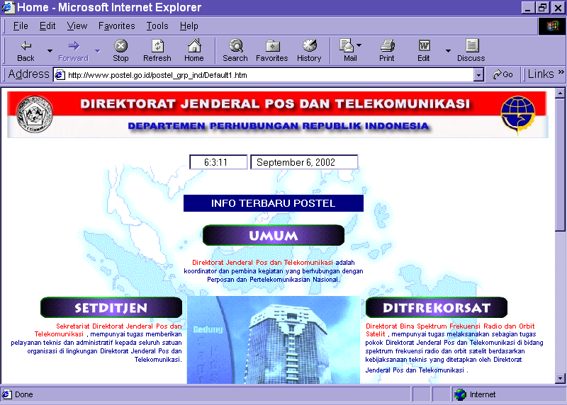
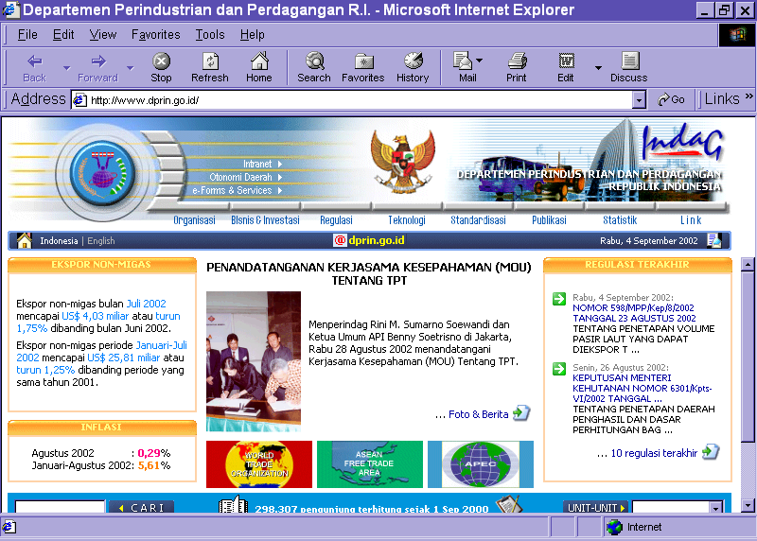
There are basically two (2) major government institutions that influence the Indonesian ICT environment, these institutions are the Directorate General of Post and Telecommunication (www.postel.go.id), which controls the telecommunication and internet infrastructure, and the Ministry of Industry and Trade (www.dprin.go.id) that controls the ICT industries.

    - DISTANCE EDUCATION & E-LEARNING

Formal distance education and e-learning would be rare in Indonesia as current regulation prevent such services to be provided to the Indonesian people. In addition, transfer of credit may or may not be applied in some cases, and would create difficulties in providing distance learning services. To best of my knowledge, there are two (2) major distance education activities running in Indonesia. Indonesian Open University, http://www.ut.ac.id, is the formal open university run by the Indonesian government. Some work is currently underway at the directorate general higher education at ministry of education on setting some distance learning programs on some public universities.

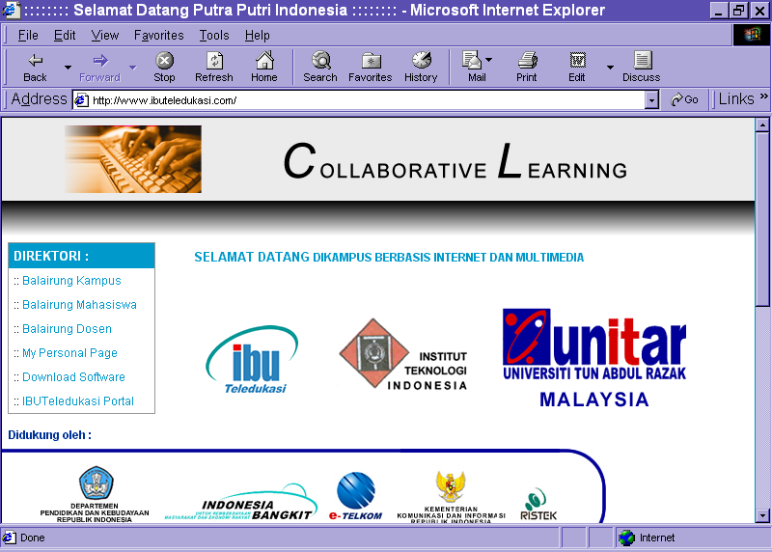
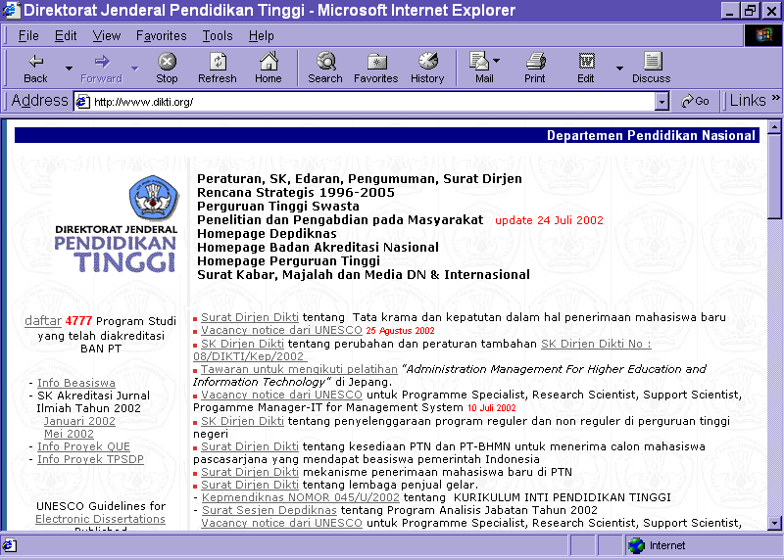
IBUTeledukasi (www.ibuteledukasi.com) seems to be a new comer in Indonesian distance learning business in 2002. Their activities seems to be in collaboration with many other institutions, including University Tun Abdul Razak in Malaysia. They seem to provide courses in high technology, such as information technology courses.

Information on some formal non-distance learning institutions can be found on the Web. A total in excess of 1300 higher educational institutions are providing higher educational degree in Indonesia. Detailed information on various higher education services can be found at the director general of higher education Web site, i.e., www.dikti.org.

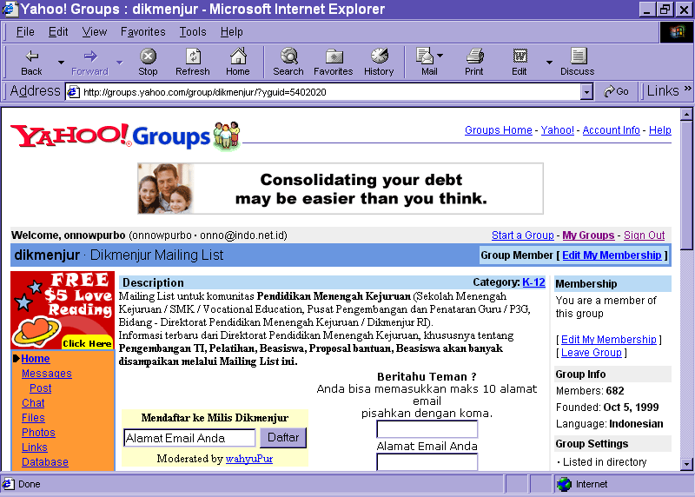
In reality, most of the distance learning and e-learning processes are actually been performed in a very informal manner. It basically says that no certificate, no accreditation, no permit necessary in the real life distance learning & e-learning processes adopted by most Indonesian online communities. Most of these Indonesian learning communities can be found at yahoogroups.com (http://groups.yahoo.com). The transfer of knowledge is performed through a long term on going e-mail discussions. Hundreds of these mailing lists can be easily found at yahoogroups.com. Mailing lists name, such as, indoprog, indoprog-vb, and javaid, is representing such vast virtual communities that provide informal platform for rapid knowledge exchange. It should be noted that knowledge provided by communities for communities are very current as well as practical knowledge. None of these knowledge may be sufficiently obtained through the formal education system, which very much controlled by the conventional national curriculum. Having such practical knowledge and community acknowledgement would be a license to success in IT communities; not to mention other professions. It is not surprising to see much of these communities would gather around certain learning mailing list on the Internet.
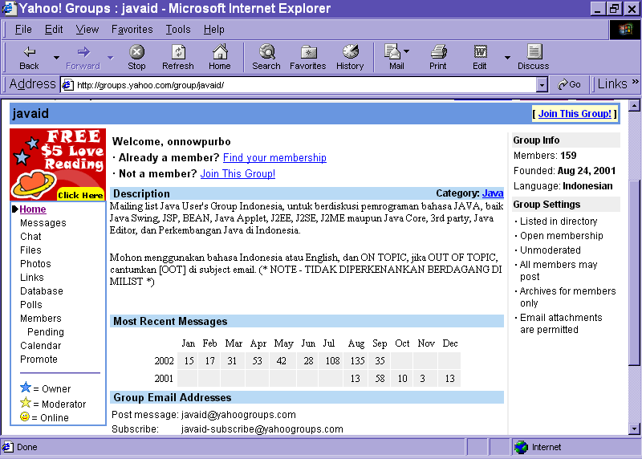
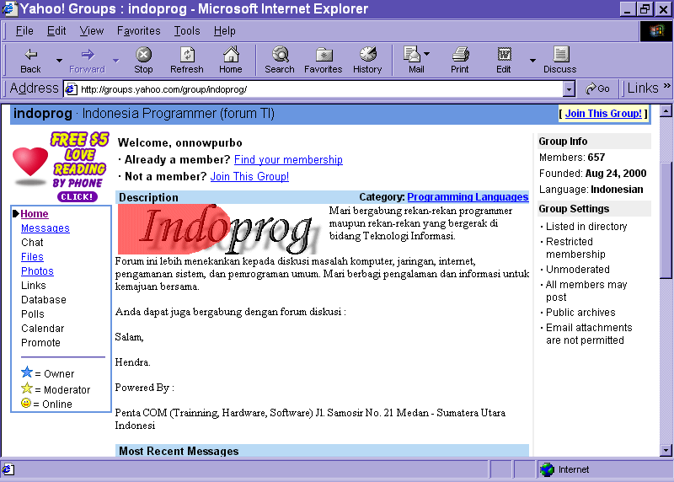

    - E-COMMERCE / E-BUSINESS

Google search using keyword e-commerce Indonesia, Indonesia e-business, indonesia e-trade and indonesia commerce reveals an overwhelming 500,000 URLs. These URLs will be mixed Indonesian and a significant number of English pages. Using very Indonesian keyword, such as, usaha export import and dagang luar negeri, reveals only about 5000 pages.

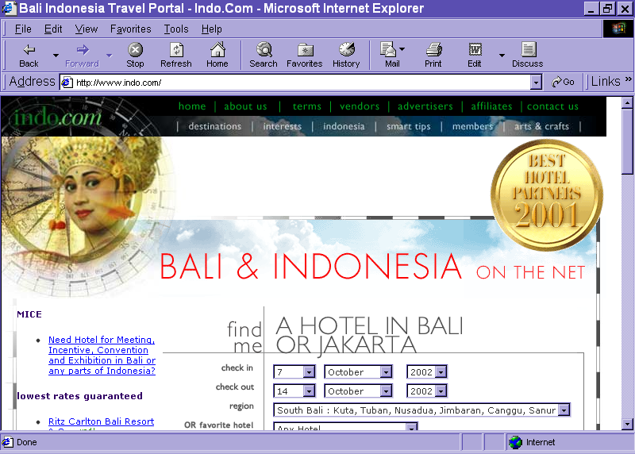
It shows that Indonesian e-commerce / e-business content on the Internet are quite massive. One of such example is www.indo.com. It is one of the favourite site for tourism in Indonesia. It carries various tourism related pages, such as, information of the culture, booking of hotels as well as Indonesian handy craft page.

Web pages may not reflect all Indonesian e-commerce / e-business activities on the Internet. Electronic mailing lists would be best place to probe a more active interaction among Internet users. Yahoogroups.com is the best place to probe interaction within the Internet communities. Searching in http://groups.yahoo.com using very Indonesian keywords, such as, e-commerce Indonesia, dagang, peluang usaha, and perdagangan, reveals about 150 Indonesian mailing lists related to e-commerce / e-business. However, only few of them are very active and having large number of subscribers. Some e-commerce / e-business activities are performed not in a general e-commerce mailing list rather specific topics / areas mailing list.

Based on data obtained from Digital Planet 2002, published by WITSA http://www.witsa.org, we will find that e-commerce in Indonesia is not very attractive. Indonesian e-commerce contributes only 0.10% of total commerce or about US$2.11 per capita in 2001.

 | 1999 | 2000 | 2001
Internet Commerce % of Total Commerce | 0.02% | 0.04% | 0.10%
Internet Commerce per Capita | $0.37 | $1.09 | $2.11

Table : Internet Commerce in Indonesia
Source: Digital Planet 2002, published by WITSA http://www.witsa.org

    - TELEMEDICINE

Google will likely to reveal the number of Web pages related to certain topics. To probe pages related in Indonesian telemedicine, several keywords, such as, Indonesia telemedicine, Indonesia kesehatan, kesehatan, sehat, and konsultasi kesehatan, will reveal in excess of 264.000 pages related Indonesian telemedicine. Kesehatan (health in English) reveal close to 50% of the Indonesian telemedicine pages.
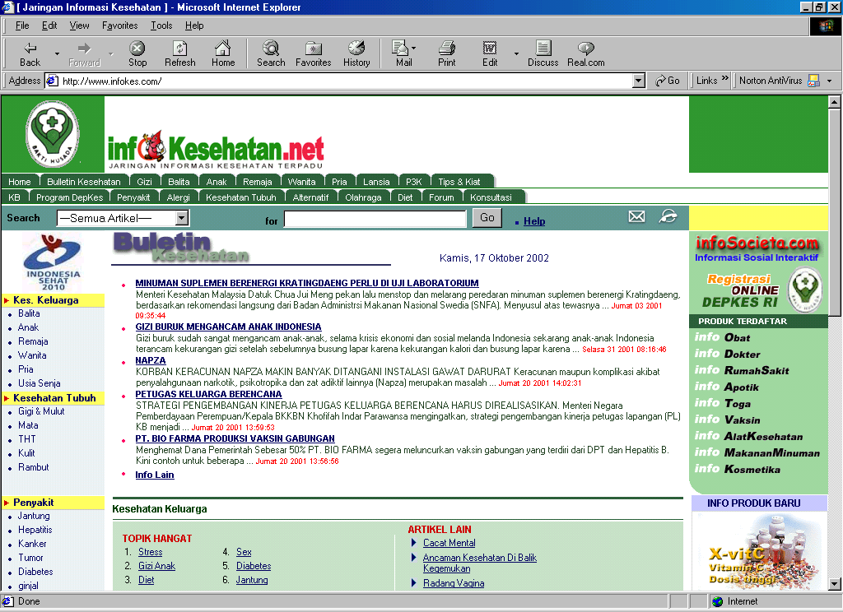
Most of the telemedicine activities on the Web are not as advanced as most people think. It is basically community health consultation processes. One of such example is www.infokes.com, where people may found many articles on health as well as direct interaction with the physicians. Some Indonesian hospitals are also putting information on their Web sites. Having health related sites triggers the development of pharmacy related sites. We can easily find many Indonesian pharmacy related sites.

Those who like to investigate more advanced medical electronics and telemedicine practices, in which patients can be remotely treated, are currently in research activities in several universities in Indonesia. Prof. Dr. Soegiardjo Soegidjoko from Electrical Engineering Department of Institute of Technology Bandung (www.elka.ee.itb.ac.id) is one of the leading scientists in Indonesian medical electronics and telemedicine research activities.
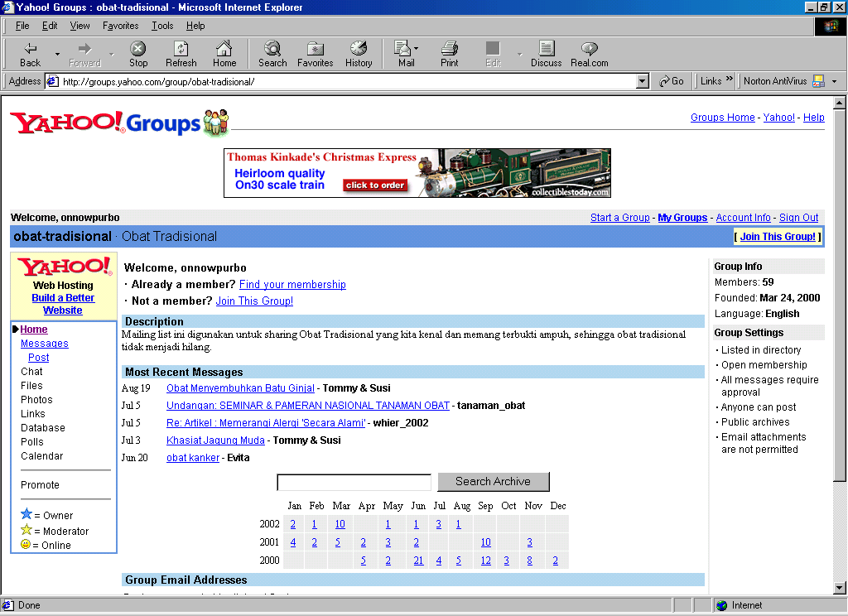
Web is traditionally very passive in interacting with Internet audience. To see a more active interaction, one may check http://groups.yahoo.com that carries a significant portion of Indonesian Internet communities. Using several keywords, such as,
kesehatan, obat, sehat. and konsultasi kesehatan, will reveal in excess of 400 health related Indonesian mailing lists. Most of these mailing lists are having a few subscribers, only few dozen of mailing lists have an ample number of subscribers. Several of such example is obat-traditional@yahoogroups.com and kesehatan-indonesia@yahoogroups.com.

    - E-CONFERENCE / FORUM / E-COMMUNITY

Having the Internet infrastructure deployed would not be enough before we see the behavior of Indonesian Internet community. We may basically have two (2) types of users, namely,

- The old timer, the veteran Internet users.
- The beginners, occasional users.

Most beginners would likely to access the web. Thus, the beginners can be easily probed from their activities during surfing the Internet. It can be easily analyzed from the proxy cache log of the Internet café’s server.

Different from the beginners, e-mail is the transport media used by the Internet old timers. It would be of interest as e-mail is actually the media for constructing e-conference, forum and e-community within the Indonesian Internet society. In this section, the characteristics and activities within the Indonesian Internet society will be analyzed through ways they interact in various Internet mailing lists.

We will examine the behavior of the old timers. It can be probed through the way they interact on various Indonesian mailing lists on the Internet. It was started in early ’90, some Indonesians started the first Indonesian mailing list at Indonesians@jamus.berkeley.edu. It gradually grows into many mailing lists. In ’96, Institute of Technology Bandung (ITB) was putting two (2) Pentium servers on-line the Indonesian Internet community. It manages to serve more than 200+ mailing list. Currently, major Indonesian mailing lists can be found at

- http://www.yahoogroups.com also known as http://groups.yahoo.com may be the busiest mailing list server on the Internet, which serves 45.000+ Indonesian mailing lists. In this work, we will evaluate more closely the characteristics of mailing lists at http://groups.yahoo.com.
- http://groups.plasa.com runs by TelkomNet, the Indonesian Telkom ISP. As of mid February 2002, reported by Luqman El Hakiem Syamlan (luke@telkom.co.id) they serve 2299 Indonesian mailing lists.

The evaluation process of the characteristics of Indonesian community on the Internet can be easily performed at http://groups.yahoo.com. Shown in the figure is the home page of http://groups.yahoo.com. To find Indonesian communities on the net, one can enter Indonesian keywords and press “search” button. In the evaluation process, I use 100+ keyword to find 45.000+ Indonesian mailing lists on http://groups.yahoo.com.

Right after the “search” button is pressed, http://groups.yahoo.com will provide us a list of mailing lists that contain this particular keyword. It shows the name of mailing list, description of the mailing list, number of subscriber, and type of mailing list (open or closed mailing list).

Since the number of mailing list is quite large, in the process, I choose only the one with more than one hundred subscriber will be thoroughly evaluated.

By clicking the name of the listed mailing list, we may find more information on particular mailing list, such as, total member, date the mailing list was found, language usage, archive of messages, monthly statistics of messages, as well as many administrative back office utilities to support the operation of the mailing lists.

Many of the information provided by http://groups.yahoo.com is quite useful in evaluating the characteristics of Indonesian communities on the Internet.

Number of Mailing Lists | 1278
Pornographic | 73 (5.7%)
Social Functions | 360 (28.2%)
Religious | 158 (12.4%)
Politics | 96 (7.5%)
Knowledge | 257 (20.1%)
Hobby | 110 (8.6%)
Business | 224 (17.6%)

During the end of the year 2001, I was evaluating http://groups.yahoo.com. I managed to see 30.000+ mailing lists out of 45.000+ mailing lists, which only 1278 mailing lists have more than 100 subscribers. It is interesting to note that most (28.2%) of the Indonesian cyber communities are using the mailing list mainly to say hello and other social functions. Next are the communities for getting knowledge (20.1%) and business activities (17.6%). The number of mailing lists on pornographic, religious, politics, and hobby are much less.

Total subscribers | 465,749
Pornographic | 59,871 (12.9%)
Social Functions | 89,372 (19.2%)
Religious | 56,035 (12.0%)
Politics | 32,388 (7.0%)
Knowledge | 83,648 (18.0%)
Hobby | 48,342 (10.4%)
Business | 96,093 (20,6%)

Subscriber distribution follows closely the distribution of mailing lists. Note that pornographic mailing lists seem to attract more subscribers. It is interesting to note that the number of total subscriber is only 450.000+ subscribers, far less than the four (4) million Indonesian Internet users as claimed by APJII. Seems most of Indonesian Internet users are beginners, and not knowing how to interact or join the Indonesian mailing lists.

Message Distribution in 2001 | 1,635,395
Pornographic | 42,590 (2.6%)
Social Functions | 376,604 (23.0%)
Religious | 194,714 (11.9%)
Politics | 187,588 (11.5%)
Knowledge | 291,396 (17.8%)
Hobby | 236,023 (14.4%)
Business | 306,480 (18,7%)

The total messages generated in the year 2001 follows fairly similar pattern as the distribution of mailing lists. It is interesting to note that pornographic messages comprise only 2.6% of total messages.

Subscriber Activeness | Average Messages / Subscriber / Month
Pornographic | 0.71
Social Functions | 4.21
Religious | 3.47
Politics | 5.79
Knowledge | 3.48
Hobby | 4.88
Business | 3.20

The activeness of subscriber to interact can be measured as the average number of messages generated per subscriber per month. A surprising fact pop up, people in political communities seems to much talking with an average message close to six (6) messages per subscriber per month. Although, most people do not like to hear about it. It may represent the typical political atmosphere in Indonesia. Hobbyists are next in the row on those who like to talk.

Interesting findings are found in political mailing lists, at least nine (9) mailing lists on Marxists and socialists. Some of the large mailing lists are sosialista (149 subscribers), pemudasosialis (75 subscribers), sosialisgroup (92 subscribers), and the largest is indo-marxist (618 subscribers). Their traffic is quite low on the average of 1-5 e-mail per month, shown the inactiveness of socialist’s ideology.

Partai Keadilan (PK) is identified as the most active Indonesian party that uses Internet as their main driving interaction media. Most of PK mailing lists are easily identified with pk in the first two characters on their mailing list name. Some of their large mailing lists are partai-keadilan (534 subscribers), PK_Linkbisnis (528 subscribers), pk-bandung (167 subscribers), pkjaksel (114 subscribers), pk-pesanggrahan (107 subscribers)., an d the largest is pk-info (1064 subscribers). Most of these mailing lists have quite modest traffic with 50-100 mail per month, only partai-keadilan has the highest traffic close to 1000 e-mail per month that really shows the activeness of Partai Keadilan as compared to the old-economy parties in Indonesia.

Total consumed bandwidth | 1,732 Kbps
Pornographic | 704 Kbps (40.7%)
Social Functions | 237 Kbps (13.7%)
Religious | 149 Kbps (8.6%)
Politics | 113 Kbps (6.6%)
Knowledge | 270 Kbps (15.6%)
Hobby | 103 Kbps (6.0%)
Business | 153 Kbps (8.8%)

Assuming an average 5Kbyte per message on normal mailing lists, and 30 Kbytes per message on pornographic mailing lists, it is found that the Indonesian mailing lists consume 1,7Mbps bandwidth with pornographic (40.7%) consumes most of the bandwidth. Bandwidth-wise, the normal traffic may actually subsidize those who download pictures from the Internet.

The most difficult task is to drive the mass within the mailing lists, one should understand techniques, such as, information warfare and psychological warfare, to lead such mass. It is an art in itself. Only knowledgeable leaders will be respected by the communities and would be able to drive communities in cyber space. These leaders would take initiatives and lead the mass, which, unfortunately, in some cases, would put him in opposite side to the Indonesian government policies. In contrast, those bureaucrats, government leaders who normally received their position by normal carrier promotion processes would likely to fail in dealing and driving such community masses.

3.5 ICT INDUSTRIES AND SERVICES:

Not much data on ICT can be found in the Indonesian Ministry of Industry and Trade data (www.dprin.go.id). There are some data on electronics / hardware manufacturers, i.e,

Electronics component manufacturer 11
Electronics spare parts manufacturer 10
Electronics equipments manufacturer 10

Quite significant & consistent ICT industrial data can be found in the Indonesian Chamber of Commerce site (www.kadin.net.id/busisinessnet/) and the Indonesian Yellow Pages (www.yellowpages.co.id). A list of 574 ICT companies all over Indonesia can be found at the Indonesian Chamber of Commerce site.

A total of 649 Indonesian ICT companies can be easily searched through the Indonesian Yellowpages www.yellowpages.co.id, which is somewhat consitent to the Indonesian Chamber of Commerce. The summary is as follows

computer consultants 53
computer internet 59
computer programming consultants 52
computer software 68
computer total solution 27
multimedia 13
software 88
e-commerce 2
information technology 24
internet - services 133
internet data 13
internet portal 25
internet provider 90
web design 2

It is shown clearly that demand in Internet related business is quite high as reflected in the large number of companies offering Internet services. Computer consultants, programming, software, as well as providing total solutions are also maturing to meet the demand.

Based on the Indonesian Yellowpages data, the Indonesian ICT companies are distributed unevenly. Most of them are located in Jakarta, followed by Bandung, which is only 4 hours drive from Jakarta. Only few companies spread outside Jawa island, namely, Medan (29), Palembang (2) and Bali (15).

Jakarta 466
Surabaya 25
Medan 29
Bandung 75
Denpasar 15
Yogyakarta 14
Semarang 23
Palembang 2
Total 649

As reported in Digital Planet 2002 (www.witsa.org), detailed IT & ICT spending of several countries can be found. The Indonesian ICT spending in million US$ is as listed in the table.

 | 1993 | 1994 | 1995 | 1996 | 1997 | 1998 | 1999 | 2000 | 2001
Spending US$M
IT Hardware | $548 | $707 | $907 | $1,059 | $933 | $219 | $519 | $722 | $752
Software | $41 | $60 | $83 | $107 | $102 | $21 | $73 | $91 | $124
IT Services | $93 | $123 | $113 | $128 | $115 | $34 | $46 | $64 | $85
Internal | $98 | $110 | $119 | $113 | $106 | $108 | $150 | $164 | $199
Other Office Equipment | $57 | $77 | $87 | $96 | $84 | $20 | $47 | $65 | $68
Total IT | $837 | $1,077 | $1,309 | $1,503 | $1,340 | $402 | $835 | $1,106 | $1,228
Telecommunications | $1,965 | $2,551 | $3,027 | $2,960 | $3,434 | $1,425 | $2,054 | $2,215 | $2,311
Total ICT | $2,802 | $3,628 | $4,336 | $4,463 | $4,774 | $1,827 | $2,889 | $3,321 | $3,539

Much larger (>60%) spending in telecommunication sector dominates the ICT spending. Most of IT spending is in IT hardware. Only small fraction of the IT spending is on software, services and other office equipments. The economics is not fully recovered, ICT spending is still much below the peak in 1997. During the 1998 economic turmoil, a dip in ICT spending is expected.

3.5.1. INDONESIA INTERNET INFRASTRUCTURE

The easiest way to probe the Indonesian Internet infrastructure development is through monitoring the expansion of Indonesian Internet Service Provide (ISP). Commercial ISP was started by IndoInternet, which is known as IndoNet http://www.indo.net.id in 1994.

Most of the commercial Indonesian Internet infrastructure can be investigated through the Indonesian Internet Service Provider Association also known as Asosiasi Penyelenggara Jasa Internet Indonesia (APJII) http://www.apjii.or.id. As of mid 2001, there are

- 170+ Principal ISP lisense Holder
- 125 Member APJII
- 50+ active in providing services
- in 100+ cities, all provinces
- APJII provide common facilities, such as,
- APJII Indonesia Internet Exchange (IIX)
- APJII IDNIC
- Domain Registration & NIR (APNIC)

Currently, 170+ ISP licenses have been granted with about 50+ operational ISP. In reality, 60-70% Indonesian Internet users are served by various forms of Internet cafes (known as warnet in short for warung internet). It is interesting to note that none of these activities are driven by the Indonesian government; they are mostly private & community driven.

Based on the annual report of the Indonesian ISP Association (APJII) that can be downloaded from http://www.apjii.or.id, the estimated Internet users and subscribers up to the end of 2002 is as follows,

 | Subscribers | Users
1998 | 134.000 | 512.000
1999 | 256.000 | 1.000.000
2000 | 400.000 | 1.900.000
2001 | 581.000 | 4.200.000
2002* | 1.000.000 | 8.000.000

Table: Growth Indonesian Internet Subscribers and Users
*Estimated up to the end of 2002
Source: APJII (www.apjii.or.id)

It is clearly shown that a doubling of Internet users is common growth rate in Indonesia. In early 2002, APJII estimated that the total Indonesian Internet users are around four (4) million users.

More detail study on its profile can be found in the research done by APJII. It is common to see a majority of male, young (25-35 years old) and educated people (high school graduate, university students or young professionals) would compose the majority of the Indonesian Internet users.

As reported by APJII, the subscriber distribution in the year 2001 is shown in the figure, some of the big ISPs, such as, IndosatNet, LinkNet, CBN, RadNet, Centrin, Indonet may capture large portion of the users. However, one should aware that TelkomNet is providing TelkomNet Instant access at +080989999 with no requirement for registration. Thus, unable to probe the real number of its subscriber.

Although, Indonesian would prefer to use international domain naming, such as, .com and .org, due to its flexibility and easiness in getting the name. A growth in new domain registered in the Indonesian top-level domain ID-TLD is apparent.

 | New Domain | Total Domain
1998 | 1.480 | 2.526
1999 | 2.153 | 4.679
2000 | 4.239 | 8.918
2001 | 3.945 | 12.413
Table : Indonesian Domain
Source: www.idnic.net.id

In the year 2001, there is a decreased in new domain. Budi Rahardjo, the ID-TLD, argues that the reduction is mainly due to global dotcom failure worldwide. Budi is not relating to the use of .com or .org on Indonesian sites.

The allocated public IP address and AS number in Indonesia is growing as clearly shown in the table.

 | Accumulative IP block | AS Number
1999 | 256 | 3
2000 | 1072 | 16
2001 | 1553 | 29
2002* | 1649 | 34

Table : Increase in IP address and AS Number.
*up to April 2002
Source: APJII (www.apjii.or.id)

To reduce the international Internet traffic, APJII is setting two (2) Indonesia Internet Exchanges (IIX) in Jakarta, i.e., in Elektrindo Building in Mampang, Jakarta and in Telkom Building in Jalan Gatot Subroto, Jakarta. Both IIX are interconnecting with each other. The IIX serves the connection of all ISPs in Jakarta with zero interconnection charges. The same principle is currently being pursued in various cities in Indonesia. It is needed, as most of intra-city traffic is now routed through Jakarta.

From MRTG (Multi Router Traffic Graph) reports administered by Johan Alam (johar@the.net.id) the Administrator of IIX, we will find a significant number of increase in peak bandwidth through the IIX.

 | Feb 99 | Jan 00 | May 01 | Mar 02 | Sep 02
Peak (Mbps) | 2.05 | 3.07 | 40.96 | 245.76 | 255.4
Table: Peak IIX Traffic
Source: IIX (www.iix.net.id)

By analyzing the above traffic one may find that the traffic increased is mainly due to increase in corporate subscribers with an estimated increased of 2.500 dedicated lines. In addition to it, Indonesian Internet users find more interesting Internet applications that require high bandwidth, such as, transferring MP3 files, multimedia, and online gaming over the network.

As reported by Johar Alam (johar@the.net.id) the administrator of Indonesian Internet Exchange (admin@iix.net.id), in the year 2002, the total IIX in country peak bandwidth is in access of 250Mbps. Since the international traffic is normally about three (3) times of local bandwidth, the peak Indonesian international bandwidth is estimated about 800Mbps. The peak bandwidth is normally about 80% of the maximum bandwidth. Thus, it is safe to estimate a maximum bandwidth of 1Gbps from Indonesia to the Internet The ratio of in-coming and out-going Internet traffic volume is about 1:10 as Indonesian is still consume more information rather than produce information.

In Indonesia, the government, namely DIRJEN POSTEL http://www.postel.go.id, provides two steps of licenses, namely,

- Principal License – saying principally the government gives the permission for one to setup the ISP.
- Operational License – after normally one year, through an evaluation process, those who pass the process will receive operational license as the permit to provide service to the public.

As reported by APJII, the table shows clearly that large number of ISP licenses are granted by the government. Thus, it seems no restriction is applied and only the professional would be able to show its capacity to operate an ISP and receive the operational license. Although, the assessment procedure by DIRJEN POSTEL to obtain the operation license should be re-evaluated.

 | ISP | NAP | Multimedia
1994 | 2
1995 | 18
1996 | 37
1997 | 43
1998 | 44
1999 | 50 |  | 8
2000 | 139 | 5 | 18
2001 | 172 | 16 | 24
2002* | 179 | 16 | 24

Table: Lisence provided by DIRJEN POSTEL
*up to first quarter of 2002.
Source: APJII (www.apjii.or.id)

Of the above licensed companies, some may apply for membership at the Indonesian ISP Association APJII www.apjii.or.id. As shown on the table, there are about 125 member of APJII as of the first quarter of 2002.

Not all licensed companies will joined the Indonesian ISP Association (APJII). APJII member is growing from 41 members up to around 125 in the first quarter of 2002. Shown in the table is the growth of APJII member by type of license.
 | 1999 | 2000 | 2001 | 2002*
ISP | 41 | 74 | 105 | 112
NAP | - | 1 | 3 | 5
Multi-Media | - | 3 | 5 | 6
Misc** | - | - | 2 | 2
Total | 41 | 78 | 115 | 125

Table: Growth of APJII Member
*up to the first quarter 2002
** Wireless Internet & Internet for Research Education (IPTEKNET)
Source: APJII (www.apjii.or.id)

Not all APJII member require services, such as, IP address allocation and interconnection to the Indonesian Internet Exchange. Current status of APJII member is shown in the table.

 | 1999 | 2000 | 2001 | 2002*
Member | 41 | 78 | 115 | 125
Operational | 35 | 63 | 82 | 86
Connected to IIX | 12 | 24 | 49 | 54

Table: APJII Member Status
* up to 1st quarter 2002
Source: APJII (www.apjii.or.id)

In the end of October 2002, Indonesian Internet Body is established. It serves a fairly similar role as ICANN or IANA, especially acting as the National Internet Registry (NIR) as other NIR such as JPNIC, TWNIC etc. Especially to provide IP address allocation and domain name for those who needs it. It is supported by several supporting groups, namely,

- ALM: At Large Membership
- GAC: Government Advisory Committee
- NGAC: Non Government Advisory Committee
- ASO: Address Support Organization
- DNSO: Domain Name Supporting Organization
- PSO: Protocol Supporting Organization

As it is a fairly new organization, the interaction is currently performed at internet-id@yahoogroups.com.

3.6 EXAMPLES OF INNOVATIVE AND KEY INITIATIVES:

3.6.1. OVERVIEW OF INDONESIAN INTERNET INITIATIVES

From the field experience, to build the Indonesian Internet infrastructure & society, human factor is the most important key. Ability to educate, provide free education on various aspects of the Internet would be paramount in shifting the mind set of Indonesian society in looking at Internet. Mind shift within the society will surprisingly ignite them to invest & build their own infrastructure at virtually no cost from the government and any donor agencies.

If I may use a simple model of the circle of knowledge, it contains knowledge generation, packaging and disseminating processes as shown in the picture. Today, not many people act as the one who generate knowledge. It is worsen by the slow information & knowledge flow within the circle of knowledge over conventional means and media.

Having Internet based media, information & knowledge flow can be really accelerated. Most of knowledge put in softcopy in public domain. CD-ROM and Web servers are typical packaging technique used in the disseminating knowledge in electronic form. The trick is to accelerate the circle of knowledge, the faster the circle of knowledge can be run the more mass and audience will be affected, the more value is for the distributed knowledge. In this kind of process, copyright renders the acceleration of circle of knowledge, thus, reduces the value of the distributed information / knowledge. It is not surprising to see most of the Indonesian Internet activists would prefer to put their knowledge in copyleft & copywrong state.

In the accelerated circle of knowledge, it would in the end educate many people and may transform part of the communities into knowledge producer rather than passively stays as knowledge consumers. It is the ultimate goal to see more knowledge producer, writer etc. cultivated as a result from abundant freely available knowledge over the network. Some of these knowledge producers are quite militant and normally becoming the driving force behind the Internet development in Indonesia.

Most of the Indonesian Internet activists, such as, I Made Wiryana (Germany), Michael Sunggiardi (Bogor), Adi Nugroho (Makassar), Irwin Day (Makassar), Ismail Fahmi (Bandung), RMS Ibrahim (Jakarta) etc. would prefer to publish their work freely on the Internet. You may find their work in Indonesian Digital Knowledge Foundation (IDKF) http://www.bogor.net/idkf, Pandu Team Website http://www.pandu.org, or VLSM http://bebas.vlsm.org. It contains more than five thousand (5000+) articles and references on various aspects of the Internet.

Copyleft & copywrong movement provides free literature and education and really helps the building of Indonesian Internet society. Many Indonesian new dotcommers may mirroring these sites, thus, enable rapid distribution of the knowledge to the society.

Since most, if not all, of the necessary knowledge is freely distributed, some may ask - what about the reward, especially financial reward, for those who provide the free knowledge? Fortunately, God is fair and provides ample rewards in unimaginable ways. Well, to be more practical, in a more realistic picture, it goes very pragmatics. When one distributes one’s knowledge freely to public, public is educated & demand on certain aspect of technology or services arise. The private sector or entrepreneur may take up this opportunity. In the end, the public will receive the required technology or services provided by the entrepreneurs within the public or larger private sector, which, will in the end receive capital gain. The private sector sees this in a simple ways, the one who create demand in the market should be supported for maintaining the demand / market. It is logical to see one who provides free knowledge may receive most attention and sponsorship in various forms such as arrangement of seminars, workshops, talk show etc. Thus, enable the knowledge producer to continually distribute their knowledge freely to public.

One may be surprised by the amount of funding & sponsorship received by putting the copylefted knowledge in public domain. Depending on the coverage of the audience / readers, it may surpass the salary of professional executive with fixed job and fixed income in Jakarta.

Some of these sponsorships are going into seminars and roadshow, in fact, during this manuscript is written (July 2002), I am in roadshow program of a total of 37 cities all over Indonesia. The one-day seminars only cost US$3/person with all the snack, Linux CDs, magazine not to mention all the door prices. In each seminars / cities, it is normal to have 300+ attendees, not to mention its multiplier effects through radio talkshows in each cities and various other programs.

In schools, we provide seminars for free in many schools. This program is arranged by the Indonesian School Information Network (Jaringan Informasi Sekolah) http://www.jis.or.id. It is our hope that the young generation will have a much better living environment that ours the old ones.

Interaction among the society in the circle of knowledge is normally conducted in Internet mailing lists. To name a few, these mailing lists are genetika@yahoogroups.com (more on IT politics), majalahneotek@yahoogroups.com (IT beginners), linux-admin@linux.or.id, linus-setup@linux.or.id as well as many other mailing lists.

Since the necessary knowledge is freely available to public, in most cases, it will attract the public to invest on its own infrastructure using their own money. In economic framework, the small medium entrepreneurs in the public are putting their money in IT businesses & gradually turn their money into profit and re-invest it as the business goes well. This gradual cycle of investment and business operations may gradually accumulate public’s money in IT businesses and enable them to build their own Internet infrastructure using the freely available knowledge on Internet. Consequently, it is not surprising to see the grassroots movement has much stronger roots in the society rather than any action done by the government.

Phil Karn, one of the Wireless Internet guru once said, either lead or follow but please don’t block the road for those who would move forward. In many cases, less Bank’s loan, less “informal” taxes, and less licenses requirements, would certainly facilitate the building of Internet infrastructure and society in Indonesia.

3.6.2. A GLIMPSE ON COMMUNITY BASED INTERNET INFRASTRUCTURE

The Indonesian Internet network topology in early 1993 is fairly simple. It connects four (4) institutions, namely, BPPT Ministry of Research and Technology, University of Indonesia, LAPAN Indonesian Space Institute, and Institute of Technology Bandung. Using the amateur radio technology based, a radio network running at Very High Frequency 144MHz, and Ultra High Frequency 430MHz are used to link all of these institutions. The network is running at very slow speed 1200bps (1.2Kbps). PC 286 running DOS 3.3 with Network Operating System (NOS) downloaded from ftp://ftp.ucsd.edu/hamradio/packet/tcpip/ is commonly used at the main gateway and router. BPPT & UI are acting as the main gateway to the worldwide network.
Since then, homebrew radio modem based on TCM3105 one chip modem as shown in the picture was commonly distributed among the Indonesian network geek to build our own network. The same technology is currently being used to integrate schools in remote areas to the Internet. To name a few, schools in southern mountain of Jogyakarta are the one that are implementing this technology.

I have to admit, this simple & low cost technology is limiting the Internet usage for e-mail only. It takes approximately one night for sending a one (1) Mbyte of data. Although, it is enough to open the mind set people in remote areas and integrate them into the cyber society.

As Internet café grows, it spurs alternatives technology to use old 486 machines as Internet terminal. Linux with Linux Terminal Server Program (LTSP), can be found in http://www.ltsp.org or http://www.ltsp.or.id, solves our problem in both low cost investments as well copyright problem. It is not surprising to see a lot of Indonesian Internet café with geek administrator would use old 486 terminals.
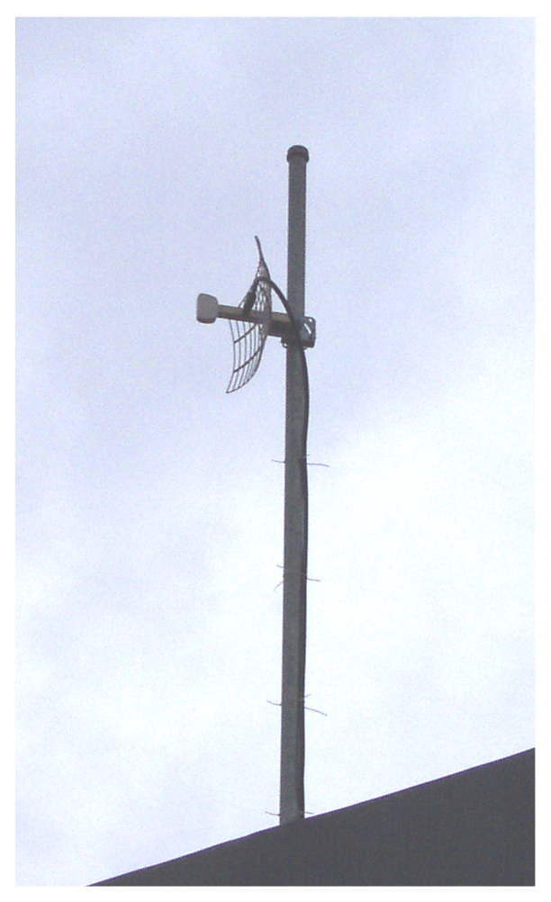

Analyzing cash flow in these Internet cafés, it would clearly shown that most of the money is actually going into Indonesian Telco pocket for paying the telecommunication lines, not to mention, current increase in Indonesian Telco’s tariff. It really drives the community to seek altrenatives to build our own network with out having to rely on Indonesian Telco. The easiest way, supported by ample technology for building the network is the wireless LAN technology running at 2.4GHz. With approximately US$150 / unit, one with strong Linux background may easily build a low cost gateway / router to integrate a LAN or a community to the Internet at 11Mbps if we put external antenna with sufficient gain to reach the Access Point. Shown in the picture is my 19 dBi 2.4GHz antenna used at home to integrate my LAN at home as well as my surrounding neighborhood to the Internet for 24 hour access at 11Mbps at Rp. 330.000 / month (approximately US$30 / month).

Building low cost home made 2.4GHz antenna is not that difficult, a tincan with 90 mm diameter, and 215 mm length can be easily used as 2.4GHz antenna and quite good for 3-4 km distances. It cost approximately US$5-10 per antenna. This tipe of antenna is currently being used by many Internet Cafes in Jogyakarta for reducing their investment.

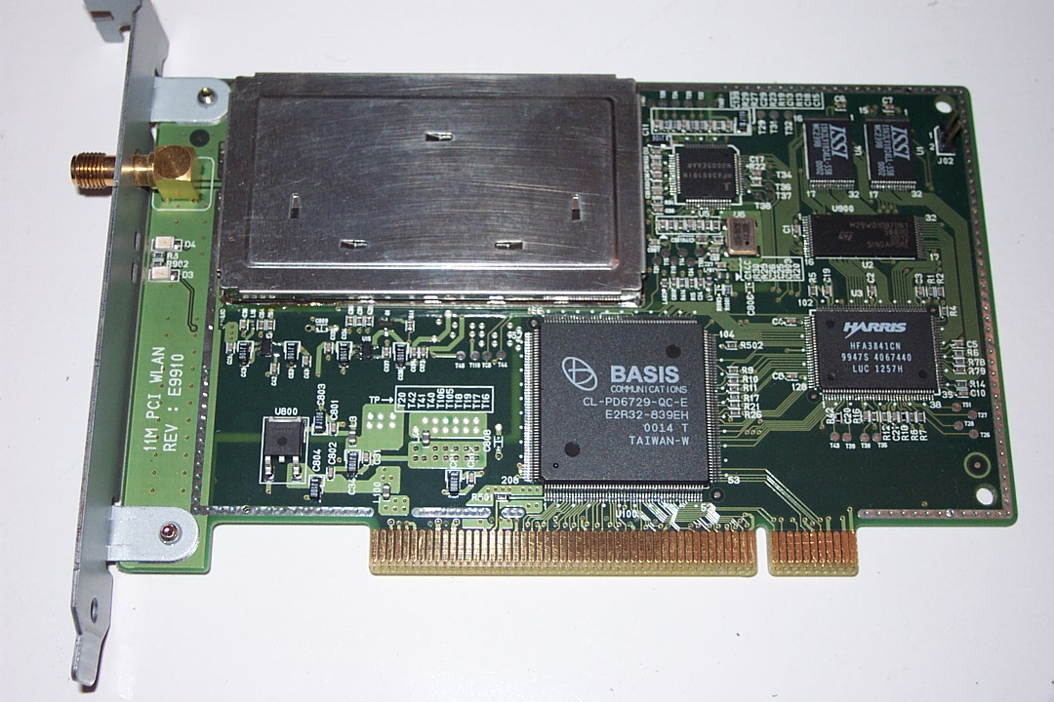
The 2.4GHz radio and modem is integrated into a US$150 wireless LAN card. It is fairly similar to normal Ethernet card. The major difference is in the antenna connector pop up at the end of the card to be used to connect the coax cable and external antenna to the card. The Linux’s driver of the card is available in public domain, such as, http://www.sourceforge.org will really help those who like to build their own infrastructure.

The 2.4GHz wireless Internet solutions can easily find on the Internet, such as, http://hydra.carleton.ca, http://www.wavelan.com, http://www.ydi.com, http://www.wipop.com, or at http://www.google.com use WLAN or 2.4GHz as keyword. One should explore alternative on 5 or 5.8GHz for the newest equipments.

Having the solution to build an alternative for high-speed local access network, we need to think on how to build the regional network. The only liberalized infrastructure for regional network is the satellite network. Most of Internet cafes in Bandung, Jogyakarta, Surabaya, Malang etc, are now adopting a hybrid satellite and wireless Internet infrastructure to build the whole community based infrastructure. As shown in the figure, several Internet Cafés, also known as WARNETs, share the satellite access to the Internet. Two ways satellite access will remove their dependence to any Indonesian Telco operators for regional access.

Satellite access is quite expensive, it costs approximately US$5000 per Mbps per month. Thus, sharing the cost with 10-20 Internet cafés is very logical to reduce the cost to US$250-500 / month / Internet café. US$500 / month / Internet café is affordable knowing some of these cafés can easily get US$50-100 / day from their customer. High-speed wireless technology is used to share the bandwidth among these Internet cafés.

Another emerging controversial technology is the Internet telephony. References on it are freely available at http://www.ietf.org, http://www.iptel.org, http://www.sipforum.org and can be used to build a community based telephone network at very low cost. More and more heroic stories may pop up in the near future in building the infrastructure and bypassing the high tariff-ed conventional incumbent infrastructure. As expected, the government would likely to protect the interest of incumbent telecommunication operators.

I have to admit that these solutions may not be appropriate for some countries, especially those with tight rules on frequency usage. Most, if not all, the time, we run the equipments without any license from the government. Fortunately, the Indonesian media helps keep us from being jailed. We only hope to give the best and low cost solutions for the Indonesians to be integrated into the Internet & reducing any existence of digital divide.


Behind all the movement and activities in deploying such heroic infrastructure that rely heavily on the community initiative, I have to admit that educated, dedicated & militant people is the key to success. It shows clearly the strength of community education in attempting to transform Indonesia into knowledge-based society. The persons behind these high technology gadgets are young and energic enthusiasts. In the picture is the typical example of these young ones. In the figure, these young ones happen to be my students at Computer Network Research Group (CNRG) at Institute of Technology Bandung (ITB).

3.6.3. INDONESIAN INTERNET GRASSROOT MOVEMENT

Aside from the commercial & legal ISPs, quite significant activities can be noted in some grassroots movements. Their activities are driving most of Indonesian Internet activities. They are the Internet Café and the high-speed (11-54Mbps) wireless Internet technology.

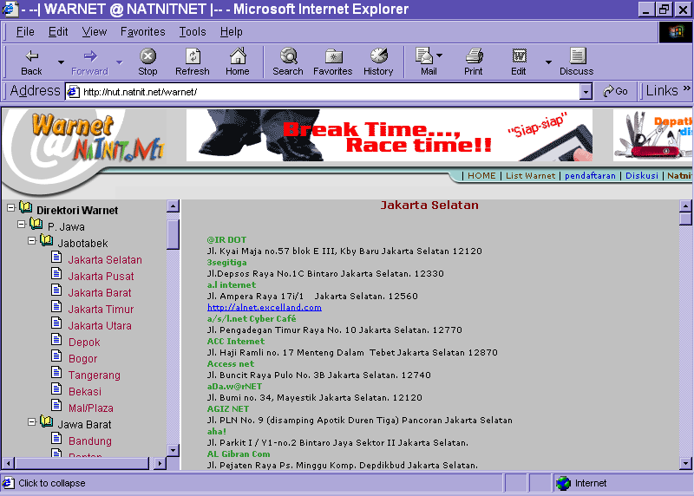
Currently (late 2002), there are 2000+ Internet Cafes in Indonesia. About 1489 Internet Café registers in http://www.natnit.net/warnet/. Unfortunately, we will likely to see an unequally distribution of Internet Café over Indonesia. More than 50% of the Indonesian Internet café is located in Jakarta & its surrounding areas. About 87% are located in Jawa island. While the rest of Indonesia should be pleased with only 200 Internet Café, of which, 25% is located in Bali and a large portion in Sumatera Island.

Most of the Indonesian Internet Cafes are self-finance. Most of us are hanging out at asosiasi-warnet@yahoogroups.com at an average of 50-100 e-mails per day. The Indonesian Internet Cafés are organized under Indonesian Internet Café Association (AWARI). AWARI was founded in 25 May 2000, and currently leads by Judith M.S (me@judithms.com), Michael Suggiardi (michael@batutulis.com), and Abdullah Koro. One of the their ultimate objective is to fight for expanding our own network and implementing the concept towards self-finance community based network and most likely less dependent on the Indonesian Telco services.

Based on the technology & business plan described freely in http://www.bogor.net/idkf, we managed to reduce the cost for public users to access Internet at Rp. 5000 / hour (approximately US$0.5/hour) at various Internet cafés. At Indonesian schools, the cost for accessing the Internet can be brutally reduced to Rp. 5000 / month / student (approximately US$ 0.5/student/month). Thus, Internet is actually accessible to a much wider range of people than simply those who can afford a personal computer. Investment for building Internet café in the range of Rp. 50-100 million (approximately US$5-10.000) would return easily within one (1) to two (2) year time. Thus, it is not surprising to see many small medium businesses as well as schools are now putting their money to build their own Internet infrastructure. Internet Café is an affordable solution for Indonesian to access the Internet.

Having 25.000 high schools with 2-3 million students, it would a strategic move increase the Internet penetration by Interneting the schools (currently only 1200+ schools & 200+ universities are on the Internet). We have to admit that Dr. Gatot H.P. (gatothp@aol.com) at Ministry of Education is phenomenal in leading the Indonesian vocational schools to the cyberspace. If conducive policy is implemented, it may enable 20+ million Indonesians to Internet in next 4-5 years. More over, no loan is necessary from the World Bank, IMF & ADB.

High-speed (11-54Mbps) wireless Internet is used technology to build the community based Internet infrastructure with no Telco. It runs on Instrumentation Scientific Medical (ISM) band in 2.4GHz and 5-5.8GHz. At the moment, 1000+ corporate users including the good Internet cafes and some residential users use it. Most of the wireless Internet operators are hanging out at indowli@yahoogroups.com and struggling for low cost, if not free, frequency license. We hope no tariff is required for people to use the air.

3.6.4. INDONESIA DIGITAL LIBRARY NETWORK

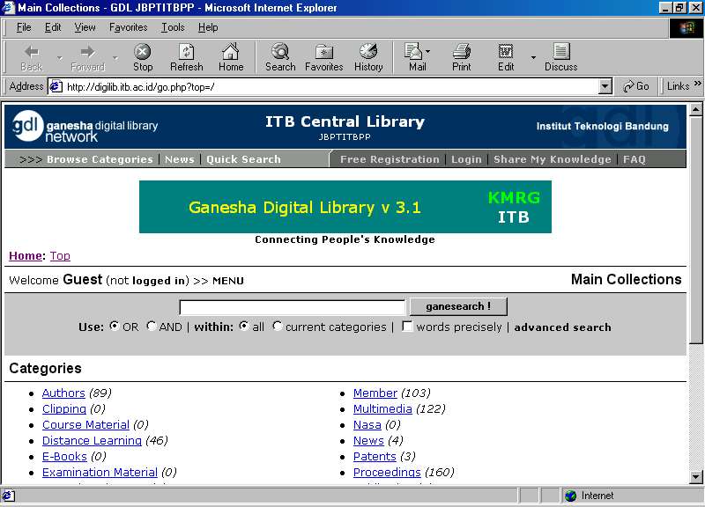
Lead by Ismail Fahmi (ismail@itb.ac.id) at Knowledge Management Research Group (KMRG) kmrg@kmrg.itb.ac.id, a free software for Digital Library has been developed. A working network of the Indonesia Digital Library can be found at http://www.indonesiadln.org and http://gdlhub.indonesiadln.org. Its initial research activities was funded by International Development Research Center (IDRC, http://www.idrc.ca) Canada and Yayasan Litbang Telekomunikasi Informatika (YLTI, http://www.ylti.or.id).

The Ganesha Digital Library 3.1, an open-sources/free software, can be run on a system running Unix/Linux or Windows 98/NT/2000 or Windows 95 with winsock32. Apache web server using PHP4 scripting language to interact with MySQL database may be used by dedicated or dial-up infrastructure to create the knowledge infrastructure.

It is currently able to integrate 30 digital library all over Indonesia as well as some Asian countries. Some examples are a Pakistani NGO (peace786pk@yahoo.com) and Penang Library Network at University Science Malaysia (USM). There are 80 institutions has been registered to use and to try being part of the library. A total in excess of 1500 download of digital library software have been performed; not counting those who receive and copy the software from available CD-ROM.

Having such technology will enable institutions, individuals as well as access centers, such as, Internet café to be part of a large knowledge infrastructure. It promotes sub-networks, such as, health, agriculture and human right. Not surprising to see awards have been given to this initiative by American Society for Information Science and Technology (ASIST) in November 2001 as well as e-Award from Indonesian Infocom Business Community (I2BC) in September 2002.

Work is currently underway to implement an open, free environment to share universal knowledge, and, thus, enable the integration of the current infrastructure to a much larger open archive activities at http://www.openarchive.org.

3.7 ENABLING POLICIES:

To be honest, the government of Indonesia (GoI) is putting a lot of money into ICT & setting several national teams for it. It was all started in 1998, lead by Pak Jonathan Parapak, we worked on the Nusantara 21 concept; the softcopy of Nusantara 21 concept can be downloaded from http://www.bogor.net/idkf/. At that time, many nations were working on their National Information Infrastructure (NII) ignited by Al Gore’s Global Information Infrastructure (GII) initiative.

The Nusantara 21 concept was than being used as reference by the National Coordinating Team for Telematics set by the Indonesian president (both Mr. Habibie and Pak GusDur). Their concept was adopted by BAPPENAS (the National Development Coordinating Body) and was used for getting a World Bank’s specific investment loan. As reported in World Bank (http://www.worldbank.org/ict), the World Bank funded US$ 34,5 million Indonesian Information Infrastructure Development Program (IIDP) was approved in November 1997. There is no grant in the commitment. The project closing date is 06/30/2003. IIDP consists of several smaller projects, such as,

- TATP the Training Assistantship for the civil servant at Ministry of Industry and Trade as well as small percentage to selected Small Medium Enterprises.
- IPTEKnet concept at Ministry of Research and Technology, for integrating the government institutions to the Internet. It would be the base for Indonesian e-government.
- E-commerce concept at Ministry of Tourism.
- Copyright Law at Ministry of Law & Legal Matters.
- National Information Technology (IT) Framework at BAPPENAS, the National Development Coordinating Body.

If I can say it in a plain language, most, if not all, of the funding is gone for paying the International consultants to write pages of concepts, working papers, law & legal matters. To best of my knowledge, no investment in real infrastructure and things that really help the people access the Internet. Thus, the US$34.5 million has very little direct impact to the Indonesian people.

Recently in the year 2001, the state ministry of research and technology is launching the Internet Café Technology & Science Technology CD. Since the Indonesian government has budget limitation, the one who drive behind the activities are mostly coming from the private sector. The Internet Café Technology aims to build 9000 Internet café with the investment from private sector, such as, Myoh.com and Hewlett Packard (HP) Indonesia. The investment will then be returned by the Internet café users though its access fee. In the early 2002, they managed to build a couple of these Internet cafés.

The Science Technology CD contains research done under the state ministry of research and technology. It is distributed freely to the public. Sekolah 2000 foundation (http://www.sekolah2000.or.id) and Master Data with a lot of sponsorship from private sectors supports the production and distribution of the CDs.

To best of my knowledge, the only government movement that managed to provide significant impact on Indonesian Internet society is the vocational school’s Internet movement (dikmenjur@yahoogroups.com). Dr. Gatot H.P. (gatothp@aol.com), the director of vocational schools at ministry of education, is the one who drive the movement. Unlike other bureaucrats, Dr. Gatot H.P is very responsive on e-mail. In the year 2001, he work closely with other Indonesian Internet societies and manages to push 1400+ (out of 4000) Indonesian vocational schools into the Internet. We are very proud on their accomplishments.

The Indonesian people should be happy with the support coming from the Indonesian private sector. Private sector’s investment and various sponsorships are the one that keep Indonesian Internet alive today. It is sad that only small fraction of the US$ million loan directly reaches the Indonesian people. One may ask the necessity of the US$ 34,5 million loan.

3.8 REGULATORY ENVIRONMENT:

Table. Summary of laws and regulations affecting the ICT sector

Issues | Status
Electronic transaction | Draft, by University of Indonesia (UI)
Cyber-crime | Draft, by Pajajaran University
Consumer laws for e-commerce and distance trading | Not available; There is conventional Consumer Protection Act (UU 8/1999).
Data protection and privacy | Not available.
Broadcasting licensing and content regulation | Broadcasting Act (UU 24/1997); fight is underway to make it more people oriented.
Internet-related licensing for Internet services providers, Internet cafes, telecentres, etc. | Telecommunication Act (UU36/1999); no license required for Internet Café & TeleCenters.
Digital signature | Draft, by University of Indonesia (UI)
Convergence and multimedia regulation | Telecommunication Act (UU 36/1999); still lacking in addressing convergence.
Intellectual property rights regime | Intellectual Property Right Act (UU 19/2002)
WTO status, regional memberships, basic commitments related to telecommunications under WTO, foreign equity limits | WTO member
Telecommunication Act | Telecommunication Act (UU 36/1999)
Local domain name registry and dispute resolution | Ministerial Decree on Telecommunication Services (KEPMEN 21/2001)

Most of the softcopy of Indonesian laws and regulations can be downloaded from the Web. Some of the web that carries related softcopy is,

- http://www.internews.or.id - on broadcasting and telecomm policy & law. Internews provides the English translation for some Act.
- http://www.hukumonline.com - softcopy of various law, regulation as well as news.
- http://www.postel.go.id - policy & regulation in telecommunication sector.
- http://www.dprin.go.id - data, policy & regulation in various industries (including ICT).

In Indonesia, theoretically all draft of law and regulation can be submitted by anyone; and must be approved by the House of representative (DPR) prior to officially signed by the President. In reality, government agencies submit most drafts as ordinary people has no interest and no funding for such activities.

In ICT sector, the drafts are created by

- Directorate General of Copy Right and Patent.
- Directorate General of Post and Telecommunication (http://www.postel.go.id).
- Ministry of Industry and Trade (http://www.dprin.go.id).

In ICT sector, economics investigator within the police force (http://www.polri.go.id) performs the law enforcement. Major problem in Indonesian law enforcement is that not many law enforcement officers have the necessary knowledge and, in some unfortunate cases, money talk. In some cases, it may be better to discuss it through appropriate person in the media, such as, Majalah Forum, Hukum Online, and Internews, as they have a much better networking and much rapid responds.

3.9 OPEN SOURCE MOVEMENT:

Indonesian Open Source movement is very active. Linux education processes are very intense; community based seminars, talk show, workshops are frequently organized and sponsored by many local, national and international companies. A significant portion of Indonesian Linux activities is driven by the Indonesian Linux user group, A.K.A, Kelompok Pengguna Linux Indonesia (KPLI) at www.linux.or.id. The Indonesian Linux users counting project is done at www.linux.web.id.

The Indonesian Linux users cluster around several mailing lists and Web sites. Most active Linux mailing lists are located under linux.or.id, such as, linux-admin@linux.or.id and linux-setup@linux.or.id, and some are located in yahoogroups.com, such as, majalahneotek@yahoogroups.com, linux-heboh@yahoogroups.com.

At the moment, there are at least three (3) Indonesian Linux Distribution, namely,

- Trustix Merdeka (www.trustix.web.id).
- Bijax written by University Bina Nusantara (www.binus.ac.id) students.
- WinBI adopted from Trustix Merdeka and supported by Ministry of Research and Technology.

Linux Terminal Server Program (LTSP) http://www.ltsp.org is making a significant influence on Indonesian ICT arena as it provides a low cost solution in many Internet café and school networking.

Most of the favorite Linux Web sites are usually associated with Linux magazines, such as,

- InfoLinux magazine (http://www.infolinux.web.id & www.infolinux.co.id).
- Neotek magazine (http://www.neotek.co.id), more info on hacking techniques.

A significant number of Linux, Internet, IT books written by Indonesia has been published only in the last 4-5 years. Several publishers, such as, Elexmedia Komputindo (http://www.elexmedia.co.id) in Jakarta, and Andi Offset in Jogyakarta, are the most active Indonesian IT book publishers.

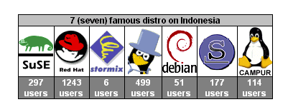
Vote results from www.linux.web.id, www.infolinux.co.id, & Jakarta.linux.or.id, it clearly shows that RedHat, Mandrake, Slackeware and SuSE to be the favorite Linux distribution in Indonesia. Shown in the figure is the seven (7) favorite Linux distribution voted in www.linux.web.id.

Militancy of Indonesian Linux users is pretty high. Based on the vote results run on www.linux.or.id, questioning would Microsoft wins its war against Open Source? Only 13.04% answer Yes; the 80.82% majority answers No, and the 6.14% rest unknown.

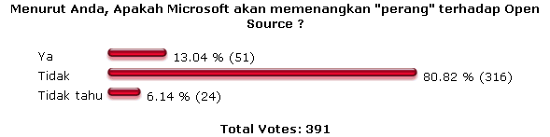

Some important insight into the Linux communities can be found in several votes performed in various Web sites. Some of the vote results done at www.infolinux.co.id shows that,

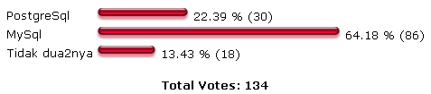
MySQL seems to be favorite database software among Indonesian Linux users.

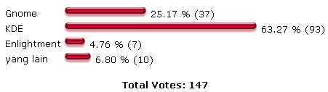
KDE seems to be the most favorite Windows among Linux users.

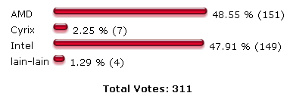
Interestingly, a significant number of Indonesian Linux users actually uses AMD as their processor of choise.

3.10 RESEARCH INTO ICT:

Only in the last ten (10) years, two (2) Indonesian ministries, namely, ministry of research and technology (www.ristek.go.id) and ministry of education (www.dikti.org), invest in excess of US$3 million for more than 110 research activities in ICT. In addition to the government’s funded researches, smaller portion of research activities are performed through private sector contract works. Unfortunately, it would be much more difficult to investigate private sector research activities.

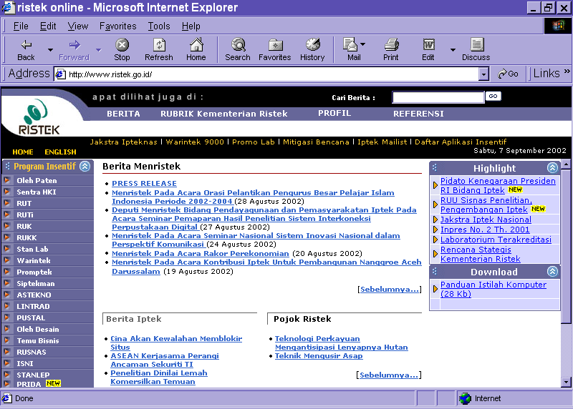
The Indonesian National Research Council at the Ministry of Research and Technology has been providing funding for about 88 ICT researches. There are five (5) ICT research themes performed, namely, electronics components, telecommunication technology, software, signal processing, and power. 65% of the research activities are on electronics components and telecommunication technology. Less than 20% are on software research. More than 40% of the ICT hresearches, funded by Ministry of Research and Technology, are done and lead by researchers at Institute of Technology in Bandung (www.itb.ac.id).

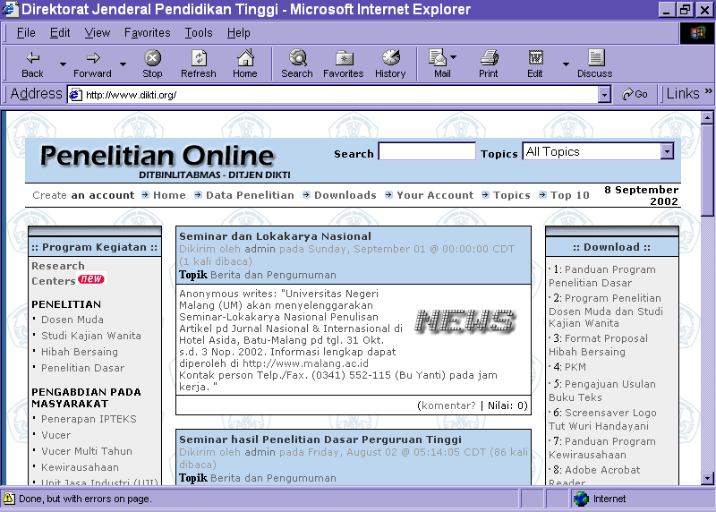
The Higher Education Directorate General at Ministry of Education (www.dikti.org) are supporting more than 36 research activities in ICT. About 44% of the research is in electronics system; followed by software research at 25%. The rest of the research is in telecommunication technology, signal processing and power.

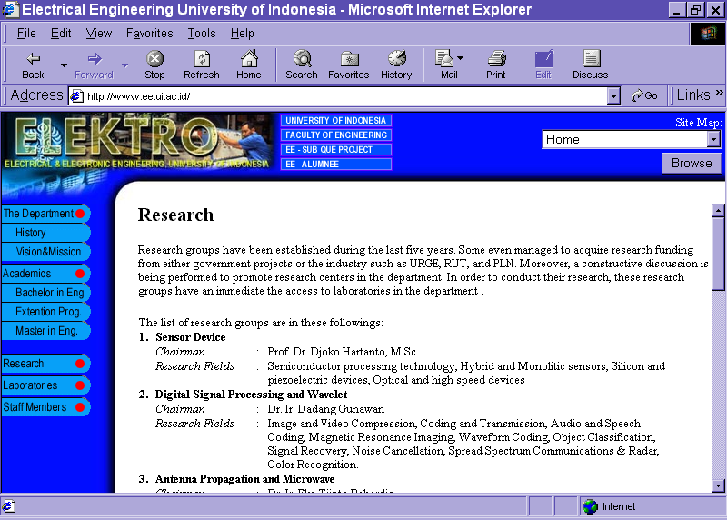
Some of private sector research activities can be probed from some university pages, such as, inter university center on microelectronics (http://www.paume.itb.ac.id), computer science department at university of Indonesia (http://www.cs.ui.ac.id) or electrical engineering department at University of Indonesia (http://www.ee.ui.ac.id).
3.11 FUTURE TRENDS:

In terms of technology, a significant impact may be apparent in wireless 11Mbps WiFi as well as low cost Linux based system specially the one running on Linux Terminal Server Program (LTSP) as it provides a significant low cost solution for Internet café, school network as well as neighborhood networking.

Private sector and academia might be the two (2) most influencing part in Indonesian ICT industry. Indonesian private sector enjoy the benefit of free market competition in PC and IT market. The Indonesian policy and regulatory framework seem to aim for a non-monopolistic telecommunication industry. In reality, Indonesian telecommunication industry is virtually a “strongly” regulated market. It is hoped that a more egalitarian policy and regulatory can be implemented in the telecommunication sector.

Academia is in reality driven by energetic young educated Indonesians that adopt new technology through Internet Web access and various Internet mailing lists. Some of these students influence their surrounding communities by building and running Internet café, writing articles and books in Indonesian language, which, in turn, significantly impact their communities.

Having a high speed transparent media to transport information and knowledge among Indonesian people, it is hoped to see the evolution of Indonesian civil society as well as knowledge based society as more and more Indonesian having Internet access. Unfortunately, it will take several Indonesian generations to reach 80-90% Indonesian with Internet access.

Since regulation may affect ICT market, Indonesian government might play a significant role in policy and regulatory framework to speed up the transformation process of Indonesian society.

Some of the challenges and obstacles identified are,

- Youth would be the agent of change in the Indonesian knowledge based society evolution process. Thus, education processes would be the crucial success factor.

- Accountable leaders would be the key catalyst of the evolution process. Unfortunately, it is not an easy job to find accountable Indonesian leaders.

- Putting technology in place is the easiest part. Its social, politics, policy, cultural aspect that may create the unnecessary barrier. Build the usefulness of technology into the values of the culture would solve.

- Demand-created supply scheme works best as compared to supply-created demand. It is an art in itself like chicken and egg, which comes first?

- Education is the heart of transformation processes and, thus, creates an aggregation demand that would provide a significant impact.

- Regulation is not God's law. Regulation can affect but cannot create a demand nor a market. Unfortunately, mistakes in regulation can be disastrous.

- Privatization and competition may create the needed constructive environment. Balanced by empowering and funding rural and underserved communities' infrastructure is essential.

- Network of small independent telephone companies and cooperative much more suitable and agile in adapting technology, providing advance services for rural and underserved areas.

- Community helps communities for higher multiplier effect while maintaining low cost overhead.

4. ANNEXES

4.1 SELECT BIBLIOGRAPHY ON THE COUNTRY/TERRITORY:

www.bps.go.id - Indonesian government statistical bureau
www.yahoo.com - Internet portal, good for starting point
groups.yahoo.com - Most Indonesian mailing lists hosted at this site.
www.google.com - Internet search engine, best place to start.
www.yellowpages.co.id - Indonesian Yellowpages.
www.indopage.com - Indonesia Directory Service.
www.kadin.net.id/businessnet/ - Indonesian Chamber of Commerce.
www.hukumonline.com - Online Indonesian law & legal matters
www.internews.or.id - non-profit organization on news & media
www.linux.or.id - Indonesian Linux community portal.
www.apjii.or.id - Indonesian ISP association.
www.iix.net.id - Indonesian Internet Exchange.
www.mastel.or.id - Indonesian Telecommunication Society.
www.natnit.net/warnet/ - Indonesian Internet Café
www.postel.go.id - Directorate general of post and telecommunication
www.dikti.org - Directorate general of higher education
www.ristek.go.id - Ministry of research and technology
www.indonesia.go.id - Indonesian government portal
www.dprin.go.id - Ministry of Industry and Trade
www.kompas.com - KOMPAS, Indonesian main news source
www.detik.com - Detikcom, Indonesian leading online media
www.bogor.net/idkf - large Indonesian ICT knowledge site
www.pandu.org - large Linux articles and book site
bebas.vlsm.org - large ICT knowledge site

4.2 CHART OF KEY FACTS:

Total population 228,437,870 (2001)
Rural population as a percentage of total population -
Key economic sectors -
Literacy in national language(s) 89.92% (pop. >10 years)
Literacy in English -
Computer ownership per 100 inhabitants 1.01 (2001)
Telephone lines per 100 inhabitants 3.11 (2001)
Internet hosts per 10,000 inhabitants 1.27 (2000)
Internet café/telecentre per 10,000 inhabitants. 0.073 (2002)
Internet users per 100 inhabitants 1.82 (2002)
Cell phone subscribers per 100 inhabitants 1.73 (2001)
Number of websites in the national language too many
Number of websites in English and other languages too many
National bandwidth within the country/territory 255.4MBps (2002)
National bandwidth to and from the country/territory 1 Gbps (2002 est.)
Ratio of in-coming and out-going Internet traffic volume 1:10 (2002 est.)
Where possible, include data to reflect women users and -
women subscribers of ICT

Key Economic Sectors (CIA – The World Fact Book)

GDP US$ 654 billion (2000 est)
GDP - real growth rate 4% (2000 est)
GDP - per capita US$ 2900 (2000 est)
GDP - composition agriculture 21%
industry 35%
services 44% (1999 est)
Population below poverty 20% (1998 est)
Household income lowest 10% 3.60%
highest 10% 30.30% (1996 est)
inflation rate 9% (2000 est)
labor force 99 million (1999 est)
labor force agriculture 45%
industry 16%
services 39% (1999 est)
unemployment rate 15%-20% (1998 est)
budget revenues US$26 billion
expenditures US$30 billion
industries petroleum and natural gas; textiles, apparel, and footwear; mining, cement, chemical fertilizers, plywood; rubber; food; tourism
industrial production growth rate 7.50% (2000 est)
export US$64.7 billion (f.o.b 2000 est)
import US$40.4 billion (c.I.f, 2000 est)
debt - external US$ 144 billion (2000 est)

4.3 REFERENCES:

- Digital Planet 2002: The Global Information Economy, The World Information Technology and Services Alliance, February 2002.

