Low Cost Broadband IP Satellite Backbone in Indonesia

Onno W. Purbo
(onno@indo.net.id)
http://sandbox.bellanet.org/~onno/
A Common Indonesian

Abstract

This will report on several IP based satellite backbone in operation in Indonesia. Basically, shared VSAT IP service, such as, Digital Video Broadcasting (DVB) service seems to be the favorite low cost solution for broadband IP satellite backbone, as compared to the more costly Single Channel Per Carrier (SCPC).

Typical questions, such as, typical configurations; which provides the service will be described. Some of these services especially receive only IP VSAT service may be run without any government license.

A typical one way received only IP based DVB VSAT services may be obtained US$33-270 / month. While two ways DVB/RCS VSAT service is around US$700-800 monthly including the monthly VSAT rental and maintenance fee.

Having IP based broadband backbone will enable many added value services, such as, neighborhood or city-wide network through WiFi 2.4GHz infrastructure and VoIP community network. These community based services may be described.

Introduction

Basic typical question is “What would be the low cost dedicated IP solution for rural / remote sites or small cities?”.

If one look for the solution through Indonesian telecomm, one might find that typical charge of US$1 per hour through their dial-up services at 080989999 numbers.

If one look for dedicated IP connection to the Internet in remote Indonesia through Indonesian telecomm service, one might find the calculation would be very much simple, i.e., 24 hours times 30 days times US$1 / hour. Thus, the dedicated IP connection cost would be in the range of US$720 / month. We hope the speed reaches the maximum dial-up speed of 56Kbps, which is the upper limit for most cases in remote / small cities.

To be honest, US$600-800 / month for dedicated Internet connection would be out of questions for most Indonesians. Thus, the typical basic / common solution would be shared access cost through neighborhood network, school network, offices network etc. to obtain an affordable US$15-30 / month / house for 24 hours Internet connection. The operating cost calculation is quite straightforward, the monthly dedicated Internet connection cost (US$600-800 / month) divide by the number of schools / neighbor / offices. A typical 20-30 neighbor is sufficient to reduce the monthly cost to an affordable US$15-30 for individual users / houses.

A neighborhood network is basically a cyber café technology with a proxy server or Network Address Translator (NAT) box to share a single Internet access to many computers behind the NAT box. Commonly used UTP (LAN) cables run across the neighborhood to connect all computers. Since UTP cable is limited to 100-200 meters, we normally putting a hub or switch box every 100-200 meters, to act as a repeater for the LAN cables to reach longer distances.

Neighborhood network has been a common solution for many Indonesian residential areas. Unfortunately, the government has been very slow in responding to the regulatory framework and has been considering such network as a not legal (but not really illegal) network.

In some cases, we need to deploy a city wide area network. A typical city wide area network must cover an area with radius 5-15 km (or about 25-150 km square). UTP / LAN based technology is not sufficient to cover such ranges. We normally used WiFi 2.4GHz equipments to do the tasks. Most Taiwanese low cost WiFi 2.4GHz is normally designed for indoor usage. Most of us enclosed such equipments in plastics boxes, replace the default antenna using a high gain parabolic antenna and put it for 5-15 km outdoor operations.

The individual charges can be extremely low for Internet connection to schools through city wide area network. Shared Internet access would cost about US$40-70 / month / school after sharing the backbone access to several schools within the city. Considering typical schools would have 500-1000 students, the final operating cost as well as investment for buying computers would be around US$0.20-0.50/student /month. The return of investment for the computer equipment would be around one to two years time.

The monthly cost in getting the community access as well as school access to the Internet can be reduced significantly to sub-US$1 level per month per students. The whole investment may be payback within 1-2 years time. The most important aspect of the whole initiatives is the communities and the schools don’t have to rely on government funding nor loan from the World Bank nor IMF.

Thus, it solved most of our problems in getting low cost (and self-financed) access for neighborhood and city wide area network. Most of the technology is very well documented and can be downloaded from many sites, such as, http://www.apjii.or.id/onno/, http://sandbox.bellanet.org/~onno/, http://www.apc.org/tiki/, and http://www.thewirelessroadshow.org.

Having solved the neighborhood and city wide area network, our next task is to find the solution for low cost nation or international access. There are basically two (2) major competing technologies, i.e. satellite based or fiber optic based backbone infrastructure.

In some / major cities, it is quite easy to find fiber optics backbone provided by Indonesian Telkom or XL http://www.xl.co.id (one of the Indonesian cellular operator).

Due to bureaucratic reasons and service commitment, many of us would prefer to use XL’s fiber optics backbone infrastructure, ensuring high quality, high capacity, and reliable services. Combined with fixed wireless transmissions, VSAT, and submarine fiber optics, the network spans across Java, Bali, Lombok, Sumatra, Kalimantan, Sulawesi, and Singapore (as Business Solution’s international Leased Line gateway).

Unfortunately, in many Indonesian areas, it would be difficult to get access to fiber optics backbone. Thus, the solution would be satellite based backbone infrastructure. The cost structure must remain about US$600-800 to reach an affordable US$15-30 / month end user charges. In the next section, I will describe the situation in satellite based IP backbone in Indonesia. To be honest, some of these activities are currently considered as not legal. Although, it is not illegal either.

Overview of Satellite Based IP Backbone Technology

There are basically two (2) major commonly used satellite based IP backbone technologies, namely,

- Single Channel Per Carrier (SCPC).
- Digital Video Broadcasting (DVB).

SCPC technology is basically a dedicated media, in which, the satellite link is used for point to point only and not shared with other users. The quality of service of SCPC link is excellent. Unfortunately, a 64Kbps SCPC link would cost us in Indonesia about US$2000-2500 / month.

To save the cost, one most share the satellite bandwidth / access with others and divide the cost respectively. Digital Video Broadcasting (DVB) technology has the ability to share a single satellite downlink to many users. The end users need to decode the data transmitted from the satellite through a DVB card, which normally cost about US$100-150, plug in a Windows or Linux box that will act as a router for the rest of the network. Thus, a DVB box will solve for the incoming traffic from the Internet to the neighborhood or city wide network.

Some DVB technology uses normally terrestrial network, such as, dial-up or 2.4GHz WiFi to route the outgoing traffic to the Internet.

In some cases, getting a dial-up or 2.4GHz WiFi access to local Internet Service Provider (ISP) is out of questions. In such cases, we need satellite access for both incoming and out going traffic. Most commonly used DVB based technology for both incoming and outgoing traffic is the DVB/FTDMA technology. Both incoming and outgoing traffic is shared over the satellite link. For a 64Kbps DVB/FTDMA shared access may cost about US$200-700 / month depending on either we rent or having our own the VSAT ground station.

It is common to see a US$700/month DVB/FTDMA VSAT access is shared to a city wide area network through WiFi 2.4GHz City Wide Network, and then shared again through UTP / LAN neighborhood network to reach US$15-30/month/house.

Let us now review some of the Satellite based IP backbone provider that run the service in Indonesia.

Received Only IP Based Satellite Access
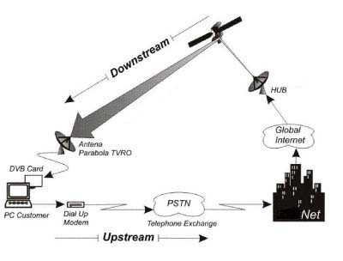
Installing and running a received only satellite ground station requires no licensed from the Indonesian government.

Thus, received only IP based satellite access is the safest service that can be provided to the Indonesian communities without having to struggle in getting the any licensed from the government.

Shown in the figure (copied from http://www.makmurparabola.com) is the configuration of typical received only broadband IP based satellite link as the downstream. It is fairly safe and no licensed is required. The request (upstream traffic) may be directed through a dial-up modem, or ADSL connection, or WiFi connection to the Internet Service Provider.

Received only IP based Satellite Access is normally used to increase the system capacity especially for international traffic. It would be advisable to have a local Internet connection to local Internet Exchange, such as, Indonesian Internet Exchange (IIX) http://www.iix.net.id before doing any received only IP based satellite access.

Such configuration is normally used by corporate users, including cyber cafe, hotel, manufacturing industries, hotel etc. Personal / community network, including apartment, real estate etc. as well as personal users.

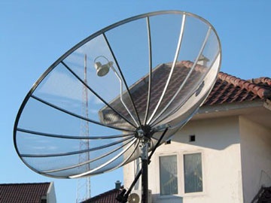
We need to set up a satellite ground station with a minimal parabolic antenna diameter of 180 cm including the Low Noise Amplifier (LNA), coaxial cable (such as RG6) that costs about US$120-200 as shown in the figure from Makmur Parabola; a pentium III personal computer 256Mbyte RAM as DVB Router with Windows or Linux operating system; Mikrotik router software (http://www.mikrotik.com); a dial-up 56Kbps modem for Internet dial-up connection, or ADSL, cable modem, 2.4GHz WiFi connection for uplink connection.

The key equipment would be a DirecPC ™ or DVB card, such as, Penta Value or Broadlogic 2030, that can decode downlink data from the satellite. A DirecPC ™ or DVB card, including CD-ROM and manual would normally cost about US$250. A registration fee of US$100 is fairly typical to use the service.

There are several received only IP based satellite access that served the Indonesian clients, such as,

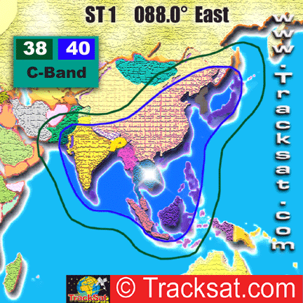
Makmur Parabola (http://www.makmurparabola.com). Makmur Parabola is not a licensed telecommunication service provider. They are merely installing parabolic satellite receiving antenna. In addition, they are reselling downstream only Internet access through Singapore Telecom 1 (88 East) satellite. Shown in the figure is Singapore Telecom 1 (88 East) 40 dBW and 38dBW coverage. DirectPC ™ equipment is used for receiving the Internet downstream signal from the main hub located in Hong Kong. The monthly charges is quite affordable at US$33 (64Kbps downstream), US$66 (128Kbps downstream), and US$198 (256Kbps downstream).

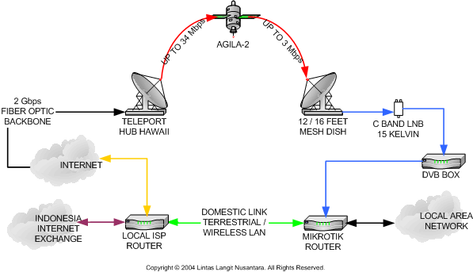
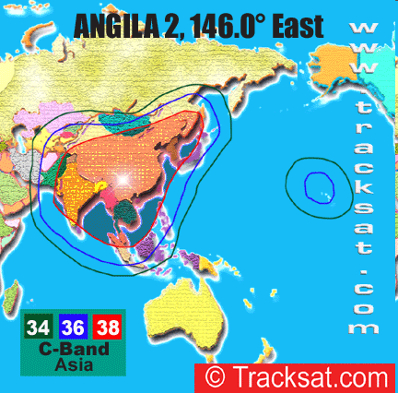
Lintas Langit Nusantara (http://www.lintaslangit.net) located in Malang East jawa island is an active group that supports the Indonesian wireless community at indowli@yahoogroups.com . Lintas Langit also provides received only IP based satellite link via Angila 2 (146 East) that covers the west part of Indonesia. Typical setup as shown in the figure can be used to get a downstream up to 34Mbps from teleport hub in Hawaii. Typical monthly fee including the rent of satellite ground station and dedicated public IP for 64Kbps downstream around US$270/month.

Telesindo http://www.telesindo.com is a VSAT Provider located in Jakarta, that can provide broadband satellite access at 4.42Mbps – 24Mbps. It is an IP based system. No detail technology and topology is provided.

PalapaNet http://www.palapanet.com is a subsidiary of Satelindo http://www.satelindo.co.id. PalapaNet manages Palapa (Palapa C) Satellites. They provide several IP based services including i-Cast (DVB/IP gateway) Point to Multipoint Concept for Internet & content distribution using a bandwidth sharing mechanism of DVB/IP platform over their Palapa C satellite. No more detail is provided.

Two Ways IP Based Satellite Backbone

In some cases, we need two ways IP based satellite backbone to the Internet. To be able to transmit to the satellite, one needs to get the service from an Indonesian licensed operator. As VSAT technology is fairly common, thus, in some cases, we may easily obtain a direct International VSAT service from a reseller or unlicensed operators. Such action may create a significant headache to the Indonesian telecommunication regulators, such as, Indonesian Post & Telecommunication http://www.postel.go.id.

There is basically several competing two ways IP based satellite backbone, namely,

- Single Channel per Carrier (SCPC), the most expensive IP based satellite backbone. A satellite channel / carrier are dedicated to a link / client, and, thus, quite expensive in the range of US$2000-2500 / month for 64Kbps dedicated link.

- Time Division Multiple Access (TDMA), the early method to share a single satellite channel to many clients. The channel efficiency in TDMA is quite poor.

- Digital Video Broadcasting (DVB) http://www.dvb.org is one of the latest and efficient methods to share the downstream satellite link to several users / clients. The latest method to have a shared uplink to the satellite is the Digital Video Broadcasting, Return Channel via Satellite (DVB/RCS). An earlier version such as, Digital Video Broadcasting, Frequency / Time Division Multiple Access (DVB/FTDMA) (Gilat’s http://www.gilat.com proprietary technology) and DVB/SCPC has been used by several operators to provide two ways IP based satellite link to the Internet. Using the DVB based technology, the cost for two ways IP based satellite link may be reduced to US$600 / month.

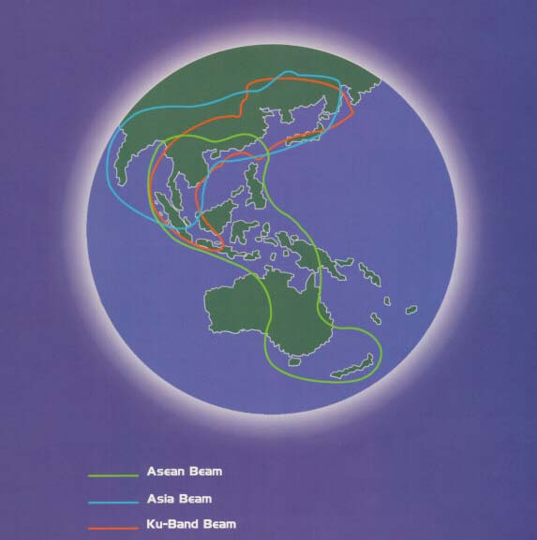
Most public IP infrastructure / services are now moving towards DVB based infrastructure to attain a lower cost access to the end users. Some two ways DVB based IP services in Indonesia are,

Pasific Satellite Nusantara (PSN) http://www.psn.co.id physically located in Jakarta offered two ways IP based DVB/FDTMA through Palapa C1 satellite (footprint shown in the figure) on its ASEAN beam that covers all Indonesia as well as Papua New Guinea and Northen Australia. PSN’s DVB/FTDMA product is called BINA at infobina@pesat.net.id. Cost for a dedicated 64Kbps DVB/FTDMA is in the range of US$700/month.

Infokom http://www.infokom.net located in Jakarta is one of the old timers in VSAT provider in Indonesia. Infokom offers many variant of VSAT Services, such as, Point to Point SCPC (Single Channel Per Carrier) and MCPC (Multiple Channel Per Carrier), Bandwidth On Demand (BOD) enabling us to increase link speed up to 2 Mbps when needed, TDMA and two (2) ways broadband. Interestingly, Infokom provides IP based DVB/FTDMA VSAT service with an upgradeable outbound DVB-S data rate up to 52.5Mbps and inbound data rate up to 512Kbps. It covers the whole Indonesia. No satellite is specified in the service, we assume one of the Palapa Satellite. In case of emergency, a redundant dial-up back-up service is provided.

Primacom Interbuana http://www.primacom.com provides a broadband service that combines the secure-technology of TDM/TDMA and DVB (Digital Video Broadcast) technology that provides broadband access up to 48 Mbps. No more detailed is provided.

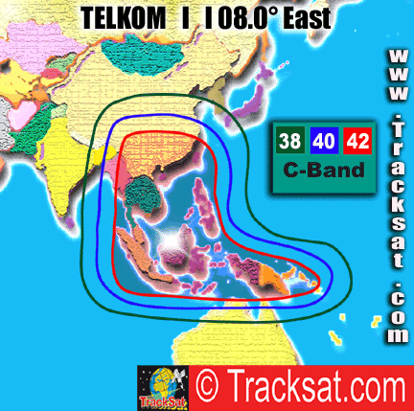
Lintas Langit Nusantara (http://www.lintaslangit.net) provides LinkStar Internet Access. It is based on DVB/RCS Time Division Multiple Access (TDMA) Multi Frequency (MF) to ensure more equal bandwidth sharing mechanism to reach link capacity and cost-effective of dedicated link. Telkom-1 satellite (108 East) is used in the service via a teleport hub in Hong Kong. For an upstream 6-32Kbps and downstream 16-64Kbps monthly cost about US$350/month. Shown in the figure is the typical configuration of the DVB/RCS TDMA MF access. Other configuration offered by Lintas Langit Nusantara is DVB/SCPC via AGILA-2 satellite. DVB/SCPC service via AGILA-2 satellite at 64Kbps will have monthly cost of about US$700/month.
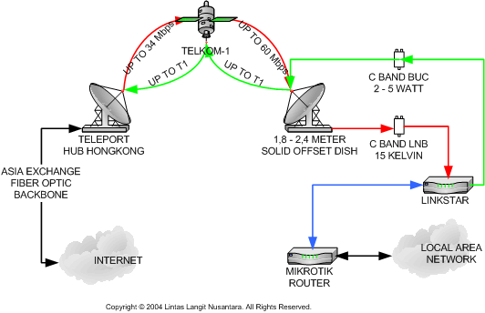

PalapaNet http://www.palapanet.com is a subsidiary of Satelindo http://www.satelindo.co.id. They managed Palapa Satellite (Palapa C). They provide several IP based services including i-Connect : Shared Internet Link, a point to point Internet service designed for the small to midsize enterprise using the Internet gateway-sharing concept to provide efficiency & value to customers while maintaining high level service quality. No more detail is provided.

For those who wish to save some more cost, it may be done by buying own satellite ground station and removing the extra US$400-500/month for renting and maintenance fee of the VSAT ground station. DVB/RCS VSAT ground station may cost around US$1500 in North America. Unfortunately, the DVB/RCS TDMA-MF VSAT ground station is around US$6500 each in Indonesia.

Value Added Services over VSAT IP backbone

Having a dedicated broadband Internet access, one may add value added services over VSAT IP backbone. Some of the value added providers are:

Satelkom http://www.satelkom.com provides MeteorVoice™ VoIP service using low density Internet Telephony Gateway, such as, VG 1002, that run both VoIP protocols H.323 and SIP.

Infokom http://www.infokom.net provides triple bundling, namely media, internet and phone. Their services focus on media related VAS such as Premium call, premium short message services, televoting, etc. and telecommunications related VAS such as VOIP, interconnection settlement, call centers, etc.

In many cases, we normally share the satellite backbone (as well as fiber optics backbone if any) to surrounding neighborhood via UTP cables for short distances (100-200 meters) or WiFi 2.4GHz infrastructure tuned for outdoor usage for city wide network. Today, we have more than 10.000+ WiFi outdoor links in Indonesia, considering many of these links are not legal (but also not illegal), the number WiFi links can be exponentially high if the government can un-license the 2.4GHz and 5.8GHz band for Internet usage. Most of the knowledge to install and run such system may be freely downloaded from http://sandbox.bellanet.org/~onno/

Having dedicated connection to the Internet has enable many free VoIP services.There are two (2) major free VoIP infrastructures, namely, (1) H.323 based VoIP Merdeka at Root Gatekeeper 202.53.224.172 and (2) SIP based VoIP Rakyat at http://www.voiprakyat.net. Some of the Internet Telephony Gateway (ITG) of these free VoIP Infrastructure may reach PSTN numbers at free of charges.

Final Remarks

It is our hope to see 200 million Indonesian have access to phone, and 100 million Indonesian connected to the Internet by 2015. To be honest, current Indonesian policy & regulatory framework does not aim to reach such explicit goal. In reality, low cost IP based satellite and WiFi 2.4GHz city-wide broadband infrastructure may be the main vehicle to reach such explicit goal.

The main strategic approach would be a self-finance process in connecting all 220.000+ Indonesian schools to the Internet at US$10 / school / month! Thus, would cost US$0.10-0.50 / student / month, and will enable 48+ million future Indonesian students get connected to the Information infrastructure as well as encouraging 100+ million parents to get connected. All process may be community’s self-finance without World Bank / IMF loan; the knowledge to do it can be freely downloaded from http://www.bogor.net/igts/.

