MULTIMEDIA TRAINING KIT
Miscellaneous: Access Point SMC
Developed by: Onno W. Purbo

Simple Configuration of an Access Point
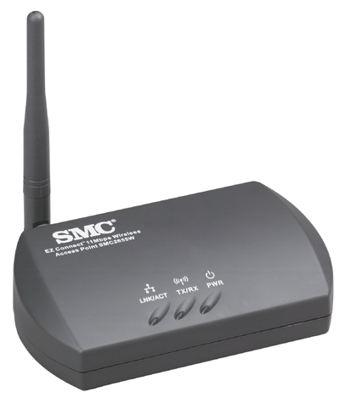
In this particular example, an SMC (http://www.smc.com) EZ Connect 11Mbps Wireless Access Point SMC2655W is used. It is my favorite tiny Access Point for office and home. The Access Point utility software will automatically scan the network and find the SMC Access Point. The Access Point MAC address and its name will be shown in the AP’s name field. “default” is the factory set login password, can be used to login into the Access Point configuration page.

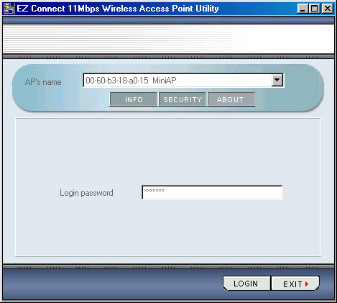

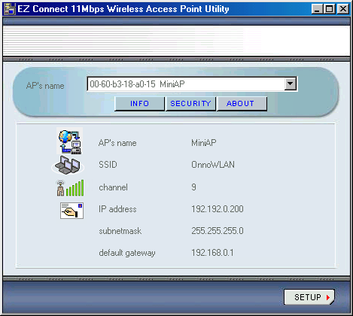
The next page shown after we login into the Access Point is the information page. It shows the configured radio and TCP/IP settings. We can change the setting by clicking the Setup button in the right corner.

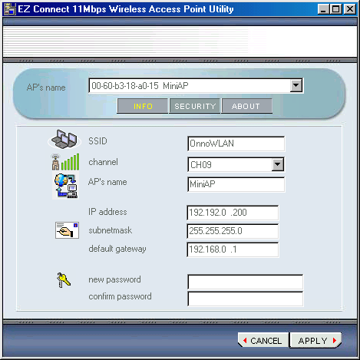
In setup page, we can set the ESSID, channel (frequency), AP name for the radio side as well as the TCP/IP configuration, including IP address, netmask, and default gateway.

Since the Access Point is a bridge, the client may bypass the TCP/IP settings of the Access Point, rather set the client’s TCP/IP settings directly for the router on the LAN but not the Access Point.

