MULTIMEDIA TRAINING KIT
Miscellaneous: Log View
Developed by: Onno W. Purbo

Log View
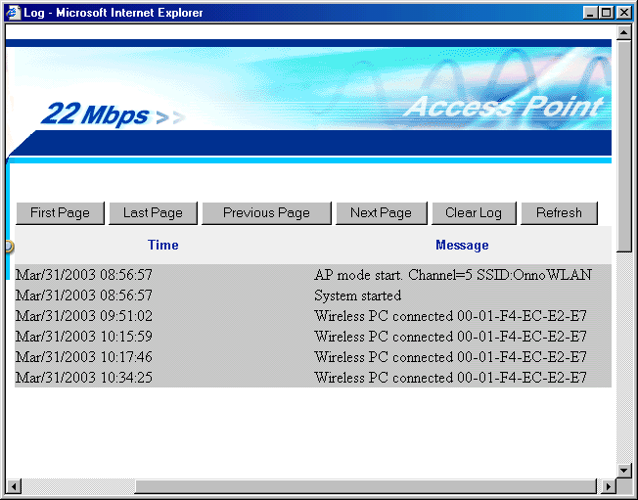
In some Access Point, it may keep the log of activities of the Access Point.

Through the Web interface we can view the log of the Access Point to make sure there is no intruder using the facility.

