MULTIMEDIA TRAINING KIT
Miscellaneous: Antenna and Cabling
Developed by: Onno W. Purbo

Antenna and Coaxial Cable

For those who is previously not familiar with radio world, it is advisable to read some of the amateur radio books, such as, the ARRL Antenna Handbook (http://www.arrl.org), ARRL Technical Information Pages (http://www2.arrl.org/tis/tismenu.html) and W1GHZ online microwave antenna handbook at (http://www.qsl.net/n1bwt/preface.htm). Surfing to various amateur radio sites will help us to gain information and necessary software to build our own antenna. There are many things to be considering in antenna installation, such as grounding system, good coaxial cable and type of antenna. Having WiFi card is not enough; survival key is in the antenna system used. Some the good sites to buy the antenna equipment can be found on the Internet, such as, http://www.ydi.com, http://www.rflinx.com.

Type of Antenna

We have basically several type of antenna used in WiFI based Metropolitan Area Network, some of them are:

- Omnidirectional Antenna usually used at the Access Point (AP). It has 360-degree radiation pattern.
- Sectoral Antenna usually used at the Access Point (AP). It has higher gain than omnidirectional antenna, but normally only cover much reduced area 90 to 180-degree coverage.
- Directional Antenna usually used at the client side. It has high gain, it is normally aimed to the Access Point (AP).

Some countries mandate that the entire radio system be certified together. It means that only antennas tested with the radios can be used. This is for sure an FCC regulation, and many countries follow those regulations. That being said, enforcement of that regulation is almost impossible.
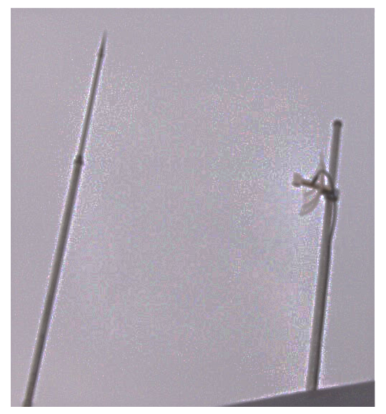
Shown in the figure is my antenna at home. It is a directional antenna, a 19 dBi parabolic antenna. It is used for 24 hour Internet connection link to the Access Point located about one (1) km away.

As it is placed about 1.5 meter on top of my two story house roof, the antenna is actually located about 9-10 meters above the ground. The antenna is screwed into a three (3) meter long 1.5-inch tubing plows half its length into the wall. The height of the antenna is enough to reduce any mutipath, or signal reflection problems at we need only about 3.5 meter clearance for the signal.

In a proper lightning protection installation is needed to protect the equipments. Protecting against lightning is a matter of reducing electrical potential, not being shorter then the guy next door. A well grounded cell tower, with proper lightning rods will be of no help to a nearby antenna..

Antenna Gain

In a wireless system, antennas are used to convert electrical waves into electromagnetic waves. The amount of energy the antenna can ‘boost’ the sent and received signal by is referred to as the antennas Gain.

Antenna gain is measured in:

- dBi - relative to an isotropic radiator
- dBd - relative to a dipole radiator

The relationship between dBd and dBi can be represented in the following equation

0 dBd = 2.15 dBi

In most cases, we use dBi as our antenna gain measurement.

Omnidirectional Antenna

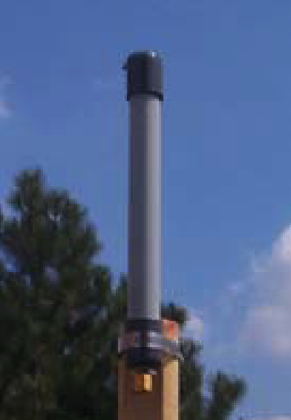
Omnidirectional antennas have normally a 360-degree RF radiation from it. It is vertically polarized E-field. Omnidirectional antenna gain is normally low around 3 to 12 dBi. It is used for Point-to-Multi-Point (P2MP) links. It is quite good for 1-5 km coverage, especially if the client uses high gain directional antenna.

Shown in the figure is the example of an omnidirectional antenna. It is a RFDG 140 a 2.4GHz 6.5 dBi Omnidirectional antenna made by RF Linx (http://www.rflinx.com).

Shown in the below figure is typical radiation pattern of the RFDG 140 omnidirectional antenna. The horizontal radiation is fairly close to 360-degree radiation. The horizontal radiation is basically the E-Field. In contrast, the vertical polarization is very narrow slice of signal radiation.

All of these mean that only stations within 360-degree radiation patterns that will be served by an omnidirectional antenna. An omnidirectional antenna may not serve station far above the antenna.
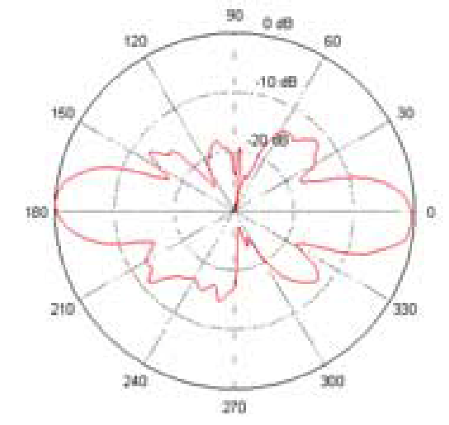

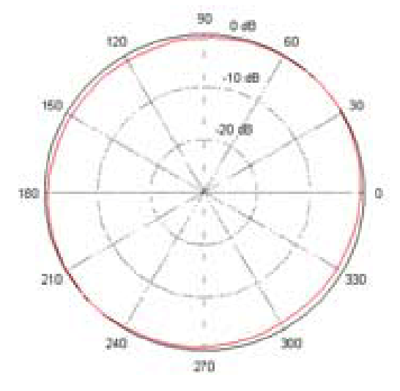

Sectoral Antenna
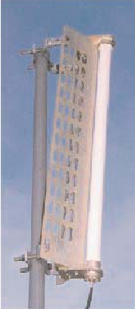
Sectoral Antenna is fairly similar to an omnidirectional antenna. It is used for the Access Point to serve a Point-to-Multi-Point (P2MP) links. Some sectoral antenna is vertically polarized, some horizontally polarized.

Sectoral antenna is normally having a much higher gain than omnidirectional antenna in the range of 10-19 dBi. It is quite good for serving an area of 6-8 km distances. Narrowing the beam-width of horizontal radiation to only about 45-180 degree must unfortunately compensate higher antenna gain. It natural benefit as it defines a narrower service area.

Shown in the figure below is the radiation pattern of sectoral antenna. The horizontal radiation patterns is mostly radiated away of the front end of the antenna. Not much radiation behind the sectoral antenna. The vertical polarization is very narrow fairly similar to omnidirectional antenna.

A sectoral antenna will usually placed on top of a high tower and tilted slightly so that the horizontal radiation will serve the area below it.

Shown in the figure is a 2.4GHz vertically polarized 180 deg. sectoral antenna model A2.45LP14 sell at YDI.COM. The typical horizontal and vertical pattern of the antenna is shown in the figure.

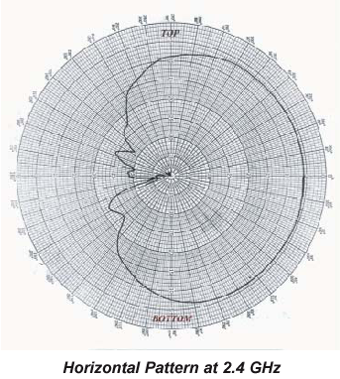
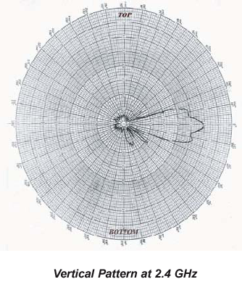

Directional Antenna

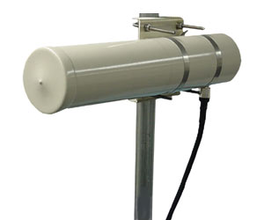
At client side, we normally use a directional antenna aiming to distance Access Point. There are many type of directional antenna, the commonly used directional antenna are,

- Yagi
- Flat Panel
- Parabola

Others may be shown in the homebrew antenna, such as, tincan antenna.

Yagi antenna is basically a dipole (sometimes called a radiator) with director elements in front of it. The more director element in front of the radiator leads to a higher antenna gain. Yagi antenna has normally 7-19 dBi gain. For short distances, it would be advisable to use a lower gain antenna.

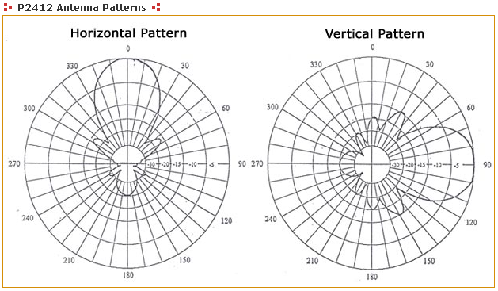
A 12 dBi gain P-2412 2.4 GHz directional, radome-enclosed, Yagi antenna is shown in the figure. The typical radiation pattern of the yagi antenna is shown in the figure. As shown clearly, the horizontal radiation pattern is fairly similar to vertical radiation pattern. Both horizontal and vertical radiations are aiming away from the antenna and no radiation behind the antenna. The wide angle radiation is quite typical for low gain directional antenna.

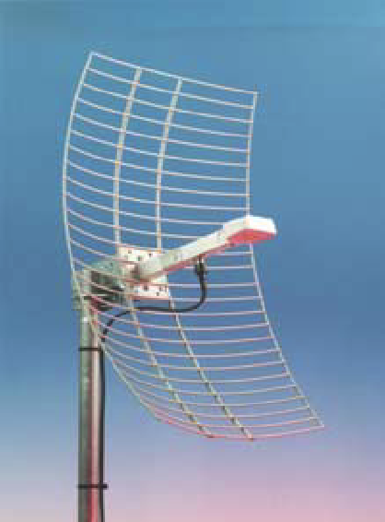
To increase antenna gain, people will normally use parabolic reflector to reflect the RF signal generated by the dipole radiator in front of it. A parabolic antenna has usually 18-28 dBi gain. Shown in the figure is an RFL-MANT 19 a 19 dBi parabolic antenna. RFL-MANT19 is made by RFLinx http://www.rflinx.com.

The parabolic antenna radiation pattern is fairly similar to yagi antenna. However, it has a much narrower angle as most of the RF energy aims towards a single direction. Thus, a parabolic antenna is much more difficult to aim. Consequently, it is more fragile to physical and mechanical disturbance especially by strong wind. Thus, for short distance, it is not that effective to use such high gain antenna.

The figure below shows the integrated antenna patterns of the RFL-MANT antenna of both 19 dBi and 24 dBi antenna. Shown clearly the horizontal and vertical pattern is fairly similar. A 19 dBi antenna has a wider 3dB beam angle about 17 degree than that a 24 dBi antenna (about 8 degree 3 dB beam angle).
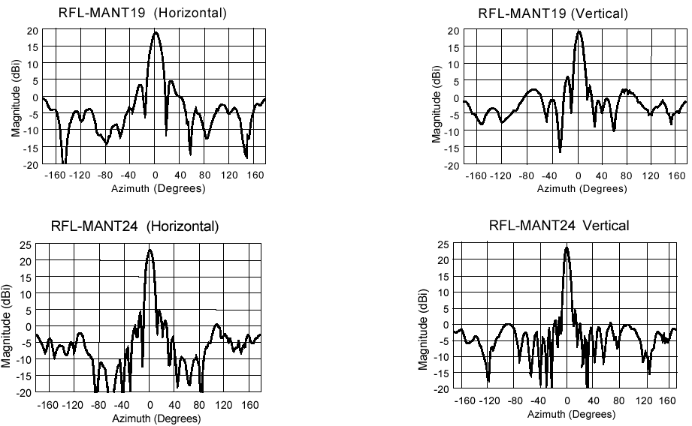

Antenna Polarization

Electromagnetic radio signal propagate through the air in two polarizations, electric field (E-field) or magnetic field (H-field), crossing 90-degree each other. An antenna polarization is relative to the E-field of antenna.

- If the E-field is horizontal, than the antenna is Horizontally Polarized.
- If the E-field is vertical, than the antenna is Vertically Polarized.

No matter what polarity you choose, all antennas in the same RF network must be polarized identically regardless of the antenna type.

Using a correct polarized antenna, it would be possible for us to:

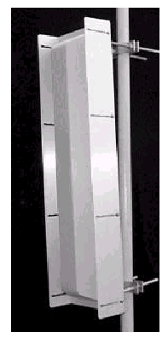
- Increase isolation on unwanted signal source. Cross polarization (x-pol) discrimination is around 20-25 dB.
- Reducing interference.
- Defining coverage area.

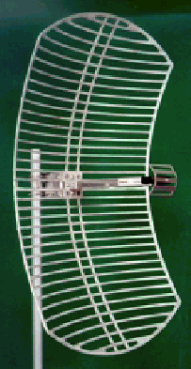
Shown in the right figure is a sectoral antenna. A sectoral antenna as well as an omnidirectional antenna is normally stand vertically. It creates a vertically polarized E-field. Due to its radiation pattern that covers a large area, sectoral and omnidirectional antennas are normally used for the Access Point in Point-to-Multi-Point (P2MP) link. Thus, it is logical to see a vertically polarized antenna in Point-to-Multi-Point configuration. It may not totally correct. We may found horizontally polarized omnidirectional or sectoral antennas.

The antenna shown in the figure is a parabolic reflector with a small dipole antenna in front of it. The dipole radiator is in horizontal position. It thus creates a horizontally polarized E-field. Horizontally polarized antenna is normally used for Point-to-Point (P2P) communication link.

