MULTIMEDIA TRAINING KIT
Miscellaneous: Advanced Antenna Topics
Developed by: Onno W. Purbo

Power Divider For A Simple Repeater
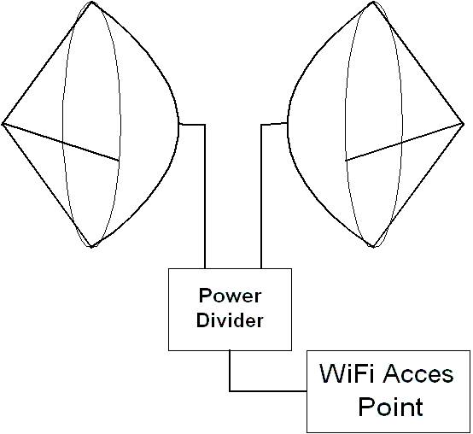
Power divider sometimes called power splitter may be used to combine several antennas together as shown in the figure. There are many reasons to combine several antennas into a single antenna system. Often, antennas are combined to modify the directivity and the gain of an antenna system. We might have situations in which we need to combine antennas to create a custom coverage pattern.

A power divider will spread the power into equal amount of power to each individual antenna within the antenna system. In figure, a 802.11b Access Point is connected to two (2) back-to-back antennas through two-port power divider. Through the divider one-half of the power goes to each antenna. Such configuration may be used to pass traffic from the North antenna to South antenna; the Access Point acts as a repeater.

Vertical Antenna Isolation
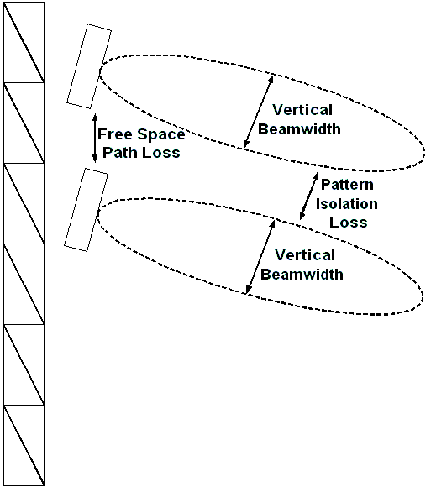
Separating two antennas vertically is fairly simple to do. Mounting the antenna one above the other may do the separation.

There are two mechanisms interact in isolating the two system, i.e.,

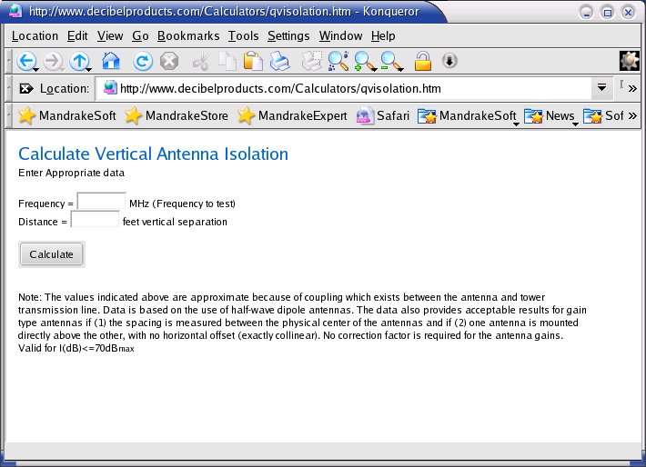
- The Free Space Loss as signal travel over the air. Traveling 3 meter distance at 2.4GHz, signal will experience 49 dB Free Space Loss. In other words, only 1/100,000 of the signal will remains.
- Pattern isolation will be possible if the antenna has a fairly narrow vertical beam width with no significant minor lobe upward or downward.

Note that the antenna’s near field may vary significantly as nearby object may affect the signal strength. The above mechanisms are valid for antenna’s far field. It is still useful to give some estimate on the reality.
Vertical Separation (Meters) | Vertical Isolation (dB @ 2.4GHz)
0.3 | 43
0.4 | 48
0.5 | 52
0.6 | 55
0.7 | 58
0.8 | 60
1 | 64
1.2 | 67
1.5 | 70
1.8 | > 70
2 | > 70
2.5 | > 70

The vertical isolation calculation can be done online through http://www.decibleproducts.com/Calculayions/qvisolation.htm. Shown in the figure is the resulting vertical isolation for two dipole antennas at 2.4 GHz for various distances.

Horizontal Antenna Isolation
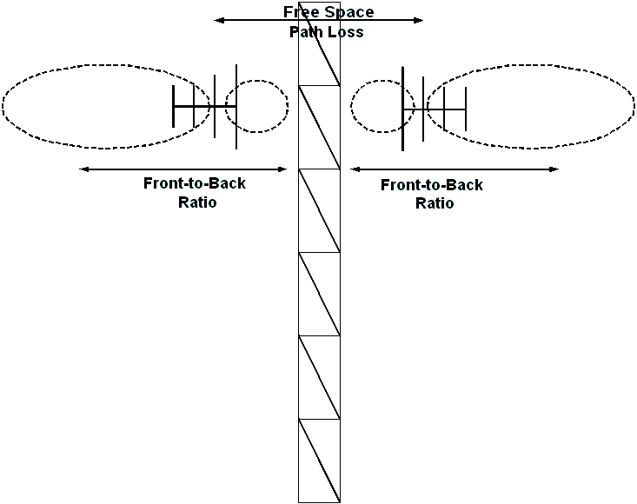
Horizontal antenna isolation can be obtained when we put two (2) antennas horizontally separated. It can be easily done on the rooftop.

As in vertical antenna isolation, there are two mechanisms interact, namely,
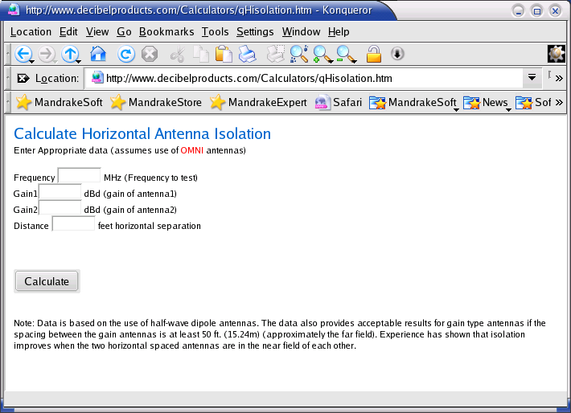
- Free Space Loss as signal travel.
- Pattern isolation. In a directional antenna, there is a Front-to-Back ratio (F/B). The energy of the main (front) lobe of an antenna divided by the energy of the back lobe of the antenna. A good antenna will focus most of the energy to the main (front) lobe and very little to the back lobe. The higher F/B the better pattern isolation for the horizontal antenna isolation.

The horizontal isolation calculation can be done online through http://www.decibleproducts.com/Calculations/qHisolation.htm. Shown in the figure is the resulting horizontal isolation for two (2) 24 dBi antennas at 2.4GHz for various distances.
Horizontal Separation (Meters) | Horizontal Isolation (dB @ 2.4GHz)
0.5 | 10
1 | 16
2 | 22
5 | 30
6 | 32
8 | 34
10 | 36
12 | 38
15 | 40
20 | 42
30 | 46
40 | 48

Diversity Antenna: Point To Point

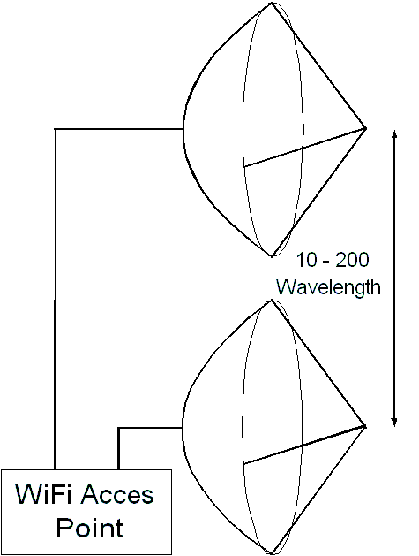
The primary fading mechanism affecting outdoor microwave links is multipath fading. To maximize the ability to receive the faded signal, some wireless equipment incorporated a diversity antenna feature. Thus, if the received signal from the main antenna fades or degrades, the signal from the diversity antenna may be selected.

Space diversity is the primary diversity technique used in low cost WiFi installation. This requires that the main antenna separated enough with the diversity antenna about 10 - 200 wavelength (or about 1.3 – 25 meter) in case signal at the main antenna is faded, the diversity antenna does not fade.

Vertical separation between two diversity antennas is normally used for point-to-point links in suburban or rural areas.

Diversity Antenna: Point To Multipoint
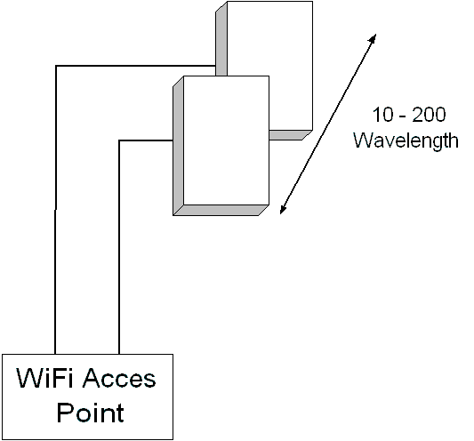
Unlike point-to-point links, a point-to-multipoint in urban area will likely to benefit from horizontal separation of the two (2) diversity antennas. The separation between the two (2) diversity antennas is around 10-200 wavelengths.

Some notes on in implanting diversity antennas, such as, make sure the Access Point implements diversity switching, place the Access Point at the midway between the two (2) diversity antennas to reduce any signal loss. However, if we are not sure, it would be better to disable diversity and use one antenna.

