MULTIMEDIA TRAINING KIT

ANTENNA HANDOUT
Developed by: Onno W. Purbo

MULTIMEDIA TRAINING KIT 1
ANTENNA HANDOUT 1
About this document 1
Copyright information 1
A Glimpse on Antenna Concept 2
Antenna Gain 2
Antenna Polarization 3
Type of Antenna 4
Omnidirectional Antenna 4
Sectoral Antenna 5
Directional Antenna 6
Cable and Connector 8
Coaxial Cable 8
Connector 8
Pigtail 9
Some Notes On Antenna Installation 10
Example of Homebrew WiFi Antenna 10
USB Tincan Antenna 11
USB Parabolic Antenna 12
Tincan Antenna 13

About this document
These materials are part of the Multimedia Training Kit (MMTK). The MMTK provides an integrated set of multimedia training materials and resources to support community media, community multimedia centres, telecentres, and other initiatives using information and communications technologies (ICTs) to empower communities and support development work.

Copyright information
This unit is made available under the Creative Commons Click and type in license version. To find out how you may use these materials please read the copyright statement included with this unit or see
Click and type in license URL

A Glimpse on Antenna Concept

Antenna Gain
In a wireless system, antennas are used to convert electrical waves into electromagnetic waves. The amount of energy the antenna can ‘boost’ the sent and received signal by is referred to as the antennas Gain.

Antenna gain is measured in:

dBi - relative to an isotropic radiator
dBd - relative to a dipole radiator

The relationship between dBd and dBi can be represented in the following equation

0 dBd = 2.15 dBi

In most cases, we use dBi as our antenna gain measurement.

Antenna Polarization
Electromagnetic radio signal propagate through the air in two polarizations, electric field (E-field) or magnetic field (H-field), crossing 90-degree each other. An antenna polarization is relative to the E-field of antenna.

- If the E-field is horizontal, than the antenna is Horizontally Polarized.
- If the E-field is vertical, than the antenna is Vertically Polarized.

No matter what polarity you choose, all antennas in the same RF network must be polarized identically regardless of the antenna type.

Using a correct polarized antenna, it would be possible for us to:

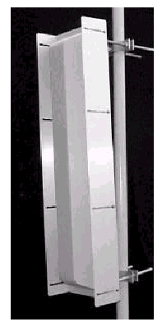
- Increase isolation on unwanted signal source. Cross polarization (x-pol) discrimination is around 20-25 dB.
- Reducing interference.
- Defining coverage area.

Shown in the right figure is a sectoral antenna. A sectoral antenna as well as an omnidirectional antenna is normally stand vertically. It creates a vertically polarized E-field. Due to its radiation pattern that covers a large area, sectoral and omnidirectional antennas are normally used for the Access Point in Point-to-Multi-Point (P2MP) link. Thus, it is logical to see a vertically polarized antenna in Point-to-Multi-Point configuration. It may not totally correct. We may found horizontally polarized omnidirectional or sectoral antennas.

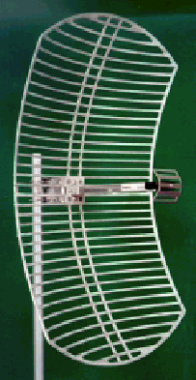
The antenna shown in the figure is a parabolic reflector with a small dipole antenna in front of it. The dipole radiator is in horizontal position. It thus creates a horizontally polarized E-field. Horizontally polarized antenna is normally used for Point-to-Point (P2P) communication link.

Type of Antenna

We have basically several type of antennas used in WiFI based Metropolitan Area Network, some of them are:

- Omnidirectional Antenna usually used at the Access Point (AP). It has 360-degree radiation pattern.
- Sectoral Antenna usually used at the Access Point (AP). It has higher gain than omnidirectional antenna, but normally only cover much reduced area 90 to 180-degree coverage.
- Directional Antenna usually used at the client side. It has high gain, it is normally aimed to the Access Point (AP).

Omnidirectional Antenna
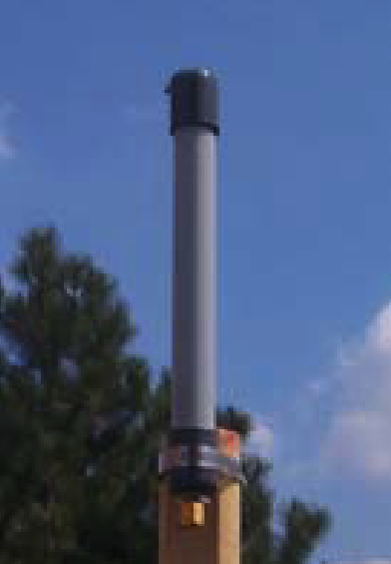
Omnidirectional antennas have normally a 360-degree RF radiation from it. It is vertically polarized E-field. Omnidirectional antenna gain is normally low around 3 to 12 dBi. It is used for Point-to-Multi-Point (P2MP) links. It is quite good for 1-5 km coverage, especially if the client uses high gain directional antenna.

Shown in the figure is the example of an omnidirectional antenna. It is a RFDG 140 a 2.4GHz 6.5 dBi Omnidirectional antenna made by RF Linx (http://www.rflinx.com).

Shown in the below figure is typical radiation pattern of the RFDG 140 omnidirectional antenna. The horizontal radiation is fairly close to 360-degree radiation. The horizontal radiation is basically the E-Field. In contrast, the vertical polarization is very narrow slice of signal radiation.

All of these mean that only stations within 360-degree radiation patterns that will be served by an omnidirectional antenna. An omnidirectional antenna may not serve station far above the antenna.
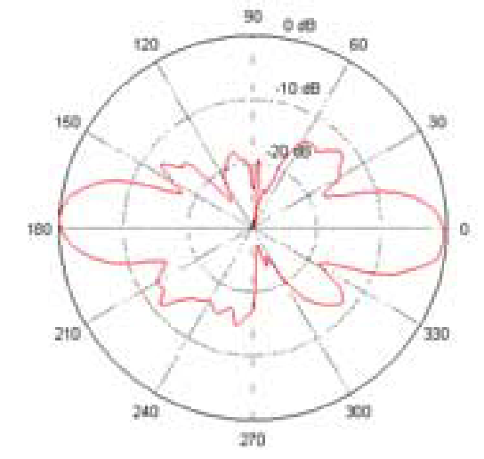
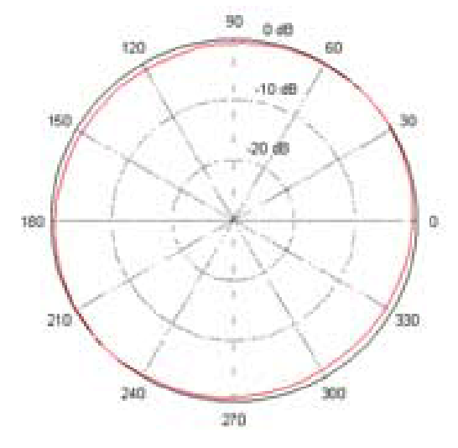

Sectoral Antenna
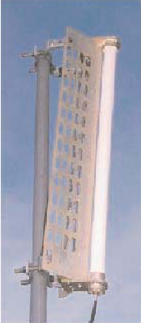
Sectoral Antenna is fairly similar to an omnidirectional antenna. It is used for the Access Point to serve a Point-to-Multi-Point (P2MP) links. Some sectoral antenna is vertically polarized, some horizontally polarized.

Sectoral antenna is normally having a much higher gain than omnidirectional antenna in the range of 10-19 dBi. It is quite good for serving an area of 6-8 km distances. Narrowing the beam-width of horizontal radiation to only about 45-180 degree must unfortunately compensate higher antenna gain. It natural benefit as it defines a narrower service area.

Shown in the figure below is the radiation pattern of sectoral antenna. The horizontal radiation patterns is mostly radiated away of the front end of the antenna. Not much radiation behind the sectoral antenna. The vertical polarization is very narrow fairly similar to omnidirectional antenna.

A sectoral antenna will usually placed on top of a high tower and tilted slightly so that the horizontal radiation will serve the area below it.

Shown in the figure is a 2.4GHz vertically polarized 180 deg. sectoral antenna model A2.45LP14 sell at YDI.COM. The typical horizontal and vertical pattern of the antenna is shown in the figure.

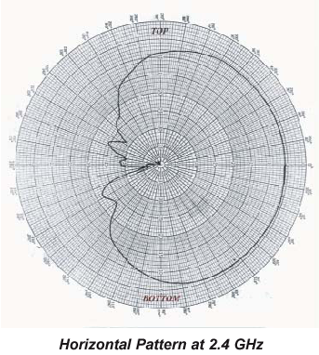
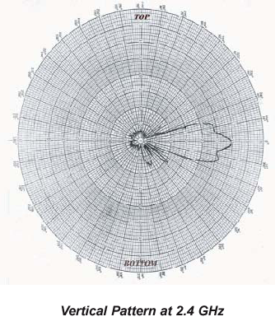

Directional Antenna
At client side, we normally use a directional antenna aiming to distance Access Point. There are many type of directional antenna, the commonly used directional antenna are,

- Yagi
- Flat Panel
- Parabola

Others may used homebrew antenna, such as, tincan antenna.

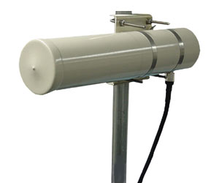
Yagi antenna is basically a dipole (sometimes called a radiator) with director elements in front of it. The more director element in front of the radiator leads to a higher antenna gain. Yagi antenna has normally 7-19 dBi gain. For short distances, it would be advisable to use a lower gain antenna.

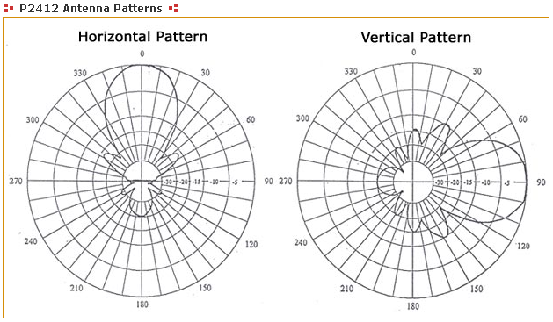
A 12 dBi gain P-2412 2.4 GHz directional, radome-enclosed, Yagi antenna is shown in the figure. The typical radiation pattern of the yagi antenna is shown in the figure. As shown clearly, the horizontal radiation pattern is fairly similar to vertical radiation pattern. Both horizontal and vertical radiations are aiming away from the antenna and no radiation behind the antenna. The wide angle radiation is quite typical for low gain directional antenna.

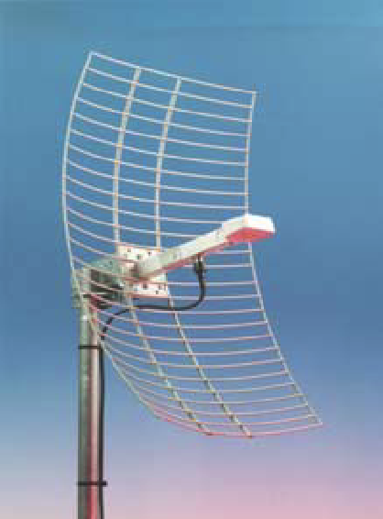
To increase antenna gain, people will normally use parabolic reflector to reflect the RF signal generated by the dipole radiator in front of it. A parabolic antenna has usually 18-28 dBi gain. Shown in the figure is an RFL-MANT 19 a 19 dBi parabolic antenna. RFL-MANT19 is made by RFLinx http://www.rflinx.com.

The parabolic antenna radiation pattern is fairly similar to yagi antenna. However, it has a much narrower angle as most of the RF energy aims towards a single direction. Thus, a parabolic antenna is much more difficult to aim. Consequently, it is more fragile to physical and mechanical disturbance especially by strong wind. Thus, for short distance, it is not that effective to use such high gain antenna.

The figure below shows the integrated antenna patterns of the RFL-MANT antenna of both 19 dBi and 24 dBi antenna. Shown clearly the horizontal and vertical pattern is fairly similar. A 19 dBi antenna has a wider 3dB beam angle about 17 degree than that a 24 dBi antenna (about 8 degree 3 dB beam angle).

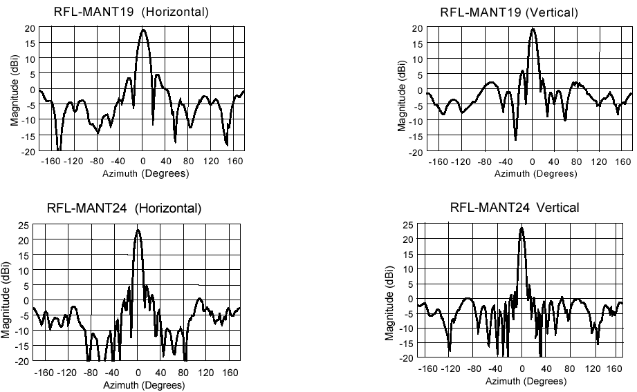

Cable and Connector

Coaxial Cable
Coaxial cable is normally used to connect a radio transceiver to an antenna.

Each coaxial cable is designed for specific impedance. In WiFi equipment as well as most radios, we normally used 50-ohm impedance coaxial cable. Fail to meet the impedance will reflect the radio signal from the transmitter back into the transmitter rather than to the antenna. Thus, the impedance of the transmitter, the coaxial cable and the antenna must match to 50 ohm.

Unfortunately, the use of coaxial cable introduces signal loss before it reaches the antenna or vice versa the receiver. Shown in the table is the cable loss at 2.4 GHz for several type of coaxial cable.

Cable Type Loss / 10 meters(on 2.4GHz).
RG 8 3.3 dB
LMR 400 2.2 dB
Heliax 3/8” 1.76 dB
LMR 600 1.7 dB
Heliax ½” 1.2 dB
Heliax 5/8” 0.71 dB

Some of us normally restrict the length of coaxial cable to less then one (1) meter. Consequently, we must put the Access Point or other WiFi equipment up on top of the tower. A UTP Local Area Network (LAN) cable then run down from the top of the tower to the Network Operating Center (NOC) located at the bottom of the tower. Environment enclosure should be used to protect the WiFi equipment located on top of the tower.

Connector
To connect the Wireless LAN (WiFi) equipments, coaxial cable and the antenna, we uses special connectors. There are several type of RF connector can be used at such high frequency. A good connector will normally have 0.3-0.5 dB losses. Unfortunately, a good connector will likely to cost around US$5-7 each. There is cheap connector that cost US$1 each. Unfortunately, bad connector will likely to give a significant signal loss and, thus, reducing the system operating margin.

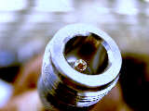
There is several type of RF connector that normally used in WiFi equipments, namely,

N-Female connector is usually used at the antenna or lightning protector.

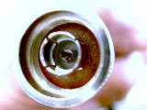

N-male connector is usually used at the coaxial cable to connect the antenna.


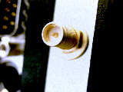
Male SMA Right Hand Polarization connector is usually used for the small coaxial cable (usually called pig tail) to connect to Female SMA connector on Wireless LAN card.

Female SMA Right Hand Polarization connector is usually located on Wireless LAN card.

Pigtail
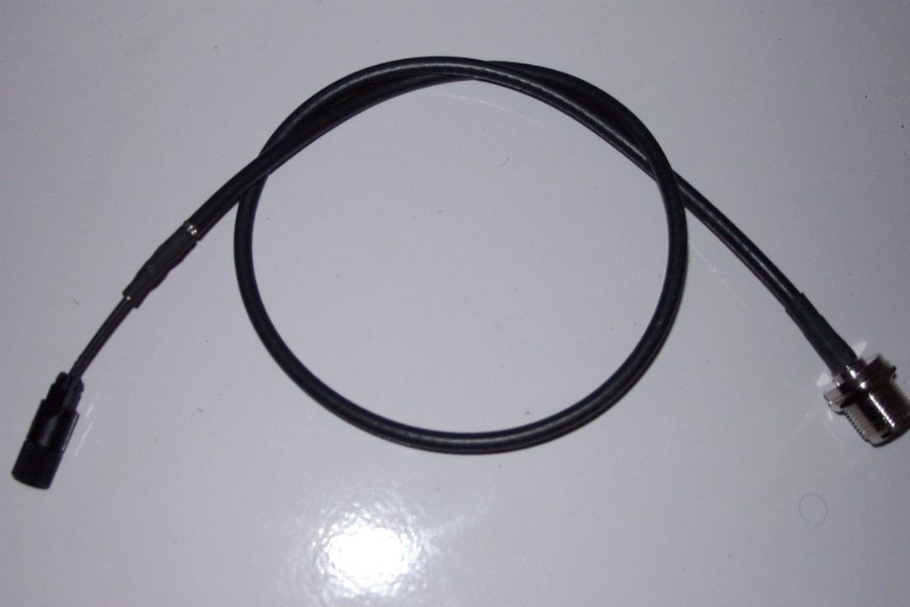
Since Wireless LAN (WLAN) uses female SMA connector, while the antenna and the heliax coaxial cable uses N-type connector. We need a cable interface between the two (2) types of connector. In WiFi parts, we usually use a pigtail to do the job. It is a short coaxial cable with SMA connector at one end, and N-type connector at the other end.

Some of us even use these pigtails directly to the antenna without any connection through long heliax coaxial cable to minimize any cable loss. Consequently, we need to put the Access Point on top of the tower.

Some Notes On Antenna Installation

Example of Homebrew WiFi Antenna

Build your own WiFi 2.4GHz antenna? Why not? It is one of the fun parts in playing with WiFi technology. There are several references on homebrew 2.4 GHz antennas on the Internet. Some of them are,

- http://www.oreillynet.com/cs/weblog/view/wlg/448 (the famous Pringles can antenna).
- http://users.bigpond.net.au/jhecker/ (homebrew 2.4GHz antenna helical)
- http://www.saunalahti.fi/~elepal/antenna1.html (homebrew simple yagi antenna).
- http://www.seattlewireless.net/index.cgi/BuildingYagiAntennas (yagi antenna).
- http://www.qsl.net/ki7cx/wgfeed.htm (feed system for parabolic antenna).
- Etc. much more.

All can be easily find on http://www.google.com by key in “homebrew 2.4GHz antenna”. You will be surprise. By a little bit of creativity one can easily make your own homebrew antenna. The followings are some of the home brew antenna build by my friends.

USB Tincan Antenna


Judhi Prasetyo judhi@prasetyo.net, an IT professional in Singapore, has been putting a tincan on his USB WLAN card.

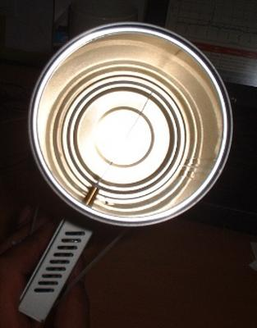
Show in the figure, the USB WLAN card is connected to his IBM laptop.USB WLAN cards have normally a small antenna sticking from it. Using such small antenna, normally about 3 dBi gain, limits the range to a maximum of around 200 meter.

He drilled a hole into a tin can and stick the small antenna of the USB WLAN card into the tin can. He has very his own tin can antenna. The advantage of putting a tin can into the small antenna is in effect aiming all the RF energy into a single direction. Thus, it can reach further distances in a single direction.

Some of us may add parabolic reflector in front of the tin can extend the distance further.

USB Parabolic Antenna
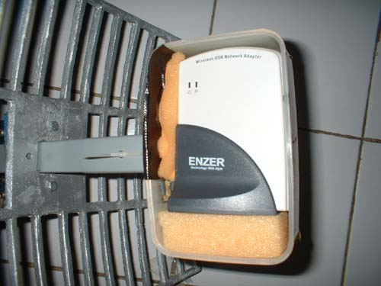
M. Ihsan ihsan@sofrecom.co.id, an IT professional in Jakarta, is building a simple parabolic antenna using a USB WLAN card.

He put the USB WLAN card in front of a parabolic reflector. The USB WLAN card is put into a plastic enclosure for environmental protection.
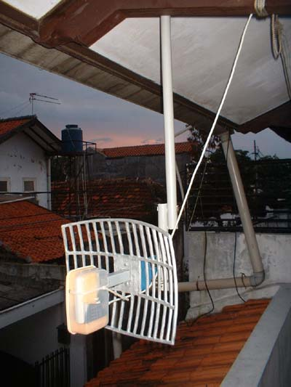
As demonstrated in Indonesia, vocational school (high school level) students may be made these parabolic reflectors for the antenna.

Having no coaxial cable in the system as it uses USB cable to the computer, the cable loss is basically none.

For those who wish to make their own parabolic reflector, W8GVU has written a page on parabolic reflector calculation formula at http://www2.gvsu.edu/~w8gvu/geo/geo2.html.

Tincan Antenna

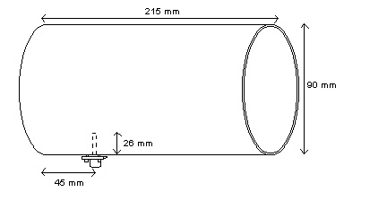
One of the famous homebrew 2.4GHz antennas is the tin can antenna. It is very easy to build and high success rate. In this particular example, the antenna is build by M. Ihsan ihsan@sofrecom.co.id.

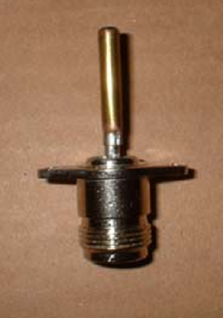Typical dimension of the tin can antenna is shown in the figure. Typical dimension of the can is about 9 cm diameter and 21 cm length. A small omnidirectional antenna about 2.6 cm length sticks into the can about 4.5 cm from the bottom of the can.

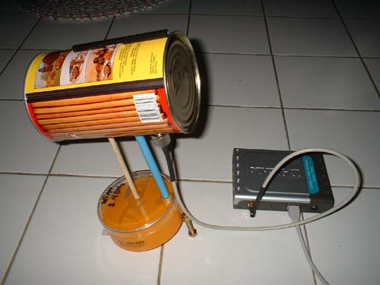
The radiator in a tin can antenna is a 2.6 cm length omnidirectional radiator. It can be build by soldering a 2.6 cm metal stick into an N-type male connector. Some people put screw sticking on the stick to tune the length of omnidirectional radiator to get the maxim match of the antenna.

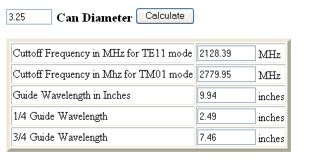
In some cases, we need to calculate the possibility to use a certain diameter tincan for 2.4GHz antenna. The calculation is provided at http://www.turnpoint.net/wireless/cantennahowto.html. Shown in the figure is the calculated result for a 3.25 inches diameter. Make sure the tincan can be operated in frequency 2.4-2.47 GHz.

