MULTIMEDIA TRAINING KIT
Miscellaneous: Homebrew Antenna
Developed by: Onno W. Purbo

Homebrew WiFi Antennas

Build your own WiFi 2.4GHz antenna? Why not? It is one of the fun parts in playing with WiFi technology. There are several references on homebrew 2.4 GHz antennas on the Internet. Some of them are,

- http://www.oreillynet.com/cs/weblog/view/wlg/448 (the famous Pringles can antenna).
- http://users.bigpond.net.au/jhecker/ (homebrew 2.4GHz antenna helical)
- http://www.saunalahti.fi/~elepal/antenna1.html (homebrew simple yagi antenna).
- http://www.seattlewireless.net/index.cgi/BuildingYagiAntennas (yagi antenna).
- http://www.qsl.net/ki7cx/wgfeed.htm (feed system for parabolic antenna).
- Etc. much more.

All can be easily find on http://www.google.com by key in “homebrew 2.4GHz antenna”. You will be surprise. By a little bit of creativity one can easily make your own homebrew antenna. The followings are some of the home brew antenna build by my friends.

USB Tincan Antenna

Judhi Prasetyo judhi@prasetyo.net, an IT professional in Singapore, has been putting a tincan on his USB WLAN card.

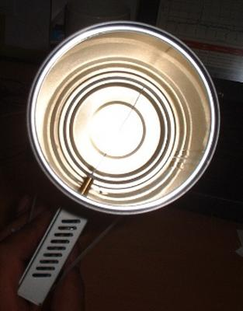
Show in the figure, the USB WLAN card is connected to his IBM laptop.USB WLAN cards have normally a small antenna sticking from it. Using such small antenna, normally about 3 dBi gain, limits the range to a maximum of around 200 meter.

He drilled a hole into a tin can and stick the small antenna of the USB WLAN card into the tin can. He has very his own tin can antenna. The advantage of putting a tin can into the small antenna is in effect aiming all the RF energy into a single direction. Thus, it can reach further distances in a single direction.

Some of us may add parabolic reflector in front of the tin can extend the distance further.

USB Parabolic Antenna
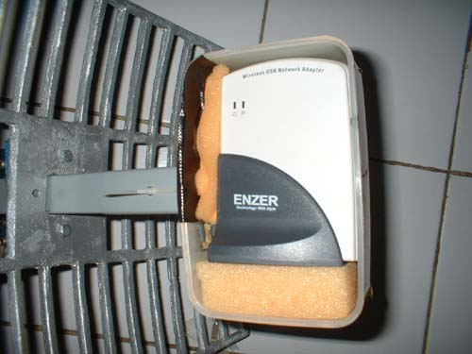
M. Ihsan ihsan@sofrecom.co.id, an IT professional in Jakarta, is building a simple parabolic antenna using a USB WLAN card.

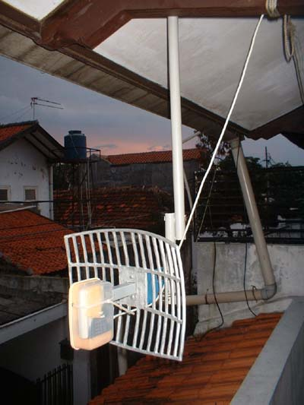
He put the USB WLAN card in front of a parabolic reflector. The USB WLAN card is put into a plastic enclosure for environmental protection.

As demonstrated in Indonesia, vocational school (high school level) students may be made these parabolic reflectors for the antenna.

Having no coaxial cable in the system as it uses USB cable to the computer, the cable loss is basically none.

For those who wish to make their own parabolic reflector, W8GVU has written a page on parabolic reflector calculation formula at http://www2.gvsu.edu/~w8gvu/geo/geo2.html.

The Famous Tincan Antenna

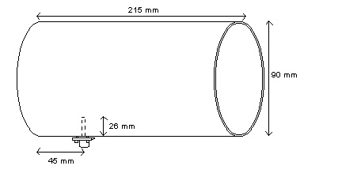
One of the famous homebrew 2.4GHz antennas is the tin can antenna. It is very easy to build and high success rate. In this particular example, the antenna is build by M. Ihsan ihsan@sofrecom.co.id.

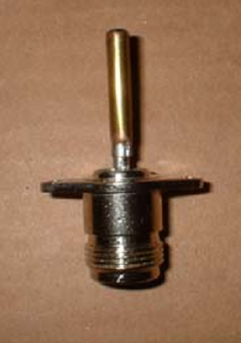Typical dimension of the tin can antenna is shown in the figure. Typical dimension of the can is about 9 cm diameter and 21 cm length. A small omnidirectional antenna about 2.6 cm length sticks into the can about 4.5 cm from the bottom of the can.

The radiator in a tin can antenna is a 2.6 cm length omnidirectional radiator. It can be build by soldering a 2.6 cm metal stick into an N-type male connector. Some people put screw sticking on the stick to tune the length of omnidirectional radiator to get the maxim match of the antenna.
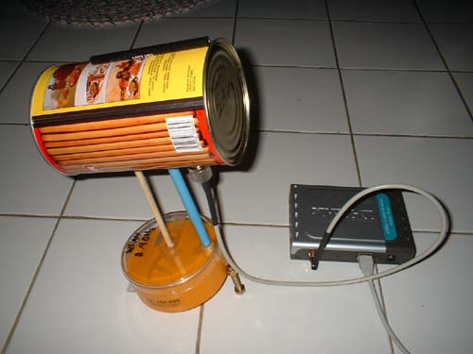

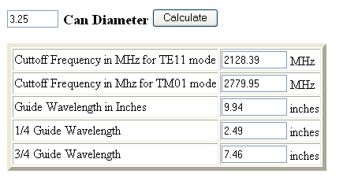

In some cases, we need to calculate the possibility to use a certain diameter tincan for 2.4GHz antenna. The calculation is provided at http://www.turnpoint.net/wireless/cantennahowto.html. Shown in the figure is the calculated result for a 3.25 inches diameter. Make sure the tincan can be operated in frequency 2.4-2.47 GHz.

