MULTIMEDIA TRAINING KIT
Miscellaneous: Antenna Installation
Developed by: Onno W. Purbo

Some Notes on Antenna Installation
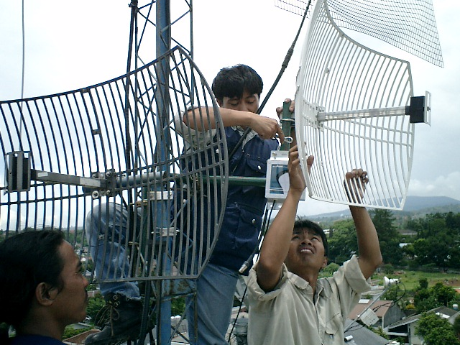

These installation pictures are the courtesy of my colleague Henry Syarifuddin, henry@cgd.co.id. Their team use SmartBridges http://www.smartbridges.com wireless equipment for their outdoor installation.

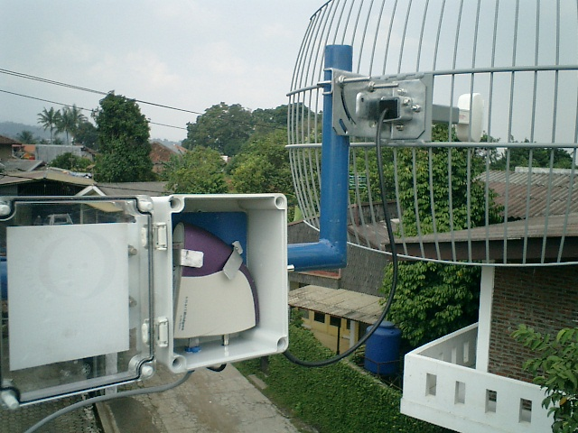
An example of a WiFi client installation is shown in the figure. A client premise equipment (CPE) is enclosed in a plastic environmental protection enclosure. It is connected through very short, less than one (1) meter, coaxial cable to a 24 dBi parabolic antenna. The whole installation is installed far above the ground. Unshielded Twisted Pair (UTP) cable is then run from the CPE to the computers at the bottom of the antenna. Power is injected into the CPE through a Power Over Ethernet (PoE) jack prepared for the UTP cable used by the CPE. A special outdoor UTP cable or Shielded Twisted Pair (STP) cable is used.
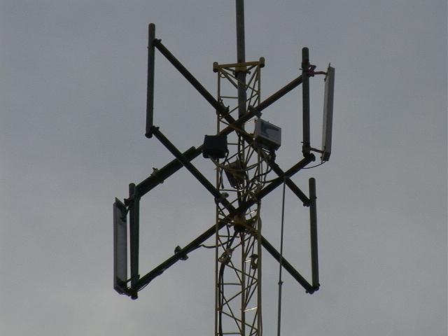
Similar to the client side, the Access Points are normally put on top of the tower. The coaxial cable connecting the Access Point to the sectoral antenna is kept short, sometimes below one (1) meter. Several Access Points running on several different channels with no interference to one and another are put together on a single tower.

