MULTIMEDIA TRAINING KIT
Miscellaneous: Coax and Connector
Developed by: Onno W. Purbo

Coaxial Cable

Coaxial cable is normally used to connect a radio transceiver to an antenna. Each coaxial cable is designed for specific impedance. In WiFi equipment as well as most radios, we normally used 50-ohm impedance coaxial cable. Fail to meet the impedance will reflect the radio signal from the transmitter back into the transmitter rather than to the antenna. Thus, the impedance of the transmitter, the coaxial cable and the antenna must match to 50 ohm.

Unfortunately, the use of coaxial cable introduces signal loss before it reaches the antenna or vice versa the receiver. Shown in the table is the cable loss at 2.4 GHz for several type of coaxial cable.
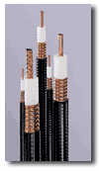
Andrew Corporation Heliax
Cable Type | Loss / 10 meters  (on 2.4GHz).
RG 8 | 3.3 dB
LMR 400 | 2.2 dB
Heliax 3/8” | 1.76 dB
LMR 600 | 1.7 dB
Heliax ½” | 1.2 dB
Heliax 5/8” | 0.71 dB

The field experience shows that it would be best if one uses at least LMR coaxial cable. For those who are fortunate enough may use the high performance heliax coaxial cable. It is quite expensive for most of us in developing countries to buy such cable as it costs in the range of US$ 25 / meter. Black market price of heliax cable would be around US$3-4/meter. We normally find heliax coaxial cable from a used or unused cut heliax coaxial cable from a telecommunication project. If it is possible, do not use RG-8 coaxial cable for the installation.

Some of us normally restrict the length of coaxial cable to less then one (1) meter. Consequently, we must put the Access Point or other WiFi equipment up on the tower. The UTP Local Area Network (LAN) cable then run down from the top of the tower to the Network Operating Center (NOC) located at the bottom of the tower. Environment enclosure should be used to protect the WiFi equipment located on top of the tower.

Coaxial / Antenna Connector

To connect the Wireless LAN (WiFi) equipments, coaxial cable and the antenna, we uses special connectors. There are several type of RF connector can be used at such high frequency. A good connector will normally have 0.3-0.5 dB losses. Unfortunately, a good connector will likely to cost around US$5-7 each. There is cheap connector that cost US$1 each. Unfortunately, bad connector will likely to give a significant signal loss and, thus, reducing the system operating margin.

There is several type of RF connector that normally used in WiFi equipments, namely,

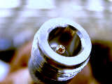
N-Female connector is usually used at the antenna or lightning protector.

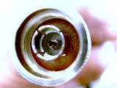

N-male connector is usually used at the coaxial cable to connect the antenna.

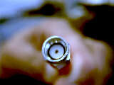

Male SMA Right Hand Polarization connector is usually used for the small coaxial cable (usually called pig tail) to connect to Female SMA connector on Wireless LAN card.

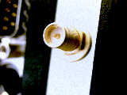

Female SMA Right Hand Polarization connector is usually located on Wireless LAN card.

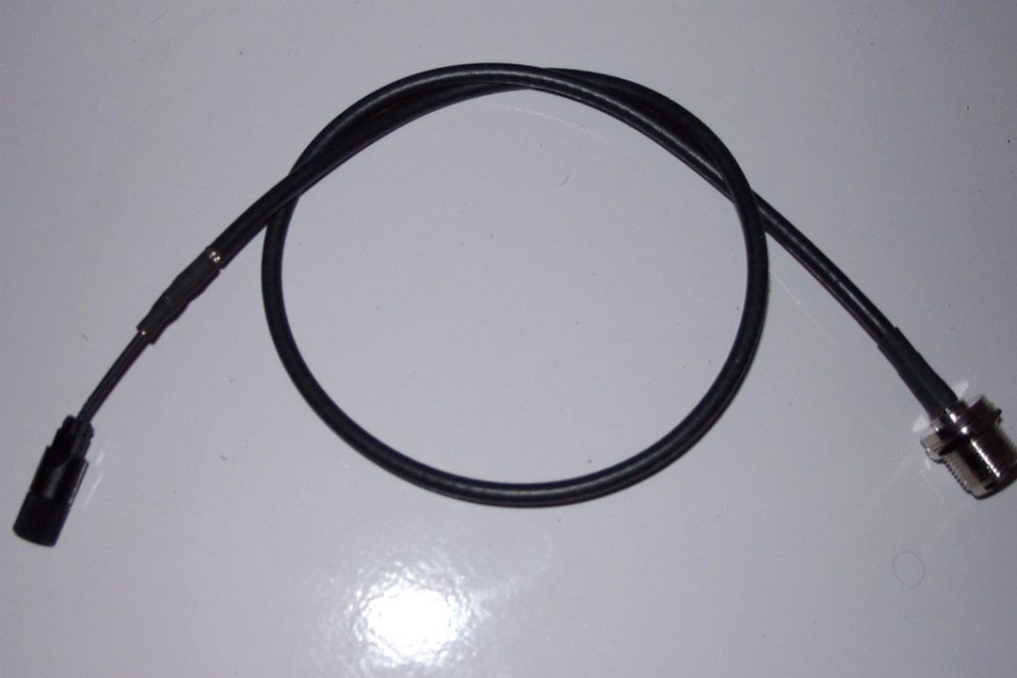
Since Wireless LAN (WLAN) uses female SMA connector, while the antenna and the heliax coaxial cable uses N-type connector. We need a cable interface between the two (2) types of connector. In WiFi parts, we usually use a pigtail to do the job. It is a short coaxial cable with SMA connector at one end, and N-type connector at the other end.

Some of us even use these pigtails directly to the antenna without any connection through long heliax coaxial cable to minimize any cable loss. Consequently, we need to put the Access Point on top of the tower.

