MULTIMEDIA TRAINING KIT
Miscellaneous: Simple Radio Concept
Developed by: Onno W. Purbo

A Simple Introduction to Radio Concepts

In this chapter, some of the Radio Frequency (RF) terminologies and concepts will be described.

Frequency

Frequency is the number of complete cycles per second in alternating current direction. The standard unit of frequency is the hertz, abbreviated Hz. One (1) Hz is the frequency at which the current complete one cycles. Depending on the number of cycles, we are looking at

Kilohertz (kHz) thousand of cycles
Megahertz (MHz) million of cycles
Gigahertz (GHz) billion of cycles
Terahertz (THz) zillion of cycles

The Wavelength
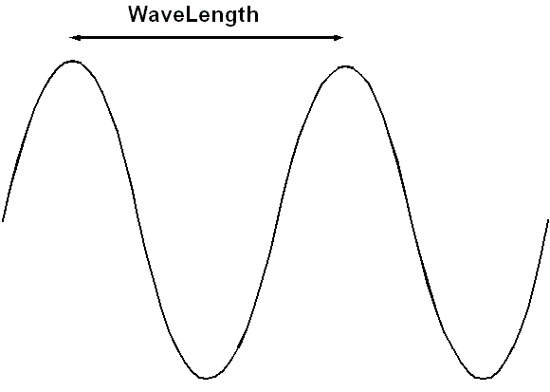
Wavelength is the distance between identical points in the adjacent cycles of a waveform. In Radio Frequency (RF), the wavelength length is usually in meters, centimeters, or millimeters ranges.

The size of the wavelength depends on the frequency of the signal. In higher frequencies, we will see a shorter wavelength. At frequency of 2.4 GHz or 2400 MHz the wavelength is around 12.5 cm. The wavelength can be calculated using the following equation,

Wavelength (in meter) = 3 x 10^2 / Frequency (in MHz)

3 x 10^2 is coming from the speed of light, the speed of the radio signal travels over the air. The speed of the wave may be slightly different in metal. The wavelength is important to remember, especially when installing antennas. To obtain the ideal radiation pattern, an antenna should ideally be installed no closer than 10 wavelengths to the nearest reflective surface. Thus, 2.4 GHz band, we are looking at 1.2 meter to the nearest reflective surface.

Tx Power

Tx is short for “Transmit”. All radios have a certain level of Tx power that the radio generates at the RF interface. This power is calculated as the amount of energy given across a defined bandwidth and is usually measured in one of these two units:

dBm – a relative power level referencing 1 milliwatt
W – a linear power level referencing Watts

The relation between dBm and Watts can be calculated through the following formulas,

dBm = 10 x log[Power in Watts / 0.001W]
W = 0.001 x 10[Power in dBm / 10 dBm]

Rx Sensitivity

Rx is short for “Receive”. All radios also have a certain ‘point of no return’, where if they receive a signal less than the stated Rx Sensitivity, the radio will not be able to ‘see’ the data. This ‘point of no return’ Rx sensitivity is stated in dBm or W.

In most radios, the receiver sensitivity is defined at certain level of Bit Error Rate (BER). A Bit Error Rate (BER) of 10-5 (99.999%) is normally used. In WiFi equipments, we are looking at receiver sensitivity in the range of –79 to –80 dBm. The actual radio signal level received at the receiver radio is normally higher than the Rx sensitivity and it will vary depending on many factors.

The noise level is must be lower than Rx sensitivity; in WiFi equipments, we are looking at –90 to –96 dBm noise level. Noise is defined as any unwanted signal received by our receiver.

Radiated Power

In a wireless system, antennas are used to convert electrical waves into electromagnetic waves. Antenna gain is referred as the amount of energy the antenna can ‘boost’ the sent and received signal by. Antenna gain is measured in:

dBi: relative to an isotropic radiator
dBd: relative to a dipole radiator

The relationship between dBd and dBi is as follows,

0 dBd = 2.15 dBi

We normally used dBi in most the calculations.

Energy Losses

In all wireless communication systems there are several factors that contribute to the loss of signal strength. Cabling, connectors, lightning arrestors will impact the system performance if not properly installed. In a ‘low power’ system every dB you can save is important!! Remember the “3 dB Rule”.

For every 3 dB gain/loss you will either double your power (gain) or lose half your power (loss). For example,

-3 dB = 1/2 power (we lose half the power)
-6 dB = 1/4 power (we lose three quarter of the power)
+3 dB = 2x power (double the power)
+6 dB = 4x power (increase the power by factor of four)

Sources of loss in a wireless system: free space, cables, connectors, jumpers, and obstructions

Limiting The Radiated Power

The regulator as well as community consensus will likely to set a certain guideline of the maximum amount of energy radiated out of an antenna. This ‘energy’ is measured in one of two ways:

Effective Isotropic Radiated Power (EIRP) measured in dBm
= power at antenna input [dBm] + relative antenna gain [dBi]

Effective Radiated Power (ERP) measured in dBm
= power at antenna input [dBm] + relative antenna gain [dBd]

Effective Isotropic Radiated Power is mostly used. We normally limit the EIRP to around 36 dBm. Some will adopt different maximum EIRP for Point-to-Point (P2P) links and Point-to-Multi-Point (P2MP) links, to about 36 dBm and 30 dBm, respectively.

Effective Isotropic Radiated Power Examples
TX Power | Power Gain / Loss | Resulting Power | Antenna gain | Resulting EIRP | Legal?  (Yes or No)
1 Watt  (+30 dBm) | -1 dB loss via 1 m coax | + 29 dBm | +6 dBi | +35 dBm | Yes
100 mW  (+20 dBm) | +14 dB Amplifier | +34 dBm | +8 dBi | +42 dBm | No
25 mW  (+14 dBm) | +14 dB Amplifier | +28 dBm | +8 dBi | +36 dBm | Yes

Direct Sequence Spread Spectrum (DSSS)

Also known as Direct Sequence Code Division Multiple Access (DS-CDMA), DSSS is one of two approaches to spread spectrum modulation for digital signal transmission over the air.Most of IEEE 802.11 deployed are using DSSS to transmit the data as it gives quite high operating speed normally around 11Mbps (for IEEE 802.11b in 2.4GHz). Each transmitted station will consume wide bandwidth around 22MHz.

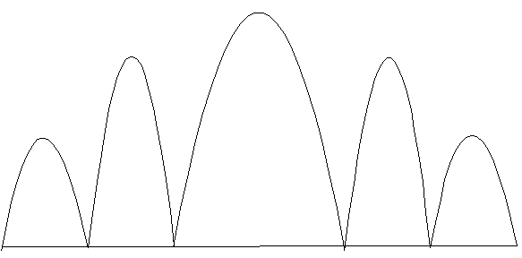
The stream of information to be transmitted is divided into small pieces, each of which is allocated to a frequency channel across the spectrum. When transmitted, the data is combined with a higher data-rate bit sequence (also known as a chipping code) that divides the data according to a spreading ratio. The transmitter and the receiver must be synchronized with the same spreading code.

Two communication links with two different spreading codes may share the same frequency with minimal interference to each other. Thus, multiple accesses to the channel is done through different spreading code.

The chipping code helps the signal resist interference and also enables the original data to be recovered if data bits are damaged during transmission.

Frequency Hopping Spread Spectrum (FHSS)

Also known as Frequency Hopping Code Division Multiple Access (FH-CDMA), FHSS radios transmit "hops" between available frequencies according to a specified algorithm that can be either random or preplanned.

The transmitter operates in synchronization with a receiver, which remains tuned to the same center frequency as the transmitter.

FHSS system is much slower than that of DSSS. It consumes less bandwidth, normally about one (1) MHz or less. Consequently the FHSS speed is slower than DSSS. However, from most of my colleague experiences, FHSS seems to have a better change of survival in a long range and highly congested network.

Free Space Propagation

As the signal leaves the antenna it propagates, or disperses, into space. The antenna selection will determine how much propagation will occur.

At 2.4 GHz it is extremely important to ensure a path (or tunnel) between the two antennas is clear of any obstructions. Degradation in the signal will likely to occur if the propagating signal encounters any obstructions in the path. Trees, buildings, hydro poles, and towers are common examples of path obstructions.

The greatest amount of loss in your wireless system will be from Free Space Propagation. The Free Space Loss is predictable and given by the formula:

FSL(dB) = 32.45 + 20Log10F(MHz) + 20Log10D(km)

The Free Space Loss at one (1) km using a 2.4 GHz system is:

FSL(dB) = 32.45 + 20Log10(2400) + 20Log10(1)
= 32.45 + 67.6 + 0
= 100.05 dB

100+ dBm Free Space Loss (FSL) is quite large. Considering the Effective Radiated Isotropic Power (EIRP), the energy of the signal radiated out of the antenna is only around 30-36 dBm. We are looking at –70 to about –80 dBm of energy at the receiver antenna.

Line of Sight

Attaining good Line of Sight (LOS) between the sending and receiving antenna is essential in both Point to Point and Point to Multipoint installations. Generally there are two types of LOS that are used discussed during installations:

- Optical LOS - is related to the ability to see one site from the other
- Radio LOS – related to the ability of the receiver to ‘see’ the transmitted signal

the Fresnel Zone theory is used to quantify Radio Line of Sight. Think of the Fresnel Zone as a football shaped tunnel between the two sites that provides a path for the RF signals.

Some use the acceptable Radio Line of Sight that at least 60% of the first Fresnel Zone plus 3 meters is clear of any obstructions. Some adopts 80% of the first Fresnel Zone as the acceptable Radio Line of Sight.

When obstructions intrude on the acceptable Fresnel Zone many issues can arise which will affect the performance of the system. The main issues are:

- Reflection. The incident wave propagates away from smooth scattering plane. Multipath fading is when secondary waves arrive out-of-phase with the incident wave causing signal degradation as they mixed.

- Refraction. The incident wave propagates through scattering plane but at an angle. Frequencies less than 10 GHz are not affected by heavy rains, snow, “pea-soup” fog. At 2.4 GHz, attenuation is 0.01 dB/Km for 150 mm/hr of rain.

- Diffraction. The incident wave passes around obstruction into shadow regions.

