MULTIMEDIA TRAINING KIT
Miscellaneous: Channel Performance Under Load
Developed by: Onno W. Purbo

Channel Performance Under Load

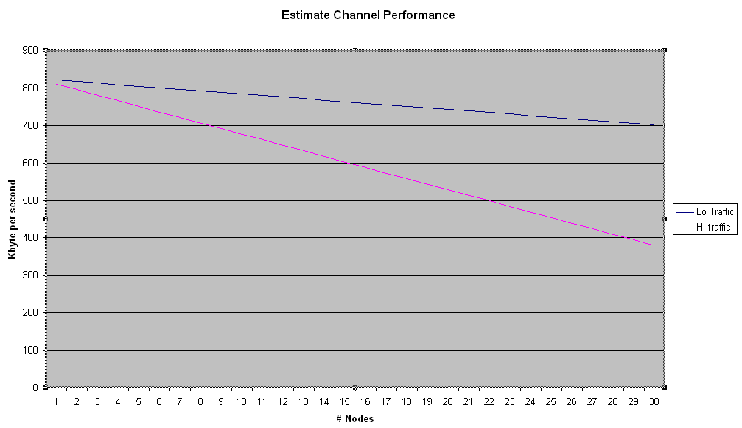
To give some ballpark figure on the system, a short calculation on the throughput will be demonstrated. IEEE 802.11 based equipment is mostly a half-duplex radio system. It means it cannot simultaneously transmit and receive. Consequently, the actual throughput is not 11Mbps, rather around a maximum of 6-7 Mbps. The actual throughput is somewhat lower as some of the time is consumed by overhead protocol and time for the radio to switch between transmitter and receiver. Thus, it is likely to see a maximum of 5-6 Mbps (or about 600-800Kbyte per second) actual throughput in the overall system. We will likely to see such maximum throughput if only two (2) stations communicating through the channel.

Unfortunately, WiFi is a shared infrastructure. It means only one station can use the frequency at a time. More station uses the channel more time delay for each station before it can use the channel. Thus, it is logical to see a drop in channel throughput per station as more station use the same frequency.

More degradation in the throughput will likely to be more apparent if more station downloading or uploading large file, such as, high e-mail traffic, high FTP or downloading files from the Web. The system will experience less degradation for low traffic, and, thus, more station can be accommodated.

As shown in the figure, the maximum number of stations can share the same frequency is fairly limited and depending the type of traffic. At low traffic, we are looking at a maximum of 30 stations before we see a significant drop in the throughput. While at high traffic, the channel may hold only a limited number of stations (around 10-15 stations) before a significant drop is apparent. Thus, we need to limit to around 10-30 stations

In such condition, one should reuse the frequency after certain distance. Thus, limiting the power for each station to create a cell of maximum 20-30 stations for each channel is essential. Thus, confirming to 36 dBm EIRP is significantly important to assure frequency reuse in the area. Note that the station within one cell (with one channel) may have different ESSID. It has nothing to do with the number of Access Point in the cell. The maxim number of stations remains around 20-30 stations; no matter how many Access Points serve each cell.

We should also design the frequency correctly to minimize the interference between each cell. An orthogonal channel set should be used to provide enough frequency separation to co-locate several RF links in the band without interfering with each other.

