MULTIMEDIA TRAINING KIT
Miscellaneous: P2P Links
Developed by: Onno W. Purbo

Insertion of Point To Point (P2P) Links

In some cases, we need to use Point-to-Point (P2P) links in our communication links, for example, the link between main offices to its branch. These Point-to-Point (P2P) links must share the same frequency as other wireless links in the area specially the Point To Multi Point (P2MP) link. Keep in mind that we need to minimize the interference from P2P links on the P2MP links.

Note that most of the Point-to-Multi-Point (P2MP) links will likely to use omnidirectional or sectoral antenna at the Access Point. It is normally a vertically polarized antenna.

One of the simplest trick to minimize interference of the P2P links on the P2MP links are by,

- Using different antenna polarization. P2MP links are normally using vertical polariztion. By using horizontal polarization for P2P links, we will normally have around 25 dB signal separations. It is quite large for a signal.
- Set P2P channel in between two (2) orthogonal channels that used by P2MP links.

For a three (3) orthogonal channel set, the Point-to-Point (P2P) channel will be,

Channel 3 2422 MHz
Channel 8 2447 MHz

For a four (4) orthogonal channel set, the Point-to-Point (P2P) channels are

Channel 3 2422 MHz
Channel 7 2442 MHz
Channel 11 2462 MHz

We may have 25 dB separations between vertical and horizontal polarization antenna. Since the frequency in four (4) orthogonal channels is quite crowded, P2P links may add noticeable noise into the system.

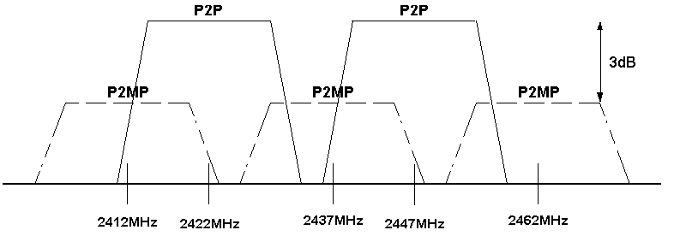

Shown in the figure is an example of the band with P2P inserted in between the P2MP links running on the orthogonal channel.

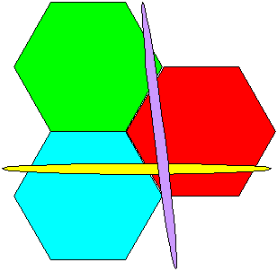
The figure shows the example of two (2) P2P links inserted into three (3) P2MP cell. It does not do much harm into the system. Using different polarization and different channel has reduced the interference.

