MULTIMEDIA TRAINING KIT
Miscellaneous: Radio Link Calculation
Developed by: Onno W. Purbo

Radio Link Calculation

Unlike Indoor usage, ability to calculate radio link budget & distances is very critical if one wants to use Wireless LAN equipments for bypassing Telco’s last mile. Such rigorous calculation is not necessary for those who run WiFi for indoor applications.

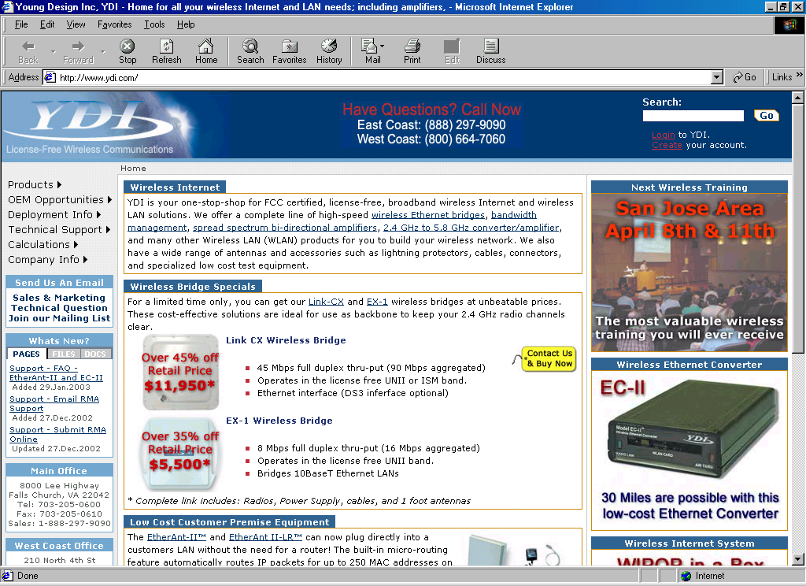
Unfortunately, those who have very minimal radio knowledge might be having some difficulties in doing it. Fortunately, http://www.ydi.com carries a simple radio link calculation accessible from the Internet.

Since YDI.COM site includes all the formulas and, thus, anyone can always write their own routines in Excel. I would strongly suggest for accessing the site for playing with the radio link calculation. For those who wish to obtain the excel version for some of the calculation, it can be freely downloaded from http://www.apjii.or.id/onno/practical-guide-rebelnet/ppt-wlan/, http://sandbox.bellanet.org/~onno/the-guide/wifi/ as well as in some folder in http://www.bogor.net/idkf/

There are several critical parameters need to be properly calculated to make sure the system will correctly perform, namely,

- System Operating Margin (SOM), it correlates the transmitter power, type of antenna, length of coaxial cables and distance. We can make sure if our system has a sufficient power margin to reach such distance.
- Free Space Loss (FSL), loss in radio power after traveling certain distance.
- Fresnel Zone Clearance (FZC), to see the required antenna height needed to pass any obstacle.
- Antenna bearing, antenna down tilt, and antenna down tilt coverage radius are needed to know the exact point or area of your radio beaming into.

A power conversion calculation utility is also provided to convert dBm into Watt vice versa. The conversion is fairly simple, i.e.,

dBm = 30 + Log 10 (Watts)
Watts = 10^((dBm - 30)/10)
MilliWatts = 10^(dBm/10)

The calculation provided in YDI.COM is in miles and feet, and, thus, one need to convert into meter if needed. For your convenient, the following is the needed conversion table

Meter = Feet * 0.3048
Km = Miles * 1.609344

Free Space Loss (FSL) Calculation

As radio signal travels the signal will be loss in free space. The amount of free space loss can be empirically calculated.
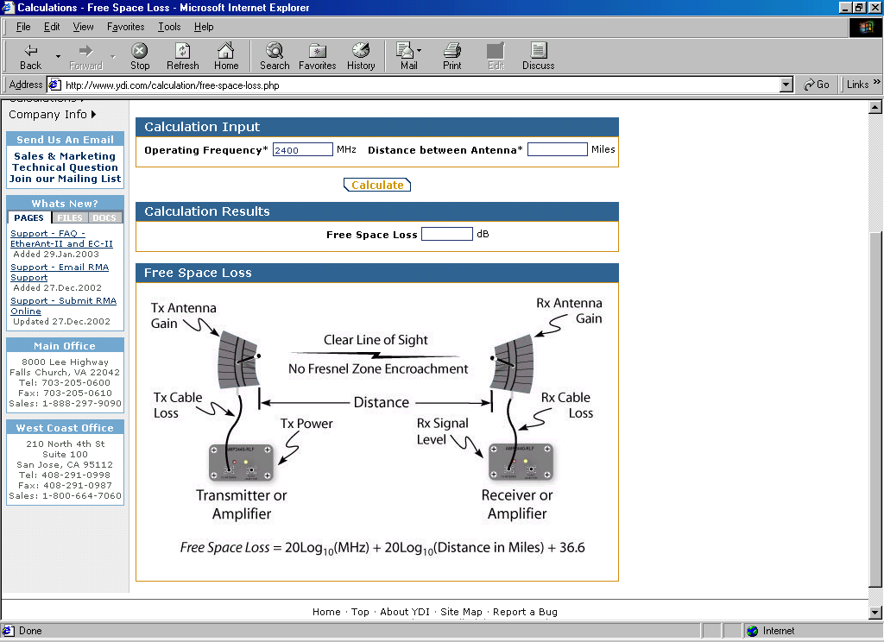
Shown in the figure is the Free Space Loss (FSL) calculation page provided by YDI.COM. As shown in the Figure, there are two (2) main parameters needed to calculate FSL, namely,

- Operating Frequency (in MHz)
- Distance Between Antennas (in Miles)

The output of the calculation is

- Free Space Loss (in dB)

The formula as shown clearly in the figure is

Free Space Loss (dB) = 20 Log10 (MHz) + 20 Log10 (Distance in Miles) + 36.6

We will normally see a Free Space Loss in the range of 100 dB for radio signal operating in 2.4GHz frequency traveling in one (1) km distance. For example, the free space loss of signal traveling for 5 km distance on 2400MHz (2.4GHz) will be 114dB.

Line of Sight (LOS)

In a high frequency radio communication, line of sight condition between the transmitter and receiver is very critical. There are two type of Line of Sight (LOS), namely,

- Optical Line Of Sight, both stations should be able optically see each other.
- Radio Line Of Sight, there should be no reflection, nor diffraction of the radio signals.

Optical LOS is quite simple to understand, Radio LOS on the other hand may require more rigorous calculation to make sure not much distraction on the propagated radio signal. A Fresnel zone is an area that no obstacle can be exists. Shown in the figure is the 1st, 2nd and 3rd Fresnel Zone. It is an elliptical zone connecting the two (2) stations.

We normally use 80% of the first Fresnel Zone as our clearance reference in which no obstacle are permitted. Others, such as, Waverider may use 60% of the First Fresnel Zone + 3 meters as clearance reference.

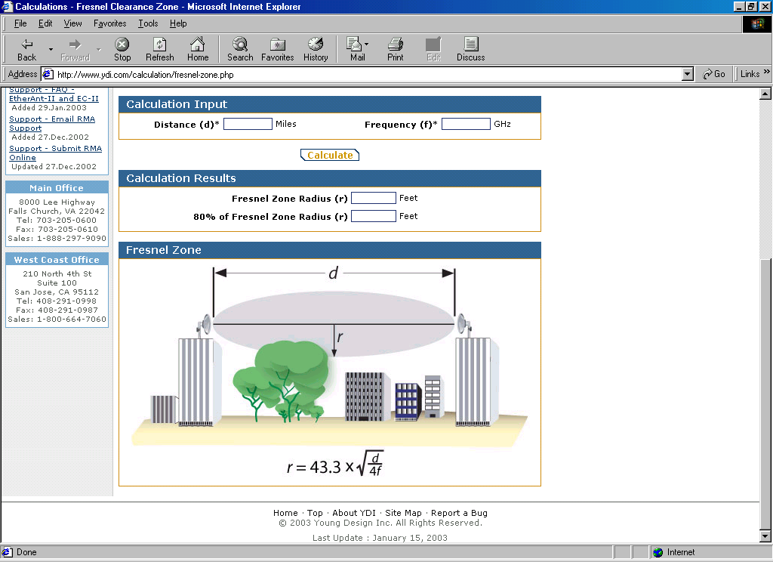
The simplified equation to calculate the radius of Fresnel Zone can be obtained at YDI Web site, namely,

R = 43.3 sqrt (d / 4f)

Where R is the radius of Fresnel Zone in feet, d is the distance between two nodes in miles and frequency in GHz.

To give some ideas on the required clearance , a table of calculated Fresnel Zone Clearance (FZC) for 1-7 km distances for WiFi station operating at 2.412GHz (channel 1) is provided.

Distance (km) | Minimal Clearence (m)
1 | 3.3
3 | 5.9
4 | 6.7
5 | 7.5
6 | 8.2
7 | 9.0

We basically need somewhere between 3.3 up to 9 meters clearance for such distances. The longer the distance the higher the antenna should be to match for the calculated Fresnel Zone.

System Operating Margin (SOM) Calculation

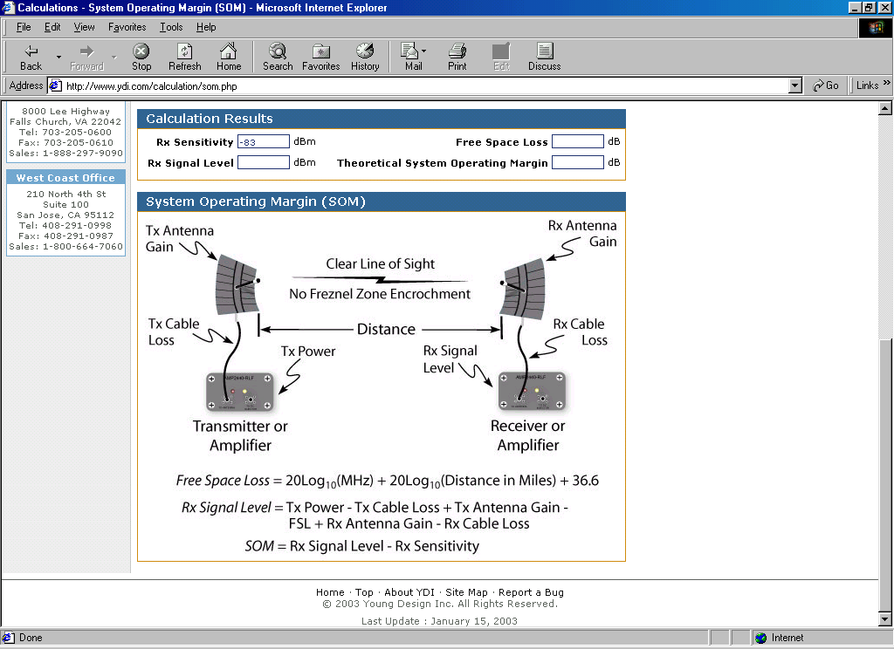

Shown in the Figure is the System Operating Margin (SOM) calculation page. It has many input parameters with three (3) main outputs, namely,

RX Signal Level (dBm)
Free Space Loss (dB)
Theoretical System Operating Margin (dB)

We need to make sure that we have about 10-15 dB of System Operating Margin (SOM) to give some space for any fading & multipath in the received radio signal.

To be able to calculate these three (3) parameters, we need to provide the formula with data on

Frequency (MHz) used for the communication.
Distance (Miles) between the two stations.

TX Power (dBm), WLAN card transmitter power normally about 30-100mW range.
TX Cable Loss (dB), loss in the cable from the transmitter to the antenna. Depending on type of the cable & its length. It would be better to restrict the length to less then 10 meter.
TX Antenna Gain (dBi)
Free Space Loss (FSL)
RX Antenna Gain (dBi)
RX Cable Loss (dB), loss in cable from the antenna to the receiver.
RX Sensitivity, is the receiver sensitivity.

Having all the necessary data of the parameters, we may then proceed to calculate the System Operating Margin (SOM) to make sure the system will perform correctly. The System Operating Margin (SOM) is basically the calculated margin between the received signal level and the reveiver sensitivity.

SOM = Rx signal level - Rx sensitivity.

While the received signal level (Rx signal level) can be calculated by adding and subtracting the transmitter power (TX power) with other parameters as shown in the simple equation, such that,

Rx signal level = Tx power - Tx cable loss + Tx antenna gain – FSL
+ Rx antenna gain - Rx cable loss.

Most of the data needed can be found in the manual or specification of the equipments. Else, in some software, such as, iwconfig in Linux, we can see the TX power of our WLAN card. Most of WLAN card will likely to have TX Power around 15-20 dBm (around 30-100mW).

It is advisable to set a minimal of 10-15 dB operating margin to give some safe space for any fading, reflection, multipath in the radio signal.

To give some ball park figures, example of calculated system will be explained. In most IEEE 802.11b radios, the receiver sensitivities are around –80 to –85 dBm. At the client side, we normally use directional antennas, such as parabolic antenna with gain around 19-24 dBm. Signal loss for short coaxial cables including its connectors is quite low in the range of 2-3 dB.

The coverage of the system by allowing 10-15 dB operating margin is highly depends on the type of antenna used at the Access Point. If an omni-directional antenna @ 10-12 dBi gain used, we are looking at 4-5 km range of the communication points. While if a sectoral antenna @ 12-14 dBi gain is used at the Access Point, we are looking at 6-8 km distances for communication.

It is not technologically correct to use power amplifier to extend the distance, as it will interfere other nodes on the frequencies and, thus, ruin the frequency reuse scenario in the region. Collaboration with other users is desperately needed to make sure all may share the frequency equally.
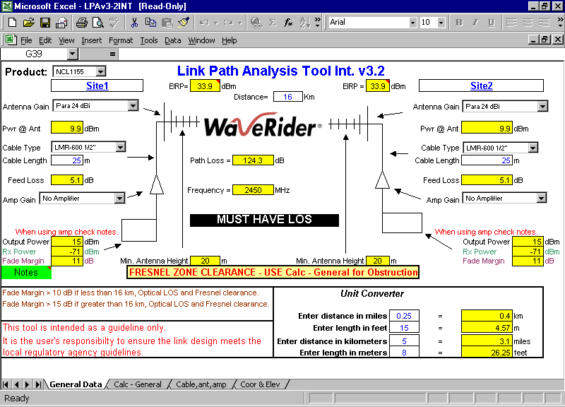
Some equipment manufacturers provide the software to help calculating the System Operating Margin (SOM) as well as other required parameters. One of the example is the WaveRider http://www.waverider.com. They provide specially designed Excel program to match their equipments. Thus, one can easily calculate the System Operating Margin for certain equipment settings.

Effective Isotropic Radiated Power (EIRP)

In a Wireless Wide Area Network run in a city, it is important that the frequency can be reuse after certain distances. As demonstrated earlier that it will reach a distance of 4-5 km (or 8-10 km diameter) for an omnidirectional antenna; and 6-8 km distance for sectoral antenna at the Access Point. Thus, after 4-10 km we can always reuse the frequency for others to use it.

To make sure frequency reuse can be correctly implemented in an area, maximum radio power should be defined. One example of such restriction is the Effective Isotropic Radiated Power (EIRP). Effective Isotropics Radiated Power (EIRP) is basically the power of radio signal at the tip of the antenna just before it is radiated into the air, and, thus,

EIRP (dBm) = TX Power – TX Cable Loss + TX Antenna Gain.

Depending on the countries, the regulation may likely to set a certain EIRP to restrict the power of the system as well as SOM. We will normally looking at 30-36dBm as the maximum EIRP

To give some ideas on the maximum transmitter power (TX power) can be used, an example of EIRP calculation is provided. For example, we use 24dBi directional antenna with cable coax loss of 3 dB. With 36dBm maximum EIRP, through a simple calculation, we will see that the maximum transmitter power can be used is only 15 dBm or only 30 mW. Thus, it is very limited power.

Aiming the Antenna
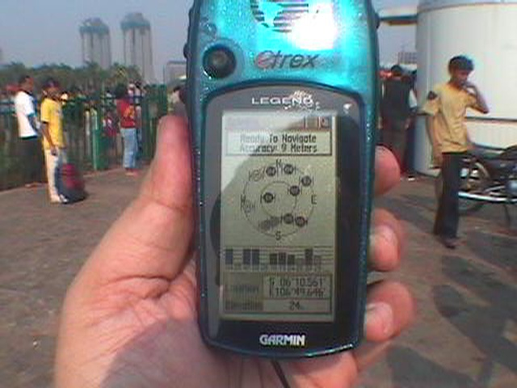
Another job to be done in the field is aiming the antenna to correct direction to maximize the radio signal. A Global Positioning System (GPS) receiver would certainly help in getting the correct location. A simple handheld GPS receiver, such as, GARMIN series, may provide the coordinate of the location at 10-15 meter accuracy. We are looking at US$150-350 for a handheld GPS receiver. The more expensive GPS receiver may have more feature and more accurate coordinate & elevation.
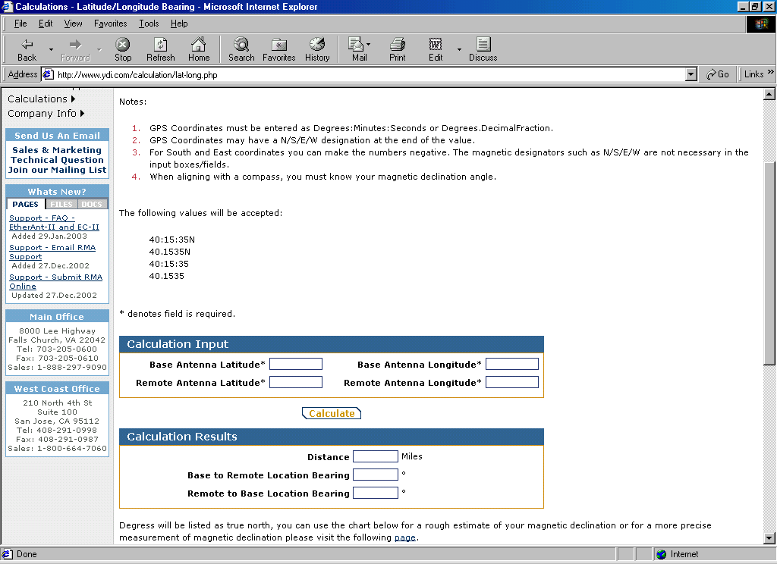
Having the information on the coordinate of the nodes, we can easily calculate the distance as well as the antenna bearing for each location. All we have to do is entering the coordinate into the YDI Web, than it will provide the distance and the antenna bearing.

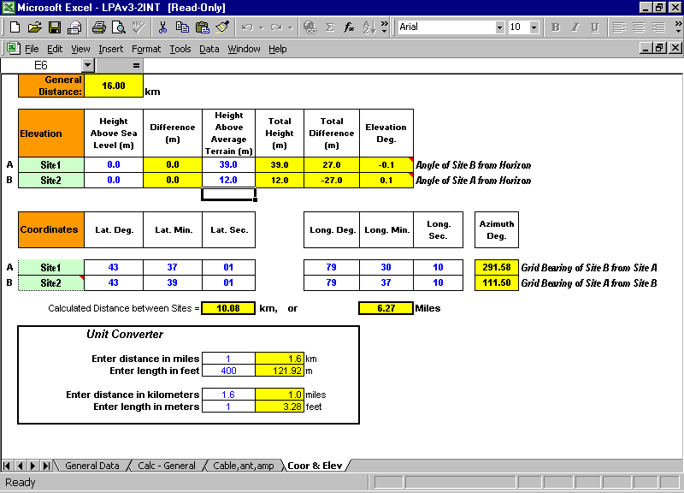
Similar function can be obtained through the software provided by several vendor, such as, Waverider http://www.waverider.com.

In some cases, it may provide the antenna tilt for such distances.

Antenna Tilt Angle

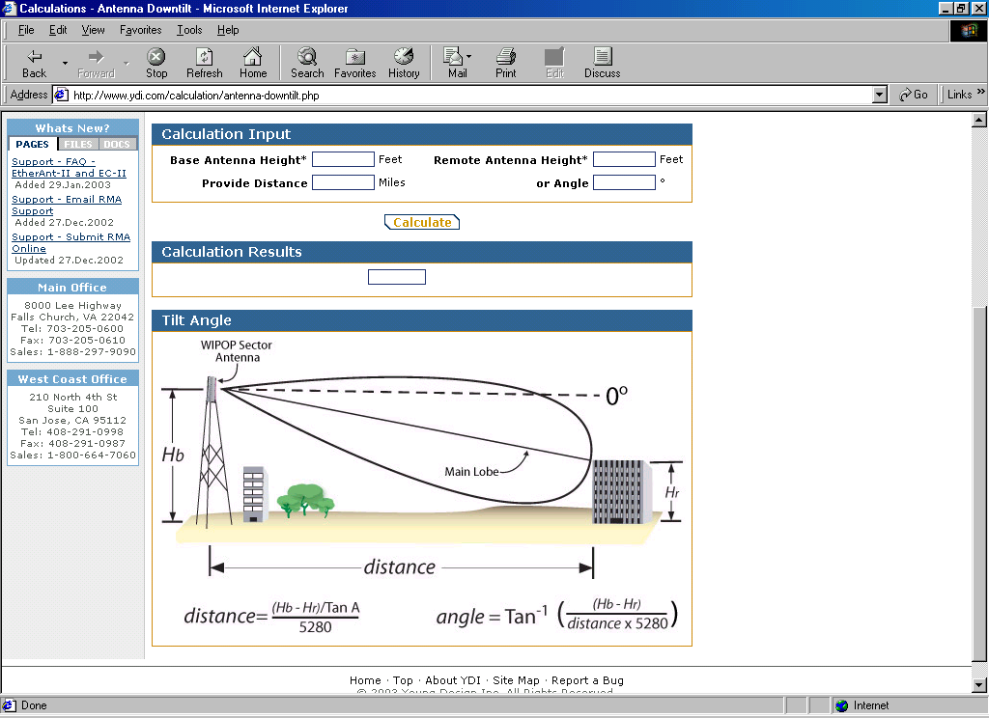

Although the antenna tilt may be insignificant, we can always check the tilt of the antenna through simple equation. As shown on the YDI Web, the equation is quite simple, i.e.,

Distance = (( Hb – Hr ) / Tan A ) / 5280

Angle = Tan⁻¹ ( Hb – Hr ) / ( distance x 5280 )

Where Hb is the height of the base station, Hr is the height of the receiving antenna; A is the angle in radian.

To give some ideas, for a 30 meters base station antenna height at 3 km distance, it will require only 0.35 degree tilt of the antenna to reach a 10 meter receiving antenna. Thus, it is actually fairly insignificant tilt. The higher the base station antenna; the shorter the distance more tilt will be required.

Down Tilt Coverage

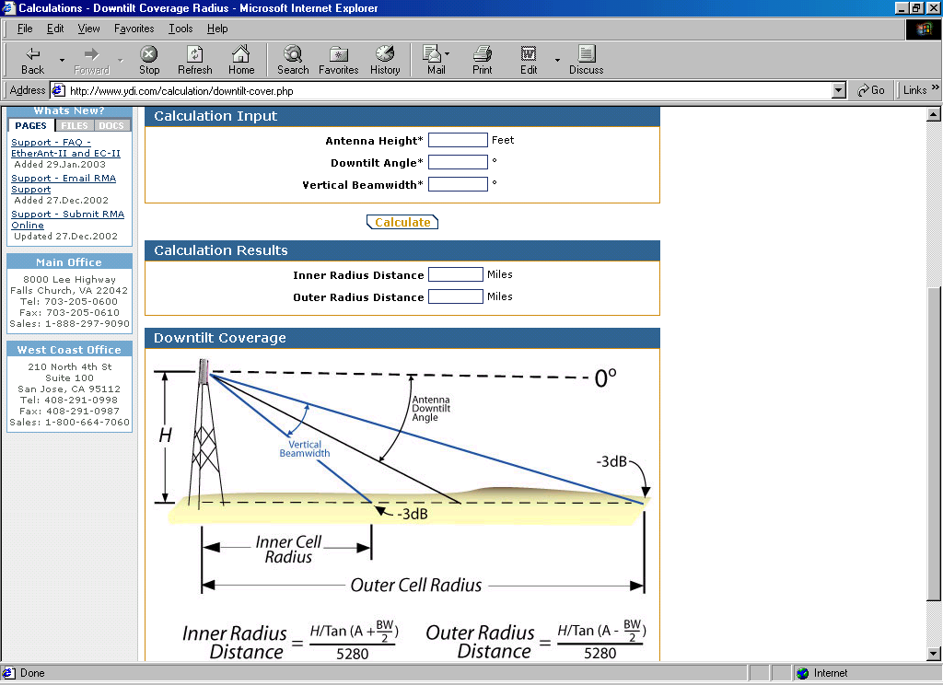

In some cases, we need some sort of estimate of the coverage of the cell. It can be easily calculated through YDI Web as shown in the picture. The equation is also quite simple, i.e.,

Inner Radius Distance = ( H / Tan (A + BW/2) ) / 5280

Outer Radius Distance = ( H / Tan ( A – BW/2) ) / 5280

Where H is the height of base station antenna. A is the tilt angle of the antenna. BW is the beam width of the antenna. It is normally fairly narrow around 10-15 degree depending on the antenna gain

To give some ideas, for a 30 meters Access Point antenna height, with beam width 10 degree tilted 0.2 degree, we will see inner radius around 150 meters, and outer radius around 8.7 km. Thus, we will see around 8.5 km coverge.

