MULTIMEDIA TRAINING KIT
Miscelleneous: Grounding System
Developed by: Onno W. Purbo

Grounding System

Lightning ground in detailed can be read at http://www.arrl.org/tis/info/lightning.html. There is basically three (3) types grounding system, namely:

- Safety ground, usually used for high voltage power equipments.
- Lightning ground, to run the lightning directly to the earth.
- RF ground, for grounding the radio equipments.

All of these three grounding systems are needed, we normally adding lightning ground for our electricity, our phone lines as lightning will likely to strike through any lines outside the system. Please note that each of these grounding lines must be separated and not be interconnected to each other.

RF Grounding system is especially needed for omnidirectional and sectoral antenna. Directional antenna usually has its own RF ground. Several radial cables in the ground may construct the RF ground of the coaxial cable.
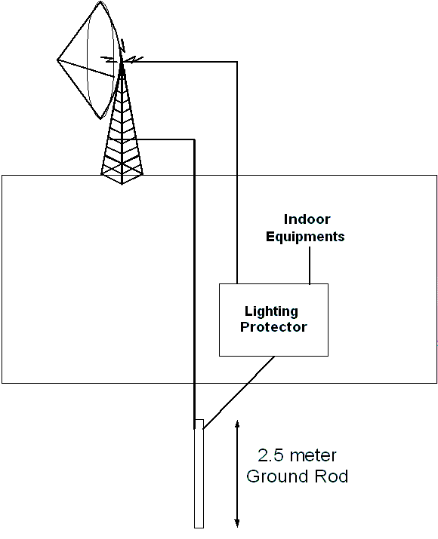
Shown in the figure is the typical grounding system. A much more detail the grounding accessories & its installation are shown in the capture figure from http://www.glenmartin.com/catalog/lighting.htm.

The best ground wire route is to run the shortest possible large diameter ground wire straight down from the antenna system to the ground rod. The lightning protector must also be grounded.

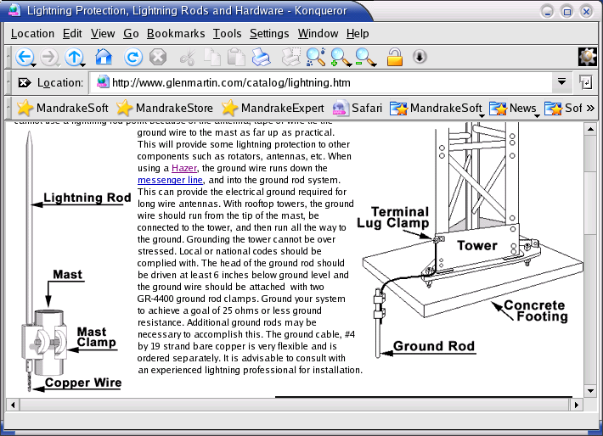
A 2.5-meter long metal is typically used as the ground rod. Some of my friend drill a hole into the ground until it reach the ground water, and plug the cable from the lighting arrestor into ground rod that touches the ground water.

One of the major problems by the grounding system is the keep increasing ground resistance. It may increase in time. Some of my friends use urea that usually used by farmer on their farm to keep the ground resistance down.

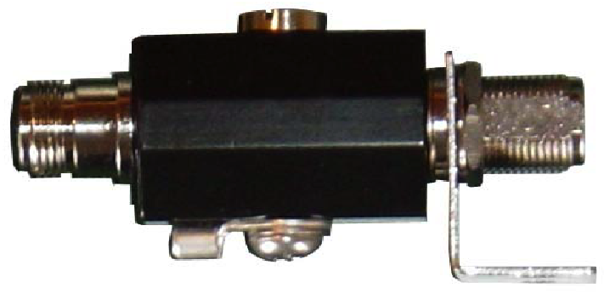
Shown in the picture is RFL-SP a gas discharge surge protector builds by RFLinx http://www.rflinx.com that can be operated between 100 up to 3000 MHz. It has 0.1 – 0.4 dB insertion loss. The ultra fast gas discharge design gives quick responds to power surges and dumps the excess power into the ground.

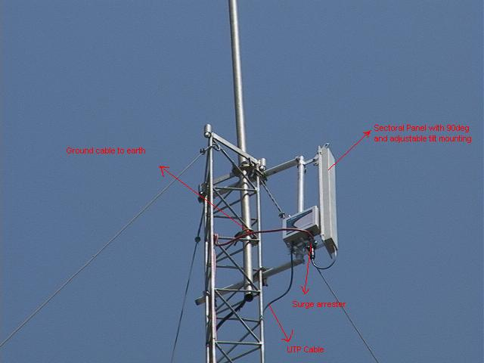
To guard the antenna from lightning strike, both the antenna and the tower are grounded into the earth through lightning protector as shown in the figure. These installation pictures are the courtesy my colleague Henry Syarifuddin, henry@cgd.co.id. Their team use SmartBridges http://www.smartbridges.com wireless equipment for their outdoor installation.

