MULTIMEDIA TRAINING KIT
Miscellaneous: Tower
Developed by: Onno W. Purbo

Unlike the plumbing pipe used in my home installation, there is several type of tower configurations. There are countless tower manufacturers, but two to look into are Trylon Towers of Canada, and Webb Industries out of South Africa. Webb is also an antenna manufacturer. With the dollar conversion, South African solutions can become much more cost effective over US solutions.
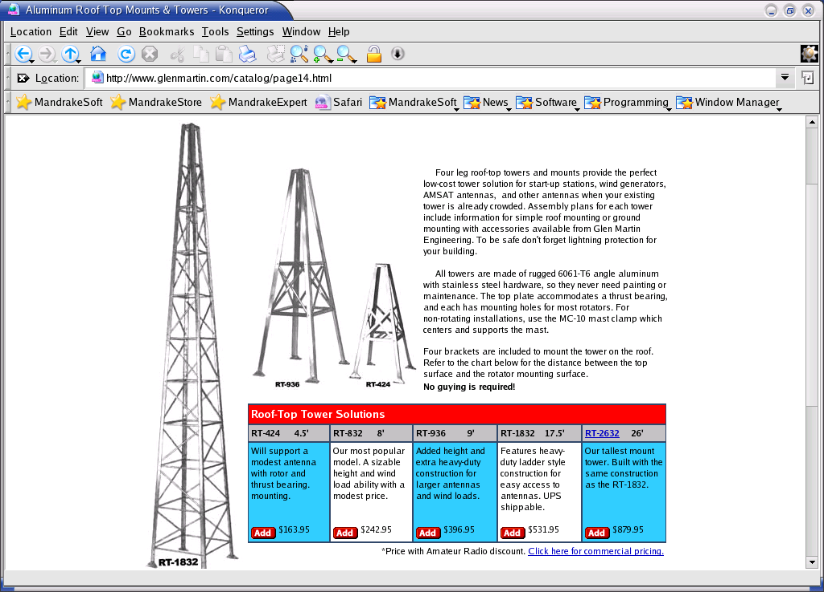
As shown in http://www.glenmartin.com, the simplest low cost roof-top start-up / client configuration is the four leg tower configuration. The tower height is between 1.5 – 8 meter, and cost between US$ 164 – 880, respectively.

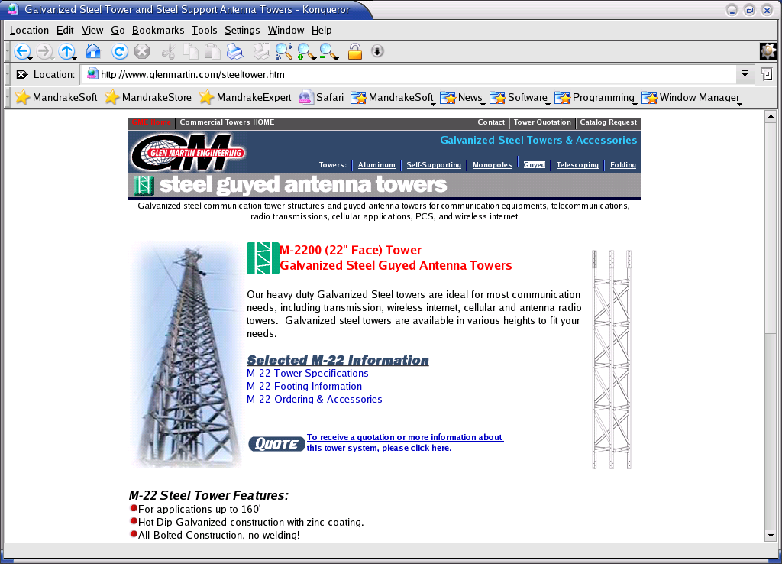
For the Access Point, up to about 50-meter height, we may use a guyed antenna tower. It is based on triangle element stack 3-meter length shown in the figure. The tower is supported by guyed wire tied on every stack.

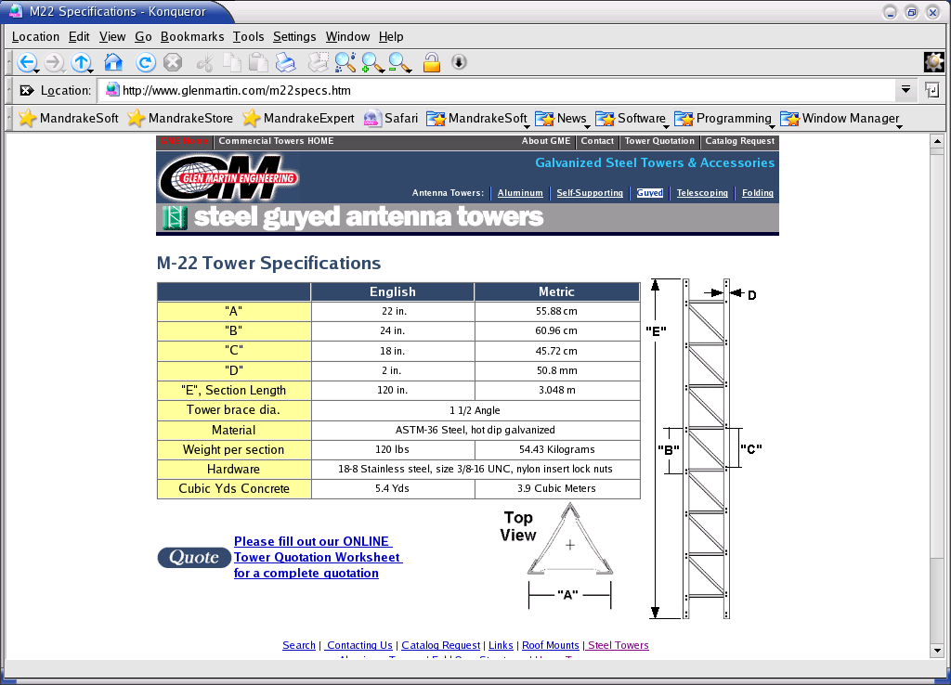
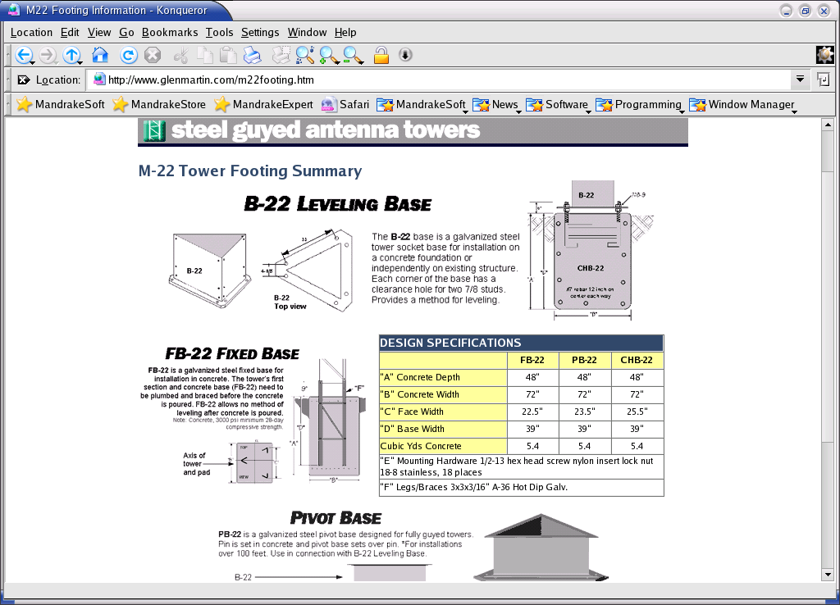
There are at least three (3) type of base for guyed antenna tower, i.e, leveling based so that we can adjust the tower base level, fixed based non-adjustable, and pivot base for sitting over pin that pinned into a concrete.

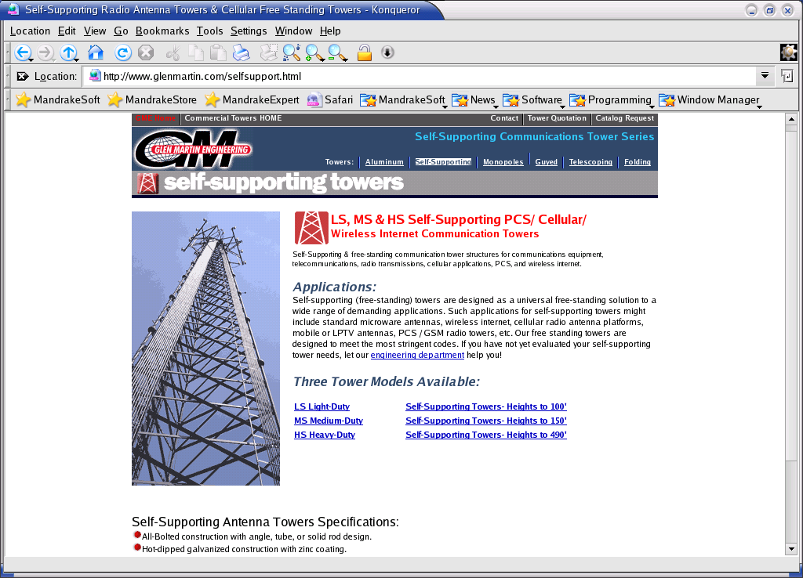
If space is limited, or need to have a high tower installation, a self-support (or free-standing) tower might be the solution. Light duty specification may be used up to 30 meters. The highest self-supporting tower may reach 150 meter. It is not a cost effective solution for most WiFi operator. A better solution would be rent a space at the tower run by the cellular operators.

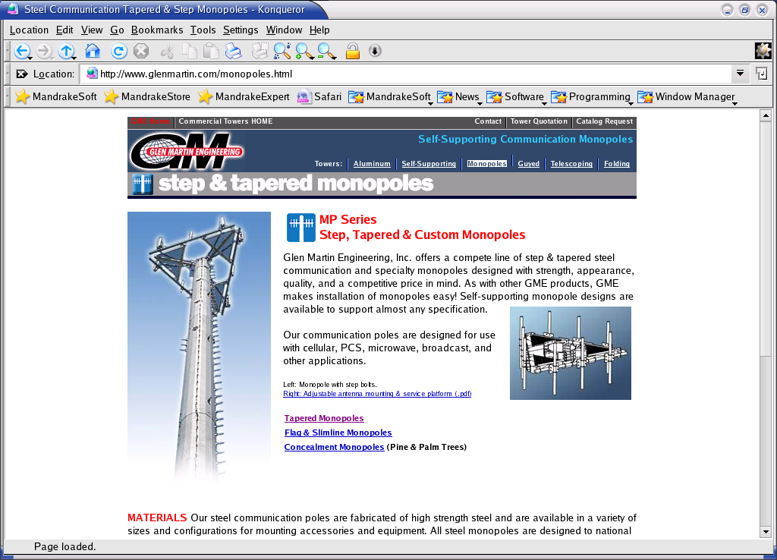
For strength, appearance and quality, there is self-supporting monopole design. It may cost dearly for most WiFi operators.

In some cases, we need to calculate the maximum safe height of a self-supporting tower for any antenna configuration as a function of wind velocity. Frank Travanty, W9JCC has written a good article on “Tower and Antenna Wind Loading as a Function of Height”, QEX July/August 2001, pp. 23-33 (http://www.arrl.org/qex/1123.pdf).

