Indonesian Internet Evolution

Onno W. Purbo
Ex. Indonesian Civil Servant
Ex. Lecturer at Institute of Technology in Bandung (ITB)
Independent Information Technology (IT) Writer
onno@indo.net.id

Acknowledgement & Dedication

I would like to dedicate this work to all my friends, volunteers, who passionately help in educating the Indonesians for further understanding of the Internet as well as putting all the materials in public domain. To name a few, they are I Made Wiryana (Germany), I Wayan Wicaksana (Jakarta), Michael Sunggiardi (Bogor), Umar Tjokroaminoto (Medan), Adi Nugroho (Makassar), Irwin Day (Makassar), Ismail Fahmi (Bandung), Donny BU (Jakarta), Bona (Jakarta), Louis Larry (Surabaya), Adnan Basalamah (Bandung), RMS Ibrahim (Jakarta) etc. It is a great pleasure to know and to work with all of you guys.

Abstract

In this paper, fifthteen (15) years of experience in empowering a bottom-up self-finance Indonesian Internet infrastructure will be described. It describes the development in commercial Internet Service Provider (ISP) in Indonesia, a glimpse on historical perspective as well as technical aspects that empowers a self-finance bottom-up Internet infrastructure. A glimpse on Indonesian Internet community profile and characteristics will be presented.

It is not money, technology nor government help, it is clearly shown that human factor; dedication, the community education is the most important key factor in empowering a self-finance bottom-up Indonesian Internet infrastructure. The community / society education processes are driven by many Indonesian volunteers. Consequently, only small fraction, if none, of World Bank, IMF, and ADB funding have ever been directly received by these communities. In some cases, some organizations may claim the success of Indonesian Internet development to get funding from various donor agencies.

References

Most of the copylefted reference and technical materials can be freely downloaded from http://www.bogor.net/idkf, http://bebas.vlsm.org, http://free.vlsm.org, and http://pandu.dhs.org.

Some Historical Perspectives

RMS Ibrahim, Suryono Adisoemarta, Muhammad Ihsan, Robby Soebiakto, Putu, Firman Siregar, Adi Indrayanto, Basuki Suhardiman, Arman Hazairin are some of the legendary names in early Internet development in Indonesia around 1992-1995. Most of the current Indonesian Internet users may not know them. Each of them has dedicated their knowledge in building part of early historical Indonesian Internet. In early 1990, Indonesian Internet was known as PaguyubanNet.

Solidarity, helping each other strongly binds us together. It is quite different than current spirit of Indonesian Internet, more commercial, more individualistic especially those involve in commerce over the Internet.
Articles on the existence on Indonesian Internet can be traced down in several Indonesian national newspaper, such as, KOMPAS, in the end of 1990, we can find an article entitled “jaringan komputer biaya murah menggunakan radio” (low cost radio based computer network) as well as some short articles in Elektron Magazine published by Electrical Engineering Students Society of Institute of Technology Bandung (ITB) around 1989.

The early Internet development in Indonesian was inspired by the activities in Indonesian amateur radio especially the Amateur Radio Club (ARC) ITB in 1986. Equipped with HF SSB Kenwood TS430 belong to Harya Sudirapratama YC1HCE and Apple ][ computer with 64Kbyte RAM belong to YC1DAV, 10-20 young ITB students, such as, Harya Sudirapratama YC1HCE, J. Tjandra Pramudito YB3NR (now a lecturer at UNPAR), Suryono Adisoemarta N5SNN (now a Proffessor in Texas,US) and me YC1DAV, we learn to our senior amateur radio such as Robby Soebiakto YB1BG, Achmad Zaini YB1HR, Yos YB2SV, YB0TD in 40m band. Mas Robby Soebiakto YB1BG is one of the amateur radio guru among us in Indonesia, he teaches us how to conduct data communication over radio known as packet radio, and interact using TCP/IP protocols on top of it. YB1BG teaches us on using the amateur satellites for data communication. The learning process is later helped by many Indonesian mailing lists, such as, ybnet-l@itb.ac.id, ybqrp@yahoogroups.com, orari-news@yahoogroups.com etc.

The packet radio technology developed by the amateur radio, is the early Indonesian Internet technology implemented to link friends at Ministry of Research and Technology (Jakarta), University of Indonesia (Jakarta), Indonesian Aerospace Institute (Bogor) and Institute of Technology Bandung (Bandung), later known as Paguyuban Network in 1992-1994.

RMS Ibrahim (A.K.A. Ibam) was the driving force behind the operation of Internet at University of Indonesia (UI) in Jakarta. Using UUCP Protocol UI helps us transfer the mail from our slow radio network in Indonesia to the Internet vice versa. Ibam is the first man in Indonesia who handles Indonesia (ID) Country Code Top Level Domain (ccTLD) later known as Indonesia Network Information Center IDNIC (http://www.idnic.net.id).

Muhammad Ihsan was a research staff member at LAPAN Ranca Bungur not too far from Bogor, south of Jakarta, in early 1990’s. M. Ihsan was supported by his supervisor Dr. Adrianti and working together with DLR (equivalent of NASA in Germany) trying to setup packet radio computer network in 2 m and 70 cm band, later known as JASIPAKTA. M. Ihsan station, located in Bogor, is the one who relays the traffic from ITB in Bandung to Jakarta.

Mr. Firman Siregar was the driving force at Ministry of Research and Technology who managed packet radio gateway in 70 cm band. A simple 386 machine running Network Operating System (NOS) on top DOS operating system servers as the main radio gateway for the traffic from LAPAN and ITB. Indonesian Internet is in its infancy, traffic to the Internet uses X.25 packet network connected to the gateway at DLR in Germany. The network at Ministry of Research and Technology was later known as Research and Technology Network (a.k.a IPTEKNET) http://www.iptek.net.id.

Putu is the name attached to the development of PUSDATA (Data Center) at Ministry of Industry and Trade during Mr. Tungki Ariwibowo’s time. Started with a small Bulletin Board System (BBS) in early 1990 and provides free e-mail service to public, we may now enjoy the transparency many public policy and public documents of Ministry of Industry and Trade at http://www.dprin.go.id. Both Putu and Tungki Ariwibowo should receive most of the credit in transforming a government institution into cyberspace. Mr. Tungki Ariwibowo is the first Indonesian Minister who actively responds to e-mails.

By the end of 1992, Suryono Adisoemarta N5SNN went back to Indonesia. His arrival was exploited by the students at ITB’s Amateur Radio Club, such as, Basuki Suhardiman (now at AI3 ITB), Aulia K. Arief (now at jalawave.net), Arman Hazairin (now at Telkomsel cellular) supported by Adi Indrayanto (now completing his PH.D in England) worked on the packet radio gateway at ITB. Having mainly guts to try new things and a used 286 machine, Institute of Technology Bandung (ITB) may be the poorest institution in Paguyuban Network. The radio modem, also known as Terminal Node Controller (TNC), used at ITB was borrowed from Muhammad Ihsan at LAPAN Ranca Bungur.

Start with a slow 1200bps packet radio in early 1993, ITB gradually built the Internet communities in Bandung and its surroundings. In 1995, ITB received a free 14.4Kbps leased line to RISTI Telkom as part of IPTEKNET. It really open the mind set of many the students and young Internet enthusiasts in Bandung. In September 1996, it was the main turning point for ITB, they invested on Ku-Band satellite ground station and integrating ITB into Asia Internet Interconnection Initiatives (AI3) research network to Japan at 1.5Mbps bandwidth (now 2Mbps). ITB added 2Mbps interconnection to TelkomNet for local traffic, which in the end set ITB as one of the leading institution to integrate 25+ Indonesian educational institutions to the Internet around 1997-1999 known as AI3 Indonesia network.

I have to admit that ITB is not the only one who led integrating education institutions to the Internet. Dr. Gatot H.P. at Ministry of Education is currently leading integrating 1000+ vocational schools to the Internet. We are still long way to go with the total of 1300 colleges / universities, 10,000 high schools, 10,000 madrasah / pesantren / Islamic schools, 4,000 vocational schools. It would be a challenging task to integrate all of these educational institutions.

In 1989-1990-an, the first Indonesian mailing list is set at the legendary Indonesians@janus.berkeley.edu. The experience was clearly shown the powerfulness of community building through cyber interaction. It inspires many cyber-Indonesians, and set many Indonesian mailing lists. In 1997, ITB serves the cyber communities on its two mailing list servers on Pentium machines running FreeBSD. Currently, more Indonesians are using the free service at http://groups.yahoo.com for their mailing list servers. The characteristics of Indonesian communities will be described later in the paper.

It is glimpse of some historical aspects on Indonesian Internet. It was an enjoyable process and involving many good and dedicated Indonesians who like to share their knowledge, expertise and resources for the good of Indonesian society.

Key Strategies

From the field experience, to build the Indonesian Internet infrastructure & society, human factor is the most important key. Ability to educate, provide free education on various aspects of the Internet would be paramount in shifting the mind set of Indonesian society in looking at Internet. Mind shift within the society will surprisingly ignite them to invest & build their own infrastructure at virtually no cost from the government and any donor agencies.

If I may use a simple model of the circle of knowledge, it contains knowledge generation, packaging and disseminating processes as shown in the picture. Today, not many people act as the one who generate knowledge. It is worsen by the slow information & knowledge flow within the circle of knowledge over conventional means and media.

Having Internet based media, information & knowledge flow can be really accelerated. Most of knowledge put in softcopy in public domain. CD-ROM and Web servers are typical packaging technique used in the disseminating knowledge in electronic form. The trick is to accelerate the circle of knowledge, the faster the circle of knowledge can be run the more mass and audience will be affected, the more value is for the distributed knowledge. In this kind of process, copyright renders the acceleration of circle of knowledge, thus, reduces the value of the distributed information / knowledge. It is not surprising to see most of the Indonesian Internet activists would prefer to put their knowledge in copyleft & copywrong state.

In the accelerated circle of knowledge, it would in the end educate many people and may transform part of the communities into knowledge producer rather than passively stays as knowledge consumers. It is the ultimate goal to see more knowledge producer, writer etc. cultivated as a result from abundant freely available knowledge over the network. Some of these knowledge producers are quite militant and normally becoming the driving force behind the Internet development in Indonesia.

Most of the Indonesian Internet activists, such as, I Made Wiryana (Germany), Michael Sunggiardi (Bogor), Adi Nugroho (Makassar), Irwin Day (Makassar), Ismail Fahmi (Bandung) etc. would prefer to publish their work freely on the Internet. You may find their work in Indonesian Digital Knowledge Foundation (IDKF) http://www.bogor.net/idkf, or in Pandu Team Website http://pandu.dhs.org. It contains more than five thousand (5000+) articles and references on various aspects of the Internet.

Copyleft & copywrong movement provides free literature and education and really helps the building of Indonesian Internet society. Many Indonesian new dotcommers may mirroring these sites, thus, enable rapid distribution of the knowledge to the society.

Since most, if not all, of the necessary knowledge is freely distributed, some may ask - what about the reward, especially financial reward, for those who provide the free knowledge? Fortunately, God is fair and provides ample rewards in unimaginable ways. Well, to be more practical, in a more realistic picture, it goes very pragmatics. When one distributes one’s knowledge freely to public, public is educated & demand on certain aspect of technology or services arise. The private sector or entrepreneur may take up this opportunity. In the end, the public will receive the required technology or services provided by the entrepreneurs within the public or larger private sector, which, will in the end receive capital gain. The private sector sees this in a simple ways, the one who create demand in the market should be supported for maintaining the demand / market. It is logical to see one who provides free knowledge may receive most attention and sponsorship in various forms such as arrangement of seminars, workshops, talk show etc. Thus, enable the knowledge producer to continually distribute their knowledge freely to public.

One may be surprised by the amount of funding & sponsorship received by putting the copylefted knowledge in public domain. Depending on the coverage of the audience / readers, it may surpass the salary of professional executive with fixed job and fixed income in Jakarta.

Some of these sponsorships are going into seminars and roadshow, in fact, during this manuscript is written (July 2002), I am in roadshow program of a total of 37 cities all over Indonesia. The one-day seminars only cost US$3/person with all the snack, Linux CDs, magazine not to mention all the door prices. In each seminars / cities, it is normal to have 300+ attendees, not to mention its multiplier effects through radio talkshows in each cities and various other programs.

In schools, we provide seminars for free in many schools. This program is arranged by the Indonesian School Information Network (Jaringan Informasi Sekolah) http://www.jis.or.id. It is our hope that the young generation will have a much better living environment that ours the old ones.

Interaction among the society in the circle of knowledge is normally conducted in Internet mailing lists. To name a few, these mailing lists are genetika@yahoogroups.com (more on IT politics), majalahneotek@yahoogroups.com (IT beginners), linux-admin@linux.or.id, linus-setup@linux.or.id as well as many other mailing lists.

Since the necessary knowledge is freely available to public, in most cases, it will attract the public to invest on its own infrastructure using their own money. In economic framework, the small medium entrepreneurs in the public are putting their money in IT businesses & gradually turn their money into profit and re-invest it as the business goes well. This gradual cycle of investment and business operations may gradually accumulate public’s money in IT businesses and enable them to build their own Internet infrastructure using the freely available knowledge on Internet. Consequently, it is not surprising to see the grassroots movement has much stronger roots in the society rather than any action done by the government.

Phil Karn, one of the Wireless Internet guru once said, either lead or follow but please don’t block the road for those who would move forward. In many cases, less Bank’s loan, less “informal” taxes, and less licenses requirements, would certainly facilitate the building of Internet infrastructure and society in Indonesia.

Indonesian Internet Community Development

Having the Internet infrastructure deployed would not be enough before we see the behavior of Indonesian Internet community. We may basically have two (2) types of users, namely,

- The old timer, the veteran Internet users.
- The beginners, occasional users.

Most beginners would likely to access the web. Thus, the beginners can be easily probed from their activities during surfing the Internet. It can be easily analyzed from the proxy cache log of the Internet café’s server. Different from the beginners, the characteristics of Internet old timers can be easily analyzed from the way they interact through various Internet mailing lists.

An example of web access behavior is provided by Adi Nugroho adi@internux.co.id who managed the proxy server of 50% of Internet Café in Makassar, Sulawesi. Shown in the table is the data provided for 20-27 January 2002.

20.Jan 02 00:25:52 - 27.Jan 02 00:24:09
# Request-destinations by 2ndlevel-domain
destination | %
*.yahoo.com | 6.96%
*.yimg.com | 6.77%
*.bolehmail.com | 4.69%
<error> | 2.98%
*.plasa.com | 2.52%
*.astaga.com | 2.02%
*.17tahun.com | 1.72%
*.doubleclick.net | 1.46%
*.extrajos.com | 1.40%
*.msn.com | 1.16%
*.akamai.net | 1.00%
*.freebiespider.com | 0.85%
*.geocities.com | 0.76%
*.rileks.com | 0.75%
202.53.225.* | 0.74%
*.chek.com | 0.61%
*.detik.com | 0.49%
*.adbutler.com | 0.44%
*.kompas.com | 0.40%
*.icq.com | 0.27%
other: 2nd-level-domains | 62.01%

Typical web access behavior can be summarized as follows,
- Search engine & web mail are the most accessed sites. It basically tells that most beginners would roam through the Internet through the help from search engines, while e-mail seems to be their main activities.
- News & online media are next in the row.
- Right after it is the Indonesian pornographic site, although, it is only small only percentage. In contrast to heavily cover by the media, pornographic sites are not the main focus for most beginners.
- 2.98% users are normally mistyped the URL. Thus, users may be vulnerable to crackers who create sites that catch mistyped URLs.
- Yahoo.com & its family are the most (13%) accessed sites. I guess, it is a common phenomenon worldwide.

Next, we will examine the behavior of the old timers. It can be probed through the way they interact on various Indonesian mailing lists on the Internet. It was started in early ’90, some Indonesians started the first Indonesian mailing list at Indonesians@jamus.berkeley.edu. It gradually grows into many mailing lists. In ’96, Institute of Technology Bandung (ITB) was putting two (2) Pentium servers on-line the Indonesian Internet community. It manages to serve more than 200+ mailing list. Currently, major Indonesian mailing lists can be found at

- http://www.yahoogroups.com also known as http://groups.yahoo.com may be the busiest mailing list server on the Internet, which serves 45.000+ Indonesian mailing lists. In this work, we will evaluate more closely the characteristics of mailing lists at http://groups.yahoo.com.
- http://groups.plasa.com runs by TelkomNet, the Indonesian Telkom ISP. As of mid February 2002, reported by Luqman El Hakiem Syamlan (luke@telkom.co.id) they serve 2299 Indonesian mailing lists.

The evaluation process of the characteristics of Indonesian community on the Internet can be easily performed at http://groups.yahoo.com. Shown in the figure is the home page of http://groups.yahoo.com. To find Indonesian communities on the net, one can enter Indonesian keywords and press “search” button. In the evaluation process, I use 100+ keyword to find 45.000+ Indonesian mailing lists on http://groups.yahoo.com.

Right after the “search” button is pressed, http://groups.yahoo.com will provide us a list of mailing lists that contain this particular keyword. It shows the name of mailing list, description of the mailing list, number of subscriber, and type of mailing list (open or closed mailing list).

Since the number of mailing list is quite large, in the process, I choose only the one with more than one hundred subscriber will be thoroughly evaluated.

By clicking the name of the listed mailing list, we may find more information on particular mailing list, such as, total member, date the mailing list was found, language usage, archive of messages, monthly statistics of messages, as well as many administrative back office utilities to support the operation of the mailing lists.

Many of the information provided by http://groups.yahoo.com is quite useful in evaluating the characteristics of Indonesian communities on the Internet.

Number of Mailing Lists | 1278
Pornographic | 73 (5.7%)
Social Functions | 360 (28.2%)
Religious | 158 (12.4%)
Politics | 96 (7.5%)
Knowledge | 257 (20.1%)
Hobby | 110 (8.6%)
Business | 224 (17.6%)

During the end of the year 2001, I was evaluating http://groups.yahoo.com. I managed to see 30.000+ mailing lists out of 45.000+ mailing lists, which only 1278 mailing lists have more than 100 subscribers. It is interesting to note that most (28.2%) of the Indonesian cyber communities are using the mailing list mainly to say hello and other social functions. Next are the communities for getting knowledge (20.1%) and business activities (17.6%). The number of mailing lists on pornographic, religious, politics, and hobby are much less.

Total subscribers | 465,749
Pornographic | 59,871 (12.9%)
Social Functions | 89,372 (19.2%)
Religious | 56,035 (12.0%)
Politics | 32,388 (7.0%)
Knowledge | 83,648 (18.0%)
Hobby | 48,342 (10.4%)
Business | 96,093 (20,6%)

Subscriber distribution follows closely the distribution of mailing lists. Note that pornographic mailing lists seem to attract more subscribers. It is interesting to note that the number of total subscriber is only 450.000+ subscribers, far less than the four (4) million Indonesian Internet users as claimed by APJII. Seems most of Indonesian Internet users are beginners, and not knowing how to interact or join the Indonesian mailing lists.

Message Distribution in 2001 | 1,635,395
Pornographic | 42,590 (2.6%)
Social Functions | 376,604 (23.0%)
Religious | 194,714 (11.9%)
Politics | 187,588 (11.5%)
Knowledge | 291,396 (17.8%)
Hobby | 236,023 (14.4%)
Business | 306,480 (18,7%)

The total messages generated in the year 2001 follows fairly similar pattern as the distribution of mailing lists. It is interesting to note that pornographic messages comprise only 2.6% of total messages.

Subscriber Activeness | Average Messages / Subscriber / Month
Pornographic | 0.71
Social Functions | 4.21
Religious | 3.47
Politics | 5.79
Knowledge | 3.48
Hobby | 4.88
Business | 3.20

The activeness of subscriber to interact can be measured as the average number of messages generated per subscriber per month. A surprising fact pop up, people in political communities seems to much talking with an average message close to six (6) messages per subscriber per month. Although, most people do not like to hear about it. It may represent the typical political atmosphere in Indonesia. Hobbyists are next in the row on those who like to talk.

Interesting findings are found in political mailing lists, at least nine (9) mailing lists on Marxists and socialists. Some of the large mailing lists are sosialista (149 subscribers), pemudasosialis (75 subscribers), sosialisgroup (92 subscribers), and the largest is indo-marxist (618 subscribers). Their traffic is quite low on the average of 1-5 e-mail per month, shown the inactiveness of socialist’s ideology.

Partai Keadilan (PK) is identified as the most active Indonesian party that uses Internet as their main driving interaction media. Most of PK mailing lists are easily identified with pk in the first two characters on their mailing list name. Some of their large mailing lists are partai-keadilan (534 subscribers), PK_Linkbisnis (528 subscribers), pk-bandung (167 subscribers), pkjaksel (114 subscribers), pk-pesanggrahan (107 subscribers)., an d the largest is pk-info (1064 subscribers). Most of these mailing lists have quite modest traffic with 50-100 mail per month, only partai-keadilan has the highest traffic close to 1000 e-mail per month that really shows the activeness of Partai Keadilan as compared to the old-economy parties in Indonesia.

Total consumed bandwidth | 1,732 Kbps
Pornographic | 704 Kbps (40.7%)
Social Functions | 237 Kbps (13.7%)
Religious | 149 Kbps (8.6%)
Politics | 113 Kbps (6.6%)
Knowledge | 270 Kbps (15.6%)
Hobby | 103 Kbps (6.0%)
Business | 153 Kbps (8.8%)

Assuming an average 5Kbyte per message on normal mailing lists, and 30 Kbytes per message on pornographic mailing lists, it is found that the Indonesian mailing lists consume 1,7Mbps bandwidth with pornographic (40.7%) consumes most of the bandwidth. Bandwidth-wise, the normal traffic may actually subsidize those who download pictures from the Internet.

The most difficult task is to drive the mass within the mailing lists, one should understand techniques, such as, information warfare and psychological warfare, to lead such mass. It is an art in itself. Only knowledgeable leaders will be respected by the communities and would be able to drive communities in cyber space. These leaders would take initiatives and lead the mass, which, unfortunately, in some cases, would put him in opposite side to the Indonesian government policies. In contrast, those bureaucrats, government leaders who normally received their position by normal carrier promotion processes would likely to fail in dealing and driving such community masses.

Development of Commercial Internet Infrastructure in Indonesia

The easiest way to probe the Indonesian Internet infrastructure development is through the expansion of Indonesian Internet Service Provide (ISP). Commercial ISP was started by IndoInternet known as IndoNet http://www.indo.net.id in 1994.

Most of the commercial Indonesian Internet infrastructure can be probed through the Indonesian Internet Service Provider Association also known as Asosiasi Penyelenggara Jasa Internet Indonesia (APJII) http://www.apjii.or.id. As of the mid of 2001, there are

- 160+ Principal ISP lisense Holder
- 80 Member APJII
- 40+ active in providing services
- in 100+ cities, all provinces
- APJII provide common facilities, such as,
- APJII IIX
- APJII IDNIC
- Domain Registration & NIR (APNIC)

Currently, 160+ ISP licenses have been granted with about 60+ ISP operational. In reality, 60-70% Indonesian Internet users are served by various forms of Internet cafes (known as warnet in short for warung internet). It is interesting to note that, none of these activities are driven by the Indonesian government; they are mostly private & community driven.

In Indonesia, the government, namely DIRJEN POSTEL http://www.postel.go.id, provides two steps of licenses, namely,

- Principal License – saying principally the government gives the permission for one to setup the ISP.
- Operational License – after normally one year, through an evaluation process, those who pass the process will receive operational license as the permit to provide service to the public.

As reported by APJII, the figure shows clearly that large number of ISP licenses is granted by the government. Thus, it seems no restriction is applied and only the professional would be able to show its capacity to operate an ISP and receive the operational license. Although, the evaluation procedure to obtain the operation license should be evaluated.

As reported by APJII, the subscriber distribution in the year 2001 is shown in the figure, some of the big ISPs, such as, IndosatNet, LinkNet, CBN, RadNet, Centrin, Indonet may capture large portion of the users. However, one should aware that TelkomNet is providing TelkomNet Instant access at +080989999 with no requirement for registration. Thus, unable to probe the real number of its subscriber.

The growth as well as targeted total Indonesian Internet users are shown in the figure obtains from APJII. It is clearly shown that a doubling of Internet users is common growth rate in Indonesia. In early 2002, APJII estimated that the total Indonesian Internet users are around four (4) million users.

More detail study on its profile can be found in the research done by APJII. It is common to see a majority of male, young (25-35 years old) and educated people (high school graduate, university students or young professionals) would compose the majority of the Indonesian Internet users.

To reduce the international Internet traffic, APJII is setting the Indonesia Internet Exchange (IIX) located in Elektrindo Building in Mampang, Jakarta. The IIX serves the connection of all ISPs in Jakarta with zero interconnection charges. The same principle is currently being pursued in various cities in Indonesia. It is needed, as most of intra-city traffic is now routed through Jakarta.

Indonesian Internet Disaster

Two (2) major stumbling blocks in Indonesian Internet development are the Indonesian government and the stubborn incumbent. In this short section, I would like to name a few of their bad deeds in impeding the development of Internet in Indonesia. Those who are interested to trace back the fact may want to read the archive of Indonesian mailing lists, such as, genetika@yahoogroups.com, telematika@yahoogroups.com, asosiasi-warnet@yahoogroups.com.

Basically, the incumbent is paranoid on internet telephony (A.K.A. Voice over Internet Protocol). While the 1999 Indonesian telecommunication acts (can be downloaded from http://www.hukumonline.com) guarantees a fully competitive telecommunication industry, the incumbent tried to use its power to distored the industry. Some of the examples are:

- Internet Service Providers (ISP) in Kalimantan, Sulawesi, Bali, Sumatra have to pay US$30/incoming call line/month from the normally US$3/month/incoming call line.
- Some ISPs, like IndosatNet, have to suffer as their application for E1 lines are rejected by the Incumbant.
- Application for E1 lines in offices are purposely rejected.
- Request for leased line from ISP, is redirected to use TelkomNet (the incumbent owned ISP).
- In Sulawesi, it was reported in genetika@yahoogroups.com, that the Incumbent is purposely reject request for incoming call lines for ISP.

Interestingly, no action are carried out by the authority although a written complain has been filed.

As expected, the government policy are lagging and full of holes in many aspects. No competitive safeguard is one of the major flaw in government policy framework. In addition, old paradigm that ISPs must uses dial-in port still intact in government mind, thus, no ISP licenses will be granted for those ISP that are not using dial-in port.

In tactical framework, basically, no creativities are allowed. Everything must registered, and request for licenced. Not to mention the unoffical government taxes born by the small medium enterprises, such as, the Internet cafés. Interesting to note that increasing illegal sweeping by the government officials and the police are currently (in may-june 2002) underway, to revoke, to seize “illegal” VoIP & Wireless Internet equipments. Things to note that some of these “illegal” VoIP equipments are legally located at the Incumbent automated switching building.

The Government of Indonesia’s Way in “Building” the Super Highway.

After reading through this paper, one may ask – how does the government of Indonesia contribute in facilitating the transformation of Indonesian people into the cyber space?

To be honest, the government of Indonesia (GoI) is putting a lot of money into it & setting several national teams for it. In 1998, lead by Pak Jonathan Parapak, we worked on the Nusantara 21 concept; the softcopy of Nusantara 21 concept can be downloaded from http://www.bogor.net/idkf/. At that time, many nations were working on their National Information Infrastructure (NII) ignited by Al Gore’s Global Information Infrastructure (GII) initiative.

The Nusantara 21 concept was than being used as reference by the National Coordinating Team for Telematics set by the Indonesian president (both Mr. Habibie and Pak GusDur). Their concept was adopted by BAPPENAS (the National Development Coordinating Body) and was used for getting a World Bank loan that was received by the Government of Indonesia in 1998. I think, it is around a couple hundred billion rupiah loan, it is known as Information Infrastructure Development Program (IIDP). Some of IIDP project is still on going in early 2002.

IIDP consists of several smaller projects, such as,

- TATP the Training Assistantship for the civil servant at Ministry of Industry and Trade as well as small percentage to selected Small Medium Enterprises.
- IPTEKnet concept at Ministry of Research and Technology, for integrating the government institutions to the Internet. It would be the base for Indonesian e-government.
- E-commerce concept at Ministry of Tourism.
- Copyright Law at Ministry of Law & Legal Matters.
- National Information Technology Framework at BAPPENAS, the National Development Coordinating Body.

If I can say it in a plain language, most, if not all, of the funding is gone for paying the International consultants to write pages of concepts, working papers, law & legal matters. To best of my knowledge, no investment in real infrastructure and things that really help the people access the Internet. Thus, these hundred of billion rupiah has very little direct impact to the Indonesian people.

Recently in the year 2001, the state ministry of research and technology is launching the Internet Café Technology & Science Technology CD. Since the Indonesian government has some budget limitation, the one who drive behind the activities are mostly coming from the private sector. The Internet Café Technology aims to build 9000 Internet café with the investment from private sector, such as, Myoh.com and Hewlett Packard (HP) Indonesia. The investment will then be returned by the Internet café users though its access fee. In the early 2002, they managed to build a couple of these Internet cafés.

While the Science Technology CD contains the research done under the state ministry of research and technology. It is distributed freely to the public. Sekolah 2000 foundation (http://www.sekolah2000.or.id) and Master Data with a lot of sponsorship from private sectors supports the production and distribution of the CDs.

To best of my knowledge, the only government movement that managed to provide significant impact on Indonesian Internet society is the vocational school’s Internet movement (dikmenjur@yahoogroups.com). Dr. Gatot H.P. (gatothp@aol.com), the director of vocational schools at ministry of education, is the one who drive the movement. Unlike other bureaucrats, Dr. Gatot H.P is very responsive on e-mail. In the year 2001, he work closely with other Indonesian Internet societies and manages to push 1000+ (out of 4000) Indonesian vocational schools into the Internet. We are very proud on their accomplishments.

The Indonesian people should be happy with the support coming from the Indonesian private sector. Private sector’s investment and various sponsorships are the one that keep Indonesian Internet alive today. It is sad that only small fraction of the billions loan directly reaches the Indonesian people. One may ask the necessity of the previous Bank’s loan.

Glimpse On Technical Aspects

The Indonesian Internet network topology in early 1993 is fairly simple. It connects four (4) institutions, namely, BPPT Ministry of Research and Technology, University of Indonesia, LAPAN Indonesian Space Institute, and Institute of Technology Bandung. Using the amateur radio technology based, a radio network running at Very High Frequency 144MHz, and Ultra High Frequency 430MHz are used to link all of these institutions. The network is running at very slow speed 1200bps (1.2Kbps). PC 286 running DOS 3.3 with Network Operating System (NOS) downloaded from ftp://ftp.ucsd.edu/hamradio/packet/tcpip/ is commonly used at the main gateway and router. BPPT & UI are acting as the main gateway to the worldwide network.
Since then, homebrew radio modem based on TCM3105 one chip modem as shown in the picture was commonly distributed among the Indonesian network geek to build our own network. The same technology is currently being used to integrate schools in remote areas to the Internet. To name a few, schools in southern mountain of Jogyakarta are the one that are implementing this technology.

I have to admit, this simple & low cost technology is limiting the Internet usage for e-mail only. It takes approximately one night for sending a one (1) Mbyte of data. Although, it is enough to open the mind set people in remote areas and integrate them into the cyber society.

As Internet café grows, it spurs alternatives technology to use old 486 machines as Internet terminal. Linux with Linux Terminal Server Program (LTSP), can be found in http://www.ltsp.org or http://www.ltsp.or.id, solves our problem in both low cost investments as well copyright problem. It is not surprising to see a lot of Indonesian Internet café with geek administrator would use old 486 terminals.
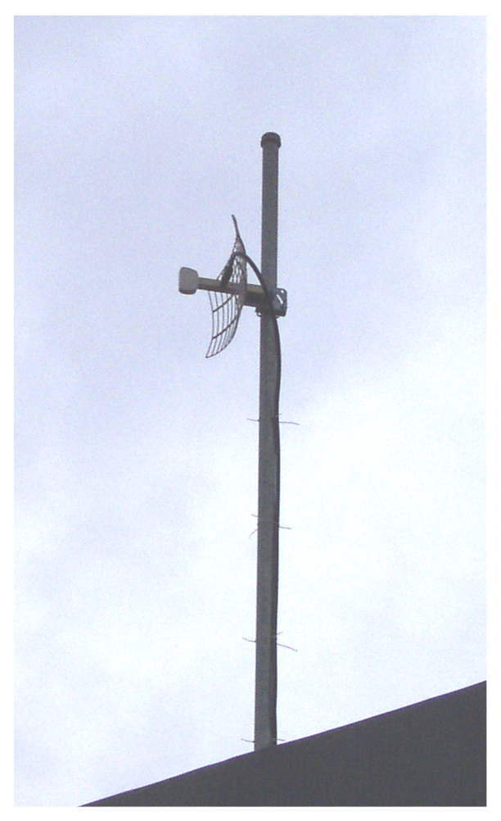
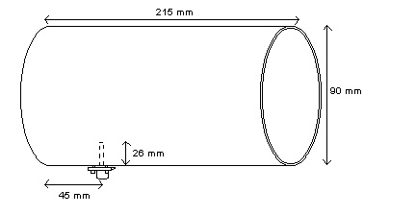
Analyzing cash flow in these Internet cafés, it would clearly shown that most of the money is actually going into Indonesian Telco pocket for paying the telecommunication lines, not to mention, current increase in Indonesian Telco’s tariff. It really drives the community to seek altrenatives to build our own network with out having to rely on Indonesian Telco. The easiest way, supported by ample technology for building the network is the wireless LAN technology running at 2.4GHz. With approximately US$150 / unit, one with strong Linux background may easily build a low cost gateway / router to integrate a LAN or a community to the Internet at 11Mbps if we put external antenna with sufficient gain to reach the Access Point. Shown in the picture is my 19 dBi 2.4GHz antenna used at home to integrate my LAN at home as well as my surrounding neighborhood to the Internet for 24 hour access at 11Mbps at Rp. 330.000 / month (approximately US$30 / month).

Building low cost home made 2.4GHz antenna is not that difficult, a tincan with 90 mm diameter, and 215 mm length can be easily used as 2.4GHz antenna and quite good for 3-4 km distances. It cost approximately US$5-10 per antenna. This tipe of antenna is currently being used by many Internet Cafes in Jogyakarta for reducing their investment.

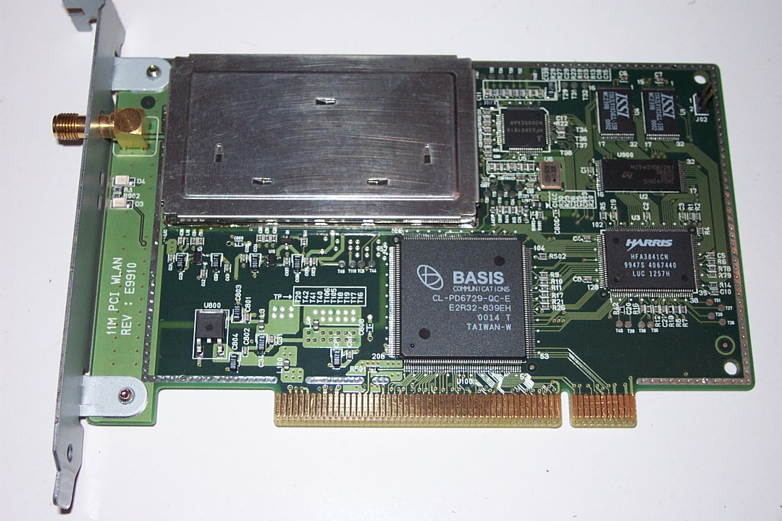
The 2.4GHz radio and modem is integrated into a US$150 wireless LAN card. It is fairly similar to normal Ethernet card. The major difference is in the antenna connector pop up at the end of the card to be used to connect the coax cable and external antenna to the card. The Linux’s driver of the card is available in public domain, such as, http://www.sourceforge.org will really help those who like to build their own infrastructure.

The 2.4GHz wireless Internet solutions can easily find on the Internet, such as, http://hydra.carleton.ca, http://www.wavelan.com, http://www.ydi.com, http://www.wipop.com, or at http://www.google.com use WLAN or 2.4GHz as keyword. One should explore alternative on 5 or 5.8GHz for the newest equipments.

Having the solution to build an alternative for high-speed local access network, we need to think on how to build the regional network. The only liberalized infrastructure for regional network is the satellite network. Most of Internet cafes in Bandung, Jogyakarta, Surabaya, Malang etc, are now adopting a hybrid satellite and wireless Internet infrastructure to build the whole community based infrastructure. As shown in the figure, several Internet Cafés, also known as WARNETs, share the satellite access to the Internet. Two ways satellite access will remove their depence to any Indonesian Telco operators for regional access.

Satellite access is quite expensive, it costs approximately US$5000 per Mbps per month. Thus, sharing the cost with 10-20 Internet cafés is very logical to reduce the cost to US$250-500 / month / Internet café. US$500 / month / Internet café is affordable knowing some of these cafés can easily get US$50-100 / day from their customer. High-speed wireless technology is used to share the bandwidth among these Internet cafés.

Another emerging controversial technology is the Internet telephony. References on it are freely available at http://www.ietf.org, http://www.iptel.org, http://www.sipforum.org and can be used to build a community based telephone network at very low cost. More and more heroic stories may pop up in the near future in building the infrastructure and bypassing the high tariff-ed conventional incumbent infrastructure. As expected, the government would likely to protect the interest of incumbent telecommunication operators.

I have to admit that these solutions may not be appropriate for some countries, especially those with tight rules on frequency usage. Most, if not all, the time, we run the equipments without any license from the government. Fortunately, the Indonesian media helps keep us from being jailed. We only hope to give the best and low cost solutions for the Indonesians to be integrated into the Internet & reducing any existence of digital divide.


Behind all the movement and activities in deploying such heroic infrastructure that rely heavily on the community initiative, I have to admit that educated, dedicated & militant people is the key of success. It shows clearly the strength of community education in attempting to transform Indonesia into knowledge-based society. The persons behind these high technology gadgets are young and energic enthusiasts. In the picture is the typical example of these young ones. In the figure, these young ones happen to be my students at Computer Network Research Group (CNRG) at Institute of Technology Bandung (ITB).

Grassroot Indonesian Internet Infrastructure

Aside from the commercial & legal ISPs, quite significant activities can be noted in some grassroots movements. Their activities are driving most of Indonesian Internet activities. They are the Internet Café and the high-speed (11-54Mbps) wireless Internet technology.

Currently (early 2002), there are 2000+ Internet Cafes in Indonesia. The data of the Indonesian Internet cafés may be downloaded from http://warnet.idaman.com and http://www.natnit.net. Most of the Internet Cafes are self-finance. Most of us are hanging out at asosiasi-warnet@yahoogroups.com at an average of 50-100 mails per day. The Indonesian Internet Cafés are organized under Indonesian Internet Café Association (AWARI). AWARI was founded in 25 May 2000, and currently leads by Judith M.S (me@judithms.com), Michael Suggiardi (michael@batutulis.com), and Abdullah Koro. One of the their ultimate objective is to fight for expanding our own network and implementing the concept towards self-finance community based network and most likely less depence on the Indonesian Telco services.

Based on the technology & business plan described freely in http://www.bogor.net/idkf, we managed to reduce the cost for public users to access Internet at Rp. 5000 / hour (approximately US$0.5/hour) at various Internet cafés. At Indonesian schools, the cost for accessing the Internet can be brutally reduced to Rp. 5000 / month / student (approximately US$ 0.5/student/month). Thus, Internet is actually accessible to a much wider range of people than simply those who can afford a personal computer. Investment for building Internet café in the range of Rp. 50-100 million (approximately US$5-10.000) would return easily within one (1) to two (2) year time. Thus, it is not surprising to see many small medium businesses as well as schools are now putting their money to build their own Internet infrastructure. Internet Café is an affordable solution for Indonesian to access the Internet. Having 25.000 high schools with 2-3 million students, it would a strategic move increase the Internet penetration by Interneting the schools (currently only 1200+ schools & 200+ universities are on the Internet). We have to admit that Dr. Gatot H.P. (gatothp@aol.com) at Ministry of Education is phenomenal in leading the Indonesian vocational schools to the cyberspace. If conducive policy is implemented, it may enable 20+ million Indonesians to Internet in next 4-5 years. More over, no loan is necessary from the World Bank, IMF & ADB.

High-speed (11-54Mbps) wireless Internet is used technology to build the community based Internet infrastructure with no Telco. It runs on Instrumentation Scientific Medical (ISM) band in 2.4GHz and 5-5.8GHz. At the moment, it is being used by 1000+ corporate users including the good Internet cafes and some residential users like me at home. Most of the wireless Internet operators are hanging out at indowli@yahoogroups.com and fighting for low cost, if not free, frequency license. We hope no tariff is required for people to use the air.

Some Final Remarks

Copyleft & copywrong movement done by many volunteers (not the government) really help in providing knowledge to the society. It empowers bottom up processes through technical literature publications in various printed media and books, as well as many Internet mailing lists, mostly, hosted at yahoogroups.com.

Having the knowledge distributed to the society, it helps educating the society and enables them to build their own infrastructure. In the end, a self-finance bottom-up Internet infrastructure is build & driven by the people with no World Bank, ADB, IMF and no government involvement.

Wireless Internet & Internet café technology is the key infrastructure. Most of the infrastructures are self-finance by the Indonesian people with no WB, IMF & ADB funding. One may later question the need of Bank’s loan.

