Typical Mainstream Approaches

In this chapter, I am very much bias to typical Indonesian Government approaches, such as,

- Set idea & surrounding issue of an important idea, e.g., ICT infrastructure for rural, telecenter, e-government, regional autonomy, and decentralization.
- Spread the idea. Organize many seminars, workshops, and videoconferences with many International bodies through out the country.
- Do piloting. Getting some funding or loan for pilot project & run the project to show the results.
- Get some loan. Proposed loan for larger scale implementation.
- Set the policy & legal framework to privatize & to liberalize the market for replication or scaling up.
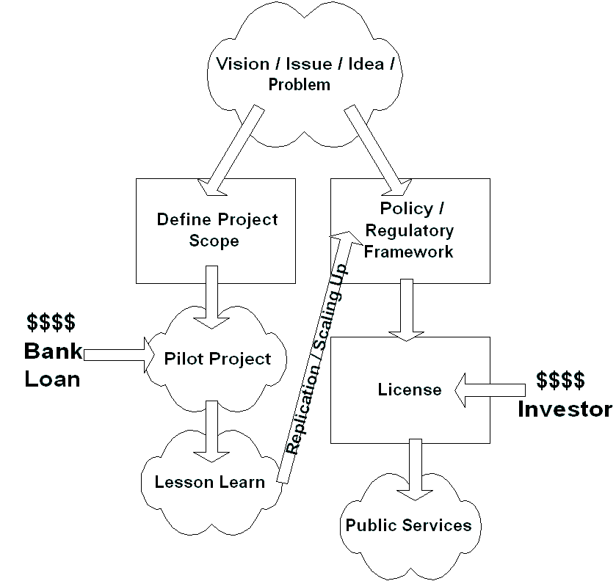
- Promise the best. Hope for sustainability.

Such approach may accelerate development process and most appropriate route in a committed and clean government. In a heavily corrupted government, such route is unfortunately just another way to propose a project and getting at least 60% of the fund into the official’s personal account. It is a painful nightmare for those who live in the country. A corrupt environment will unfortunately impede government ability to reach their objectives / vision if any.

“Building” the Super Highway.

One may ask – how does the government of Indonesia contribute in facilitating the transformation of Indonesian people into the cyber space?

Honestly, the government of Indonesia (GoI) is putting a lot of money into it & setting several national teams for it. In 1998, lead by Jonathan Parapak, we worked on the Nusantara 21 concept; the softcopy of Nusantara 21 concept can be downloaded from http://www.bogor.net/idkf/. At that time, many nations were working on their National Information Infrastructure (NII) ignited by Al Gore’s Global Information Infrastructure (GII) initiative.

The Nusantara 21 concept was than being used as reference by the National Coordinating Team for Telematics set by the Indonesian presidents (both Mr. Habibie and Pak GusDur). Their concept was adopted by BAPPENAS (the National Development Coordinating Body) and was used for getting a World Bank loan. A US$ 34,5 million World Bank loan went into Indonesian Information Infrastructure Development Program (IIDP) that was approved in November 1997. There is no grant & charity in the commitment. The project closing date is 06/30/2003. To be honest, from IIDP Project, nothing is left for the Indonesian people. Unfortunately, the Indonesians have to return the loan ☹

Information Infrastructure Development Program (IIDP) consists of several smaller projects, such as,

- TATP the Training Assistantship for the civil servant at Ministry of Industry and Trade as well as small percentage to selected Small Medium Enterprises.
- IPTEKnet concept at Ministry of Research and Technology, for integrating the government institutions to the Internet. It would be the base for Indonesian e-government.
- E-commerce concept at Ministry of Tourism.
- Copyright Law at Ministry of Law & Legal Matters.
- National Information Technology Framework at BAPPENAS, the National Development Coordinating Body.

If I can say it in a plain language, most, if not all, of the funding is gone for paying the International consultants to write pages of concepts, working papers, law & legal matters. To best of my knowledge, no investment in real infrastructure and things that really help the people access the Internet. Thus, these hundred of billion Rupiah has very little direct impact to the Indonesian people.

In tactical framework, basically, no creativities are allowed. Everything must registered, and request for licensed. Sweeping activities to revoke and to seize “illegal” VoIP & Wireless Internet equipments is common. It is interesting to note that some of these “illegal” VoIP equipments are legally located at the Incumbent automated switching building. Not to mention the unofficial government taxes born by the small medium enterprises, such as, the Internet cafés.

Licensing may be a way to liberalize the market. In the implementation, it may be used as financial compensation for the officials and no room for homebrew equipments. Not much room for community based infrastructure possible within the current policy / regulatory framework.

In the year 2001, the state ministry of research and technology is launching the Internet Café Technology & Science Technology CD. Since the Indonesian government has some budget limitation, the one who drive behind the activities are mostly coming from the private sector. The Internet Café Technology aims to build 9000 Internet café with the investment from private sector, such as, Myoh.com and Hewlett Packard (HP) Indonesia. The investment will then be returned by the Internet café users though its access fee. In the early 2002, they managed to build a couple of these Internet cafés.

The Science Technology CD contains the research done under the state ministry of research and technology. It is distributed freely to the public. Sekolah 2000 foundation (http://www.sekolah2000.or.id) and Master Data with a lot of sponsorship from private sectors supports the production and distribution of the CDs.

To best of my knowledge, the only government movement that managed to provide significant impact on Indonesian Internet society is the vocational school’s Internet movement (dikmenjur@yahoogroups.com). Dr. Gatot H.P. (gatothp@aol.com), the director of vocational schools at ministry of education, is the one who drive the movement. Unlike other bureaucrats, Dr. Gatot H.P is very responsive on e-mail. In the year 2001, he work closely with other Indonesian Internet societies to integrate all vocational schools to the Internet. In 2005, their team managed to connect 4000+ Indonesian vocational schools into the Internet. We are very proud on their accomplishments.

The Indonesian people should currently be happy with the support from the Indonesian private sector. Private sector’s investment and various sponsorships are the one that keep Indonesian Internet alive today. It is sad that only small fraction of the billions loan directly reaches the Indonesian people. One may ask the necessity of the previous Bank’s loan.

Incumbent Paranoia

Incumbent paranoia seems to be the major current illness in the Indonesian telecommunication industry. Privatizing the Indonesian Telco with delayed market liberalization tends to distort the market in favor the now private majority Incumbent. While the 1999 Indonesian telecommunication acts (can be downloaded from http://www.hukumonline.com) guarantees a fully competitive telecommunication industry, the incumbent tried to use its power to distort the industry. Some of the examples are:

- Delay investment for better tariff; take years in waiting list to get a new line.
- Internet Service Providers (ISP) in Kalimantan, Sulawesi, Bali, Sumatra have to pay US$30/incoming call line/month from the normally US$3/month/incoming call line.
- Some ISPs, like IndosatNet, have to suffer as their request for E1 lines have been rejected.
- Request for E1 lines in offices are purposely rejected. VoIP has been indicated as the main reason.
- Request for leased line from ISP, is redirected to use TelkomNet (the incumbent owned ISP).

Interestingly, no action are carried out by the authority although a written complain has been filed.

As expected, the government policy is lagging and full of holes in many aspects. No competitive safeguard is one of the major flaws in government policy framework. In addition, old paradigm that ISPs must uses dial-in port still intact in government mind, thus, no ISP licenses will be granted for those ISPs that are not using dial-in port, such as, WiFi based ISP.

