Monitoring the Gatekeeper Activities

Monitoring the activities on a Gatekeeper creates a lot of headache for most network administrator. Fortunately, openh323 gatekeeper gnugk equipped with two (2) mechanisms to monitor the activities in a Gatekeeper, namely,

- Through status port (normally telnet to port 7000).
- Tracing the activity of a Gatekeeper through command line –ttt.

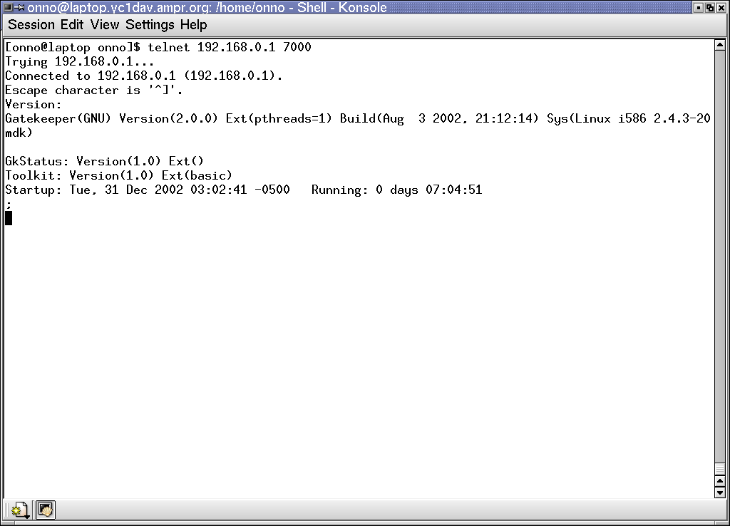
Monitoring the Gatekeeper Status Port

Telnet to the Gatekeeper at port 7000 will connect us the status port of the gatekeeper. Short banner on the Gatekeeper will be shown. The above screen shot is taken after,

telnet 192.168.0.1 7000

Assuming a gatekeeper is running at 192.168.0.1.
One of the headaches for beginner operator is to know all the command of the status port. By simply entering “h” command, we will see all the commands of the status port.
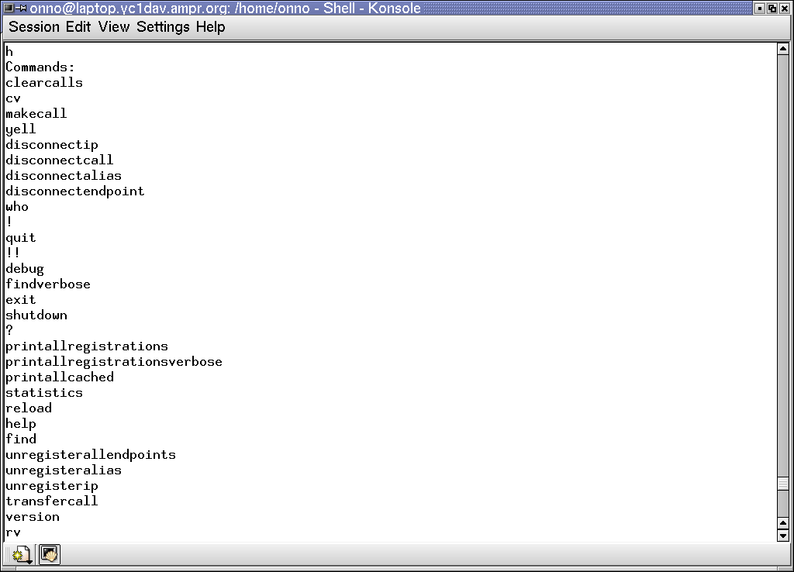
Some of the commands are quite straightforward. Some of the frequently used commands have a single two characters shorten command.

A complete description on each command can be found on the openh323 gatekeeper gnugk manual. The manual is normally shipped in the ZIP or tar file of gnugk binary. Or one can always check their web site at http://www.gnugk.org.

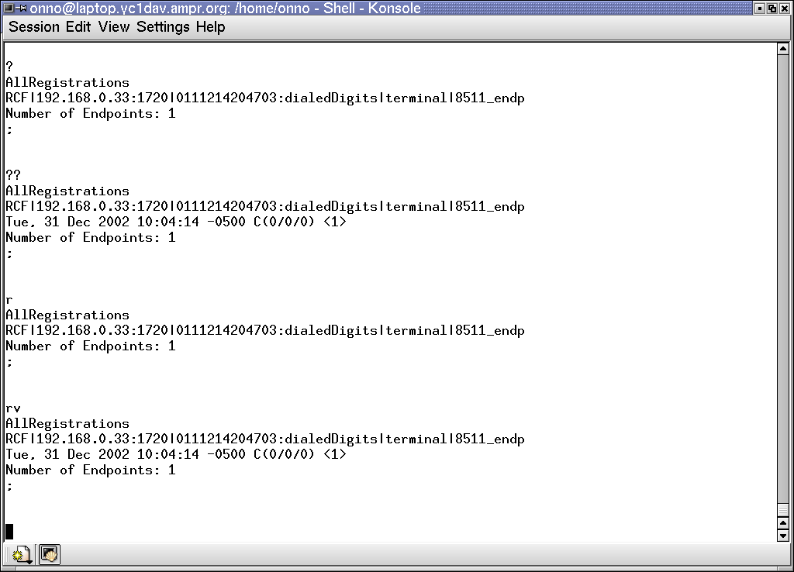
A glimpse on the frequently used status port commands, “?” or “r” will show all the endpoints and gateways register to the Gatekeeper.

“??” or “rv” shows a more elaborate information on the registered endpoint / gateways.

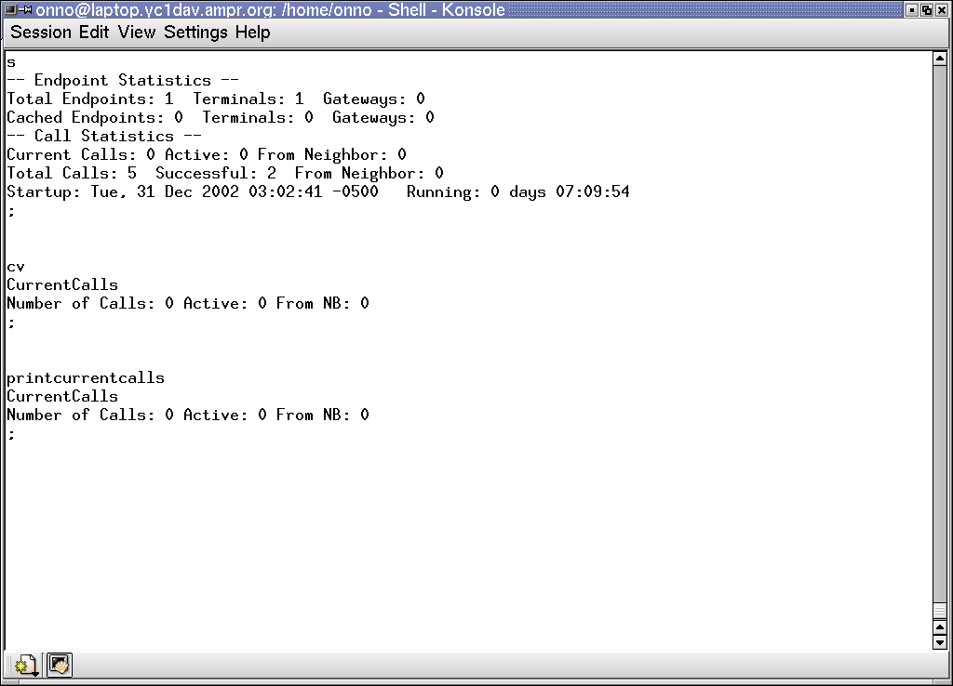
Through the “s” command, we can see the statistics of the Gatekeeper, such as, total registered endpoints, total calls, how many successful calls, how long has it been running etc.

The “cv” or “printcurrentcalls”, we can see the detailed information of current call over our Gatekeeper.

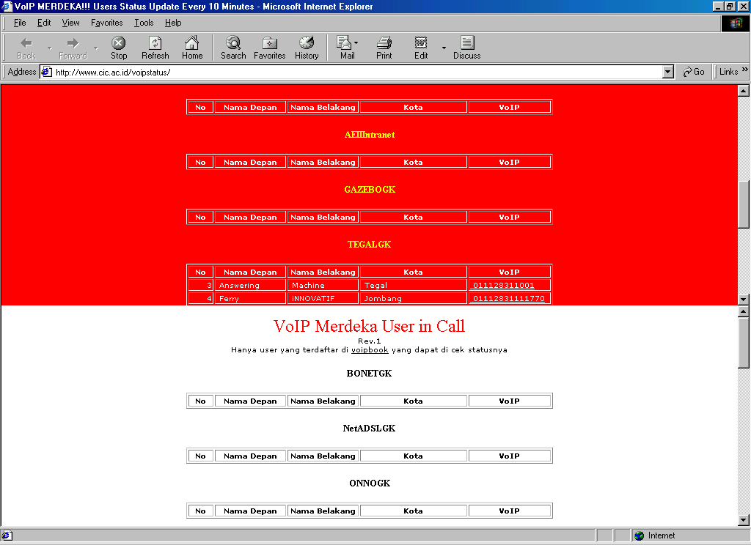
For those who are quite creative can easily write a script to get the information from the status port and put into a user-friendlier Web interface. The script may also be written to get the information from several Gatekeepers simultaneously.

Shown in the figure is the Web interface at http://www.cic.ac.id/voipstatus/ to monitor online VoIP users on more than 20 gatekeepers. The Web interface is written by Ken a collage student at STMIK CIC in Cirebon city under supervision of Harijanto Pribadi harijanto@besmart-it.com.

To be able to access the status port of the Gatekeeper, one has to ask permission to the administrator of the Gatekeeper.

Tracing the Gatekeeper Activities

Another way to see the activities in a Gatekeeper is by tracing the Gatekeeper. To be honest, telnet to the status port would give a much user-friendly results. Anyway, if you wish to debug what’s going on in the Internet Telephony Gatekeeper / infrastructure, tracing a Gatekeeper may give some insight of the infrastructure. There is several level of tracing. The examples of tracing command line are,

gnugk –t –c /etc/myconfiguration.ini –o /var/log/trace-result
gnugk –tt –c /etc/myconfiguration.ini –o /var/log/trace-result
gnugk –ttt –c /etc/myconfiguration.ini –o /var/log/trace-result

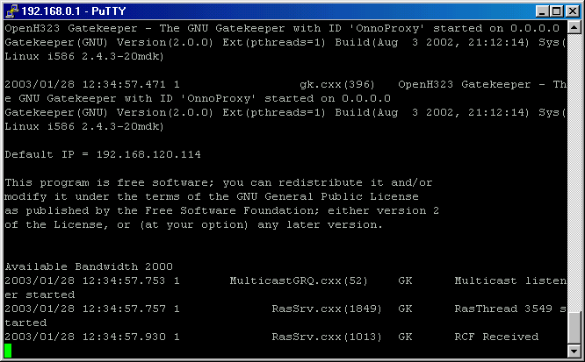
the –o switch is used to redirect the tracing output to a file to be examine later. The –t switch actives the tracing process. The more –t, the more result will be shown and will likely to get confused.

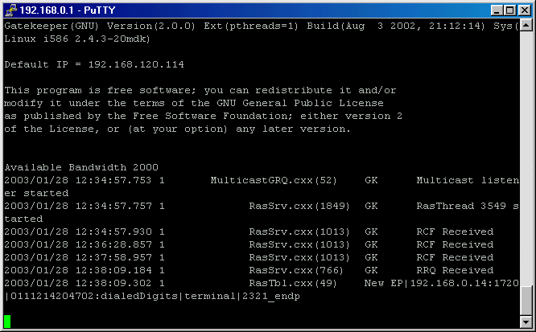
In the following figure, it shows an Endpoint (EP) at IP address 192.168.0.14 using a phone number 0111214204702 registered to the Gatekeeper. The registration is shown as New EP in the last line. One line prior to registration of the Endpoint (EP), the Gatekeeper received a message RRQ, a Registration Request.

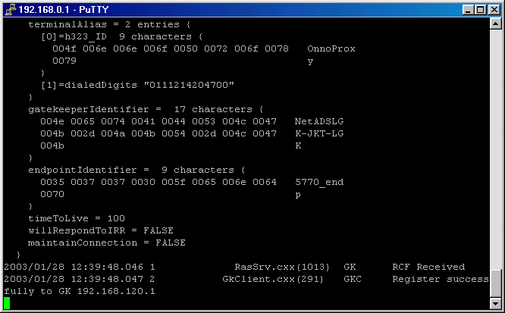
In the following figure we use more trace switches –ttt. We will see a much more messages on the console screen.

The figure shows a child Gatekeeper register to a parent Gatekeeper at IP address 192.168.120.1. Shown in the last two (2) messages, our Gatekeeper received an RCF (Registration Confirm) message from 192.168.120.1; and our Gatekeeper client module saying that “Register successfully to GK 192.168.120.1”. Such message is very important in proxy Gatekeeper configuration to make sure that it registers correctly to the public Gatekeeper.

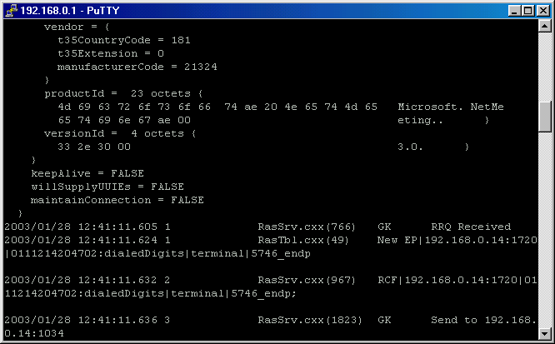
In the figure, the trace (-ttt) result of a registration process of an Endpoint (EP) to the Gatekeeper is shown. In the last four (4) messages, it shows a Registration Request (RRQ) is received from 192.168.0.14 New Endpoint (EP). Gatekeeper immediately sends Registration Confirm (RCF) message to 192.168.0.14 as shown in the last two (2) lines.

