Internet Telephony Gateway

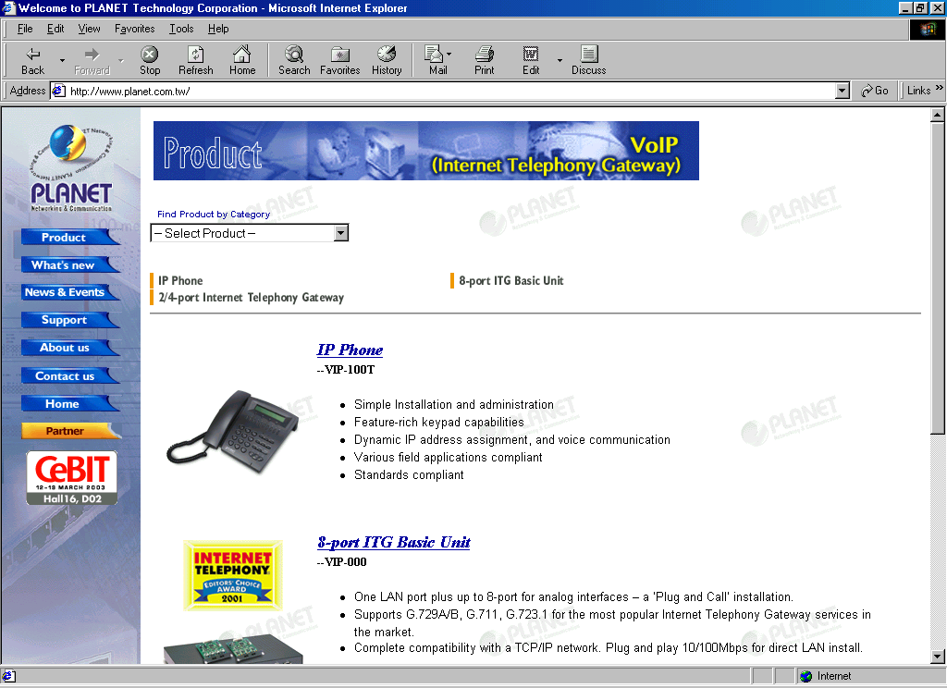
In my experiments, I used Planet Internet Telephony Gateway (ITG) build in Taiwan. The ITG can be reviewed at http://www.planet.com.tw.

I use Planet Internet Telephony Gateway (ITG) in this experiment, as they are the only one who lent me Internet Telephony Gateway. I am always open for any other Internet Telephony Gateway (ITG).

Planet’s Internet Telephony Gateway (ITG) as well as many others Taiwanese VoIP equipments is quite reliable & much lower cost than Cisco. Configuration of an Internet Telephony Gateway (ITG) is quite simple. It can be performed through telnet, serial port or web interface.

An ITG is fairly similar to a hub. It has an RJ-45 connector for LAN connection. It has several RJ-11 connectors for connection to phone, PBX and Telco.

InterNet Telephony Gateway (ITG) Four (4) Ports

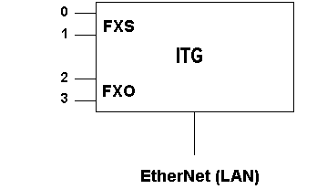
The most favorite Internet Telephone Gateway (ITG) is the four (4) ports ITG, such as, the Planet VIP-400 series. There is several RJ-11 port configurations of VIP-400 series ITG, namely,

- 4 FXS
- 4 FXO
- 2 FXS & 2 FXO

In the figure, it is shown the 2 FXO & 2 FXS configuration. FXS is an RJ-11 that has a 48-volt in it. FXS is fairly similar to Telco. It can be connected to the phone and CO-line of PBX. FXS is good for those who like to use the VoIP using a phone without any computer.

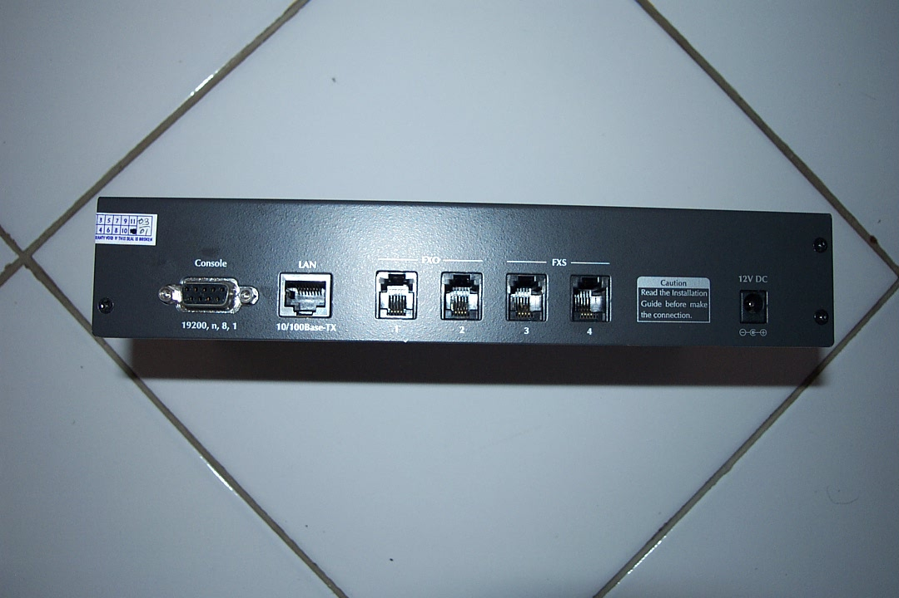
FXO is an RJ-11 that has no voltage in it. It is fairly similar to a phone. FXO can be used to connect directly to Telco’s line or Extension line from PBX. FXO lines are normally used for bypassing long distance calls.

For programmer of ITG, we must be a bit careful as the port numbers printed on the back of ITG as 1, 2, 3, and 4, should be programmed as channel 0, 1, 2, and 3.

Each port will consume about 12-13 Kbps in full duplex. It means a VIP-400 ITG series will consume about 50 Kbps if all ports are operational in full duplex. It will surely consume the whole dial-up Internet connection. Having about 50 Kbps bandwidth, it will surely be used a 64 Kbps leased line.

To give some ideas on its price, in early 2003, a VIP-400 series in Indonesia will cost about US$ 450. While in the year 2002, a VIP-400 is about US$ 600. I strongly hope the price will going down by time.

InterNet Telephony Gateway (ITG) with Eight (8) Ports

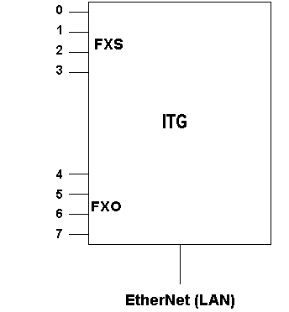
For big offices with 24 hours 128 Kbps leased line connection or higher speed. It may be possible to use eight (8) ports Internet Telephony Gateway. It will consume about 110 Kbps when all ports are in operation in full duplex.

Planet VIP-000 is an example of eight (8) ports ITG. It has two (2) slots. A planet’s ITG comes with a modular 4 RJ-11 ports slot. Populating the slot with two (2) modules, we have several configuration of VIP-000, namely,

- 8 FXO
- 8 FXS
- 4 FXO & 4 FXS

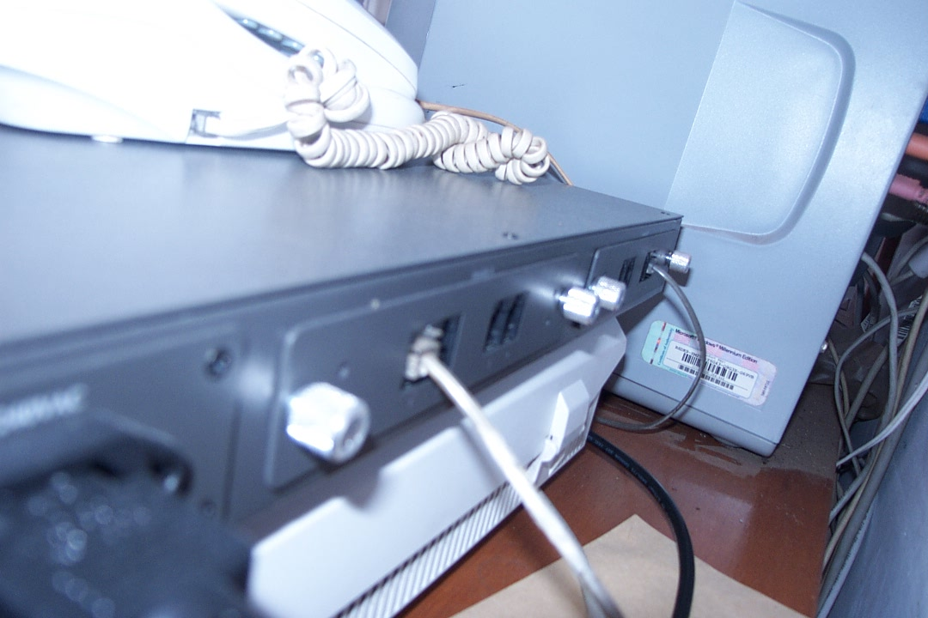
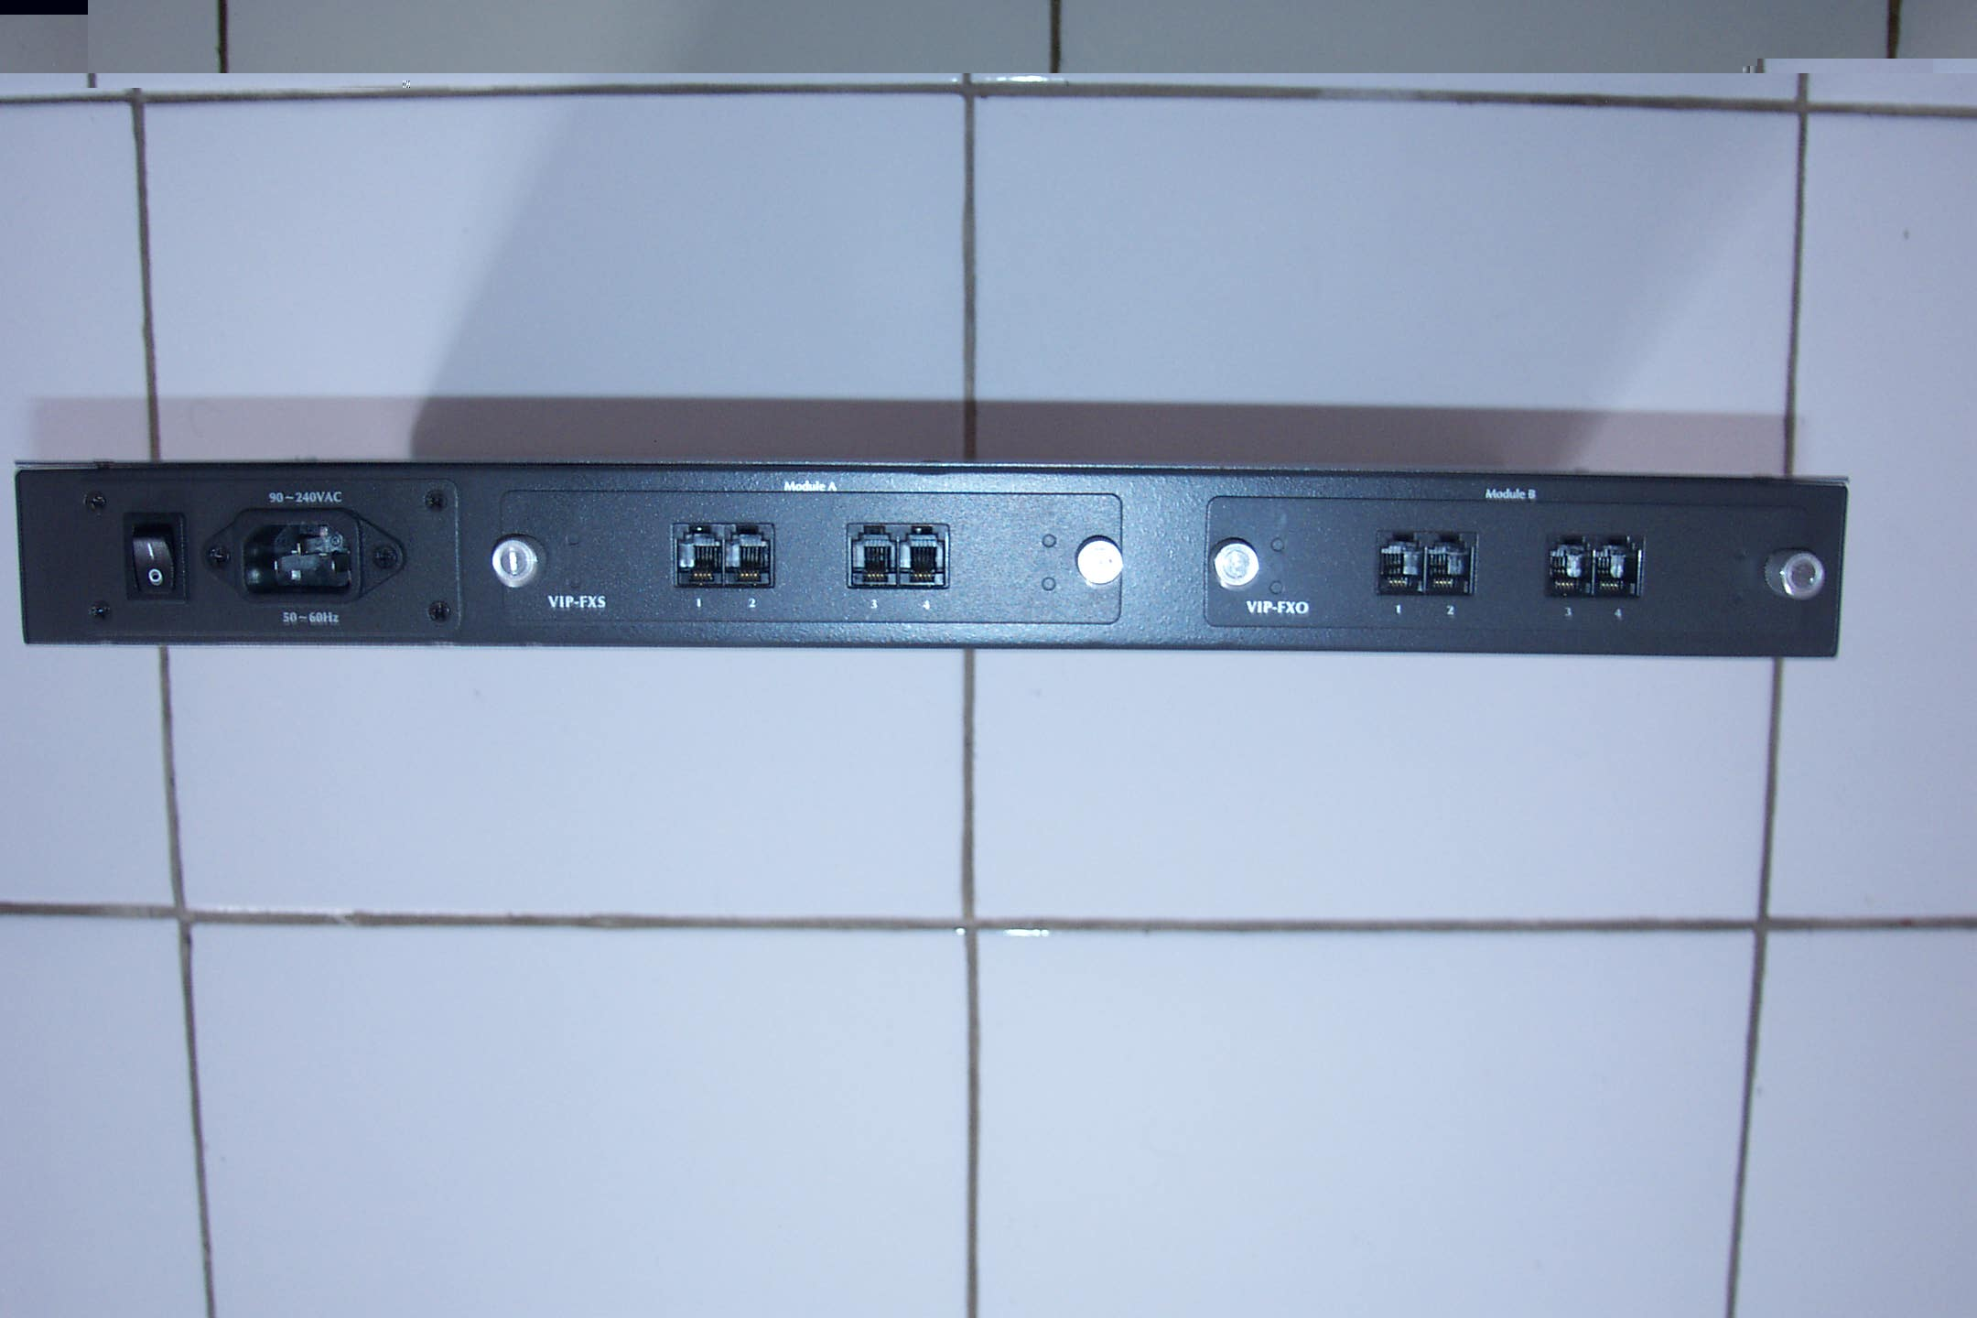
Shown in the figure is the Internet Telephony Gateway (ITG) VIP-000 with eight (8) RJ-11 ports. Programmer should be caution as the port number on the back of module A and module B is actually the same, namely, 1, 2, 3, and 4. Module A 1-4 is programmed as 0-3. While module B 1-4 is programmed as 4-7.

