Internet Telephony Gateway As Part of Internet Telephony Infrastructure

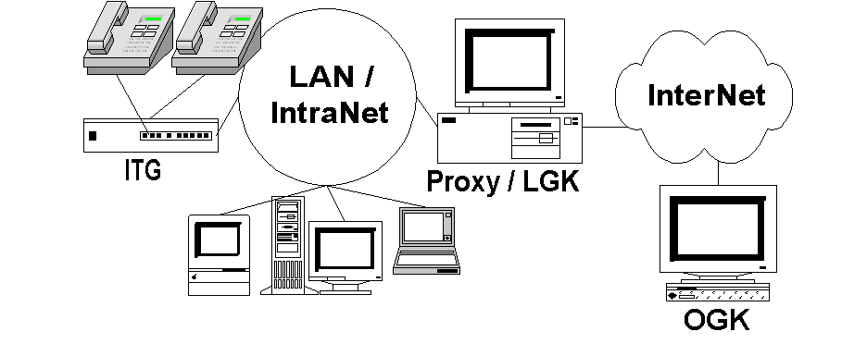
In this chapter, we will discuss on how to integrate an Internet Telephony Gateway (ITG) into an Internet Telephony infrastructure. The assumed topology is the Internet Telephony Gateway (ITG) is located behind a firewall / proxy server. The ITG will register to a Gatekeeper located at the proxy server. The proxy Gatekeeper should be run to in routed mode. The proxy gatekeeper must register to a higher level Public Gatekeeper on the Internet.
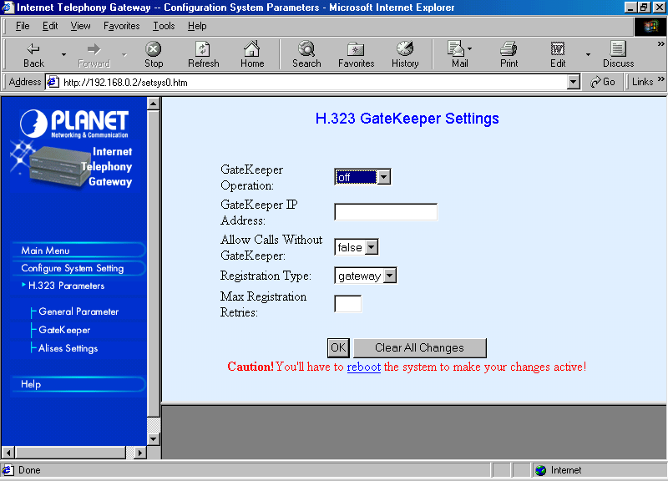
For those who are a little bit allergic in setting an Internet Telephony Gateway (ITG) through text mode interface, may set the Internet Telephony Gateway (ITG) through the Web. Although, configuring an ITG through the text interface may have much more options rather than the Web interface.
Integrating an Internet Telephony Gateway (ITG) into a Internet Telephony Infrastructure is fairly simple. All we need to configure are,

- Configure the port phone number.
- Configure the Gatekeeper to register to.
- Configure the phone number to be registered to the Gatekeeper.

In some cases, we can do the above configuration manually from the Gatekeeper side.

One of the most difficult settings would be to integrate the FXO ports on the Internet Telephony Gateway (ITG) to PBX. Such configuration will enable other Endpoint (EP) on the Internet to call to Telco’s phones through the PBX and, thus, bypassing the long distance charges. It may violate the telecommunication law & regulation though.

If we are a bit creative, we can register our Telco’s number, e.g. 06132322200, to the Gatekeeper. While this number is actually mapped to the Internet Telephony Gateway (ITG) connected to local PBX. Such scenario will than enable anyone on the Internet Telephony Infrastructure to call the same phone using Telco’s phone number without using any Telco’s line.

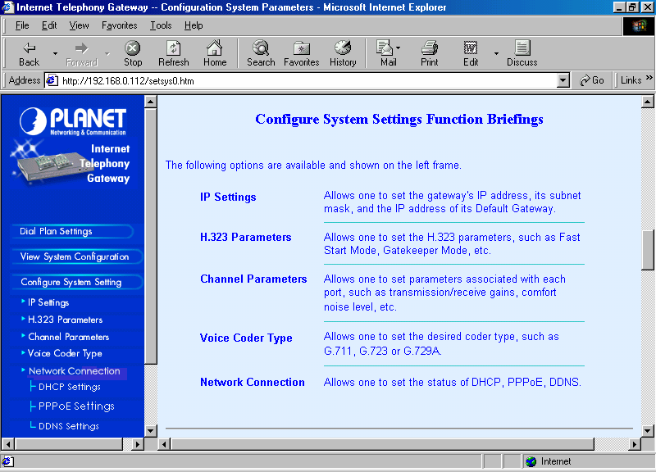
Configure System Settings
Through the configure system settings section on the Web, we can configure,

IP Settings.
H.323 Parameters
Channel Parameters
Voice Coder Type.

In addition to it, we can configure the network connection parameters, such as, PPPoE, DHCP and DDNS.

Setting the General H.323 Parameter
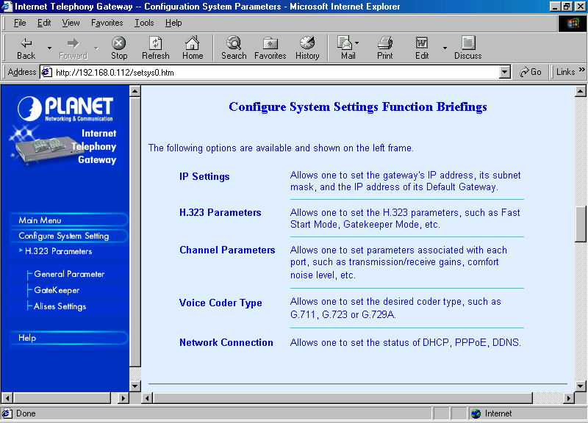
Integrating an ITG to a Internet Telephony infrastructure can be done through programming the Configure System Setting → H.323 Parameters.

There are three (3) parameters to be programmed, namely,

General Parameter
Gatekeeper
Alias Settings

Gatekeeper & Alias Settings are the two (2) important parameters to be configured. The General parameter may be leave as it is.
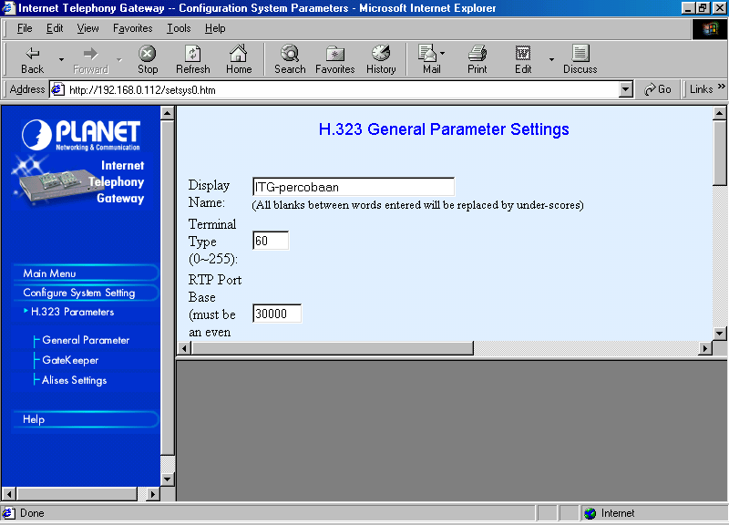
In the General Parameter settings, we can set the display name of the ITG, Terminal type, RTP ports. The Terminal type is normally set around 60.

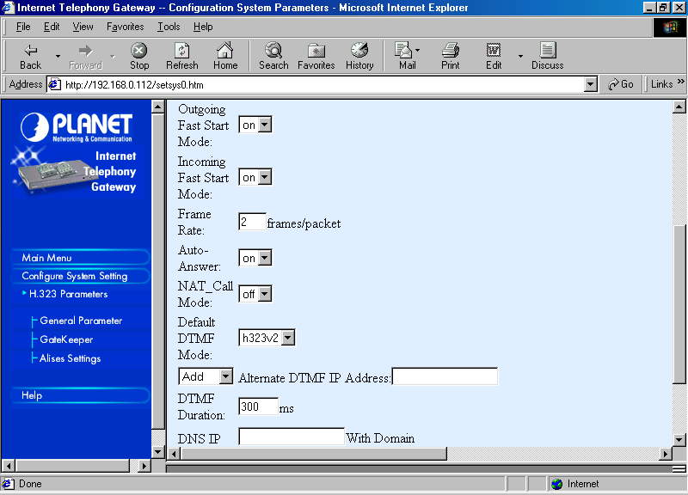
In the next General Parameter settings, we can set the outgoing fast start and incoming fast start to on. It will give a significant effect to NetMeeting calls from PC. The General parameter may also be used to set the Auto Answer; NAT Call mode if it is located behind a NAT box.

Registering an ITG to a Gatekeeper
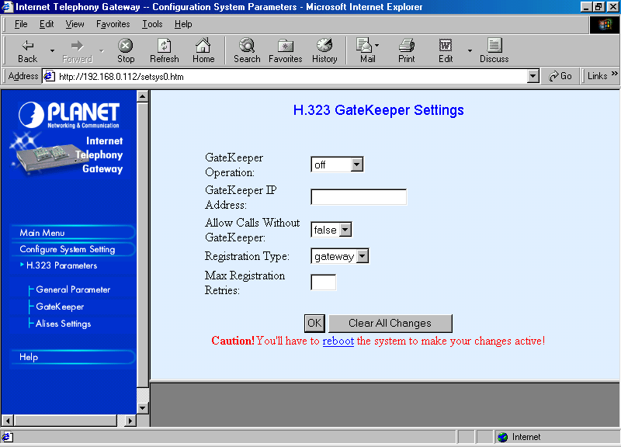
The most fatal parameter in configuring the Internet Telephony Gateway (ITG) is in settings the H.323 Gatekeeper. It can be done through Configure System Settings → H.323 Parameters → Gatekeeper.

The default Internet Telephony Gateway (ITG) runs without any Gatekeeper. However, in a complex Internet Telephony infrastructure, a gatekeeper is an integral part of the Internet Telephony infrastructure. Thus, it is necessary to register the ITG to one of the gatekeeper.

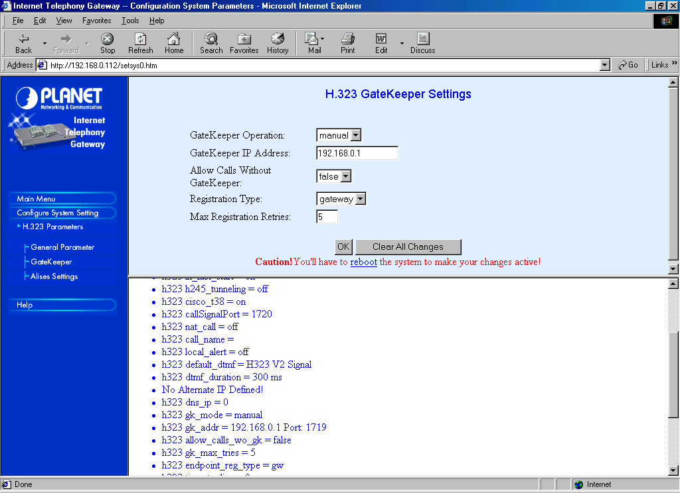
There are two (2) options in registering to the Gatekeeper, i.e., manually or Automatically registering to the Gatekeeper. Problem will likely to arise in automatic registration especially if there are several Gatekeepers running in the network. Thus, it would be advisable to manually register to the Gatekeeper.

We need to specify the IP address of the Gatekeeper. The IP address must be correct with a real Gatekeeper running.

The registration type can be either as gateway or terminal with many phone numbers.

In a Internet Telephony infrastructure with many Gatekeepers, it would be advisable to set the Gatekeeper manually. In manual settings, we need to correctly set the IP address of the Gatekeeper.
I normally set the “Allow Calls Without Gatekeeper’ as false. It will force all calls to be made through the Gatekeeper.

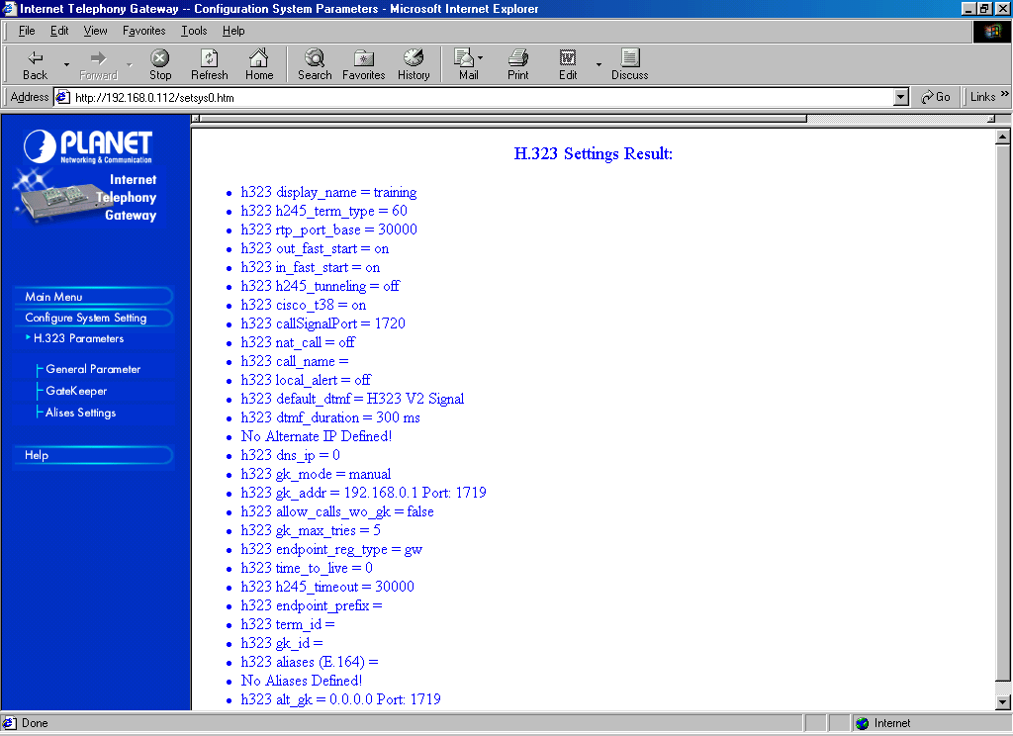
After the configuration is completed, the Internet Telephony Gateway (ITG) will show all the H.323 parameters to be reviewed.

At this point, we have configured the Internet Telephony Gateway (ITG) to register to the Gatekeeper during Internet Telephony operations.

Having the Internet Telephony Gateway (ITG) register to the Gatekeeper is one thing. It is important for the ITG to tell the Gatekeeper; the number it serves. There are basically two (2) ways to register the number to the Gatekeeper, namely,

- Registering a list of phone number – normally in E.164 format.
- Registering the area code – normally through setting the endpoint prefix.

Registering E.164 Phone Number
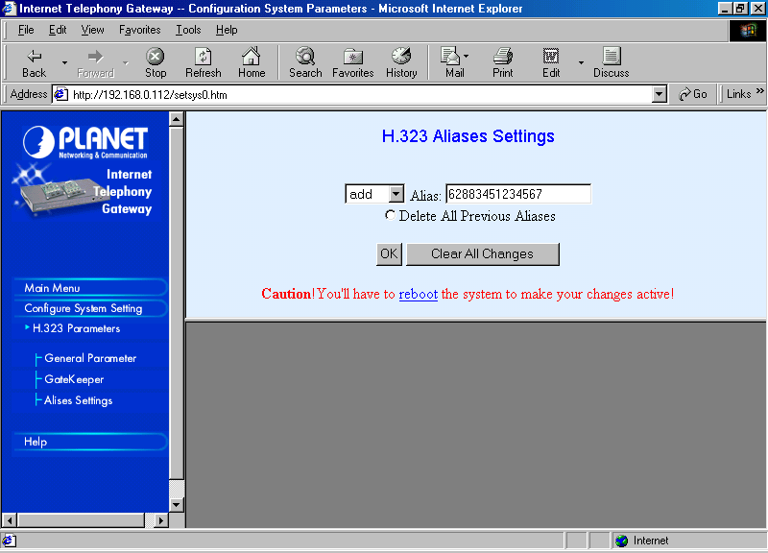
To registering the list of phone number served by the Internet Telephone Gateway (ITG), we need to list it one by one through Configure System Settings → H.323 Parameters → Alias Settings. We can add or delete a certain number from the list.

To remove all previous number, we can “Delete All Previous Aliases” before we add new phone number into the Alias Settings.

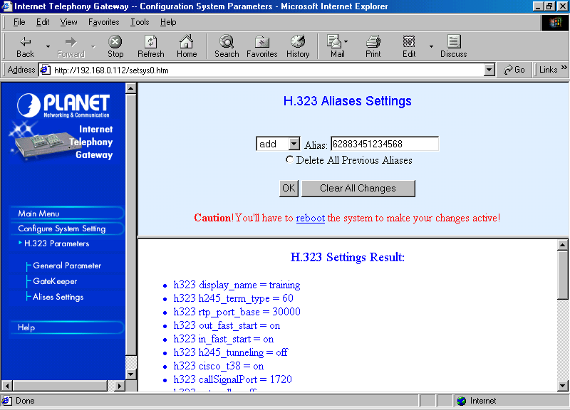
Each phone number has to be added manually through the add option and click OK afterward.

Note that the phone numbers added to the H.323 Aliases are basically any number. Telco’s number may also register into the H.323 alias. Consequently, we can call phone using its Telco’s phone number from Internet Telephony infrastructure.
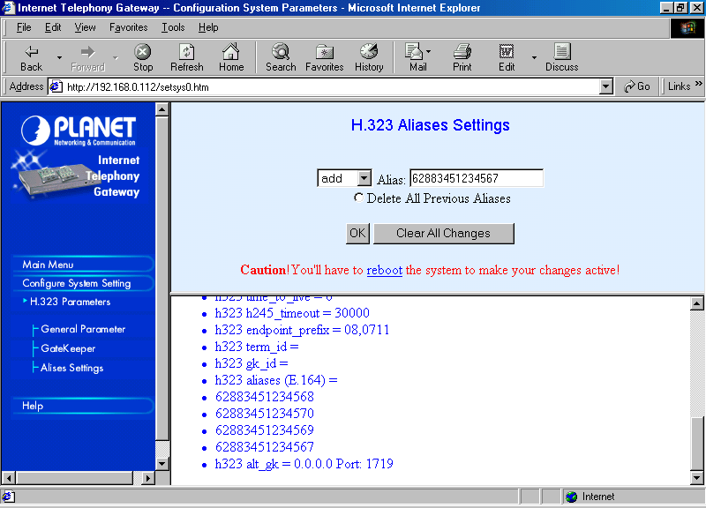
After all phone numbers are registered into the H.323 Aliases. The ITG will show the list of phone number entered for review.

Shown in the examples, the listed numbers are,

h323 aliases (E.164)=
62883451234567
62883451234568
62883451234569
62883451234570

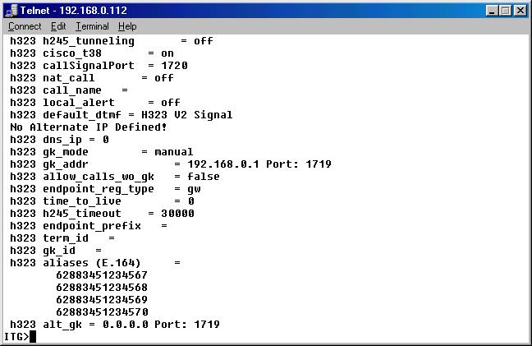
A similar result will be showed via telnet console.

As we enter the command “show h323”, it will show all the configure H.323 parameters inckuding the H.323 aliases (or E.164).

Having the Internet Telephony Gateway (ITG) registering its phone number to proxy Gatekeeper is not enough. All Endpoint (EP) within the IntraNet will be able to call the phone number registered on the Internet Telephony Gateway (ITG), as the phone numbers are registered to the local proxy Gatekeeper.

To enable all Endpoint on the Internet to be able to call the phone number on the Internet Telephony Gateway (ITG) located behind the firewall. We need to program the proxy Gatekeeper to manually register the number to the public Gatekeeper on the Internet. Thus, the same phone numbers registered in the Internet Telephony Gateway (ITG) must be programmed manually in the proxy Gatekeeper to be registered to public Gatekeeper on the Internet to broadcast it to the rest of Endpoint (EP) on the Internet.

Programming of proxy Gatekeeper at the proxy server to register the phone number to public Gatekeeper on the Internet is performed through [Endpoint] section. Example of the configuration in the proxy Gatekeeper is listed below,

[Endpoint]
Gatekeeper=202.53.224.172
Type=Gateway
H323ID=TestingProxyGK
E164=62883451234567,62883451234568, 62883451234569, 62883451234570
TimeToLive=100
RRQRetryInterval=10
ARQTimeout=2
UnregisterOnReload=1

The phone numbers to be broadcasted to the public Gatekeeper on the Internet is listed in the E164 parameter. The IP address of the public gatekeeper is listed in Gatekeeper parameter. If we want to let the public Gatekeeper knows that the proxy Gatekeeper serves a certain prefix, it can be done through prefix parameter in the proxy Gatekeeper configuration.

Note that each public Gatekeeper is normally serving a certain prefix. For example in the Indonesian Free Internet Telephony MaverickNet, the list of public Gatekeeper with its prefix are as follows,

202.155.39.157 - for area code 62 88 (Root Gatekeeper).
218.100.4.194 - for area code 62 88 888
      - - for area code 62 88 999
202.150.8.15 - for area code 62 88 925

We have to make sure that the registered phone number used in Internet Telephony Gateway (ITG) and proxy Gatekeeper use the same prefix as the public Gatekeeper. If it is not using the same prefix, no one on the Internet will be able to call the ITG behind the proxy Gatekeeper.

In some cases, we want to register into the public Gatekeeper using our own phone number. It can only be done through the main / primary Root Gatekeeper. Say we want to register 16132322200 into the public Gatekeeper. In the Indonesian Free Internet Telephony MaverickNet can only be done via the Root Gatekeeper at 202.53.224.172 that does not assumed for any prefix.

Note that if a Telco number is registered into the Root Gatekeeper, it enables all the phone on the Internet Telephony infrastructure to call the Endpoint using Telco’s phone number. It may not be necessary to pass the traffic via Telco’s infrastructure as all will be done through the Internet.

Registering an Area Code
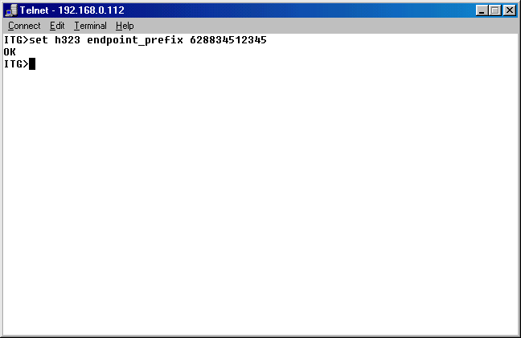
Rather than registering the phone number one by one, another alternative to registering the phone number is by registering the whole prefix or area code.

Unfortunately, the setting process to register a prefix served by a Internet Telephony Gateway (ITG) to the proxy Gatekeeper cannot be done through the Web Interface. We need to configure it through the console text mode interface, namely,

set h323 endpoint_prefix 628834512345

By configuring the prefix, we don’t need to list all the phone number one by one through E.164, rather the whole prefix / area code in a single command.
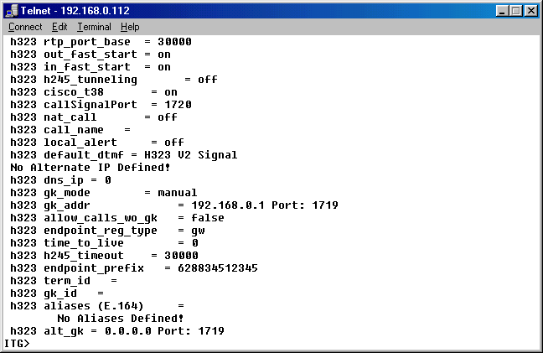
By entering the command “show h323”, we will see all the configured H.323 commands on the Internet Telephony Gateway (ITG). Make sure the h323 endpoint_prefix has been configured to the correct prefix.

Note that in this setting, the E614 paramater can be leave blank.
At this point, the proxy Gatekeeper will knows that the Internet Telephony Gateway (ITG) serving a certain prefix, in this case, 628834512345. However, to enable all Endpoint (EP) on the Internet to call the ITG, we need to program the proxy Gatekeeper to register the prefix to the public Gatekeeper.

The configuration of proxy Gatekeeper to broadcast a certain prefix to public Gatekeeper can be done through the [Endpoint] section. Shown in the listed example is part of section [Endpoint] that will enable the proxy Gatekeeper to register the prefix to public Gatekeeper, i.e,

[Endpoint]
Gatekeeper=202.53.224.172
Type=Gateway
H323ID=TestingProxyGK
Prefix=628834512345
TimeToLive=100
RRQRetryInterval=10
ARQTimeout=2
UnregisterOnReload=1

Note that we need to program only one / single prefix to cover the whole list of number under the same prefix. In this example the public Gatekeeper used is the Root Gatekeeper 202.53.224.172 of the Indonesian Free Internet Telephony MaverickNet.

For those who wish to broadcast Telco’s prefix into the Internet Telephony infrastructure, we need to register directly to the Root Gatekeeper. Care should be done, as broadcasting the Telco’s prefix would jam the network. It is not advisable to broadcast the whole Telco’s prefix, rather only the phone number one by one.

I am normally only broadcasting the prefix of Free Internet Telephony MaverickNet into the Root Gatekeeper. While the Telco’s number is broadcast one by one, but not the whole prefix.

