Configuring Internet Telephony Gateway via Telnet
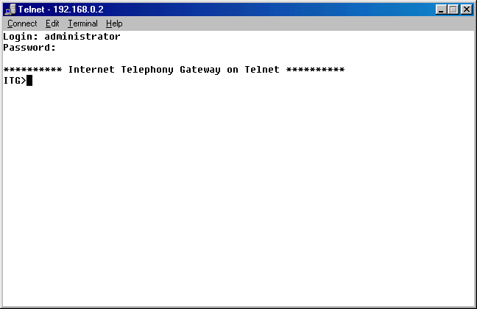
An alternative way to configure a Internet Telephony Gateway (ITG) can be done via Telnet. The Telnet interface is the same as serial port interface.

I normally used the serial interface RS323 connection for setting the IP address of the Internet Telephony Gateway (ITG). The default setting for the serial interface is 19200 bps 8N1 with no flow control.

Having the IP address set, we can telnet to the Internet Telephony Gateway (ITG) and set the device. The factory set username and password is administrator and 123, respectively. We should see the ITG> prompt as soon as entering the telnet interface.

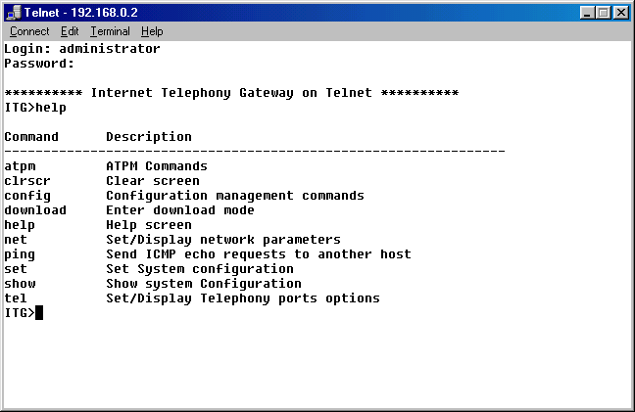
All commands to configure the ITG can be seen by entering “help” command at ITG> prompt.

Some of the frequently used commands are,

- atpm – to program the phone number.
- config – to active, delete or store into memory of a configuration.
- net – to configure network parameters, such as, IP address.
- set – to configure others parameter, such as, H.323.

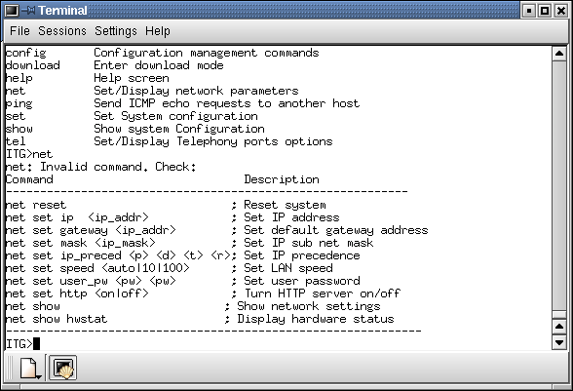
The most used command in the beginning of the operation of an ITG is the “net” command. We can use “net” command to set the IP address, gateway, netmask, LAN speed, administrator password as well as turn the web server on / off.

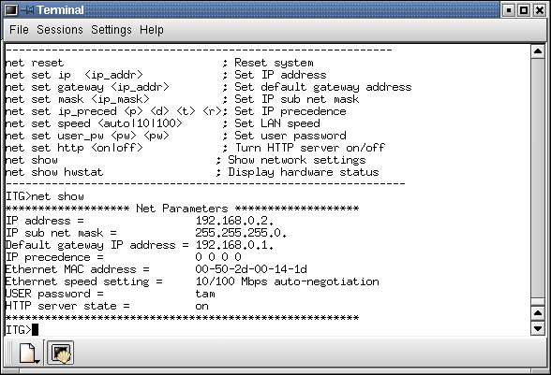
To review the current settings, we can invoke the “net show” command from ITG> prompt.
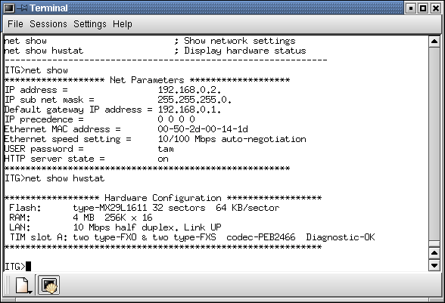

To review the condition of our equipment, the LAN as well as the RJ-11 telephone ports, we can invoke the “net show hwstat” command from ITG> prompt. Make sure the Diagnostic results are OK.
Configuring the IP address, gateway and netmask can be easily be done from the ITG> prompt, for example,

ITG> net set ip 192.168.0.2
ITG> net set gateway 192.168.0.1
ITG> net set mask 255.255.255.0

It is fairly similar to our networking configuration in normal PC workstation. Make sure these are correctly configured.

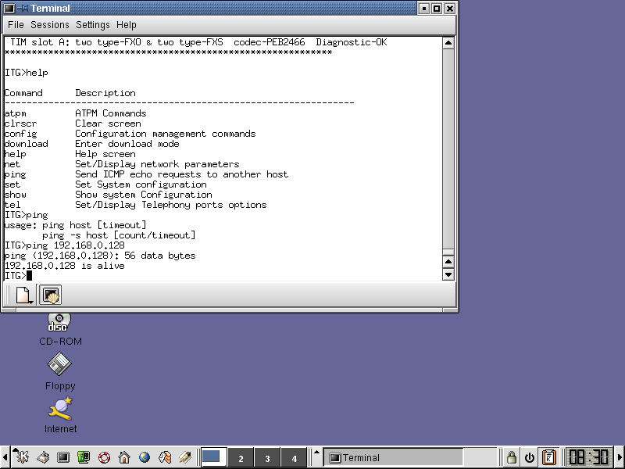
To make sure that the ITG is connected properly to the network, we can invoke the command, say, “ping 192.168.0.1” from ITG> prompt. We should receive “192.168.0.1 is alive” message if the machine is alive.

The next logical step would be configuring the phone number. It would be much easier to configure the phone number through Web interface. However, we can always use the text mode interface to configure the phone number through “atpm” command.

Configuring Phone Numbers
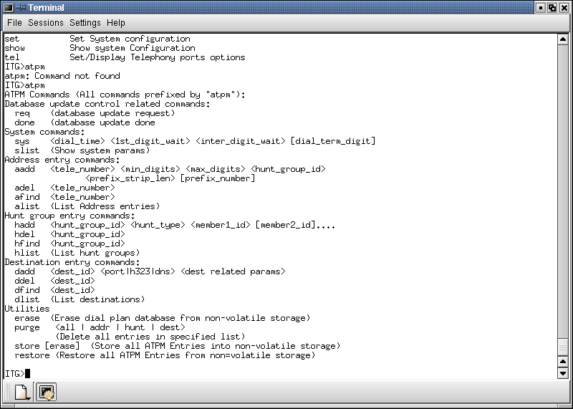
To see all available commands to configure the telephone numbers, we can invoke “atpm” from ITG> prompt. In general, there are four (4) facilities in “atpm” command, namely, (1) address entry of the phone number, (2) hunt group of several destinations, (3) destination entry, and (4) some utilities.
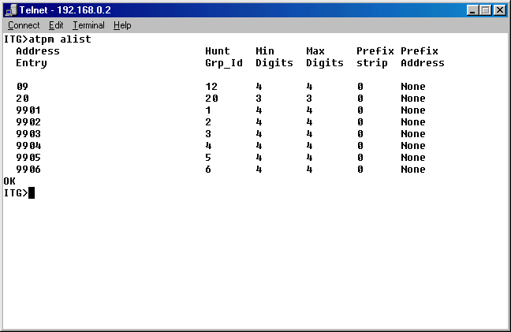
The destinations can be RJ-11 Ports at the ITG, or IP address of NetMeeting, Answering Machine, Gatekeeper.

In “atpm” command, we can add, del, find and list of an entry table. However, no edit command is available. We need to invoke “atpm req” before programming, and end it with “atpm done”.

Please note that, during programming process, the programmed phone number are stored in RAM. We need to store it to NVRAM to permanently keep it using “atpm store”.
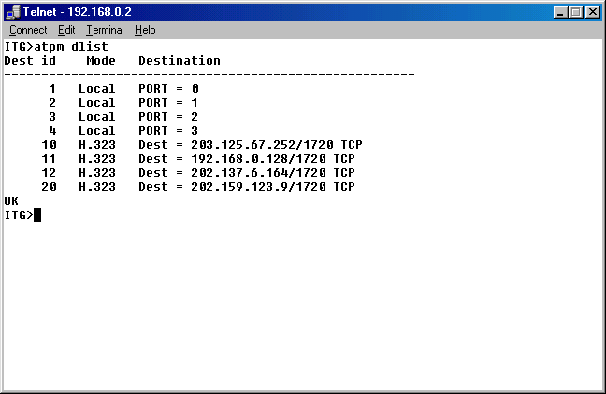
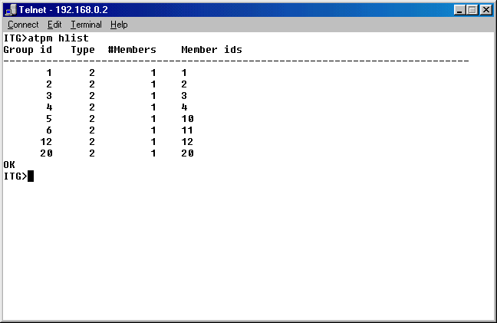
I strongly suggest using the Web interface to perform the telephone number programming. Telephone number programming is the fun part in ITG Programming and highly depends on the scenario and network configuration.

Configuring the H.323

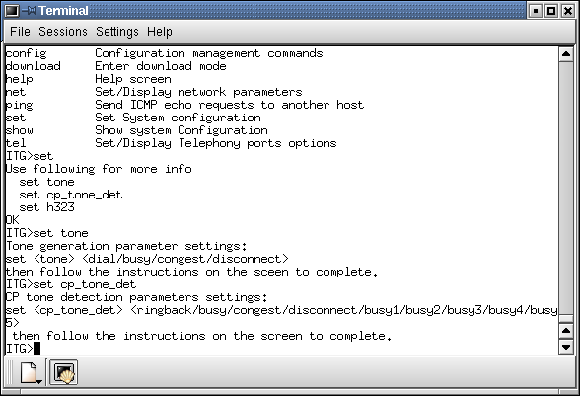
The next logical configuration step after configuring the phone number is setting H.323 parameters.

It can be done using the “set” command in ITG> prompt.

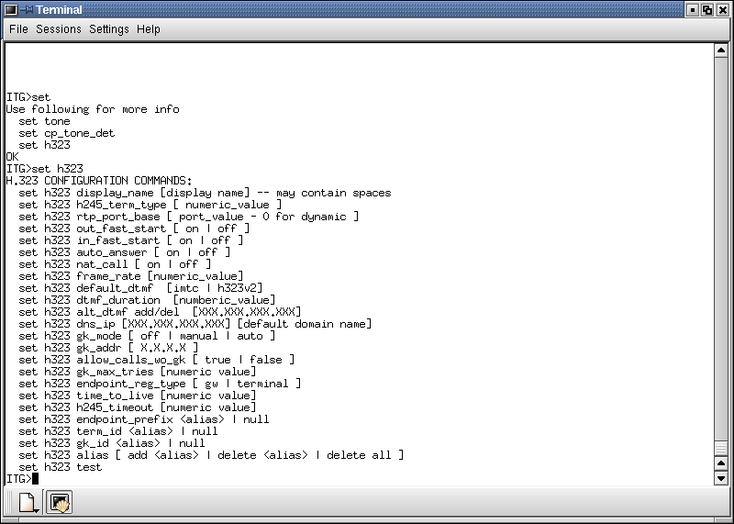
The “set h323” command is used a lot to configure the ITG to connect the VoIP infrastructure.

To see all available H.323 command, it can be done through,

ITG> set h323

Several frequently used H.323 parameters to integrate an Internet Telephony Gateway (ITG) to any VoIP infrastructure would be,

ITG> set h323 gk_mode manual
ITG> set h323 gk_addr 192.168.0.1
ITG> set h323 endpoint_reg_type gw
ITG> set h323 alias add 62883451234567
ITG> set h323 endpoint_prefix 021
…..
Etc.

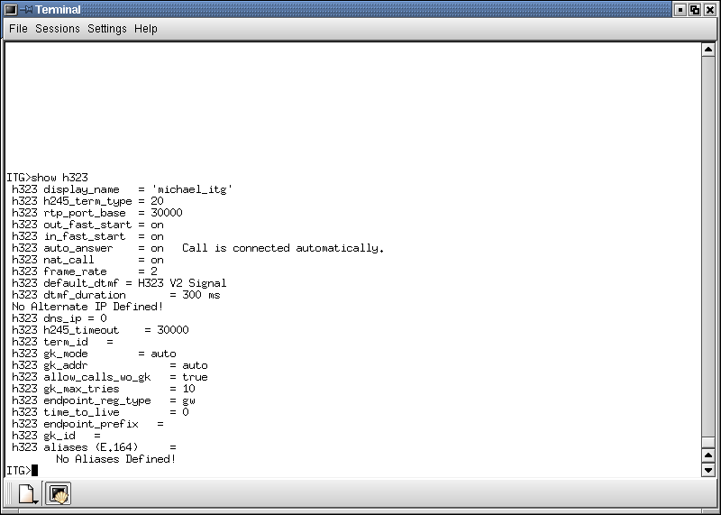
To review and check the H.323 parameter configuration, it can be done through,

ITG> show h323

The H.323 parameter configuration largely depends on the scenario & network configuration. Most of the parameter can be easily configured via Web interface especially for beginner. In reality, we still need the text interface in configuring H.323 parameters, as not all H.323 parameters are web configurable, such as, endpoint prefix.

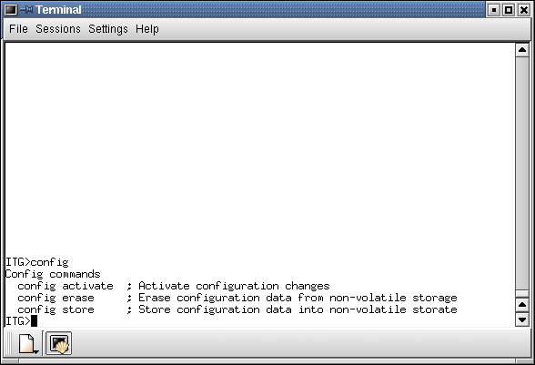
We use config command in the end of configuration process. The config command can be used to active, erase and store the configuration into non-volatile memory.

Make sure we invoke

ITG> config store

After we completed the programming.

