Web Configuration of Internet Telephony Gateway

In this section, web configuration of an Internet Telephony Gateway (ITG) will be discussed. To be able to Web configure the ITG, the ITG’s IP address of its LAN card must be firstly set. It is normally done through serial port. Hyper terminal in Windows can be used, though Start → Programs → Accessories → Communication → Hyperterminal. The serial speed is 19.2Kbps 8N1 with no control flow..
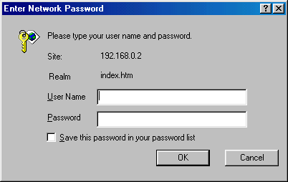
As soon as the ITG’s IP address is configured. We can use web browser to access the ITG. The ITG will ask for username and password before we can configure it. In this particular example, the IP address of the ITG is 192.168.0.2.

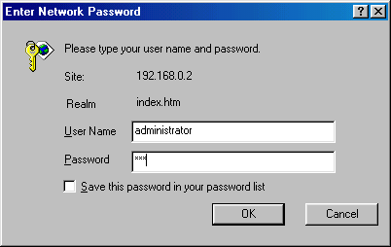
The factory set value of username and password are “administrator” and “123”, respectively.

We can change the password in the text mode interface through telnet or serial configuration at ITG> prompt.

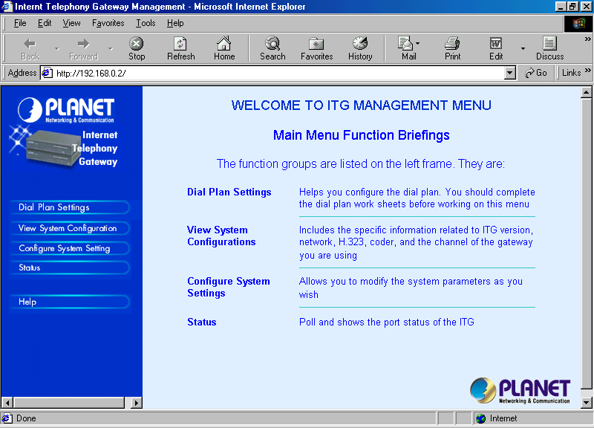
The main ITG configuration page will be shown as soon as we complete the username and password.

There are four (4) major configuration facilities provided through the Web, namely,

- Dial plan settings.
- View System Configuration.
- Configure System Settings.
- Status of the Gateway.

Configuring Phone Number in ITG
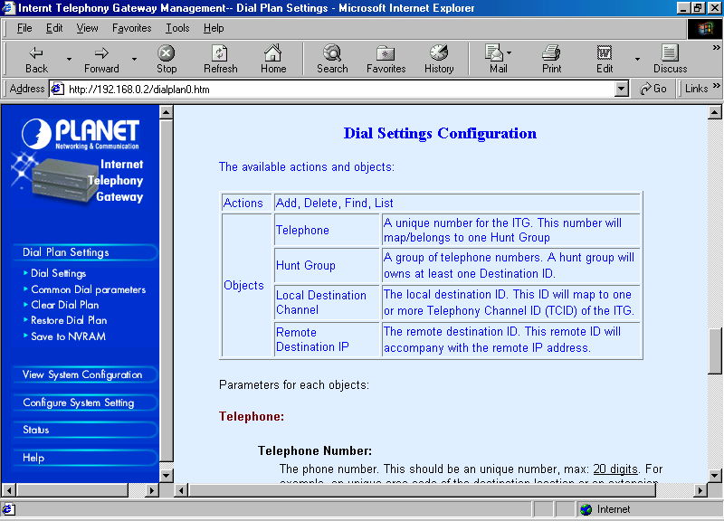
The first step in ITG configuration is normally configuring the phone number the dial plan settings. We normally need to set the scenario on how the ITG connected to the phone lines, how to call the other VoIP Endpoints before we configure the dial plan settings.

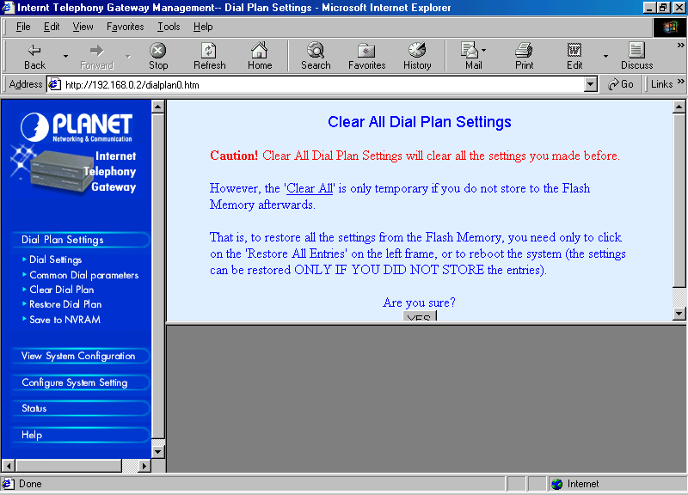
Before any dial plan settings is performed. I normally clear all the previously programmed phone numbers by selecting
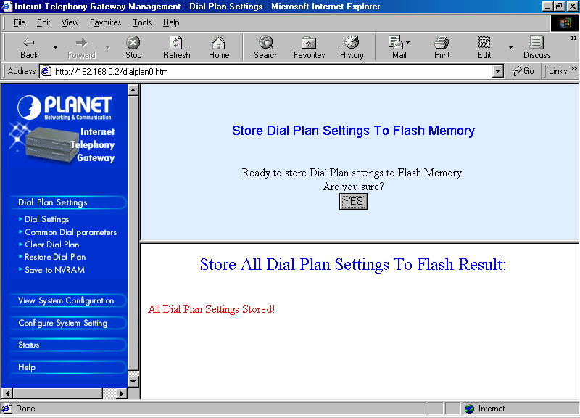
“Clear Dial Plan”. Please don’t forget to select “Save to NVRAM” every time we complete any dial plan settings else the programmed phone number will be disappeared as we reboot the ITG.

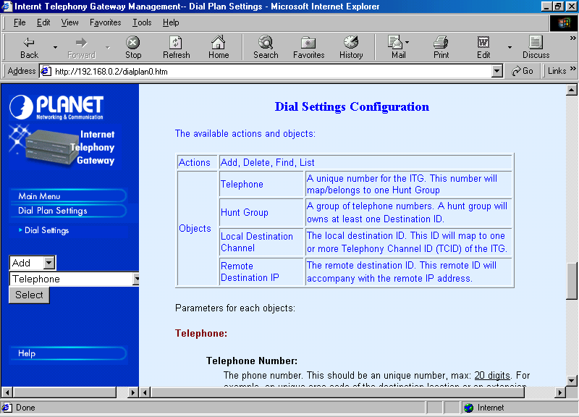
Programming the phone number is fairly easy. It can be done through,

Dial Plan Settings → Dial Settings.

We will see the choices programming the phone number on the ITG.

We can do the programming for the (1) Telephone, (2) HuntGroup, (3) Remote_Destination_IP, and (4) Local_Destination_Channel. In the newer version of the firmware, we can also program the remote destination hostname.

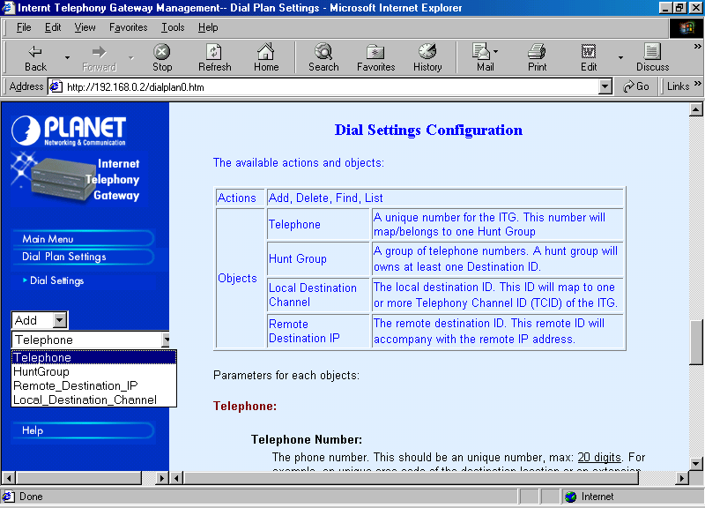
The remote destination channel is the RJ-11 ports located on the back of the ITG. Please be careful in setting the port number. The RJ-11 port number noted on the back of the ITG, i.e, 1, 2, 3, and 4, is channel no. 0, 1, 2, and 3, respectively, during the programming. Similarly for an eight (8) channel ITG.

In the phone number programming process, we can add, delete, find and list the settings but not edit the settings. Thus, correcting an error can only be done through delete and add.
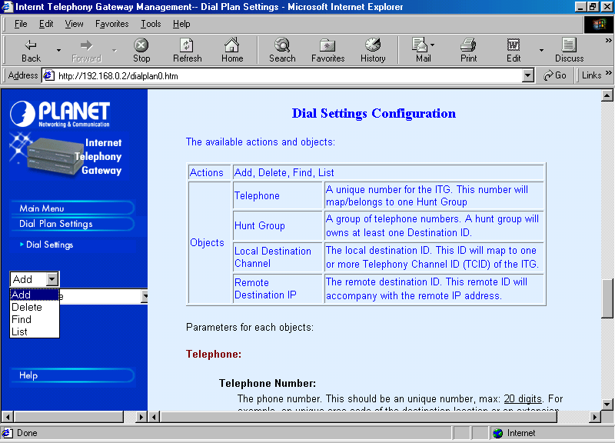

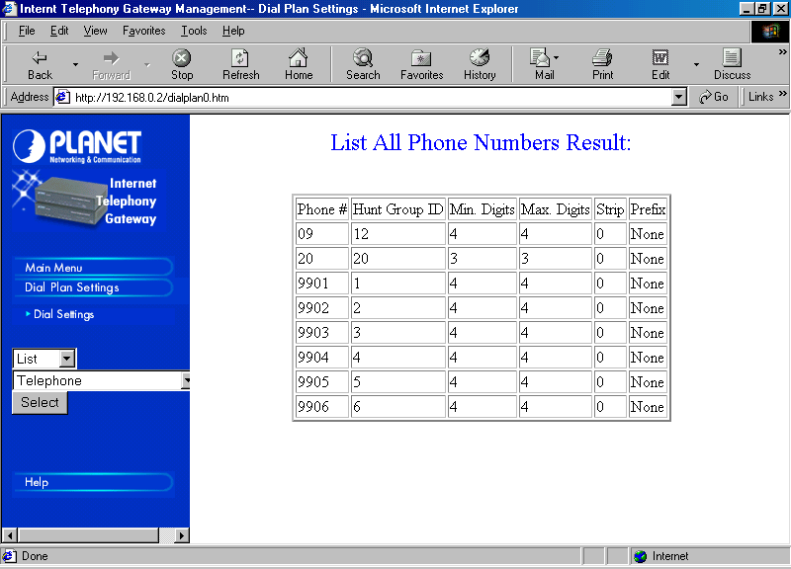
Selecting List → Telephone → Select, we will see all the phone number programmed on the ITG.

I normally reserved Hunt Group ID 0 to 7, and also Destination ID 0 to 7 for programming a number (not a hunting number) to PORT 0 to 7. It will make our life a little bit easier in further programming.
.

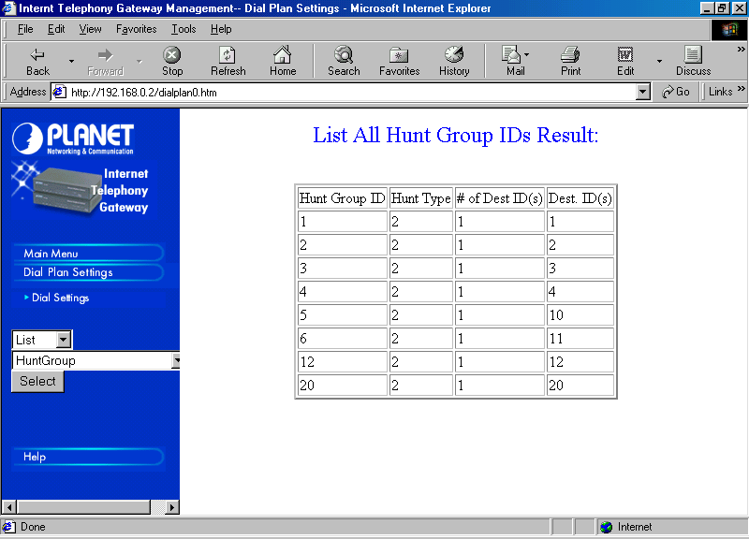
A similar list will be shown for HuntGroup. Through List → HuntGroup → Select, we will see the hunting list programmed in the ITG. If a HuntGroup is programmed for more destination, we will see more than one destination in Dest ID(s) column; and the # of Dest ID(s) is more than one.

Note that the Destination ID is not the RJ-11 port located on the back of the ITG. It is merely a destination code to map to the actual destination.
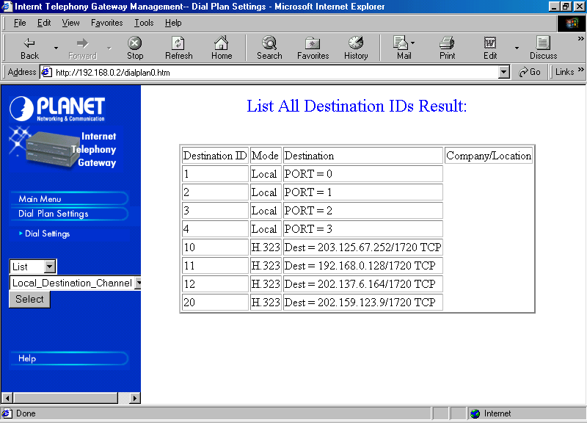
The list of the actual destination of each destination ID can be seen through List → Local_Destination_Channel → Select.

Shown in the figure, some of the destinations are the RJ-11 ports, and some are IP addresses.

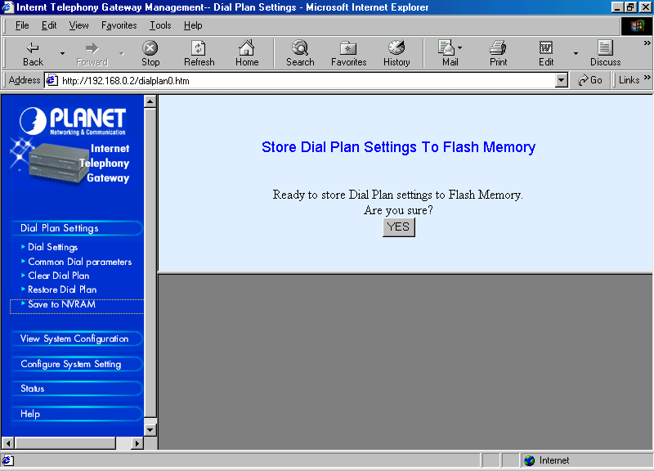
As soon as we complete the dial plan settings, please don’t forget to save it to the NVRAM else all the numbers will be vanished as we reboot or turn off the Internet Telephony Gateway (ITG).

View System Configuration
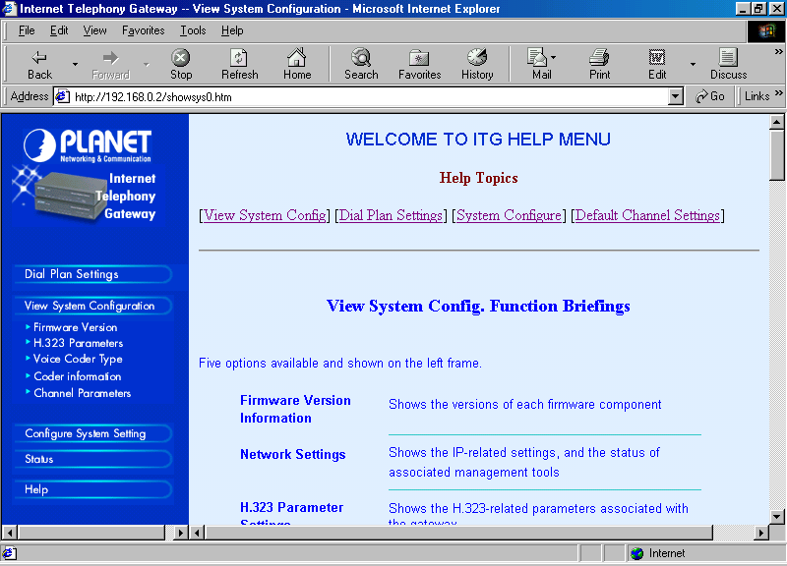
Review of the System Configuration can be seen through the “View System Configuration” menu.

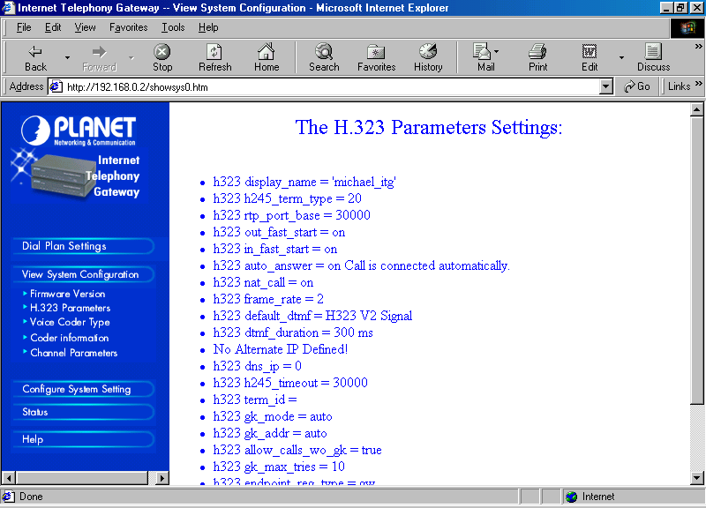

One of the most critical parameter to be review is the H.323 parameter. We need to carefully review the H.323 parameters as they are the main protocol used in Internet Telephony operations.

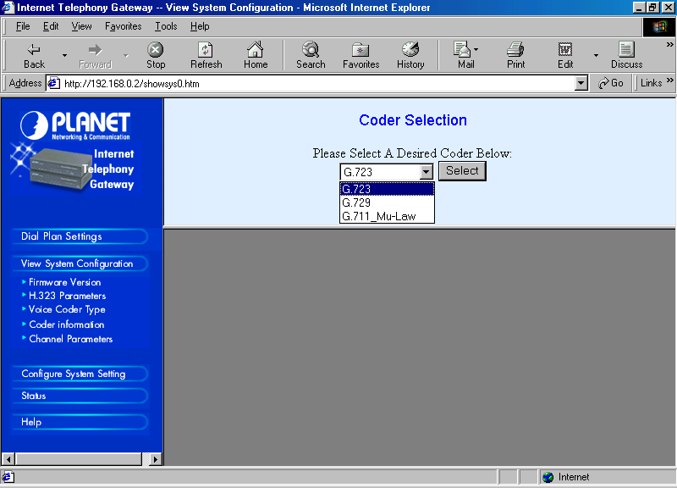
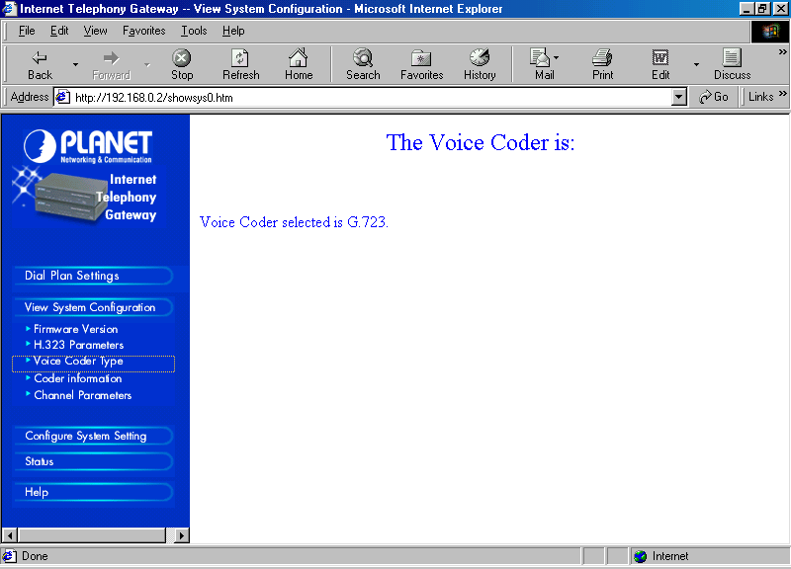
“Voice Coder Type” will set the audio compression used during voice transmission. The type of voice coder used will settle on the bandwidth usage in the communication system. The settings of Voice coder type can be done through View System Configuration → Voice Coder Type.

There are three (3) voice coder available on the Internet Telephony Gateway (ITG), namely, G.723, G.729, and G.711. G.723 will produce the lowest bandwidth at about 6Kbps (half duplex) or about 12 Kbps (full duplex).

Microsoft NetMeeting will normally be able to communicate perfectly to the Internet Telephony Gateway (ITG) using G.723 compression. Using G.723 may create some problems to communicate with a non-Microsoft software, such as, GnomeMeeting and OpenPhone, as they don’t normally have G.723 built-in. G.723 is copyrighted by Microsoft.

Configure System Settings

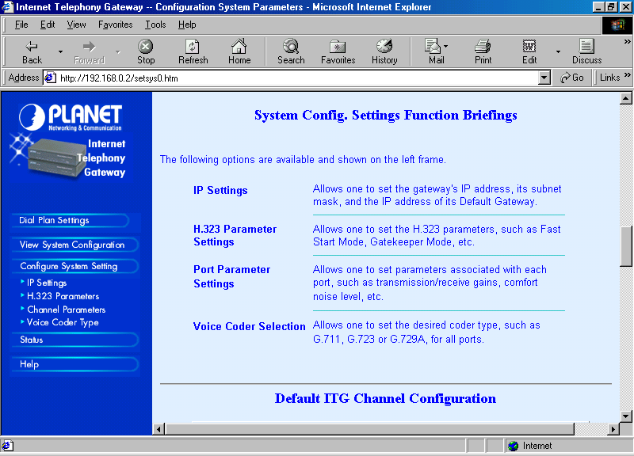
Configuring an ITG can be done through “Configure System Setting”, such as,

IP Settings, to configure the IP address, gateway and netmask.

H.323 Parameter, to configure several parameter related to H.323 protocol parameter, especially configuring the E.164 phone number to be reported to the Gatekeeper.

Channel Parameters, normally used to configure the audio volume of incoming and outgoing voice. It is basically equivalent to setting the mic and speaker volume in NetMeeting. I normally set the audio volume to around 2 dBs. The default value –1 dBs is fairly low and a bit difficult to hear.

The detailed system configuration will be discussed in other chapters, as it highly depends on the interconnection of the ITG with other systems.

