Phone Number Programming on the ITG

In this chapter, phone number programming or dial plan settings on a Internet Telephony Gateway (ITG) will be described. The programming steps will start from a simple technique gradually towards more complex settings.

Programming A Phone Number

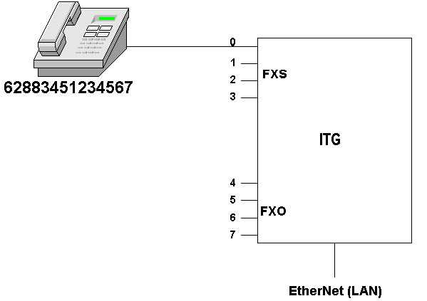
One of the most common simple configurations is having a phone connected to one of the FXS port. In scenario shown in the figure, a handset attached to RJ-11 FXS PORT 0 will be programmed to have phone number of 62883451234567.

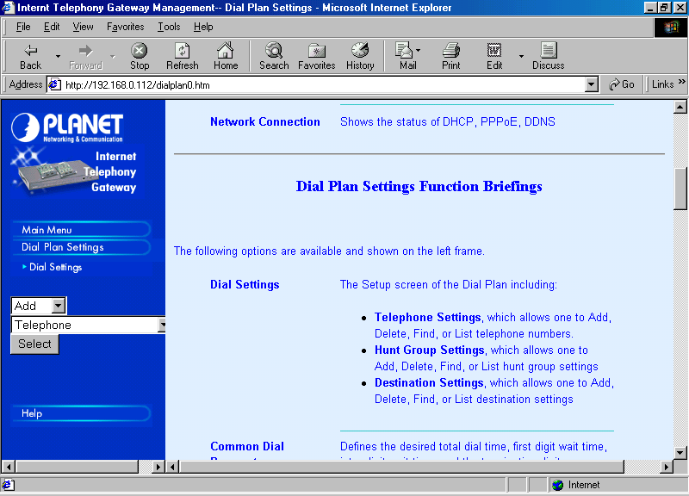
The settings can be done through the Web Interface. After logon to the Web interface, we may configure the number through,

Dial Settings → Add → Telephone → Select.

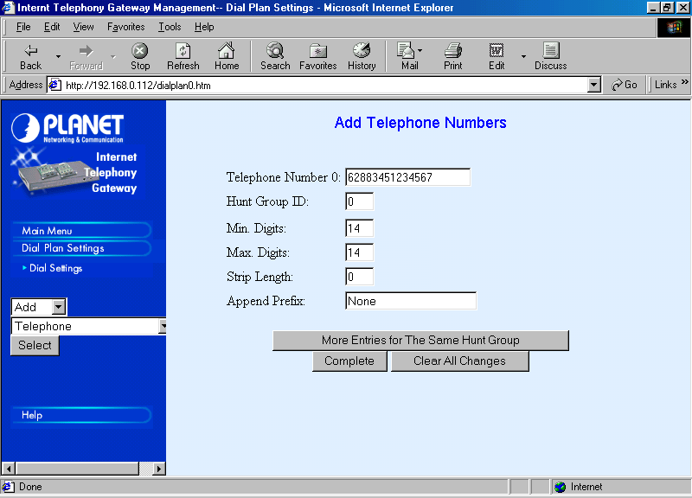
Click Select to configure the phone number.

Fill Telephone Number 0 with the particular number 62883451234567.

Since, the phone number is not a hunting system. I normally set the HuntGroup ID to be same as the PORT number. In this case, the PORT number is 0 so is the HuntGroup ID.

The Min. and Max. Digits of 62883451234567 is 14. In some cases, Minimum and Maximum Digits may be different.

Since no more processing of the number is required, we set the Strip Length to 0 and Append Prefix None. Append Prefix and Strip Length is particularly useful to pass a certain Telco’s number through a PBX.
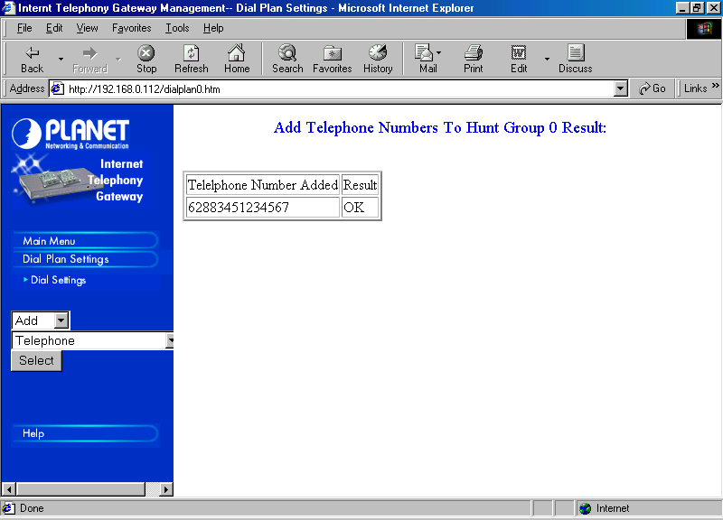
After Complete button is pressed, the ITG will let us know that a phone number 62883451234567 has been successfully added to the table.

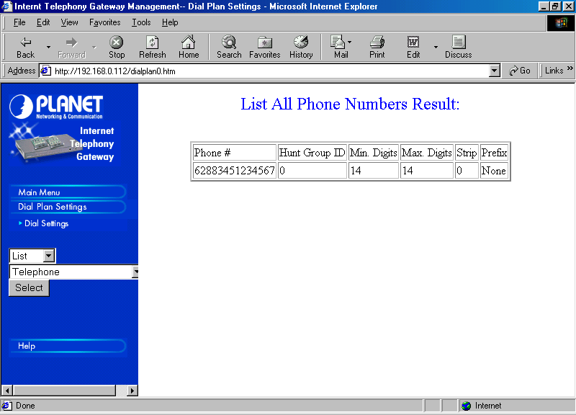
To review and check the programmed phone number, we may select Dial Plan Settings → Dial Settings → List → Telephone → Select. Shown in the right frame is the list of phone number on the ITG’s table.

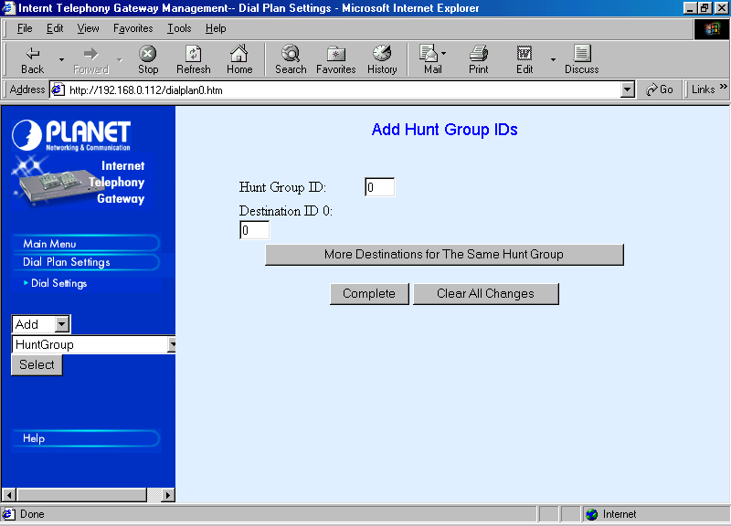
Next step is to map the HuntGroup ID to Destination ID. Please note that the Destination ID just an ID, and has nothing to do with the Port number. To perform the mapping, it can be done through,
Dial Settings → Add → HuntGroup → Select.

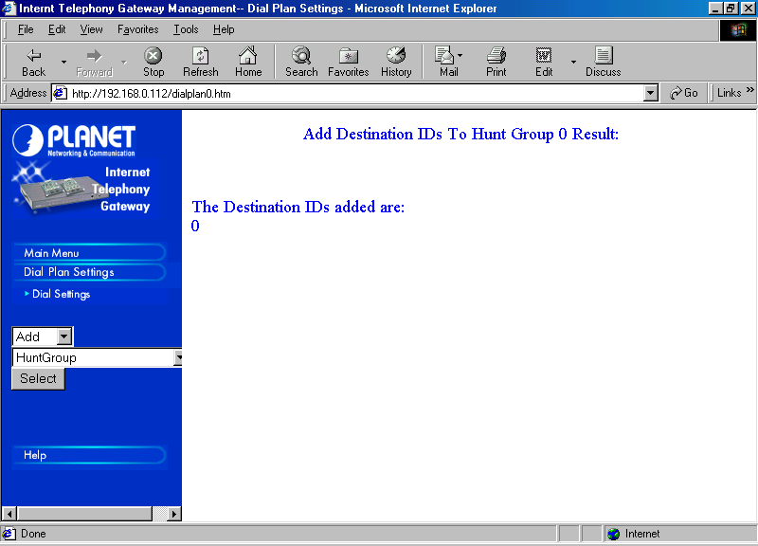
Since this particular number is not in a hunting system, I normally configure the HuntGroup ID to be the same as the FXS Port number used; in this case is 0.

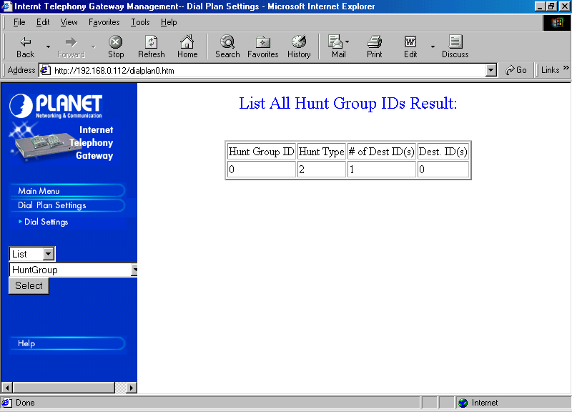
As “Complete” is clicked, the ITG let us know that Destination ID 0 is added.

To review and check on the HuntGroup ID mapping, it can be done through List → HuntGroup → Select.
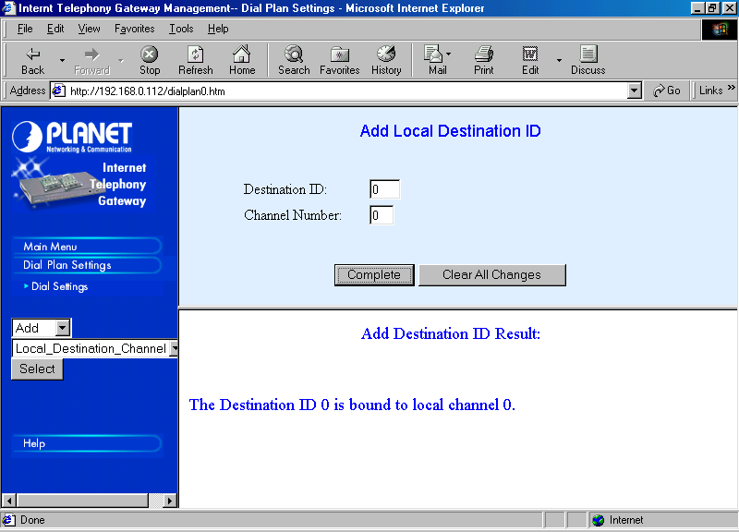
Next step is to Map the Destination ID to the actual Local Destination Channel, namely, the FXS PORT 0. To perform the mapping, it can be done through Dial Settings → Add → Local_Destination_Channel → Select.

All we have to do is fill the Destination ID 0 and Channel Number 0. Press “Complete” as completed.

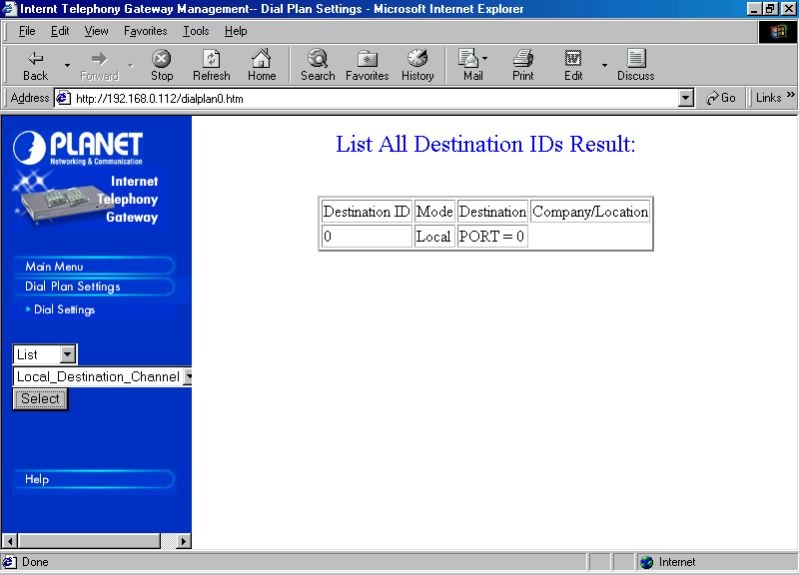
To review and check on the Destination ID mapping, it can be done through Dial Settings → List → Local_Destination_Channel → Select. We should be able to see the mapping table between Destination ID and the Destination.

The ITG’s phone number programming of FXS PORT 0 to 62883451234567 has been completed. We need to tell the proxy Gatekeeper as well as the public Gatekeeper on the existence of our numbers. Such configuration will be discussed in other chapters.

Programming Many Numbers
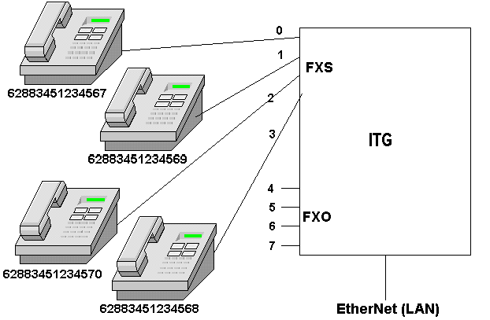

Let us discuss a little bit more complex configuration. As shown in the above figure, we want to configure such that each FXS port would have a number, namely,

FXS PORT 0 6288 345 1234567
FXS PORT 1 6288 345 1234569
FXS PORT 2 6288 345 1234570
FXS PORT 3 6288 345 1234568

In principle, the programming process is basically only repeating the previous programming to other ports.

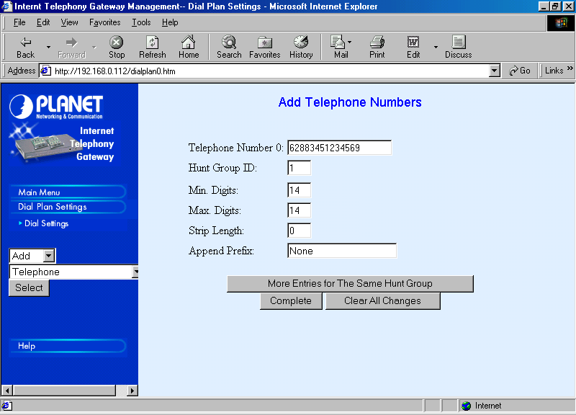
Telephone number programming can be done through Dial Settings → Add → Telephone → Select. Every single number is filled into the Telephone Number column. To minimize any confusing during the programming process, HuntGroup ID is set to be the same as the FXS PORT used. In our case all the Minimum and Maxumum Digits are equal to 14.

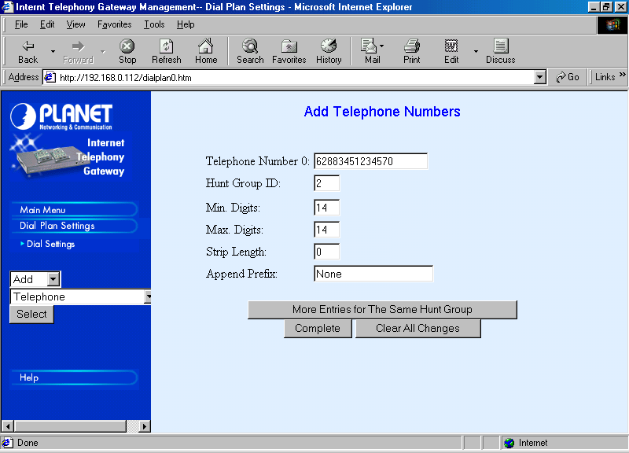
We have to complete the telephone number programming to all numbers from 62 883451234567 up to 62883451234570. The HuntGroup ID used well be 0 up to 2, respectively.

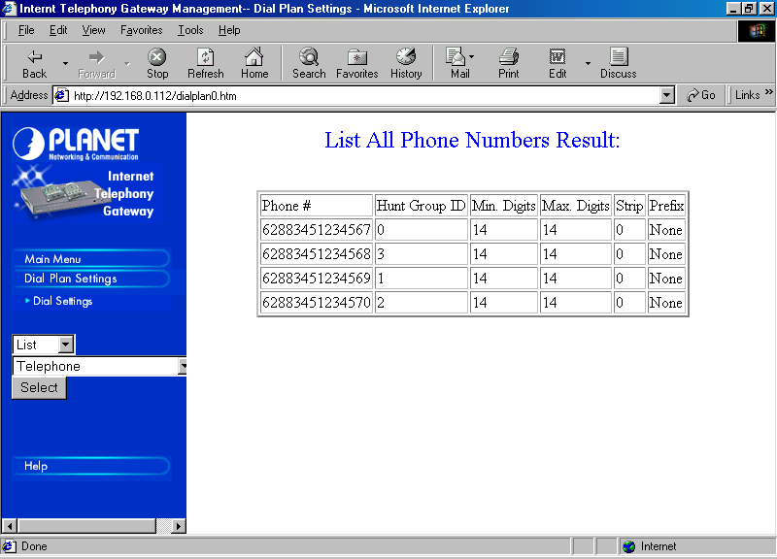
To review and check the programmed telephone number, it can be done through Dial Settings → List → Telephone → Select. Please check carefully the mapping between the phone number to its respective HuntGroup ID.

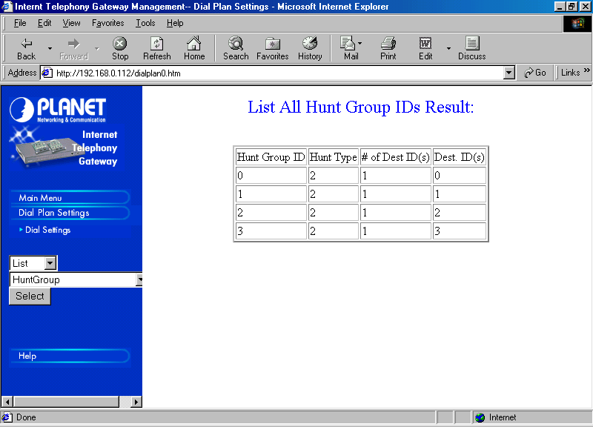
The mapping of HuntGroup ID to its respective Destination ID is fairly straightforward similar to the previous programming technique. The major difference, we have to do it for much more HuntGroup ID.

To make our life easier, in a non-hunting system, the HuntGroup ID and Destination ID is set to be the same as the FXS PORT Number. As we complete the HuntGroup ID programming, review can be performed through Dial Settings → List → HuntGroup → Select. In a non-hunting system, the # of Dest ID(s) must be one (1).
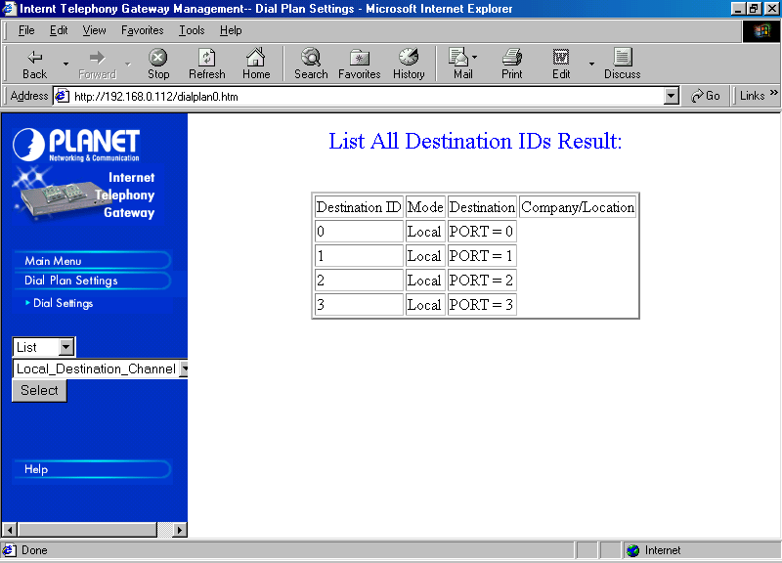
The next programming process is to map the Destination ID to its respective Local Destination Channel, in this case the respective FXS PORT number. To make our life easier, we set the Destination ID to be the same as the FXS PORT Number.

As we complete the Destination ID programming, review can be done through Dial Settings → List → Local_Destination_Channel → Select.

We have completed the ITG programming for many phone numbers. Each FXS RJ-11 PORT has its own number. We need to tell the proxy Gatekeeper as well as the public Gatekeeper on the existence of our numbers. Such configuration will be discussed in other chapters.

Hunting System Programming

Let us make our life a bit difficult, suppose we want all FXS RJ-11 PORT can be reached through a single number, say, 62883451234560. Thus, in addition to a separate number of each RJ-11 FXS PORT, i.e, 62883451234567, 62883451234568, 62883451234569 and 62883451234570, one can call any of these RJ-11 FXS PORT through a single number, i.e., 62883451234560.
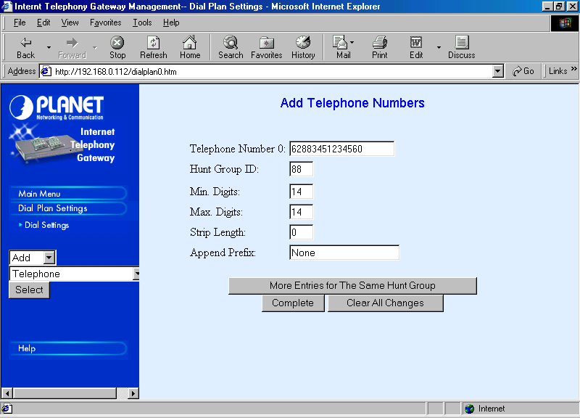
Firstly, we need to program the number 62883451234560 into the ITG through Dial Settings → Add → Telephone → Select. The Minimum & Maximum Digits are similar to the previous programming, i.e., 14. None of the digits will be stripped and no additional prefix added.

Major trick in hunting system programming is in the HuntGroup ID. In the above example, I use 88 as the HuntGroup ID. Well, the HuntGroup ID may basically be any number we like. In this case, I am using any number above 7 to differentiate it to a non-hunting system.

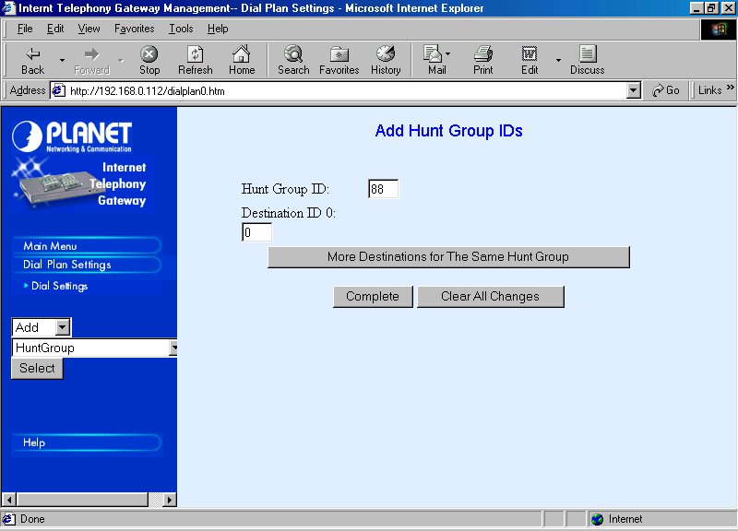
Through Dial Settings → Add → HuntGroup → Select we can configure the Destination ID for the HuntGroup ID 88. We can start to fill with Destination ID 0. Unlike the previous programming session, in hunting system, we need to press “More Destinations for The Same Hunt Group”, NOT “Complete”.
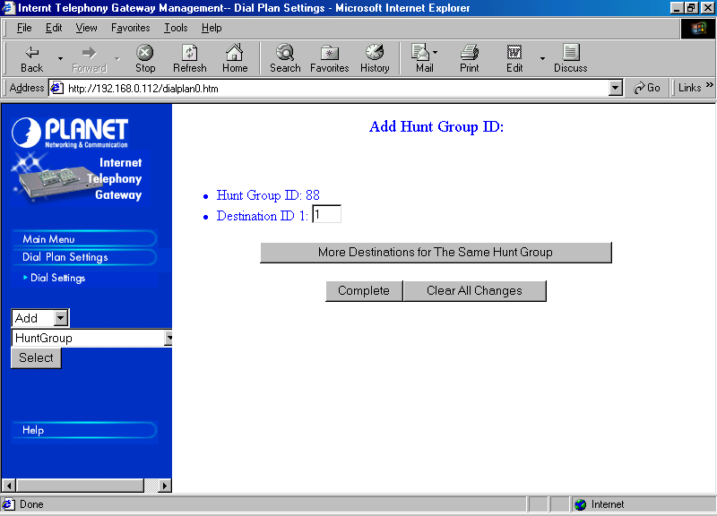
We can then fill the next Destination ID 1 as well as other Destination ID by pressing “More Destinations for The Same Hunt Group” until all destinations have been covered.

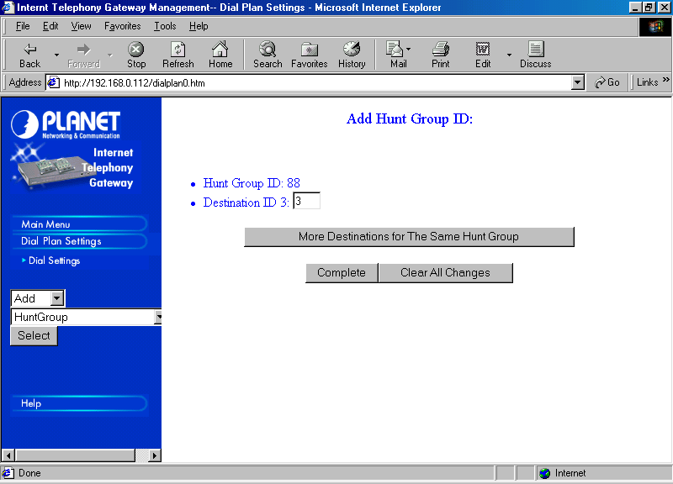
Since VIP-000 has only four (4) RJ-11 FXS PORTs. Destination ID 3 is the last destination to be programmed into the HuntGroup ID table.

After Destination ID 3 is entered; we need to press “Complete” NOT “More Destinations for The Same Hunt Group”.

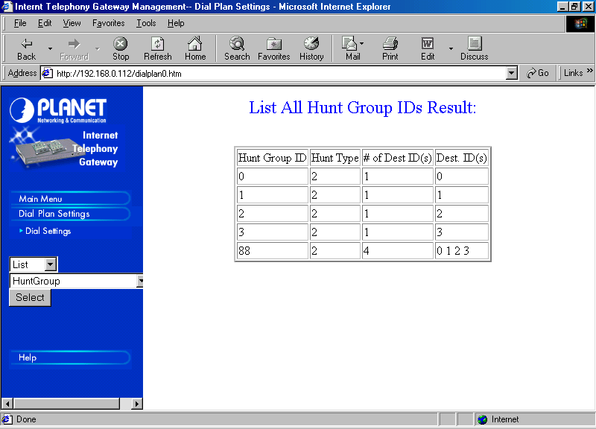
To review and check the HuntGroup ID, it can be done through Dial Settings → List → HuntGroup → Select.

We should see an entry for HuntGroup ID 88, it must has # of Dest ID of four (4), with Destination ID 0, 1, 2, and 3.

At this point, the ITG knows that there are four (4) destinations to be called for HuntGroup ID 88.

The ITG’s hunting system programming for phone number 62883451234560 has been completed. We need to tell the proxy Gatekeeper as well as the public Gatekeeper on the existence of our numbers. Such configuration will be discussed in other chapters.

Programming Outgoing Call to Other 6288 numbers

So far our programming concerns how to process any incoming calls to the Internet Telephony Gateway (ITG). Unfortunately, any outgoing calls from the ITG must be programmed, as the ITG will not know for to reach a destination unless we program it. In this section, programming an ITG to perform outgoing calls to other 6288 numbers will be demonstrated.

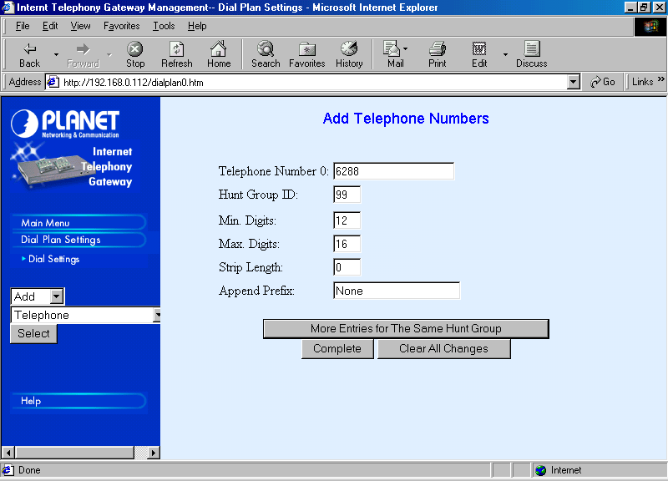
One of the main characteristics of the Indonesian Free VoIP MaverickNet, it always starts with 6288 as its first four (4) digits.

Programming 6288 into the ITG can be done through Dial Settings → Add → Telephone → Select. Enter the number 6288 without adding any additional number.

I normally select the HuntGroup ID for an outgoing call to 6288 any number above the PORT number (0-7). In this case, I select 99 as the HuntGroup ID for calling 6288.

Unlike previous examples, the Minimum and Maximum Digits are significantly different. A Minimum digit of 0 and Maximum Digit of 16 is selected to accommodate a large variety of 6288 numbers.

No digit to be stripped, and no prefix to be appended. The process in adding the 6288 numbers is completed, and “Complete” button can be pressed.
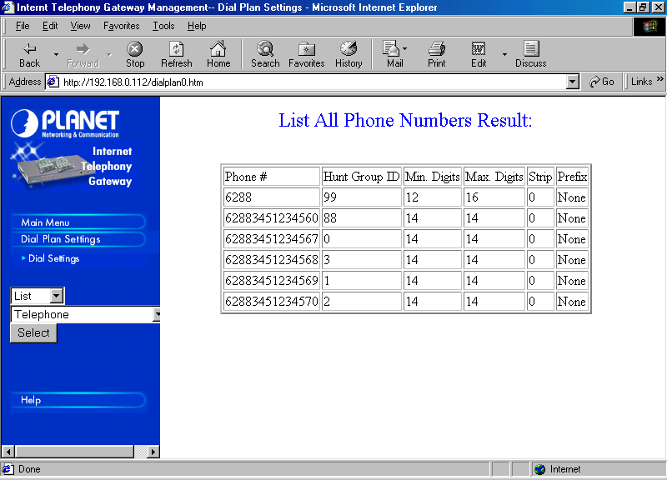
We may review and check the programmed phone numbers through Dial Settings → List → Telephone → Select.

There must be 6288 number in the table with HuntGroup ID of 99.

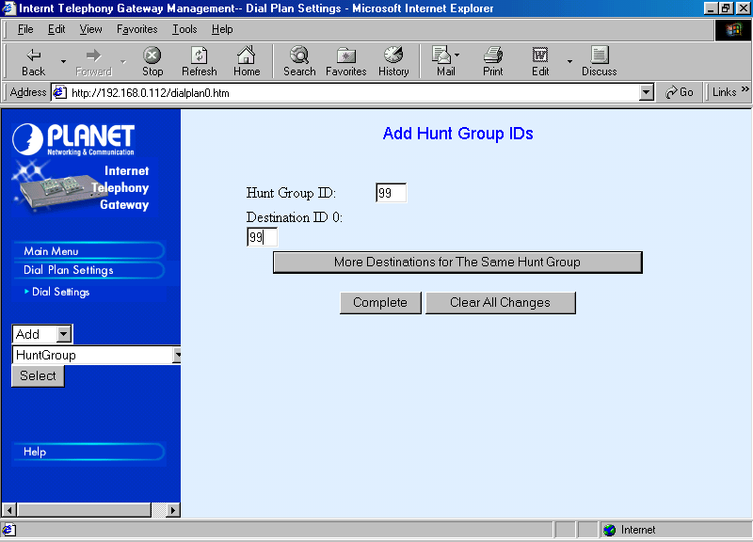
Our next task is to map the HuntGroup ID to certain Destination. To make our life easier, it might be a good idea to pick the same number for Destination ID, namely, 99. As usual, the programming process can be done through Dial Settings → Add → HuntGroup → Select. Press “Complete”, as completed.

To review and check the programmed HuntGroup ID, it can be done through Dial Settings → List → HuntGroup → Select.
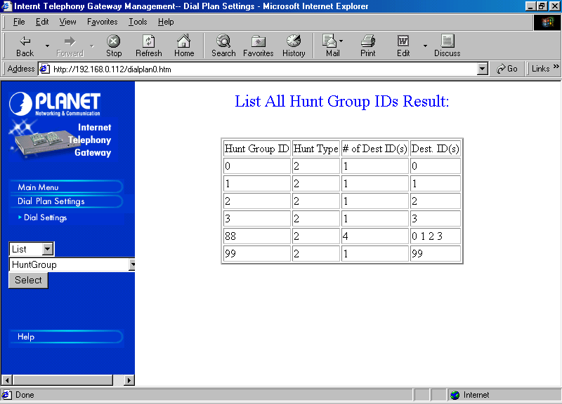
We must be able to see HuntGroup ID 99 with only one (1) destination to Destination ID 99.

Our next task is to map the Destination ID 99 to all phones with 6288 numbers as the Remote Destination. It is the most challenging and trickiest part of programming the Internet Telephony Gateway (ITG).

The only logical Remote Destination that may help reaches us to any other numbers in the VoIP infrastructure is our proxy Gatekeeper (in this example cade running at 192.168.0.1).

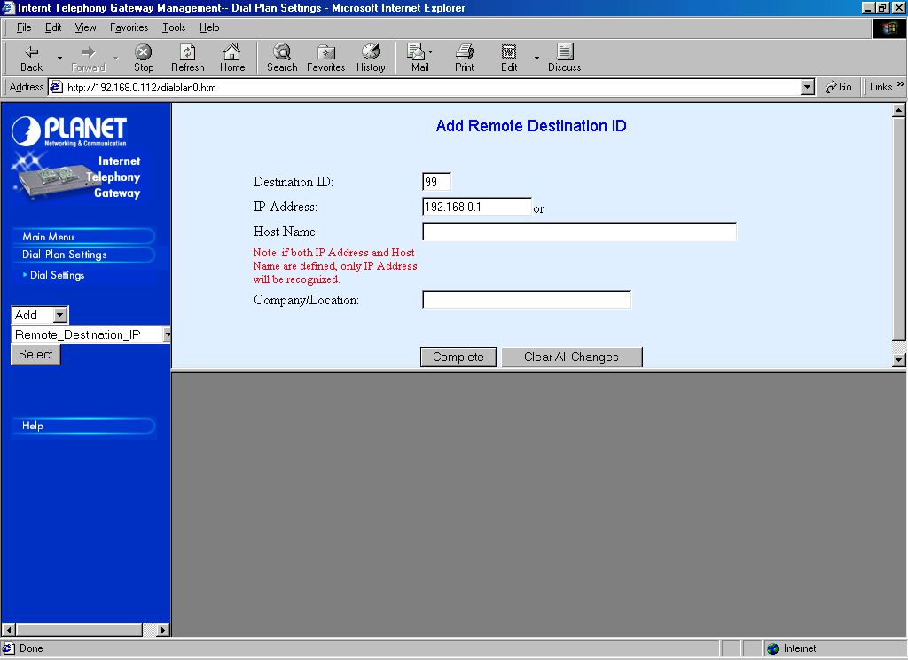
Thus, we need to map Destination ID 99 to the proxy Gatekeeper IP address. It can simply be done through Dial Settings → Add → Remote_Destination_IP → Select.

Fill 192.168.0.1 as IP Address for Destination ID 99. Press “Complete” as completed.

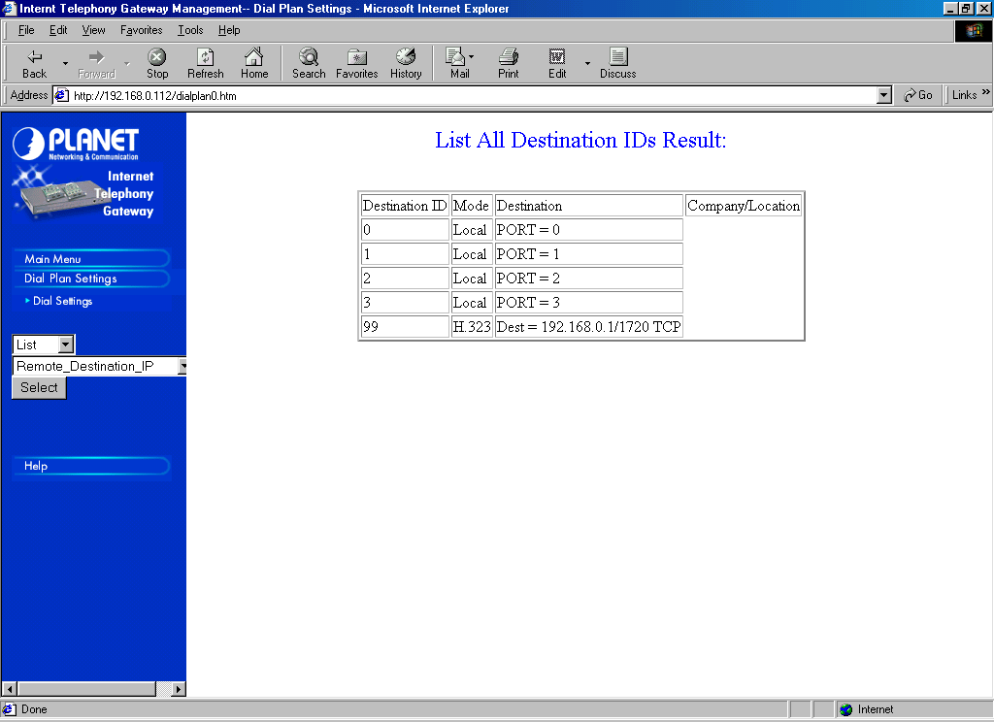
To review and check the Remote Destination programming, it can be done through Dial Settings → List → Remote_Destination_IP → Select. We must be able to see Destination ID 99 directed to IP address 192.168.0.1.

If the Gatekeeper IP address is not 192.168.0.1, we need to insert the correct Gatekeeper IP address.

The Internet Telephony Gateway (ITG) can now communicate with all phones beginning with 6288.

Fairly similar techniques can be programmed to introduce a certain Telco’s area code or even a country code to the Internet Telephony Gateway (ITG). As more and more offices have a 24 hour Internet connection. The above configuration techniques may then be used to bypass any long distance charges.

