Integrating an Internet Telephony Gateway to PBX
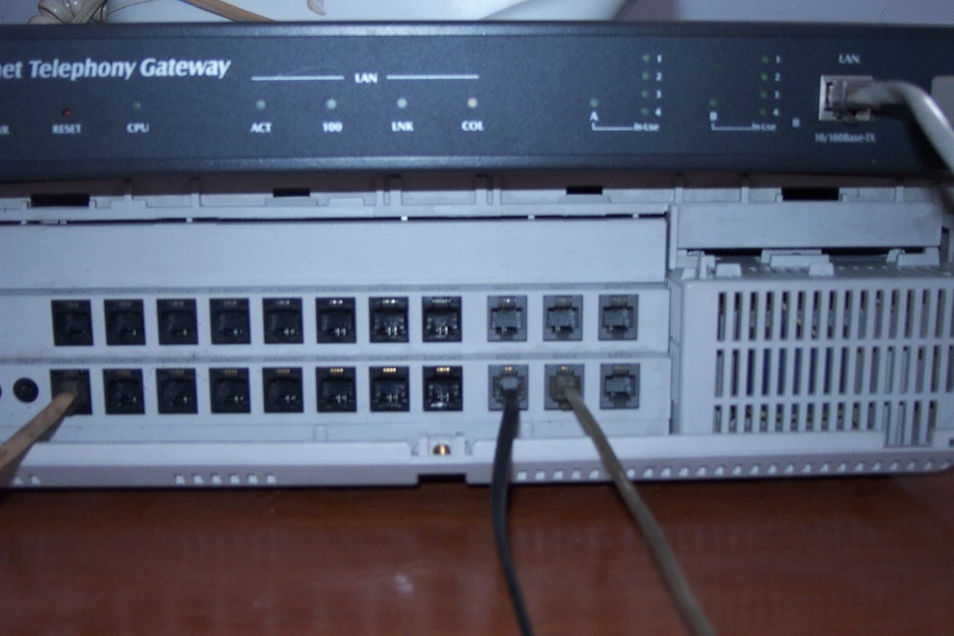
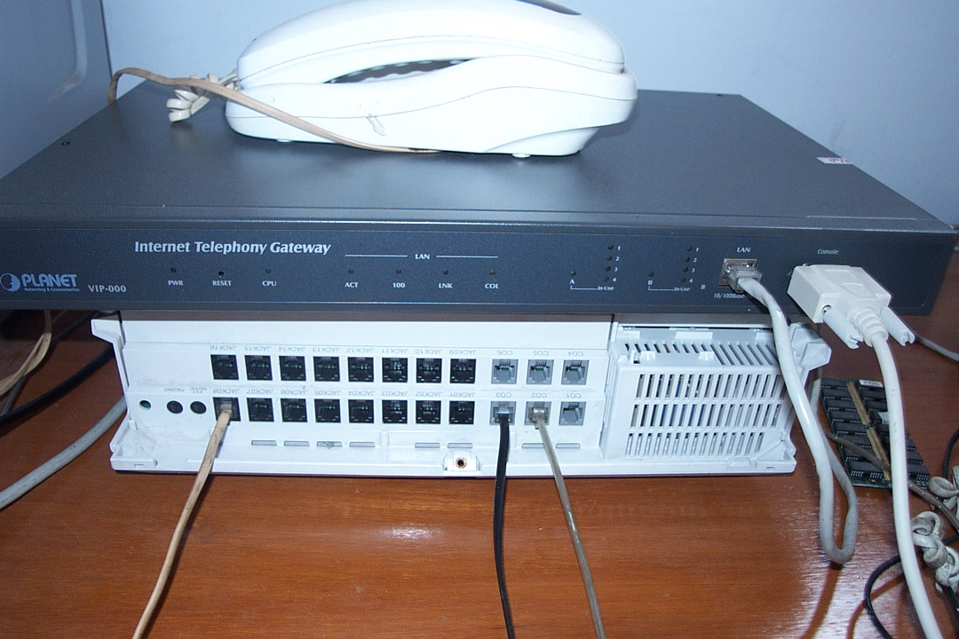
One of the most interesting driving forces behind VoIP movement is to integrate the Internet Telephony Gateway (ITG) to the PBX installed in most offices. As most modern offices as well as some houses are having 24 hours Internet connection, connecting the ITG to local PBX in these offices may in turn bypassing all phone traffic to the Internet without any necessary to connect to Telco.

Shown in the figure is a Panasonic KX-TA 616 PBX, one of the favorite PBX in Indonesian offices. On top of it is the Planet VIP-000, an 8 port ITG. Panasonic KX-TA 616 has 16 extension and 6 CO lines may be connected to Telco.
.
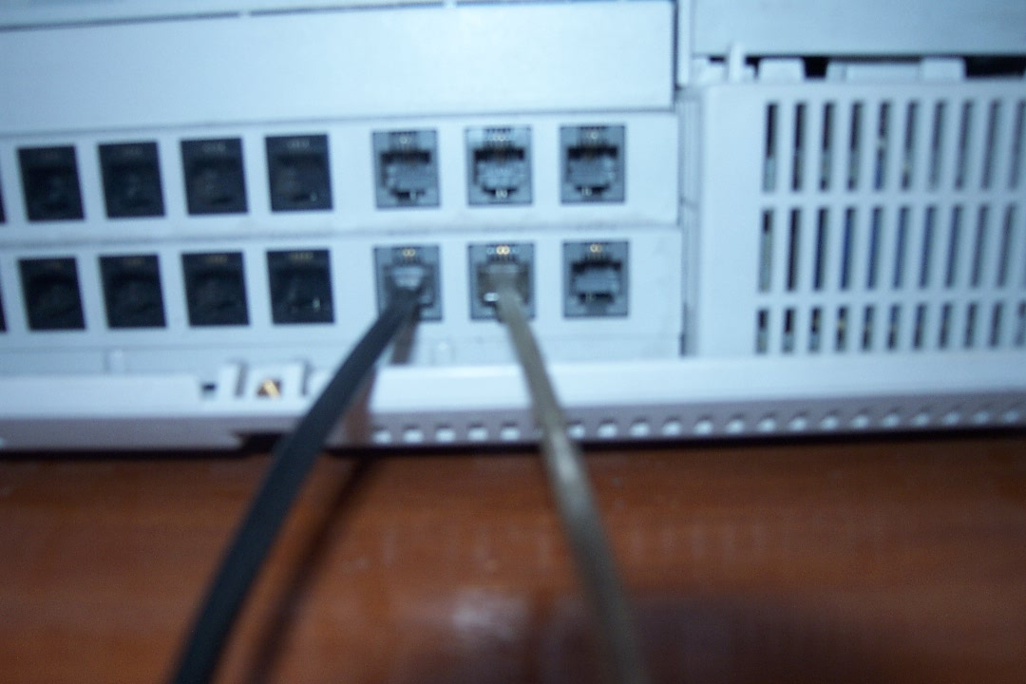
The RJ-11 ports are normally marked and numbered for each extension or CO lines. The extension and CO ports colored differently, in Panasonic KX-TA 616, the extension is darker; while the CO lines are light color.

In a Panasonic KX-TA 616, as well as other PBX, we normally

- Press 9 to make outside call through the CO line.
- Extension number starts from 101, 102, 103 …upto 116.

There may be some differences in the extension number in other PBX. To use a PBX in a VoIP infrastructure, we may leave the PBX program as it is. In most cases, no additional PBX programming is necessary.

However, if we share the PBX CO lines for both Telco and VoIP Internet Telephony Gateway (ITG), we may need to program the PBX so that

- Any VoIP phone number should goes to CO lines connected to the ITG.
- Other numbers can be programmed to the Telco CO lines.

In Indonesia, the VoIP phone numbers are normally starts with 6288 digits. Thus, would be easy to program the Automatic Route Selection (ARS) facility built-in the Panasonic KX-TA 616 or KX-TA 308. The ARS programming can be read in page 3-4 to 3-8 of the Installation Manual Panasonic Advanced Hybrid System.

Connecting ITG’s FXS to PBX’s CO

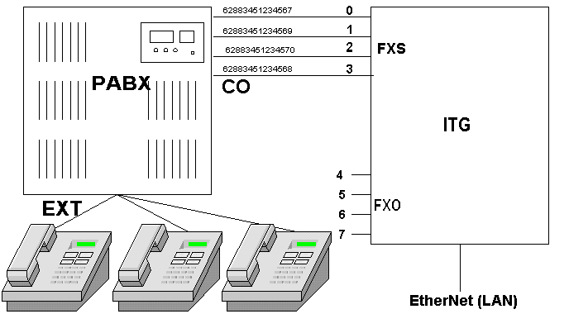
Let us look at an example / scenario to connect an Internet Telephony Gateway (ITG) to PBX. In this scenario, the ITG’s FXS lines are connected to the PBX CO lines. The ITG’s FXS lines are fairly similar to Telco’s lines with 48 Volt in it. In this scenario, we want each FXS has different numbers, such as,

62883451234567 FXS 0
62883451234569 FXS 1
62883451234570 FXS 2
62883451234569 FXS 3

Programming and registering these numbers to gatekeeper has been discussed in previous chapters.

In this scenario, we can immediately connect the ITG’s FXS to PBX CO lines. Anyone, calling the above numbers from VoIP infrastructure will immediately pass to the extensions behind the PBX. Hunting number can also be used for FXS 0-4, same handset behind the PBX will ring.

Automatic Route Selection (ARS) programming needs to be done at the PBX if the CO lines are shared with Telco’s lines. Such programming is needed to make sure all VoIP traffic will goes to the any of the FXS lines.

Closely examining the way ITG’s FXS connected to PBX CO lines, each of the PBX CO lines have each very own number. These numbers are registered in VoIP network by the Internet Telephony Gayeway (ITG) and, thus, can be called from VoIP network.

Connecting ITG’s FXO to PBX’s EXT
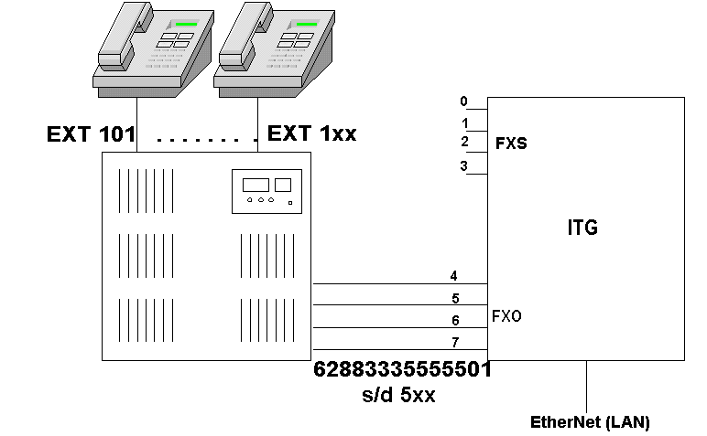
A totally different scenario and result will be apparent as we connect the ITG’s FXO to the PBX’s EXT. Unlike the FXS connection to CO, connecting a FXO to PBX EXT may be used to allocate VoIP number for each extension, for example,

62883335555501 extension 101
62883335555502 extension 102
62883335555503 extension 103
62883335555504 extension 104
..
628833355555xx extension 1xx

Depending on the number FXO lines available, if Planet VIP-000 is used, we may have four (4) FXO lines to make four (4) simultaneous calls.

In the next section, detailed programming of the FXO as well as registering to the gatekeeper will be discussed.

Phone Number Programming

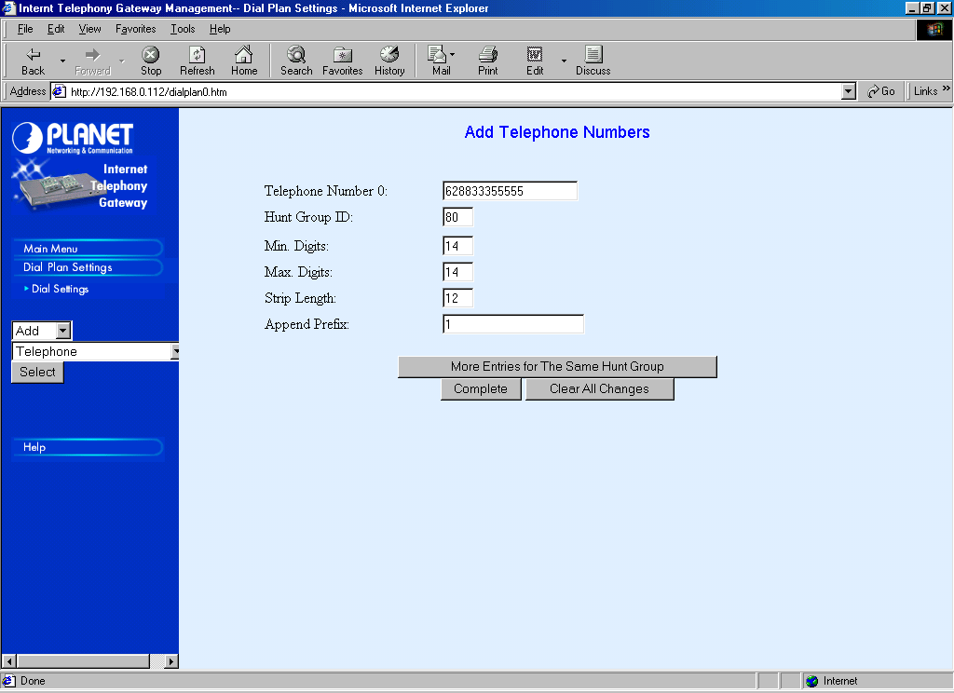
Phone number programming may be performed through the Web, namely, Dial Plan Settings → Dial Settings → Add → Telephone → Select.

Enters the 6288333555 phone number. 6288333555 is actually the prefix to be allocated for all the PBX’s EXT connected to the ITG’s FXO.

Since we will connect all four (4) FXO lines to the PBX’s EXT, 6288333555 is set to hunt all four (4) FXO lines. I am setting The Hunt Group ID to 80, nothing special with the number 80.

What we like to do is mapping the each following number to its respective EXT, such that,

62883335555501 goes to EXT 101
62883335555502 goes to EXT 102
62883335555503 goes to EXT 103
62883335555504 goes to EXT 104
..
628833355555xx goes to EXT 1xx

Note that the Minimum & Maximum digit of 62883335555501 to 628833355555xx is all 14 digits.

To convert 628833355555 into 1, all we have to do is set the Strip Length to 12 and Append Prefix 1. The mapping will be performed automatically by the ITG. Thus, the actual tone injected from the ITG’s FXO to PBX EXT are 101, 102, .. etc. and the respective handset will ring. Don’t forget to press “Complete” as completed.
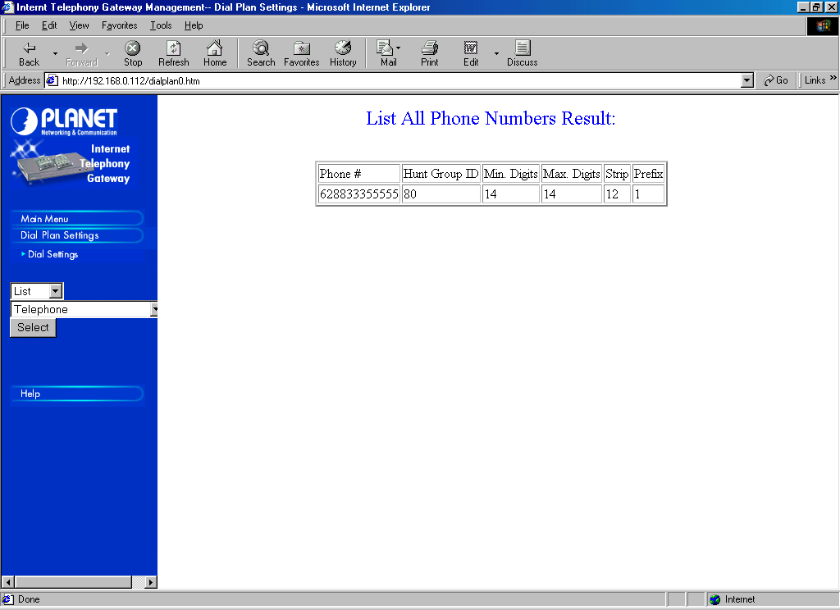
To check our settings, it can be done through Dial Settings → List → Telephone → Select. It will show that the number 628833355555 has been registered with HuntGroup ID 80, Strip Length 12 and Append Prefix 1.

The next step is to map the HuntGroup ID to certain Destination ID. The Destination ID may then map to appropriate ITG’s FXO ports.

Hunt Group Programming
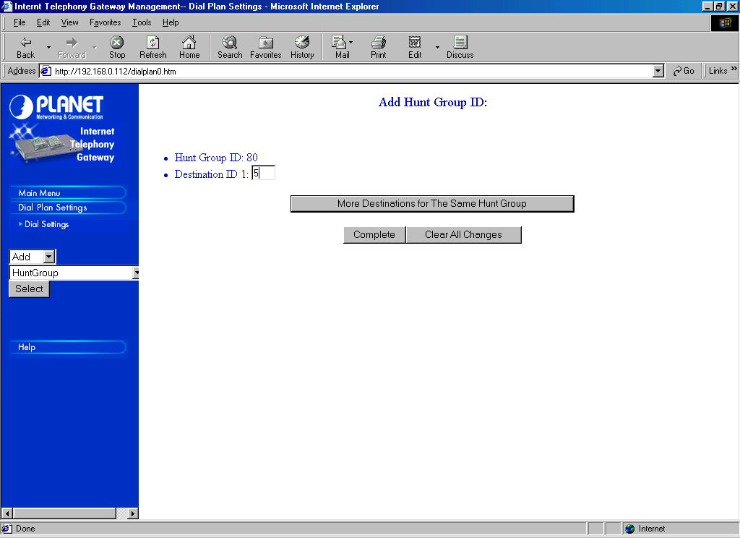
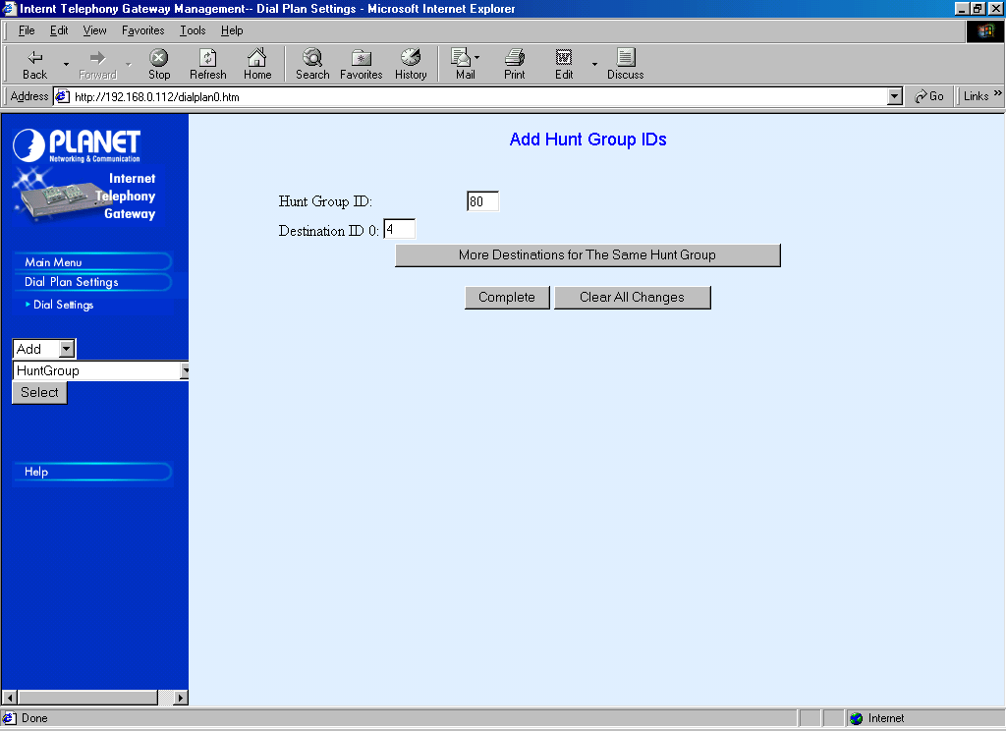
HuntGroup programming can be done through Dial Settings → Add → HuntGroup → Select. Enter 80 in HuntGroup ID.

Put 80 in Hunt Group ID. Since it will directed to RJ-11 FXO port number 4, 5, 6, and 7, to make our life easier, we will set the Destination ID 4, 5, 6 and 7, respectively, through “More Destination for The Same Hunt Group”.

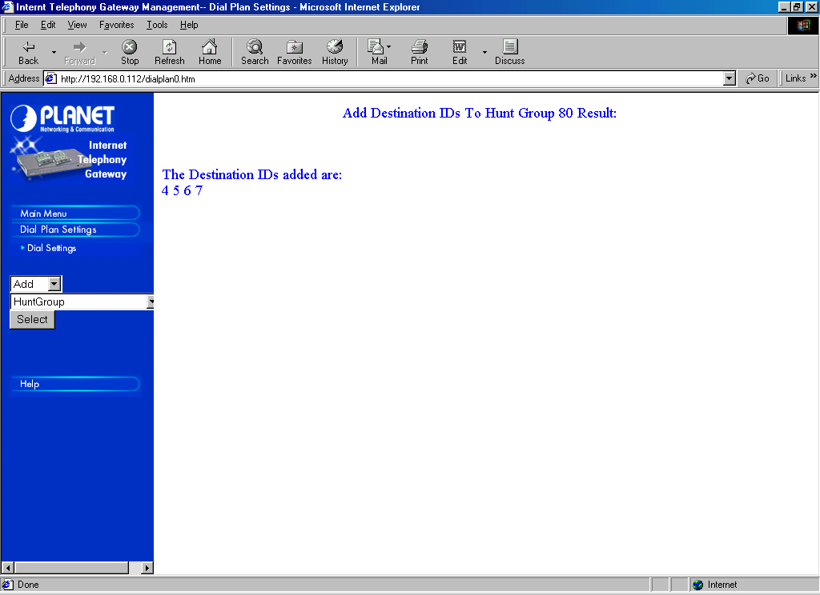
Upon filling Destination ID 7, press “Complete”. The Internet Telephony Gateway (ITG) will show that “The Destination IDs added are: 4 5 6 7”.
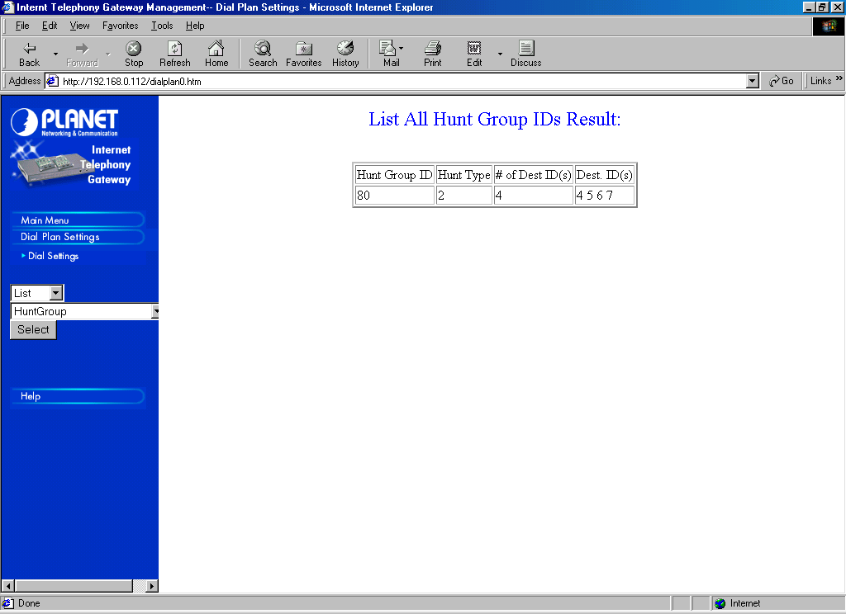
To review and check on the Destination ID, we can use Dial Settings → List → HuntGroup → Select.

Port Number Programming
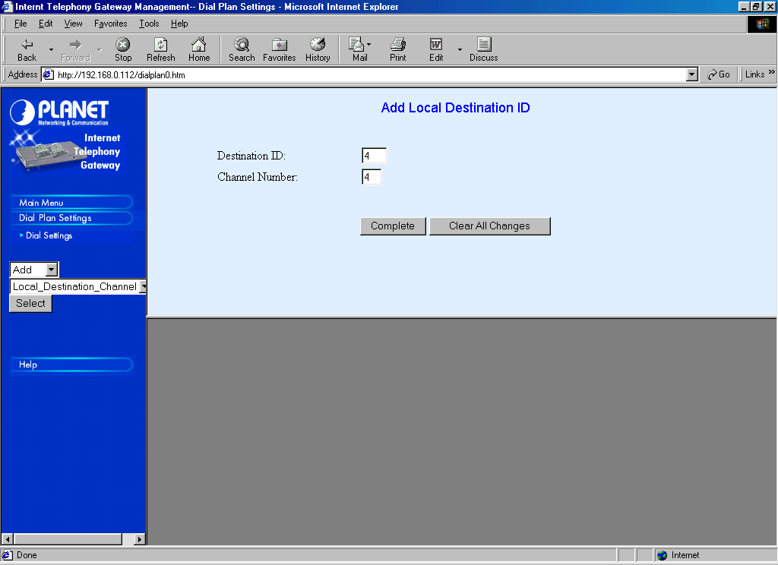
The final step in dial plan settings is mapping the Destination ID and, in our case, the Local Destination Channel (the FXO Ports). The mapping can be done through Dial Settings → Add → Local_Destination_Channel → Select.

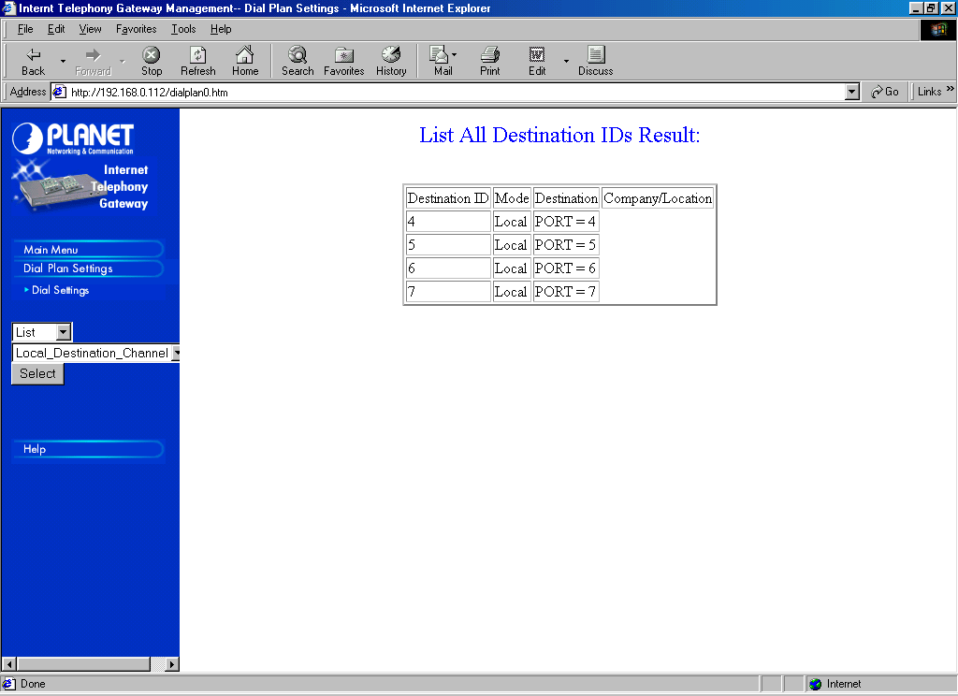
We need to map Destination ID 4, 5, 6 and 7 to Local Destination Channel 4, 5, 6 and 7, respectively.

To review and check the mapping between Destination ID and Local Destination Channel can be done through Dial Settings → List → Local_Destination_Channel → Select. We will see a mapping table between Destination ID and FXO PORTs.

Please don’t forget to save it to NVRAM / permanent memory from the Dial Plan Settings else we will loose the number as we reboot or turn off the ITG. The next step is to tell the Gatekeeper that the ITG serving particular numbers.

Registering Gateway to Proxy Gatekeeper

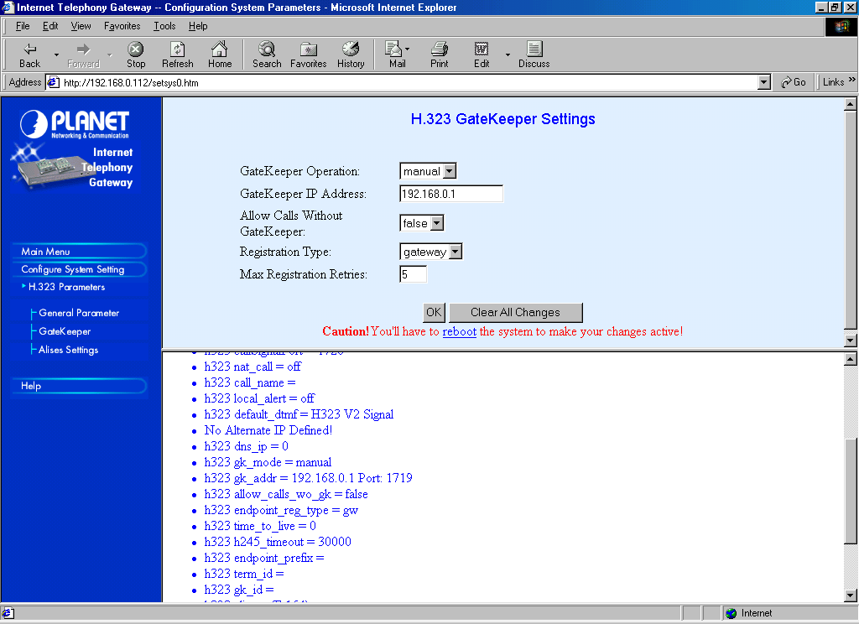
In introducing the proxy Gatekeeper that the ITG serves 62883335555xx, we need to configure the ITG, which proxy Gatekeeper to be registered and the endpoint prefix served by the ITG.

To configure the ITG on the proxy Gatekeeper to be registered can be done through Configure System Settings → H.323 Parameters → Gatekeeper. Set the Gatekeeper Operation to manual. Fill Gatekeeper IP address to the appropriate proxy Gatekeeper IP address; in this example is 192.168.0.1.
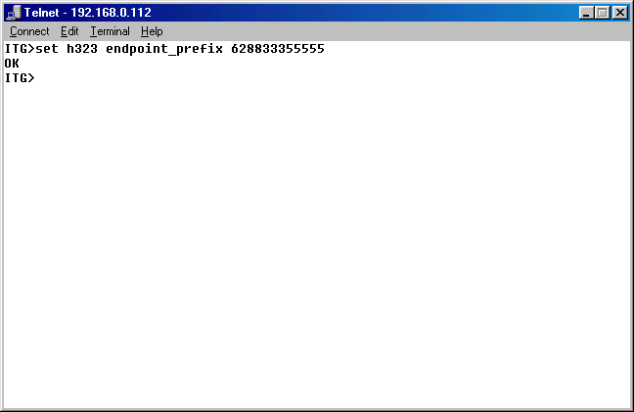
To configure the ITG on the endpoint prefix to be registered to proxy Gatekeeper, it can only be done through telnet or serial console. Through the console, in ITG> prompt, we can enter the command

ITG> set h323 endpoint_prefix 628833355555

Please don’t forget the store the configuration to NVRAM. In the console, it is done through,

ITG> config store

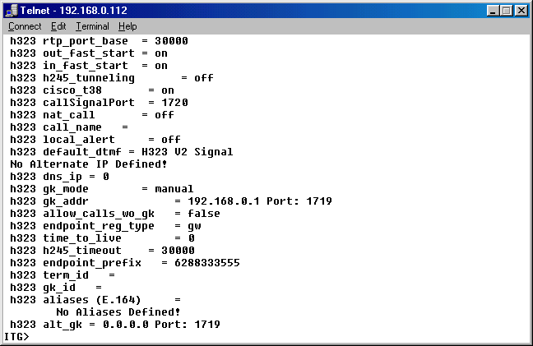
To review and check the configuration from the console, entering the command

Show h323

We should be able to see

h323 endpoint_prefix = 628833355555.

At this point, when we reboot the Internet Telephony Gateway (ITG), the local proxy Gatekeeper located at the proxy server attach to our Local Area Network (LAN) will recognize the existence of our ITG and the phone number it serves.

Registering A Proxy Gatekeeper To Public Gatekeeper

To let others at VoIP infrastructure knows on the existence of numbers, we need to configure the proxy Gatekeeper to register to one of the public Gatekeeper. The prefix 628833355555 must be registered to the public Gatekeeper during its process.

The registration process to public Gatekeeper can be done through [Endpoint] section in the proxy Gatekeeper configuration file. For example,

[Endpoint]
Gatekeeper=202.53.224.172
Type=Gateway
H323ID=TestingProxyGK
Prefix=628833355555
TimeToLive=100
RRQRetryInterval=10
ARQTimeout=2
UnregisterOnReload=1

In this particular example, the proxy Gatekeeper will register to a public Gatekeeper located at 202.53.224.172. The registration of Endpoint prefix is set in the Prefix parameter. Public Gatekeeper 202.53.224.172 can also be used for phone number of any countries.

For the Indonesian Free VoIP MaverickNet, we can also use several public Gatekeepers for specific prefix, such as,

202.155.39.157 - for area code 62 88
218.100.4.194 - for area code 62 88 888
      - - for area code 62 88 999
202.150.8.15 - for area code 62 88 925

Please use the prefix correctly else no one will be able to call our proxy Gatekeeper.

