Direct Connection To Telco

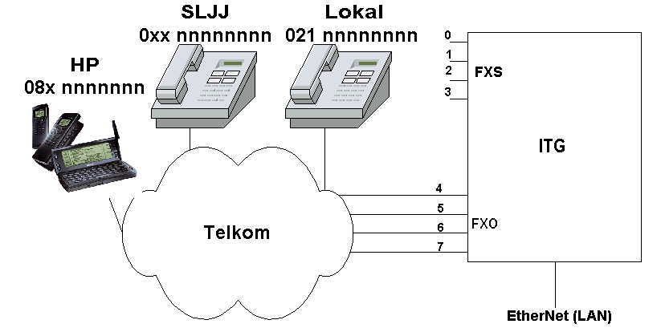

Some Government and Telco operators may dislike the knowledge written in this chapter. Reader digression is advised. In this chapter, method to interconnect the Internet Telephony Gateway (ITG) directly to Telco’s line as well as cell phone will be described. The scenario developed for this chapter is to connect the RJ-11 FXO PORT 4, 5, 6 and 7 directly to Telco’s line. It should be able to pass traffic to Telco and from Telco.

In terms of the programming, two (2) scenarios are developed, i.e.,

- Allow all VoIP users to call all Telco’s numbers starting with exit code 0. It means we allow all long distance calls to pass through. It is the finest way to go bankrupt.
- Allow all VoIP users to call only certain area code, such as, 021, 081185, and 081194, do that only local numbers can be reached from VoIP infrastructure.

In reality, I normally allow only certain numbers to be connected through VoIP infrastructure, such as, my wife’s handphone, my home number etc.

Note that the Internet Telephony Gateway (ITG) operators will receive all Telco’s charges. Unfortunately, nothing is free in passing the traffic through Telco lines.

In Indonesia, we need to get a government licensed to interconnect the VoIP infrastructure directly to Telco’s infrastructure especially for those who run the service for money. This chapter is trying to tell that the technique is pretty much easy to do.

Programming Area Code 0 in ITG

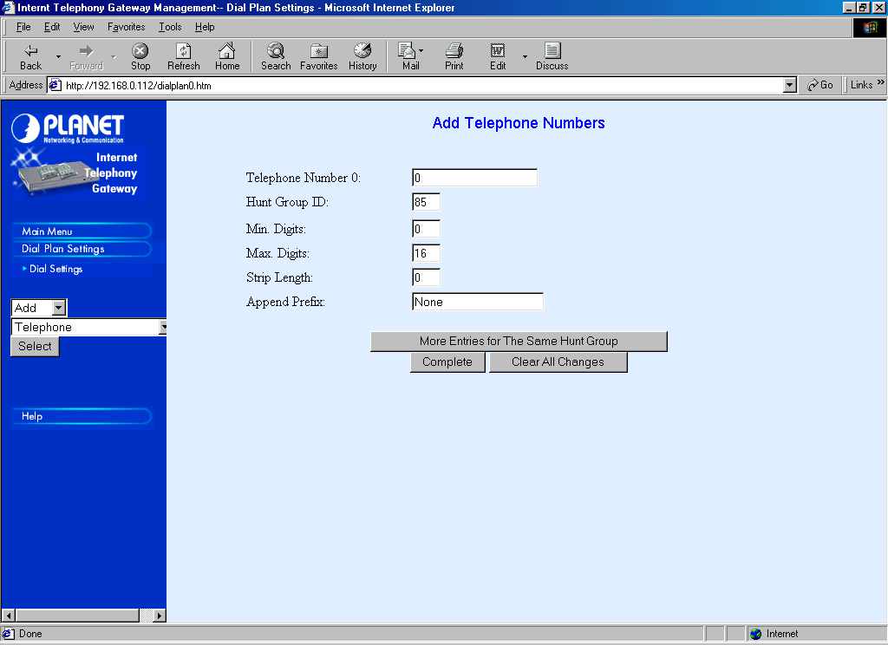
Phone number programming to connect to Telco’s lines is fairly similar to other phone number programming. It can be done through Dial Plan Settings → Dial Settings → Add → Telephone → Select.

To enable all VoIP Users to be able to access the exit code 0, all we have to do is fill 0 in Telephone Number entry, Minimum Digit 0 and Maximum Digits 16.

Since we are going to hunt all calls to FXO PORT 4, 5, 6, and 7, the HuntGroup ID is set to a number other than 0-7, in this case 85. No digits to be stripped, except local area code, in this case 021. No prefix to be appended.
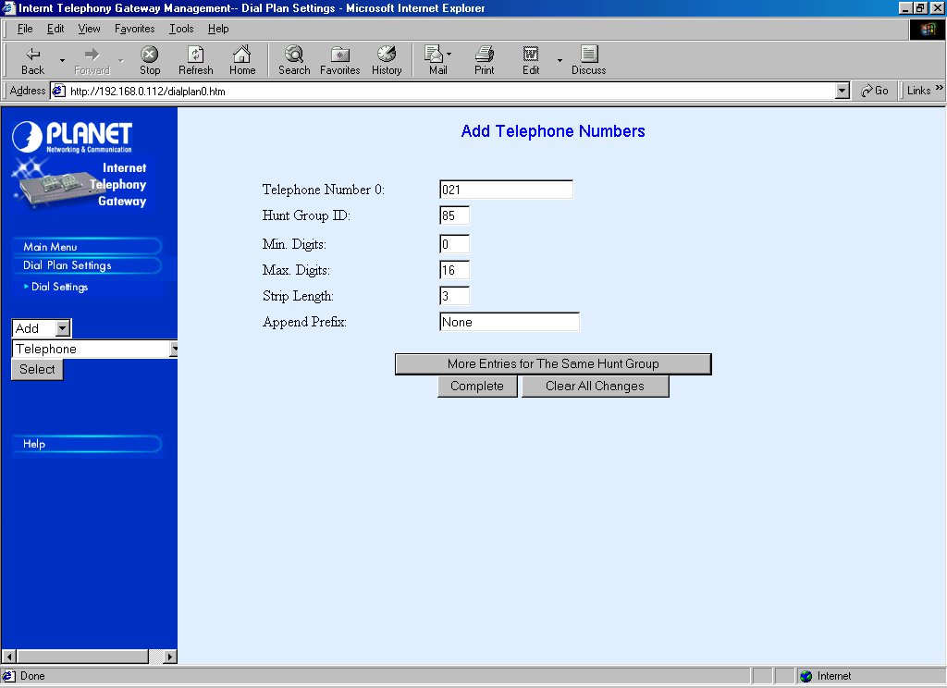
For local numbers, in this case area code 021, we need to strip the area code digits before we pass it to Telco’s lines. In this example, in programming area code 021, we stripped three (3) digits. The rest of the program is basically the same as other phone number program.

To review and check our phone number configuration, it can easily be done through Dial Settings → List → Telephone → Select.
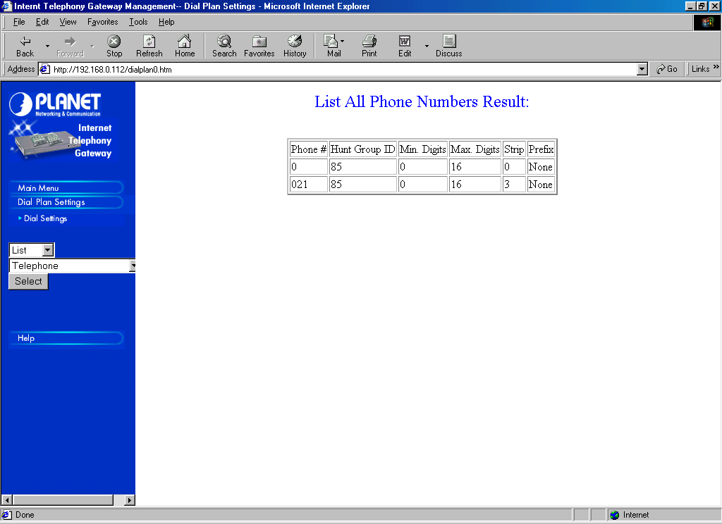

Programming Area Code 081185 & 081195 in ITG

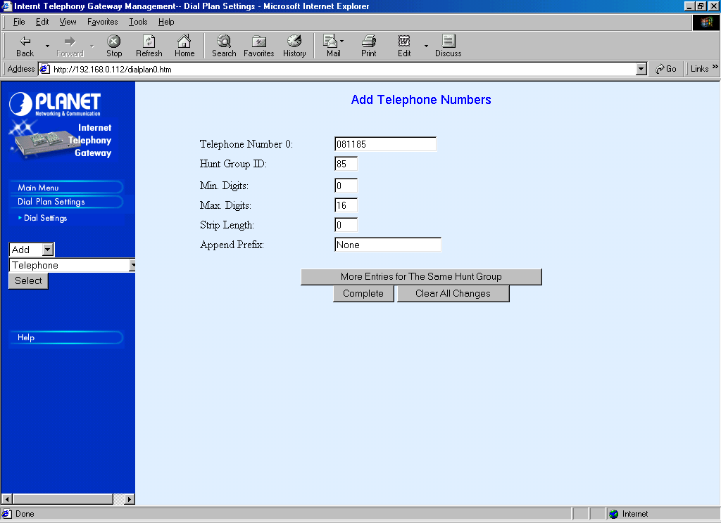
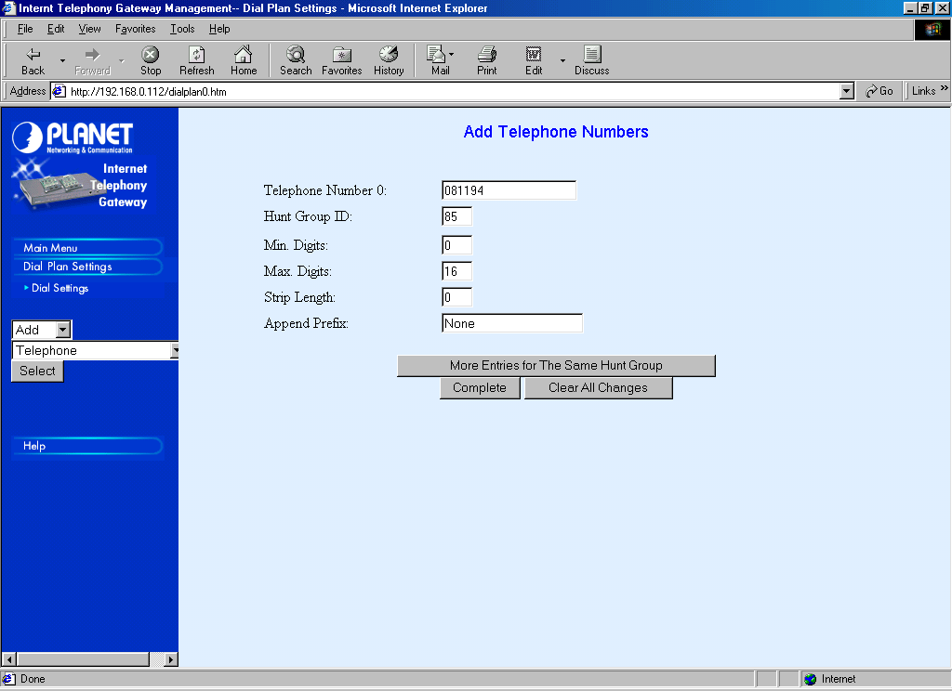
For those who wish to limit the access to certain area codes, it can easily be done by programming the area code of interest rather than putting the global exit code 0 into the table. In this example, the area code of interest is 081185 and 081194.

In most cases, I normally open the FXO PORT not to all code area rather only to certain phone numbers.

There is nothing different and special in setting / programming area code 081185 and 081194 into the table. All parameters are the same as programming the area code 0 described above.

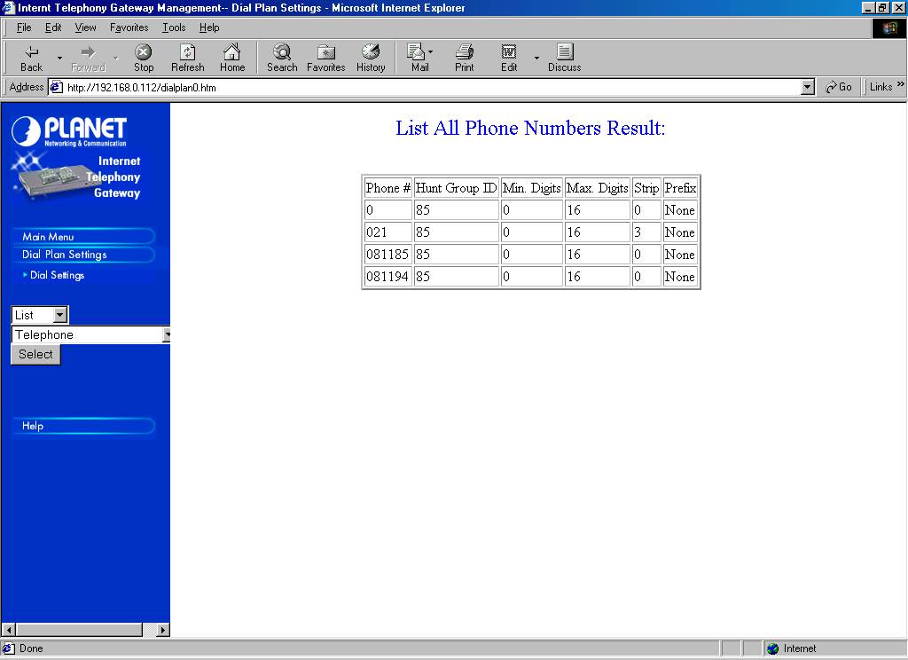
To review and check our phone number configuration, it can be easily be done through Dial Settings → List → Telephone → Select.

Our next step is to program the HuntGroup ID to the correct destinations.

Hunting Group Programming

The HuntGroup ID 85 programming is simultaneously directed to Destination ID 4, 5, 6, and 7 to do the hunting for FXO PORT 4, 5, 6, and 7. It can easily be done through Dial Settings → Add → HuntGroup → Select.
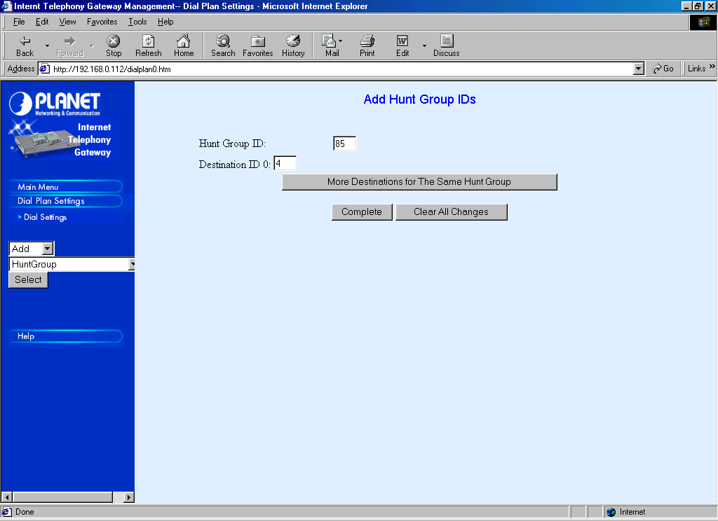
Fill HuntGroup ID to 85. Fill Destination ID to 4. Press “More Destinations for The Same HuntGroup”, to do the hunting. Fill Destination ID 5, 6, and finally 7 before we press “Complete”.

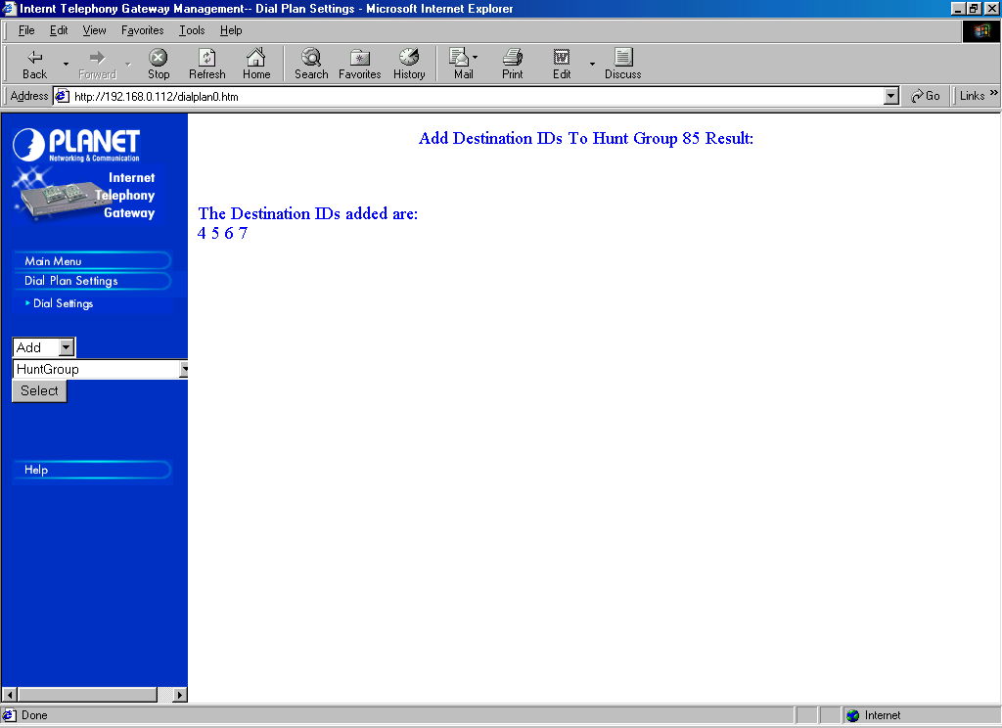
The Internet Telephony Gateway (ITG) will show that “The Destination IDs added are: 4 5 6 7” as soon as we press “Complete”.

To review and check the map between HuntGroup ID and Destination ID can be done through Dial Settings → List → HuntGroup → Select.
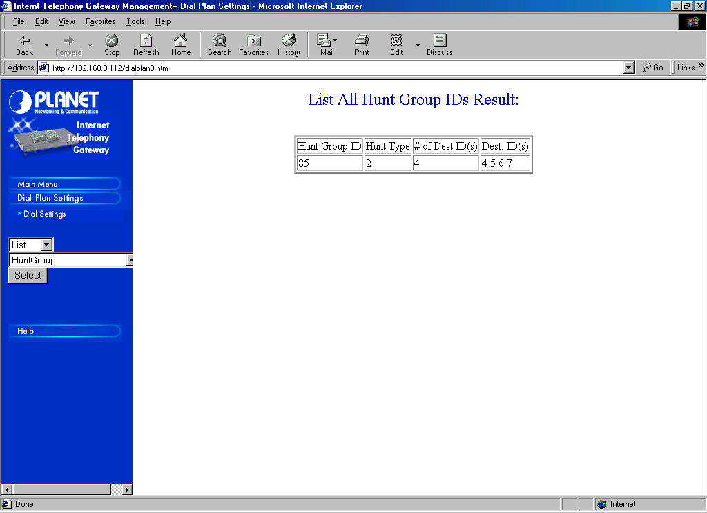

Our next step would be to map each Destination ID to its respective Destination Channel.

Port Number Programming

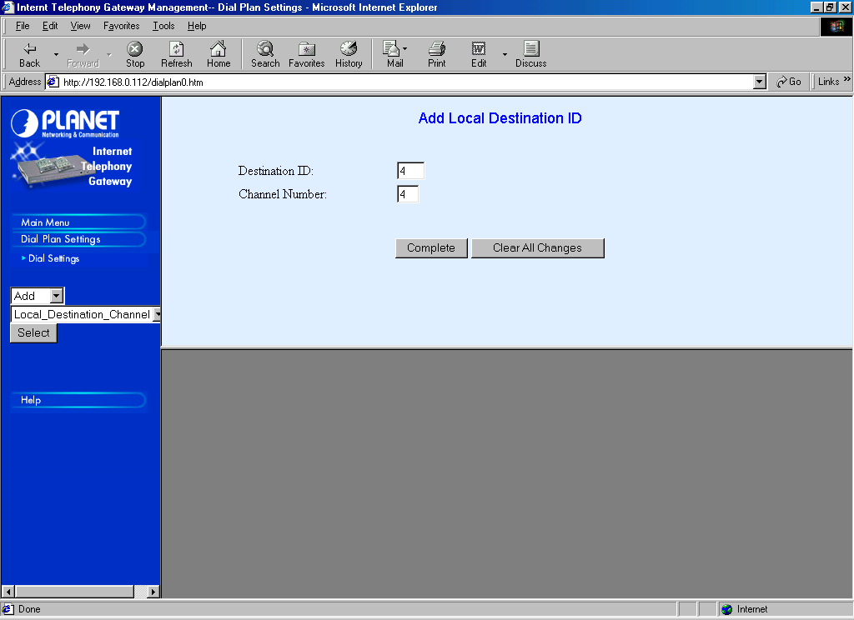
To map the Destination ID to each respective port can be done through Dial Settings → Add → Local_Destination_Channel → Select.

We need to map each Destination ID 4, 5, 6, and 7 to Local Channel Number 4, 5, 6 and 7, respectively. Don’t forget to press the “Complete” as completed.
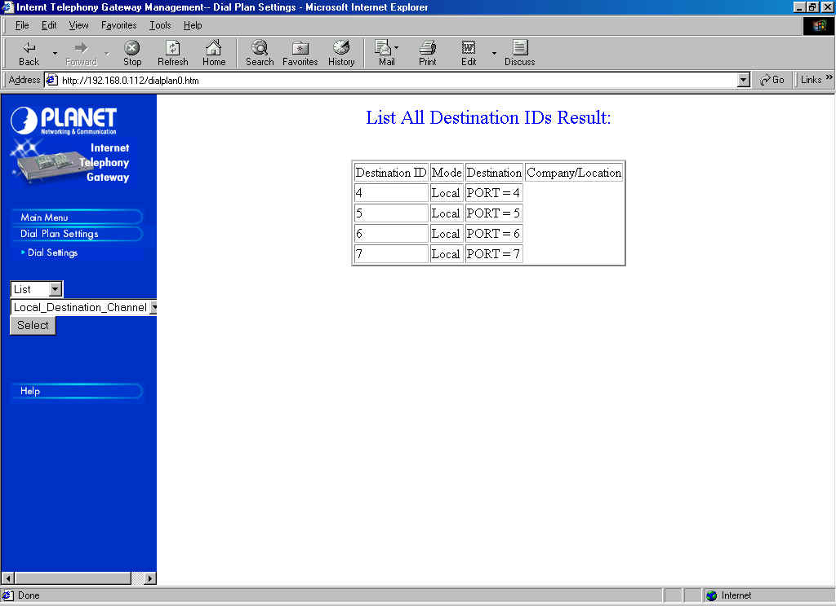
To review and check the mapping of port number, it can be done through Dial Settings → List → Local_Destination_Channel → Select.

We have basically completed the phone number programming of the ITG to be able to connect to certain Telco’s area codes. Our next task would be to tell the proxy Gatekeeper as well as the public Gatekeeper to let all VoIP users knows regarding our existence.

Registering Area Code 0 to Gatekeeper

Having all numbers correctly programmed, we need to program so that the Internet Telephony Gateway (ITG) would tell the Gatekeeper regarding the existence of area code 0. Registration to local proxy Gatekeeper may be done via the Web Internet through Configure System Settings → H.323 Parameters → Gatekeeper. Or it can be done through the text mode interface, such as,

ITG> set h323 gk_mode manual
ITG> set h323 gk_addr 192.168.0.1
ITG> set h323 endpoint_reg_type gw

To simply things, we can tell the proxy Gatekeeper that the ITG will handle all calls start with 0 prefix. Off course, it is not a good idea to do such registration to the public Gatekeeper, as it will surely make us go bankrupt to pay all the Telco long distance bills.

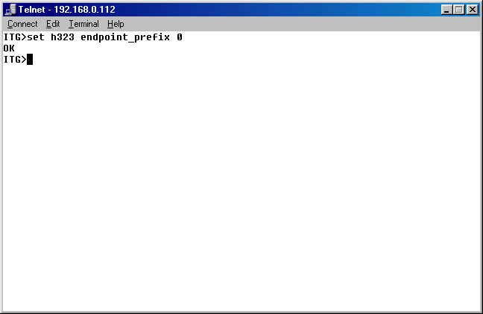
The enable the Internet Telephony Gateway (ITG) to register the area code 0 to the proxy Gatekeeper, it can be only done through h323 endpoint_prefix command. Shown in the figure is the example in setting the ITG to tell the proxy Gatekeeper that it handles all traffic for prefix ZERO (0) through command,

ITG> set h323 endpoint_prefix 0

To review and check the H.323 parameter configuration can be done by invoking the command,
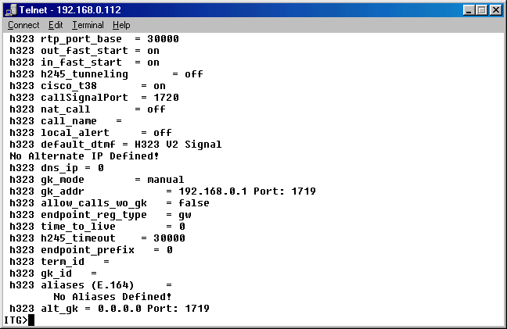
ITG> show h323.

Registering To Public Gatekeeper

Having the Internet Telephony Gateway (ITG) registers to the local proxy Gatekeeper, our next step is to configure the proxy Gatekeeper to register to public Gatekeeper as all the ITG registration will not be automatically pass by the proxy Gatekeeper to public Gatekeeper.

To let all VoIP users know on the existence of the area code or certain Telco numbers, we have to configure the proxy Gatekeeper so that all the numbers handled by ITG will be reported to the public Gatekeeper. The registration process is done through the [Endpoint] section in the configuration file.

The not recommended way to register to public Gatekeeper is registering the area code (prefix) 0 to the public Gatekeeper. An example of the not recommended way is shown below,

[Endpoint]
Gatekeeper=202.53.224.172
Type=Gateway
H323ID=TestingProxyGK
Prefix=0
TimeToLive=100
RRQRetryInterval=10
ARQTimeout=2
UnregisterOnReload=1

The public Gatekeeper used here is 202.53.224.172. Recommended ways to register to public Gatekeeper is just registering some of the approved phone numbers, such as, home / friend phone numbers and some cell phones. Having these personal phone registers will enable us to call home over the Internet while traveling. The recommended [Endpoint] section configuration may be,

[Endpoint]
Gatekeeper=202.53.224.172
Type=Gateway
H323ID=TestingProxyGK
E164=0214204770,0811564678,021436865
TimeToLive=100
RRQRetryInterval=10
ARQTimeout=2
UnregisterOnReload=1

Registering Area Code 021, 081184, 081195 To Gatekeeper

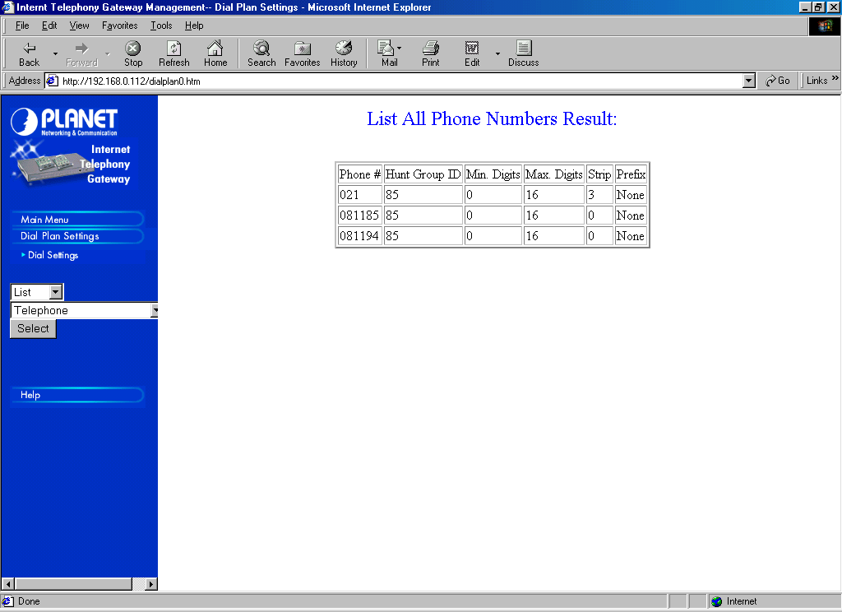
For Internet Telephony Gateway (ITG) operators who want to give service to carry traffic for several specific area codes, in this example is limited to only 021, 081185 and 081194, one of the simplest configurations to tell the proxy Gatekeeper by using the endpoint prefix command.
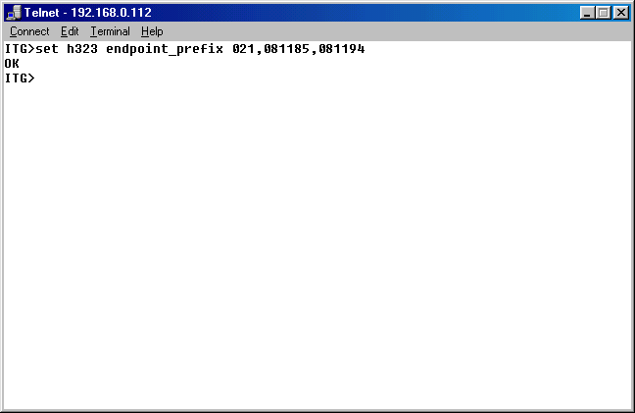
It may not be advisable to use endpoint_prefix command for several area codes simultaneously. However, if one insisted, we can always try through,

ITG> set h323 endpoint_prefix 021, 081185, 081194.

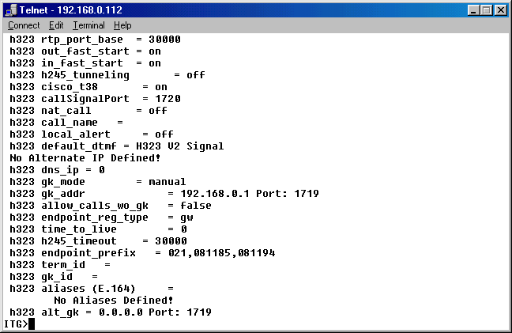
To review and check the H.323 parameter configuration can be done by invoking the command,

ITG> show h323.

The next step would be to configure the proxy Gatekeeper to tell the public Gatekeeper that several area codes, namely, 021, 081184, and 081195 will be served by devices behind the proxy Gatekeeper. The configuration is done in [Endpoint] section, such that,

[Endpoint]
Gatekeeper=202.53.224.172
Type=Gateway
H323ID=TestingProxyGK
Prefix=021,081184,081195
TimeToLive=100
RRQRetryInterval=10
ARQTimeout=2
UnregisterOnReload=1

In reality, I will not suggest to register Telco’s area code to the public Gatekeeper, rather registering only some of the important phone numbers.

