Telco Connection Through PBX

In this chapter, a subtle way to connect your VoIP infrastructure to Telco will be described. The connection is made through a PBX, as there is nothing wrong by connecting a PBX to Telco. Thus, there is no direct connection between Internet Telephony Gateway (ITG) to Telco infrastructure, as everything goes via the office PBX system. In Indonesia, a direct and commercial connection between VoIP infrastructure and Telco would require a special licensed from the Ministry of Telecommunication. Some Government and Telco operators may dislike the knowledge written in this chapter.
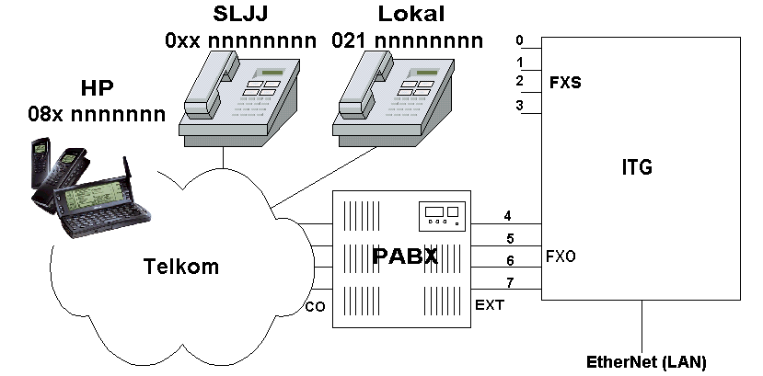

In this chapter, we develop a scenario commonly found in most offices as shown in the figure. The scenario is as follows,

- An office with PBX with many Extension lines.
- The PBX is connected to several Telco lines.
- Some of PBX Extensions are connected to the Internet Telephony Gateway (ITG).

In such infrastructure, the scenario leads to,

- All Extension would be able to interact to numbers on Telco as well as VoIP infrastructure.
- All VoIP users would be able to call the extension. VoIP users might be able to call Telco numbers if permitted.
- Telco users would be able to call Extension. Telco users might be able to call VoIP users of permitted.

In this chapter, an example on how to configure the Internet Telephony Gateway (ITG) in interconnection with Telco through a PBX will be described. Two (2) scenarios in Telco area code integration will be described, such as,

- Allowing all VoIP users to connect to the whole Telco’s number start with exit code 0. It is the best way to make us bankrupt.
- A little bit better scenario, only allowing some area codes, in this example is 021, 081185 and 081194, are permitted to pass traffic to Telco via PBX.

In reality, I normally allow to pass calls to only few Telco numbers from Internet Telephony Gateway via the PBX. These numbers are normally known destinations, such as, partners, friends, family that might be useful to be reach while via Internet while travel.

Programming Area Code 0 into ITG
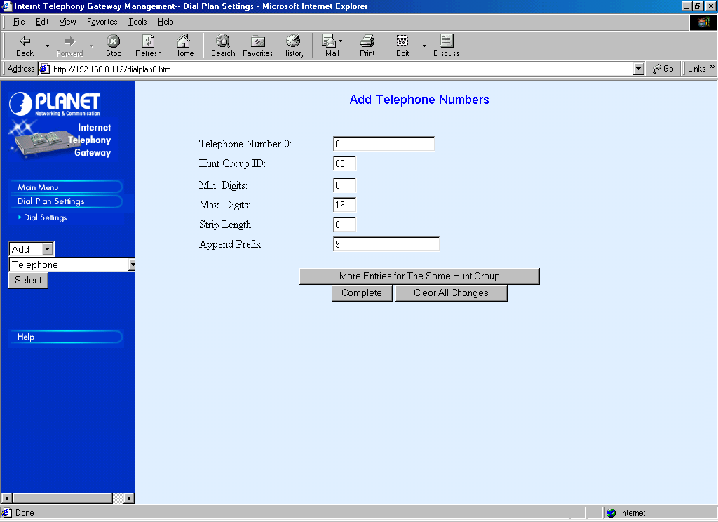
Phone number programming to connect to Telco’s lines is fairly similar to other phone number programming. It can be done through Dial Plan Settings → Dial Settings → Add → Telephone → Select.

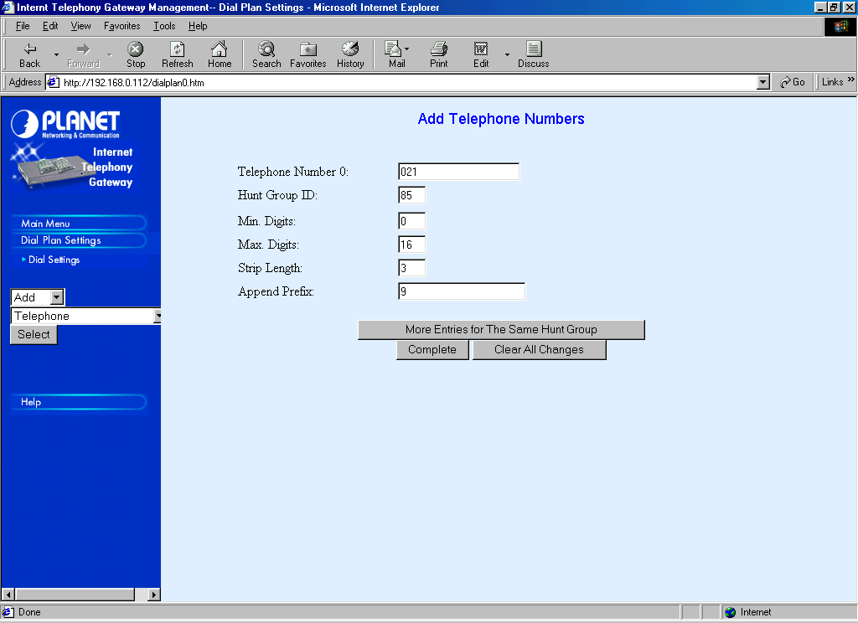
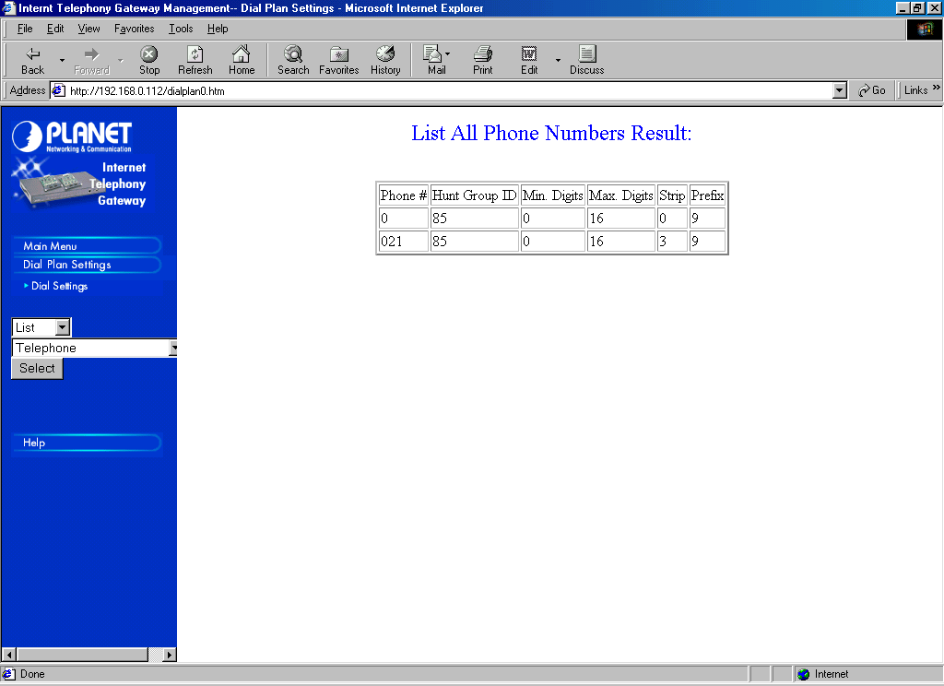
To enable all VoIP Users to be able to access the exit code 0, all we have to do is fill 0 in Telephone Number entry, Minimum Digit 0 and Maximum Digits 16. Since the call must be relayed through a PBX, we need to add “9” in front of the numbers granted the PBX allow us to do long distance calls. To add digit “9” in front of the Telephone Number, it can be done through setting the Append Prefix entry to 9.

Since we are going to hunt all calls to FXO PORT 4, 5, 6, and 7, the HuntGroup ID is set to a number other than 0-7, in this case 85. No digits to be stripped, except local area code, in this case 021. We need to append prefix “9” to the number to be able to pass the calls to Telco via CO lines in PBX.

For local numbers, in this case area code 021, we need to strip the area code digits. In this example, in programming area code 021, we stripped three (3) digits. We need to append prefix “9” before we pass the call to PBX. The rest of the program is basically the same as other phone number program.

Programming Area Code 021, 081185 & 081195 into ITG

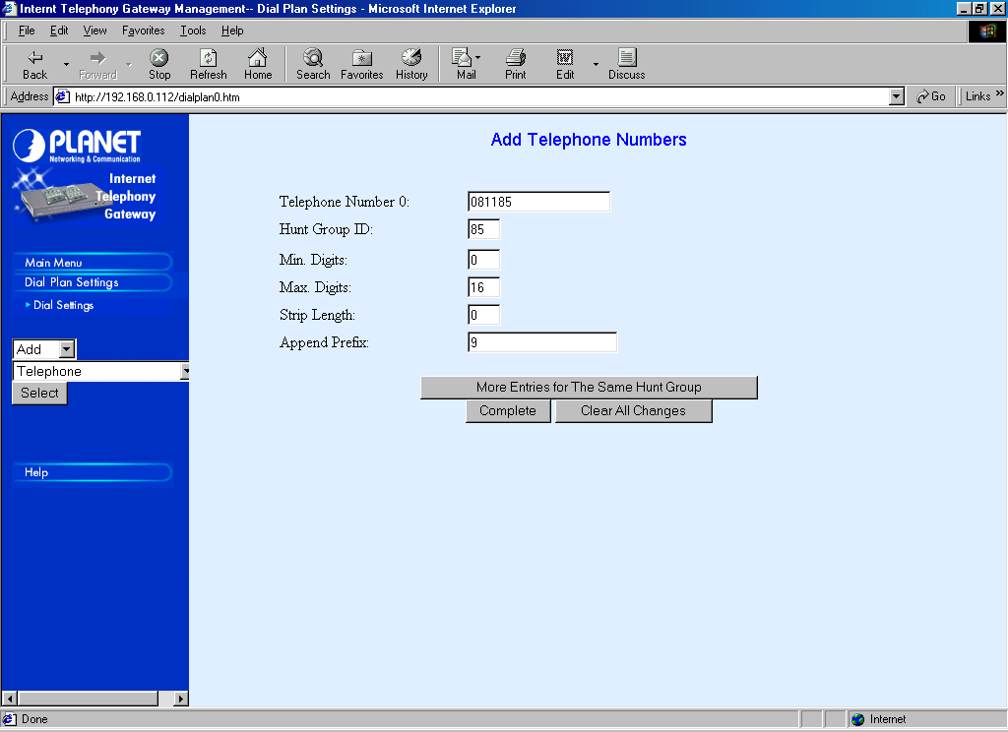
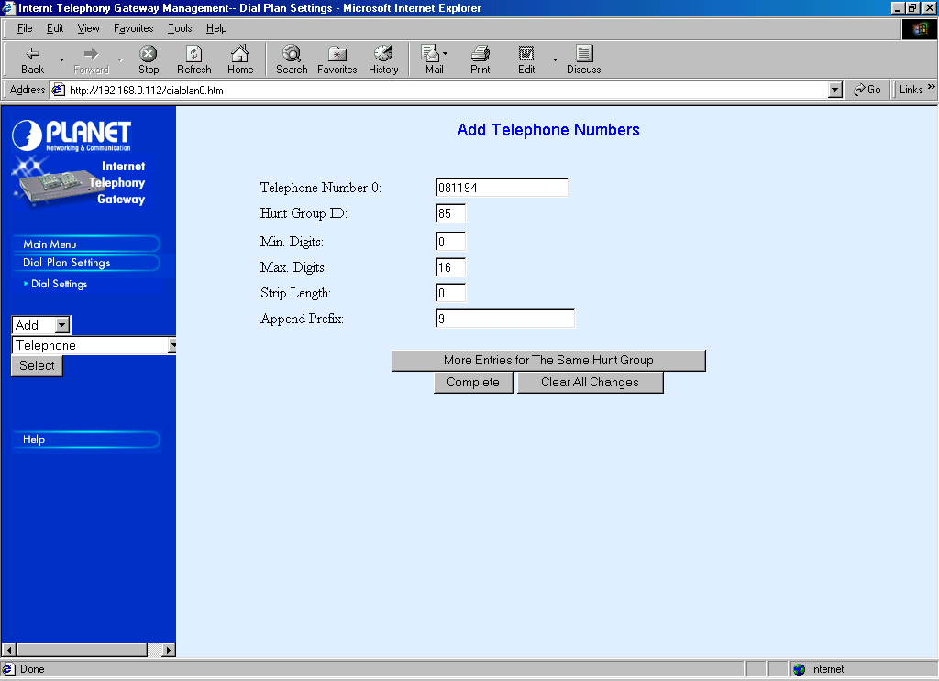
In reality, we normally limit the access to certain area codes or even only several known phone numbers, it can easily be done by programming the area code of interest rather than putting the global exit code 0 into the table. In this example, the area code of interest is 081185 and 081194.

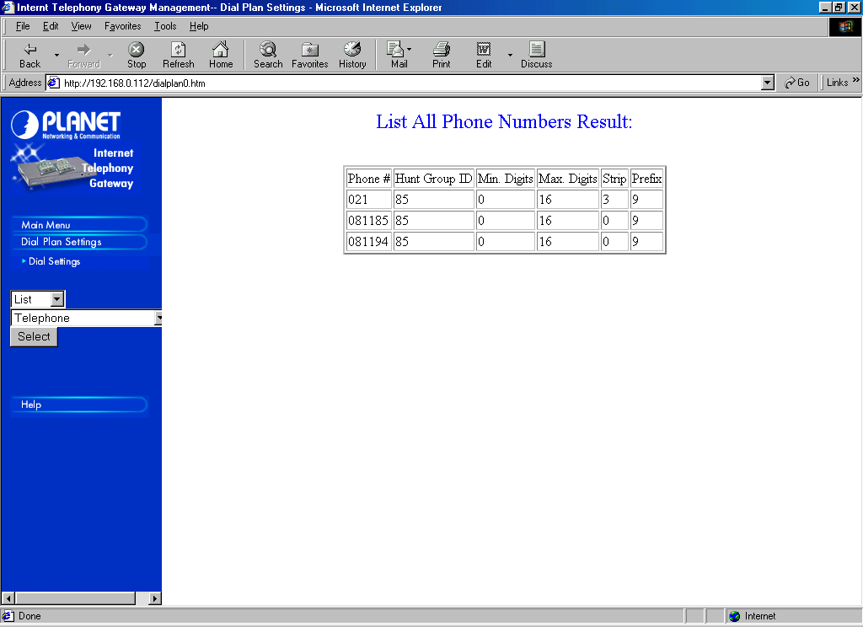
Since all the Telco calls should be passed through the PBX, the only major difference in programming the ITG is in appending prefix “9” in the telephone numbers. The prefix “9” is needed to pass the call through the PBX.

Hunting Group Programming
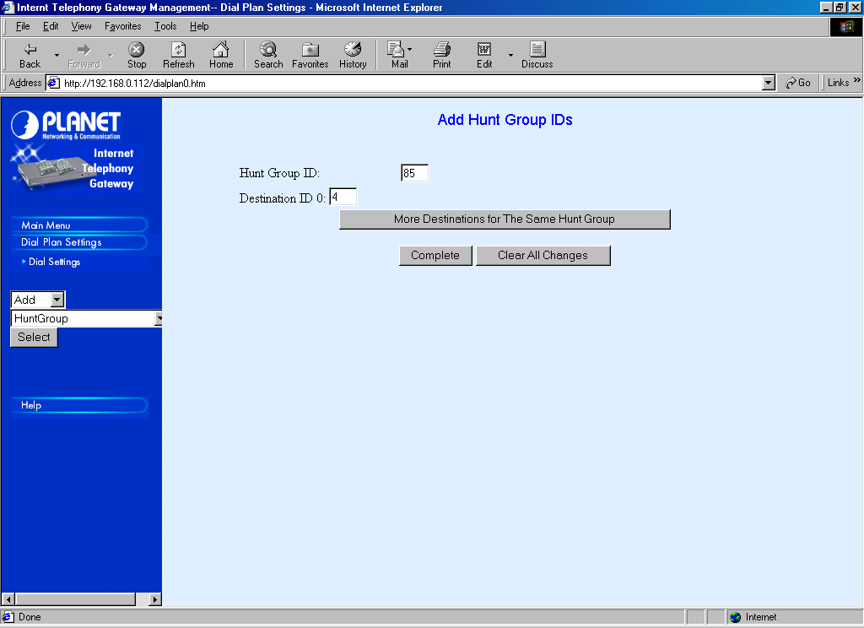
The HuntGroup ID 85 programming is simultaneously directed to Destination ID 4, 5, 6, and 7 to do the hunting for FXO PORT 4, 5, 6, and 7. It can easily be done through Dial Settings → Add → HuntGroup → Select.

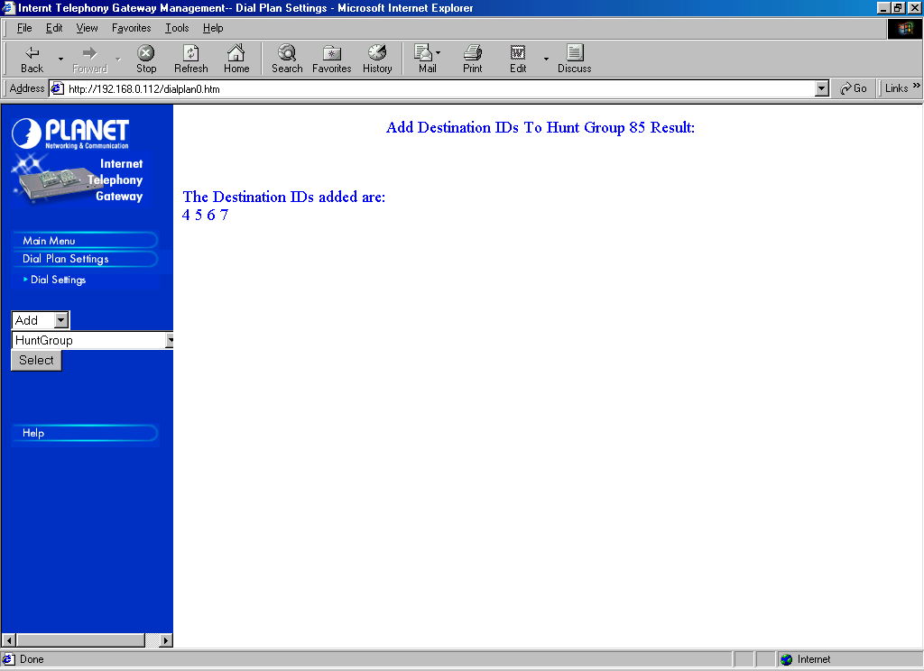
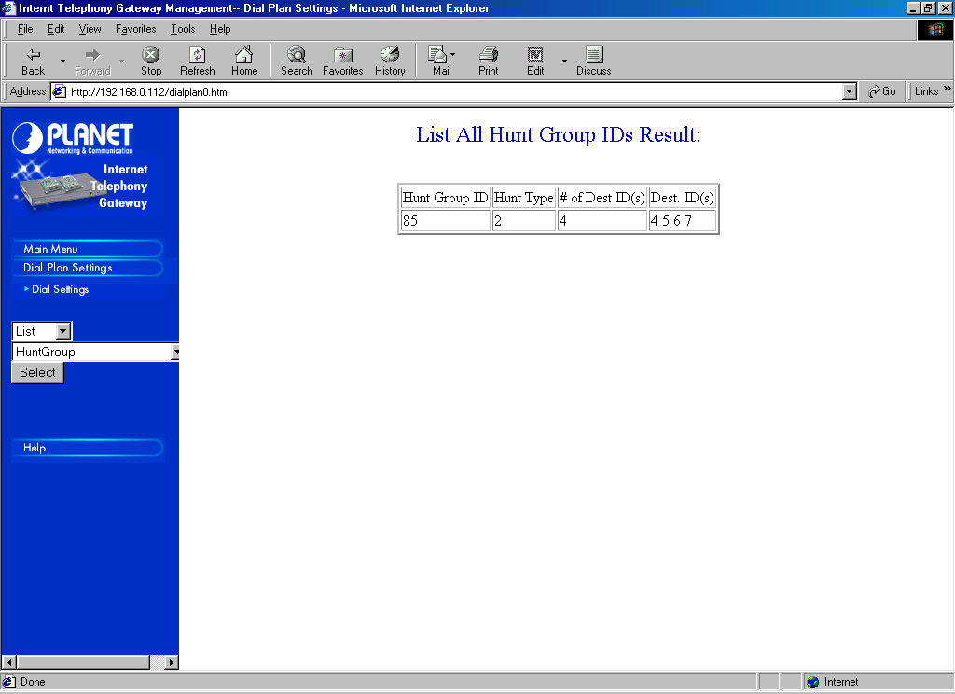
Fill HuntGroup ID to 85. Fill Destination ID to 4. Press “More Destinations for The Same HuntGroup”, to do the hunting. Fill Destination ID 5, 6, and finally 7 before we press “Complete”. To review and check the map between HuntGroup ID and Destination ID can be done through Dial Settings → List → HuntGroup → Select.

Port Number Programming

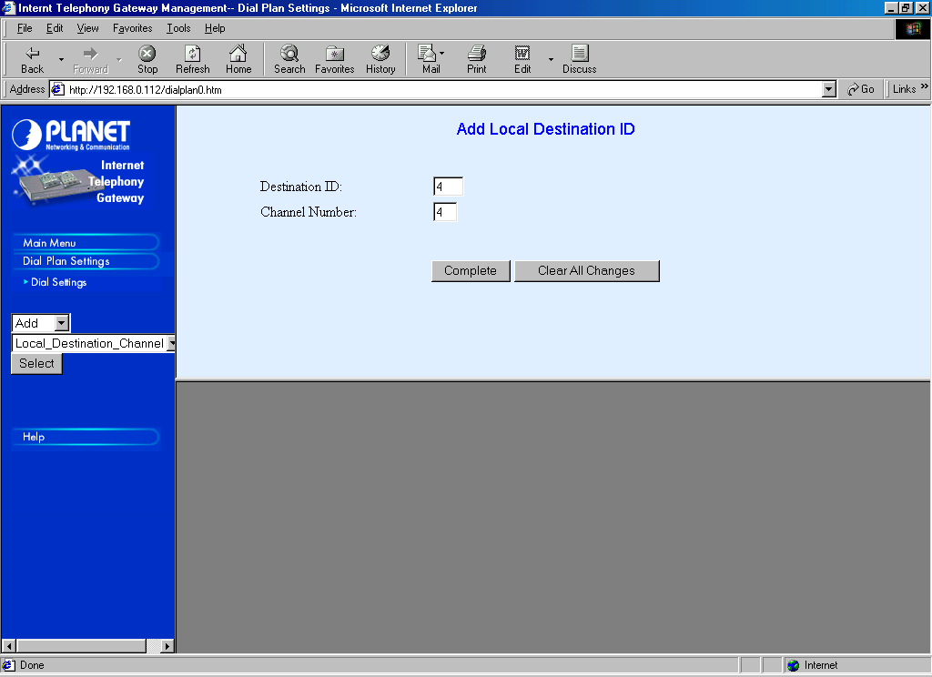
To map the Destination ID to each respective port can be done through Dial Settings → Add → Local_Destination_Channel → Select.

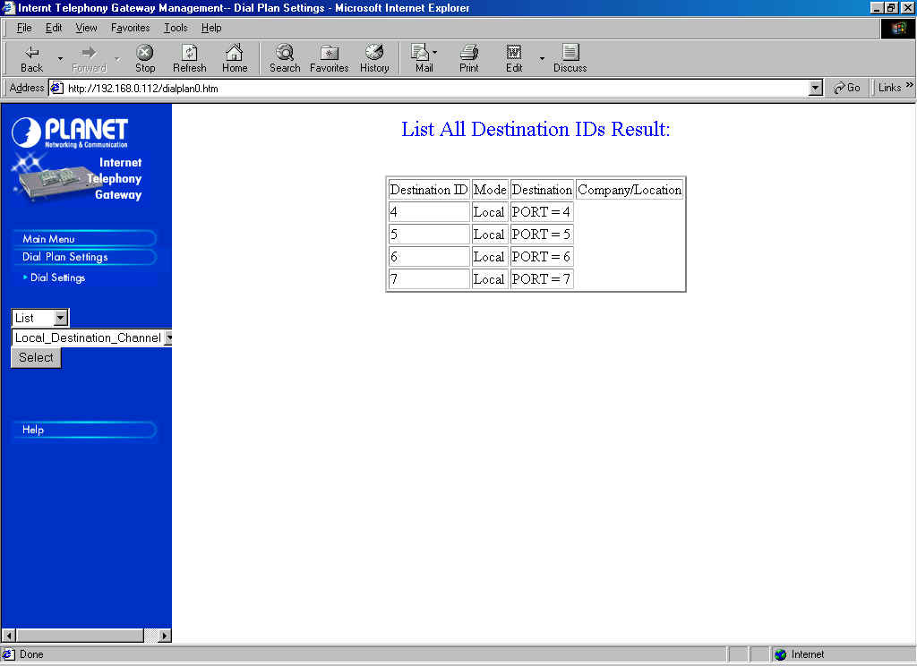
We need to map each Destination ID 4, 5, 6, and 7 to Local Channel Number 4, 5, 6 and 7, respectively. Don’t forget to press the “Complete” as completed.

To review and check the mapping of port number, it can be done through Dial Settings → List → Local_Destination_Channel → Select.

We have basically completed the phone number programming of the ITG to be able to connect to certain Telco’s area codes.

Configuring the Proxy Gatekeeper

Our next task would be to tell the proxy Gatekeeper as well as the public Gatekeeper to let all VoIP users knows regarding our existence. The configuration process of the registration process of an Internet Telephony Gateway to proxy Gatekeeper and the configuration of [Endpoint] section of proxy Gatekeeper to tell the public Gatekeeper regarding the the existence of our ITG interconnection to Telco will not be discussed in detail in this chapter, as it has been discussed in other chapters.

Recommended way to register to public Gatekeeper is just registering some of the approved phone numbers, such as, home / friend phone numbers and some cell phones. Having these personal phone registers will enable us to call home over the Internet while traveling. The recommended [Endpoint] section configuration may be,

[Endpoint]
Gatekeeper=202.53.224.172
Type=Gateway
H323ID=TestingProxyGK
E164=0214204770,0811564678,021436865
TimeToLive=100
RRQRetryInterval=10
ARQTimeout=2
UnregisterOnReload=1

