Borrow Telco’s Number in VoIP Infrastructure

Most people want to be called using their normal Telco’s phone numbers rather than using an invented VoIP number. In this scenario, we want the any calls originated from Telco as well as VoIP must reach the same handset behind a PBX on the same phone number. In other words, VoIP users must be able to call our handset using Telco’s number BUT without passing the traffic through any Telco infrastructure. Please note that VoIP users are on the Internet and can be anywhere in the world. Thus, bypass of any long distances charges is naturally done through the settings.

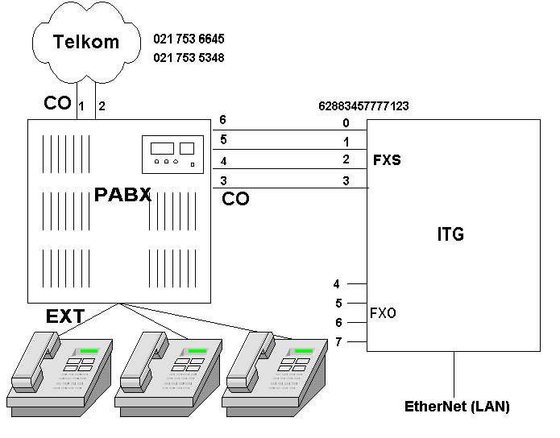
In Indonesia, the regulation clearly stated that only those who do the VoIP service commercially and have the traffic connected to Telco must ask for license from the Department of Telecommunication. Telco and the regulator are always accusing us who operate VoIP is steal their Telco’s pulse / traffic. Using such scenario, all traffic are passed through the Internet and no connection ever been made through Telco’s infrastructure. Thus, there are no way for Telco and the regulator to blame us for stealing their traffic.

Shown in he figure is the equipments used in the scenario. The normal office configuration centralized on a PBX with several handsets on its extension and connected to several Telco’s CO line at the PBX. In this scenario, the Telco’s numbers are 021 753 6645 and 021 753 5348 connected to two (2) of PBX CO lines.

In this scenario, we add an Internet Telephony Gateway (ITG) with all of its four (4) FXS PORT connected to the PBX CO lines. Thus, in effect, the ITG is acting as the Telco’s lines. The ITG is connected to the VoIP infrastructure through the normal LAN connection with a proxy Gatekeeper installed at the proxy server. We may add a VoIP number to the Internet Telephony Gateway (ITG) if we wish. In this example, we may configure all the four (4) FXS PORT to have a single VoIP number, e.g., 628834577777123.

Having the Internet Telephony Gateway (ITG) connected to the CO PBX, we may also program the ITG to tell the proxy Gatekeeper as well as the public Gatekeeper on the existence of the two Telco’s number, i.e, 021 753 6645 and 021 753 5348, to these Gatekeepers. Consequently, all VoIP users will recognize how to reach our PBX (as well as all the handsets behind the PBX) from the VoIP infrastructure. Through such configuration, the VoIP calls and traffic will not pass through any Telco’s infrastructure rather through the ITG and the Internet.

As a result, all phone calls, both Telco’s originate calls as well as VoIP originate calls will reach the same handsets behind the PBX. Our friends at the office will hardly notice that there are two (2) different originating calls. Interestingly, callers from VoIP infrastructure use the same Telco’s number to call the office. Thus, everything looks the same and no violation to the regulation at much lower long distance cost.

On the PBX side, we need to do a little bit of Automatic Route Selection (ARS) programming as both Telco and VoIP ITG are connected through CO lines. For simpler PBX programming, we can always the ITG FXO Lines to connect to the PBX Extension. However, we need to tell the PBX users to do double stage dialing to VoIP through certain extension at the PBX.

Let’s do the configuration.

Programming the Phone Number in ITG
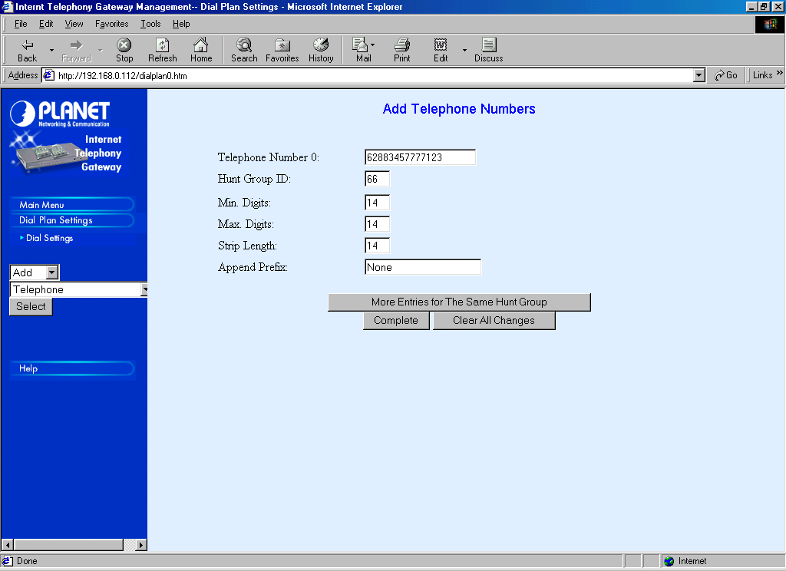
The programming of VoIP number 628834577777123 into the ITG to hunt through all four (4) ITG FXS is fairly straightforward through Dial Plan Settings → Dial Settings → Add → Telephone → Select.

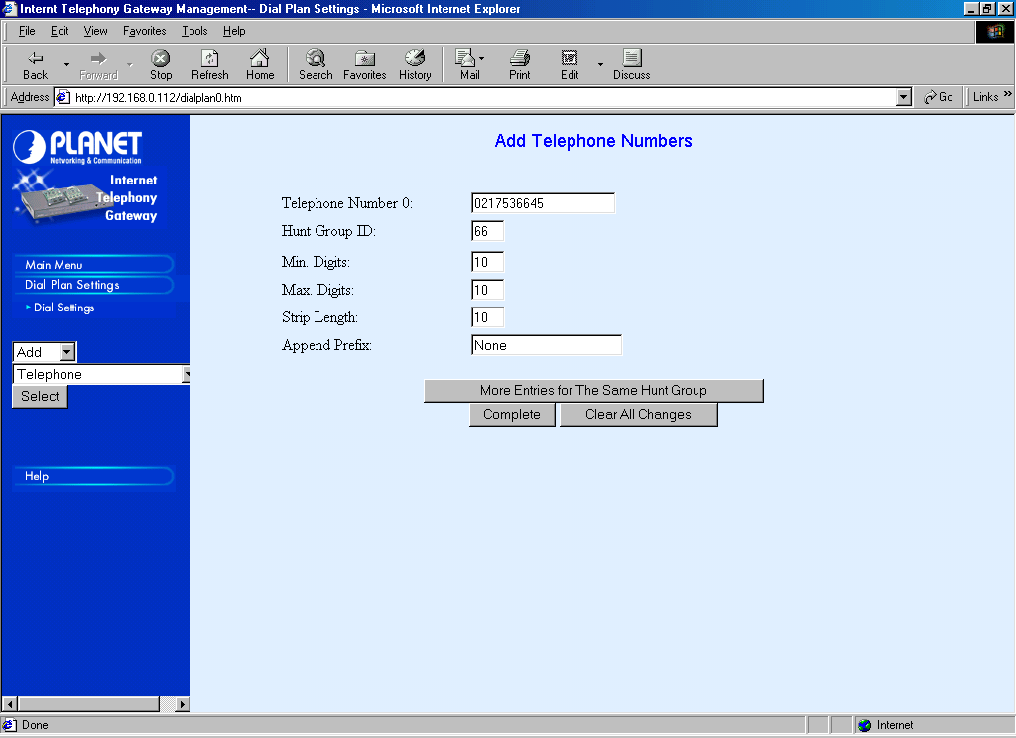
A HuntGroup ID of 66 is set to reach the ITG FXS PORT 0, 1, 2, and 3.

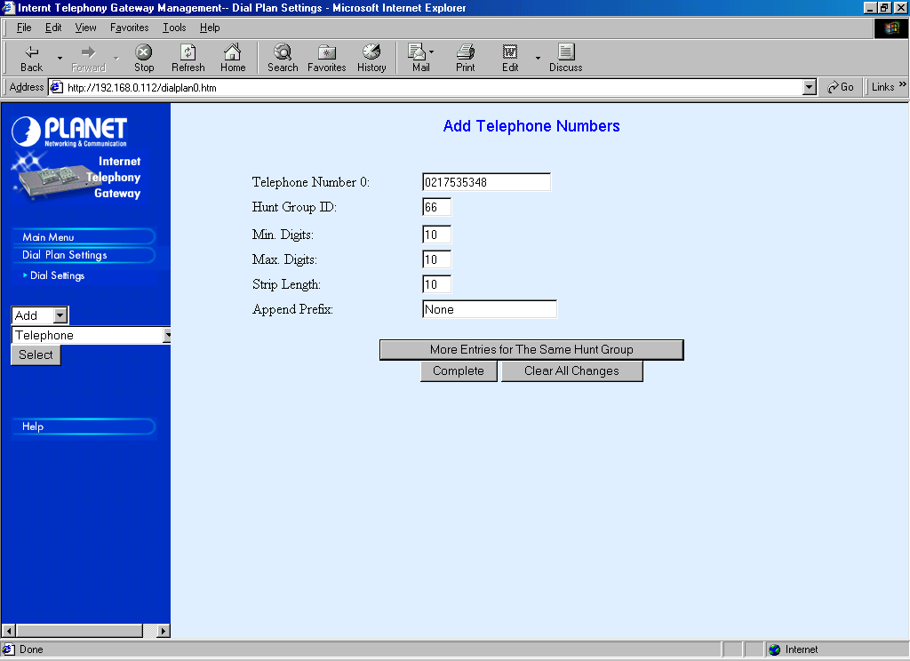
The main trick to steal Telco’s number, we do the same number programming to HuntGroup ID 66 for our Telco’s number, in this case, 0217356645 and 0217353548. These Telco’s number will then reaches the PBX through ITG FXS PORT 0, 1, 2, and 3.

Hunting Group Programming
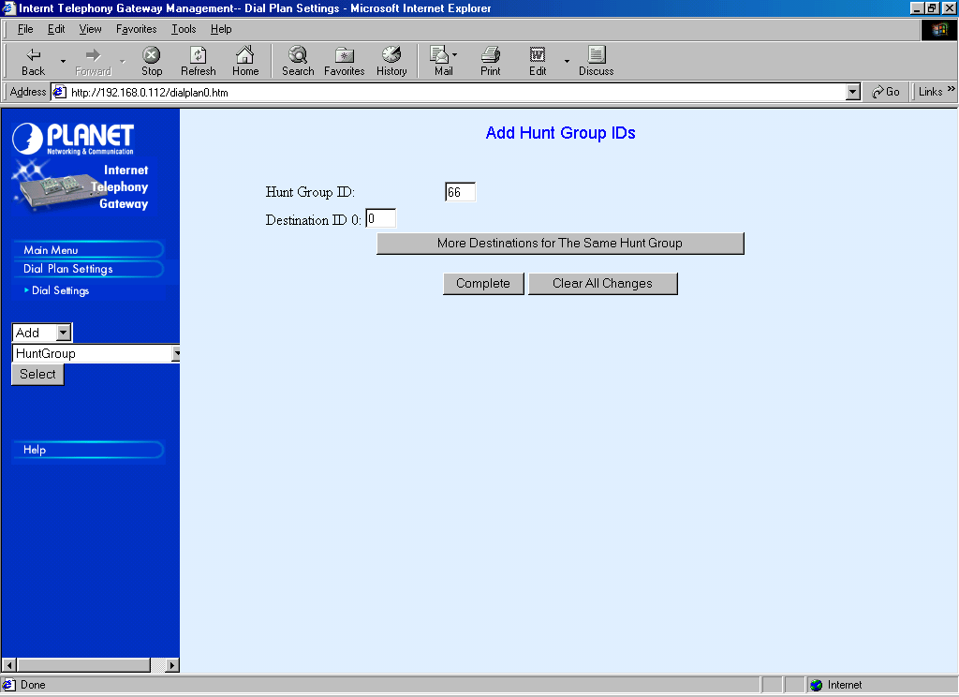
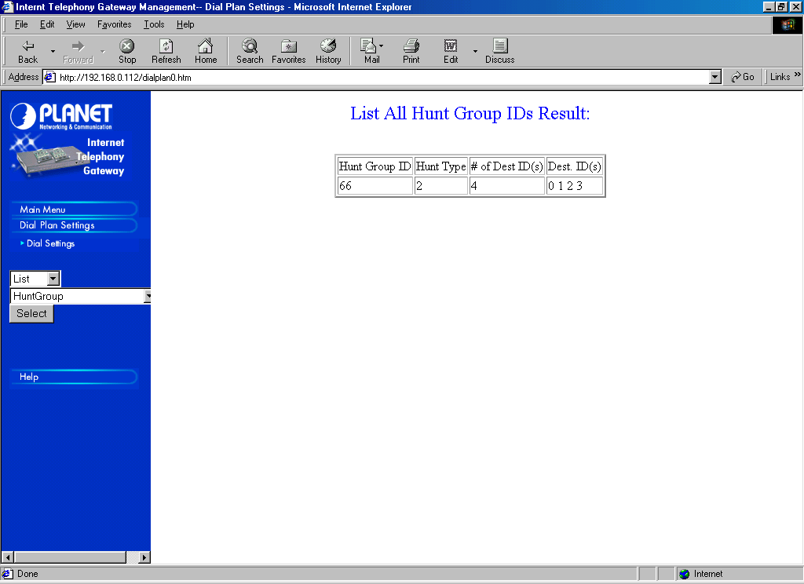
After the telephone numbers programming is completed. We can continue the programming process to set the Destination ID. Since the HuntGroup ID 66 should reach ITG FXS PORT 0, 1, 2, and 3. To make our live easier, the HuntGroup ID 66 is better set to Destination ID 0, 1, 2, and 3.

To review and check the HuntGroup ID programming, it can be done through Dial Settings → List → HuntGroup → Select. It must shows that HuntGroup ID 66 has 4 # of Destination ID, namely, 0, 1, 2, and 3.

Port Programming

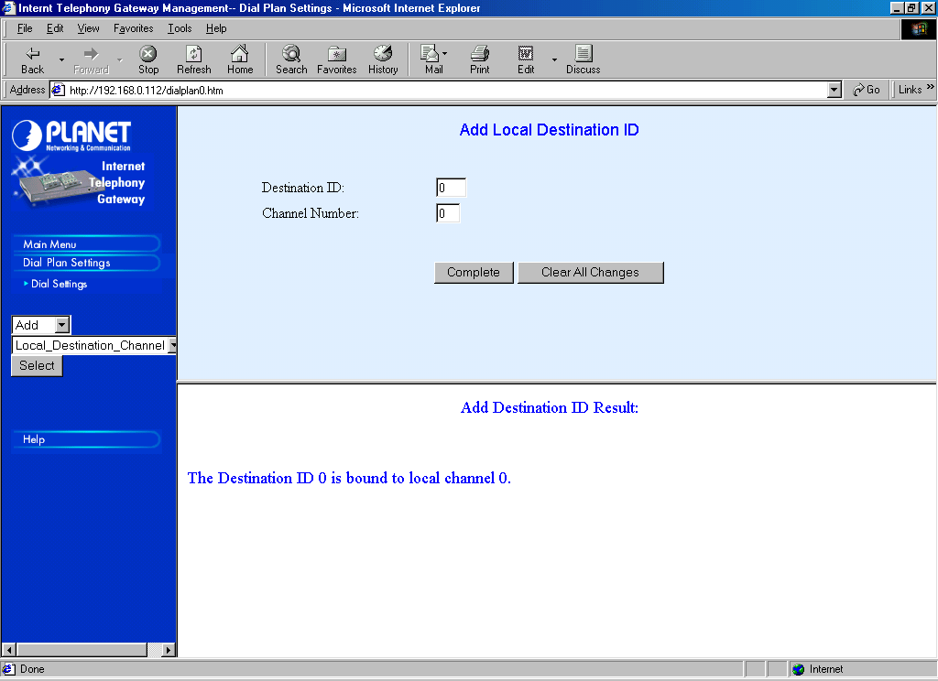
So far we have mapped the HuntGroup ID 66 to Destination ID 0, 1, 2, and 3.

In this section, we need to map each Destination ID 0, 1, 2, and 3 to Channel Number 0, 1, 2, and 3, respectively. It is done through Dial Plan Settings → Dial Settings → Add → Local Destination Channel.

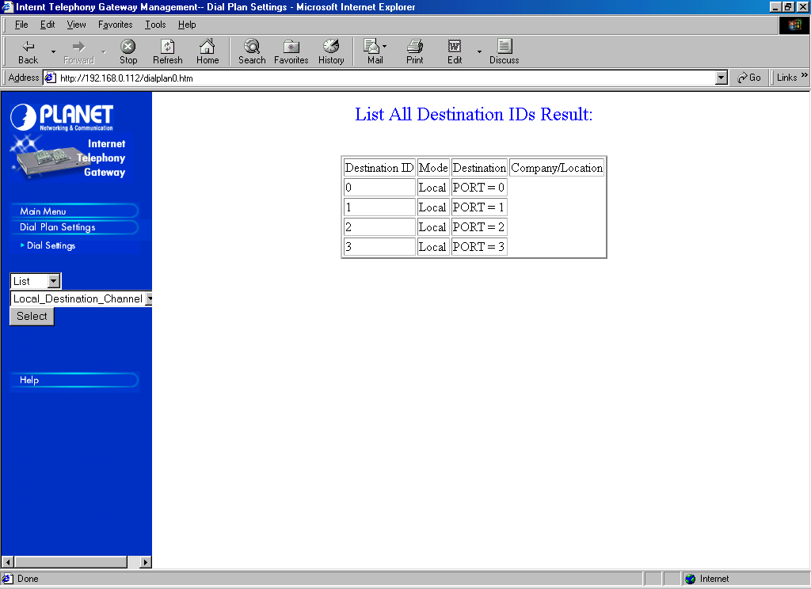
To review and check the Local Destination Channel programming, it can be done through Dial Settings → List → Local_Destination_Channel → Select.

At this point, the Internet Telephony Gateway (ITG) understands how to pass the call for 628834577777123, 0217356645 and 0217356648. The next logical step would be programming the ITG to tell the proxy Gatekeeper on the existence of these telephone numbers.

I normally add a little bit more programming to the ITG to enable it to call all 6288 numbers in the VoIP infrastructure. Unfortunately, it requires some Automatic Route Selection (ARS) programming for the PBX to select which CO lines to be used.

Outgoing Call Programming

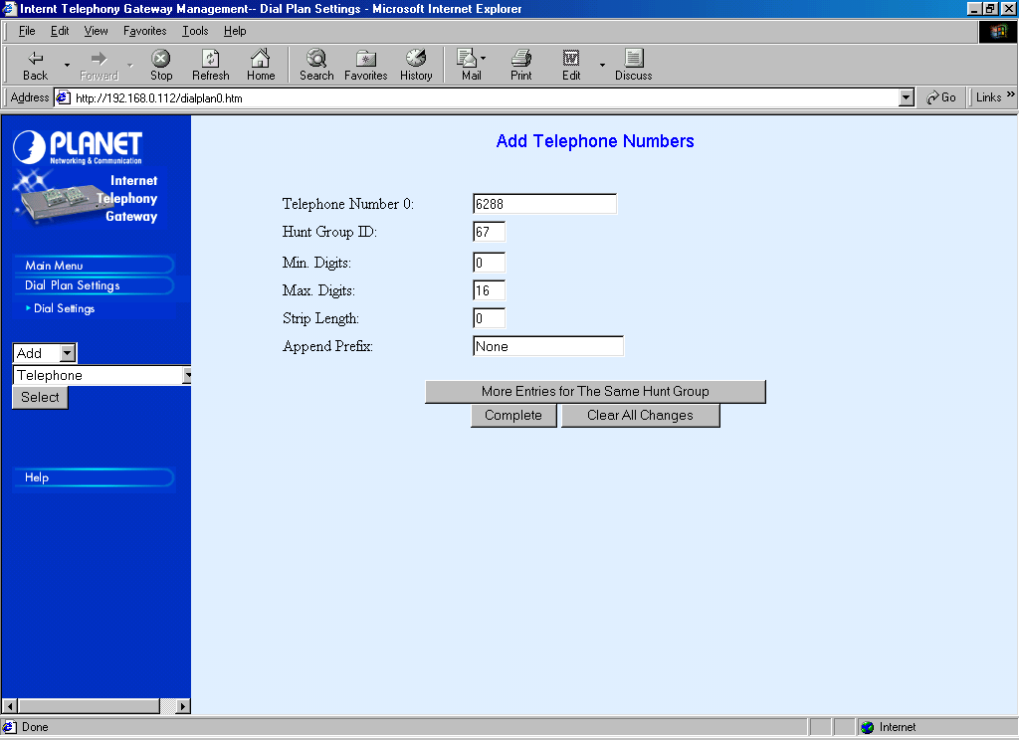
Outgoing call programming to enable users to call VoIP number beginning with 6288 can be easily done through Dial Settings → Add → Telephone → Select. Fill the 6288 in the Telephone Number with 0 Minimum Digit and 16 Maximum Digits. The HuntGroup ID must be differentiated to the incoming calls. In this example, the outgoing HuntGroup ID is set to 67.
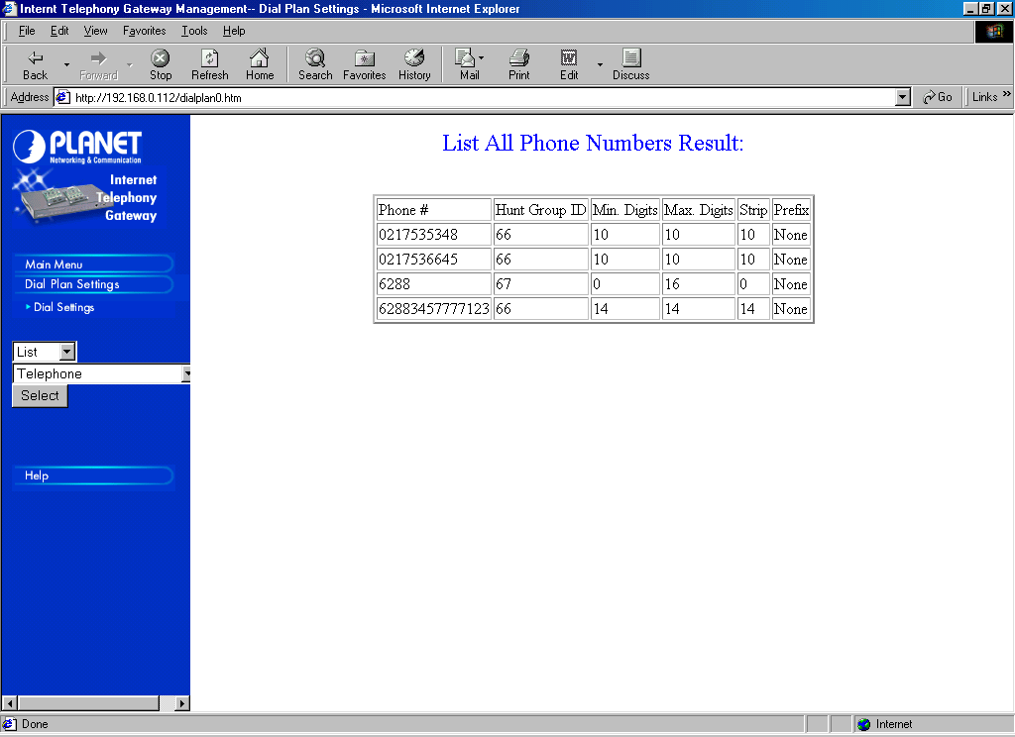
To check and review all the telephone numbers programmed on the ITG can be done through Dial Settings → List → Telephone → Selecct. We will see at least four (4) entries in the table.

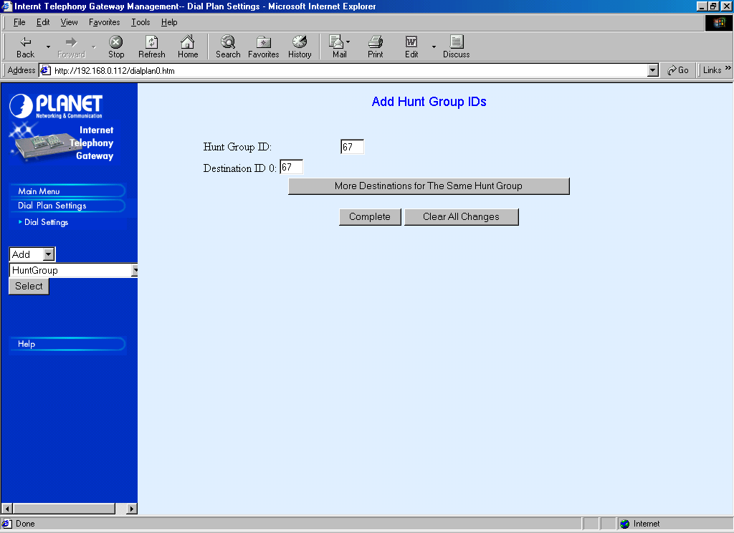
We need to direct the HuntGroup ID 67 to the proxy Gatekeeper. To make our life easier, the HuntGroup ID 67 is mapped to Destination ID 67 through Dial Settings → Add → HuntGroup → Select. We can then map Destination ID 67 to the proxy Gatekeeper.
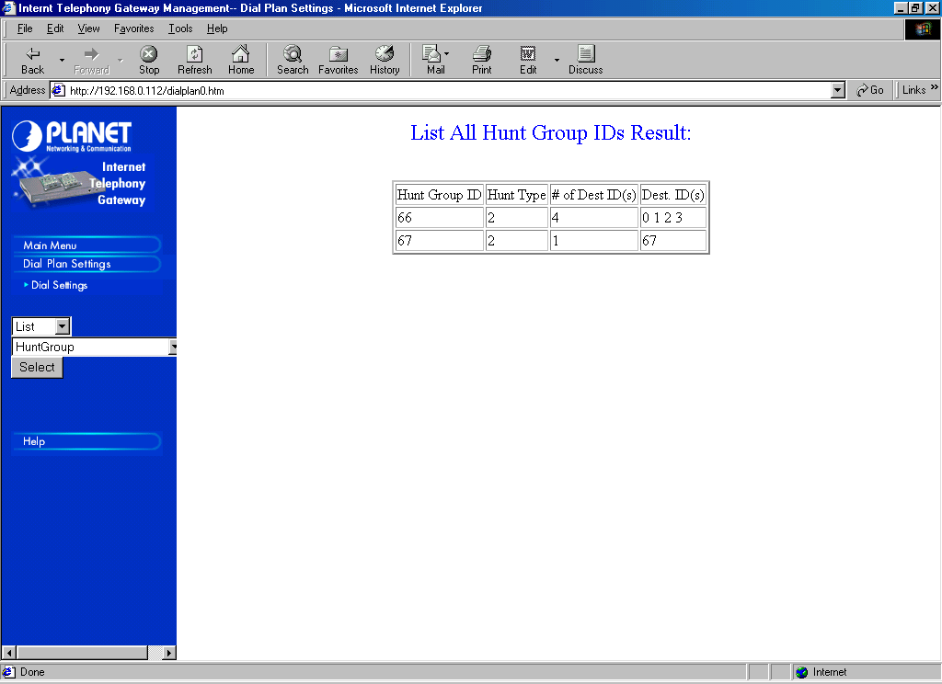
To review and check the HuntGroup ID programming, it can be done through Dial Settings → List → HuntGroup → Select. We should be able to see at least two (2) HuntGroup ID, namely, HuntGroup ID 66 mapped to Destination ID 0, 1, 2, and 3; and HuntGroup ID 67 mapped only to Destination ID 67.

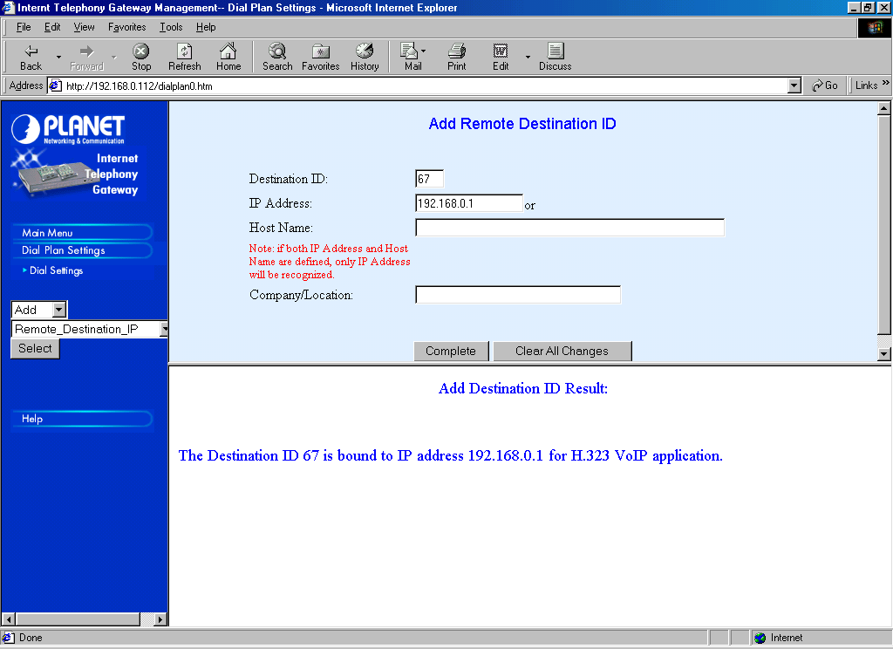
Our next task is to map Destination ID 67 to the proxy Gatekeeper. It can be done through Dial Settings → Add → Remote_Destination_IP → Select. Fill 67 in the Destination ID and the proxy Gatekeeper IP address in the IP address column, in this example, the proxy Gatekeeper IP address is 192.168.0.1. Press “Complete” as completed.

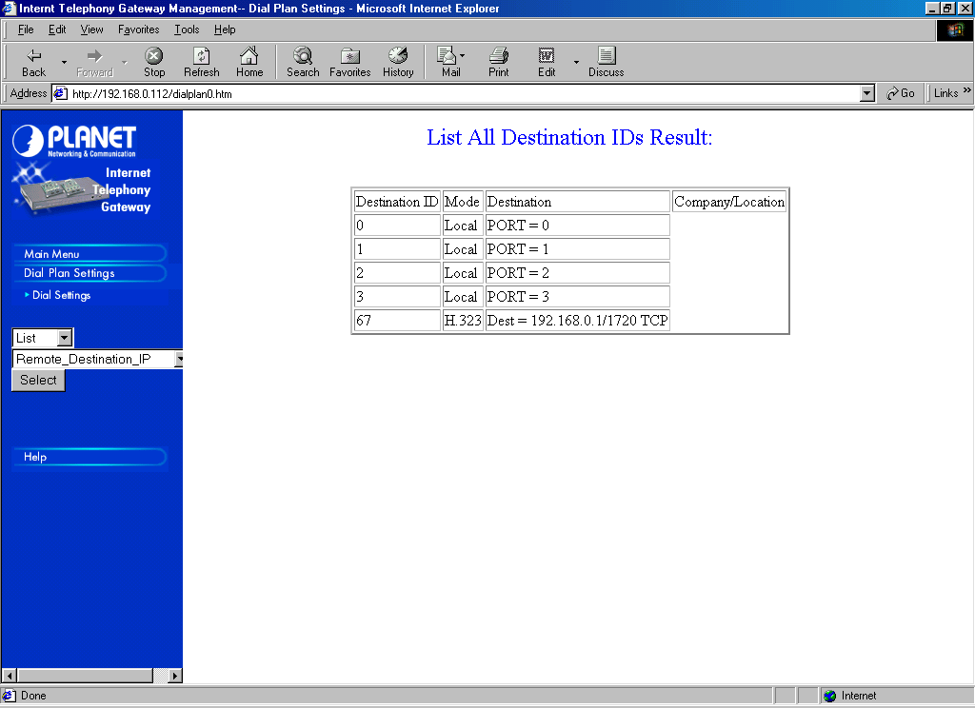
To review and check the entire destination, it can be done through Dial Settings → List → Remote_Destination_IP.

We have completed the Dial Plan Setting programming on the ITG. Our next step is to program the ITG to tell the local proxy Gatekeeper on the existence of these phone numbers.

H.323 Parameter Programming

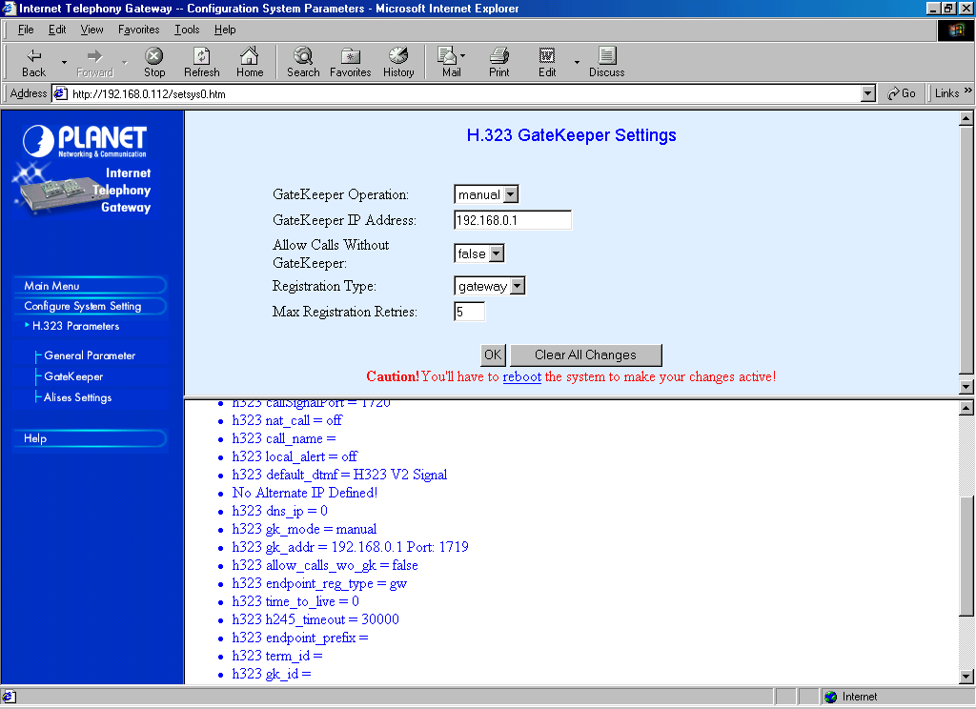
To train the local proxy Gatekeeper regarding the existence of our phone numbers, namely, 0217356645 and 0217353548, as well as our VoIP number 628834577777123, we can do it through Configure System Setings → H.323 Parameters → Gatekeeper.

Set the Gatekeeper operation to manual, with Gatekeeper IP address 192.168.0.1 assuming the proxy Gatekeeper IP address is 192.168.0.1. Registration type of the ITG to the proxy Gatekeeper sets to Gateway.
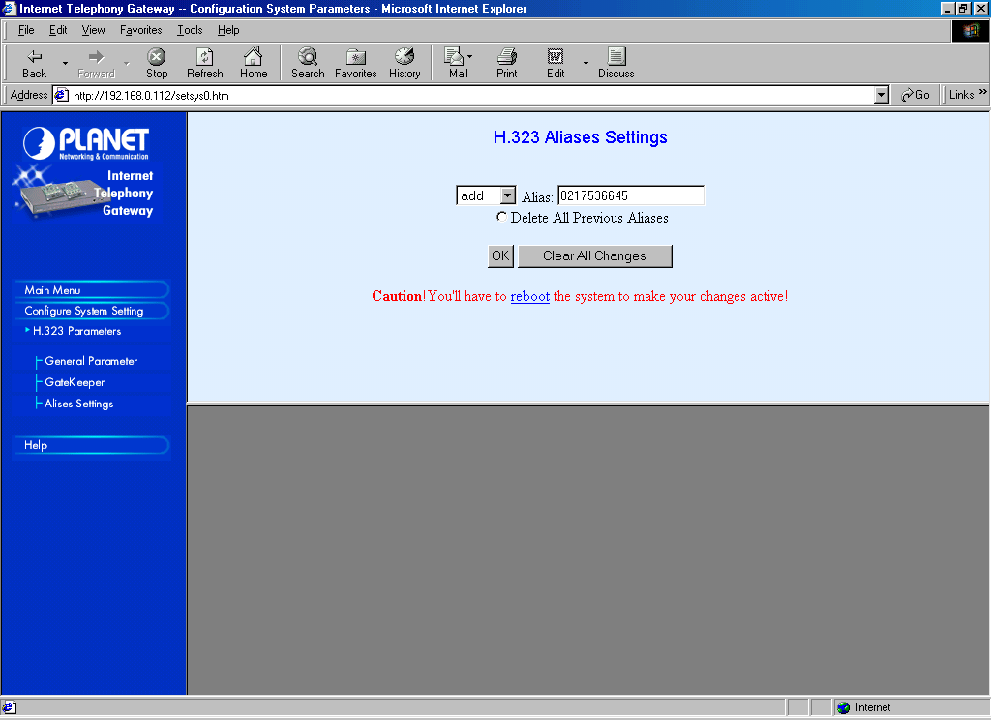
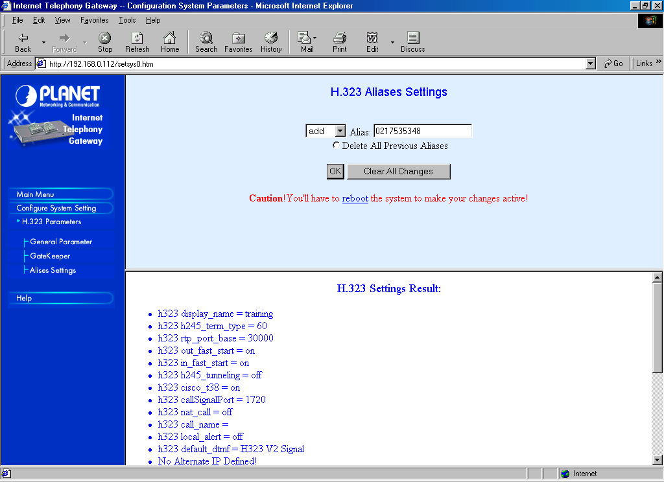
Having the ITG programmed to register to the local proxy Gatekeeper, all we need is to tell the phone numbers programmed on the ITG.

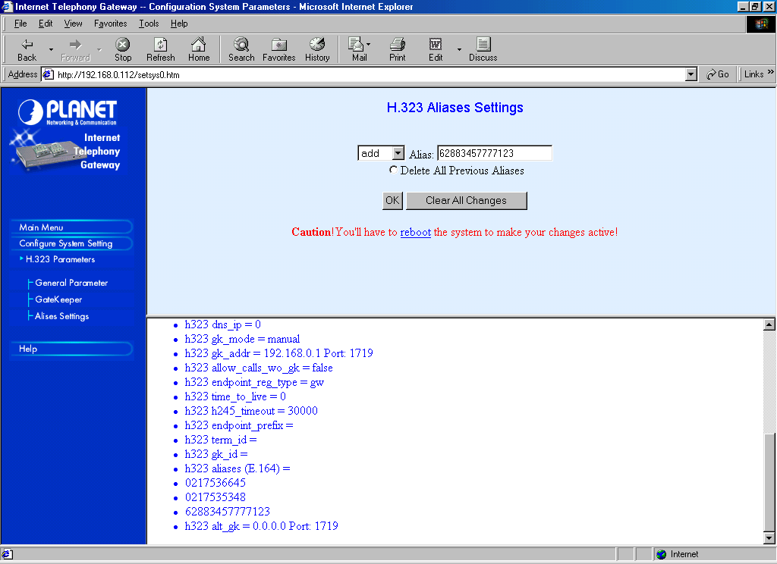
to register the phone numbers to the proxy Gatekeeper, it can be done through Configure System Settings → Alias Settings → Add → 0217536645 → OK, follows with Add → 0217535348 → OK, and finally Add → 628834577777123 → OK.

As we complete entering all alias E.164 aliases (the phone numbers), it will be shown in the h323 parameter alias (E.164) shown in the frame underneath.
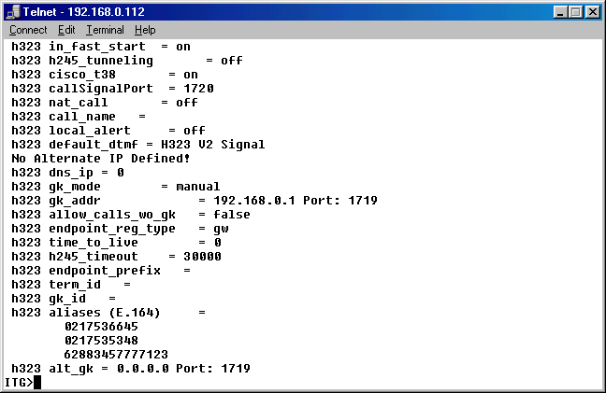
To review and check the E.164 alias, we can also telnet to the ITG. At the ITG> prompt, enter show h323. It will shows all h323 parameters including the h323 alias (E.164), we should see the numbers 0217536645, 0217535348 and 628834577777123 listed.
We need to check if the E.164 really registerd to the local proxy Gatekeeper running on 192.168.0.1. Checking the status port of the proxy Gatekeeper can easily do it.
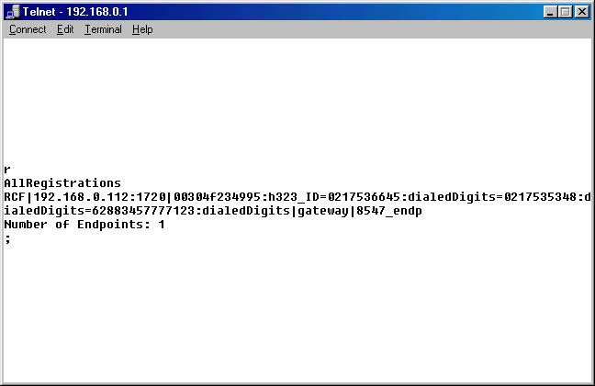
All we have to is telnet to the proxy Gatekeeper at port 7000, such that,

telnet 192.168.0.1 7000

enter the command “r”. We must the all registered endpoint at the Gatekeeper. One of the registered Endpoint must be our ITG (in this example the IP address is 192.168.0.112). As shown, the ITG (192.168.0.112) received the Registration Confirmed RCF. The ITG serves several dialedDigits, namely,

0217356645
0217353548
628834577777123

Having the ITG correctly registers to the proxy Gatekeeper. Our next agenda is programmed the proxy Gatekeeper to register to higher level public Gatekeeper.

Proxy Gatekeeper Programming

The registration of the phone numbers 0217356645, 0217353548 and 628834577777123 to the higher public Gatekeeper has to be done manually. Unfortunately, the proxy Gatekeeper will NOT automatically register the registered ITG number to the public Gatekeeper.

In this example, the registration process is done through [Endpoint] section of the proxy Gatekeeper configuration file. Shown below is the [Endpoint] section,

[Endpoint]
Gatekeeper=202.53.224.172
Type=Gateway
H323ID=TestingProxyGK
E164=0217356645,0217353548,628834577777123
TimeToLive=100
RRQRetryInterval=10
ARQTimeout=2
UnregisterOnReload=1

Please see carefully, in the above settings the proxy Gatekeeper will register directly to Gatekeeper 202.53.224.172. No prefix is registered. Only the E164 is used to register the entire numbers.

That’s it. All users on the VoIP Infrastructure will recognize our phone numbers and will be able to call us directly from the VoIP Infrastructure without having to pass the traffic through Telco infrastructure. It is a much elegant way to bypass Telco’s infrastructure.

