A Glimpse on How the H.323 works

Similar to many other interactions through the Internet, a collection of protocol is normally used to control the communication processes. There are basically two (2) major protocol family may be used in an Internet Telephony infrastructure, namely,

- Session Initiation Protocol (SIP).
- H.323

Both are designed to use in multimedia communication via the Internet. It includes Video and Voice over Internet Protocol which also known as VoIP. In this work we focus more on Internet Telephony, rather than a more general voice over IP.

To be honest, SIP is far more superior to the older H.323 protocol. SIP is an open protocol developed by Internet communities. However, for practical reasons, it is much more easily and low cost to find H.323 equipments for rapid deployment of Internet telephony infrastructure in developing countries.

The Typical Internet Telephony Architecture
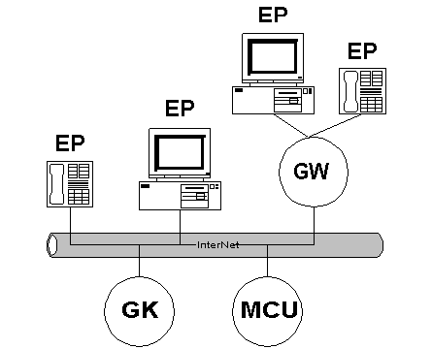

As shown in the figure, in general, the component that supporting H.323 architecture is fairly simple, namely,

- EP, or End Point, is the multimedia endpoints. It can be a computer with NetMeeting or GnoneMeeting, FAX machine, phone, or IP Phone with build-in camera.
- GW, or Gateway, is the interface between many Endpoint (EP) to a larger Internet Network. Gateway can be hardware, such as, Internet Telephony Gateway (ITG), that can be used to connect normal phone, Telco lines, PBX to Internet Telephony infrastructure on the Internet. A Gateway may also be Gatekeeper software located at the firewall or proxy server. In this case, the gateway would act as interface for any Endpoint (EP) in the IntraNet to the InterNet network.
- MCU, or Multi Conference Unit, is software that acts as the conference server. Through an MCU a conference of several EP can simultaneously be performed.
- GK, or Gatekeeper, is the phone soft switch within the Internet Telephony infrastructure. It receives all registration on Endpoint (EP) in the network; keep the map of IP address of Endpoint with respective phone number as well as a number of functions. A Gatekeeper (GK) is a software run a PC.

A Glimpse on H.323 Protocol

The way H.323 works is fairly simple,

- Each Gatekeeper (GK) is normally configured to serve a certain prefix or area code.
- Every Endpoint (EP) and gateway (GW) should register to Gatekeeper (GK) that has same prefix. If we register to Gatekeeper with different prefix, we can still call other Endpoint (EP) but others will not be able to call us.
- If an Endpoint (EP) wants to initiate a call, it should ask (admission request) to the Gatekeeper (GK) to ask for its destination.
- Gatekeeper (GK) will then check its table, or its neighboring Gatekeeper, on the IP address of the specified phone number.
- As the IP address of the destination Endpoint (EP) discovered, the Gatekeeper (GK) will pass the information to the origin Endpoint (EP).
- Having the required information, the origin Endpoint (EP) may initiate the call to the destination Endpoint (EP).
- If the destination Endpoint (EP) answers the call, the communication can be preceded.

Most people will likely to forget that not all Endpoint (EP) has 24-hour Internet connection. Some Endpoint (EP) has only dial-up connection, so that the ability to check whose online would be important.

Scenario of Gatekeeper

From the Gatekeeper point of view, there are two (2) scenarios in sending & receiving video / audio transmission over Internet Telephony infrastructure, namely,

- Routed Mode – all the video and audio signal for the two (2) communicated Endpoint (EP) will be relayed through the Gatekeeper (GK). Ability to relay video & audio signal is crucial at proxy / firewall for IntraNet – Internet communication. It is unfortunately will give additional CPU and bandwidth load of the Gatekeeper PC.
- Direct Mode – all the video and audio signal of all communication Endpoint (EP) are not relayed through the Gatekeeper (GK). Gatekeeper (GK) is merely help in registration, authorization and admission processes. It is the choice of communication mode within a Virtual Private Network (VPN) or on the Internet with no communication between IntraNet and Internet.

From the field experience in the Indonesian Free Internet Telephony MaverickNet, the Gatekeeper specification is not too high. A Pentium II 200MHz, 128Mbyte RAM, and 2 Gbyte harddisk would be sufficient to serve the community.

