Bandwidth Requirement For Internet Telephony

In deploying an Internet Telephony and Video Conferencing over the Internet, one has to carefully examine the bandwidth requirement to assure a successful conference. In general, there are two (2) major requirements, namely,

- Video bandwidth requirement
- Audio / Voice bandwidth requirement.

If Internet telephony / voice communication is of interest, we are looking at low bandwidth requirement as low as 5.3 Kbps. At the most, the required bandwidth would be around 64 Kbps for no compression (Telco’s like compression). However, if video conferencing is of interest, we are looking at a much higher bandwidth requirement. It is not surprising to see various compression techniques used to reduce the bandwidth requirement.

To give some idea, a video channel without compression will require 9 Mbps. It is quite wide. Current compression techniques capable squeeze video and audio channel into 30 Kbps and 6 Kbps channel, respectively. A two way videoconference may be easily performed on a full duplex 64 Kbps Internet link.
.
As more people, telecenters, cybercafes, and neighborhood network are using WiFi equipments at 11-22 Mbps on 2.4GHz, some even experimenting with 54 Mbps on 5.8 GHz. The last mile bandwidth is actually very wide. All we need is to unite all telecenters, offices, cybercafes and neighborhood network to interconnect their last mile infrastructure and having own broadband infrastructure.

Bandwidth For Audio Transmission

Audio will consume a much narrower bandwidth as compared to any video transmission. In this chapter, the typical compressed audio bandwidth will be described. Transmitting compressed audio via TCP/IP (Internet) infrastructure has been a mode of operation in getting low cost long distance & international calls.

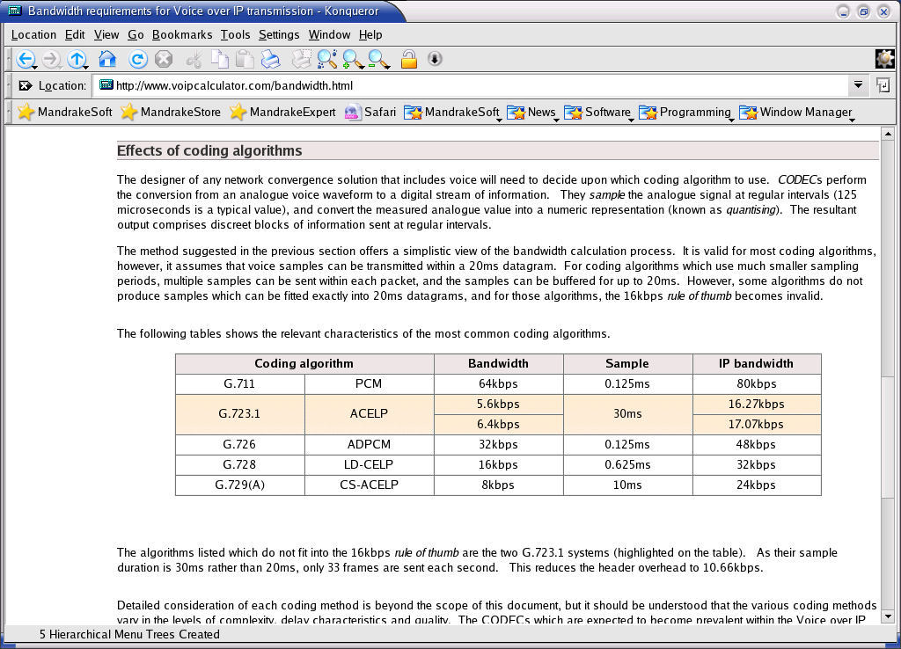
Some of the frequently used audio coding-decoding (CODEC) standards are shown in the table provided by http://www.voipcalculator.com. G.711 is the PCM uncompressed audio coding algorithm; it requires 64 kbps bandwidth or about 80 kbps bandwidth including IP headers. G.723.1 may be the most frequently used audio CODEC as it requires the least bandwidth about 5-6 Kbps.

Mean Opinion Score (MOS) is the approach to measure the reception quality of the audio. A better quality (higher MOS) will likely to be obtained at lower compression rate, such as, G.711. Low compression or uncompressed audio leads to wider bandwidth and, thus, lower computational requirement (lower Mega Instruction Per Second / MIPS).

However, for bandwidth conservation, a higher audio compression, such as, G.723.1 would of Interest. G.723.1 may provide the one of the highest bandwidth compression. With current Digital Signal Processing (DSP) technology, the computation time can be reduced and, thus, not significantly degrade the Mean Opinion Score (MOS) of the audio quality. It is not surprising to see most of Internet telephony communications currently performed using G.723.1 compression.

Bandwidth For Video Transmission

Some of the good references for bandwidth requirement for video transmission over Internet are,

http://www.crs4.it/~luigi/MPEG/mpeggloss-h.html
http://www.4i2i.com/h263_video_codec.htm
http://www-mobile.ecs.soton.ac.uk/peter/h263/h263.html

Those who like to read the original H.* standards, it should be available from the International Telecommunication Union (ITU) http://www.itu.int. It may be costly to get the standard direcly from ITU. A better way in getting the standard would be to do google search using H.261, H.263, or H.323 as keywords.

There are at least two (2) major standard in sending video through narrow band channel, namely,

- H.261 – usually used for ISDN channel with speed n p x 64Kbps; where p may be 1, 2, 3, …, 30.
- H.263 – aim for a much lower bandwidth video transmission at 20-30 Kbps and up.

H.263 may be one of the frequently used video compression for Internet based video conferencing. Some of the important notes to be bare in mind are,

- Black and white video will likely to consume much less bandwidth as compare to color video transmission.
- Low video frame per second (fps) will consume less bandwidth than higher frame per second (fps).

A good video is usually transmitted at around 30 frame-per-second (fps). Uncompressed video at 30 fps will consume about 9 Mbps of bandwidth.

Calculate Internet Telephony Bandwidth Requirement
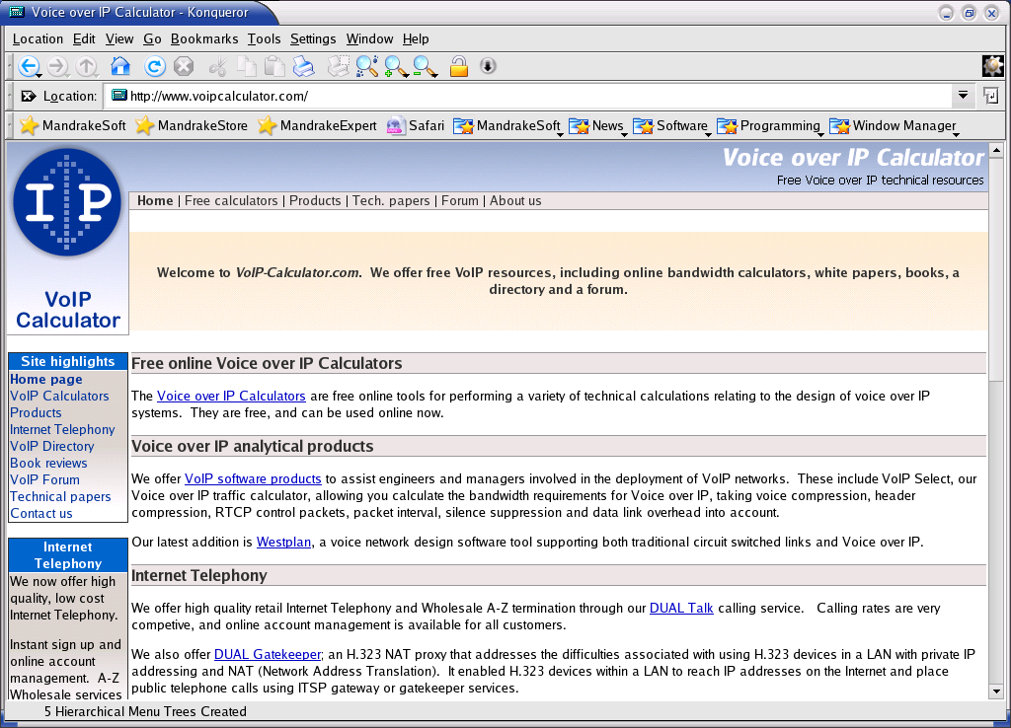
Ability to calculate the required bandwidth or Internet telephony lines needed for certain maximum traffic load. Fortunately, some sites, such as, http://www.voipcalculator.com & http://www.erlang.com/calculator/, provides a free access to their calculation subroutine through their web. There are several aspects of Internet telephony infrastructure can be calculated, such as,

- Lines and Bandwidth calculator.
- Erlangs and Bandwidth calculator.
- Minutes and Lines calculator.
- Erlangs and Lines calculator.

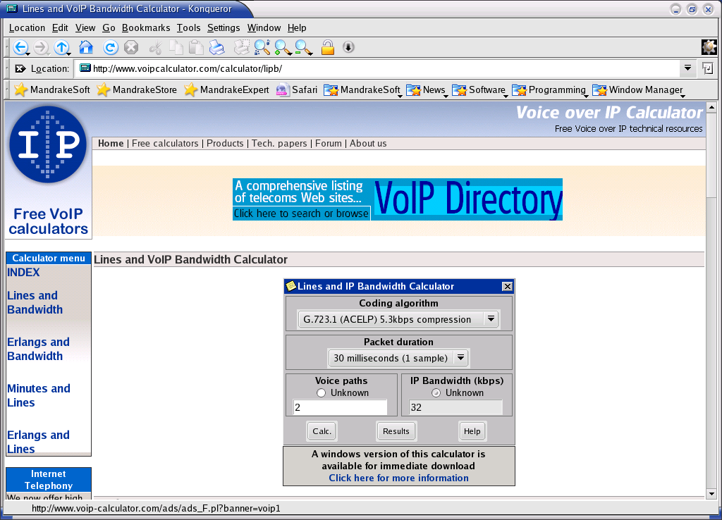
The Lines and IP Bandwidth Calculator can be used to estimate the bandwidth required through an IP based network for a fixed number of voice paths. There are several coding algorithm can be used to for coder-decoder (CODEC) of the audio, the favorite CODEC are G.723.1 and G.729. The frequency at which the voice packets are transmitted have a significant bearing on the bandwidth required. The selection of the packet duration (and therefore the packet frequency) is a compromise between bandwidth and quality. Lower durations require more bandwidth. However, if the duration is increased, the delay of the system increases, and it becomes more susceptible to packet loss; 20ms is a typical figure.

In the example calculated IP bandwidth, the several voice paths with packet duration 30 millisecond (1 sample) with G.723.1 (ACELPS) 5.3 kbps or MP-MLQ 6.4 kbps will be shown. We basically are looking at a maximum of four (4) voice path in a 64 kbps bandwidth. The above calculation is not taking account any reduction due to Real Time Protocol (RTP) header compression and multiplexing.
Voice Path | IP Bandwidth (ACELPS) | IP Bandwidth (MP-MLQ)
1 | 16 kbps | 18 kbps
2 | 32 kbps | 35 kbps
3 | 48 kbps | 52 kbps
4 | 64 kbps | 69 kbps

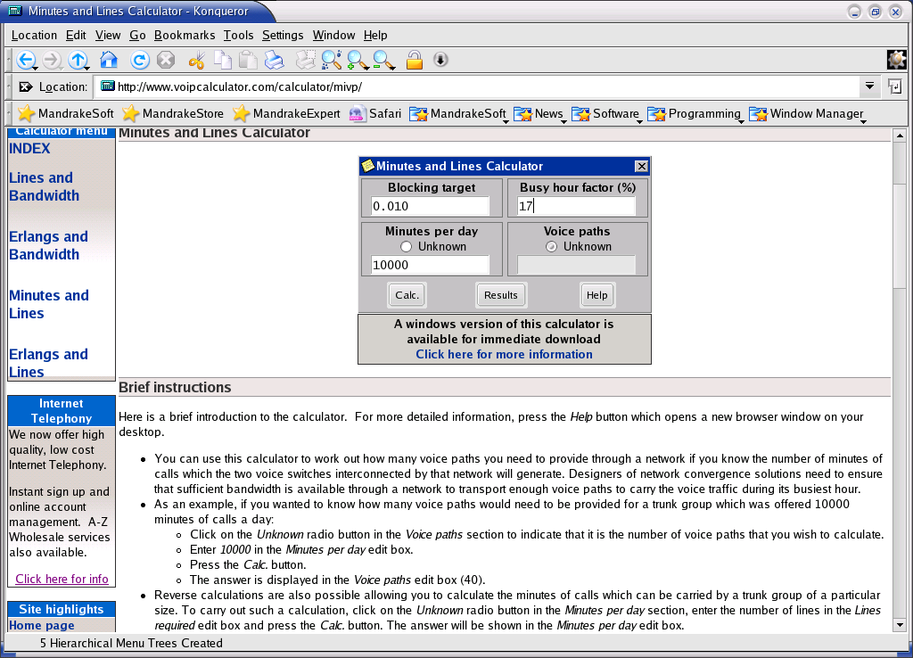
Minutes and Lines Calculator - The Minutes and Lines Calculator can be used to estimate the number of voice paths that should be provided through a wide area network if we know the number of minutes of calls which the two voice switches interconnected by that network will generate each day. Network designers need to ensure that sufficient bandwidth is available through a network to transport enough voice paths to carry the voice traffic during its busiest hour.

The busy hour factor is the percentage of daily minutes that are offered during the busiest hour of the day. 17% (the default) is a reasonable figure for a business that operates an 8-hour working day, but a higher figure could be entered if the business in question operates a shorter working day, or if frequent calls are being made to a different time zone. Blocking target is the ratio of calls that will be blocked because no lines are available. 0.010 (the default) means that 1% of calls would be lost. This is a normal figure for traffic engineering, but other figures can be entered into this edit box. Some example of the calculated result is shown in the figure. We basically have about 300 minutes busy traffic for four (4) VoIP lines.
Minutes | Lines
10000 | 40
5000 | 23
1000 | 8
882 | 7
670 | 6
476 | 5
300 | 4
158 | 3
52 | 2
3 | 1

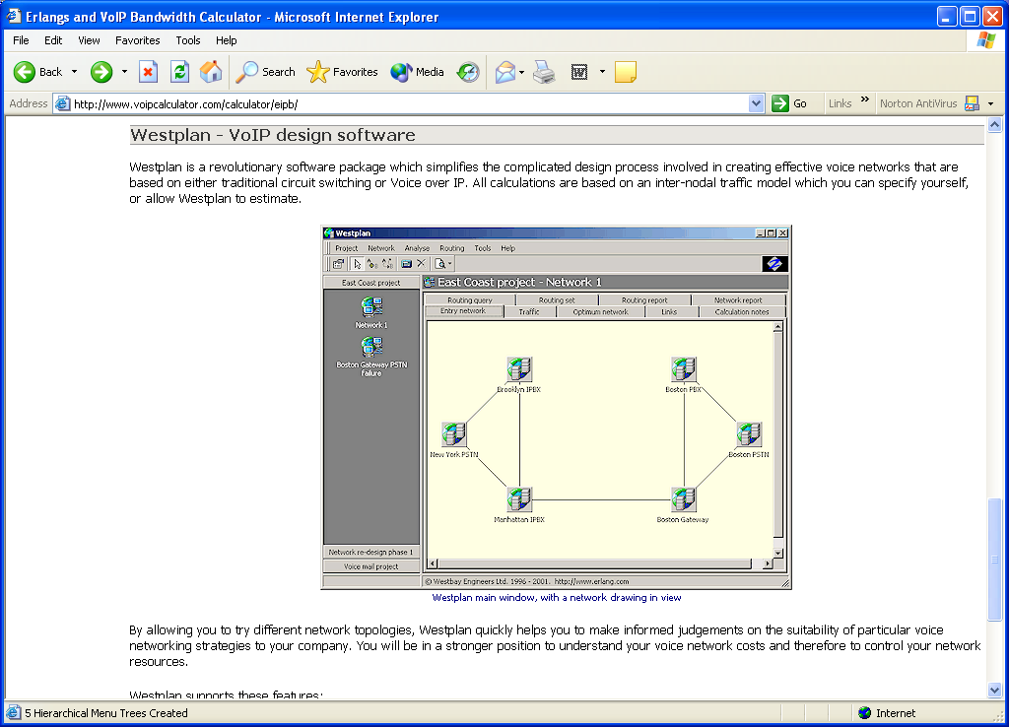
In addition to the above free calculators, http://www.voipcalculator.com is offering a commercial software package that simplifies the complicated design process involved in creating effective voice networks that are based on either traditional circuit switching or Voice over IP, called Westplan. All calculations are based on an inter-nodal traffic model that we can specify ourself, or allow Westplan to estimate. Westplan supports the following features:

- Point and click network diagrams
- Voice over IP bandwidth calculations
- Layer 2 support for PPP, Frame Relay, Ethernet, ATM and HDLC.
- Analogue, T1 and E1 transmission facilities
- User-definable routing rules
- RTP compression for VoIP
- Full justification reports for each analysis
- Clear printed reports
- Context sensitive help

