The Indonesian Internet Telephony MaverickNet

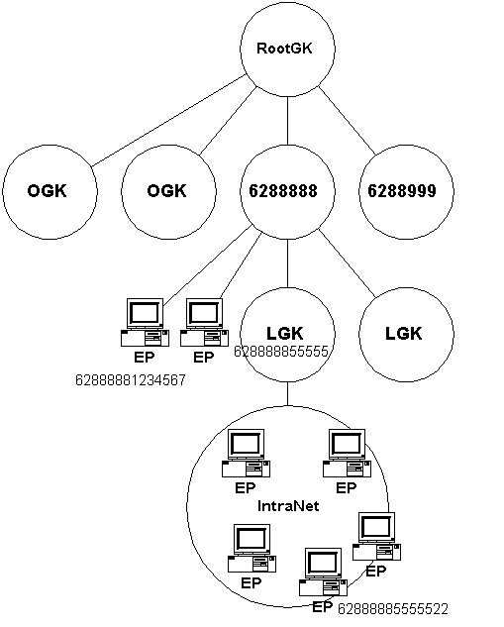
In this chapter an example of free Internet Telephony infrastructure, such as, the Indonesian Internet Telephony MaverickNet, will be reviewed. It may be one of the most complex countrywide Internet Telephony infrastructures ever implemented.

In a common Internet Telephony infrastructure, the architecture is normally quite simple consisting a gatekeeper and several gateway or gatekeeper at the proxy server.

Shown the complicated gatekeeper structure of Indonesian Internet Telephony MaverickNet in the figure. There are three (3) level of gatekeeper, namely,

- RootGK – it normally runs as the highest-level gatekeeper in the infrastructure. In the Indonesian Internet Telephony MaverickNet, it is located at the Indonesian Internet Exchange (IIX).
- The second level gatekeeper is a stand-alone gatekeeper in the Internet to be used by public. It is basically a public gatekeeper. Some of my friends in Indonesian Internet Telephony Mavericknet called it as Operator Gatekeeper (OGK).
- The third level gatekeeper is the gatekeeper located at the Proxy Server. It is basically a proxy gatekeeper. Some of my friends in Indonesian Internet Telephony MaverickNet call it as Local Gatekeeper (LGK).

Please note how the numbering is set. An endpoint (EP) with a number of 62888881234567 must register to a public gatekeeper that handles prefix 628888. If the EP 62888881234567 registers to other public gatekeeper, other EP will not be able to call EP 62888881234567.

In the same figure, it is shown an endpoint EP 6288888555522 in an IntraNet located behind a proxy gatekeeper (LGK). The proxy gatekeeper must handle prefix of 628888855555.

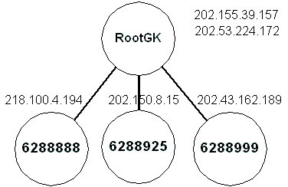
At the moment this manuscript is written, there are a couple public major gatekeepers serving the Indonesian Free Internet Telephony MaverickNet, namely,

- Two (2) machines act as the RootGK located at IP address 202.155.39.157 and 202.53.224.172.
- A couple more gatekeepers acting as the public gatekeeper serving a specific prefix, such as,

202.155.39.157 - for area code 62 88 (Root Gatekeeper).
218.100.4.194 - for area code 62 88 888
      - - for area code 62 88 999
202.150.8.15 - for area code 62 88 925

Some of friends in Indonesian Free Internet Telephony MaverickNet are donating their gatekeeper for public usage. Some of them can be reviewed at http://gk.vision.net.id.

Intergation of Indonesian Internet Telephony MaverickNet to Internasional Network

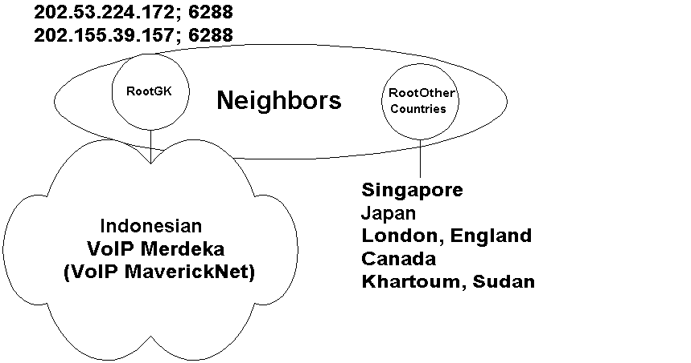

Effort is currently underway to integrate the network into other international gatekeeper network. The integration is done through gatekeeper Neighbors settings. There are several active gatekeeper neighbors, such as, Singapore, Jepang, Inggris, Jerman, Canada, and Sudan. The complete neighbors entry is as follows,

[RasSrv::Neighbors]
BerlinGK=217.160.169.175;149 # Berlin, Jerman
HOTLINKSGK=217.14.129.19:1720;822 # London, Inggris
GONGGALIGONG=61.201.199.150;8199 # Jepang
SGGK6288=netscafe.net;6588 # Singapore
CISCGK=voip.cisc.org;140388 # Canada
sudan-khartoum-gk=212.0.145.164;24911 # Khartoum, Sudan

Note that these neighbors are not the formal Telco gatekeepers. The volunteers in these countries run it.

Assumed Architecture to Integrate An Internet Telephony Gateway

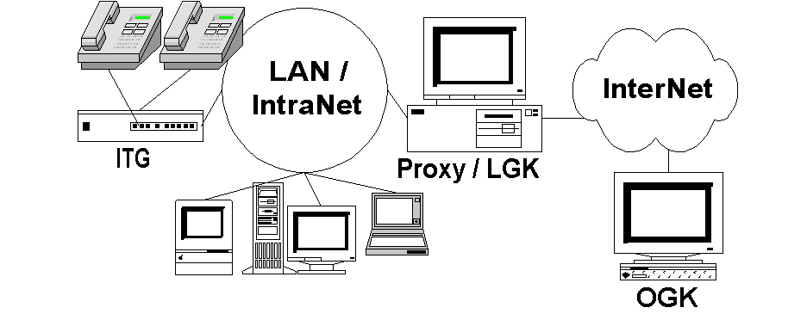
The assumed network topology in integrating Internet Telephony Gateway (ITG) into the network is shown in the figure. It is assumed that,

- The ITG is located in an IntraNet behind a Firewall / Proxy Server that runs proxy gatekeeper.
- The ITG may be connected to a normal phone / PSTN either directly or via PBX.
- The LAN / IntraNet is connected to the Internet through other computer that act as proxy server / gateway.
- The proxy gatekeeper may register to a public gatekeeper or directly to root gatekeeper.

In this assumption, there is no assumption on the used phone number. We can actually register Telco numbers via the gateway to the gatekeeper. Thus, anyone can always use his or her Telco number.

