Numbering Plan in a Internet Telephony Infrastructure

Numbering plan is crucial in the operation of a Internet Telephony Infrastructure. Fairly similar to an Internet network, there should no Endpoint using the same phone number. Each phone number should be registered to a Gatekeeper that handles the same prefix.

In the case of a Internet Telephony infrastructure constraint within an Intranet boundary, it may normally rely on a single Gatekeeper. Things are absolutely simple. A complicated numbering plan is not necessary.

However, this gets more complex and difficult when we want to integrate the Internet Telephony infrastructure to other Internet Telephony network, and other office networks. Coordinating the phone number among all Gatekeepers would be essential for interconnection among these Internet Telephony networks.

In the Indonesian Free Internet Telephony MaverickNet, the coordination is performed through mailing list, such as, gk-admin@yahoogroups.com and voipmerdeka@yahoogroups.com, and Web for getting the prefix, such as, http://www.cic.ac.id/gkregistration/. The Indonesian Free Internet Telephony MaverickNet decided to use 6288 as the first four digits. 62 are the country code. 88 are the area code. The area code is normally defined in the fundamental technical plan of the country’s regulator. In the case of Indonesian Free Internet Telephony MaverickNet, we are basically “claim” the 88 area code as the Indonesian government will not give any free network any area code. The next three digits after 6288 are additional digit of each Gatekeeper connected to the Indonesian Free Internet Telephony MaverickNet.

In the Indonesian Internet Telephony Network, these prefix digits are coordinated through http://www.cic.ac.id/gkregistration/. The numbering structure would be something like,

cc aa ppp nnnnn

Where,

cc is the country code
aa is the area code
ppp is the prefix of each Gatekeeper
nnnnn is the actual Endpoint numbers.

There is no defined length of the Endpoint numbers. It is normally around 4-8 digits.

In the next section, we will review the numbering plan for dial-up Endpoints, public Gatekeeper and proxy Gatekeeper.

Numbering Plan for Dial-Up Endpoints

Dial-up users / endpoints need to logon to a public Gatekeeper and use the Gatekeeper prefix as the beginning of their number. It would be nice if there is public Gatekeepers for each country for an Endpoint to register to. Unfortunately, it is not the case.

For those who want to use their country’s phone number and has no Gatekeeper servicing their country, you may try the Indonesian Free Internet Telephony MaverickNet Gatekeeper 202.53.224.272. The 202.53.224.172 Gatekeeper is designed to register any phone numbers.

For those who register to 202.53.224.172 Gatekeeper may use the following suggested numbering format,

cc aa(a) ppp nnn

where,

cc is the country code (can be 1 digit country code, such as, North America)
aa(a) is the two / three digits area code
ppp is the prefix of each Gateway.
nnn(nn) is the 3-5 digits actual Endpoint numbers.

The activists in The Indonesian Free Internet Telephony MaverickNet are quite generous and donate their machines for people to freely register their Endpoint and Gateways. The IP address of the major public Gatekeeper in the Indonesian Free Internet Telephony MaverickNet are,

202.155.39.157 - for area code 62 88
218.100.4.194 - for area code 62 88 888
      - - for area code 62 88 999
202.150.8.15 - for area code 62 88 925

Note that most Gatekeepers will handle a specific area code. Please make sure that the area code used in the number at the Endpoint is the same as the area code of the public Gatekeeper.

.
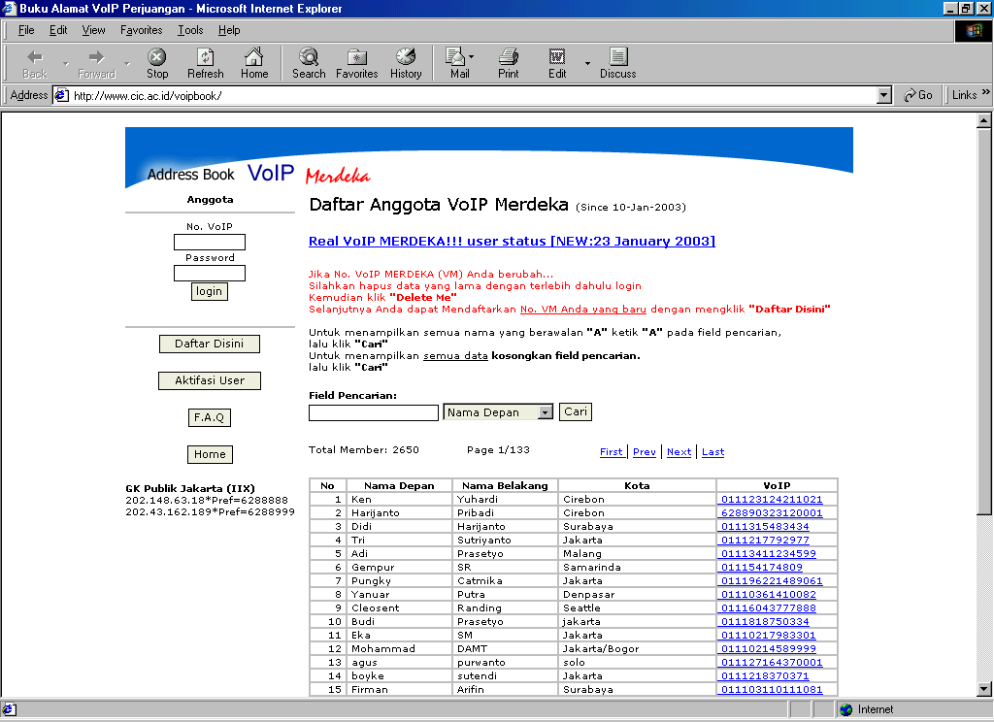
To avoid any conflict in Endpoint phone number and the creating a phone book, the Indonesian Free Internet Telephony MaverickNet establish a registration Web for getting the prefix. The Web is lead by Hariyanto Pribadi hariyanto@uptkom.cic.ac.id, the leader of Computer Center at STMIK CIC a computer collage in Cirebon. The Web is accessible at http://www.cic.ac.id/voipbook/

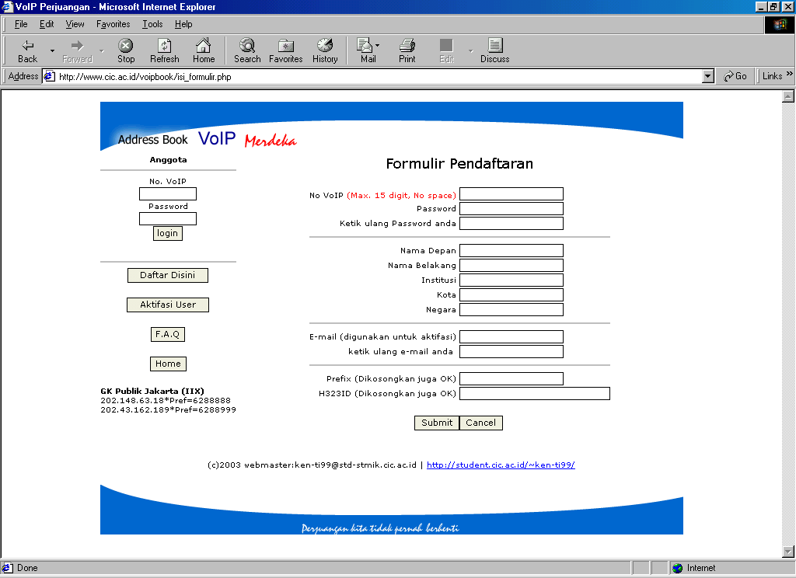
The Indonesian Free Internet Telephony Mavericknet may register their name, institution, city, e-mail etc.
.

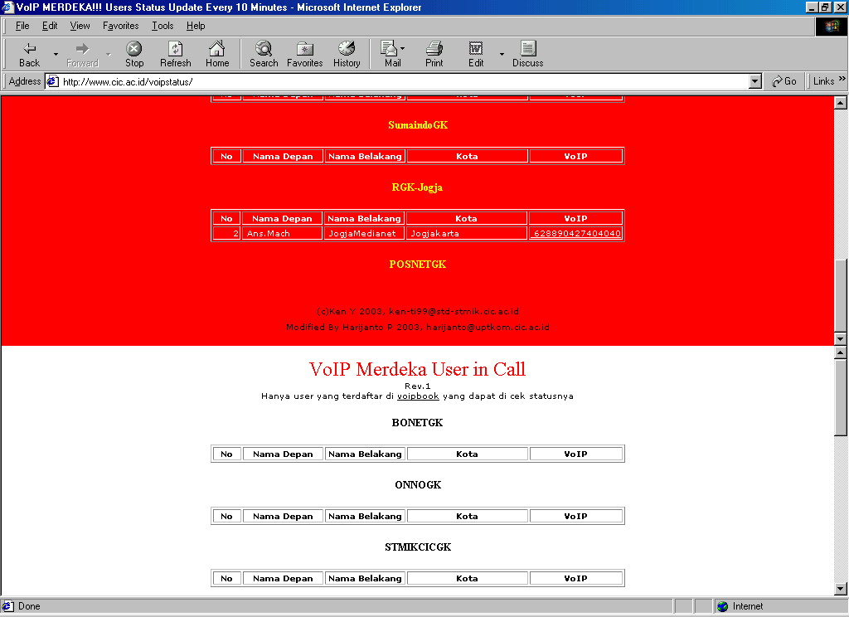
Having the phone book established, we can check whose online through another Web called Internet Telephony status at http://www.cic.ac.id/voipstatus/.

Numbering Plan for A Public Gatekeeper

There is quite a number of public Gatekeepers in addition to the major public Gatekeepers, such as,

202.155.39.157 - for area code 62 88
218.100.4.194 - for area code 62 88 888
      - - for area code 62 88 999
202.150.8.15 - for area code 62 88 925

For example,

ISP IndoNet - running Gatekeepers for 62 88 903
Vocational Schools - running Gatekeepers for 62 88 122

Within an area code, they add 2-3 digits for representing each Gatekeeper. Note that unlike Telco infrastructure, an area code or prefix in Internet Telephony infrastructure is representing a Gatekeeper. Each Gatekeeper must have different area code / prefix.

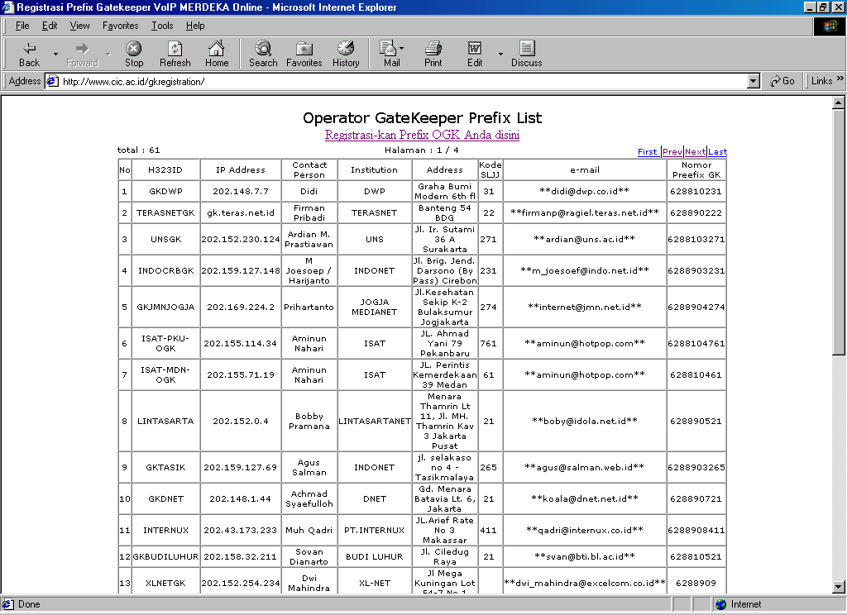
To avoid any duplication in the public Gatekeeper prefix, again, Hariyanto Pribadi hariyanto@uptkom.cic.ac.id and his team at STMIK CIC computer collage setting up a Gatekeeper prefix registration Web site at http://www.cic.ac.id/gkregistration/.

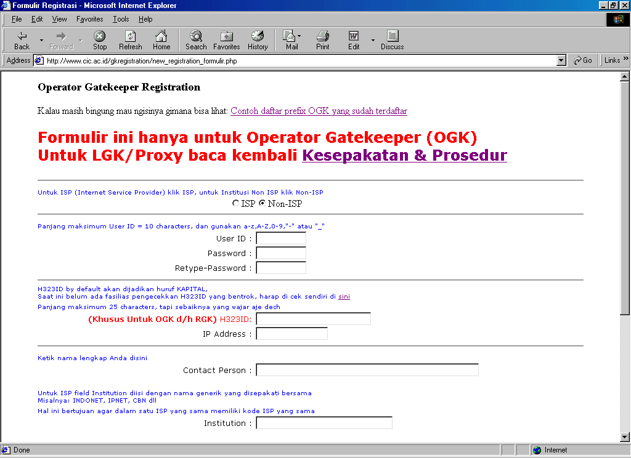
To get a prefix for a public Gatekeeper, GKRegistration Web will ask the contact of the responsible person, the institution, address, e-mail address. In addition, it will ask for more technical question such as, the H323ID, IP address of the public Gatekeeper. We normally submit user ID and password that can be later used to revise our entry.

After the registration performed, the Web will allocate a prefix with 6288 in the first four (4) digits. At the time this manuscript is written, it seems only Indonesia doing such prefix registration.

A public Gatekeeper must register to the Root Gatekeeper to be able to communicate with other Gatekeeper on the network.

In most cases, we need to use your one own country code & own phone number, you are welcome to build your own Root Gatekeeper or public Gatekeeper and coordinate with us to be able to call to each others. You are also welcome to use 202.53.224.172 as your Root Gatekeeper and register your country’s phone number. The 202.53.224.172 may accept any format of number.

Numbering Plan for A Proxy Gatekeeper

For those of you who run a proxy Gatekeeper with a static IP address. I would suggest using the prefix mechanism used in public Gatekeeper and configure the proxy Gatekeeper to Root Gatekeeper to be able to communicate with other Gatekeeper on the network.

Problem may arise especially for proxy Gatekeeper with dynamic IP address, such as, dial-up proxy or xDSL proxy. The mechanism designed for public Gatekeepers do not apply. At the moment there is no registration mechanism for Gatekeeper with dynamic IP address. I guess one may develop one based on dynamic DNS.

Anyhow, the current solution for proxy Gatekeeper with dynamic IP address is to register to one of the public Gatekeeper and use their prefix, namely,

218.100.4.194 - for area code 62 88 888
      - - for area code 62 88 999
202.150.8.15 - for area code 62 88 925

For example, our proxy Gatekeeper register to 202.150.8.15 public Gatekeeper, the prefix & the endpoint number of our proxy Gatekeeper would be

62 88 925 ppp xxx

Where,

- - the Internet Telephony MaverickNet
925 - prefix of 202.150.8.15 public Gatekeeper
ppp - the prefix of our proxy Gatekeeper
xxx - the endpoint number.

In the above numbering plan is enough for allocating 1000 endpoint. In the case we need more endpoint to be numbered, all we have to do is increasing the xxx length.

In most cases, we need to use your one own country code & own phone number, you are welcome to build your own Root Gatekeeper or public Gatekeeper and coordinate with us to be able to call to each others. You are also welcome to use 202.53.224.172 as your Root Gatekeeper and register your country’s phone number. The 202.53.224.172 may accept any format of number.

