Video Conferencing Over VoIP Infrastructure

Unlike the normal Telco infrastructure, the VoIP infrastructure is basically ready to use for low cost video conferencing for its member provided that we have enough bandwidth, about 56 kbps, between the Endpoints. The basic H.323 protocol used in the infrastructure is naturally designed for multimedia communication on top of Internet Protocol.

If we are lucky enough to have access to new handycam or a much low cost Webcam, our system is basically ready for low cost PC based video conferencing using NetMeeting. I use several camera at home that can be used for video conferencing, such as, Cheez camera (a relatively low cost webcam with very good quality 350,000 pixel), Logitec webcam, Sony handycam & JVC handycam. These cameras are normally designed to be connected to the computer through either USB or Firewire. The newer computers are normally equipped with the USB or Firewire ports.

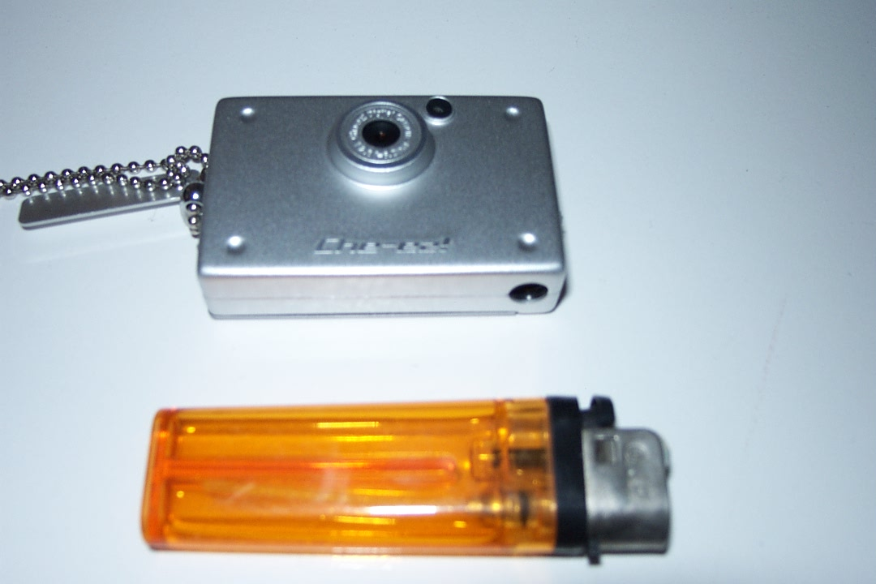

For a quick video conferencing through computer, webcam would be the simplest additional equipment to be used. A webcam normally comes with the CD driver. Its installation is normally fairly simple and straightforward.

The Webcam in the Operating System
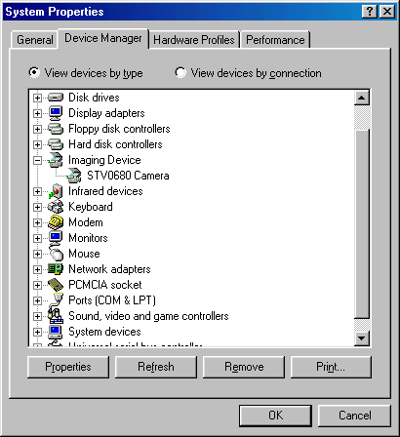

After the webcam driver installed, we can check whether the operating system recognizes the newly installed Webcam.

In Windows 98, it can be done through,

Start → Settings → Control Panel → System → Device Manager.

We will likely to see our Webcam under Imaging Device. As shown in the figure my Cheez camera is known as, STV0680 Camera, to the Windows 98 operating system.

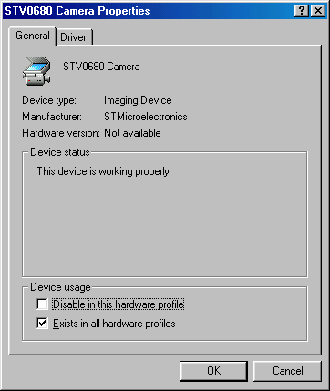

Click the right mouse button on the STV0680 Camera will show the property of the connected camera.

Through the property page, we can check the Device Status. It should properly work.

Video Setup in NetMeeting 3.01

Setting Microsoft NetMeeting 3.01 for videoconference is fairly simple. Video configuration can be done through,

tools → options → video

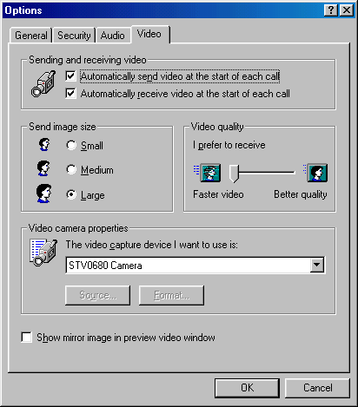
Basically, there are four (4) sections for video configuration. The section on sending and receiving video is basically set the ability to send and receive video. We can check so that NetMeeting will automatically send video at the start of each call, and also automatically receive video at start of each call.

In the send image size section, we can choose the size of the image to either small, medium or large. The smaller size will likely to consume smaller bandwidth.

In the video quality section, we can set the quality of the video to either faster video on one end, or better quality on the far end. If not much movement in the video, we can set the video quality section to better quality.

The last section is the Video camera properties. In this section, we can choose the video capture device used for video conferencing.

Video Communication via the Internet

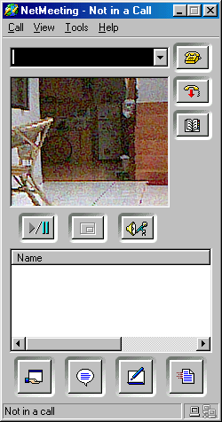
After the driver installed, the operating system and NetMeeting 3.01 recognizing the camera, we are basically ready for video conferencing.

The easiest way to test the video on the NetMeeting 3.01 is by clicking the play & pause button on the NetMeeting 3.01 panel.

Shown in the figure is the NetMeeting 3.01 receiving video signal from the Webcam camera. It is ready to conduct video conferencing.

During the video conferencing session, sometimes we need to see our own video during the video conferencing.
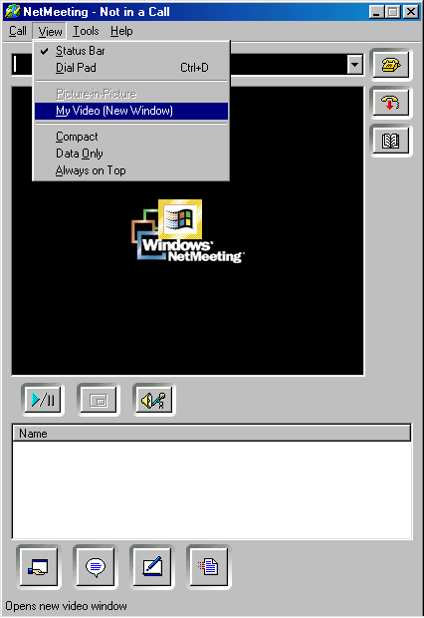
During the video conferencing session, video signal received by NetMeeting 3.01 will be displayed on the display box on the NetMeeting 3.01.

The facility to see our own video is located at View → My Video.

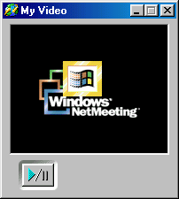
A small box of My Video will appear as we click View → My Video. If no video signal, in the My Video box, a black background with Windows NetMeeting symbol appears.

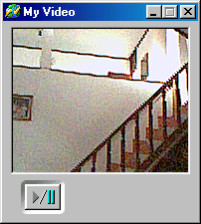
If we click on the play button, we will see the video signal from our Webcam on the My Video screen.

At this point, we are ready to perform video conferencing and see our own video signal during the process.

