Gatekeeper Installation Technique

Gatekeeper is the most important component in a VoIP infrastructure. Gatekeeper is basically the phone switch within the infrastructure that will control the communication among VoIP endpoints. A gatekeeper stores a list of IP address of endpoints and its phone number. It is fairly similar to Domain Name System (DNS) on the Internet.

In this work, we use openh323 gatekeeper. Openh323 gatekeeper is open source software that can be freely used, including changing its source code provided that you share it with others without having to scare of the copyright law.

There are many version of gatekeeper software. After playing around with several version of gatekeeper software, I finally come to conclusion that openh323 gatekeeper, which is the derivation of opengk, is one of the best open source gatekeeper software there is. Openh323 gatekeeper is relatively simple, easy to install, easy to use, and has a good performance as well as the possibility to further develop as the source code is open.

Downloading the Openh323 Gatekeeper Software

Open H.323 gatekeeper can be obtained from www.sourceforge.net or www.sf.net using the keyword openh323 gatekeeper. We can also download the software from its homepage at www.gnugk.org. Openh323 gatekeeper is available in Linux as well as Windows version.

Please note that it is open source software. Thus, we can freely use it without having to worry about copyright law.

I have tried several versions of openh323 gatekeeper on several operating systems, some of them are:

- gk-2.0a-linux-bin.tgz work well on Linux Mandrake 8.0.
- gk-2.0.2-linux-bin.tgz work well on Linux Mandrake 9.0
- gk-2.0.2-windows-bin.zip work well on Windows 98 and WindowsXP
- gk-2.0.3-linux work well on Linux Mandrake 9.0.

I am for some reasons having some difficulties to run the binary on Linux RedHat machines. Many of my colleagues have successfully compile and run the source on FreeBSD and Linux RedHat.

There is development version of the gatekeeper on www.gnugk.org for those who like to use the leading edge code.


To give some ideas, shown in the following figure is the screen capture of while downloading the gatekeeper software from www.sourceforge.net. Note that www.sourceforge.net is one of the largest open source developments site.

As soon as we enter www.sourceforge,net or www.sf.net or sourceforge,.net, we will see a familiar screen as shown in the figure. Entering the keyword openh323 gatekeeper into the search column on left. Clik search button to get the list of software match openh323 gatekeeper.

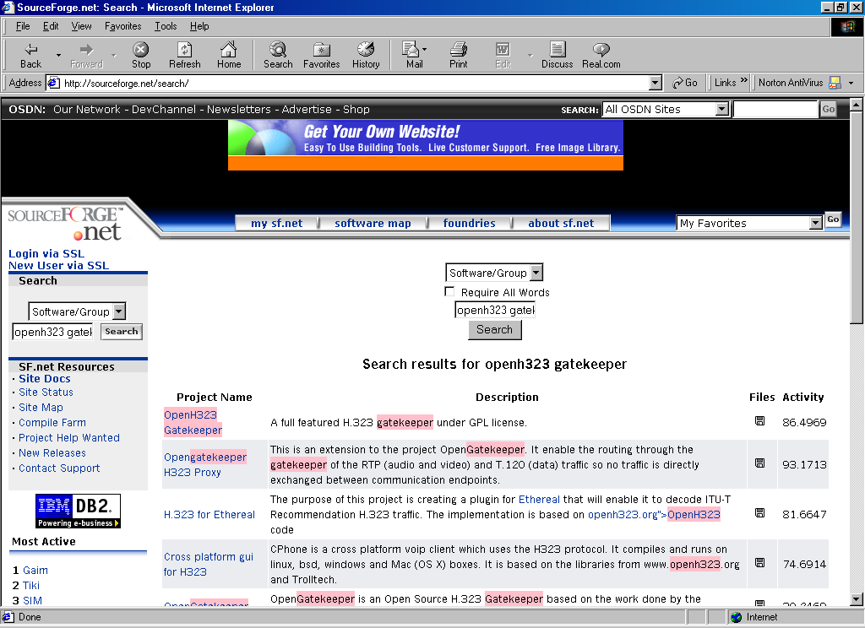
Sourceforge will shows the list of software match the description of openh323 gatekeeper. Among all software listed, pick openh323 gatekeeper. It is normally located around the top rank of the list.

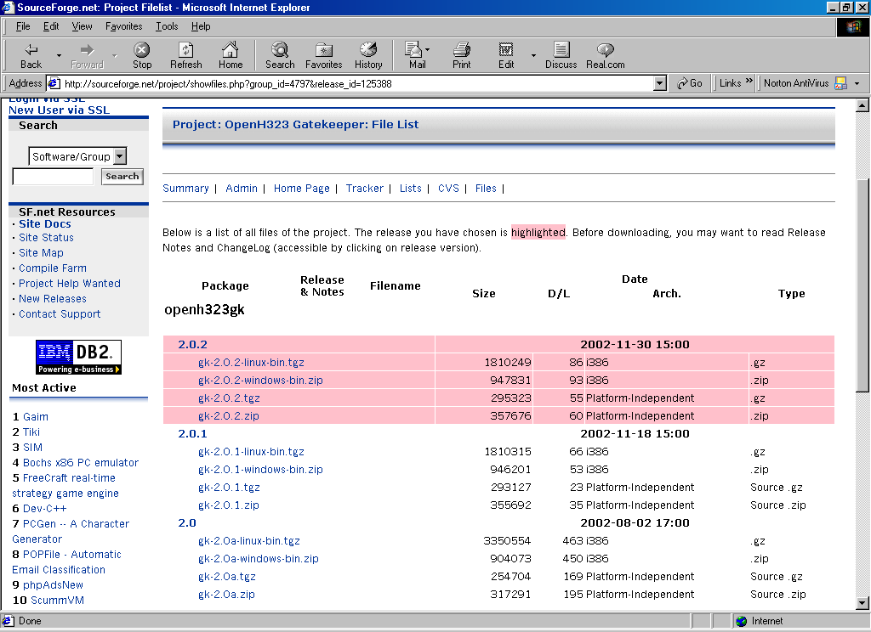
Click on the openh323 gatekeeper on the list, we will then enter the page of openh323 gatekeeper at sourceforge.

Entering the download section, we can then pick version of the software. Openh323 gatekeeper is basically available in binary (executable) and source code, both in Linux and Windows.

The stable version is 2.0.5 and above, it would advisable to download the lower version as well. Sometimes the latest version doesn’t work correctly in some version of the operating systems.

Gatekeeper Installation in Windows

I have tried to install & run openh323 gatekeeper on Windows 98 and XP machine. I have not tried it on other Windows operating system. Through various discussions, it seems the system can easily run on Windows 2000 / NT or XP Pro, which unfortunately I have not used it at all.

For those who use Windows 98, we can operate the openh323 gatekeeper in tandem with any proxy softwares, such as, Wingate or Winroute, on the same machine. Virus might be the most problem faced by those who use Windows.

Installation procedure of openh323 gatekeeper in Windows 89 is much more simpler than Linux. In this example, the binary distribution of openh323 gatekeeper version 2.0.2 will be used. The steps would be

- copy gk-2.0.2-windows-bin.zip to any directory, for example, D:\temp.
- extract gk-2.0.2-windows-bin.zip for example using Winzip.
- you’ll see the folder D:\temp\openh323gk\
- the executable gnugk.exe is located at D:\temp\openh323gk\bin\
- configuration examples are located at D:\temp\openh323gk\etc\

At this point, we can enter D:\temp\openh323gk\bin\ and run gnugk. The first command line I normally used is

gnugk –h

It will show all the command line for gnugk.

The most difficult task would be in configuring the parameter of the configuration file. To make things easier, the completed configuration file can be placed on the same folder as gnugk.exe, such as, D:\temp\openh323gk\bin\, and renamed it to something like myconfiguration.ini

To run the gatekeeper automatically everytime Windows run, I normally put a pointer in the StartUp menu. In Windows 98, it can be set through,

Start → Settings → Task bar & Start Menu .. → Start Menu Programs → Add ..

Next, all we have to do is to key in the following command line

D:\temp\openh323gk\bin\gnugk –c d:\temp\openh323gk\bin\myconfiguration.ini

It might be advisable to key in the above command in the autoexec.bat to enable the openh323 gatekeeper as soon as the computer turns on.

It would be advisable to try the command line in MSDOS prompt if it is successful or not before we put it into Start Menu Programs or Autoexec.bat. During debugging process, the gnugk can be run from MSDOS prompt, directly from d:\temp\openh323gk\bin\ folder, and activating the trace facility as follows

gnugk –ttt –c myconfiguration.ini

Thus, we can see and trace messages to see the process at the gatekeeper.

Visualization of Gatekeeper Installation in Windows
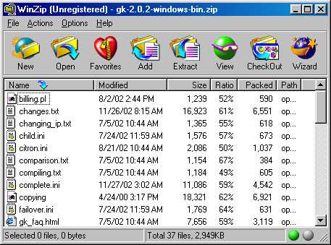
To make the life easier for the beginners, in this section some of the screen capture during installation processes will be shown.

As soon as the binary distribution is downloaded from http://www.gnugk.org, we can extract the binary distribution using Winzip. In this example, I use gk-2.0.2-windows-bin.zip binary distribution. In an XP machine, extraction program seems to be readily available build-in.
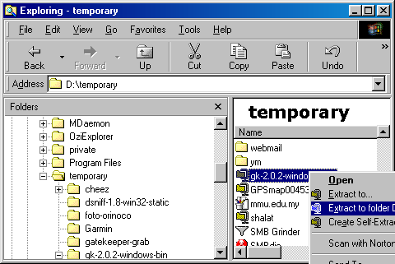
As the extraction process is completed, you can see a folder called gk-2.0.2-windows-bin with /openh323gk folder inside.

All of the programs to run the openh323 gatekeeper are available in openh323gk folder.

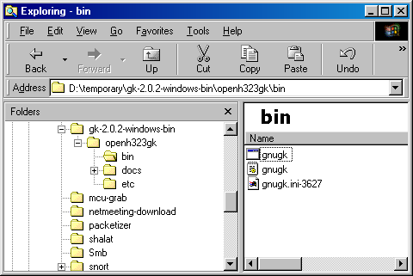
The openh323 gatekeeper is the gnugk.exe. It is located in /openh323gk/bin/.

The openh323 gatekeeper gnugk.exe needs configuration file to operate correctly. I normally use the example configuration file located in /openh323gk/etc/ as a reference in configuration and installation settings. The simplest & minimal configuration file is the gnugk.ini.

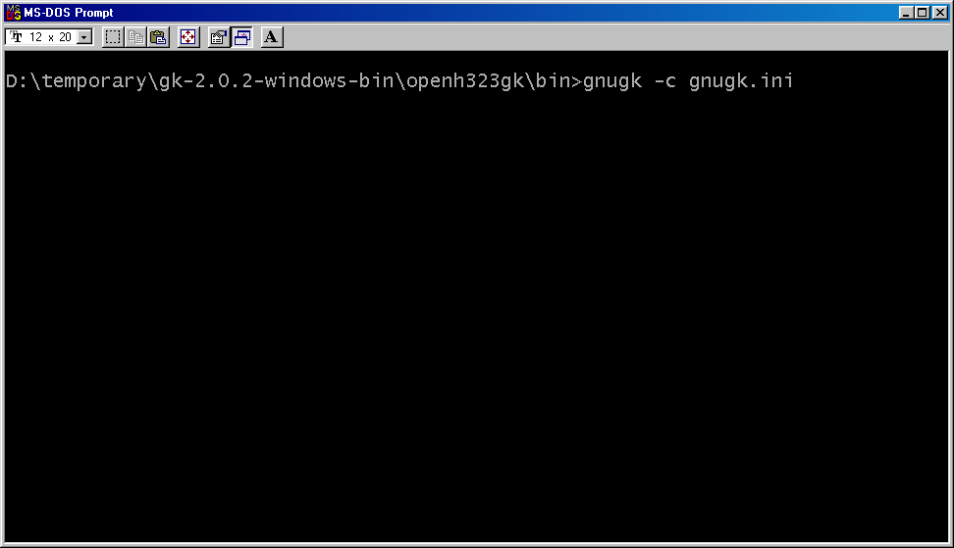
For a start, we can copy the gnugk.ini located in /openh323gk/etc into /openh323gk/bin.

As gnugk.ini and gnugk.exe located in the same folder, we can run the command via DOS Prompt,

gnugk –c gnugk.ini

if you like to debug the gatekeeper to see if it is working correctly or not, all we have to do is add the trace command to it, for example,
gnugk –ttt –c gnugk.ini

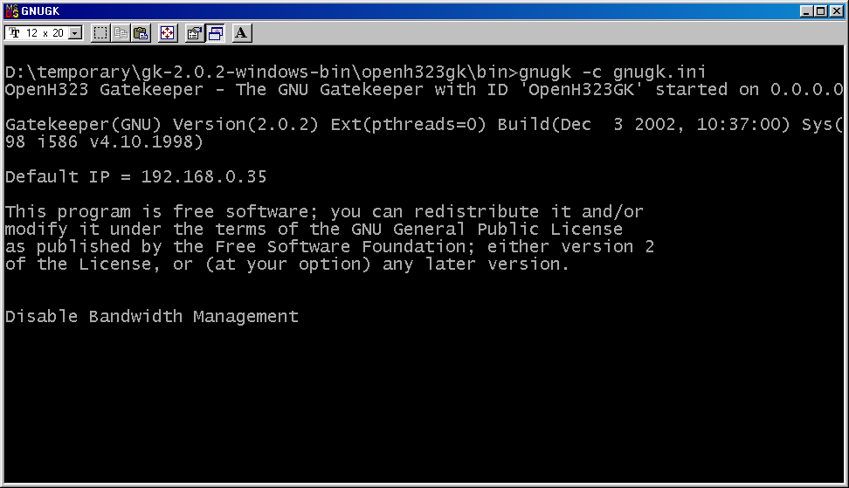
Since gnugk.ini is the most simplest gatekeeper configuration, we will see some message over the screen.

Some of the important note that has to be observed by beginner operators, namely,

- The Default IP has to be the IP address that will be used by the gatekeeper. Sometimes, openh323 gatekeeper may mistakenly take 127.0.0.1 as its default IP. In such faulty, we can set the default IP through [Gatekeeper::Main] section using Home=x.x.x.x parameter in the configuration file.
- If we use the simple gnugk.ini configuration file, it is normal to see a message saying “Disable Bandwidth Management”. All it means that the gatekeeper will not care how much bandwidth is being used for VoIP. For those who has a very limited bandwidth may limit the maximum bandwidth by setting TotalBandwidth=xxxx parameter in [Gatekeeper::Main] section.

The most fatal mistake done by most beginners is forgetting to add the command “–c myconfiguration.ini” when running gnugk.ini. As a result, a WARNING sign will shows up telling that gnugk.ini don’t see the myconfiguration.ini file.

Gatekeeper Installation in Linux

Installation process in Linux is fairly similar to Windows. It adds a little more steps as compared to Windows installation. I am using Linux Mandrake distribution in my installation, thus, unable to comment on other distribution or other Unix flavors. Some of my friends may have compile openh323 gatekeeper from its source code when it runs on RedHat, Slackware and FreeBSD.

The binary distribution of openh323 gatekeeper can be downloaded from http://www.gnugk.org. Installation procedure for openh323 gatekeeper on Linux Mandrake 9.0 is as follow,

- Enter as root
- copy gk-2.0.2-linux-bin.tgz to local directory such as /usr/local/src
- cd /usr/local/src
- tar zxvf gk-2.0.2-linux-bin.tgz
- cd openh323gk
- cd bin
- cp gnugk /usr/bin
- the example of configuration files can be found in /usr/local/src/openh323gk/etc.

For those who use Linux Mandrake 9.0 will likely to be able to run openh323 gatekeeper version 2.0.2 with not much problem. To run one of the latest version, such as version 2.0.5, the latest Linux Mandrake 9.1 should be used.

At this point, we can run the gnugk, such as,

gnugk –h

to see all the command lines to activate gnugk.

We can then configure the myconfiguration.ini according to the examples found in /openh323gk/etc. To run the openh323 gatekeeper automatically, we can add the following line to /etc/rc.d/rc.local,

/usr/bin/gnugk –c /etc/myconfiguration.ini &

Similar to windows, debugging and tracing the process can be executed through,

/usr/bin/gnugk –ttt –c /etc/myconfiguration.ini

Noting the “&” is not used. It is used if we want gnugk to be run in background.

Monitoring the operation of a gatekeeper may be performed by telnet to the status port at port 7000. Through the status port, we can see who is registered on the gatekeeper as well as any call detailed record.

