Chapter 1. Introduction
This book is based on my own experiences in facilitating a community movement within Indonesia to extend communications networks. Although you may be reading this in another country, I am fairly confident that we have the same dream: to see knowledge-based communities flourishing within our societies. I am also sure that we have a similar appreciation of how Information and Communication Technologies (ICTs) can be harnessed as a tool to empower people toward a knowledge-based society.
In this book, I am suggesting a recipe for an alternative path for ICT infrastructure deployment. This path, which is flourishing in Indonesia, involves a largely self-financed, bottom-up, community-based ICT infrastructure. Were the government to address the single most pressing issue today in ICTs — increasing citizens’ access to ICTs — it could be achieved through liberalizing telecommunications so that innovators are rewarded for their use of new technologies. This, coupled with a community-driven approach, would ensure a sustainable and demand-drive information society.
We live in an era where advances in ICT technology lead to much lower costs and more user-friendly equipment. A bottom-up, community-based ICT infrastructure is not impossible to achieve. On the content side, incentives for local knowledge production could create indigenous and relevant content to provide information and knowledge that is required for wealth creation and poverty alleviation.
I strongly believe that a carefully crafted plan that mixes a hybrid of top-down government and private investor regulations, policies, and incentives, together with a community-based bottom-up approach ICT infrastructure would best suit any developing country seeking more broadly based access for its citizenry. The balance will emerge from the demand and response of the people to ICT access and services.
Because I know it well, I will stress the community-based bottom-up approach. However, to be effective, government must play a central role and create an enabling environment in which to further achieve our dreams. If we want to achieve a common vision of a knowledge-based society that can engage effectively in the global economy, it is critical that we develop an inclusive national policy process. This process must identify national objectives, targets, and milestones so that the goal can be realistically achieved.

The dawn of community-based telecom infrastructure
The current telecommunications infrastructure in Indonesia serves less than 5% of the country’s total population. According to the International Telecommunications Union (ITU), there were approximately 7.1 million fixed lines in 2002 and equivalent numbers of cellular subscribers. In January 2003, Indonesian telecommunications tariffs increased on average by 30%, largely as a result of government-imposed measures resulting from the Asian financial crisis.
Nonetheless, primarily through initiatives of the civil society and private sector, Internet user numbers have been doubling each year since 1998.
Based on the annual report of the Indonesian ISP Association (APJII) that can be downloaded from http://www.apjii.or.id, the estimated numbers of Internet users and subscribers to the end of 2002 was as follows:
Table 1. Growth in Indonesian Internet Subscribers and Users
 | Subscribers | Users
1998 | 134,000 | 512,000
1999 | 256,000 | 1,000,000
2000 | 400,000 | 1,900,000
2001 | 581,000 | 4,200,000
2002* | 1,000,000 | 8,000,000
*Estimated up to the end of 2002
Source: APJII (www.apjii.or.id)
This growth occurred largely due to the expansion of two major technologies that comprise backbone of the Indonesian bottom-up, community-based telecommunication infrastructure: WiFi (Wireless Internet) and VoIP (Voice over Internet Protocol).
Through the use of wireless technology (operating at 2.4 Ghz spectrum frequency), a number of Indonesian communities now have broadband access to the Internet at low cost (approximately Rp. 330,000, or CAD$53/month). This is made possible through cooperation among ISPs and warung Internet, or warnet (Internet cafés) in Indonesia. All Indonesian ISPs peer with one another through the Indonesian Internet Exchange (IIX), whereas many warnets are interconnected to one another using low-cost wireless technology. Approximately two-thirds of Indonesia’s Internet users rely on warnets for access. The low monthly cost of maintaining the Internet connection means lower Internet costs for people in these communities — something that was impossible previously because of the high cost of service charged by the two monopoly telecom operators (Indosat and Telkom) to the ISPs and the warnets.
The next best thing after procuring low-cost Internet is to install your very own telephony infrastructure on top of your low-cost, 24-hour Internet infrastructure. In VoIP telephony infrastructures, long-distance charges do not apply. Based on Indonesian regulations, there is no need to get a VoIP operator licence under these two conditions:
- non commercial (no fee, no charges, no telecommunication tariff); and
- it is not connected to a Public Switch Telephony Network (PSTN)/Telco’s network.
A traditional telecommunications system (or “telco”) — and most governments — believe that any ICT infrastructure requires highly skilled, trained personnel to run expensive and sophisticated equipment that can only be funded by multi-national investors. Such a belief appears to be highly embedded into many policy and regulatory frameworks, including the Indonesian telecommunication industry.
While large-scale infrastructure development can be initiated through traditional capital-intensive national operators, it can be complemented at the local level simply through permitting communities to provide low-cost, alternative communication facilities and equipment on their own. Within such an alternative framework, infrastructure can be provided at schools for as little as 50¢ per student per month.
This sounds like a dream for those who live in any developing countries like I do in Indonesia. Fortunately, in reality, it can be easily done by those with the knowledge and technical support.
Today’s ICT technology developments make increasingly high-speed and greater memory possible for much lower costs. As well, the technology is easier to use and much easier to configure than ever before. In other words, new technologies such as WiFi and VoIP mean that ICTs are becoming even more user-friendly and cheaper every day.
WiFi runs on 2.4 GHz and 5.8 GHz extended by external antennas and is quite acceptable for 5-8 km links that bypass telco’s last mile. A NeighborhoodNet is basically a telecenter infrastructure that extends its cabling to its surrounding neighbourhood instead of restricting its cabling within a room or office. NeighborhoodNet leads to much lower 24-hour Internet access costs for the whole neighbourhood.
The consequence is dramatic. The required infrastructure investment may be drastically reduced to a level that makes it affordable for a household or community to build and operate their own infrastructure. It enables a community-based telecommunication infrastructure that is built by the people, run by the people, for the people. This is a totally different concept and significant paradigm shift compared to the traditional telecommunication infrastructure, which is normally licensed by the government, built and run by the telecomm operators, for the subscriber/people. Unfortunately, most telecommunications policy and regulations — at least those in Indonesia — cannot easily adapt to such a paradigm shift.
Over ten years of community-led networking efforts have resulted in about 4 million Indonesians on the Internet, 2000 cyber cafés, and 1500 schools on the Internet, all of which run on top of 2500+ WiFi nodes. These numbers have increased exponentially in recent years. As a result of additional phone tariffs in 2003, a free VoIP infrastructure also known as Indonesian VoIP MaverickNet, was deployed on top of the Internet infrastructure. Within three months, we managed to deploy 150+ VoIP gatekeepers based on www.gnugk.org freeware to handle approximately 1000 calls/gatekeeper/day for 3000+ registered users, as well as an estimated 8000+ unregistered users.

Paradigm shift in community-based telecomm infrastructure
Most traditional approaches to telecommunication infrastructure provisioning will probably adopt fairly established models within their telecommunication industry, such as:
- licences from the government;
- foreign direct investment;
- operations by telecommunication operators; and
- services geared toward subscribers, particularly business.
Ideally, these arrangements are governed by a transparent law involving both regulation and a policy framework for the telecommunication industry. The bottom line is that government acts as the quality control for anyone who wants to provide services to the market. There is nothing wrong in adopting such an arrangement, especially if there are:
- high investment costs involved with deploying the infrastructure;
- requirements for fairly complex equipment;
- requirements for highly skilled operators; and
- an environment of no existing corruption as well as transparent government procedures and processes.
It is important to note that the government will probably control public telecommunication services through licensing mechanisms and service agreements. However, there are virtually no government control mechanisms in a private network or a small community-owned network.
The existence of click-and-drag user interfaces in most modern and low-cost ICT equipment enables the general public as well as small- and medium-sized enterprises to build their own private network. What if we interconnect these community-owned private networks into a large, virtual private network? Such a network may run into grey areas in telecommunication policy where there is no government control, which enables them to interconnect among themselves. This type of environment leads to a bottom-up, community-based ICT/telecommunication infrastructure.
In some countries, an independent, community-based telecommunication infrastructure represents a strategic move, specifically designed to help the community to procure an affordable telecommunication infrastructure. A community-based telecommunication infrastructure is:
- from the people;
- by the people; and
- for the people.
This type of infrastructure exploits the biggest holes within most governments, that is: law, policy and regulatory frameworks. These systems are unable to touch the community-based private networks in small, medium, and large enterprises as well as in many offices and residential neighbourhoods. Once equipment is standardized, interconnection among private networks can be smoothly performed. Interconnection leads to a community-based telecommunication infrastructure, which itself falls into a grey area in telecommunication regulatory frameworks.

Community-based telecom infrastructure
The basic components of the community-based telecommunication infrastructure are:
- Internet infrastructure;
- WiFi equipment, especially those that bypass telco’s last mile;
- Internet Telephony Gateway;
- PBX; and
- telephone cables and handsets that run throughout the neighbourhood.
Most of the equipment is off-the-shelf, reasonably user-friendly, and inexpensive. Our experience shows that investment within a neighbourhood network is roughly US$80-$100 per home for a 24-hour connection to the Internet. One still has to buy a computer to get connected but the cost of equipment is steadily declining. The operating costs are approximately US$15-30/month/house for 24-hour Internet connection.
If voice-only (telephone) traffic is required, the investment cost can be reduced to around US$35-45/handset. The calculation assumes the use of fairly typical 16-line PBX such as Panasonic KX-TA 616. The operating cost per handset is highly dependent on the Internet cost. For instance, a high-cost US$400 64-Kbps dedicated link incurs a US$25 cost per month for 24-hour telephone services anywhere on the Internet.

People’s education is the key
Sustainable community networking heavily relies on the ability to create a tacit knowledge-exchange platform. This platform enables knowledge-producing young authors to train others to replicate the process for greater impact and a scaling-up effect. Open source, open document, copy-left movements are encouraged. All processes are self-financed. This has nothing to do with the technological superiority of the equipment. Adjustment have to be made for different countries and their regulatory environments.

Intervention by international bodies and donor agencies
International bodies or donor agencies may speed up the scaling-up and replication processes. In a clean environment where corruption among government officials is not a problem, direct interventions to government regulatory and policy frameworks represents one of the fastest ways to get the desired results. Without minimum thresholds of good governance, such intervention will be far less successful, but can be accomplished keeping these phases of the process in mind:
- building a two-way interaction platform — to accumulate and manage community tacit knowledge;
- creating information analysis and synthesis procedures, testing and development processes;
- encouraging explicit knowledge creation, for example in books and articles; and
- expediting explicit knowledge distribution.
These processes involve large numbers of people, and represent long-term processes that attract very limited sponsorship from commercial sectors. Thus, it is not surprising that these communities rely on free Internet services, such as yahoogroups.com, to facilitate their development.
It is useful to list a few examples of processes that donor agencies could help with, without disturbing the self-financing and sustainability aspects of the particular process in question. Examples include:
- Creating free mailing list platforms at the country’s Internet Exchange to confine the discussion traffic bandwidth. It might be possible to work together with yahoogroups.com (http://groups.yahoo.com), which is a good free mailing list service.
- Setting up some sort of Slashdot or Source Forge platform so developers can test their ideas, software, and scripts before sharing them. For example, a lot of young Indonesian developers ask me if I have access to a free web server with PHP and MySQL capability so that they can test their scripts. If this could be done, young developers could then publish and share their work under GNU licence.
- Having some sort of ICT book competition to encourage young authors, which could inspire others to produce explicit knowledge.
Language barriers represent one of the biggest barriers in south-south development strategies. Personally, I don’t know what the best solution is to this dilemma.
In addition, in all interventions it is important to monitor reactions, get feed back, and interact with the community through various mailing lists. This latter point is crucial: it is critical to have an intense interaction with the community.

Alternative financially sustainable community-based movements
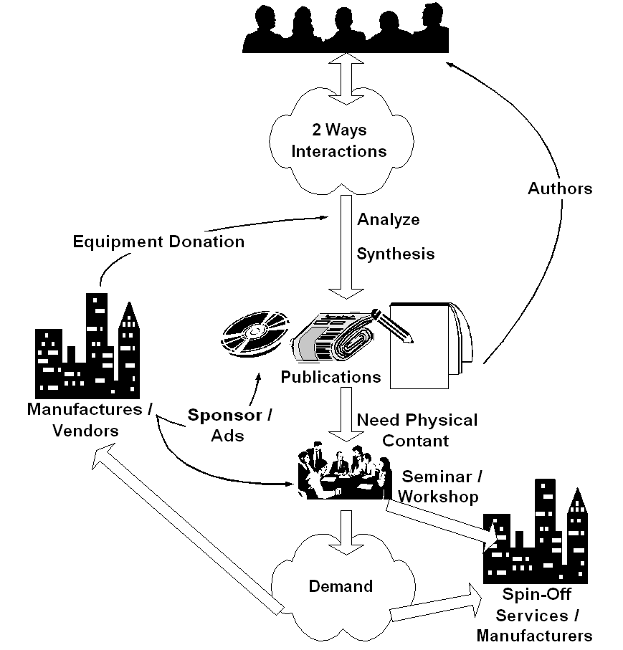

This diagram depicts my experience in creating a community-based movement in Indonesia. To sustain a digital-divide bridge deployment, a supply that is created specifically by demand is crucial, because most failed approaches are driven from the supply side. Demand for an information infrastructure, as well as the ability to exploit the abundant information and knowledge in the infrastructure, can only happen in an educated society. Failure to increase society’s education level greatly impedes the development of an information infrastructure.
Therefore, success in deploying an information infrastructure relies heavily on the quality and skill of the human resources. It is crucial to create an infrastructure that is capable of producing the required knowledge and skill base at a low cost, and the ability to access ICT knowledge in English is a real plus. Interestingly, funding is not the primary concern in deploying ICT infrastructure.
Here are a few concepts to consider when trying to create a sustainable ICT infrastructure:
- It is important to create a platform for people to do two-way interactions to facilitate a tacit (implicit) knowledge exchange. This dialogue could take the form of radio or TV talk shows, or Internet mailing lists at no cost. Unlike most situations in developed countries, no abundant local content is necessary to initiate this. Communities can create their own content through the platform that can best exploit existing knowledge.
- Developing collective community knowledge can take one or two years before individuals really start analyzing and synthesizing information. Such individuals should make their knowledge implicit, that is, in writing, which can then be distributed through conventional channels such as newspaper, magazine, radio, and television. Knowledge can then begin to transform the mindset of others who are not yet using ICT. It costs US$1-2 to access this knowledge by buying a book or magazine. Using the Indonesian example, local authors can produce publications in magazine and books and receive an average of US$25/article or US$500/book.
- Workshops and seminars are important because many people need physical contact through in order to be convinced about the relevancy of ICT. Normally 500-1000 people participate in such seminars, which generally cost US$3/person since many vendors offer sponsorships to participants so they can afford to attend.
- It is necessary to create a demand within the people to create a “digital divide bridge.” Once the demand increases, business will respond to the opportunity or else persuade people to invest their money into deploying the “bridge.” An investment of 50¢/student/month in a school network, or US$15-30/house/month in a US$2000 neighbourhood network, which offers a return on investment within one or two years represents a good incentive for people to invest their own money into the “digital divide bridge.” Success stories and word of mouth is the typical way to spread information about these types of investments, and their benefits.
- Deploying and maintaining the digital divide bridge can be achieved at a cost of 50¢/student/month at a school, or approximately US$15-30/month/house. At last, these costs reflect a financially achievable digital divide bridge where minimal support is required from financial institutions and the government. Hopefully, costs can be free of licensing fees.
- In the end, as more and more people are connected to the Internet, increasing pressure is exerted on regulators to enhance their policies.
All these scenarios are self-financed for the most part. The normal (not ideal) sequence would be awareness, demand, business response, and regulation, but these steps cannot be completed overnight. Instead, it will take years to achieve these steps. Committed leaders are urgently needed in order for the long-term deployment of the ICT movement to succeed.

Some tricks to facilitate local content creation
Creating demand is one issue, but we also need to build the surrounding skilled and technical infrastructure to support the deployment of the “bridge.” Local expertise and local content generation is crucial to this process.
One area requiring overhaul is the country’s university curriculum so that lecturers can get an up-to-date knowledge of ICT. In a fully centralized public education system, inserting new technology into the curriculum represents a major headache. One may be surprised to learn that skills in WordStar and Lotus 123 are required in computer science undergraduate programs. Because we have an out-of-date curriculum in many IT schools and universities, students are far better off educating themselves by finding their knowledge through Internet facilities in their schools.
I normally use a subtle approach within the Indonesian university student communities by interacting with them through talk shows and seminars. It is important to encourage students to rise above merely being ICT knowledge consumers: they must graduate to the stage of becoming ICT knowledge sources themselves — and this has to be achieved using the Indonesian, not English, language. This approach seems to work. Currently, there are many young ICT writers in Indonesia who are publishing their books in the Indonesian language so as to get some money to pay for their tuition fees.
Here are some steps toward creating a system with local content:
- Having access to abundant ICT information, knowledge, and skills in English by many Indonesian students as well as professionals over the Internet is very important. A significant number of Internet cafés and wired universities encourages access. Internet cafés normally cost about US$0.3/hour.
- Activating numerous technical discussion groups and mailing lists on the Internet using local language is key. This can take the form of using yahoogroups.com to enable free tacit knowledge transfer among local techies.
- Creating demand for ICT magazines is good for publishers, students, and information dissemination. Currently there are significant numbers of local-language ICT magazines that accept local contributors. Magazines sell for US$1-2. Students should be encouraged to publish their work and payment of US$15-25/article helps pay their tuition fees and living costs. At the same time, they are helping to educate other people.
- Creating more technical discussions is achieved in books, e-books, and articles published in local language. Experienced authors transform themselves into knowledge sources in local language. A royalty of US$500 for a book that can normally be written within a couple of weeks offers a good incentive for people to publish their knowledge while simultaneously educating society at large. There are currently many ICT books published in Indonesia, which costs approximately US$2-3 each. As of the writing of this manuscript, one of the publishers, PT. Elexmedia Komptindo (http://www.elexmedia.co.id), has a backlog of manuscripts to publish far into 2004.
- Creating opportunities to meet experts in the field. In most cases, simply reading articles and books, or conducting discussions over the Internet is not enough to make people want to develop their own ICT knowledge. Seeing the author or expert in person is far more compelling. For US$3-5/person, individuals can participate in many tutorials, seminars, or installation demonstrations put on by many event organizers/institutions in the country. It is not surprising to see 500-1000 people shown up for tutorials and seminars. More intensive workshops may cost more about US$20-30/session. A US$50-100 per hour or per session compensation for speakers offers a very good incentive that attracts knowledgeable speakers. It is important to note that many vendors and sponsors want to participate in these types of events, where there is such high attendance.

- Developing different types of knowledge distribution is important. Some of us are currently working on creating Video CDs in ICT education. Others put their work on the web so it can be freely downloaded. Because Internet access is quite expensive in many areas, CD distribution of the knowledge as well as many open source/Linux assists the knowledge dissemination process.
- Learning what medium works best for each level of information is important. Radio, television, and print create awareness of the process especially at the entry user level. However, these mediums do little to advance people’s technical skills.
Again, these processes can be primarily self-financed and self-propelled.
Here are some additional ways of initiating ICT knowledge within the existing education system:
- When I teach at Institute of Technology Bandung, I remove common academic demands on students such as compulsory attendance, mid-term exams, and final exams. Instead, I base the student’s mark on their ability to become a knowledge producer. I do this by encouraging students to publish articles in magazines and award their marks based upon what they produce, for instance: 5 articles gets them an A, 4 articles a B; 3 articles a C, and so on. Students who publish a book receive an A.
- To encourage students, I also give free access to the Internet for those who like to help me maintain and run the system. In the end, I ask them to write a book based on the knowledge they gain during the process.
- The private sector will gladly help us to perform the process, because we create huge and continued demand for their products. Getting free equipment to conduct experiments is not difficult. Most companies would be interested in sponsoring the seminar/workshop if 500-1000 people participate.
Key to the success of these processes is the fact that we force the young students to become knowledge producers to benefit the whole society through local knowledge generation and accumulation.
In rural and remote areas where talk-and-listen dialogue is the primary means of communication, computer and Internet-based ICT may not work well. Community radio and television might be the best alternative. One can easily build a community radio transmitter for under US$100, which enables the surrounding community to speak up and create an information-diversity environment. A network of community radios would provide a strong barrier against the domination of information by national and multinational broadcasters. However, currently such progressive initiatives are stifled by the inability to acquire frequency spectrum from the government.

