Introduction

This work will be very much biased by the Author’s experiences in facilitating the movement within the Indonesian people to build their very own internet infrastructure without relying to the government as well as the World Bank , IMF or other funding agencies.

Acknowledgement
This work is supported by the International Development Research Center (IDRC) http://www.idrc.ca

Community based Infrastructure: An Exciting Experience

Most telecommunication law and policy framework is normally aimed to do some sort of quality control on the telecommunication industry. It is normally assumed complicated technology and high capital investment involved. It is not surprising to see old policy paradigm adopted by the Indonesian government, such that,

Licensed by the Government
Invest by the Investors.
Run by the operators
For the people

There is a catch in the old policy paradigm, namely, as long as we can provide a free (no fee, no charges, no tariff) telecommunication services to the people, there is no government license required & no law to be abide except people’s (user’s) trust on system. In Community ICT infrastructure, where everything is community based and free, the fundamental paradigm may be significantly shifted into

From the people
By the people
For the people

Let’s play with the idea what if no Telco is necessary? What if no government & world bank involvement necessary in the development & building of an infrastructure in developing countries? What if it costs only 50 cents/students/month to get such infrastructure for schools in developing countries?

Sounds like a dream for those who live in any development countries like I do in Indonesia. Fortunately, in reality, it can be easily done. It is not the equipment, nor the regulation, nor the investment that counts, it is the ability to educate critical mass that gain the required information & knowledge critical to the establishment of such infrastructure.

It seems the traditional Telco & most government believes that any ICT infrastructure required a highly skilled & trained personal to run expensive sophisticated equipments that can only be funded by multi-national investors. Such believe highly imbedded into all legal and policy framework, at least, within the Indonesian telecommunication industry.

Let’s have a closer look at ICT technology development; one can easily notice few important features of any ICT technology. It gets more powerful, much smarter, more speed, more space in the memory. Fortunately, all those advanced features can be obtained at much lower costs, much easier to use, to configure, to control, and, thus, more user-friendly.

The consequence is quite dramatic. The required infrastructure investment may be drastically reduced to a level affordable for a household or community to build and operate his or her own infrastructure. Not surprising to see a common people with slight technical skill operates the infrastructure.

It enables a community based telecommunication infrastructure that builds by the people, run by the people, for the people, a totally different concept & significant paradigm shift as compared to the traditional telecommunication infrastructure, which normally licensed by the government, build and run by the telecomm operators, for the subscriber / people. Unfortunately, most telecomm policy and regulations, at least the one in Indonesia, cannot easily adapt to such paradigm shift.

Community & people education is the key success factor. Fed up & quit as civil servant in February 2000, I am dedicating myself as IT writer & delivering ICT knowledge to Indonesian in various media, such as, CD-ROM, web, books, talk show, seminars, workshops as well as answering e-mail in 100+ Internet mailing lists. A proof of concept that a knowledgeable society with access to new ICT equipments would easily deploy a self-finance own infrastructure and, thus, releasing their dependence on Telco as well as their own government in getting telecommunication services.

After 10+ years of struggling, it results in about 4 million Indonesians on the Internet, 2000+ cyber cafés, 1500+ schools on the Internet that run on top 2500+ WiFi nodes. It increases drastically in the past years. As the Indonesian government is planning to increase phone tariff in mid 2003, starting in the first week January 2003 a free VoIP infrastructure also known as Indonesian VoIP MaverickNet was deployed on top of Indonesian Internet infrastructure. Within 3+ months, we managed to deploy 150+ VoIP gatekeepers based on www.gnugk.org freeware to handle approx. 1000 calls/gatekeeper/day for 3000+ registered user, and an estimated of 8000+ unregistered users.

In practice, there are two (2) major technologies used as the major backbone of Indonesian bottom-up community based telecommunication infrastructure, namely, WiFi or Wireless Internet and Voice over Internet Protocol (VoIP). WiFi based Wireless Internet run on 2.4GHz & 5.8GHz extended by external antennas is quite good for 5-8 km links bypassing Telco’s last mile. It enables NeighborhoodNet to lower access cost as an extension to TeleCenters / CyberCafes.

As PBX in offices interconnected into the free VoIP MaverickNet via Internet Telephony Gateway, long distance & local calls is bypassed through the Internet infrastructure without any Telco interconnection. A specific VoIP MaverickNet area code, i.e., +6288, is invented. However, those who wish be called & registered to the VoIP gatekeeper using their normal Telco number, it can be easily done as the gatekeeper can recognize any form of numbers. Sadly, it means people can be called freely on Telco’s number at no charge via VoIP MaverickNet without using the expensive Telco infrastructure!

Some tutorial files on such infrastructure can be freely downloaded from our web at http://www.apjii.or.id/onno/ or http://sandbox.bellanet.org/~onno/. A community based telecommunication infrastructure will not be possible without generous knowledge sharing done by many people on the Internet. I have to thank them.

Voice communication is still dominant in Indonesia. Thus, ability to bypass long distance charges & international charges at null cost is a significant strategy to implemented.

The Structure of Community ICT Infrastructure

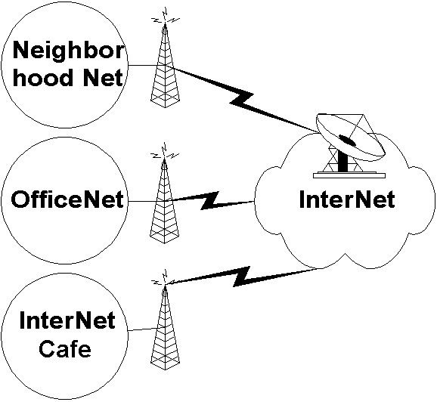
Physical structure of Community ICT infrastructure is quite simple. We normally use WiFi infrastructure to bypass our Telco’s last mile infrastructure.

WiFi is basically wireless LAN (WLAN) equipments, confirming the standard IEEE 802.11b or others, such as, IEEE 802.11a. To increase the distance, we normally put an external antenna at the end of WiFi card.

The IEEE 802.11b WLAN equipments are normally using 2.4GHz band & running at 11Mbps. Thus, it has a significantly higher speed as compared to normal dial-up connection.

Unfortunately, distance would be major drawback for WLAN (WiFi) technology. Thus, merging with fiber optics or satellite providers would be a natural strategic process for Community ICT infrastructure.

The WLAN card is normally installed at the router of an Office Network, InterNet Café or Neighborhood Network. We normally use Linux based PC as the router (or gateway) that enable inclusion of NAT/Proxy as well as H.323 Gatekeeper into a single machine.

Neighborhood Net as well as InterNet café would be a very natural selection to reduce access cost to the Internet. Neighborhood Network is basically a LAN connection for your neighborhood by running your UTP cables to your neighbors ☺

The normal Indonesian Neighborhood Net costs about US$15-45 / neighbor / month for having 24 hour Internet connection. Not bad, considering high tariff of regional leased line & satellite links imposed by the Indonesian commercial providers.

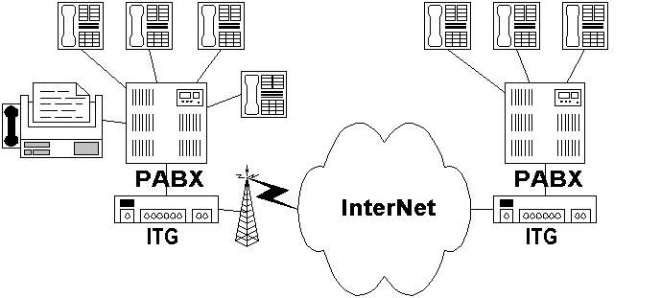
Voice communication is still a dominant mode of communication in developing country like Indonesia. Thus, low cost solution for voice telephony infrastructure would be highly accepted & appreciated.

The next best thing after having a low cost Internet infrastructure is to install your very own telephony infrastructure on top of your low cost 24 hours Internet infrastructure. Consequently, in such Voice over Internet Protocol (VoIP) telephony infrastructure, any long-distance telephony charges are irrelevant.

Based on Indonesian regulation, there is no need for getting a VoIP operator license if

- It is non-commercial (no fee, no charges, no telecommunication tariff).
- It is not connected to Public Switch Telephony Network (PSTN) / Telco’s network.

Thus, all we have to do is build our own free VoIP Network & connect all PBX in all offices, which is normally have its own Internet connection. Internet Telephony Gateway (ITG) is used to connect the PBX to VoIP Network on the Internet.

Phone numbers would be a major headache to be coordinated. The availability of open source gatekeeper, especially, OpenH323 Gatekeeper http://www.gnugk.org, really help us in building the needed phone central to managed many VoIP endpoints. Summary

There are 90+ H.323 gatekeeper, handling 2000-3000 calls / day with ~2000 registered users. Except for InterNet charges, no fee, no charges, no tariff is required for doing any calls. It was only started in the beginning of 2003, the number of subscriber, gatekeepers as well as calls / day increases quite rapidly.

In early February 2003, the quick summary of the Indonesian VoIP MaverickNet is as follows,

Country code 62
VoIP Number 6288
Root Gatekeeper 202.53.224.172
Total Gatekeeper 90+
Total Registered User 2000+
Total traffic 3000+ calls / day
Long Distance Tariff nil

Online users can be viewed at http://www.cic.ac.id/voipstatus/. List of registered users can be seen at http://www.cic.ac.id/voipbook/.

People’s Education is The Key

This section is based on my personal 10+ years experience in attempting to build a financially sustainable community based information infrastructure in Indonesia. To start with, no available funding is assumed. I may very much bias to my Indonesian experience. All activities are driven by a simple vision, to see a knowledge-based society in Indonesia. ICT is believed to be the tool of choice to accomplish the task.

Maintain a self-finance & sustainable process under intervention of international bodies or donor agencies is the most difficult task. Most people will likely to assume that international bodies would likely to bring free funding for them. It may work for pilot projects; the process may unfortunately stop as soon as the funding source dried up.

Similarly in most government approaches, bridging a digital divide with imbedded divide policy framework (operator vs. common user) and no room for community-based infrastructure seems to be arguable. Not to mention the highly corrupt environment. Significant part of the existing regulatory framework became an obstacle against our effort intended for people’s movement, and, thus, leads to unnecessary casualties in some cases.

My experience shows that it would be much easier to initiate a self-finance sustainable process if there is no funding from any donor agency to begin with. We can easily see the committed individuals & successful approaches in a free donor agency zone. Care has to be carefully planned to inject funding in a self-finance & sustainable process. Key successes rely heavily on ability to create a tacit knowledge exchange platform enabling knowledge producing young authors follow up by education processes focused on scaling & replicating the process for high impact to the society. Open source, open document, copy left movement would be significant. All processes are self-finance. It has nothing to do with the technological superiority of the equipments. Adjustment should be made for different countries & regulatory environment.

The catch would be in the ability to identify & to work with informal (most likely underground) visionary leaders / pioneers in the country / area. It would unfortunately be very difficult to find one through formal (government) channels.

Intervention by International Bodies / Donor Agencies

International bodies or donor agencies may speed up the scaling up and replication processes in society movement. In a clean environment with not much corrupt government officials, a direct intervention to government regulatory and policy framework & do e-government might be one of the fastest ways to get the result. Assuming they have a large number of “clean” law enforcement. My apology, in Indonesia, such intervention may not likely to work.

A careful intervention should be performed in one of the point in demand creating processes. It can be in

- 2-way interaction platform – to accumulate & manage community tacit knowledge.
- Information analyzing & synthesis processes. Testing & development processes.
- Encourage explicit knowledge creation, e.g., in book and article.
- Expedite explicit knowledge distribution.

Those are the processes that involving a large number of people. It is a long-term process, with very limited interest from commercial sectors to sponsor the process. Thus, it is not surprising the see these communities rely on Internet free services, such as, yahoogroups.com to facilitate their process.

Just to give some ideas on the kind of intervention by donor agencies to facilitate the process without disturbing the self-finance & sustainability process of the movement, some of them are,

- Creating free mailing list platform at the country’s Internet Exchange in confining the discussion traffic bandwidth in the country. It might be possible to work together with yahoogroups.com (http://groups.yahoo.com). To be honest, it is a good free mailing list service in the world today.
- Some sort of Slashdot or Source Forge platform for the developer to test their idea, their software, their script and share it with others. For example, a lot of young Indonesian developers ask me if I have access to free web server with PHP & MySQL capability to test their script. If such approach would like to be performed, we can set the condition for these young developers to publish & share their work under GNU license if they use the server.
- Having some sort of ICT book competition to encourage young authors. It may inspire others to produce explicit knowledge.

Language barrier would be one of biggest barrier in south-south development strategies. I personally don’t know the best solution to such barrier.

In addition, in all intervention, it is important to monitor the reaction, get feed back and interact with the community through various mailing lists. It is very important to have an intense interaction with the community. It would be difficult to move the communities by keeping some distance (namely less or slow interaction) with the communities.

Alternative Financially Sustainable Community Based Movement

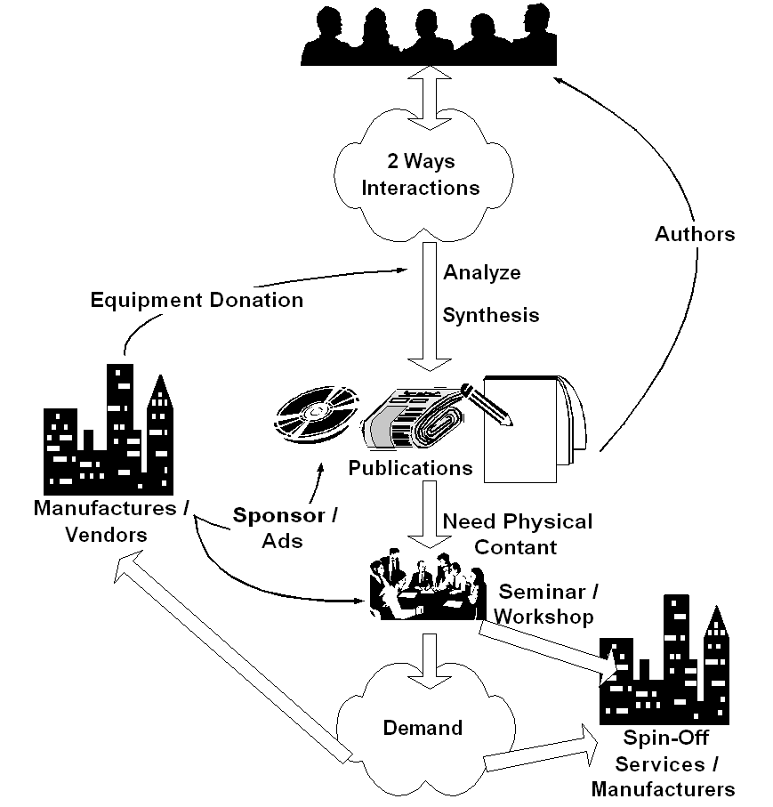
To sustain a digital divide bridge deployment, a supply created-by-demand strategy would be crucial. Most failed approaches will likely to use demand created-by-supply path. Demand in information infrastructure as well as ability to exploit the abundant information & knowledge in the infrastructure will only happen in an educated society. Failure to increase the society's level of education will likely to impede the development of information infrastructure within the society.

Key success in deploying the information infrastructure would rely heavily on the quality & skill of the human resources. Ability to distribute the needed knowledge & skill at low cost would be crucial in creating demand & needed skilled technician to deploy the infrastructure. Ability to access ICT knowledge in English would be a plus. Interestingly, please note that funding is not the primary concern in deploying ICT infrastructure.

If I may put it in point form, the simplified steps would be something like,

- Create platform for people to do 2 ways interaction. It is basically to facilitate tacit (implicit) knowledge exchange. It may be radio or TV talk shows, or Internet mailing list at no cost. Unlike most assumed condition by 1st world countries, no abundant local content is necessary to start with. Community will create their own content through platform the exploit community implicit knowledge.

- It may take 1-2 years, before some of the individual start analyze and synthesis the collective community knowledge. These young individual should make their knowledge implicit in written form. It should be distributed through conventional channels, such as, newspaper, magazine, radio & television, and thus transform the mindset of others who are not yet using ICT. It cost US$ 1-2 to access the knowledge by buying the book or magazine. They will produce publications in magazine and books and receive US$ 25 / article or US$ 500 / book.

- Some may need physical contact through seminar and workshop to be convinced. We are normally looking at 500-1000 participants / seminar. It costs US$ 3 / person to enter such seminars as many vendors may likely give sponsorship.

- Creating demand within the people for the "digital divide bridge". Once the demand increases business will respond to the opportunity else persuade people to invest their money into deploying the "bridge". A 50 cents/student/month in a school network or US$15-30/house/month in a US$2000 neighborhood network investment with RoI within 1-2 years is a good enough incentive for people to invest their own money into the "digital divide bridge". Success stories & word of mouth is the typical process to spread the words.

- Deploy & maintain the "digital divide bridge" may be done at 50 cents/student/month at school or about US$ 15-30/month/house. Ah, we finally have financially sustainable digital divide bridges with minimal support from the Bank, the government & hopefully license free.

- In the end, as more and more people connected to the Internet, pressure will be high for the regulators to work on their policies. Hoping no distortion made during the processes.

As shown clearly, all the sequences are self-finance. The normal (not the ideal) sequence would be awareness, demand, business response, and regulation. These steps would not be completed over night. It will take years to complete these steps. Committed leaders & personals are needed for such long-term deployment ICT movement.

Having an alternative bottom-up self-finance community based movement has proven to be a good ICT development model, at least for Indonesia; as a result, we are currently seeing:

- 4+ million Indonesian on the Internet
- 2500+ WiFi outdoor node for bypassing local telco infrastructure
- 2000+ Internet Cafes
- 1500+ schools on the Internet

Note that most of these results are community based funded with not much government support; as well as no funding from World Bank or IMF.

Some of the Trick To Facilitate Local Content Creation

Having the demand-created is one issue, we need to build the surrounding skilled / technical infrastructure to support the deployment of the "bridge". Local expertise and local content generation would be crucial in the process. Against most 1st world perception, no initial local content is necessary to start with. It is not difficult to start the process with no initial local content.

I wish the country’s university curriculum & lecturers have an up to date ICT knowledge. In a fully centralized public education system, inserting new technology into the curriculum would be a major headache. One may surprise to know that skills in WordStar & Lotus 123 are required in computer science undergraduate program. Having an aging curriculum in many IT schools / universities, it would be better for the students not to listen to their lecturers rather finding their knowledge through the Internet facilities in their schools.

I normally use a subtle approach within the Indonesian university student communities to interact with them through many talk show / seminar activities. Try to encourage the students the leave their stage of being an ICT knowledge consumer and transform them into ICT knowledge source in Indonesian language. Such approach seems to work, there are currently many young ICT writers in Indonesia & publishing their books in Indonesian language to get some money for their tuition fee.

If I may put the simplified steps into point forms,

- Access to abundant ICT information, knowledge & skills in English by many Indonesian students / professionals over the Internet. A significant number of Internet Cafes & wired universities help the access. It normally costs about US$0.3/hour in most Internet Cafes.

- Activate many technical discussion groups / mailing lists on the Internet using local language, e.g., using yahoogroups.com, to enable tacit knowledge transfer among local techies for free.

- It creates demand for ICT magazines; good for the publishers. There are currently a significant numbers of local language ICT magazines that will accept local contributors. The magazine sells at US$1-2/magazine. Encourage the students to publish their work in these magazines; payment of US$15-25/article is good for paying their tuition fee & living cost while educating others.

- A more technical discussion will likely be written in books in local language. Experienced writers will likely to write books & transform oneself into knowledge source in local language. A royalty of US$700-900/book, that would normally completed within a couple of weeks, is a good incentive for people to publish their knowledge while again educate the society. There are currently so much ICT books publish in Indonesia. It costs about US$2-3 / ICT book in Indonesia. As of the writing of this manuscipt, one of the publishers, namely, PT. Elexmedia Komptindo (http://www.elexmedia.co.id), receives backlog to publish manuscript far into year 2004.

- In most cases, reading articles books or discuss over the Internet is not enough. Physically see the author / the expert in person is needed. With US$3-5 / person, one can participate in many tutorials, seminars, installation demo organize by many event organizers / institutions in the country. It is not surprising to see 500-1000 people shown up in most tutorials & seminars. Many vendors & sponsors will likely to participate in such high attendance list. A full fledge workshop may cost more about US$20-30 / session. A US$50-100/hour or /session compensation for the speakers is a very good incentive for most of us.

- Some of us are currently working on creating VCD in ICT education. Others put their work on the web for free download. As Internet access is quite expensive in many areas, CD distribution of the knowledge as well as many open source / Linux is helping the knowledge dissemination processes.

- Radio, television and newspaper are helping the process especially for user level, but not really in technical skills.

Again, if we look at it all process would be very much self-finance and self-propelled. To give some more extreme ideas, we can actually mingle with current education system. For example,

- When I teach at Institute of Technology Bandung, I remove the necessary attendance. No mid term exam. No final exam. Mark is given based on their ability to become a knowledge producer. A simple example, forcing the students to publish articles in the magazine, e.g. 5 articles A, 4 articles B, 3 articles C etc. or publish a book for an A.

- Other way to encourage the students, I give free access to the Internet for those who like help me maintain and run the system. In the end, I ask them to write book based on the knowledge gain during the process.

- The private sector will be gladly helping us in performing the process as we create huge demand for their products. Getting free equipments to do the experiments is not that difficult. Most companies would be interested in sponsoring the seminar / workshop if there are 500-1000 people showed up.

In these processes, we force the young students to become a knowledge producer to benefit the whole society through local knowledge accumulation.

To give some real example, my personal experience, after many attempts to education Indonesian people since 1992, it has accumulated into

- 30+ IT book titles.
- Publishing about 1000+ articles & papers.
- 7+Gbyte, 15.000+ files of personal library & freely copyable for others.
- Most of them can be downloaded freely from http://www.bogor.net/idkf/ & http://sandbox.bellanet.org/~onno/, http://onno.vlsm.org.
- 2-3 seminar / workshops per week.
- Several radio / TV talkshows each month.
- 2-3 major roadshows various IT topics in more than 100 cities in Indonesia / year.

Copyleft is normally used in my work & others can copy it freely. In most cases, I will carry my portable USB harddrive and, thus, make it easier for others to copy my work & my library.

In rural and remote areas where talk-and-listen is the primary communication means, computer & Internet based ICT may not work well. Community radio and television might be the best alternative. One can easily build a community radio transmitter for under US$100, and, thus, enables its surrounding community to speak up and creates an information-diversity environment. A network of community radio would be a strong barrier against information domination by national / multinational broadcasters. We unfortunately have to fight again with the local government for frequency allocation.

