Homebrew Outdoor Antenna

Build your own WiFi 2.4GHz antenna? Why not? It is one of the fun parts in playing with WiFi technology. There are several references on homebrew 2.4 GHz antennas on the Internet. Some of them are,

- http://www.oreillynet.com/cs/weblog/view/wlg/448 (the famous Pringles can antenna).
- http://users.bigpond.net.au/jhecker/ (homebrew 2.4GHz antenna helical)
- http://www.saunalahti.fi/~elepal/antenna1.html (homebrew simple yagi antenna).
- http://www.seattlewireless.net/index.cgi/BuildingYagiAntennas (yagi antenna).
- http://www.qsl.net/ki7cx/wgfeed.htm (feed system for parabolic antenna).
- Etc. much more.

An elaborate homebrew antenna handbook written by Marco Zennaro and Carlo Fonda can be found at http://wireless.ictp.trieste.it/handbook/download.html. The total handbook is about 68Mbyte. However, one can always separately download each chapter. I would strongly recommend those who wish to build your own antenna to read Marco’s Handbook.

Additional information on homebrew 2.4GHz antennas can be easily find on http://www.google.com by key in “homebrew 2.4GHz antenna”. You will be surprise. By a little bit of creativity one can easily make your own homebrew antenna. The followings are some of the home brew antenna build by my friends.

USB Tincan Antenna
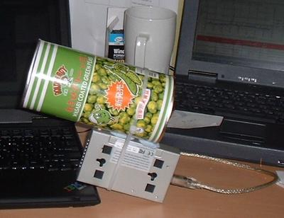
Judhi Prasetyo judhi@prasetyo.net, an IT professional in Singapore, has been putting a tincan on his USB WLAN card.

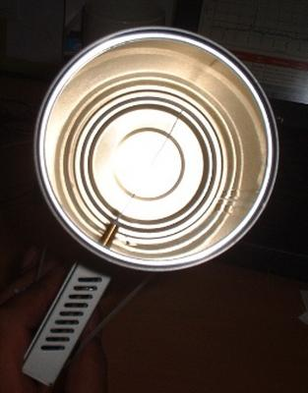
Show in the figure, the USB WLAN card is connected to his IBM laptop.USB WLAN cards have normally a small antenna sticking from it. Using such small antenna, normally about 3 dBi gain, limits the range to a maximum of around 200 meter.

He drilled a hole into a tin can and stick the small antenna of the USB WLAN card into the tin can. He has very his own tin can antenna. The advantage of putting a tin can into the small antenna is in effect aiming all the RF energy into a single direction. Thus, it can reach further distances in a single direction.

Some of us may add parabolic reflector in front of the tin can extend the distance further.

USB Parabolic Antenna
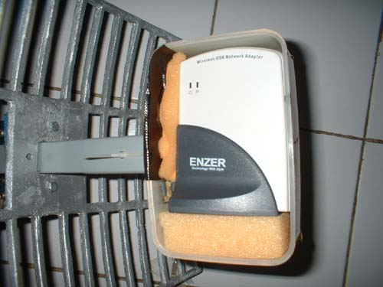
M. Ihsan ihsan@sofrecom.co.id, an IT professional in Jakarta, is building a simple parabolic antenna using a USB WLAN card.

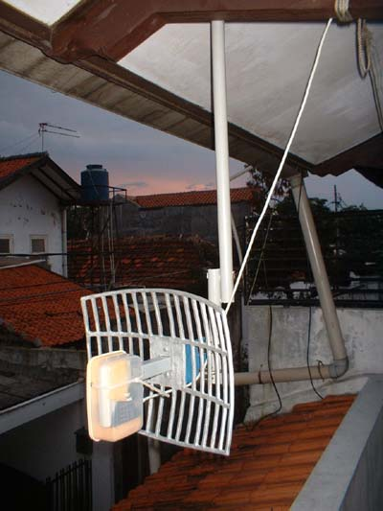
He put the USB WLAN card in front of a parabolic reflector. The USB WLAN card is put into a plastic enclosure for environmental protection.

As demonstrated in Indonesia, vocational school (high school level) students may be made these parabolic reflectors for the antenna.

Having no coaxial cable in the system as it uses USB cable to the computer, the cable loss is basically none.

For those who wish to make their own parabolic reflector, W8GVU has written a page on parabolic reflector calculation formula at http://www2.gvsu.edu/~w8gvu/geo/geo2.html.

The Famous Tincan Antenna

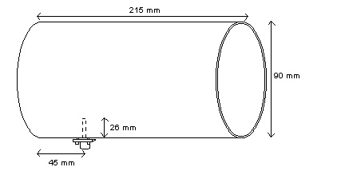
One of the famous homebrew 2.4GHz antennas is the tin can antenna. It is very easy to build and high success rate. In this particular example, the antenna is build by M. Ihsan ihsan@sofrecom.co.id.

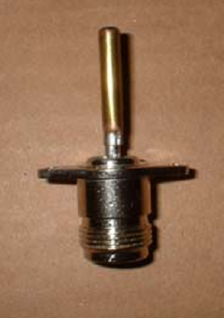Typical dimension of the tin can antenna is shown in the figure. Typical dimension of the can is about 9 cm diameter and 21 cm length. A small omnidirectional antenna about 2.6 cm length sticks into the can about 4.5 cm from the bottom of the can.

The radiator in a tin can antenna is a 2.6 cm length omnidirectional radiator. It can be build by soldering a 2.6 cm metal stick into an N-type male connector. Some people put screw sticking on the stick to tune the length of omnidirectional radiator to get the maxim match of the antenna.
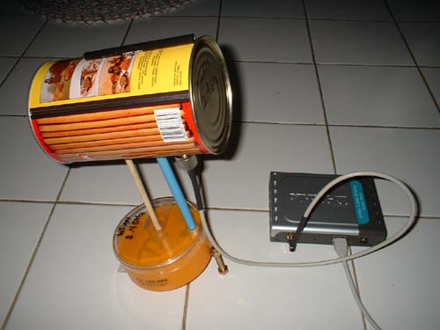

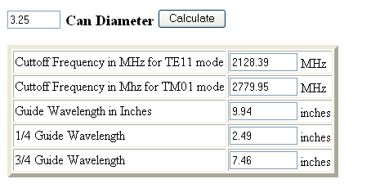

In some cases, we need to calculate the possibility to use a certain diameter tincan for 2.4GHz antenna. The calculation is provided at http://www.turnpoint.net/wireless/cantennahowto.html. Shown in the figure is the calculated result for a 3.25 inches diameter. Make sure the tincan can be operated in frequency 2.4-2.47 GHz.

Tincan Antenna Making Process

The tincan antenna making process described in this section was performed during Freifunk Wireless For Development Convention held 3-10 September 2004 in Djursland, Denmark. One can download the references to this conference from Tomas & Sebastian’s Web site http://www.thewirelessroadshow.org.

During the convention Sebastian run a session on how to build your own tincan antenna. The follows are the steps of tincan antenna making taken during the session.

Step 1


Sebastian had to shop for can juices in the store before we starts the tincan antenna making session. Thus, we have plenty of it and ready to party.

Step 2


We need to open all the cans. Well, every single one of the participants don’t mind to open the can as there will be a great incentive waiting for them.

Step 3


Ah! That’s the incentive! Food! We had a party before we need to work hard making the antenna. Not a bad idea.




Step 4

Clean up cans and make it shiny. We are ready to make the tincan antennas. All we need is the additional N-type connector. The connector is in the small plastic bag.

Step 5
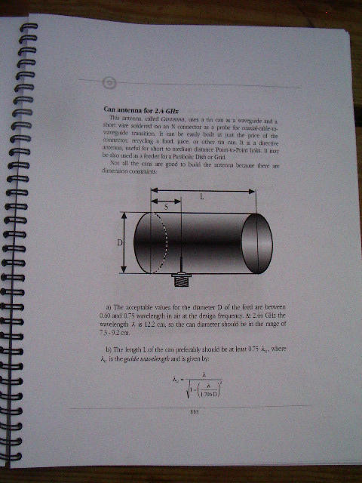
Now the brain task, we need to calculate the antenna. Use Marco & Carlo’s handbook downloaded from http://wirelesss.ictp.trieste.it.

Well, we need basically calculate the distance (S) where we will make a hole for the N-type connector on the tincan.



Step 6


Measure the location where the connector would be located and mark it.

Step 7



Nail the mark, create a hole on the connector location.

Step 8
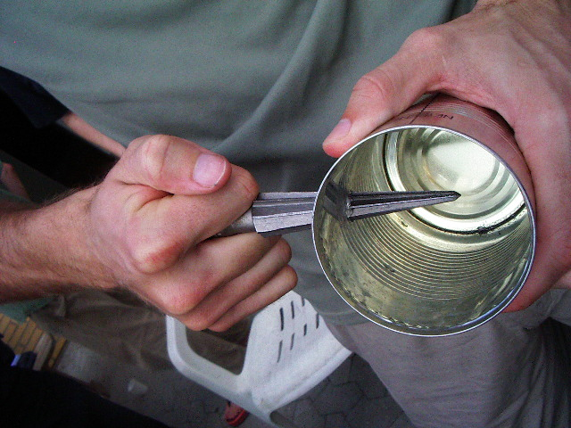
The hole created by nail is normally too small. Make the hole larger to fit the N-connector later.

Step 9



We need to find a cable and cut it to meet a quarter wavelengths in 2.4 GHz which is about three (3) centimeter.


Step 10

Solder the quarter wavelength cable to the N-type connector.

Step 11


Raida is happy holding her very first quarter wave antenna, ready to be inserted onto the can.

Step 12



Make sure it is quarter wavelength.

Step 13



Cut the quarter wavelength antenna if it is too long.

Step 14

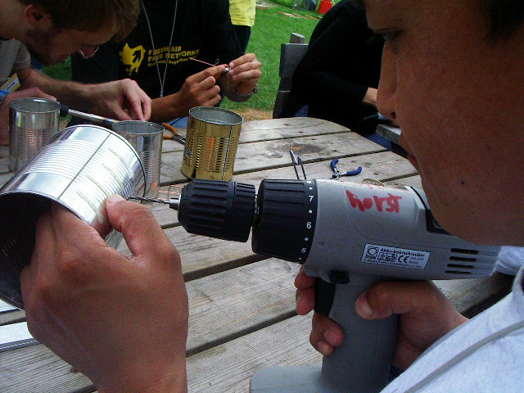

Drill four holes surrounding the bigger connector hole. It would be needed to screw then-type connector of the quarter wavelength antenna into the can.

Step 15


Screw the connector onto the can.

Step 16

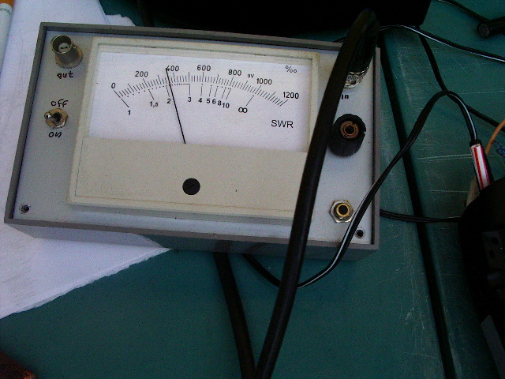

If someone has a Standing Wave Ratio (SWR) meter and a spare video amplifier, we can than measure the SWR of the antenna. A good antenna should have the SWR less than 1.5.

Step 17



Connect the antenna to the laptop via a pigtail. Marco is measuring the ability of the antenna to read far distances.



Marco is pushing the limit of the antenna. Use a used juice box instead!! Surprisingly, it works!

See the smiley face of those who make the tincan antennas …

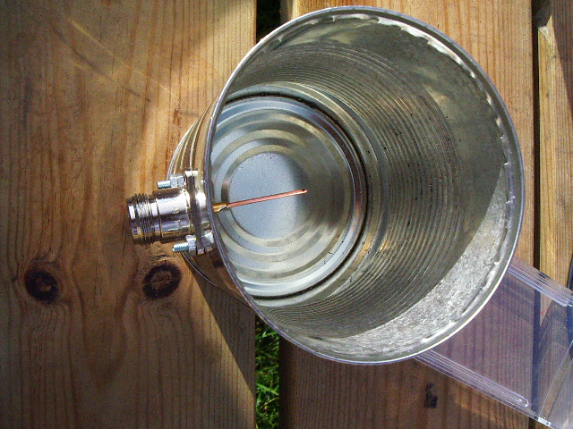
The tincan antenna …

