Site Survey Techniques & Interference Countermeasures

Site survey is the techniques to survey on the site condition to prepare the installation of the site for wireless link. One of the best-documented site survey procedure may the Waverider Site Survey Guide, WaveRider Document No. 9902VAR002 Dated 29 December 1998. Waverider http://www.waverider.com is a Toronto Canada based company.

Equipment To Perform Site Survey

List of equipment used for site survey

- Spectrum Analyzer (3GHz) if any. It is a single piece of equipment that can help the job of the surveyor. Unfortunately, it may not be affordable for most of us in developing country. Teletronics cards and software have a pretty good 2.4 GHz spectrum analyzer built into them. The cards are around US$100, and with a pigtail can be attached to external antennas. Many commercial WISPs use this as their main site survey tool.
- Laptop with PCMCI WLAN card attach to it. It is the next best thing to spectrum analyzer. It is normally affordable for most of the installer in developing countries. Some of the tools for surveying the frequency are available on PC.
- WLAN Access Point that has a site survey option in the Access Point Client mode. It exists on some Access Point & very useful for aiming the antenna etc.
- A collection of external antennas, omnidirectional and directional antennas, including pigtail and connectors.
- Strobe Light, Flashlight, Mirror, Binocular pr Telescope. Useful for evaluating Optical Line of Sight between potential sites.
- Measuring Tape, minimum 10m.
- Topographic map(s) 1:50,000 or better. In some countries, it may unfortunately be difficult find an accurate topographic map. For short distance links, it may not be necessary.
- Hand-held GPS unit, or compass. GPS is one of the most useful equipment to have during the site survey. Keep in mind that it requires sometime for GPS to get the maximum accuracy.
- Altimeter or elevation gauge, it may also be replace by some GPS, such as, GARMIN eTrex Vista.
- Safety hat.
- Ladder.

Some of Questions to Be Asked

- What are the geographic coordinates of the antenna sites?
  - A GPS may be useful to determine the coordinate of the sites, as well as determining the distance between the two. However, for short distances, it may be sufficient to estimate roughly without GPS.

- Is Line Of Sight between the antennas?
  - We must make sure no obstructions including ground in the first Fresnel Zone.

- What is the site elevation above the ground?

- Are the any objects, especially metal objects, in the vicinity of the antenna?

- Is the mechanical support for the antenna is sufficient?
  - We may face physical disturbance such as very strong wind.

- How is the path for cable UTP / coaxial run?
  - Limit UTP cable run to maximum about 150 meters. If possible put the Access Point on top of the tower to have the coaxial cable to less then one (1) meter.

- How stable the electric power supply? Do we need Uninterruptible Power Supply (UPS)?

- How easy is the access to the site? Is it 24 hours? Who has the key?

- Is the existing grounding system adequate? Should we add more grounding?

Hand Held Global Positioning System (GPS)
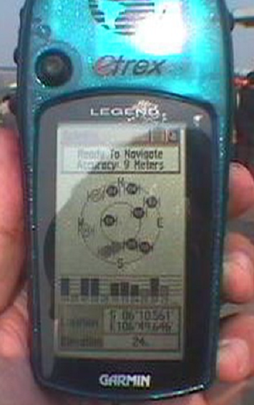
One of the most handy tool during site survey is the hand held Global Positioning System (GPS). In the picture is my handheld GARMIN eTrex Legend.

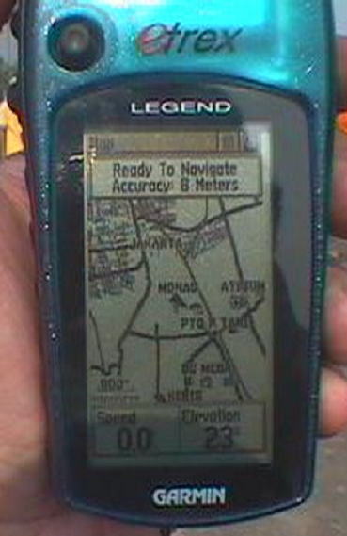The first page of the GPS is the satellite view page. In this page, we can easily find the number of GPS satellite received by the hand held GPS. Having viewed the satellite, it can then determine the coordinate as well as the elevation of our location. It will take sometimes for the handheld GPS to average the satellite signal for getting accurate reading for the coordinate. I normally have 6-12 m accuracy from eTrex Legend. For accurate elevation reading, it is advisable to use more expensive GPS equipment.

The next page is the Map View. In this page we can see the map, a two-dimension map. The Map View is designed for navigation, not much information on the elevation.

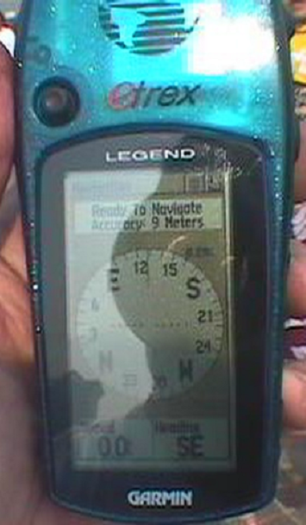
The next page is the Compass / Direction View. In this page we can check the direction of the antenna to be aim as well as the distance to certain destination / location. The destination has to be mark before we can check the direction to it.

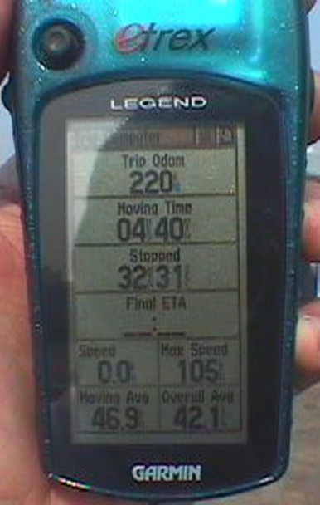

Handheld GPS such as eTrex Legend is designed to aid us during a trip. It equips with computer trip facility. We can check the trip odometer, moving time, final estimated time of arrival, maximum speed, moving average speed etc. It may not be useful for telecommunication site survey. It is fun to use though.

Site Survey Software on PC

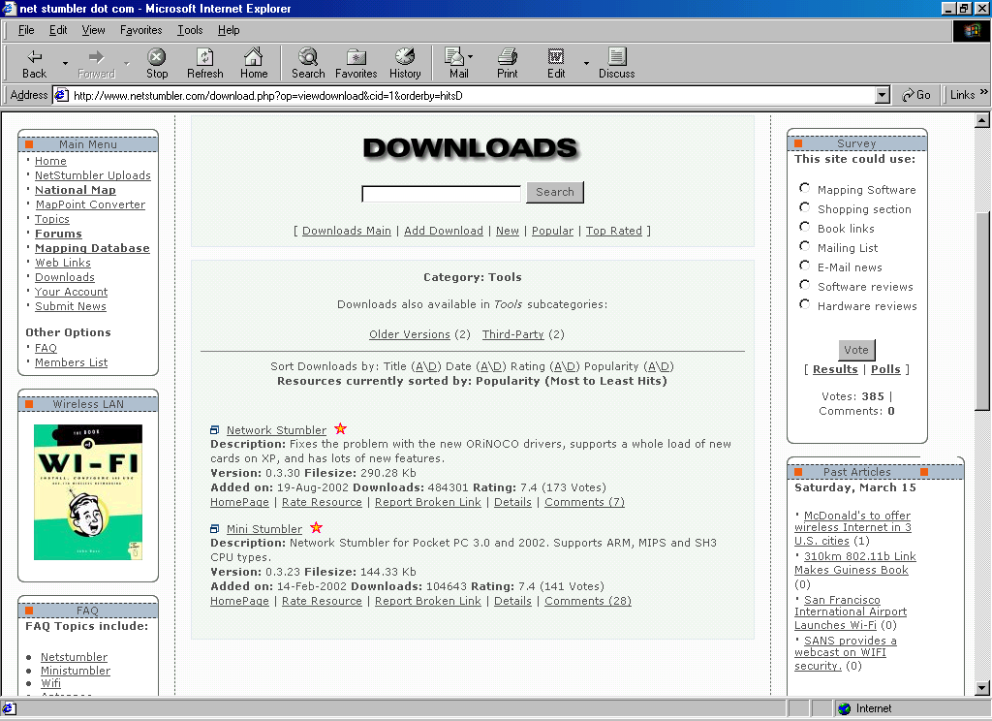
Not having a Spectrum Analyzer for most of us in developing countries is not really a disability. We normally uses our laptop equipped with PCMCIA WLAN card to do some of site survey function.

One of the favorite software to do the site survey on PC is the NetStumbler. It can be downloaded for free from http://www.netstumbler.com.

NetStumbler http://www.netstumbler.com is also hosting the survey result from various people to share the information on hostspots in their area.

Installing the software is quite straight forward as other Windows software. Clicking next button, and finish will do the job. You’ll be ready to do the site survey using netstumbler.
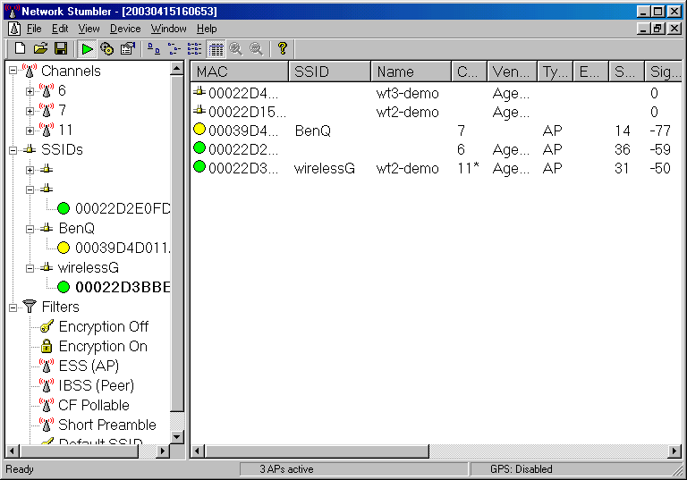
To do the site survey on NetStumbler is quite straightforward. Clicking the NetStumbler icon on desktop will immediately scan the frequency to see the available station, Access Point on the frequency.
NetStumbler will report on:

- MAC address of Access Point operating on the frequency.
- Record type of equipment used at the Access Point.
- Record the channel used by the Access Point.
- Record the ESSID of the Access Point if broadcasted.
- Record name of the Access Point if broadcasted.
- Record the signal received from the Access Point; it also give marks on the signal received; green means good level, yellow means low signal.
- Level of noise.
- Received signal to noise ratio, we need to have a highest possible signal to noise ratio.
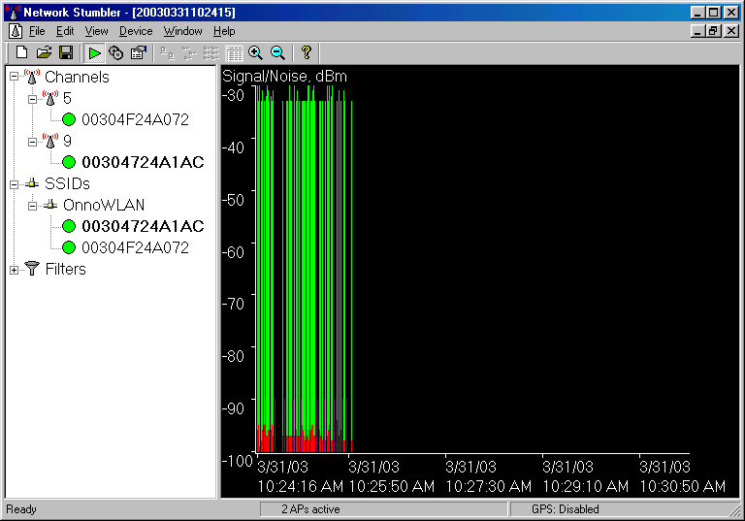
Clicking the MAC address of certain Access Point, we may see the recorded Signal (green) and noise (red) received by the card. We can see clearly the history of the signal for period of time. Such measurement is very useful for,

- Aiming the antenna.
- Checking if there is any problem with the connector.
- High level of noise means there are source of interference near by.

In most cases, we will survey the site using both omnidirectional and directional external antennas. We need to aim the antenna to all directions, not only to the direction of the remote station. We need to scan the channel for both vertical polarization as well as horizontal polarization of the antenna. All are done to approximate any possible interference to our communication links.

Major problem we have to face for not having any spectrum analyzer is inability to see what happens on the frequency as the PCMCIA WLAN card can only monitor those who transmit using IEEE 802.11 standard. We can only have some estimate on the condition through the noise received by the card.

Interference Countermeasures

One challenge that we will eventually face when operating WiFi outdoor infrastructure is in minimizing the throughput-reducing effects of interference and noise.

A strong signal is not enough for a broadband wireless receiver to work reliably. The level of received signal must be consistently higher than the received noise. The signal to noise ratio (SNR) must be as high as possible. To have a high SNR, there are two (2) simultaneous conditions to be met, i.e,

- The receiver must receive a signal that is above the receiver sensitivity.
- The noise level at the receiver input must be lower than the desired incoming signal. Noise is defined as “everything other than the desired signal”.

Fail to simultaneously meet these two (2) conditions will result in a low SNR.

Maximizing the Received Signal Level
We have direct control to maximizing the received signal. Some of the standard procedures are,

- Link budget – enough transmit power, receiver sensitivity, fade margin, and antenna gain to overcome free-space loss and the coax loss.
- Line-of-sight (LOS) – LOS path with an unobstructed view from end to end.
- Fresnel zone – enough clearance above and between path obstacles.
- Installation – makes sure the antenna is mounted securely, aligned properly, connectors waterproofed, use a good connectors (don’t use cheap connector & coax).

Minimizing the Interference and Noise Level
We normally don’t have that much control on noise and interference sources. Some of the noise sources are,

- Natural noise – atmospheric and galactic noise.
- Manmade noise - RF signal pick up by our antenna. This includes microwave oven, cordless telephone and indoor wireless LAN.
- Receiver noise – noise generated inside the receiver circuitry.
- Interference from other networks – interference caused by nearby wireless networks on the same band.
- Interference from our own network – occurs when we use the same frequency more than once, using channels that do not have enough space between them, or selecting incorrect frequency-hopping sequences.
- Interference from out-of-band signals – caused by strong nearby signal outside of the frequency band that we are using, such as, AM, FM and TV transmitters, pagers, two-way radios.

Interference Countermeasure Strategies
Some of the typical interference countermeasure strategies are as follows,

  - Use sectoral or narrow beam antennas, usually high gain antennas. It is the easiest and most effective way to reduce interference, especially in spectrum crowded areas..
  - Short paths
  - Frequency selection where not much stations using it.
  - Changing antenna polarization.
  - Adjusting antenna azimuth
  - Equipment/Antenna location.

