NoCat Authentication System

Captive Portal Concept

Captive portals are becoming a popular way for community WiFi infrastructure and hotspots operators to provide user authentication and IP flow management, e.g., basically traffic shaping and bandwidth control, without a special client application. Captive portals allow us to use a traditional Internet browser as a secure authentication device. Captive portals also have the potential to allow us to do everything securely via SSL and IPSec and setup per user quality of service rules, and still maintain an open network. Thus, the basic idea behind a captive portal is fairly straightforward. Rather than rely on the built-in security features of 802.11b to control who can associate with an Access Point, we configure the access point with no WEP, and as an open network. The Access Point is in bridged mode, and connected via a crossover cable to an ethernet card on a Linux router. The router may issue DHCP leases, throttle bandwidth, and permit access to other networks.

When a user attempts to browse to any web page, captive portals will force un-authenticated users to an Authentication web page that presents the user with a login prompt and information about the node they are connected to. If the wireless gateway has a method of contacting a Authentication server to determine the identity of the connected wireless user, then the gateway may relax its firewall rules appropriately, allowing the privileges to that user, e.g., more bandwidth or access to other machines and ports.


In this chapter, NoCatAIuth http://nocat.net, a third party authentication system will be described. NoCatAuth is written in Perl and C, it takes care of presenting the user with login prompt, contacts a user database, such as, MySQL database or password file, to lookup user credentials, securely notifies the wireless gateway of the user's status, and authorizes further access. In the gateway side, the software manages local connections, sets bandwidth throttling and firewall rules, and times out old logins after a user specified time limit. The software is released under the GPL.

The NoCatAuth package is comprised two (2) major components: a centralized Authentication system and any number of wireless gateways that communicate with the Authentication system. NoCat is visionary in becoming the credential backbone behind community wirelesss networks. A community group may maintain NoCat user database. NoCat seems actively work to integrate a single shared membership database for the various wireless groups that have expressed an interest in participating. Those who are interested in roaming agreements with other community wireless group may drop a mail at authservice@nocat.net.

NoCat is not the only open source Authentication system. A list of open source captive portal software can be obtained from http://www.personaltelco.net/index.cgi/PortalSoftware. Some of them are,

- NoCatAuth (http://nocat.net/download/NoCatAuth/). It is my favorite captive portal package. It is written in perl, supports Linux/iptables and OpenBSD/pfctl. It is GPL-ed. It supports authenticating modes against an authentication service with a wide variety of backends, including a MySQL database, PAM, RADIUS, LDAP, and more. Also features a non-authenticating "open mode" that merely requires a user to accept an AUP before they can log in.
- NoCatSplash (http://nocat.net/download/NoCatSplash/). It is written in C. It is intended to be the successor to NoCatAuth, the gateway process and all its data files fit within 200-250k, making it ideal for embedded environments.
- Opengate developed at Saga University (Japan) (http://www.cc.saga-u.ac.jp/opengate/index-e.html). It is GPL-ed, runs on FreeBSD. Uses a Java applet to keep the connection open.
- WiCap (http://www.geekspeed.net/wicap/) by BrianCaswell. It is written in Perl and runs under OpenBSD.
- StockholmOpen by the Royal Institute of Technology in Stockholm, Sweden (http://software.stockholmopen.net/index.shtml). This system is also operator neutral, allowing different users to connect through the access network to different upstream providers. Implementation in C, uses PAM, Linux/FreeBSD. BSD License.
- OpenSplash by Aleksandr Melentiev from San Francisco Wireless (http://opensplash.qalab.com/) it was inspired by the simplicity of wicap, intended to run on FreeBSD by utilizing Perl and ipfw.

A good tutorial on installing an Authentication gateway is written by Nathan Zorn, “Authentication Gateway HOWTO” (http://www.itlab.musc.edu/~nathan/authentication_gateway/). It uses a PAM LDAP module to insert an iptables rule.

Typical Connection Process
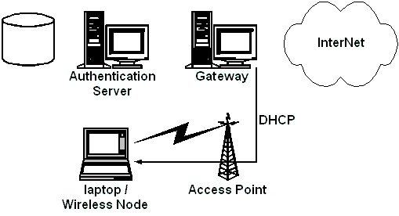
A roaming user associates with the AP. The wireless user issues a DHCP request. The gateway (or the Access Point) is immediately issued a DHCP lease and assigned an IP address. All un-authenticated IP's are firewalled so they can only talk on the local segment. All access beyond contacting the Authentication service is denied by default.

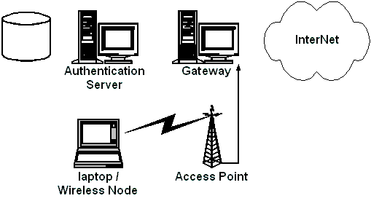
As soon as the roaming user opens their browser they will be immediately redirected to the gateway service.

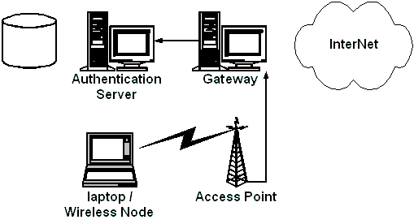
The gateway service then redirects them to the Authentication system's SSL login page after appending random token and some other information to the URL line.

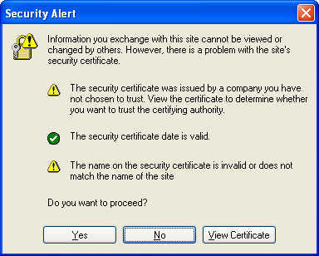

A registered SSL certificate is required in production, as the whole security of the system depends on it. A non-registered certificate would result in a Security Alert and may allow someone to spoof the Authentication service. During experiment, we may press “Yes” button at Security Alert to proceed.
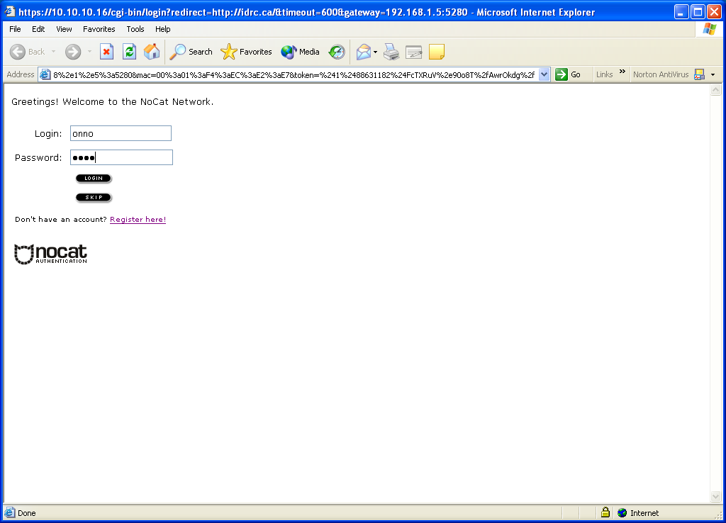
The user is then presented with three (3) choices: either login with their pre-arranged login information, click on a link to find out more about membership, or click the "Skip Login" button. For login into the infrastructure, the Authentication server authenticates them against some form of user database (LDAP, radius etc).

Once the user has either logged in correctly or skipped the process, the Authentication system then creates an outcome message, signs it with PGP, and sends it back to the wireless gateway. The gateway has a copy of the Authentication service's public PGP key, and can verify the authenticity of the message. As part of the data included in the response is the random token that the gateway originally issued to the client, it makes it very difficult to fake out the gateway with a "replay attack". The digital signature prevents the possibility of other machines posing as the Auth service and sending bogus messages to the wireless gateway.
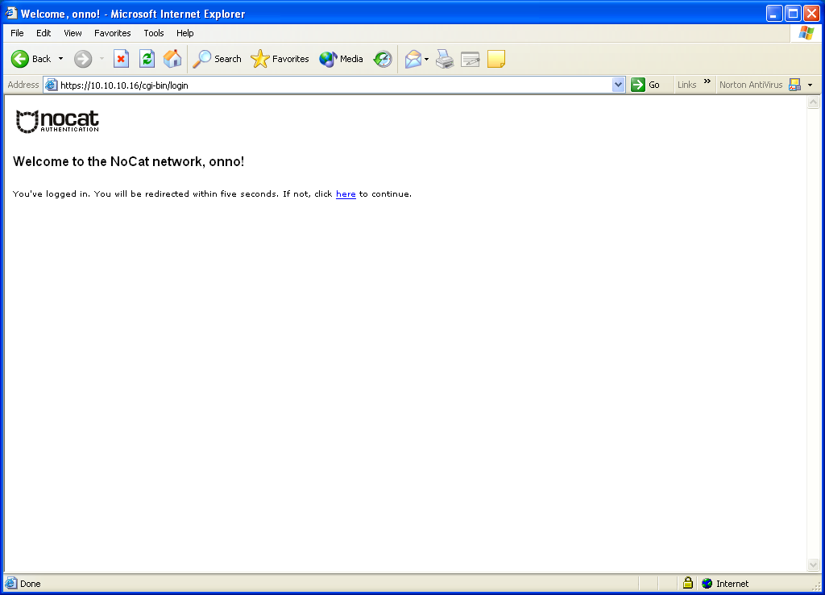
Now, if all has gone well for the user, the wireless gateway modifies its firewall rules to grant further access, and redirects the user back to the site they were originally trying to browse to.

IP security is a complicated enough already. NoCat adds to the complexity by introducing dynamic firewall rules triggered by anonymous wireless users. Isolating our wireless system from the rest of our network may minimize the security risk.

The gateway has the options to set QoS routing rules so that they get provisioned a certain amount of bandwidth, e.g., local users might get more than roaming registered users, who in turn might get more then unknown guest users.


The user can now use the infrastructure. Once every X hours/days the portal goes through its list of all the IP's allowed through the firewall, i.e., authenticated users, and checks to make sure that they are still allowed access:

- If they are, great carry on.
- If they aren't, remove their access. The next time that user wants access they will hit the portal again and have to log in.

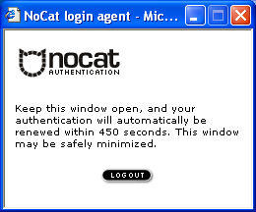
In order to keep the connection open, a small window is opened on the client side (via JavaScript) that refreshes the login page every few minutes.

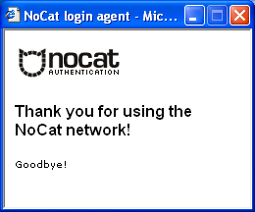
Once the user moves out of range or click the “Logout” button in NoCat login agent, the connection is reset and requires another manual login.

Software Requirement

Download Nocat
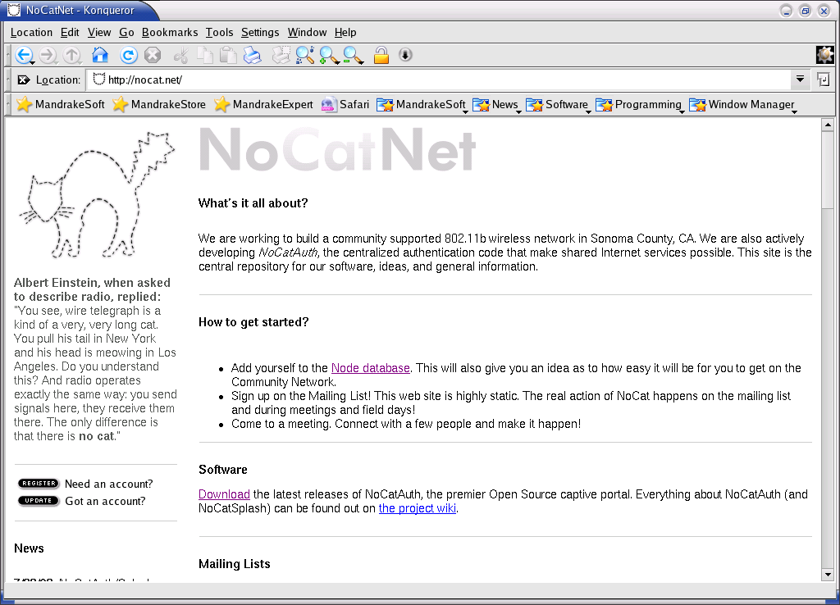
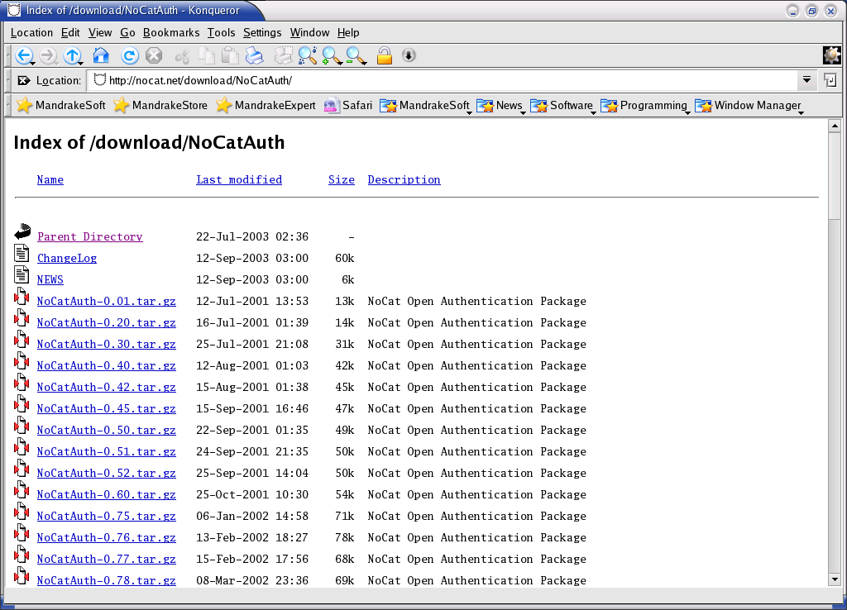
We will definitely need NoCat Authentication System. The NoCatAuth system is currently under active development. We may always get the latest version from http://nocat.net.

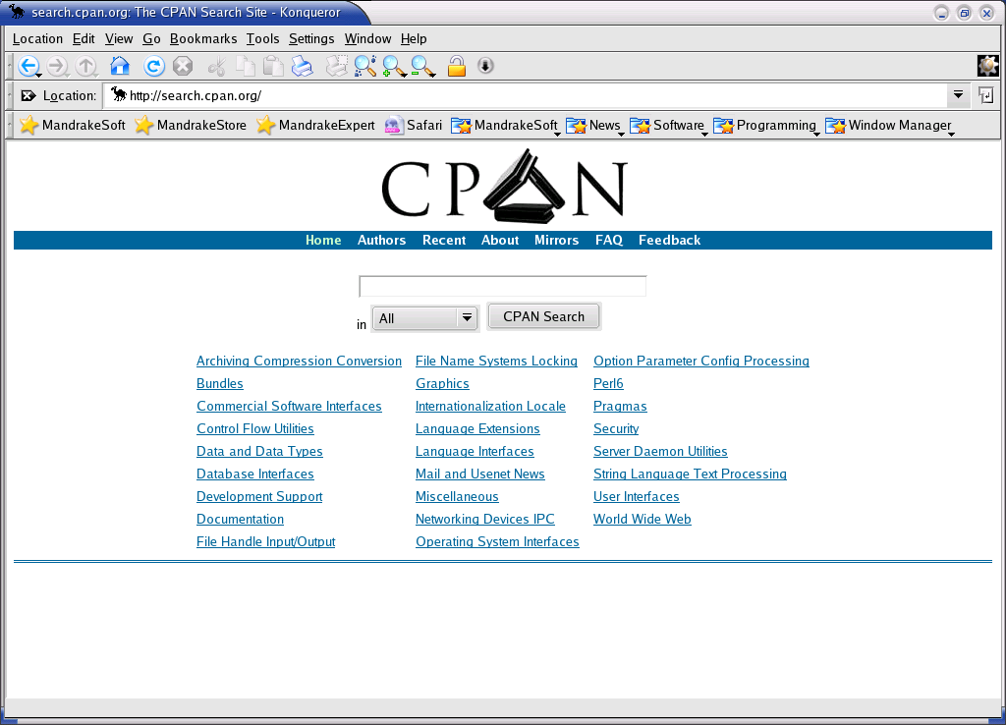
I am using Linux Mandrake 9.1 for the experiment. It has most of the required software readily installed for Gateway and Authentication service operation. For Authentication Server, some Perl scripts, such as Net::IMAP:Simple.pm and Net::Netmask.pm, need to be downloaded from CPAN http://seach.cpan.org.

Gateway Software Requirement

- Linux 2.4.x with iptables. It is readily available in Linux Mandrake 9.1.

- gpgv, a PGP signature verifier. gpgv comes with the gnupg package, which can be downloaded from http://www.gnupg.org/download.html It is readily available in Linux Mandrake 9.1.

- We may want to run dhcpd on the gateway machine else the Access Point or other DHCP server on the local network may do the job.

- If we want to try the bandwidth throttling rules, we'll also need a copy of the 'tc' tool from the iproute2 package. Get it at ftp://ftp.inr.ac.ru/ip-routing/

- Optionally and recommended, a local caching DNS server.

Authentication Server Software Requirement

- An SSL enabled webserver. Apache + mod_ssl is normally used in Linux Mandrake 9.1. In production system, it is preferably with a registered SSL certificate.

- Perl 5 (5.6 or better recommended). It is readily available in Linux Mandrake 9.1.

- Digest::MD5, DBI, and DBD::MySQL perl modules. It may be downloaded from CPAN. It is readily available in Linux Mandrake 9.1.

- Gnu Privacy Guard (gnupg 1.0.6 or better), available at http://www.gnupg.org/download.html. It is readily available in Linux Mandrake 9.1.

- For simple Authentication process, we can use local password file as an authentication source. However, if we want to participate in roaming agreements with other wireless groups, an MySQL 3.23.4x or better would definitely be necessary. NoCatAuth is also working on the use other authentication sources, such as, Radius, PAM, LDAP etc.

A registered SSL certificate is required in production, as the whole security of the system depends on it. It can be done after getting all the above installed and running first. Alternatively, we may copy the Authentication server certificate to all clients ahead of time.

Gateway Installation

The NoCat gateway software is designed to run on a very modest harware. A 486/50
with 32 MB ram should be plenty. A quick installation may follow,

$ su -
# tar zvxf NoCatAuth-x.xx.tar.gz
# cd NoCatAuth-x.xx
# make gateway
# cd /usr/local/nocat
# vi nocat.conf
# bin/gateway

As the gateway is running, we will see something like

[2003-09-28 08:38:27] Resetting firewall.
[2003-09-28 08:38:27] Binding listener socket to 0.0.0.0

Detailed Gatekeeper Installation

The gateway is designed to run on a standalone machine. The gateway process will overwrite any previously defined firewall rules when it starts. Please consider running the gateway on a dedicated machine before simply installing it on your existing firewall.

- Running a gateway requires root permissions.

- Unpack the NoCatAuth tarball.

$ tar zvxf NoCatAuth-x.xx.tar.gz

- The default installation path is /usr/local/nocat, we may change it through INST_PATH parameter in Makefile if necessary.

- From the NoCatAuth directory, run 'make gateway'. This will install the gateway software.

- Edit the /usr/local/nocat/nocat.conf file to suit. These parameters are required:

- InternalDevice must be set to the interface name of our wireless card, or the ethernet card that talks to our Access Point.

- ExternalDevice must be set to the name of the network interface that talks to the Internet. It can an ethernet card connected to the DSL or cable modem, or dialup device: eth1, ppp0, etc.

- LocalNetwork needs to be set to the network address and mask of internal (wireless) network. This typically takes the form 111.222.333.444/255.255.255.0, or 11.22.33.44/24, etc.

- DNSAddr needs to be set to the same domain name server address that your DHCP server hands out, if and only if we are using a DNS outside our LocalNetwork. In the case, we are running a caching DNS server on the gateway or anywhere else on the wireless network; we can leave this option commented out.

- GatewayMode toggles between Open, Passive and Captive mode. No authentication in an open gateway settings.

- AuthServiceAddr, AuthServiceURL, and LogoutURL depend on our chosen authentication service assuming we use Passive or Captive GatewayMode.

- IncludePorts and ExcludePorts can be set to restrict TCP ports that public users can access, e.g., to disallow email traffic.

Starting the gateway

From a root prompt, starting the gateway is as simple as

# /usr/local/nocat/bin/gateway
or
# /path/to/nocat/bin/gateway

We need to run NoCat gateway as root to be able to update the firewall rules as needed.

To start the gateway service automatically at boot time, check out the etc/nocat.rc script. Install it by copying it to /etc/rc.d/init.d, and either add a call to it in your rc.local, or symlink it to your runlevel, like this:

# ln -s /etc/rc.d/init.d/nocat.rc /etc/rc.d/rc3.d/S99nocat

Running /bin/gateway as root may give a message like,

[2003-09-28 08:38:27] Resetting firewall.
[2003-09-28 08:38:27] Binding listener socket to 0.0.0.0

Congratulations. The gateway should be running.

Some times we have problems in running NoCat especially if installed in non-standard NoCat directory, i.e., /usr/local/nocat. NoCat needs to know the location of (a) its perl libraries, and (b) its nocat.conf configuration file.

If a non-standard directory is used, nocat.conf configuration should be correctly done else we may add PERL5LIB and NOCAT variables to the shell environment before running the gateway script, such that,

$ export PERL5LIB=/path/to/nocat/lib:$PERL5LIB
$ export NOCAT=/path/to/nocat/nocat.conf

In Linux Mandrake, the utilities like iptables, modprobe, and gpgv are normally already in $PATH. If they aren’t in the $PATH, we can add it as follows,

$ export PATH=$PATH:/sbin:/usr/sbin:/usr/local/sbin

Configure the DHCP Server at The Gateway

Some of us may like to run a DHCP server at the Gateway. The configuration file of DHCP server can be found at /etc/dhcpd.conf. A sample of configuration of a DHCP server to provide IP address in the range of 192.168.1.110-192.168.1.155 is shown below,

ddns-update-style none;
subnet 192.168.1.0 netmask 255.255.255.0 {
option broadcast-address 192.168.1.255;
# default gateway
option routers 192.168.1.5;
option subnet-mask 255.255.255.0;
option domain-name-servers 10.2.2.3,10.2.2.4;

range dynamic-bootp 192.168.1.110 192.168.1.155;
default-lease-time 21600;
max-lease-time 43200;
}

Having the DHCP server configured, we need to start the DHCP server automatically at boot time. In Linux Mandrake, it can be done through,

# chkconfig dhcpd on
# service dhcpd start

Make sure that our dhcp server hands out the same DNS address listed in nocat.conf (if we're using external DNS). Otherwise, our wireless clients won't be able to resolve hostnames.

Authentication Server Installation

Authentication server installation is only needed if we really want to run our own network. However, for community WiFi infrastructure, NoCat provides NoCat’s public authentication service at auth.nocat.net.

Quick Installation

For those who likes to see the quick installtion process, as follows,

$ su -
# tar zvxf NoCatAuth-x.xx.tar.gz
# cd NoCatAuth-x.xx
# make authserv
# make pgpkey
# cd /usr/local/nocat
# vi nocat.conf
# chown apache.apache /usr/local/nocat/pgp
# chown apache.apache /usr/local/nocat/pgp/*
# vi /etc/httpd/conf/httpd.conf
# service httpd restart

Note that there is no script to execute, all we need is to restart the Web server.

Detailed Installation

The Authentication server is designed to run on a standalone machine. The installation process is as follows,

- Unpack the NoCatAuth tarball.

$ tar zvxf NoCatAuth-x.xx.tar.gz

- The default installation path is /usr/local/nocat, we may change it through INST_PATH parameter in Makefile if necessary.

- From the NoCatAuth directory, run 'make authserv'. This will install the Authentication service.

- Run 'make pgpkey'. The defaults should be fine for most purposes. To avoid any strange messages from the auth service attempts to encrypt messages, it is important not to enter passphrase during ‘make pgpkey’.

- Edit the /usr/local/nocat/nocat.conf file to suit. These parameters are required:

DataSource: Currently, must be DBI or Passwd. Use DBI for MySQL, or Passwd for local file-based authentication.

If you're using DBI, then 'Database', 'DB_User', and 'DB_Passwd' are required. Database can be set to a full dbi string, like this:

dbi:mysql:database=nocat;host=my.dbhost.net

DB_User and DB_Passwd define the db user's name and password, respectively.

If you're using Passwd as a DataSource, 'UserFile', 'GroupUserFile', and 'GroupAdminFile' are required. The default path should be OK.

- Create your authentication source, and add some users.

DBI: First, make a new database (with 'mysqladmin create nocat', for example.) Then, import the table schemas from etc/nocat.schema, like this:

$ mysql nocat < etc/nocat.schema

This should run without error. If not, make sure that you specified the proper host and user info; otherwise check your mysql installation. Then run bin/admintool to create new users and group admins.

Passwd: Default (empty) password files have been provided. Simply run bin/admintool to create new users and group admins.

- LocalGateway should be set to the gateway IP address if we intend to run the Authentication service on the same subnet or the same machine. This option requires the Net::Netmask perl module available from CPAN (http://www.cpan.org).

- We need to make sure that /usr/local/nocat/pgp and pgp/* owned by the user that the web server runs as. In Linux Mandrake 9.1, the Apache is run under user ‘apache’ and group ‘apache’.

# chown apache.apache /usr/local/nocat/pgp
# chown apache.apache /usr/local/nocat/pgp/*

Other Linux distribution may be 'www', or sometimes 'nobody'.

- We need to add the Authentication service Web configuration into Apache configuration. The example of a complete Authentication Web service configuration is shown at the end of this section. We may need to check the path and IP addresses to suit our settings. In Linux Mandrake 9.1, the configuration may be added into

/etc/httpd/conf/httpd.conf
or,
/etc/httpd/conf/vhost/Vhost.conf

- Copy /usr/local/nocat/trustedkeys.gpg to all the gateways (/usr/local/nocat/gw/pgp). If we don’t do this, the Authentication will loop and we’ll get 'Bad authentication message' in the gateway logs.

- Restart the Apache web server

# service httpd restart

That's it. Check your logs, take your time, and have fun. If you're running your own service, you should definitely join the NoCat mailing list. Details are online at http://nocat.net/.

Added Apache Configuration for the Authentication Service

NameVirtualHost *
<VirtualHost 10.10.10.16:443>
DocumentRoot /usr/local/nocat/htdocs
# ServerName localhost:443
# ServerAdmin root@localhost
SSLEngine On
SSLCertificateFile /etc/ssl/apache/server.crt
SSLCertificateKeyFile /etc/ssl/apache/server.key
Options FollowSymLinks Includes Indexes MultiViews

ScriptAlias /cgi-bin/ /usr/local/nocat/cgi-bin/

<Directory "/usr/local/nocat/htdocs">
AllowOverride All
Options FollowSymLinks Includes Indexes MultiViews
<Limit GET POST OPTIONS PROPFIND>
Order allow,deny
Allow from all
</Limit>
<LimitExcept GET POST OPTIONS PROPFIND>
Order deny,allow
Deny from all
</LimitExcept>
</Directory>

<Directory "/usr/local/nocat/cgi-bin">
AllowOverride All
Options ExecCGI
<IfModule mod_access.c>
Order allow,deny
Allow from all
</IfModule>
#
# $PERL5LIB tells Perl where to find the NoCat libraries.
SetEnv PERL5LIB /usr/local/nocat/lib
#
# $NOCAT tells NoCat where to find its configuration file.
SetEnv NOCAT /usr/local/nocat/nocat.conf

SSLOptions +StdEnvVars
</Directory>

<IfModule mod_setenvif.c>
SetEnvIf User-Agent ".*MSIE.*" nokeepalive ssl-unclean-shutdown \
downgrade-1.0 force-response-1.0
</IfModule>

<IfModule mod_rewrite.c>
RewriteEngine On
RewriteOptions inherit
</IfModule>

</VirtualHost>

Running Authentication Server on Gateway Machine

It is not recommended to run a gateway and an Authentication service on the same machine. A gateway allows anonymous, non-present people to interact with the Authentication server. Authentication service carries sensitive information like password and private keys. There is no place on a gateway that passing public traffic for such sensitive information.

NoCatAuth may run both gateway and authentication service on the same machine in separate different home directories, e.g., /usr/local/nocat/authserv and /usr/local/nocat/gateway. Without modifying the Makefile, we can do something like,

$ make PREFIX=/usr/local/nocat/gw gateway
$ make PREFIX=/usr/local/nocat/authserv authserv
$ make PREFIX=/usr/local/nocat/authserv pgpkey
$ cp /usr/local/nocat/authserv/trustedkeys.gpg /usr/local/nocat/gw/pgp

Once everything is configured, we can start the gateway by running /usr/local/nocat/gw/bin/gateway.

The NoCat Database
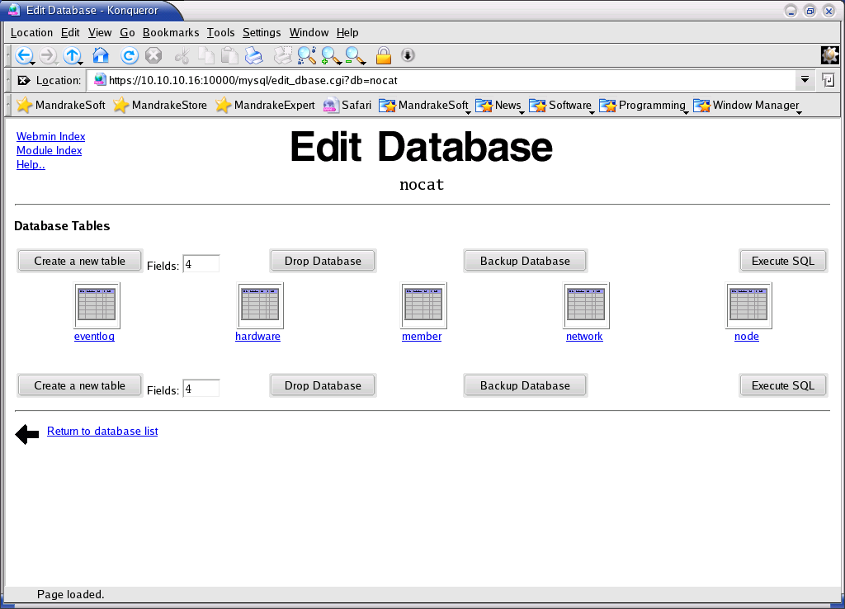
For those of us who use MySQL database as the Authentication database, we need to see or may be modify the database if needed.

In Linux Mandrake, it can easily be performed using Webmin. The NoCat database in MySQL can be access through,

https://auth-server-ip:10000 → Servers → MySQL → nocat

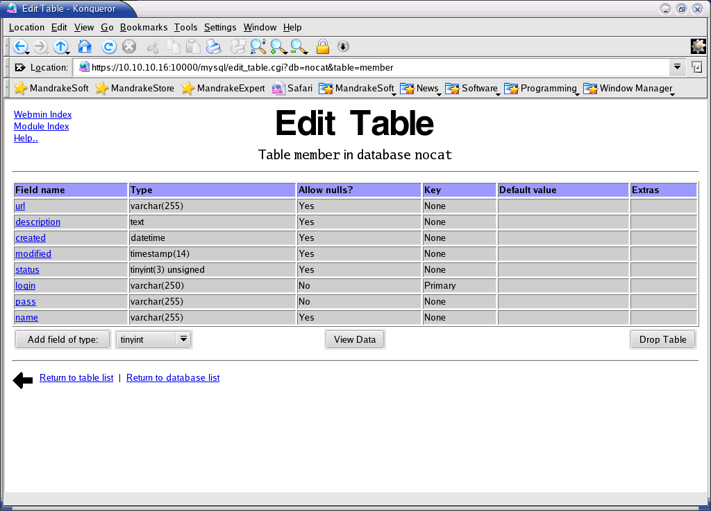
We will see several tables in nocat database, such as,

- Eventlog
- Hardware
- Member
- Network
- Node

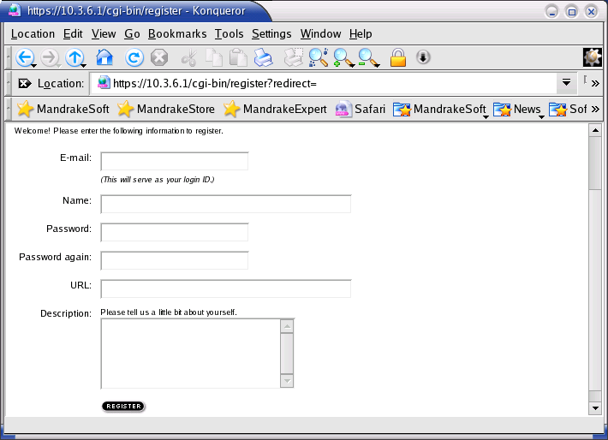
The member list is available in member database. It store several member information in its table, such as, url, description, created, modified, status, login, pass, and name. To see and modify the data it can be done through “View Data” menu at Edit Table.
In Nocat, the registration process can be done through a Web interface.

Shown in the figure is the typical view of table data. We have several options to work with the table data, such as, edit selected row, add row or delete selected row.
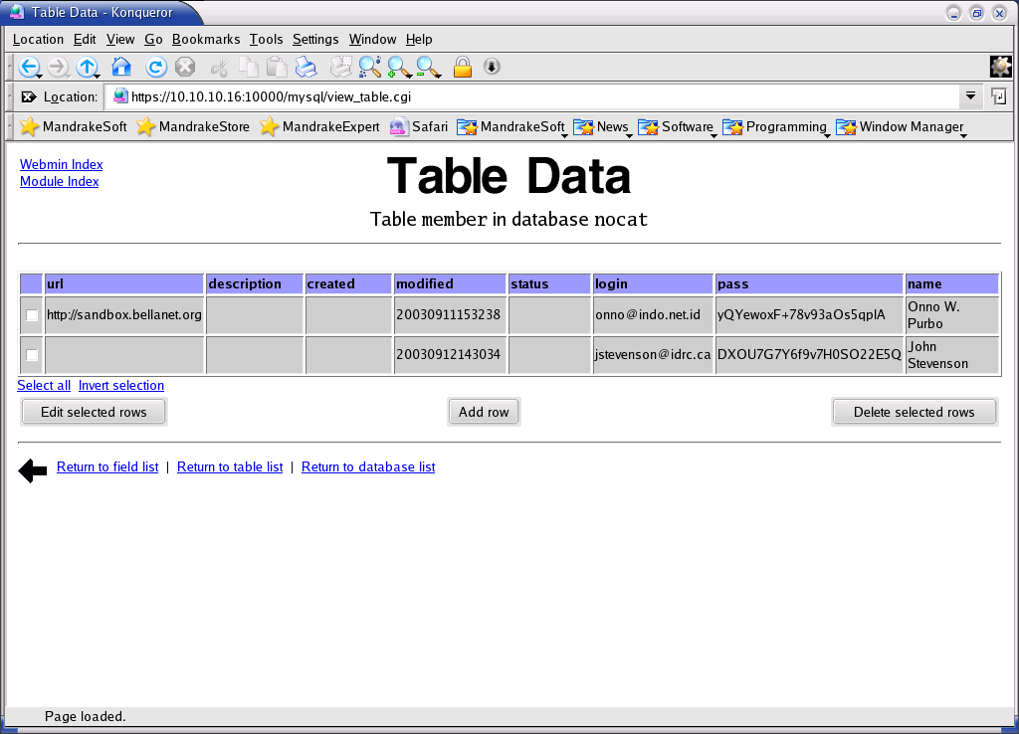

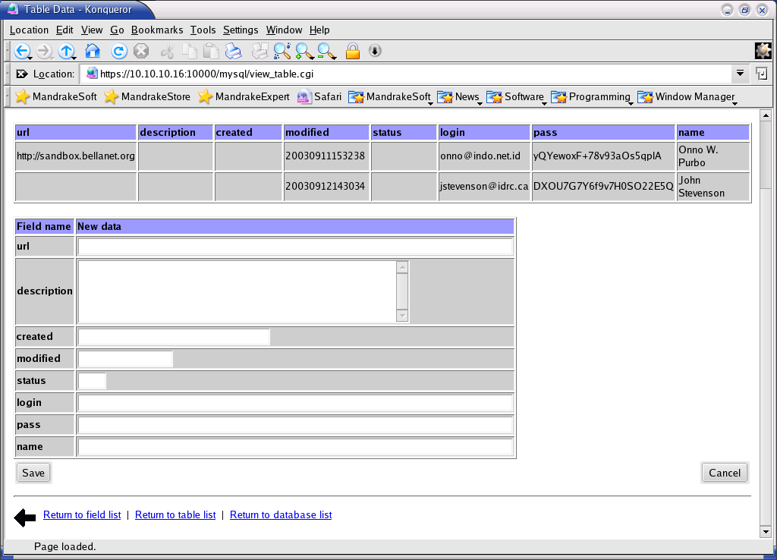
After clicking “Add row”, we can add new data into a table. Shown in the figure is the captured screen for adding new member entry to the table data.

