WiFi based Wireless Internet Infrastructure: An Overview

WiFi (Wireless Fidelity) is basically a generic term for wireless LAN equipments, also known as WLAN. It normally confirms the standard IEEE 802.11 family and, thus, supported by many vendors.

Why WiFi based Wireless Internet Infrastructure? There are few simple answers, i.e.,

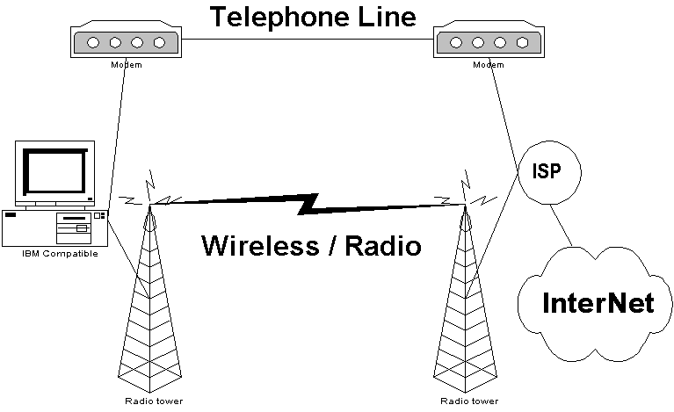
- Wireless for bypassing the need of costly & slow telephone line for accessing the Internet.
- Wireless is easy to deploy. It requires a much lower cost in the long run, rather than rely on Telco’s infrastructure.
- WiFi is basically a Wireless LAN and, thus, it runs at higher speed 1-11Mbps if the standard IEEE 802.11b is used.
- Since IEEE 802.11b is an open standard, WiFi equipments can be obtained easily in the market. Today, it costs only about 3-4 times a UTP LAN cards & going down.

Having last mile telecommunication infrastructure solved, next best thing to do is sharing the access to the surrounding neighborhood & share the access fee to reduce the cost per subscribers.

Some of the Basic Assumptions

Knowing that WiFi equipment has a limited communication range about 5-8 km due to its low power, some basic assumptions imposed, e.g.,

- It is basically to by pass last mile Telco infrastructure, about 5-8 km distance.
- The Access Point may be located at Internet Service Provider (ISP).

As for the Internet Service Provider (ISP), their Internet links may use different telecommunication media especially for long distance links. Some of the examples as

- Optical fiber.
- Microwave links.
- VSAT links.

WLAN Equipments for Outdoor usage.

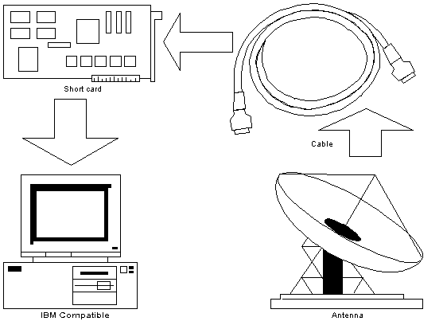
In some cases, the installation configuration can be varied quite significantly. Basically, we need four (4) major items to install WLAN for bypassing last mile Telco’s infrastructure, i.e.,

- PC router, it can be a Pentium I or Pentium II 64Mbyte RAM with Linux operating system for a more robust condition.
- WLAN Card, some people are using a PCI card with external antenna connector. For a much cheaper solution, my friends, such as sumaryo@netadsl.net, are using USB WLAN card with built-in antenna. Please note that not all WLAN card are suitable for outdoor use, some 3COM cards & Compex with no external antenna connection would be difficult for outdoor applications.
- Those who use PCI card with external antenna connector will require a pig tail and coaxial cable to connect the PCI card to external antenna. It would be much cheaper for you to use USB WLAN card, as these coaxial cables and expensive pig tail is no longer necessary. The total coaxial cable length should be kept short a RF signal loss at the coaxial cable may quite severe at such high frequency. We normally retain our coaxial cable less than 10 meters.
- An external antenna is needed for extending your communication distances. There are many 2.4GHz options. What you need is basically an external 2.4GHz antenna. If you wish to build your own 2.4GHz antenna, checking http://www.google.com and putting “Homebrew 2.4GHz antenna” may give a significant number of sites that gives you the requires knowledge on building your very own 2.4GHz antennas.

For those who use a USB WLAN card with built-in 2.4GHz antenna, you may need to do several things to make your distance longer, i.e.,

- Make your USB WLAN card weatherproof.
- Make your USB cable weatherproof.
- Put your USB WLAN card in front of a parabolic reflector for higher antenna gain. You may use a used small parabolic reflector that normally used in satellite cable TV or you may build your own.

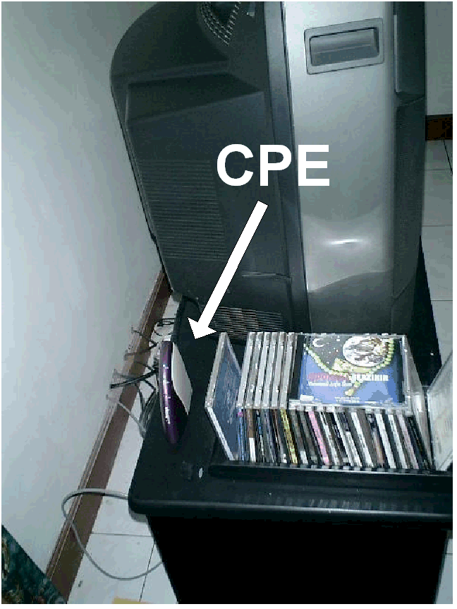
Some of us may not have the entire patients to build their own WiFi gateway from scratch. As shown by my colleague Henry Syarifuddin (henry@cgd.co.id), their group uses SmartBridges’s (http://www.smartbridges.com) Customer Premise Equipment (CPE) at the client end. As shown in the figure, it is small tiny equipment nearly unnoticeable next to the television hide behind all the CDs. The CPE has a RJ-45 connector for connecting to a UTP LAN and an SMA connector for the antenna, it is all powered by a small DC power supply. The unit is acting as the gateway can be run 24 hours with very minimal supervision.
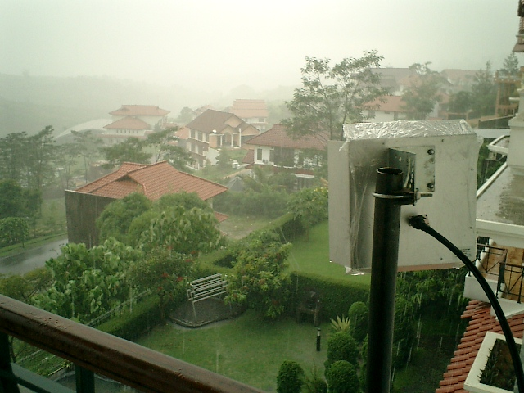
Any computer in the house or the neighborhood can then be connected to the CPE through the UTP connector build in the CPE.

A flat panel antenna can be used, if the Access Point is located not too far from the house.

A Glimpse on the Access Point at an Internet Service Provider
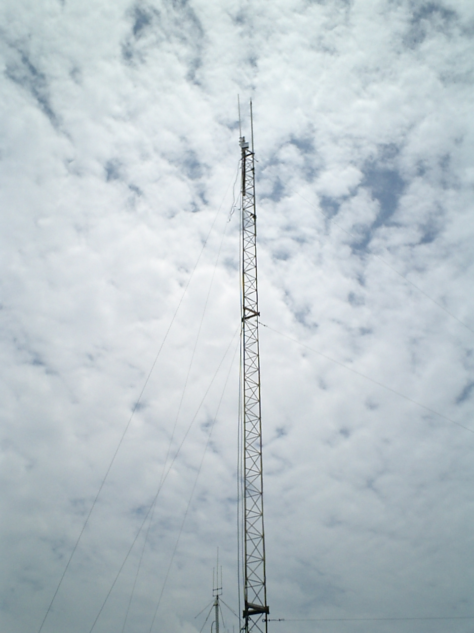
An Access Point at the Internet Service Provider (ISP) is normally located high on top of the tower. Henry Syarifuddin’s team installs this particular setting.

A closed up picture shows the SmartBridges (http://www.smartbridges.com) Access Point install on top of the tower. The coaxial cable connecting the Access Point to the Antenna is kept short to minimize the loss. An omnidirectional antenna is used. The bottom side of the antenna is visible in the close up.
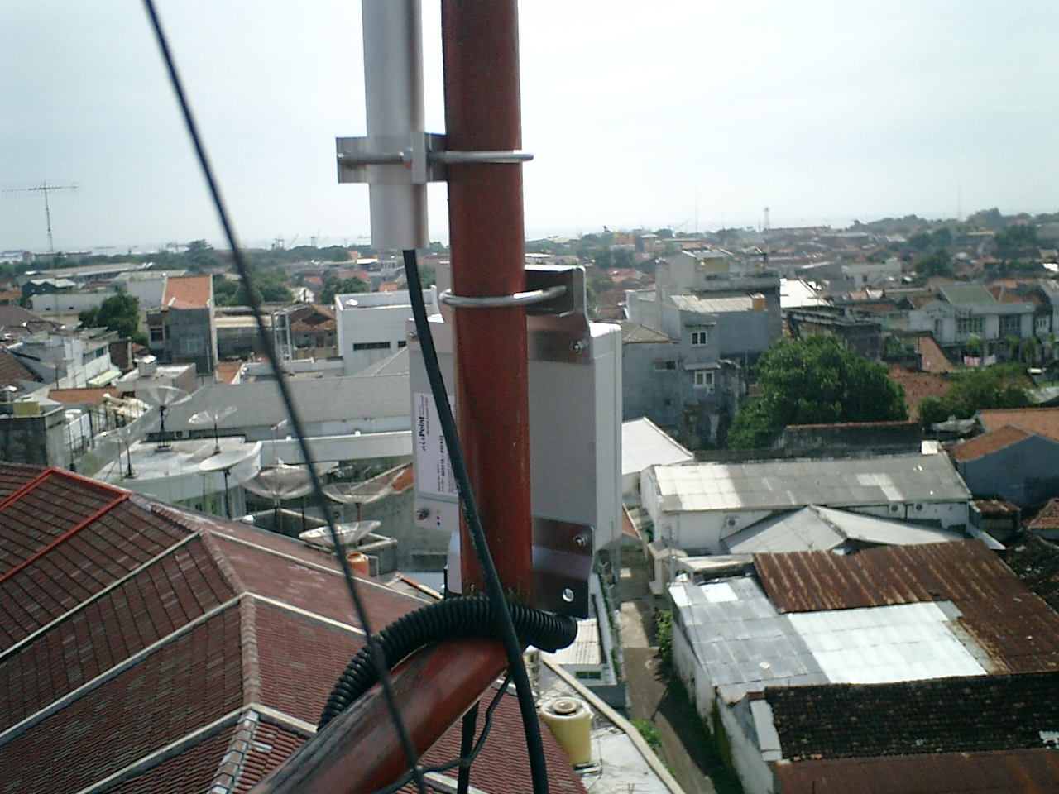

My Home Installation

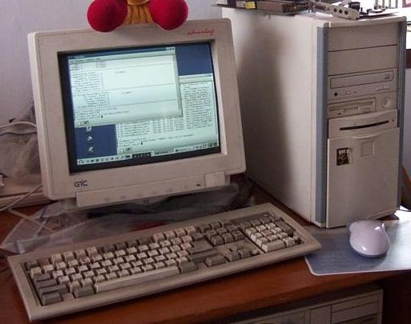
Shown in the figure is my home gateway for 24 hours Internet connection to my neighborhood. It is a Pentium I 166MHz with 128Mbyte RAM.

Linux Mandrake 8.0 is used as the operating system. In normal operation, it runs in text based mode with no Graphical User Interface (GUI).

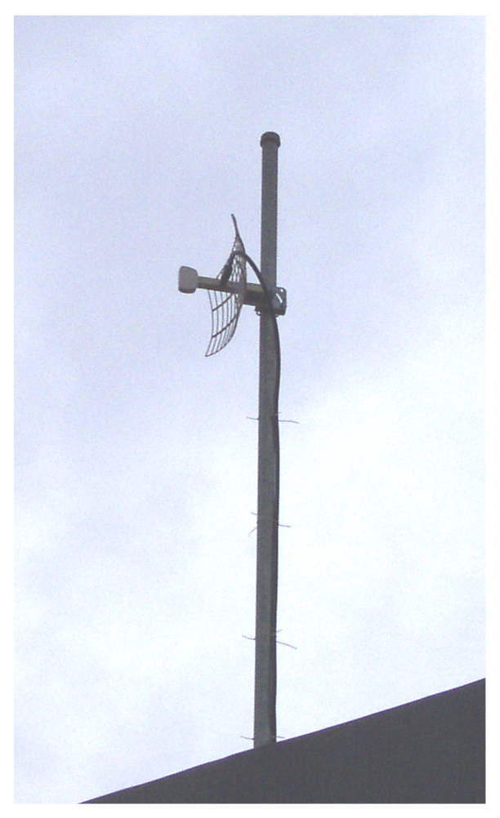
External antenna is located on the roof top above the ceiling clamped onto a 2 meter plumbing pipe that buried into the wall. It is a 19dBi parabolic antenna, much to large for reaching my access point at 1 km distance.

The Pentium I gateway has additional card connected to local LAN. Shown in the figure is my workplace at home with many PCs connected to the gateway through the LAN. All PCs can simultaneously access the Internet through the wireless gateway.
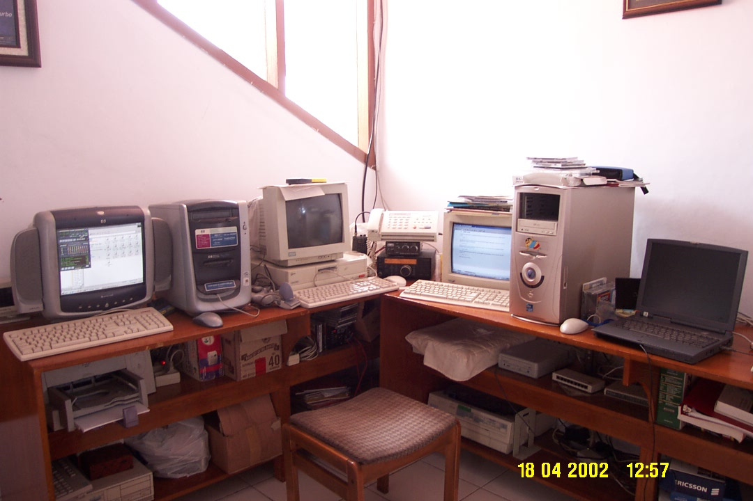

Building Neighborhood Point Of Presence

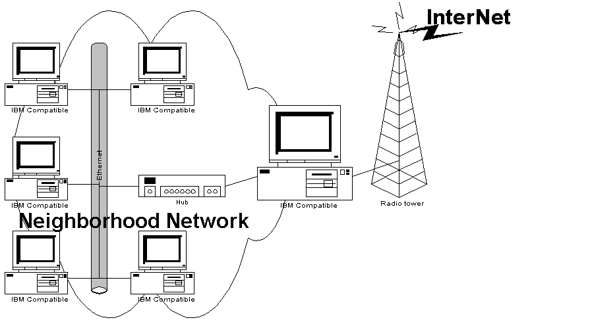

Shown in the figure is a typical configuration for neighborhood network. A single gateway with 24 hours wireless connection to the Internet connected to local UTP LAN through its second Ethernet.

Distance & environment proofing would be a major headache in implementing Neighborhood network. It would be easier for office network or Internet café, which normally run within a building.

A normal UTP line would reliably run for 100-150 meters, we need to put another hub as uplink for repeating the Ethernet signal for longer distance. I know, this is not a good practice for getting the maximum performance for the network. Fortunately, such architecture cost us quite cheap to build a neighborhood network.

Practical Installation of A Neighborhood Network

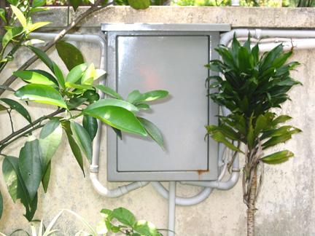
Most of the example shown in this section is taken from my friend, Michael Sunggiardi (Michael@sunggiardi.com) at his neighborhood network installation that connects about 80 houses in his neighborhood, which run at US$15 / house / month for 24 hours Internet access.

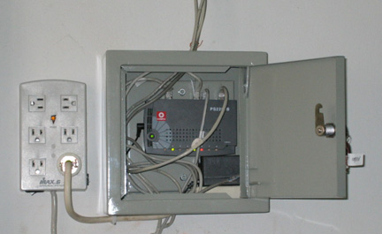
Shown in the figure is the hub for repeating the UTP cable into longer distances inside a box for outside installation. Shown in the figure the UTP cable is enclosed inside the pvc plumbing for environmental protection.

Shown in the figure is a picture of the equipment inside the box enclosure. It is basically a Hub with its power supply and UTP cabling.

To protect the system from lightning strike, it is advisable to put a lightning protector for the electric cord before it enters the equipments as shown in the figure.
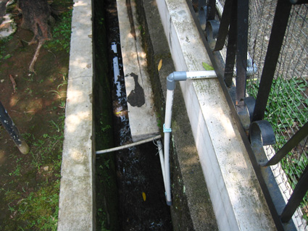
The UTP cables inside PVC plumbing is normally run across the drainage systems in the neighborhood for trouble-free installation.

Speed bump across the road is a common method to run the UTP cable across the road as it would be bureaucratically difficult to dig a hole into across the road.

