A Quick Guide on How To Shop For WiFi Equipments

In this chapter, we will review some price estimate, examples on how to shop for computer based equipments, and radio equipments Please note that this information is based on early 2003 experiences. It may likely to change significantly in years to come as more manufacturers producing the equipments at lower prices and higher performance.

To be honest, the easiest way to get these equipments is through your local computer store if any. Getting the equipment through the Internet may create a significant amount of headache. My experience shows that the local computer store price in developing countries may likely double the Internet price, as they have to ship the equipments and pay custom. Please note that most countries have a max Effective Isotropics Radiated Power (EIRP) allowed for both point to point and point to multipoint installations. Make sure maximum radiated power from the antenna fits with regulation. Normally, regulatory framework will limited the maximum radiated to reduce any possible interference.

Our experience in Indonesia, it would be beneficial if we can set some sort of WiFi community where all users, vendors, resellers, operators including some of regulator can get together regularly. In Indonesia, the platform used for the community gathering is a mailing list located at indowli@yahoogroups.com. IndoWLI stands for Indonesian Wireless Internet. It has currently 1000+ members all over Indonesia and going strong. Anyone who need help or looking for WiFi equipment can easily shout in the mailing list. It takes about 3-4 years to establish such community.

Price Estimate of A WiFi Station

In this price estimate, the investment cost is restricted to WiFi equipment only. It doesn’t cover any cost on the tower, the grounding system, the supporting equipment such as GPS etc.

Assuming professional Grade Equipments, we are looking at an estimated investment for the Access Point complete equipments in the range of:

Access Point US$62-130
Pigtail US$30
Coax US$90-130
Sectoral Antenna US$500-800
Omni Antenna US$150-240

Total Investment US$330-1100

Please note that in addition to the above equipment, we need dedicated Internet access as well as various software and equipment, such as, tower, lightning arrestor, bandwidth manager, mail server etc. It is basically a mini Internet Service Provider (ISP).

At the client side, we are looking at

PCI Card US$50-105
Pig Tail US$30
Coax US$90-130
Directional Ant US$100-250

Total Investment US$280-480

You need PC running NAT / Proxy software. Alternatively, you may use US$70 Access Point & set it as wireless bridge / client to another access point. Thus, significantly reduce the investment cost as well as operating cost.

For those who dare to use home made equipments, the investment cost can squeeze significant low. Homebrew antenna is normally used to reduce the cost significantly. Some of us finds used heliax coaxial cable significantly cheap about US$ 3 / meter. To reduce the cost significantly, we normally put the equipment on top of the tower and run the powered UTP cable (Power over Ethernet) up to the top of the tower and, thus, removing the need to have a long coaxial cable run on top of the tower.

Investment cost for the Access Point, assuming we put the equipment on top of the tower.

Access Point US$70
Pig Tail US$30
UTP cable US$30
Homebrew Antenna US$20-30

Total Investment US$150-160

We are looking at about US$200 investment cost difference between homebrew and professional grade Access Point equipment.

At the client side, the investment cost would be something like,

PCI Card US$50
Pig Tail US$30
Coax US$30
Homebrew Antenna US$20
Total Investment US$130

We are looking at about US$150 investment cost difference between homebrew and professional grade Access Point equipment.

Comparing Prices on the Internet

Internet is the best tool for comparing prices. There are sites on the Internet that dedicated for comparing prices of various stores, or online stores, and not necessary related to a particulat manufacturer. Examples of such sites are,

http://pcmag.pricegrabber.com
http://www.streetprices.com

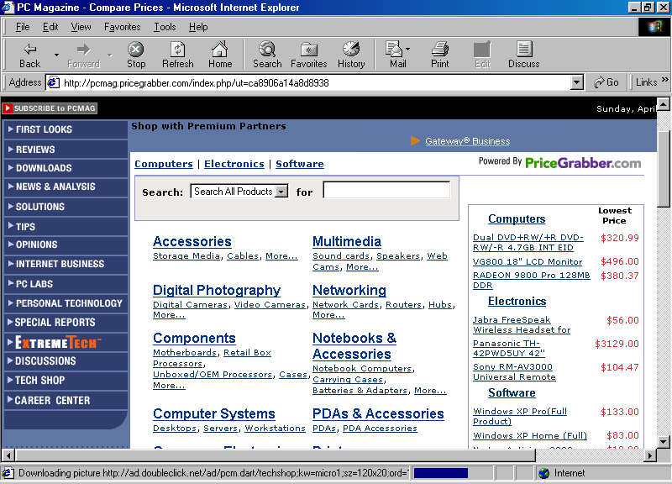
Shown in the figure is the http://pcmmag,pricegrabber.com. It is a portal for comparing price via the Internet.

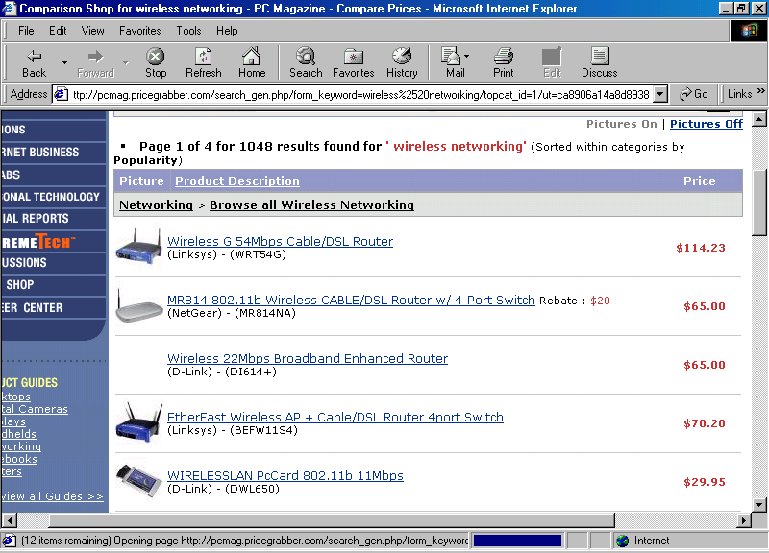
Fill the search column with appropriate keyword, such as, “wireless internet”, will present a list of wireless product as well as its price.

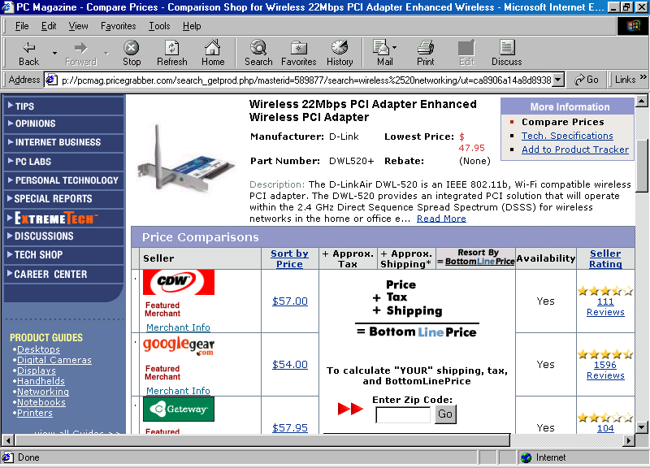
Clicking on particular product will provide the list of on-line shops that carry the product. It gives information on price, tax, shipping, availability as well as comments from other shoppers.

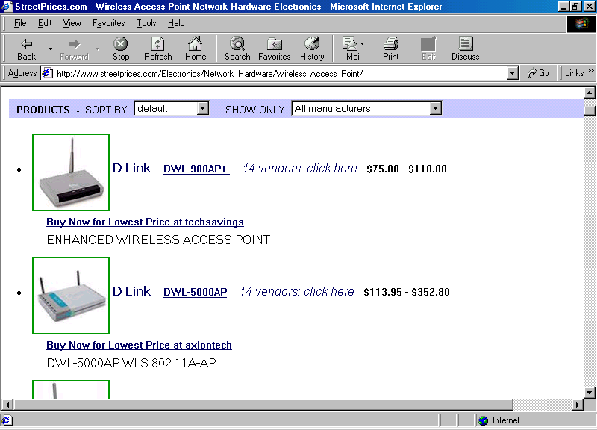
Another good place to compare prices is the http://www.streetprices.com. Similar to http://pcmmag,pricegrabber.com. It is basically another portal for comparing price on the Internet.
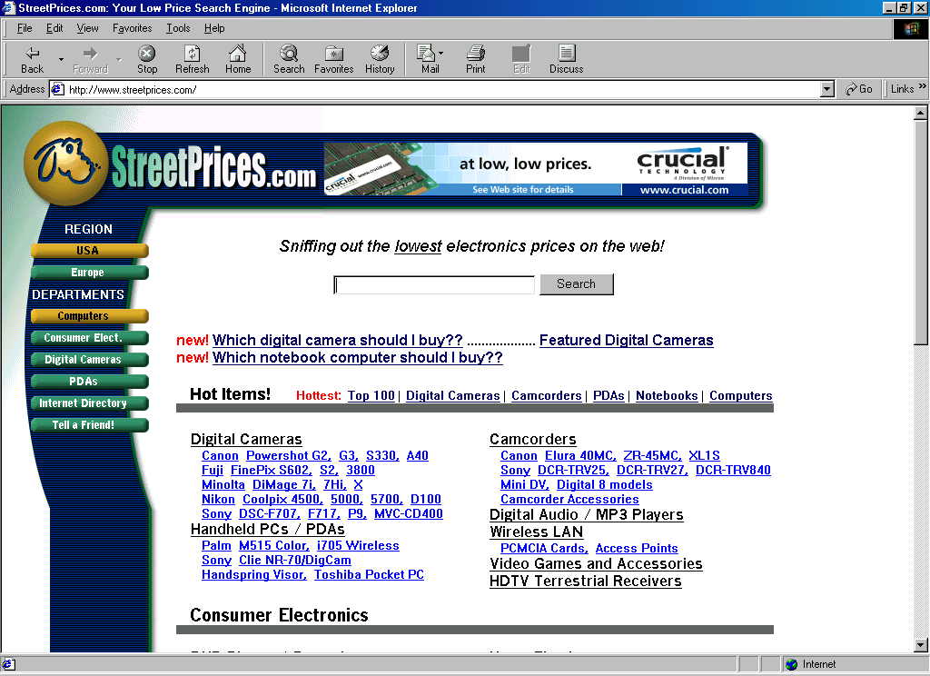
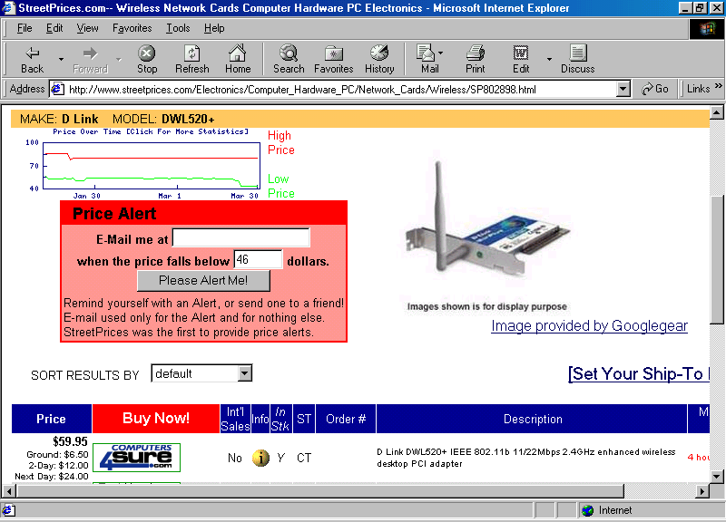
After entering the appropriate keyword and getting the list of equipment, we may click on the particular equipment to get a complete list of on line shops that sell the particular card. Good thing with http://www.streetprices.com, it gives the price history for the low prices as well as high prices.

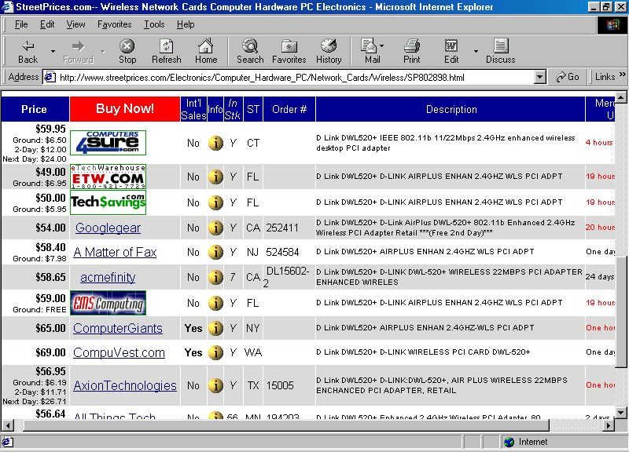

Getting Indoor WiFi Equipments
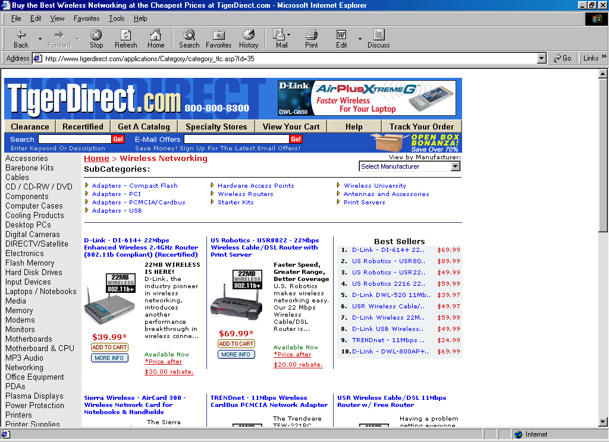
Getting WiFi equipment for indoor application would be the easiest task, one of the on-line shop may be the http://www.tigerdirect.com. We may use the indoor equipment for simple & low cost outdoor installation. However, for more serious outdoor applications, we need to consider specially designed outdoor WiFi equipment.
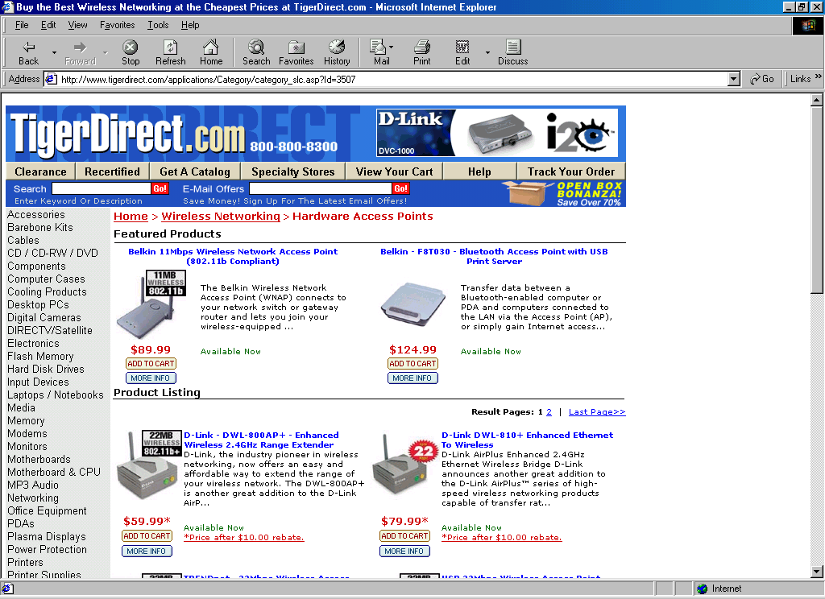
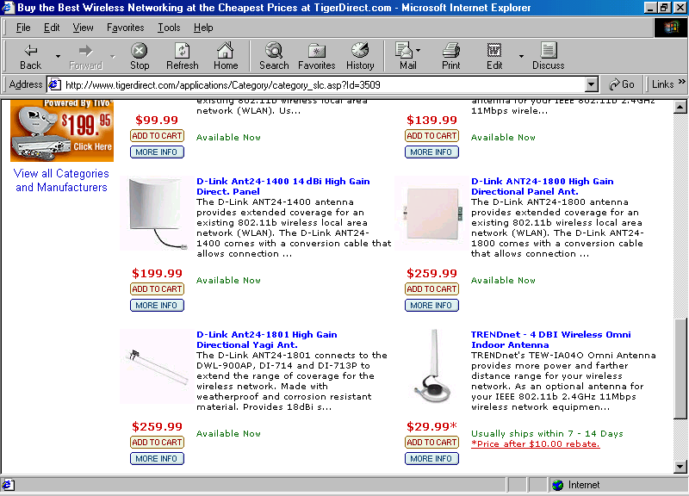
In addition to normal WiFi equipments, Access Point and WiFi cards, we can get some antennas as well as the cabling and power over Ethernet.

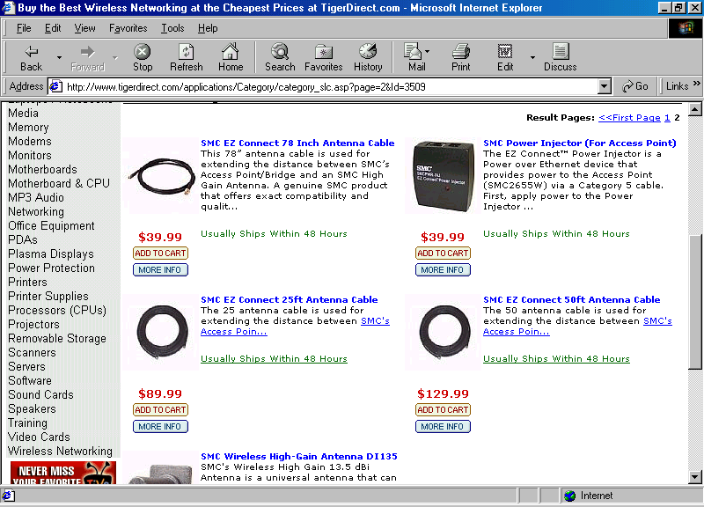
Simple low gain antennas with are offered. Connecting the WiFi equipment through the coaxial cable and the external antenna may extend the distance and be able to reach nearby office / sites. A distance of 1-3 km would be easily attainable using properly configure Indoor equipments.

Outdoor WiFi Equipment
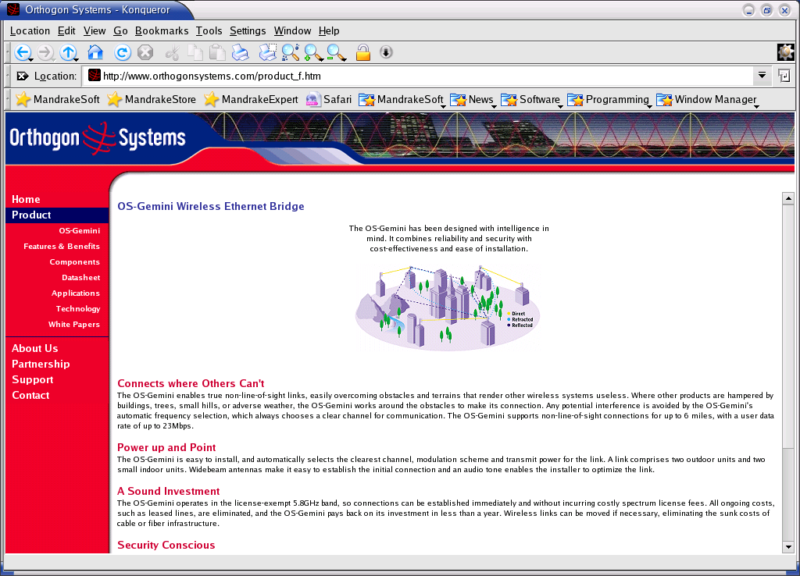
For dedicated outdoors and long distance installation, we need to consider outdoor WiFi equipments. Most of these equipments would be more expensive than indoor equipement.

These outdoor WiFi equipments are normally produced in environmental protection enclosure for outdoor installation.

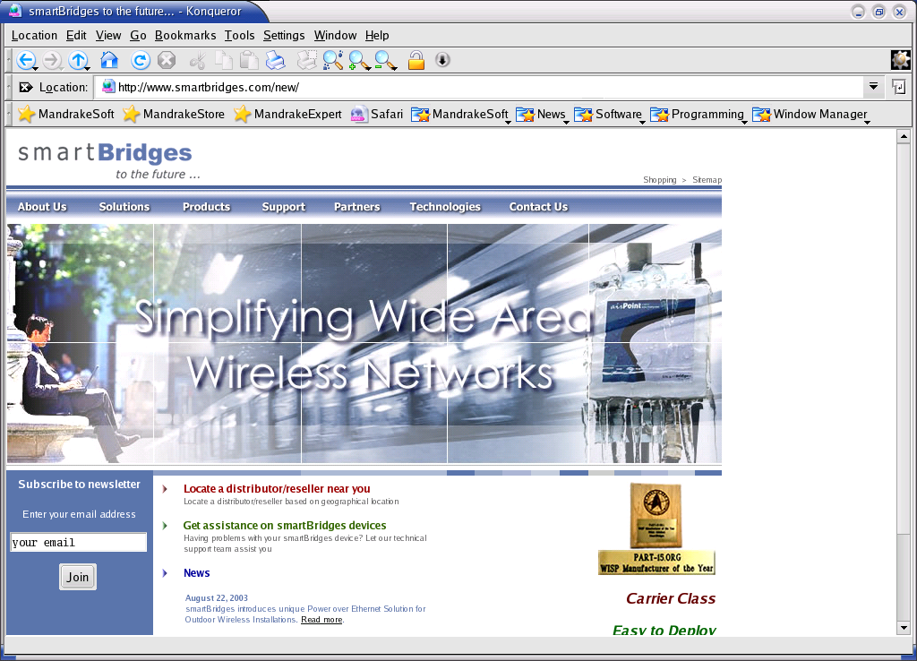
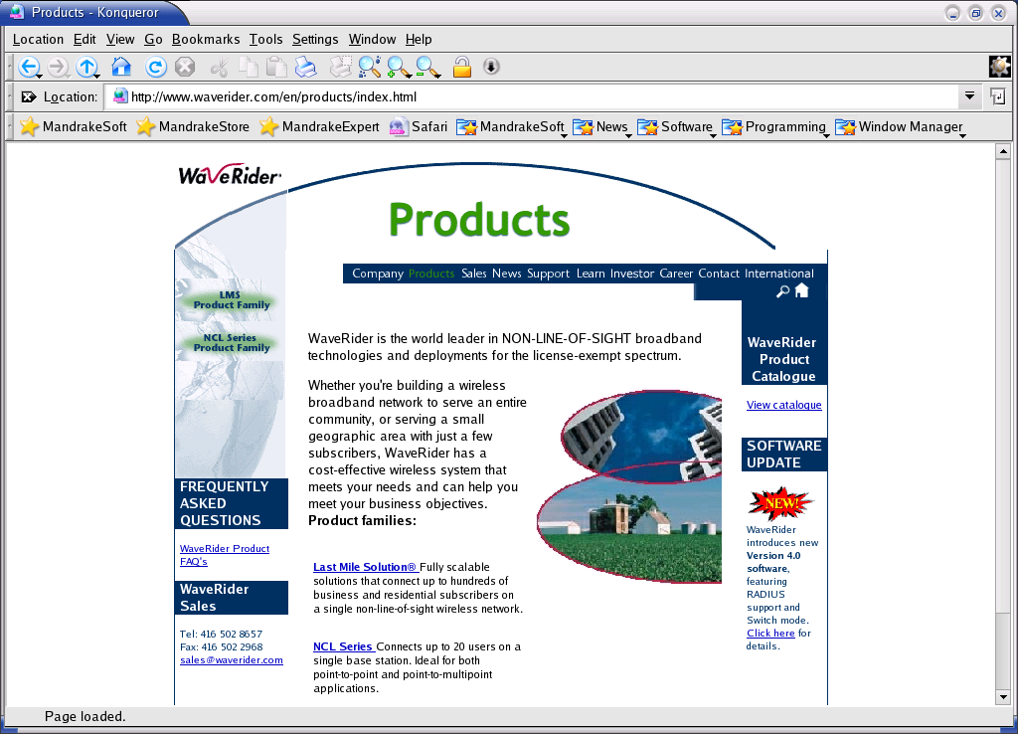
It normally has power over Ethernet build-in. Thus, the equipment can be place on top of the tower powered through a shielded Ethernet cable. Consequently, coaxial cable between the outdoor WiFi equipment and the external antenna can be kept very short, in some cases, shorter than one (1) meter. It will significantly reduce the signal loss by placing the WiFi equipment close to the antenna.

The significant different between indoor and outdoor equipment is not only in its external packaging enclosure, but also its internal firmware and radio equipments design for a more robust outdoor operation.

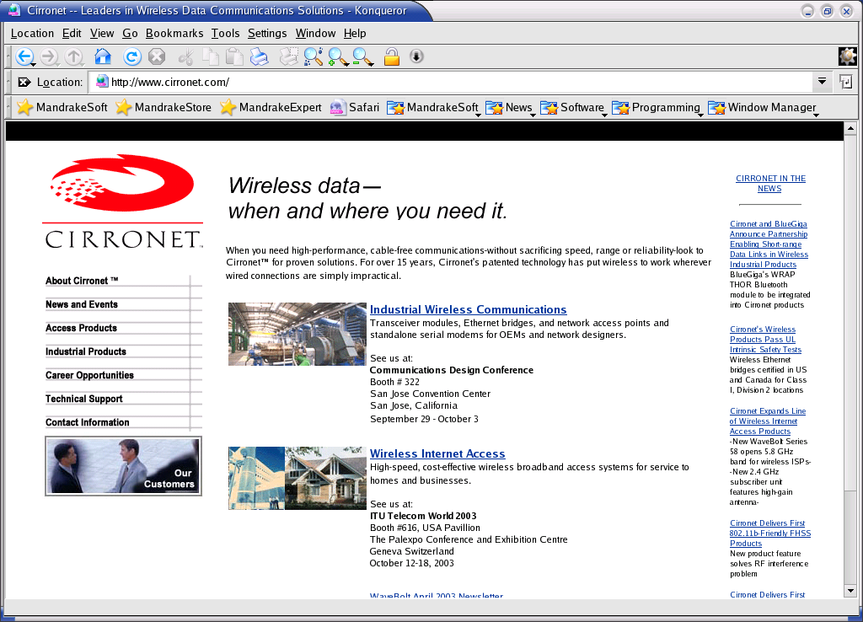
Inside the firmware, outdoor WiFi equipments may have some sort of proprietary protocol to increase data transfer reliability. For example, some may use polling mechanism on the Access Point to all the nodes on the frequency to reduce packet collisions.

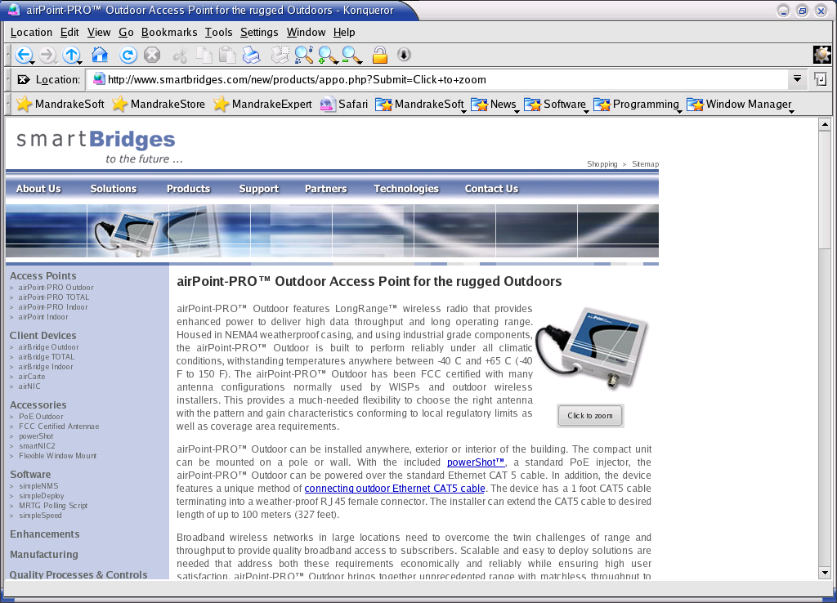
Some equipment may have latest state of the art radio equipment to fight with multipath and signal reflection. Orthogonal Frequency Division Modulation (OFDM) radios might be a good example to serve in NLOS (Near Line Of Sight) links.

Choosing the correct outdoor equipment would be a headache, some equipment gear for urban / city crowded environment with high concentration of nodes with multipath problem. Some vendors more concentrate on long distance backbone transmission in rural areas where less nodes and interference.

Some example of outdoors WiFi manufactures is,

http://www.cirronet.com
http://www.cisco.com
http://www.orthogonsystems.com
http://www.smartbridges.com
http://www.wavelan.com
http://www.waverider.com

We are looking at US$1000-2000 investment per outdoor node excluding the tower. It is very expensive for most installation. We may modify indoor equipment for outdoor usage to start a simple WiFi infrastructure.

Getting Radio Equipments
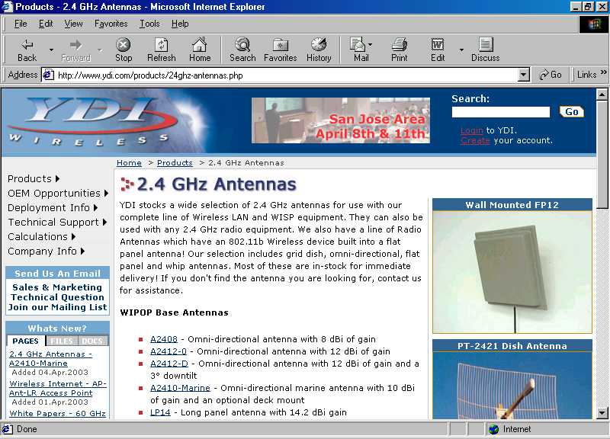
Getting the antenna, coaxial cable, lightning arrestor for outdoor installation might be difficult at the first time for technicians with computer only background. Most of advanced radio type equipment cannot be found in normal WiFi store, especially the one aim for indoor installation.

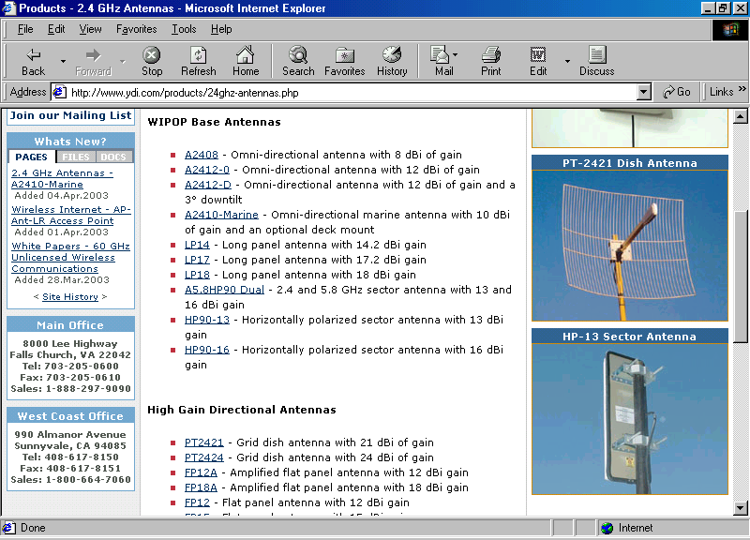
One of good example for on-line radio equipment store especially aim for WiFi outdoor installation is http://www.ydi.com.

For example, we can found various type of antennas, including omnidirectional antennas, sectoral antennas, yagi antennas and parabolic antennas on different polarization, i.e., vertically or horizontally polarized.

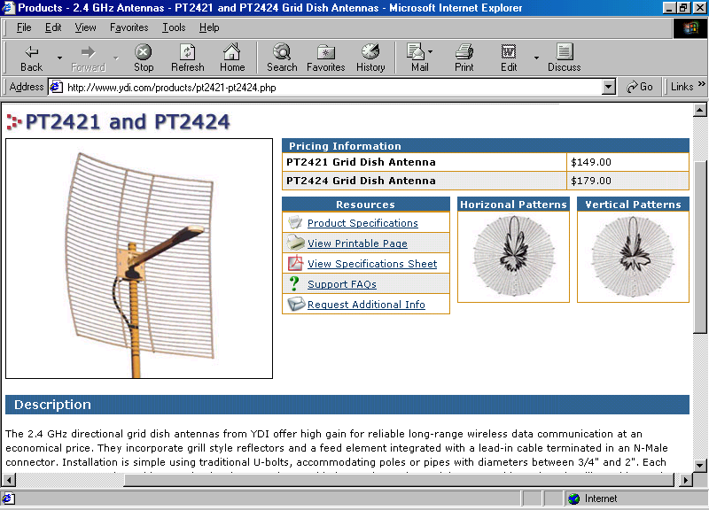
Clicking on certain antenna, we can see the picture of the antenna. Some include the antenna radiation pattern. The antenna specification in PDF format can also freely be downloaded.

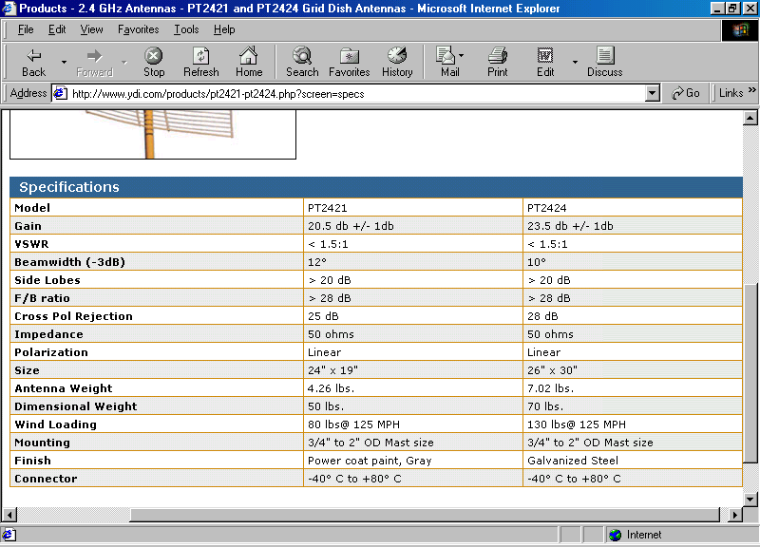
In the specification page, we can review the antenna gain, Voltage Standing Wave Ratio (VSWR) for certain frequency range, 3 dB beamwidth, Front-to-Back (F/B) ratio, cross polarization rejection, impedance etc.

Having all this information in hand, it would be very useful for selecting an appropriate antenna for our wireless wide area network.

Shop For Tower And Accessories
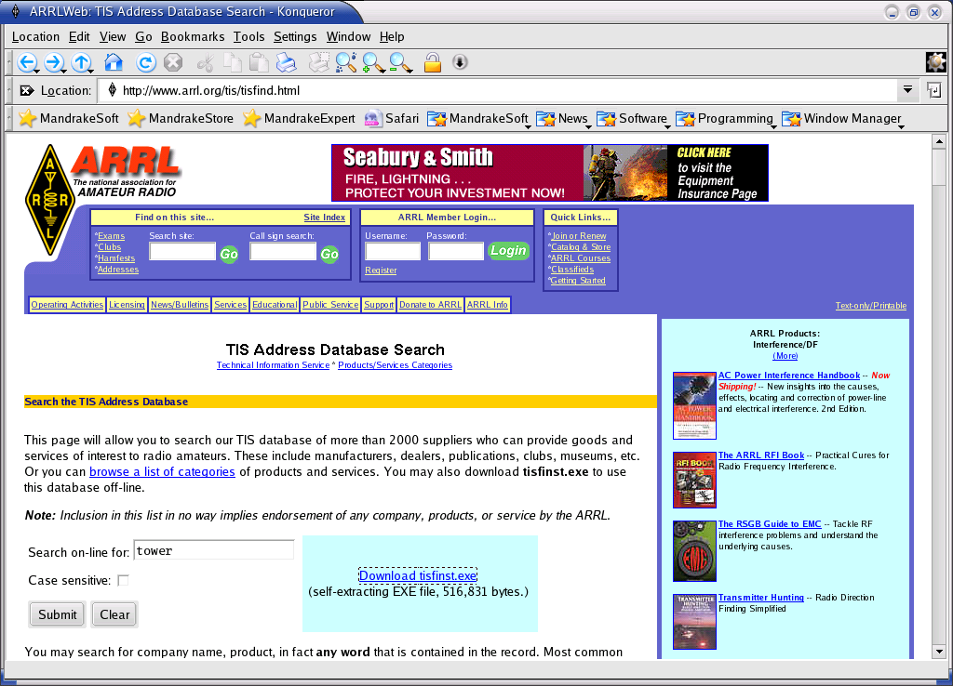
Shopping for the tower and its accessories would be much easier if we can talk to the amateur radio communities. The radio tower needed for putting outdoor WiFi equipment and antenna is fairly similar to an amateur radio tower. Check out local amateur radio club station would be the best solution.

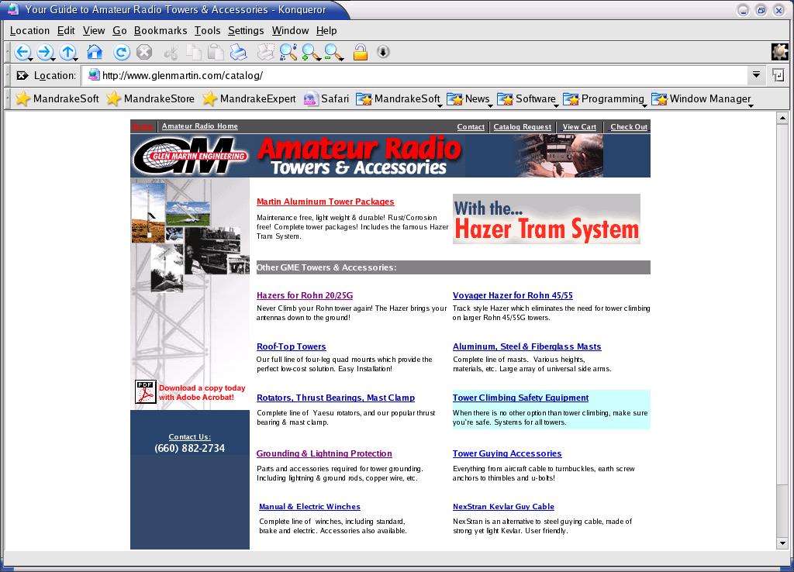
For North Americans, some of the tower manufacturers can be found at ARRL Web at URL http://www.arrl.org/tis/tisfind.html. A good example of tower manufacturer is the Glen Martin http://www.glenmarin.com.

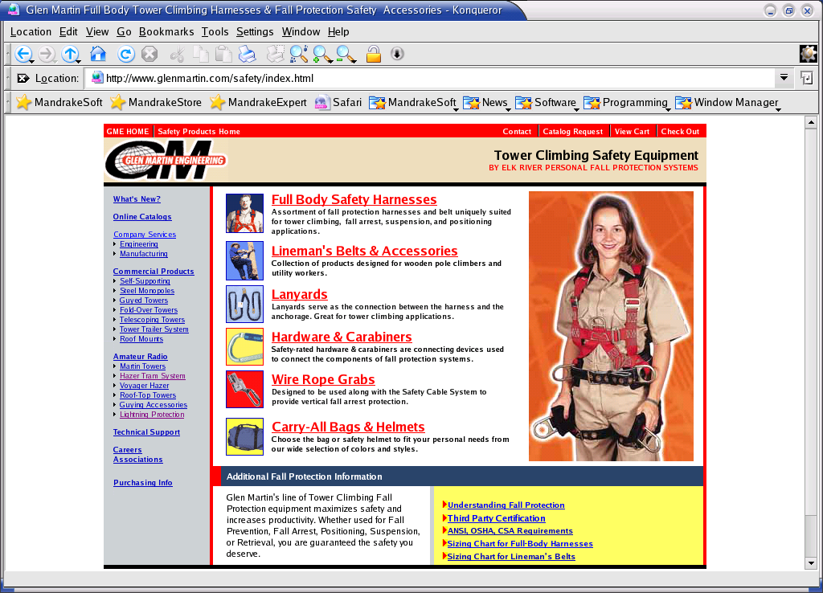
Before we buy a tower, we need to ask the question how large is the antenna? The larger the antenna, the stronger the tower would be. Check wind-loading rating of the antenna, and match it to the tower wind loading rating. Most towers are design for 80 km/h wind loading. It would be advice able to check which part of the country are we living? What kind of weather? Are we expecting any strong wind?

Please note to properly grounding (or earthing) the tower. It is the biggest defense against lightning strikes, and can also affect the performance of some radios.

A last note, please don’t forget to use all the safety harness before we do all the installation process. Some of the tower manufacturer will also sell the safety equipment as shown in the figure.

