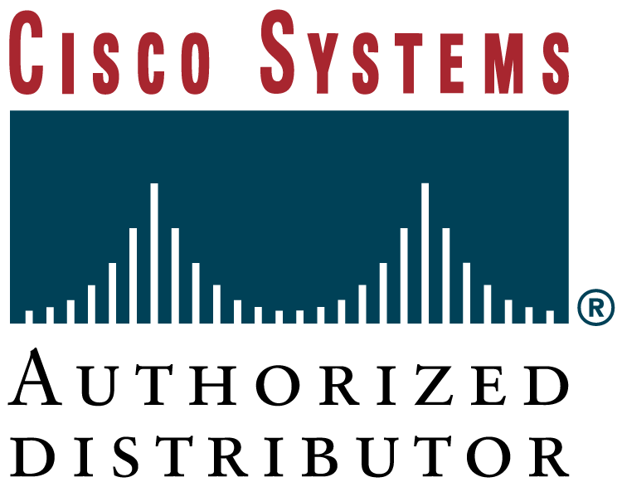

Proudly distributed by:

Aironet 350 Starter Kit
- 350 Series 11Mbps Bridge w/128-bit WEP
AIR-BR350-A-K9 (#616136)
- 50ft (15m) Low Loss Antenna Cable
AIR-420-003346-050 (#616170)
- 21dBi Solid Dish Antenna
AIR-ANT3338 (#616169)
- Lightning Arrestor w/Grounding Ring
AIR-ACC3354 (#616171)
____________________________________________________________
Aironet Specials – while stocks last FOB US$/Unit (ex-tax)

- 340 Series 11Mbps Ethernet Bridge AIR-BR342 (#213420) $ 1,169

- 340 Series 11Mbps DSSS AP w/128-bit WEP & 2 Int. Antenna $ 465
AIR-AP342E2C (#213561)

- 340 Series 11Mbps DSSS AP w/128-bit WEP & 2 RP-TNC $ 520
AIR-AP342E2R (#213421)

- 340 Series 11Mbps PCI Adapter w/128 bit WEP AIR-PCI342 (#213402) $ 190

- Antenna Kit w/13.5 dBi Yagi Ant., 50ft Cable & Lightning Arrestor $ 315
AIR-ANT-AKYAGI (#024818)

- Antenna Kit w/6 dBi Patch Ant., 50ft Cable & Lightning Arrestor $ 215
AIR-ANT-AKPATCH (#024819)

- 50ft (15m) Low Loss Antenna Cable AIR-420-003346-050 (#616170) $ 80

- 21dBi Solid Dish Antenna AIR-ANT3338 (#616169) $ 730

- Lightning Arrestor w/Grounding Ring AIR-ACC3354 (#616171) $ 143

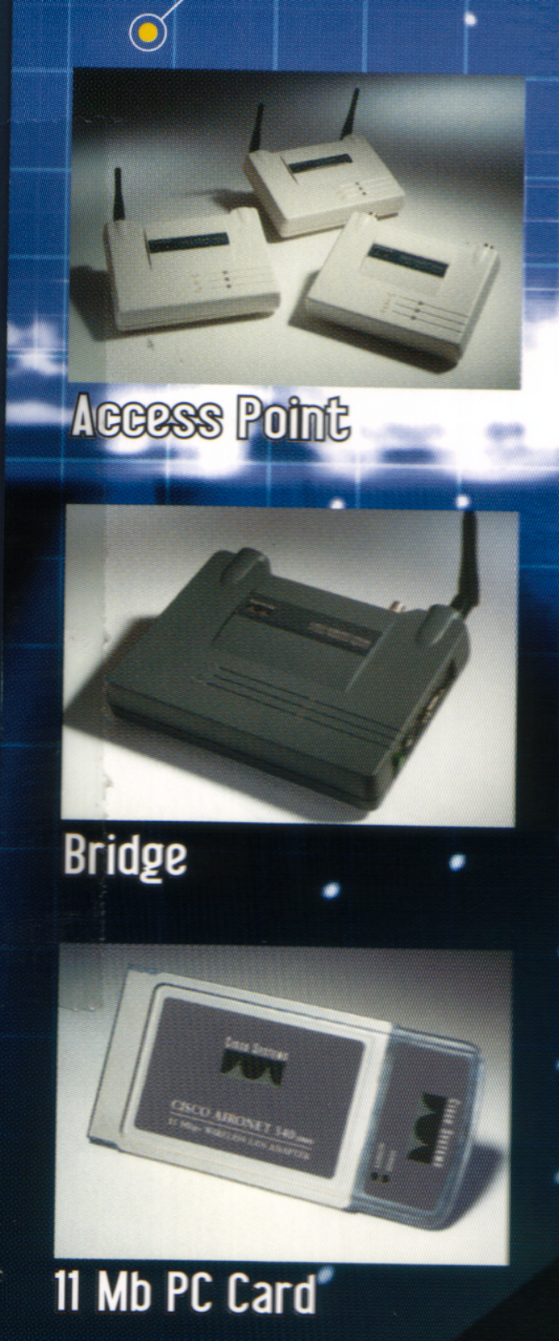
ROUTERS Specifications FOB US$/Unit (ex-tax)
1750 10/100 Modular Router w/1 VIC, 2WIC/VIC slots & IOS IP S/W (#P181216) $ 930
1750-2V 10/100 Modular Router w/2 Voice Channels IOS IP/VOICE + S/W (#181217) $ 1,430
1750-4V 10/100 Modular Router w/4 Voice Channels IOS IP/VOICE + S/W (#181218) $ 1,680
1751-V 10/100 Modular Router w/Voice , IOS IP/VOICE PLUS (#262932) $ 1,550
2501-CH 1-port Ethernet AUI, 2-port Serial, IP S/W (#616166) $ 1,485
2610 1-port 10BASE-T, 1 network module slot, 1AIM, 2 WIC + IOS IP PLUS (#784985+056089) $ 1,705
3640 4-slot Modular Router-AC Power Supply, IP S/W (#981157) $ 4,030

SWITCHES
2924C-XL-EN 22-port 10/100 (autosensing), 2-port 100BASE-FX (#071792) $ 1,140
2950-24 24-port 10/100 (autosensing) (#S321694) $ 865
2950T-24 24-10/100 ports & 2 fixed 1000BASE-T Uplink ports (#321695) $ 1,335
3524XL-EN 24-port 10/100 (autosensing), 2 1000X GBIC slots (#146605) $ 1,735

US$ 4,600

(2 x Starter Kit)

Free Palm Vx
(worth US$299)
Limit to the 1st 10 bundles

Ingram Micro (S.E.A.) Pte Ltd
205 Kallang Bahru #03-00 Singapore 339341
Sales: Ms Lee Siew Chren (65) 488 5145
Mr Johnny Cheng (65) 488 5131
Fax: 65-292 9487 or 65-292 9396
Email: siew.chren.lee@ingrammicro-asia.com
johnny.cheng@ingrammicro-asia.com
Valid till 8th Feb 2002 or while stocks last!
Prices are in USD dollars, FOB S’pore, ex-work
STAR BUY !

