

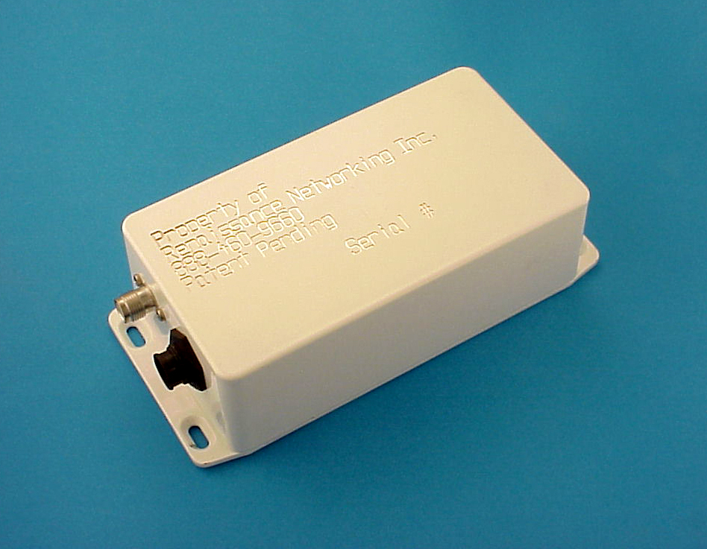
PriorityIPTM Wireless CPE Router
- Low-cost CPE with 1, 2 or 4 Subscriber Ethernet segments per antenna.
- PCMCIA interfaces provide ubiquitous 802.11 compatibility
- Remote powering of ODU distances greater than 300 feet
- Layer 3 routing, bandwidth shaping and prioritization
- Remote management via TCP/IP, SNMP, SSH, and FTP
- Extensible software drivers based on open source kernel

RNi’s Broadband Wireless Solution – Designed for ISP Deployments
RNi has designed the PriorityIPTM Wireless Customer Premise Equipment (CPE) Router with the Wireless Internet Service Provider (WISP) in mind. Accordingly, the device is engineered to be a very attractive and a very affordable solution that is loaded with powerful features and benefits that WISPs need to address their unique deployments. By integrating a fully capable TCP/IP router at the customer premise, RNi is providing the exciting benefits of wireless networks with layer three routing at every node. Specifically, the ability manage bandwidth throughout the network will allow wireless carriers to offer higher-priced guaranteed data services with significantly lower implementation costs.

RNi spent two years developing the PriorityIPTM Wireless Router and established a broadband wireless network in Phoenix, Arizona in 2000. Since 2000, RNi’s network has grown to seven cells and now provides high-speed Internet connections to hundreds of customers.

The key enabler of RNi’s Arizona network has been the PriorityIPTM Wireless CPE device. Installed at the customer’s location, this device provides configurable bandwidth throttling up to 6 Mbits/sec and layer-three bandwidth prioritization providing for end-user Committed Information Rate (CIR) guarantees. The wireless CPE router combines advanced layer-three routing with a radio transceiver to provide a low-cost, rugged outdoor package that permits ISPs the ability to deliver guaranteed Internet service via a wireless connection.

The feature set and substantial cost difference between RNi's CPE device and other available off-the-shelf solutions give ISPs that wish to rollout broadband services in a cost effective manner an intelligent choice and a key competitive advantage.

Physical Characteristics
The wireless router is made up of three distinct components (see figure 1):
- Outdoor Unit (ODU) - The ODU (approximately 3” x 6”) is mountable directly below the antenna and is remotely powered via CAT-5 cable from the IDU (approximately 1” x 2“).
- Indoor Unit (IDU) - The IDU integrates Ethernet and DC Power within the premise where the WAN and LAN are connected.
- Cable Assembly – Cable that connects the ODU and IDU.

Features

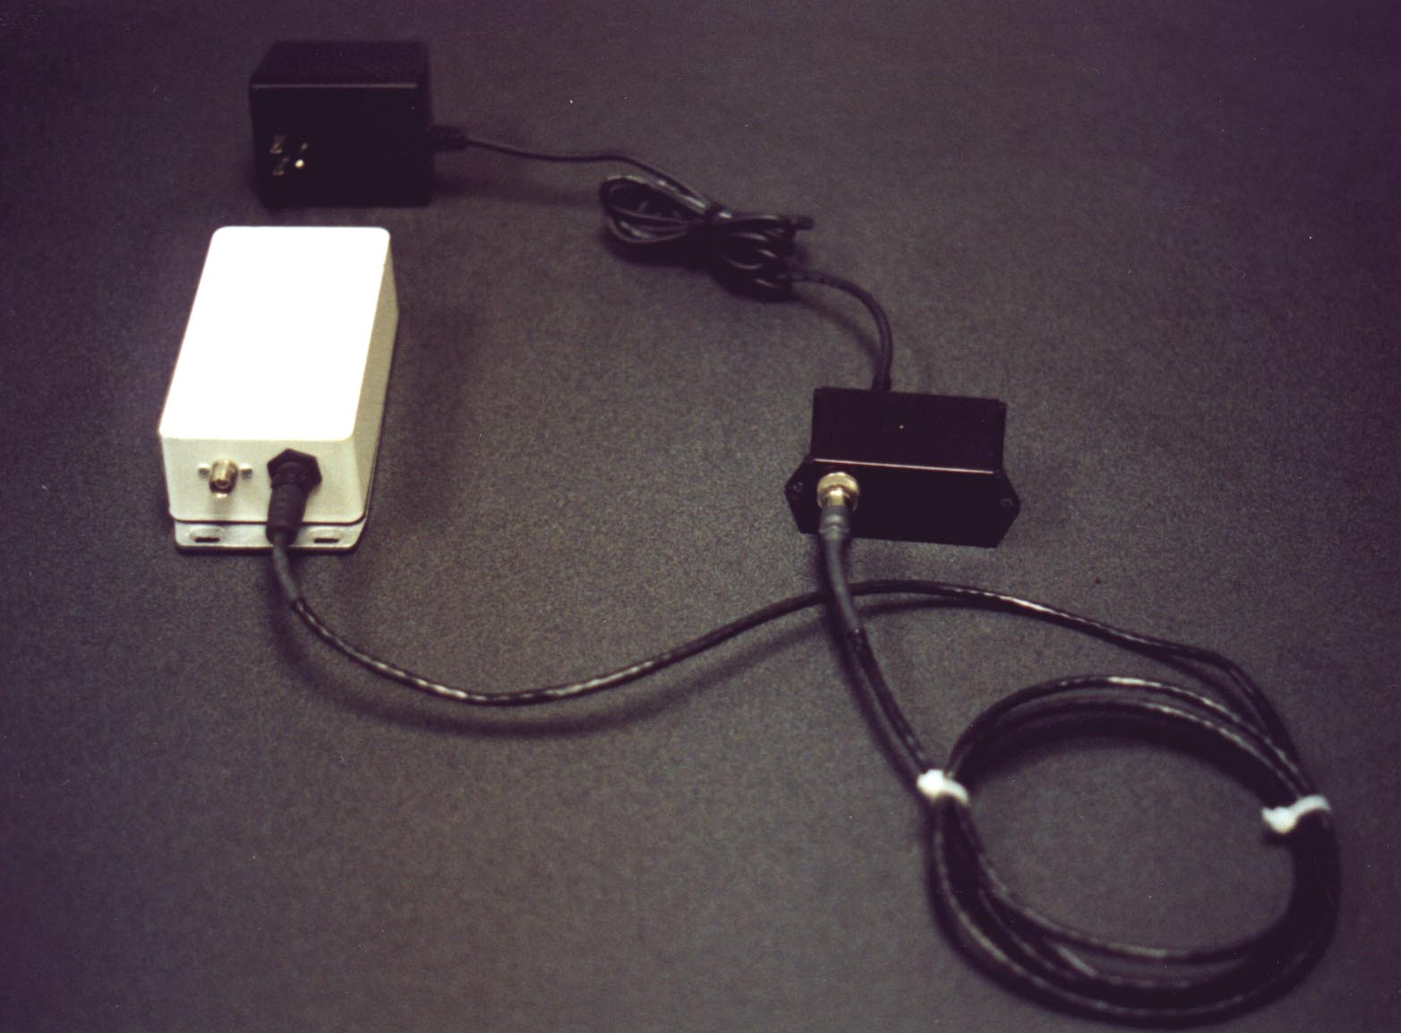
- Weather proof ODU allows for consistent RF performance due to minimal RF coaxial cable runs. Operating range –10C to 70C.
- Low-cost CPE is available with 1, 2 or 4 Ethernet ports per antenna
- Two PCMCIA interfaces leverage the mass production of sophisticated RF transceivers. Current implementation utilizes the Cisco line of 100mw 802.11 transceivers.
- Remote powering of ODU for the most flexible installation possible. Remote powering functional at distances greater than Ethernet cable length maximums (300 feet or more).
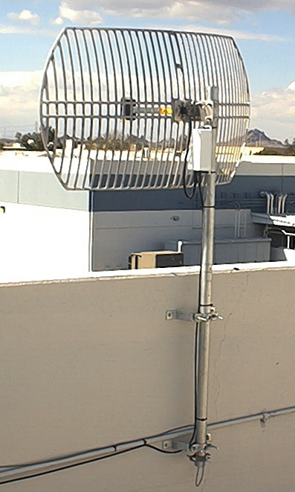
- Easy CAT-5 punch down on IDU enables fast and efficient cabling installation (1 hour installation time)
- Layer 3 bandwidth shaping and prioritization.
- Local management via Ethernet or TCP/IP.
- Remote management via TCP/IP, SNMP, SSH, and FTP. Management Access list filtering from Ethernet or wireless link.
- Software upgrade via FTP, Ethernet, or TCP/IP.
- Extensible general purpose computing platform with open source kernel
- Five minute UPS for brief power failures.
- TCP/IP Routing
- Network Address Translation (NAT)
- Dynamic Host Configuration Protocol (DHCP)
- Telnet Command Interface
- Pricing – Full Customer Premise Equipment package in $300-$600 per subscriber in volume quantities
- Compatible with Cisco, Lucent, generic Prism cards, and most DSSS PCMCIA cards
- Small Embedded Linux Motherboard with 16 MB Flash Memory
- Cabling is UV rated gel-filled CAT-5 designed for outdoor use.
- Extra Flash Memory available for Customization by ISP or OEM partner or reseller

End of Document, Revision 1.1 09/2001

