Appendix 1

Internet Users (by thousand) 2002-2003
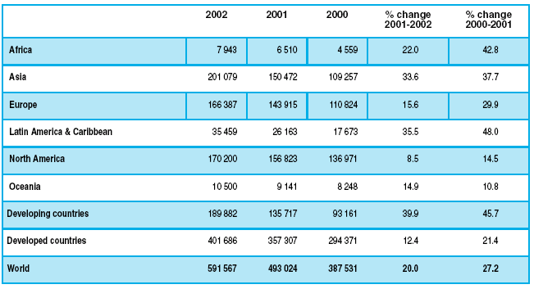
Source: ITU (2003a) and UNCTAD calculations [7]

Internet Users by Region 2002-2003

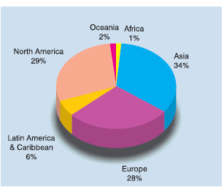

Source: UNCTAD elaboration of ITU (2003a) [7]

Appendix 2

Internet Users (thousands), 2000–2002

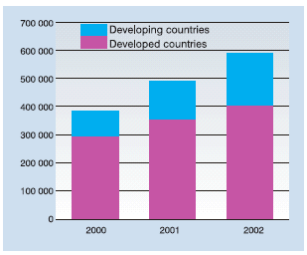

Source: UNCTAD elaboration of ITU (2003a) [7]

Appendix 3

Internet users (thousands), selected countries, 2000-2002

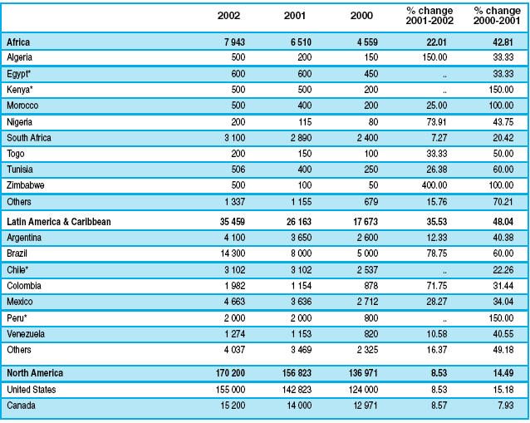
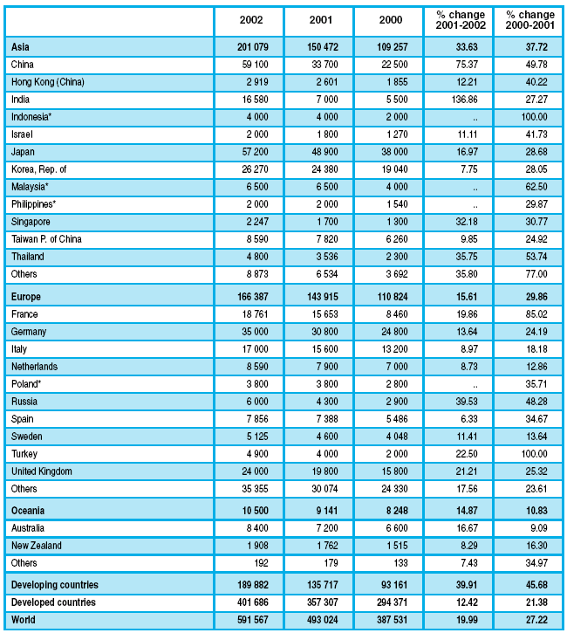

Source: ITU (2003a) and UNCTAD calculations [7]

Appendix 4

Structure of the Malaysian Manufacturing Sector [11]

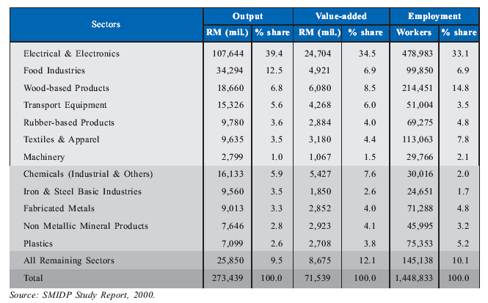

Appendix 5

Malaysian Small and Medium Enterprises Contributed in % Share [11]

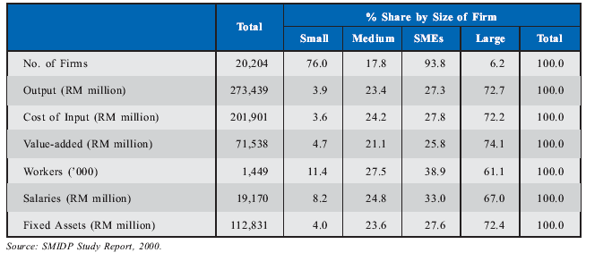

Appendix 6

SMEs : Global and Indonesian Definition [14]

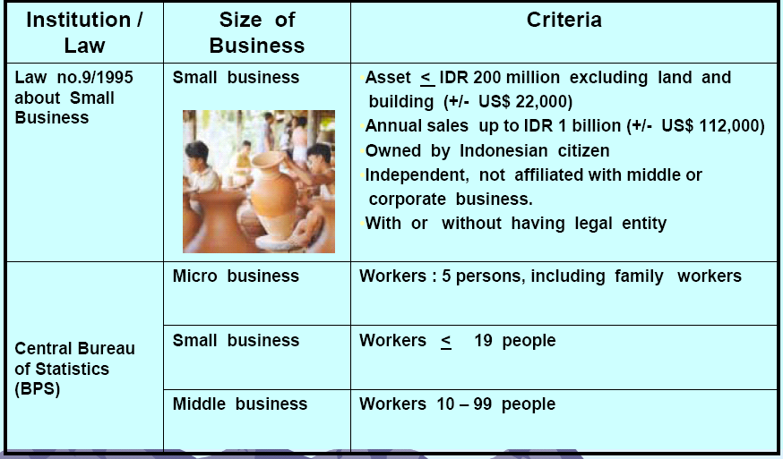

Contd..

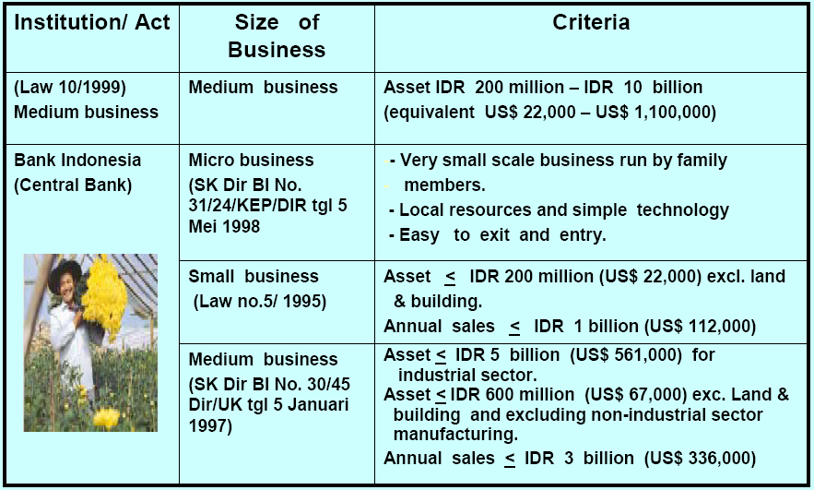

Appendix 7

Number of Enterprises in Indonesia in 2001 [14]

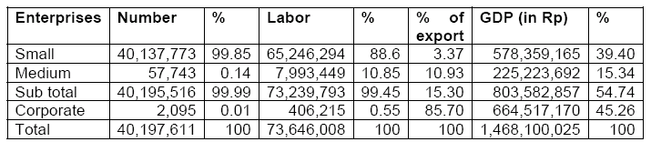

Appendix 8

Internet Users vs. Internet Buyers in Malaysia [17]

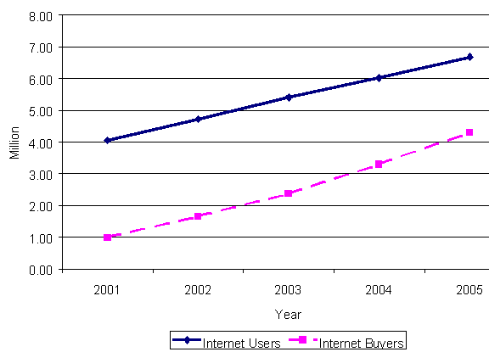

Appendix 9

Malaysian IT Education and Training Market, 1999-2004 (US$ Million) [17]

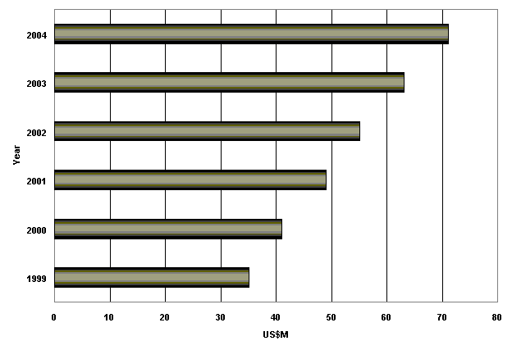

Appendix 10

Time of Internal IT Staff Spent on Various Tasks

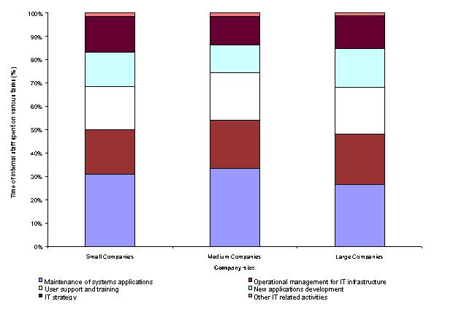

Appendix 11

Malaysia Overview

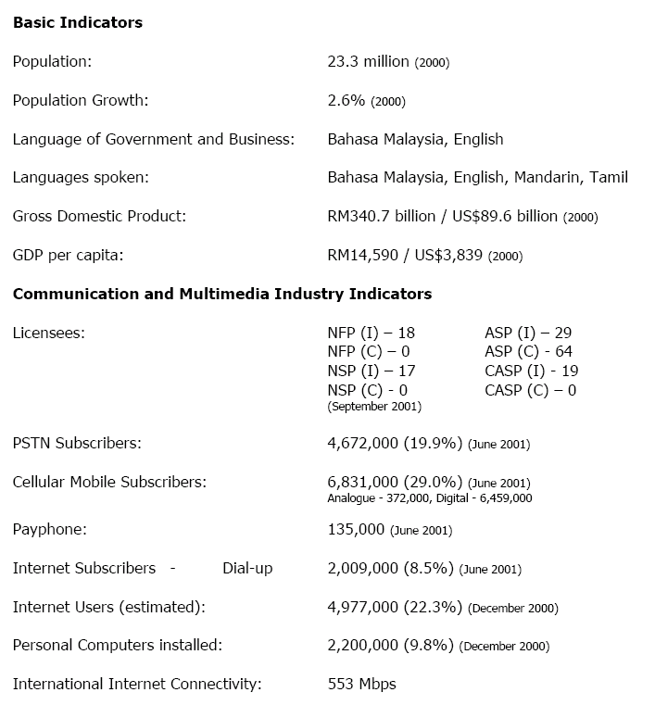

Contd…

Internet User Profile

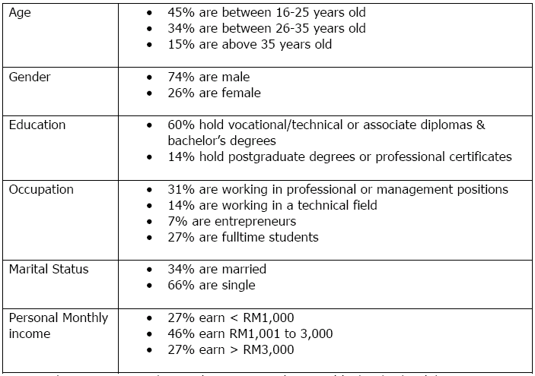

Appendix 12

The percentage of SMEs with internet access is as follows: [25]

Country % of SMEs 2000 |  | % of SMEs 2000 (with a website)
Austria | 75 | 45
Belgium | 72 | 34
Denmark | 84 | 57
EU 15 | 70 | 40
Finland | 76 | 49
France | 59 | 33
Germany | 84 | 54
Greece | 44 | 21
Ireland | 84 | 53
Italy | 68 | 40
Luxembourg | 70 | 46
Netherlands | 80 | 48
Portugal | 37 | 14
Spain | 67 | 34
Sweden | 71 | 47
UK | 70 | 40

Contd…
The percentage of SMEs with internet access using B2B is as follows: [25]

Country | % of SMEs in 2000
UK | 36
France | 31
Luxembourg | 29
Belgium | 28
Germany | 28
EU15 | 27
Ireland | 26
Austria | 25
Spain | 25
Denmark | 24
Netherlands | 23
Sweden | 23
Italy | 20
Finland | 20
Portugal | 20
Greece | 19

Contd…

The percentage of SMEs with Internet Access using B2C is as follows: [25]

Country | % of SMEs in 2000
Germany | 37
UK | 32
Denmark | 29
Luxembourg | 28
Austria | 27
EU 15 | 26
Sweden | 26
Ireland | 22
Finland | 21
Portugal | 20
France | 18
Italy | 18
Spain | 18
Belgium | 16
Greece | 16
Netherlands | 12

Appendix 13

Corruption Level, Selected Asia Countries [27]

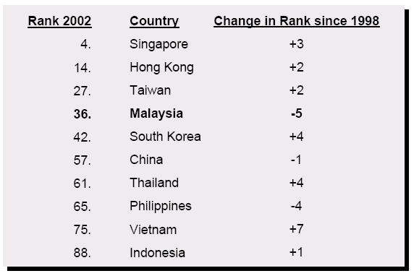

Appendix 14

Indonesian Internet Market

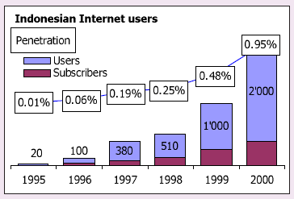

Appendix 15

SMEs Pattern in E-commerce Usage [30]

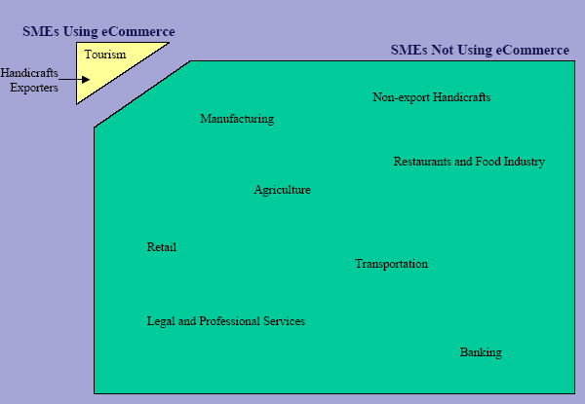

Appendix 16

E-commerce Readiness in Selected Emerging Economies [72]

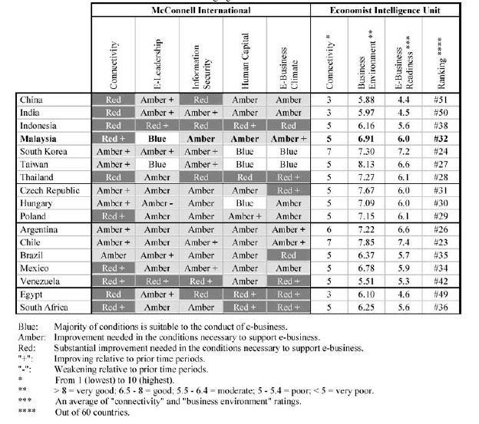

Appendix 17

Understanding Cultural Differences [99]

Individualistic and Collectivistic Cultures
 | Individualism | Collectivism
Major Characteristics | - Focus on the goals of the individual.  - "I" identity emphasized  - Universalistic.  - Many in-groups | - Focus on the goals of the group  - "We" identity emphasized  - Particularistic  - Few in-groups
Individuals’ Tendencies | - Idiocentrism  - Values stimulation, hedonism, power, self-direction  - Independent self construal | - Allocentrism  - Values tradition, conformity, benevolence  - Interdependent self construal
Communication | - Low context messages: direct, precise, clear | - High context messages: indirect, ambiguous, implicit
Example Cultures | - Canada  - Australia  - England  - France  - Ireland  - Italy  - New Zealand  - United States | - Argentina  - Brazil  - China  - Egypt  - Greece  - India  - Japan  - Mexico

Low and High Uncertainty Avoidance Cultures
 | Low Uncertainty Avoidance | High Uncertainty Avoidance
Major Characteristics | - Low Stress and Anxiety  - Dissent Accepted  - High level of risk taking  - Few rituals  - That which is different is seen as curious | - High stress and anxiety  - Strong desire for consensus  - Low levels of risk taking  - Many rituals  - That which is different is seen as dangerous
Individuals’ Tendencies | - Uncertainty orientation | - Certainty orientation
Example Cultures | - Canada  - England  - France  - Hong Kong  - India  - Jamaica  - Sweden  - United States | - Egypt  - Argentina  - Belgium  - Chile  - France  - Greece  - Japan  - Mexico

Low and High Power Distance Cultures
 | Low Power Distance | High Power distance
Major Characteristics | - Individuals are viewed as equals  - Emphasis on legitimate power  - Superiors and subordinates are interdependent | - Individuals viewed as unequal  - Emphasis on coercive/referent power  - Subordinates are dependent on superiors
Individuals’ Tendencies | - High egalitarianism | - Low egalitarianism
Example Cultures | - Australia  - Canada  - Ireland  - Israel  - New Zealand  - Sweden  - United States | - Egypt  - Ethiopia  - Ghana  - India  - Malaysia  - Saudi Arabia  - Venezuela

Masculine and Feminine Cultures
 | Masculine | Feminine
Major Characteristics | - Differentiated gender roles  - Values power, assertiveness, performance | - Overlapping gender roles  - Values quality of life, service, nurturance
Individuals’ Tendencies | - Masculine / feminine sex-roles | - Androgyny
Example Cultures | - Arab cultures  - Austria  - Germany  - Italy  - Jamaica  - Japan  - Mexico  - New Zealand  - Switzerland  - Venezuela | - Chile  - Costa Rica  - Denmark  - East African cultures  - Finland  - Netherlands  - Norway  - Portugal  - Sweden  - Thailand

Appendix 18

Respondents List for Interview
 | Respondent | Position | Institution | Tel/Fax | Email | Address
Malaysia | Mr. Alvin Song | IT & SMEs consultant | - | - | - | -
Malaysia | PRIVATE [R1] | Freelance IT analyst | - | - | - | -
Malaysia | Miss. Kamini Shanmugaiah [R2] | Freelance consultant | - | - | kamini_shanmugarah@non.agilent.com | Bayan Lepas, Free Industrial Zone, 11900 Penang, Malaysia.
Malaysia | Mr. Thomas Alan Shearer [R3] | Development Engineer | CSE Multimedia Sdn Bhd | - | thomasalanshearer@yahoo.co.uk | Office: Axis Plaza, Glenmarie, Shah Alam, Selangor, Malaysia
Indonesia | Mr. Idris F. Sulaiman, PhD | International Affairs Advisor | Indonesia Information Technology Federation | +62 21 5296 0634  +62 21 5296 0635 | idriss@indo.net.id | 11th Floor, CyberElektrindo Building, Jl. Kuningan Barat No.8, Jakarta 12710, Indonesia
Indonesia | Mr. Onno W. Purbo [R4] | Independent IT writer | - | - | onno@indo.net.id | -
Indonesia | Mr. Mas Wigrantoro R.S. | Senior staff, E-commerce consultant | - | - | maswig@internews.or.id | -
Indonesia | Mr. Setyanto P. Santosa [R5] | CEO Pacific Link Indonesia, writer and consultant | Pacific Link | - | setyanto@pacific.net.id  www.pacific.net.id/pakar/setyanto/tulisan_05.html | Plaza Great River 14 Fl, Jl. HR Rasuna Said Jakarta
Indonesia | PRIVATE [R6] | Senior staff | - | - | - | -
Indonesia | Miss. Karolin Kurnia [R7] | Senior consulting staff |  | - | karolinkurnia@hotmail.com | Jl. Dr. Cipto 18, Bandung-Indonesia

Note: The interviewees who are indicated with R1- R7 are those people who responded to the interview questions.

Appendix 19

Interview Questions

INTERVIEW QUESTIONS
(Dissertation)

MSc International Marketing Management

University of Leeds


2003/2004

‘The Prospect of E-commerce for SMEs: A Comparative Study between SMEs in Malaysia and Indonesia in the Manufacturing and Service Sectors’

FOREWORD

My name is Felycia Hakim, currently studying MSc International Marketing Management in University of Leeds, UK. As part of my dissertation, I am conducting interviews with experts in the field of E-commerce in SMEs and I would be most grateful of your time in helping me answering these questions. Your help would be very much appreciated and will surely contribute greatly to my dissertation.

My dissertation is about: ‘The Prospect of E-commerce for SMEs: A Comparative Study between SMEs in Malaysia and Indonesia in the Manufacturing and Service Sectors’.

E-commerce had a great impact for the businesses developments around the world, not to mentioned SMEs. In Asia, the development of E-commerce for SMEs is becoming increasingly significant from year to year.

Given to the importance of E-commerce in SMEs, it is very interesting to do a comparative study of the use E-commerce by SMEs between Malaysia and Indonesia. Both countries are chosen because it is challenging to analyse the prospect of E-commerce in these countries.

This dissertation will not only be analysing the present situation but also offer guidance on how to improve SMEs’ businesses utilisation of E-commerce.

Please fill out ALL of the questions in the space provided. Your answer should be based on your country only, e.g. if you are expert from Malaysia, please give comments based on this country ONLY. Do not feel limited to write within the space provided but feel free to write as much as you want. You also can add graphs, pictures, articles, or any additional information that you feel relevant for this interview.

Complete these questions and send it by email to felycia_hakim@yahoo.com no more than 5th July 2004. All your answers and personal detail will be used for study purposes only.

Once again, thank you very much for all your time in filling out these questions.

Name:
Country:
Company’s name (if you have):
Company’s /contact address:
Job Position:
E-mail:

- Do you wish me to send the result of this dissertation for your future reference? (YES/NO)

Section 1

- Can you please comment the current situation of E-commerce among SMEs in your country? (How good or bad the situation is)
A:

- How do you describe the stages/level of E-commerce adoption (whether it is beginner/early stage, intermediate stage, or advance) among SMEs in your country? Explain why.
A:

- Based on your experience, what is/are the most used E-commerce applications (e.g. email, website promotion, internet banking, etc) among SMEs in your country? Please comment why.
A:

- According to Michael Porter in 2001 (an academic Marketing and Management expert), “some industries realise that E-commerce is no longer an option by it is a necessity for survival”. Do you think this statement also applicable for SMEs? Explain why.
A:

- Please answer based on your country only - answer either (a) or (b).
  - “SMEs in Indonesia are really lagged behind other Asia countries in adopting E-commerce” (Asia Foundation, 2002). Do you agree with this statement? Please give your comment.
A:

  - Dato Seri Rafidah Aziz said: “the future of E-commerce in Malaysia is optimist” (IDC, 2002). What do you think about this opinion?
A:

- What do you think the prospect of E-commerce adoption among SMEs especially B2C in the manufacturing sector (automobile, mining, or electronic companies)? Please give examples.
A:

- How about service sector (insurance, PR, banking, hotel, tourism, etc) in B2C? Please give examples.
A:

- SMEs face a range of barriers that prevent the diffusion of E-commerce. Below are some of the major barriers that SMEs will likely to encounter in implementing E-commerce. From your experience, please list those barriers from the most important (1: the highest point) until the less important (6: the lowest point).

Culture/ People resistances
Security/Legal issue
Infrastructure
Lack of interest from top management
Knowledge
Funds

Other barriers that you specifically wish to add?
A:

- Do you think those barriers will prevent the usage of E-commerce among SMEs greatly? Please highlight 1, 2, 3, 4, or 5 for your relevant answer.

1= Strongly Disagree 2= Disagree 3=No comment 4=Agree 5=Strongly Agree

Culture/ People resistances | 1 | 2 | 3 | 4 | 5
Security/Legal issue | 1 | 2 | 3 | 4 | 5
Infrastructure | 1 | 2 | 3 | 4 | 5
Lack of interest from top management | 1 | 2 | 3 | 4 | 5
Knowledge | 1 | 2 | 3 | 4 | 5
Funds/Investments | 1 | 2 | 3 | 4 | 5

- We know that saving costs and time are one of the benefit SMEs will get in adopting E-commerce. Does E-commerce have any other particular or distinctive benefits that SMEs can get besides saving cost and time? Please give explanation and examples.
A:

- Can you please describe and give comments about the driving forces (e.g. industry change and trends, opportunity to expand and grow, threat of competitors) in propelling SMEs towards the adoption of E-commerce in your country?
A:

Section 2

A. GOVERNMENT

- How is the government’s role in your country in adopting E-commerce for SMEs?
A:

- Government implements various programmes and incentives in encouraging SMEs to adopt E-commerce. How successful those programmes and incentives had been?
A:

- So far, how did the government in your country react to the adoption of E-commerce among SMEs?
A:

- What recommendations can you give to government in order to implement E-commerce successfully among local SMEs?
A:

B. INNOVATION
Organisational innovation can be defined as the development and implementation of ideas, systems, products or technologies that are new to the organization adopting it (Rogers, 1995). Innovations in this study therefore can be classified by a broad range of types, including new products or services, new process technologies, new organisational structures. Adoption of E-commerce, hence, can be regarded as one form of innovation adoption.

- According from your experience how is the innovation level among SMEs in your country in adopting E-commerce? Please give comment.
A:

C. INVESTMENT

- So far based in your country, who is funding mostly in the adoption of E-commerce among SMEs? Is it foreign investor or only from government?
A:
- Are there any intangible investment offered either by foreign investor or government? (intangible investment such as: technology, knowledge skill, training, etc)
A:

D. PEOPLE

People here refer to SMEs.

- How is SMEs in your country progress so far in adopting E-commerce?
A:

- Not all of SMEs are willing to adopt E-commerce. Do you agree on this statement?
A:

Answer either (a) or (b) depend on your answer above.
(a). If you agree on the statement above, what do you think the reasons for those SMEs who are not willing to adopt E-commerce?
A:

(b). If you disagree on the statement above, please explain why.
A:

- According to past studies, analysts noted that SMEs’ awareness in the adoption of E-commerce is very low, especially in Asia (Castle Asia, 2002). Do you think this statement also applicable in the present situation in your country? Please clarify.
A:

- Please give recommendations for SMEs to prevent this problem arise in the future.
A:

E. INFRASTRUCTURE/TECHNOLOGY

- What is/are your views in the current stage of infrastructure/technology in adopting E-commerce in your country?
A:

- What is the connection between infrastructure/technology with the adoption of E-commerce?
A:

- Please give recommendations to improve current infrastructure/technology in your country.

A:

4. How is the government’s role in upgrading the infrastructure/technology for E-commerce among SMEs in your country? Give example for this.
A:

F. SECURITY

The security and regulatory environment set the rules for how E-commerce will be performed. Diversities between security and regulatory environments can boost or break E-commerce growth.

- How is the security issue for E-commerce so far in your country?
A:

- Can you give examples of security /legal issues in implementing E-commerce based on your country?
A:

- Do you think security/legal issue affecting the level of E-commerce adoption among SMEs? Explain why.
A:

- Can you provide any recommendations to decrease or eliminate security issues for SMEs?
A:

G. CULTURE

Culture in general is concerned with beliefs and values on the basis of which people interpret experiences and behave, individually and in groups. Cultural elements such as language, perception, education level, beliefs and value systems will influence technological innovations and people’s character.

- It is said that culture is the basic foundation in adopting E-commerce. Why culture is important in the adoption of E-commerce? Please comment.
A:

- What is/are your views regarding SMEs’ culture in the adoption of E-commerce in your country?
A:

- Do you have any suggestions on how to change their culture resistance in E-commerce? Please explain.
A:

------------------------------------The End--------------------------------------------

Appendix 20

Case Study Interview

- Please tell me about your company.
- Do you know anything about E-commerce?
- So far, how is/are your opinion about E-commerce?
- Does your company using E-commerce? Explain why or why not?
If yes:
- How did your company get started in implementing E-commerce?
- Could you please provide any examples of E-commerce activities in you company?
- What kind of benefits your company has gained so far in using E-commerce?
- Are there any problems so far in implementing E-commerce? Please comment. (in term of investment, government, security/legal issues, technology, culture)
- How does your company change since adopting E-commerce?
If no:
- Are you going to implement E-commerce in the future? Why or why not?
5. Do you have any recommendation or any opinion for other SMEs in the implementation of E-commerce?
Thank you very much for your time and your help.

Appendix 21

Interviews Answers

