GSM vs. CDMA:

Implications for the development of Wireless Communications

India is on the threshold of major telecom investments. Licenses were recently granted for the fourth cellular operators in all circles. The cellular operator has the option of deploying one of the multiple technology platforms available. Besides the cellular operators, the basic telephony sector is also heating up with WiLL (Wireless in Local Loop) being the talk of the town. Amidst all this excitement there are some voices of concern too. Given the scale of investments, everyone wants to be on the safer side, the same holding when it comes to deciding about the mobile transmission technology to be implemented. Of the many possible alternatives the two most likely probable are GSM and CDMA. When mobile telephony was introduced in India, CDMA was an emerging technology, and as such GSM was the only choice. The situation is different now and hence there is a need for evaluating the deployment alternatives. This paper tries to do a comparative evaluation of the two technologies and then suggest recommendations concerning possible deployments.

CDMA
Developed by Qualcomm for the US Military, Code Division Multiple Access is a system that enables many users to share the same frequency band at the same time (called frequency spread). Each signal is encoded differently so that it can be understood by a receiver with the same code. CDMA is often compared to an airport transit lounge, where many people are speaking in different languages. Each listener only understands one language, and therefore concentrates on his or her own conversation, ignoring the rest. But a roomful of people all talking at once soon becomes very loud. Everyone ends up trying to shout above the background noise, which just makes the problem worse. To prevent CDMA codes are chosen so that they cancel each other out.

GSM

Short for Group Speciale Mobile, GSM uses narrowband TDMA, which allows eight simultaneous calls on the same radio frequency. As of the end of 1997, GSM service was available in more than 100 countries and has become the de facto standard in Europe and Asia.

The Technologies Behind
 | GSM | CDMA
Type of Multiplexing | TDMA & FDMA | Spread Spectrum
Modulation Used | GMSK | QPSK/BPSK
Carrier Bandwidth Available | 800, 1800, 1900 MHz | 800, 1800, 1900 MHz
Per user bandwidth | 200KHz, 13 Kbps for voice, 9.6 Kbps for data | 1.25 MHz
Frequency Reuse | 3,5,7 | None
Handoff | Hard | Soft
Countries Employed In | Europe, Asia | US, South Korea

Which is better?

While it may not be possible to conclusively state which is superior, these competing technologies can be compared on some select parameters.

Cost to roll out Network
The cost parameter used in evaluating a cellular technology is data rate/per subscriber per rupee. On this parameter, CDMA scores over the GSM. CDMA based technology is also cheaper in terms of capital expenditure, measured on the scale of cost of line equipment per subscriber. A CDMA line costs $ 180 vis-à-vis $250 for a GSM line. The cost of cell sites is also reduced. The advantage in variable costs are:

Smaller cell-to-cell operation overhead

Increased efficiency (in terms of telephone traffic, or Erlang capacity)

Scalability
CDMA can support more subscribers in a given cell area for a given bandwidth. In addition, the capacity of the system is not as rigid as in GSM. While, GSM cannot add more than a fixed number of subscribers in a cell, in a CDMA network the system can add on users, though with a deterioration in service. It is also easier to extend range of reception and service area in a CDMA based network.
Quality of Service

CDMA is widely believed to offer superior voice quality. Since CDMA works on a single frequency, transition from one cell sites leads to softer handoffs in comparison to a hard one in GSM.

Cellular Communications Security
The principle of operation of CDMA makes it a very secure communication technology. Even GSM has not been found wanting in security aspect of mobile fraud.

Power requirement
The power requirements in CDMA are lower than in GSM. This results in longer battery life & low radiation risk for the user.

Hotspots
In GSM, high mobile density areas lead to creation of Hotspots, where it is not possible to add more subscribers. This happens in areas like Stock exchanges & financial districts. The CDMA based network can delay this.

Initial & Handset costs
Though running costs of CDMA based networks may not be high, they have high initial costs. If an operator is going for a second network, this may turn out to be costly as marginal increase in subscribers would not be very large. Handsets for CDMA are most expensive as compared to those for GSM.

Roaming

The biggest advantage with the GSM is its widespread deployment in Europe and Asia. This is self evident from the diagram below. CDMA currently has merely 82 million users vs. the 456 million of GSM. The user of a GSM network can thus expect easy international roaming. (See Figure)
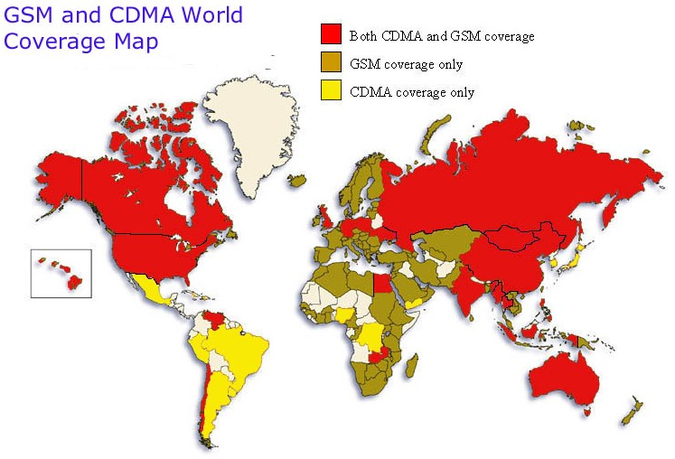

Value Added Services
Value added services like SMS, gaming and internet access have become a major source of revenue of network operators. They also help in attracting customers. Both GSM and CDMA score almost equally on this front.

There are a few factors that do not favour deploying a CDMA network. CDMA being a patented technology, all CDMA equipment & handsets require a royalty to be paid Qualcomm. Moreover, CDMA being of a new, proprietary nature not all its flaws are known

The Indian Scene
The critical factors on which decision to adopt a technology in India will depend can be examined as below:

Penetration of Telecom Network
It is imperative for India to improve the penetration of telecom services which at present is at abysmal levels compared to rest of the world. CDMA based WLL is a step in the right direction. With operators such as BSNL saying that WLL will be cheaper than landlines, it is hoped that the penetration in India would improve. Any cellular technology, likewise, should be amenable to the above objective.
Investments
In India, the cellular service providers have set up extensive GSM based networks. An estimated Rs. 21,000 crores have been sunk in building this network (entirely GSM based). A new technology such as CDMA needs to be examined for any potential destructive innovation.
Roaming
One of the major concerns of cellular operators planning to roll out a CDMA network is whether the mobile device will enable roaming facility in other parts of the country. If there is no large scale adoption of CDMA among the operators, a consumer can be stuck with a service which does not offer roaming service. With GSM already have been set as the standard all over India, this is quite a possibility. At the same time, it needs to be borne in mind that the number of subscribers going in for roaming is rather low and most of the calls being made are inter SDCA calls. There are even fewer people who opt for International roaming. An Indian consumer would not care much for premium services such as roaming as long as he gets mobility within his circle.
3G
India had an advantage over the rest of the world in that it did not have any legacy networks and was directly able to leap frog into an advanced technology like GSM. In a similar vein, while implementing any new technology, we need to consider its upgradability to 3G. 3G promises to become a major revenue driver for operators, though not in the near future. Unfortunately, at this point of time it is not clear which of the two - CDMA 2000 1X and WCDMA - CDMAone’s and GSM’s migration path to 3G respectively are going to be adopted worldwide. CDMA 2000 1X is believed to have a straighter path to 3G with fewer stages.

Recommendation
In recommending the deployment strategy for a telecom operator, the following need to be kept in mind. Firstly, Indian customer is price sensitive who would not mind a cheaper option even if it comes with a lower quality level. Second, given the low penetration levels in India, any technology which promises to increase it radically should be seriously considered. Thirdly, the telecom operator would have to make a huge investment while setting up its network; hence it is imperative that it gets the customers to make it economically viable to operate. Hence a technology which can support more customers at the same time would be beneficial to the operator. Given these considerations we suggest the following recommendations.

The Basic Services Telecom Operator
What to deploy
CDMA based Limited WiLL telephony.
Why
The current policy framework of Indian telephony is such that in case a Basic Service operator provides limited mobility then there are no spectrum costs to be paid to the government. There is therefore a possibility of providing mobile telephony services at prices equal to that of landline services. Hence Basic Service operators should take advantage of this policy and provide cheap limited CDMA based WiLL services to the customers. CDMA technology is stressed it alone can address the huge user base which would result once WiLL services are introduced.

The Fourth Cellular Mobile Services Operator
What to deploy
CDMA based cellular mobile services.
Why
The rational is quite simple. CDMA supports more user than GSM, given the same resources. This means that a mobile services operator using CDMA would be able to support more customers than an operator using GSM. In cellular mobile services industry a major portion of the costs to customers originates from the huge fixed costs borne by the operator. This cost reduces as the number of users increases, implying that more users means lesser call rates, which results in still more users. This obviously is a cycle which only a CDMA operator can support given its excess capacity as compared to a GSM one.
Given these recommendations, it is possible to create a telecom infrastructure in India which not only helps in the underlying goal of increasing telephony penetration but also suits an increasingly market dominated environment.
At the same time, we may point out that having a stand-alone CDMA network with the rest of the country having GSM based networks is fraught with technological and financial risks.
References
- WirelessAdvisor.com Forums- TDMA or CDMA,800 or 1900 – which is best?
retrieved August 11, 2002 from http://www.wirelessadvisor.com/waforums/
messageview.cfm? catid=16&threadid=3561
- War of the Standards GSM vs CDMA - M-CommerceTimes.htm
Retrieved August 12, 2002 from http://www.mcommercetimes.com/Technology/ 95
- Wireless Communications – GSM vs CDMA
Retrieved August 12, 2002 from Wireless www.telecom.globalsources.com/ MAGAZINE/WC/0206/GSMVS.HTM
- The Shosteck Group (june 2001) GSM OR CDMA :The Commercial and Technology Challenges for TDMA Operators 38 pages CDMA development group
- Cellular Operators Association of India
Retrieved August 12, 2002 from http://www.coai.com/telephny.htm

