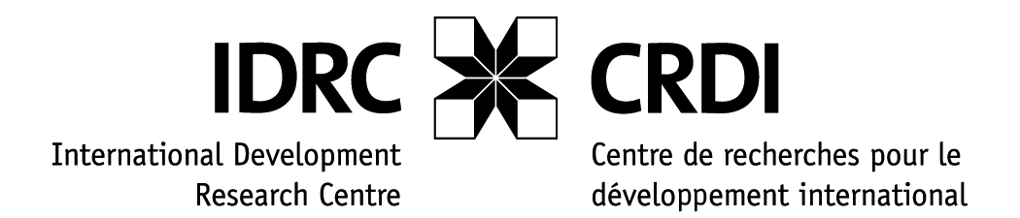

IDRC event at GKP Forum in Tunis

The International Development Research Centre (IDRC) was one of the first development agencies to embrace information and communications technologies (ICTs) as a key means for development and poverty alleviation. With established programs such as Acacia in Africa, Pan Asia Networking in Asia, and Pan Americas in Latin America, IDRC has a breadth of experience on the impact of ICTs on the lives of people in the developing world.

The goal of the IDRC event at the GKP Forum is to initiate two Dialogues on best practice that support the implementation of the WSIS Geneva Action Plan, in particular in the areas of access to information and knowledge. GKP partners and all WSIS stakeholders will therefore be invited to interact with some of the most respected Southern digital pioneers. We would expect around 50-70 participants.

Dialogue 1 – Transforming Social Systems in Development (1.5 h)
Objective: highlight how innovative technologies and solutions are being used to provide better access to social services.

Moderator:
Dr. Driss Kettani, Al Akhawayn University, e-government Pilot in Morocco

Panel:
- E-Health Innovation
- Uganda Health Information Network (UHIN), Dr. Patrick Okello,
- Anti-retroviral rollout in Free State province of South Africa, Dr. Chris Seebregts, Medical Research Council

- Education/Skills Development

- Latin American Network of Education Portals, Relpe (follow-up with Angelica on who would come and speak)
- ICT for Rural Development in Mountainous and Remote Areas of Northern Pakistan, Dr. Naveed A. Malik, Virtual University Of Pakistan

- E-government
- The Network of E-Government Leaders in Latin America and the Caribbean, Red GEALC (Follow-up with Angelica)

Note: We will have demos of UHIN, ICT for Rural Development in Mountainous and Remote Areas of Northern Pakistan and Relpe (tbc) at the Sandbox, IDRC Booth

Dialogue 2 – The open ways to Development (1.5 h)
Objective: This session will explore how FOSS, Open Spectrum, Creative Commons initiatives can facilitate access to information and knowledge.

Moderator:
Mr Tengku Azzman, MIMOS, Malaysia

Panel:

- Open Source Solution for African Universities (Avoir) Prof. Derek Keats and Prof Felix Akorli

- Open Spectrum, Onno Purbo

- Creative Commons, Heather Ford, Link Centre

- Open Source Software in Latin America (follow-up Angelica)

