

LINKSYS WIRELESS-N LAUNCH
Start a Wireless Network with Up To 4 times Farther and 12 times Faster
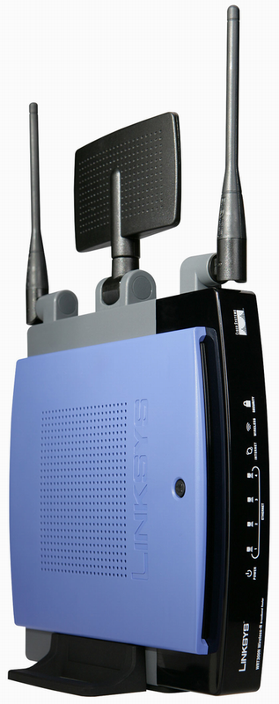

Linksys Wireless-N Broadband Router: WRT300N

- Internet-sharing Router and 4-port Switch, with a built in speed and range enhanced Wireless Access Point
- MIMO technology uses multiple radios to create a robust signal that travels up to 4 times farther and reduces dead spots
- Up to 12 times faster than Wireless-G, but also works great with Wireless-G and -B devices
- Wireless signals protected by WPA2 encryption, and your network protected from Internet attacks by a powerful SPI firewall

Linksys Wireless-N PCI Adapter WMP300N
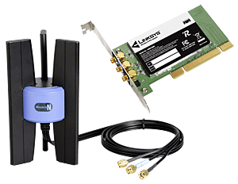
- High-speed Wireless-N (draft 802.11n) networking for your desktop computer
- MIMO technology uses multiple radios to create a robust signal that travels up to 4 times farther and reduces dead spots
- Up to 12 times faster than Wireless-G, but can also connect to Wireless-G and -B networks
- Advanced wireless security: Wi-Fi Protected Access™ (WPA2) with up to 256-bit encryption

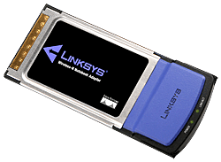
Linksys Wireless-N Notebook Adapter WPC300N

- High-speed Wireless-N (draft 802.11n) networking for your notebook computer
- MIMO technology uses multiple radios to create a robust signal that travels up to 4 times farther and reduces dead spots
- Up to 12 times faster than Wireless-G, but can also connect to Wireless-G and -B networks
- Advanced wireless security: Wi-Fi Protected Access™ (WPA2) with up to 256-bit encryption

