The Use of E-Learning towards New Learning Paradigm: Case Study Student Centered E-Learning Environment at Faculty of Computer Science - University of Indonesia 1)

Zainal A. Hasibuan
Faculty of Computer Science University of Indonesia
zhasibua@cs.ui.ac.id

Harry B. Santoso
Faculty of Computer Science University of Indonesia
harrysantoso@cs.ui.ac.id

Abstract

Faculty of Computer Science (Fasilkom), University of Indonesia (UI) develops Student Centered E-Learning Environment (SCELE) for Graduate Program in Information Technology as part of Distance Learning system, which is developed using Enterprise Resources Planning approach. SCELE is also well known as Learning Management System (LMS). Beside SCELE, Fasilkom UI also develops contents, which are conformant with SCELE, Digital Library and Online Academic Registration System to support learning process. This paper elaborates the study of SCELE, content development, and the result of system evaluation.*

1. Introduction

One of the urgent problems to be faced by Higher Educational Institutions (HEIs) in developing countries, especially country which has large amount of population, wide geographical area, and multicultural ethnics is imbalanced resources to handle the academic activities. The logical consequent is imbalanced academic quality and furthermore weakened national competitiveness.
A study performed by Directorate General of Higher Education (DGHE) Republic of Indonesia (2003) shows that currently the higher education sub sector comprises of 82 public HEI, and more than 2,236 private HEI. It enrolls around 1 million students in the public HEI and the remaining around 2.0 millions in private HEI. A smaller fraction of the student population, around additional 200,000 students, is enrolled in religious and occupational educational institutions. The current participation rate in higher education is still low (around 12.8%) compared to other developing countries in the region, such as the Philippines (32%) and Thailand (30%) [1].
According to the DGHE Strategic Plan 2003–2010, the nation's competitiveness can only be achieved under the framework of strong national character and civilization. In this respect Fasilkom, as a subset of the higher-education system, has the responsibility to provide students with the knowledge and understanding to be good citizens and to lead meaningful lives. By providing e-learning in distance education, Fasilkom will be able to contribute to widening access to higher education, and indirectly, contribute to shaping a democratic, civilized, and inclusive society that maintains national integration through its role as a moral force, and acts as the bearer of public conscience [2].
This digital era is accompanied by the astonishing development of Information and Communication Technology (ICT) which influences almost all fields, and of course, education. By the implementation of this e-learning, we believe that we can achieve following objectives:
- Give a priority to development of regional based higher education by developing focal points.
- Increase the access and equality of education.
- Improve and disseminate relevancy and quality of education.
- Improve research activities, both in terms of quantity and quality.

2. Learning Media and Technologies for Distance Education

According to Belawati [3], in developing countries, where a lot of its citizen live in low economic rate and isolated rural area, distance education system is also educational method which is believed that is capable or well-to-provide second chance for any citizens who could not follow regular (means: face-to-face method) education. Before September 2001, only Universitas Terbuka (translation: Open University) was allowed to carry out any forms of distance learning. The regulation was based on DGHE letter number 2630/D/T/2000 dated September 22nd, 2000. For about 1 (one) year later, a new set of policy was announced by The Minister of National Education, Republic of Indonesia on September 24th, 2001 that removed the ban and allowed any eligible institutions to carry out distance learning [4].
The implementation of distance learning need medium to deliver course content. After many years and the widespread of Internet utilization, the learning There are many definitions about e-learning, but here we would like to adopt from Learning and Teaching Support Network (LTSN) Generic Centre (2002): e-learning is ‘learning facilitated and supported through the use of information and communication technologies’ [5]. From the definition, we understand that e-learning concept is the utilization of ICT (e.g. television, radio, video, Internet, etc) in order to support teaching-learning activities (see Table 1).
Actually, e-learning is not relatively new in education field, and the implementations of e-learning in developed countries have proved run smoothly. But in case of Indonesia as one of developing countries, we face many problems in implementing it, such as infrastructure problem (internet connection bandwidth, learning management systems, network infrastructure) and also learning culture, which is still focus on teacher (teacher-centered). Some HEIs in Indonesia have been developing e-learning system in various ways. Some of them only limited to course materials delivery through web, and the others have had integral framework for their e-learning system to be used at wider scale, not only for regular student but also for distance student who only can study away from campus.

Table 1. The technology application examples for distance education system

Media | Technology | Applications in Distance Education System
Text | Printed | Book, module, printed tutorial.
 | Computer | Database, electronics publications.
Audio | Cassette, Radio broadcast | Audiocassette and radio programs, radio-based tutorial.
 | Telephone
Television (visual) | Broadcasting, video cassette, video discs, cable, satellite, fiber optics, video conferencing | TV broadcasting programs and video cassette, video conferencing, etc.
Computing | Computer, telephone, satellite, fiber optics, ISDN, CD-ROM, CD-I | Computer-Aided Instruction (CAI), electronic mail (e-mail), computer conferencing, graphical audio, database, multimedia, web-based learning material, etc.
Source: Bates, 1995 at [6]

In this recent day, Internet is the most popular media to carry out distance education. By using Internet, we can develop web-based learning or online learning which has many advantages, for instances, it can provide synchronous and asynchronous learning activities, and of course it can support interactive learning which will give rich learning experiences, not only for student but also the instructor (see Table 2).

Table 2. Synchronous and asynchronous learning delivery

 | Same Time  (Synchronous) | Different Time  (Asynchronous)
Same Place | Classroom | Learning Center  Laboratory  Library
Different Place | Audio conferencing  Videoconferencing  Satellite delivery  Chat Room  Instructor-led  (Synchronous Learning System)  Synchronous Streaming | WWW  Learning Management Systems  Video tape/Audio tape  CD-ROM  Archived Streamed  Video  E-mail/Listserv
Source: Distance Learning and Sun Microsystems, 1999 at [7]

3. Student Centered E-Learning Environment and the Learning Model

Student Centered E-Learning Environment (SCELE) is a Learning Management System (LMS), which was developed by e-learning team at Fasilkom UI. Open source LMS, Moodle stands for Modular Object Oriented Dynamic Learning Environment, which is motored by Martin Dougiamas, PhD, is used as core of SCELE. Moodle has been developing by using PHP (PHP-Hypertext Preprocessor) as scripting language and MySQL as database. Moodle’s main features supports SCELE, such as communication tools both synchronous (chatting) and asynchronous (news and discussion forum), user management, assessment, and also course management. We had modified Moodle so it can meet our student-centered learning model requirements. We developed LONTAR (Library Automation and Digital Archives), which uses Java Technologies and Web Services and Online Academic Registration System to be integrated into SCELE.

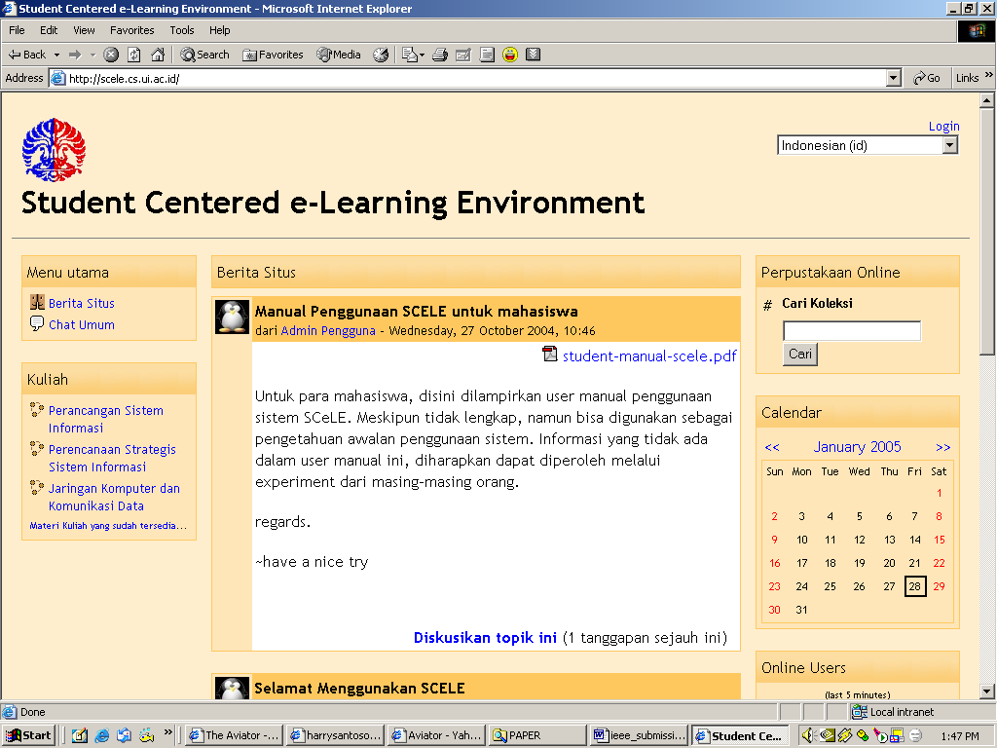

Figure 1. The User Interface of SCELE

We introduce a model of student-centered learning paradigm through SCELE as an attempt to change old learning paradigm, which focus on teacher to focus on student. By using this approach, we believe that student can meet new learning experience and can exercise active and collaborative learning. Here, teacher’s role is changing from actor into facilitator in order to guide learning process.
Goals of teaching-learning activities especially in HEI are not only knowledge transfer (hard skill/competency), but also the development of analytical-thinking (soft skill), that are very useful to face and solve the complexities of real world problems. Whilst, the complexities of real world problems are steadily increasing, creativity is rarely challenged in conventional education, which is still dominated by a course-based approach as opposed to problem-based approach. This course-based approach is characterized by a teacher-centered style that delivers courses single-handedly and often disregards other courses or disciplines. Some of these problems cannot be solved just using one discipline. Very often, a comprehensive solution for real problems requires a multi-disciplinary approach or a team approach.
The idea of student-centered learning is not limited to campus-based teaching and learning but it can be extended to distance learning. More works need to be done in order to provide a working system of student-centered learning. Overall, establishing student-centered, e-learning systems for distance learning will improve the quality of education, at the same time as increasing the possible number of students’ participating in higher education.
Distance learning will offer credit-earning courses that will be geared towards degree earning similar to conventional education. The courses will be delivered in combination with traditional face-to-face delivery and with ICT-based delivery. The local teacher (from the HEI partner) will have a role as a tutor, and will receive courses delivered by more experienced teacher from resource universities. ICT-based delivery will not be limited to web-based courses, but will include videoconference and other features of computer-mediated learning. The global connectivity of the videoconference facilities will rely on a sophisticated ICT infrastructure. One of them is the Global Development Learning Network (GDLN) infrastructure, which sponsored by The World Bank Institute, is currently available at UI. GDLN is a global network of ICT based centers, with a capability of multi-media learning that include, video conferencing, PCs linked together throughout the network to allow simultaneous working sessions, and learner-response keypads for interactivity [8].

4. Content Development and Knowledge Transfer

Even though most of course materials in the conventional education at Fasilkom are already available in the form of electronic files, it is not enough to support student-centered e-learning. Every semester, lecturers can upload their course materials to a dedicated Fasilkom web site, (http://telaga.cs.ui.ac.id/WebKuliah). The current method uses computers to disseminate the course materials in advance (one-way communication) and students can browse or download them. It is also a common practice at Fasilkom for each course to have an electronic bulletin board (forum.iki.coursename) where students and lecturers can exchange information or discuss something in addition to the class meeting. Beside that, students and lecturers interaction can also take place using electronic mail; however, each of these initiatives operates separately.
Currently Fasilkom offers undergraduate programs (regular and international programs), postgraduate programs (research-based and course-based or professional programs) and doctoral program. Each of these programs has its unique characteristics (see the section entitled teaching and learning in self evaluation). Given the nature of postgraduate professional program (MTI) which discusses more about real problems in information systems and information technology, and then it is proposed in Project Program B as the program that will be developed in student-centered e-learning systems.
Developing contents for e-learning is not just about creating course materials in electronic form. There is more to it such as providing syllabus for the courses, cases, reading assignments, quiz, exams, method of delivery, discussion, and evaluations and so forth in one integrated package. These components of e-learning have to be integrated and designed in such a way that students’ participation will be optimal.
All course materials will be designed according to modes that comply with student-centered learning model. Conventional course materials will be enriched by real-world problems and will be delivered by incorporating multimedia and animations. Relevant contents will be developed based on input from a group of experts, industries and alumni. This approach will ensure a dynamic and lively learning process. Hence, even though the students participate remotely, they still can feel an encouraging academic atmosphere.
Hence, this student-centered e-learning system should be flexible enough to accommodate other discipline. The materials and their delivery methods should be adequately conformed into its pedagogic and cognitive aspects in order to achieve learning objectives. Any e-learning content developments must be created for sound pedagogical reasons.
Three points below will show us mechanism and design of content development:
- Develop, implement, and co-ordinate contents to enable e-learning on study program.
- Establishment a set of standard for Quality Assurance (QA) in developing courses materials that will be implemented in e-learning systems. This effort involves collaborating with the central QA unit in UI.
- Establish a supporting unit for teaching staff to enable them to integrate courses into ICT by providing a learning-technology team within Fasilkom and, later on, within UI’s learning-resources unit. This unit will provide service for e-learning development.
For content development, another concern in this e-learning implementation is how to establish standard on our course materials that we developed. This time we are still in analysis and design phase to make our content to meet Sharable Content Object Reference Model (SCORM) specification. SCORM is developed by ADL (Advanced Distributed Learning) Co-Labs. The SCORM is a collection of specifications adapted from multiple sources to provide a comprehensive suite of e-learning capabilities that enables interoperability, accessibility and reusability of Web-based learning content [9]. Nowadays, there are many authoring tool products that can help us to make content which are meet SCORM specifications, for instances Macromedia Flash MX 2004TM and Dreamweaver MX TM, Articulate Presenter TM, and many others. To practice in making SCORM-conformant content we use any tools provided by ADL and another tools, for instance RELOAD Editor provided by RELOAD which is a project funded under the Joint Information Systems Committee (JISC) Exchange for Learning Programme (X4L) [10].

5. Evaluation of SCELE and Content

To evaluate the use of course material for our e-learning purpose, we have held trial activities. Out first activity was workshop on e-learning, which was followed by representatives or lecturers from various areas (islands) in Indonesia. Total participants were 65 persons; 6 persons from east region of Indonesia (Papua), 12 persons from middle region (Kalimantan), 15 persons from west region (Sumatra), 6 persons from west region (Java), and 26 persons from Jabotabek (Jakarta, Bogor, Tangerang, and Bekasi). Our second activity has been following by conventional Fasilkom UI’s Graduate Program in Information Technology students. We used Computer Networked and Data Communication course into two classes. Respondents who participated in this evaluation came from various age groups. We also get data that 15% respondents were female and 85% were male for total 47 students set involved.
Our course material consists of 3 (three) models of content: they are model level 1, level 2, and level 3. Level-1 model is simply slides, without any media such as narration, animations, or video. Several slides of level-1 content model have pictures or tables, which can be clear enough for several students. But may be there are other students who need more explanation or real implementation about some topics. So, we develop level-2 content model that is combination of any media, such as text, animations, and narrations. Besides that, there is a trigger for student to dig level-3 content, which is using another reference to sharpen students’ understanding about the topic in course material.
From the questionnaire result, we know that, in general, respondents said that SCELE system is worth to be implemented for distance learning (94% respondents). Most of respondents (87% respondents) also indicated that using SCELE motivate students to be active learners.
Most of respondents (80%) agree that course materials, which are provided through SCELE, can be

clearly understood. Animations at level-2 were indicated clear, and information, which is delivered through those animations, can be clearly understood by 77% respondents (answered only by morning class students). Similar percentage, 73% (answered only by morning class students) respondents of morning class said that audio was clearly heard, and information, which is delivered through audio narration, can be clearly understood.

Questionnaire Result

Type of Agree-Do Not Agree Question
No | Statement |  | A+ | A | DA | DA+ | ABS | Total
1. | SCELE system is worth to be implemented for distance learning |  | 17 | 27 | 2 | 0 | 1 | 47
2. | SCELE motivate students to be active learners |  | 17 | 24 | 3 | 1 | 2 | 47
3. | You can focus on learning all the time while other students and instructor were discussing by using SCELE |  | 3 | 17 | 7 | 11 | 9 | 47
4. | Course materials, which are provided through SCELE, can be clearly understood |  | 6 | 32 | 6 | 1 | 2 | 47
5. | Animations at level-2 were indicated clear, and information that is delivered through those animations, can be clearly understood. |  | 0 | 14 | 4 | 0 | 0 | 18
6. | Audio was clearly heard, and information that is delivered through audio narration, can be clearly understood. |  | 3 | 10 | 4 | 0 | 1 | 18
Type of Yes-No Question
 | Question | Statement | Number (Yes) |  |  | Percentage
1. | Based on your experience using SCELE system, can you give a statement about online learning instruction compare with traditional one? | Online instruction is better than traditional one. | 7 |  |  | 14.9 %
1. |  | Online instruction is almost same with better than traditional one. | 18 |  |  | 38.3 %
1. |  | Traditional instruction is better than online one. | 22 |  |  | 46.8 %
1. |  | Abstain | 0 |  |  | 0 %
Total |  |  | 47 |  |  | 100 %
2. | Based on your experience using SCELE system, can you give a statement about functional integrity (such as discussion, explanation, tools utility, etc) used in online learning compare with traditional one? | Online integrity is better than traditional one. | 12 |  |  | 25.5 %
2. |  | Online integrity is almost same with better than traditional one. | 12 |  |  | 25.5 %
2. |  | Traditional integrity is better than online one. | 22 |  |  | 46.8 %
2. |  | Abstain | 1 |  |  | 2.2 %
Total |  |  | 47 |  |  | 100 %

Questionnaires Answer Instruction

No | Abbreviation | Explanation
1  2  3  4  5 | A+  A  DA  DA+  ABS | Agree (in advance)  Agree  Do not agree  Do not agree (in advance)  Abstain

clearly understood. Animations at level-2 were indicated clear, and information, which is delivered through those animations, can be clearly understood by 77% respondents (answered only by morning class students). Similar percentage, 73% (answered only by morning class students) respondents of morning class said that audio was clearly heard, and information, which is delivered through audio narration, can be clearly understood.
It’s also noted that 47% respondents said that traditional class has better instructional and functional integrity than online class. And we see that 38% respondents still cannot focus on their learning all the time while other students and instructor were discussing by using SCELE. Both of the facts need further analysis, in order to obtain better explanation why that happens.
Respondents also think about bandwidth problem. In order to handle the course material with big file size, can be done by delivering them through compact disc, and not directly download through SCELE’s server.
From the evaluation results, it can be concluded that the performance of e-learning for distance learning is comparable with regular or conventional learning.

6. Conclusion

This Student Centered E-Learning Environment is developed to support distance learning and the implementation of new learning paradigm, student-centered learning. The system manages several learning activities, such as: calendar academic, course and assessment graph, news, user management, and also learning material management. It is a system that is part of enterprise resources planning in distance learning system, which is developed at Fasilkom UI.

For future work consists of:
- To extend the using of SCELE into University of Indonesia wide program.
- To develop dynamic course and assessment graph. This is indicated by color changes in the graphs. It will help students to track the status of their study activities.
- To develop ‘lightweight’ version of SCELE, so student with small bandwidth Internet access can use SCELE by offline, and only need synchronize with SCELE’s server in minutes. Then the students get updated SCELE’s content.
- To Develop content form other discipline, not only course materials for faculty of computer science, but also other faculties in University of Indonesia (University of Indonesia’s Learning Center).

7. References

[1] B.Y. Moeliodihardjo and I.B. Ardhana Putra, Report on Higher Education Sector Study Evaluation and Financing of Higher Education, Directorate General of Higher Education, 2003.

[2] Faculty of Computer Science, University of Indonesia, Full Proposal Competition-based Grant Program – Program B (Promoting Nation’s Competitiveness), Indonesia, 2004.

[3] T. Belawati, “E-Learning dalam Sistem Pendidikan Jarak Jauh: Aplikasi di Universitas Terbuka” (translation: E-Learning in Distance Education System: an Application in Open University), paper has been presented at E-Learning Seminar at University of Indonesia, 15th September 2004.

[4] R.D. Kuntoro and S. Al-Hawamdeh, “E-Learning in Higher Educational Institutions in Indonesia”, Journal of Information & Knowledge Management, Vol. 2, No. 4, iKMS & World Scientific Publishing Co., 2003, pp. 361-374.

[5] M. Jenkins and J. Hanson, e-Learning Series: A guide for Senior Managers, Learning and Teaching Support Network (LTSN) Generic Centre, United Kingdom, August 2003.

[6] A.W., Bates, Technology, open learning, and distance education, New York: Routledge, 1995.

[7] B. Paleg, “Successful Videoconference-based Learning – Without the Tears”, has been presented at 2002 Annual Conference - Polycom User Group, Yacht Club Resor, 2002.

[8] B. Y. Moeliodihardjo, “Improving Quality in Higher Education by Narrowing the Digital Gap”, Prepared for the VITTI Seminar on Regional Cooperation for digital divide and opportunity, Hanoi, Vietnam, 21-23 November, 2001.

[9] http://www.adlnet.org, Advance Distributed Learning (ADL) [online], 29 January 2005.

[10] http://www.reload.ac.uk/background.html, Reusable eLearning Object Authoring & Delivery (RELOAD) [online], 24 February 2005.

1) This paper is presented at The 5th IEEE International on Advanced Learning Technologies, 5-8 July 2005, Kaohsiung, Taiwan .
* The finding shows that the overall performance of e-learning system is comparable to conventional system.

